**Eyes on Allergies: Recognizing Watery, Red, or Itchy Eyes in Allergic Rhinitis**

Allergic rhinitis (AR), also known as hay fever, is a common condition that affects millions of children in India. It is caused by an allergic reaction to substances like pollen, dust mites, and pet dander, leading to inflammation of the nasal passages. While a runny nose, sneezing, and congestion are common symptoms, AR can also significantly impact the eyes. This paper provides pediatricians in India with a comprehensive overview of how to recognize and manage the eye-related problems associated with AR in children.

**Prevalence of Allergic Rhinitis in India**

AR is a growing public health concern in India, affecting about 20% to 30% of the population [1]. Studies show a rising trend of AR in Indian children over the past two decades [2]. The International Study of Asthma and Allergies in Childhood (ISAAC) Phase III, conducted in 2002–2003, found that 7.7% of 6 to 7-year-old children and 23.5% of 13 to 14-year-old adolescents had AR [3]. These numbers highlight the significant impact of AR in India and the need for effective management strategies.

It's important to note that AR patients can be classified into two groups: "sneeze runners" and "blockers" [2]. Sneeze runners experience primarily sneezing and a runny nose, while blockers mainly have nasal congestion. This distinction can help pediatricians understand the different ways AR can present in children. Nasal obstruction is the most common symptom of AR in Indian children [2].

**Common Allergens in India**

India's diverse climate and environment contribute to a wide range of allergens that can trigger AR. These allergens can be broadly classified into two categories: outdoor and indoor allergens.

Outdoor allergens, also known as aeroallergens, primarily include pollen from trees, grasses, and weeds, with seasonal variations in their prevalence [4]. For example, tree pollen is common in early spring, grass pollen in late spring and summer, and weed pollen in the fall.

Indoor allergens are found within homes and other enclosed spaces. These include house dust mites, mold spores, and animal dander, which are prevalent throughout the year, especially in urban areas [5]. Cockroach allergens have also been identified as a significant contributor to allergic asthma in India [6].

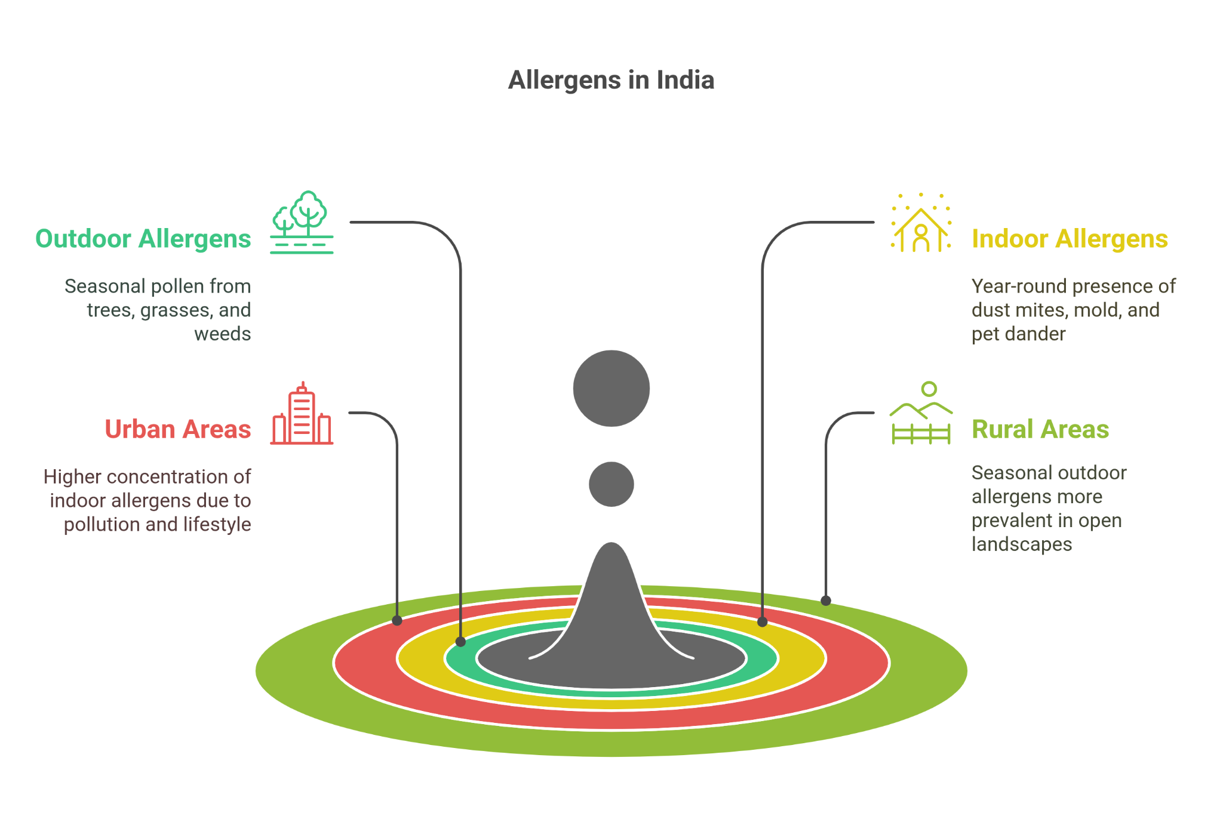

**Ocular Manifestations of Allergic Rhinitis**

AR often affects the eyes, leading to allergic conjunctivitis. This happens when allergens irritate the conjunctiva, the membrane covering the white of the eye and the inner eyelids [7]. The body releases histamine and other chemicals, causing a variety of eye symptoms. These symptoms can be categorized as follows:

* **Redness and Swelling:**
  + Redness: This is caused by the dilation of blood vessels in the conjunctiva [8].
  + Swelling: The eyelids and conjunctiva can become puffy and swollen due to inflammation.
* **Itching and Burning:**
  + Itching: This is often the most bothersome symptom, characterized by an intense urge to rub the eyes [9].
  + Burning sensation: A feeling of irritation and discomfort in the eyes [10].
* **Watery Eyes and Discharge:**
  + Watery eyes: The eyes produce excessive tears as a defense mechanism against allergens [11].
  + Discharge: A stringy, mucus-like discharge can occur, especially upon waking up.

In addition to these symptoms, allergic conjunctivitis can cause sensitivity to light (photophobia) [10]. If left untreated, allergies can potentially affect vision. Severe allergic reactions can even lead to corneal involvement, causing blurred vision or sensitivity to light [12]. These eye symptoms can significantly affect a child's quality of life, impacting their sleep, schoolwork, and daily activities [13].

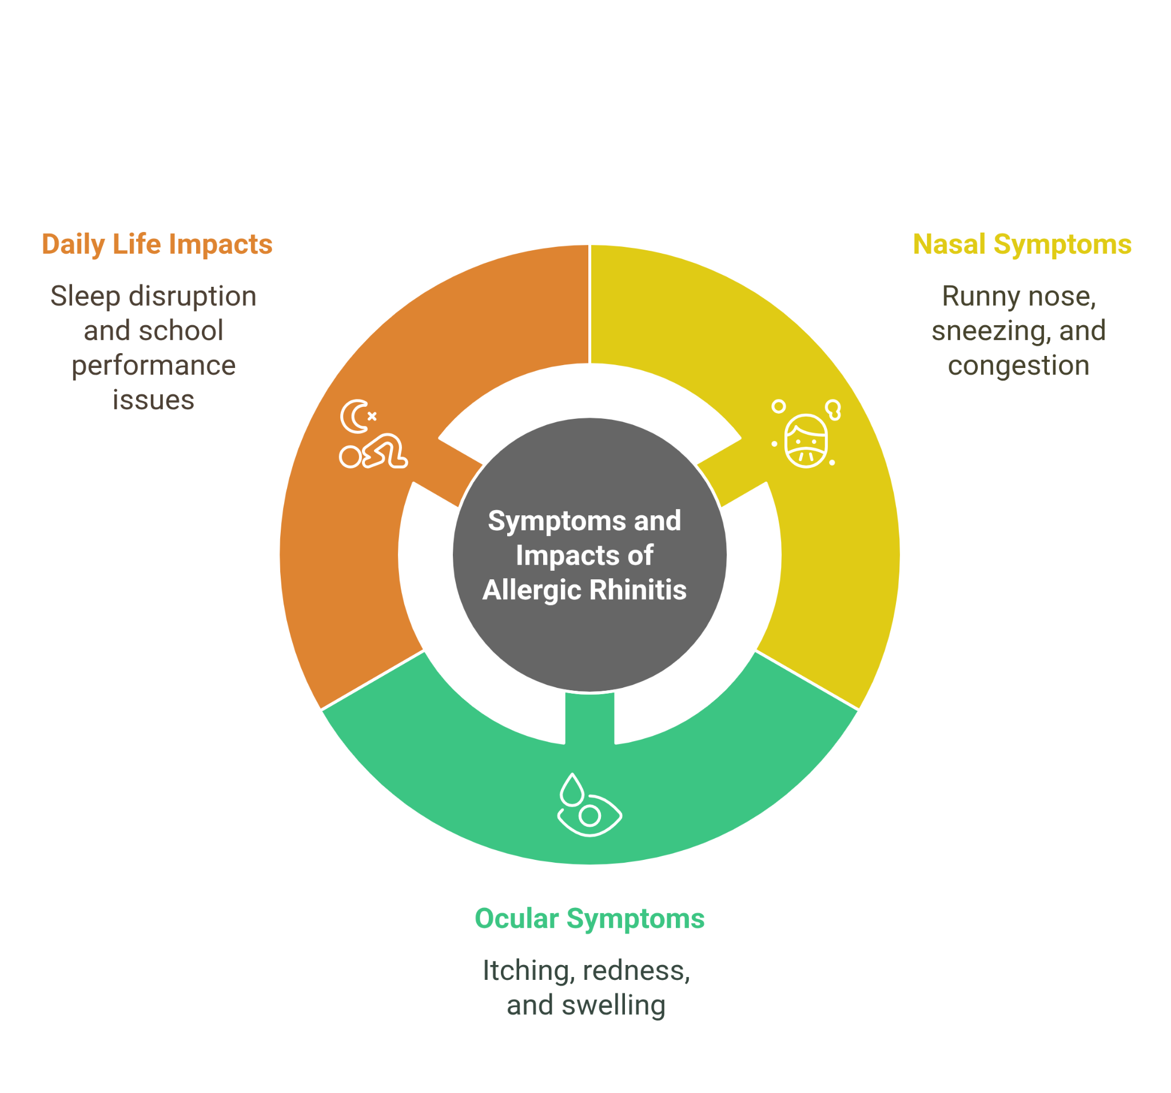

**Diagnosis of Allergic Rhinitis in Children**

Diagnosing AR in children requires a comprehensive approach that considers various factors:

* **Detailed medical history:** Ask about the child's symptoms, including when they started, how long they last, and any potential triggers. It's important to understand how these symptoms affect the child's daily life, sleep, and school performance [13]. Also, consider indirect indicators like fatigue and decreased school performance, which can be less obvious signs of AR [13].
* **Physical examination:** Look for signs of allergic rhinitis, such as pale nasal turbinates, clear nasal discharge, and "allergic shiners" (dark circles under the eyes) [14].
* **Allergy testing:** Skin prick tests or blood tests can help identify the specific allergens causing the child's symptoms [13].

It's important to differentiate AR from the common cold, as their symptoms can be similar. Unlike a cold, AR usually has a specific trigger, such as seasonal changes or exposure to a new pet, and is more likely to cause itchy, red, and watery eyes [8].

**Management of Allergic Rhinitis in Children**

Managing AR in children involves a combination of strategies:

* **Allergen avoidance:** Identifying and minimizing exposure to triggers is crucial. This may involve environmental control measures such as using air conditioning, keeping windows closed during high pollen seasons, and reducing exposure to dust mites and pet dander [15].
* **Pharmacotherapy:** Various medications can effectively alleviate AR symptoms. Intranasal corticosteroids are considered first-line therapy for persistent symptoms [16]. Antihistamines, decongestants, and leukotriene receptor antagonists may also be used depending on the child's specific needs [15].
* **Immunotherapy:** In cases of severe or persistent AR that does not respond to other treatments, immunotherapy (allergy shots) may be considered [15].

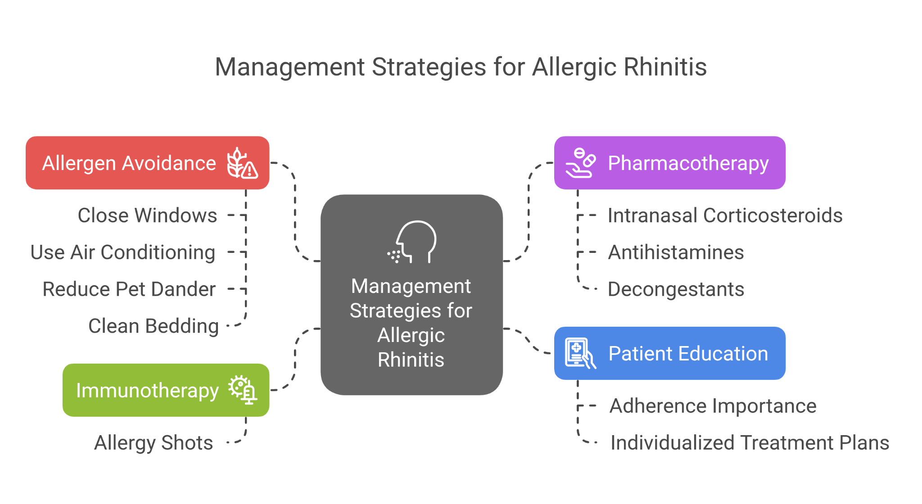

**Challenges and Considerations for Pediatricians in India**

Pediatricians in India face unique challenges in diagnosing and managing AR:

* **Lack of specialized training:** Allergy and immunology is not a recognized specialty in India, and there is a lack of specialized training programs for clinicians [17].
* **Limited access to diagnostic facilities:** Access to allergy testing and other diagnostic tools may be limited, particularly in rural areas [17].
* **High cost of medications:** The cost of medications, especially intranasal corticosteroids, can be a barrier to effective management [17].
* **Cultural beliefs and practices:** Traditional beliefs and practices may influence perceptions of AR and its management, potentially leading to delays in seeking medical attention [17].
* **Lack of India-specific scientific data and guidelines:** Current management protocols are often based on guidelines from Western countries, which may not be entirely applicable to the Indian population [17].

Another important consideration is the low medication adherence among AR patients in India. This is often due to a lack of education about the condition and a tendency towards self-medication [18]. Therefore, patient education and individualized management strategies are crucial.

**Potential Complications of Untreated Allergic Rhinitis**

Untreated AR can lead to various complications:

* **Sinusitis:** Chronic inflammation and nasal congestion can increase the risk of sinus infections [19].
* **Otitis media:** AR can contribute to middle ear infections, especially in children [19].
* **Nasal polyps:** Persistent inflammation can lead to the development of nasal polyps, which can further obstruct the nasal passages [20]. These polyps are non-cancerous growths that can cause breathing difficulties and reduce the sense of smell [19].
* **Sleep disturbances:** Nasal congestion and other symptoms can disrupt sleep, leading to fatigue and daytime sleepiness [19].
* **Worsening asthma:** AR can worsen asthma symptoms and increase the frequency of asthma attacks [21].
* **Eye complications:** Untreated allergic conjunctivitis can lead to corneal involvement, potentially causing blurred vision and other visual disturbances.

**Conclusion**

AR is a prevalent condition in India that can significantly affect children's eyes. Pediatricians play a crucial role in recognizing and managing the ocular manifestations of AR, such as watery, red, or itchy eyes. By understanding the prevalence, common allergens, diagnostic challenges, and management strategies specific to the Indian context, pediatricians can provide optimal care for their patients. Infographics can be valuable tools to enhance understanding and facilitate communication with children and their families, ultimately improving the quality of life for young AR patients.

It is important to remember that air pollution, including indoor pollution from sources like mosquito coils and incense sticks, can contribute to AR in India [6]. Therefore, advising families on minimizing exposure to these pollutants is essential. By staying informed about the latest research and utilizing effective communication tools, pediatricians can make a significant difference in the lives of children with allergic rhinitis.

#### **References:**

1. Allergic rhinitis in India: an overview - International Journal of Otorhinolaryngology and Head and Neck Surgery, accessed on March 11, 2025, <https://www.ijorl.com/index.php/ijorl/article/download/185/105/1118>

2. Global Asthma Network Phase I, India: Results for allergic rhinitis and eczema in 127,309 children and adults - PMC, accessed on March 11, 2025, <https://pmc.ncbi.nlm.nih.gov/articles/PMC10509898/>

3. Hay Fever (Rhinitis) | Symptoms & Treatment | ACAAI Public Website, accessed on March 11, 2025, <https://acaai.org/allergies/allergic-conditions/hay-fever/>

4. epidemiology of allergic rhinitis in india: a systematic review, accessed on March 11, 2025, [https://academicmed.org/Uploads/Volume5Issue5/279.%20[1717.%20JAMP_Mohamed%20Ali_QR]%201408-1413.pdf](https://academicmed.org/Uploads/Volume5Issue5/279.%20%5B1717.%20JAMP_Mohamed%20Ali_QR%5D%201408-1413.pdf)

5. COMMON CAUSES OF ALLERGY IN INDIA - Orange Health Labs, accessed on March 11, 2025, <https://www.orangehealth.in/blog/common-causes-of-allergy-in-india?post=1556>

6. Allergic conjunctivitis Information | Mount Sinai - New York, accessed on March 11, 2025, <https://www.mountsinai.org/health-library/diseases-conditions/allergic-conjunctivitis>

7. Allergic Rhinitis (Hay Fever): Symptoms & Treatment - Cleveland Clinic, accessed on March 11, 2025, <https://my.clevelandclinic.org/health/diseases/8622-allergic-rhinitis-hay-fever>

8. Allergic Conjunctivitis - Eyes - Johns Hopkins Medicine, accessed on March 11, 2025, <https://www.hopkinsmedicine.org/health/conditions-and-diseases/allergic-conjunctivitis>

9. Eye Allergies | Causes, Symptoms & Treatment | ACAAI Public Website, accessed on March 11, 2025, <https://acaai.org/allergies/allergic-conditions/eye-allergy/>

10. Hay fever (allergic rhinitis) - symptoms, treatments and causes - Healthdirect, accessed on March 11, 2025, <https://www.healthdirect.gov.au/hay-fever>

11. The Link Between Allergies and Eyes: What You Need to Know, accessed on March 11, 2025, <https://www.aspireallergy.com/blog/link-between-allergies-and-eyes>

12. A Clinical Approach of Allergic Rhinitis in Children - PMC, accessed on March 11, 2025, <https://pmc.ncbi.nlm.nih.gov/articles/PMC10528841/>

13. Pediatric Allergic Rhinitis: Practice Essentials, Background, Pathophysiology, accessed on March 11, 2025, <https://emedicine.medscape.com/article/889259-overview>

14. Allergic Rhinitis | Texas Children's, accessed on March 11, 2025, <https://www.texaschildrens.org/content/conditions/allergic-rhinitis>

15. Primary care management of allergic rhinitis in children - PMC - PubMed Central, accessed on March 11, 2025, <https://pmc.ncbi.nlm.nih.gov/articles/PMC11479000/>

16. An appraisal of allergic disorders in India and an urgent call for action - PMC, accessed on March 11, 2025, <https://pmc.ncbi.nlm.nih.gov/articles/PMC7398972/>

17. Trends, attitudes, and perceptions of Indian physicians in allergic rhinitis management, accessed on March 11, 2025, <https://publications.ersnet.org/content/erj/64/suppl68/pa732>

18. Allergic rhinitis complications - HSE.ie, accessed on March 11, 2025, <https://www2.hse.ie/conditions/allergic-rhinitis/allergic-rhinitis-complications/>

19. Allergic rhinitis - NHS inform, accessed on March 11, 2025, <https://www.nhsinform.scot/illnesses-and-conditions/ears-nose-and-throat/allergic-rhinitis/>

20. Nasal Allergy, Rhinitis and Allergic Rhinitis - Allergy & Asthma Network, accessed on March 11, 2025, <https://allergyasthmanetwork.org/allergies/nasal-allergy-allergic-rhinitis/>

21. Allergic conjunctivitis - Australasian Society of Clinical Immunology and Allergy (ASCIA), accessed on March 11, 2025, <https://www.allergy.org.au/patients/allergic-rhinitis-hay-fever-and-sinusitis/allergic-conjunctivitis>