**Nutrition's Role in Pediatric Concentration and Learning**

**Introduction**Nutrition plays a crucial role in cognitive development and learning ability in children. A balanced diet provides essential nutrients supporting brain growth, neurotransmitter production, and overall mental performance. Understanding how different nutrients impact concentration can help optimize children's diets for academic success [1].

**The Connection Between Nutrition and Brain Development**From infancy through adolescence, the brain undergoes rapid growth. Proper nutrition fuels neural development, memory formation, and problem-solving skills [2]. Key processes include:

* **Myelination and Neural Communication**: Omega-3 fatty acids contribute to myelin sheath formation, enhancing signal transmission, which is crucial for learning and memory [3].
* **Neurotransmitter Synthesis**: Amino acids from protein-rich foods are essential for neurotransmitter production, influencing mood and focus [4].
* **Antioxidant Protection**: Vitamins C and E neutralize free radicals, protecting neurons and supporting cognitive function [5].

**Critical Periods for Brain Development**Brain development is particularly critical during pregnancy (weeks 24-45) and the early childhood years. Adequate nutrition during these periods supports synapse formation and myelination, preventing cognitive deficits and supporting long-term brain health [6].

**Impact of Nutrition on Behavioral Development**Nutrition impacts mood and concentration through blood sugar regulation. Skipping meals, especially breakfast, can lead to irritability and reduced cognitive performance. Omega-3 fatty acids and B vitamins (B6, B12, folate) are vital for mood regulation and cognitive function. Deficiencies can lead to anxiety, depression, and focus difficulties [7][8].

**Important Nutrients for Concentration and Learning**Several nutrients are critical for brain health:

* **Omega-3 Fatty Acids**: Vital for brain structure and function (Sources: fatty fish, flaxseeds, walnuts).
* **Iron**: Essential for oxygen transport to the brain (Sources: red meat, spinach, lentils).
* **Zinc**: Supports neurotransmitter function (Sources: meat, dairy, nuts).
* **B Vitamins**: Crucial for energy and brain health (Sources: whole grains, eggs, leafy greens).
* **Antioxidants (C and E)**: Protect against oxidative stress (Sources: citrus fruits, berries, nuts).
* **Hydration**: Maintaining hydration is crucial for cognitive performance [11].

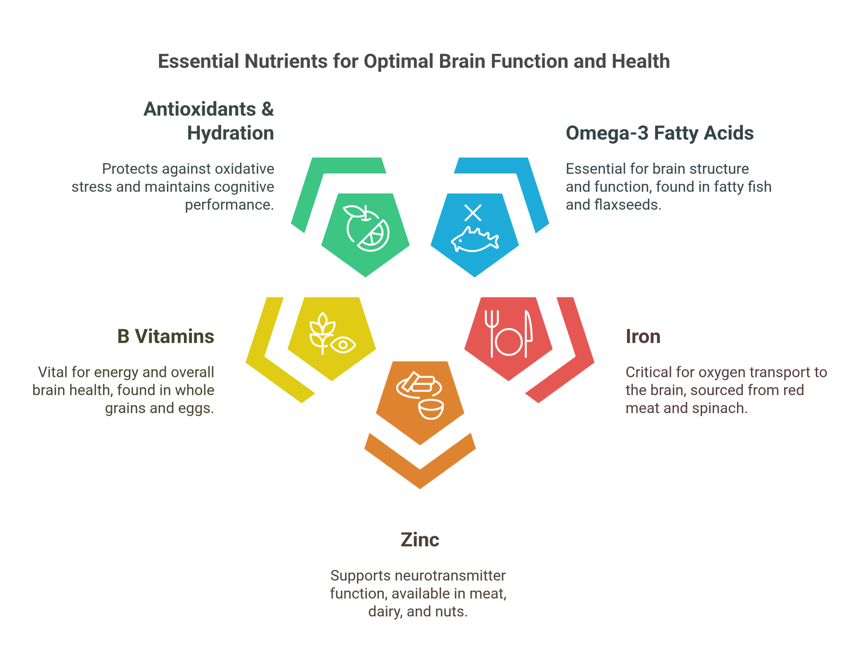

## **Effects of Nutritional Deficits on Concentration**

* **Iron Deficiency**: Leads to anemia, reduced oxygen transport, and impaired cognitive function [6].
* **Omega-3 Deficiency**: Associated with poor memory and concentration [3].
* **B Vitamin Deficiency**: Can cause fatigue, poor memory, and concentration difficulties [8].
* **Zinc Deficiency**: Results in impaired brain signaling and reduced cognitive function [7].

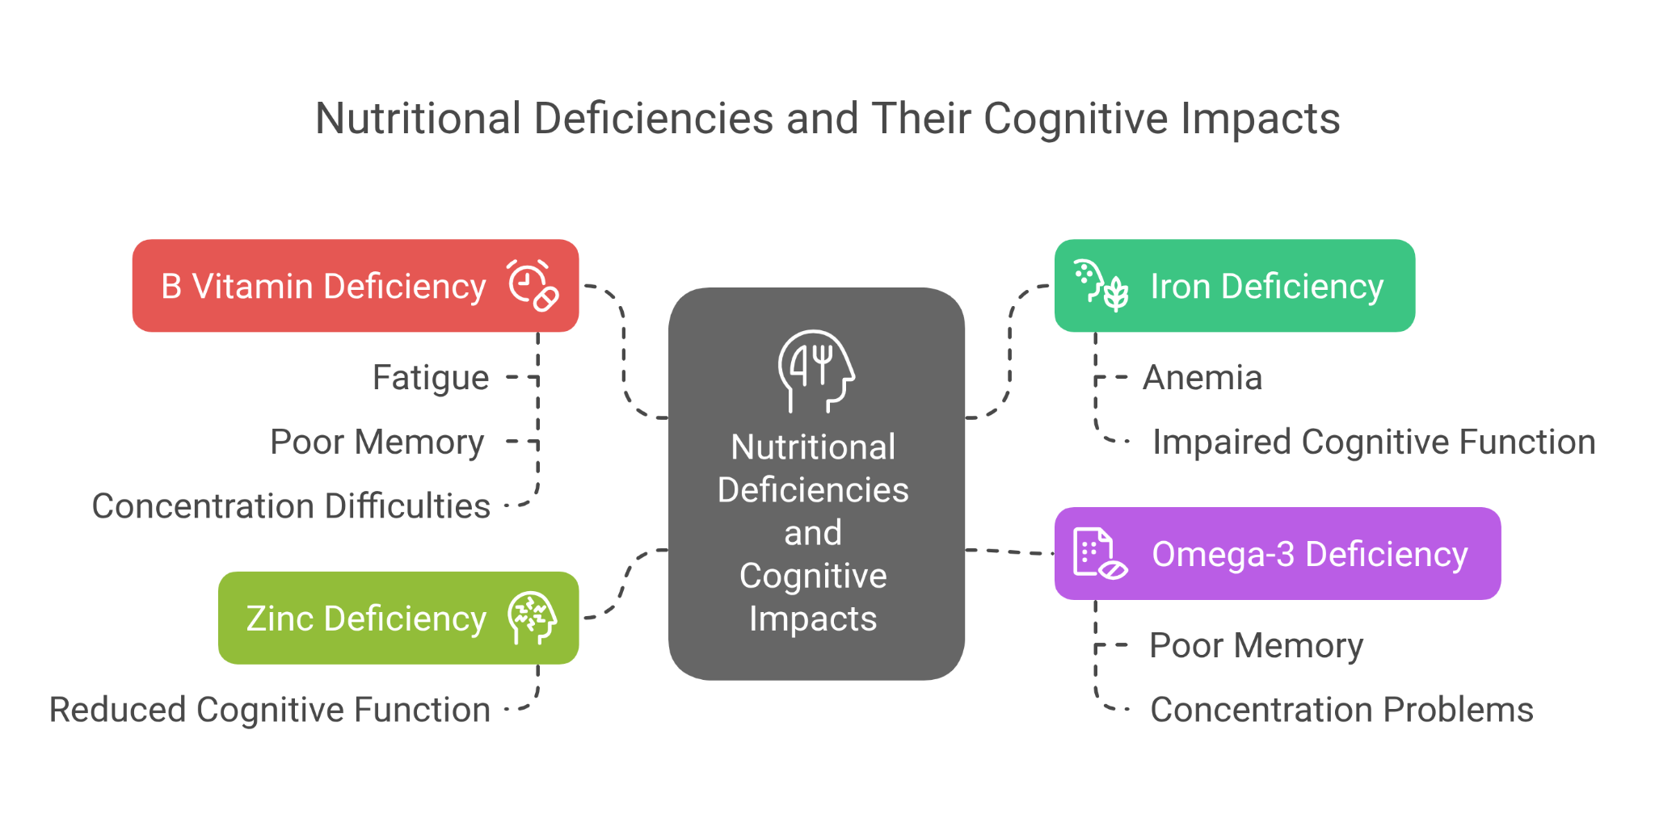

## **Sample Meal Plan and Nutritional Support**

It’s essential to prioritize balanced meals, including nutrient-dense foods for children’s cognitive growth. Regular growth and nutritional status check-ups should be performed. Use food diaries and questionnaires to assess nutritional intake. Parents should be educated about providing a variety of balanced meals to support brain development.

## **Practical Tips for Parents and Educators**

* **Offer a variety of colorful fruits and vegetables** with every meal to ensure a range of vitamins and antioxidants.
* **Serve a protein source** at each meal to help maintain stable blood sugar levels.
* **Include whole grains** for sustained energy and cognitive support.
* **Consider introducing a variety of nuts and seeds** as snacks to provide healthy fats and zinc [7].

## **Long-Term Benefits of Good Nutrition**

Good nutrition during childhood has lasting benefits, not only for cognitive development but also for emotional regulation and behavioral outcomes. Proper nutrition is linked to better academic performance, reduced anxiety, improved mood regulation, and healthier long-term cognitive function [12].

## **Conclusion**

Nutrition plays a critical role in shaping children’s ability to concentrate, learn, and succeed academically. A balanced diet rich in omega-3 fatty acids, proteins, vitamins, and minerals provides the essential building blocks for optimal brain development and cognitive function. By focusing on whole foods, reducing processed snacks, and ensuring proper hydration, parents and educators can actively support children's mental and emotional well-being for long-term success.

## **References**

1. Ansuya, Nayak, B.S., Unnikrishnan, B. *et al.* Effect of nutrition intervention on cognitive development among malnourished preschool children: randomized controlled trial. *Sci Rep* **13**, 10636 (2023). <https://doi.org/10.1038/s41598-023-36841-7>
2. Vazir S, Boindala S. Nutrition, Brain Development and Cognition in Infants, Young Children and Elderly. Proc Indian Natn Sci Acad. 2016;82(5):1495-1506. <https://www.researchgate.net/publication/309341576_Nutrition_Brain_Development_and_Cognition_in_Infants_Young_Children_and_Elderly>
3. Calder PC. Omega-3 fatty acids and inflammatory processes. Nutrients. 2015;7(11):9059-9081. <https://pubmed.ncbi.nlm.nih.gov/22254027/>
4. Wurtman RJ. The role of amino acids in neurotransmitter function. Clin Neuropharmacol. 1986;9(3):161-177. <https://pmc.ncbi.nlm.nih.gov/articles/PMC7503967/>
5. Seaward MR, Herring CM, Johnson CD, et al. Role of antioxidant vitamins in cognitive function. J Nutr. 2000;130(7):1778-1787. <https://pubmed.ncbi.nlm.nih.gov/21346712/>
6. Lozoff B, Beard J, Connor J, et al. Long-lasting neural and behavioral effects of iron deficiency in infancy. Nutr Rev. 2006;64(5 Pt 2):S34-S43. <https://pubmed.ncbi.nlm.nih.gov/16770951/>
7. Ghorbani S, Asgarian Z, Vafa M, et al. The effect of omega-3 supplementation on children with attention-deficit/hyperactivity disorder (ADHD). Nutr Neurosci. 2016;19(9):362-369. <https://pubmed.ncbi.nlm.nih.gov/30594823/>
8. Fava M, Mulrow CD, Zisook S. The role of B vitamins in depression and cognition. Psychiatr Clin North Am. 2017;40(1):117-132. <https://pubmed.ncbi.nlm.nih.gov/27655070/>
9. Larios-Pérez I, García-Jiménez P, Vázquez-Ortiz M, et al. Omega-3 fatty acids and their role in managing ADHD symptoms. Nutr Neurosci. 2017;20(7):406-417. [**https://www.researchgate.net/publication/389556452_Role_of_vitamins_and_nutrients_in_the_management_of_attention-deficit_hyperactivity_disorder_ADHD_a_narrative_review**](https://www.researchgate.net/publication/389556452_Role_of_vitamins_and_nutrients_in_the_management_of_attention-deficit_hyperactivity_disorder_ADHD_a_narrative_review)
10. Cunningham SD, Anderson G, Caruso J, et al. B vitamin supplementation and mood regulation in children. J Nutr. 2018;148(5):772-780. <https://pmc.ncbi.nlm.nih.gov/articles/PMC7288613/>
11. D'Anci KE, Constant F, Rosenberg IH. Hydration and cognitive function in children. Am J Clin Nutr. 2006;84(6):1256-64. <https://pubmed.ncbi.nlm.nih.gov/17063927/>
12. Smithers LG, Golley RK, Mittinty MN, et al. Dietary patterns at 6, 15, and 24 months of age are associated with IQ at 8 years of age. J Epidemiol Community Health. 2012;66(7):624-8. <https://pubmed.ncbi.nlm.nih.gov/22810299/>
13. Benton D. The impact of diet on the development of the brain and cognitive function. Pro Nutr Soc. 2015;74(2):112-122. <https://pubmed.ncbi.nlm.nih.gov/18683027/>
14. Taras H. Nutrition and student performance at school. J Sch Health. 2005;75(6):199-213. <https://pubmed.ncbi.nlm.nih.gov/16014126/>
15. Bryan J, Calvaresi E, Hughes D. Omega-3 fatty acids and cognitive function in children. Am J Clin Nutr. 2004;80(6):1505-1511. <https://pubmed.ncbi.nlm.nih.gov/15478684/>