### **Pediatric Vomiting and Diarrhoea: Decoding Red Flags for Severe Outcomes**

Pediatric vomiting and diarrhoea are common yet variable in severity, requiring pediatricians to differentiate between benign cases and those signaling severe outcomes. This article highlights key red flags in rare or complex scenarios, emphasizing atypical presentations that necessitate prompt intervention.

### **Decoding Red Flags for Severe Outcomes**

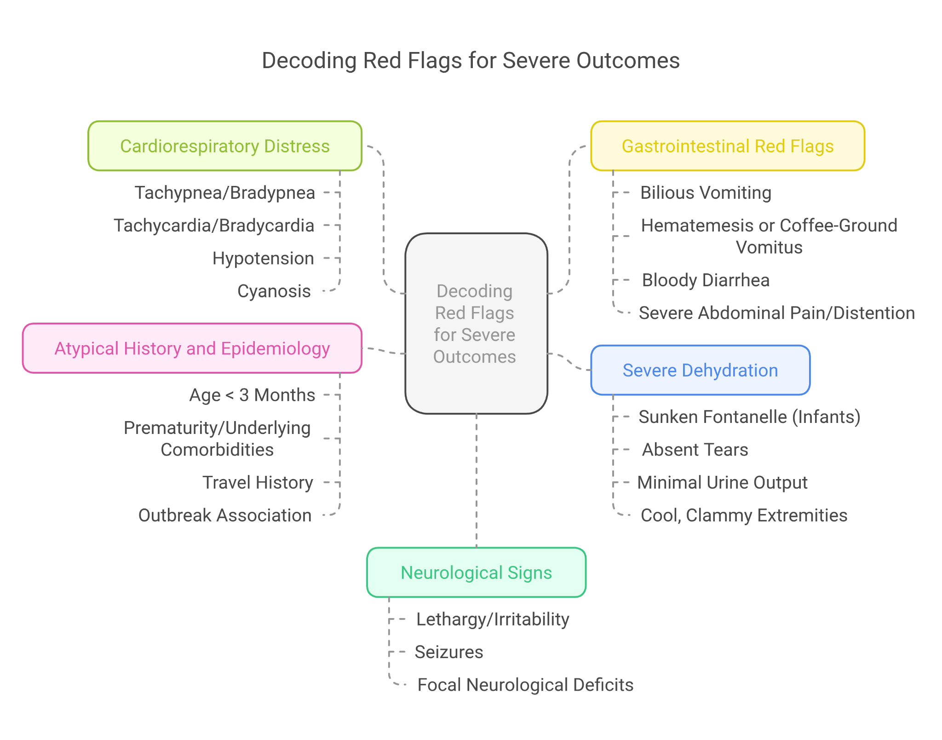

While most cases are mild, the following warning signs indicate a higher risk of severe complications:

#### **Neurological Signs [1]**

* **Lethargy/Irritability**: Early signs of dehydration, electrolyte imbalance, or CNS involvement.
* **Seizures**: May indicate severe **electrolyte disturbances (hyponatremia, hypernatremia), hypoglycemia, or CNS infections**.
* **Focal Neurological Deficits**: Weakness, paralysis, or cranial nerve abnormalities requiring immediate evaluation.

#### **Cardiorespiratory Distress**

* **Tachypnea/Bradypnea**: May indicate dehydration, metabolic acidosis, or respiratory compromise.
* **Tachycardia/Bradycardia**: Suggests dehydration, electrolyte imbalance, or cardiac dysfunction.
* **Hypotension**: A late sign of **severe dehydration and shock**.
* **Cyanosis**: Poor oxygenation requiring urgent assessment.

#### **Gastrointestinal Red Flags [2]**

* **Bilious Vomiting**: Suggests **intestinal obstruction**, especially in infants.
* **Hematemesis or Coffee-Ground Vomitus**: Indicates **upper GI bleeding**.
* **Bloody Diarrhoea**: May signal **bacterial infection (Shigella, E. coli O157:H7), inflammatory bowel disease, or intussusception**.
* **Severe Abdominal Pain/Distention**: Suggests **surgical emergencies (appendicitis, bowel obstruction, intussusception)**.

#### **Severe Dehydration [3]**

* **Sunken Fontanelle (Infants)**: Indicates **significant fluid loss**.
* **Absent Tears**: Suggests **moderate to severe dehydration**.
* **Minimal Urine Output**: Key dehydration marker.
* **Cool, Clammy Extremities**: Poor perfusion due to **shock**.

#### **Atypical History and Epidemiology [4]**

* **Age < 3 Months**: Higher risk of **severe dehydration**.
* **Prematurity/Underlying Comorbidities**: Increased risk in **cardiac, renal, or metabolic disorders**.
* **Travel History**: Raises suspicion for endemic infections.
* **Outbreak Association**: Heightened concern for virulent pathogens

### **Case Studies: Uncommon Symptoms and Severe Outcomes**

* **Atypical Intussusception**
  + **2-year-old** with intermittent vomiting, mild diarrhoea, and unusual lethargy.
  + Initially diagnosed as viral gastroenteritis.
  + Repeat exam revealed **mild distension and a right upper quadrant mass** → **Confirmed ileocolic intussusception via ultrasound**.
  + **Key takeaway**: Intussusception can have **atypical presentations**, requiring vigilance.
* **Hypernatremic Dehydration & Diabetes Insipidus**
  + **3-month-old** with persistent vomiting and diarrhoea, dehydrated despite ORS.
  + Lab tests revealed **hypernatremia** → **Diagnosis: Central diabetes insipidus**.
  + **Key takeaway**: **Unresponsive dehydration with hypernatremia** warrants further investigation.
* **Severe Rotavirus with Neurological Complications**
  + **6-month-old** with rotavirus gastroenteritis and severe **dehydration and hyponatremia**.
  + Developed **seizures**, later diagnosed with **rotavirus encephalitis**.
  + **Key takeaway**: **Monitor for neurological complications in severe gastroenteritis**.

## **Interactive Clinical Decision Tools for Pediatricians**

To aid in the rapid and accurate assessment of pediatric vomiting and diarrhoea, interactive clinical decision tools can be invaluable.

**Interactive Clinical Decision Tool Features:**

* **Symptom-Based Risk Stratification:** A digital tool that allows clinicians to input patient symptoms (vomiting frequency, diarrhoea characteristics, neurological signs, etc.) and automatically stratifies the risk of severe outcomes (low, intermediate, high).
* **Red Flag Alert System:** The tool should prominently highlight red flag symptoms as they are entered, prompting immediate consideration of further investigations or escalation of care.
* **Differential Diagnosis Generator :** Based on symptom input, the tool could generate a differential diagnosis list, including common and less common causes of vomiting and diarrhoea, aiding in considering broader diagnostic possibilities.
* **Dehydration Assessment Aid[5]:** An interactive module to guide clinicians through the clinical assessment of dehydration, incorporating physical exam findings (mucous membranes, skin turgor, capillary refill) and vital signs, and estimating dehydration percentage.
* **Electrolyte Imbalance Guide[6]:** A resource within the tool providing quick reference information on common electrolyte imbalances associated with vomiting and diarrhoea (hyponatremia, hypernatremia, hypokalemia), their symptoms, and initial management strategies.

### **Conclusion & Call to Action**

Recognizing red flags in pediatric vomiting and diarrhoea, especially atypical and severe cases, is critical for preventing adverse outcomes. Pediatricians must move beyond recognizing typical signs and actively look for subtle indicators of serious illness. Advanced diagnostic approaches, awareness of rare conditions, and clinical decision support tools can enhance accuracy and enable timely intervention.

Continuous education, case-based learning, and interactive tools are essential to equip pediatricians with the confidence and expertise to manage complex pediatric gastroenterological cases effectively.

**Citations:**

#### **[1]Gary N. McAbee, Anne Marie Morse, Ward Cook, Vivian Tang, Yuri Brosgol,Neurological Etiologies and Pathophysiology of Cyclic Vomiting Syndrome,Pediatric Neurology,Volume 106,2020,Pages 4-9,ISSN 0887-8994,**

#### **https://doi.org/10.1016/j.pediatrneurol.2019.12.001.**

#### **(**[**https://www.sciencedirect.com/science/article/pii/S0887899419309646**](https://www.sciencedirect.com/science/article/pii/S0887899419309646)**)**

#### **[2]Koyfman, A., MD. (n.d.). Pediatric dehydration: practice essentials, pathophysiology, etiology.** [**https://emedicine.medscape.com/article/801012-overview?form=fpf#a**](https://emedicine.medscape.com/article/801012-overview?form=fpf#a)

#### **[3]Signs of dehydration in infants & children. (n.d.). HealthyChildren.org.** [**https://www.healthychildren.org/English/health-issues/injuries-emergencies/Pages/dehydration.aspx**](https://www.healthychildren.org/English/health-issues/injuries-emergencies/Pages/dehydration.aspx)

#### **[4]Farfán-García, Ana E et al. “Etiology of acute gastroenteritis among children less than 5 years of age in Bucaramanga, Colombia: A case-control study.” PLoS neglected tropical diseases vol. 14,6 e0008375. 30 Jun, 2020 doi:10.1371/journal.pntd.0008375** [**https://www.researchgate.net/publication/377711742_Etiology_of_acute_gastroenteritis_among_pre-school_children_in_Peshawar-KP_Pakistan_a_case_control_study**](https://www.researchgate.net/publication/377711742_Etiology_of_acute_gastroenteritis_among_pre-school_children_in_Peshawar-KP_Pakistan_a_case_control_study)

#### **[5]THE TREATMENT OF DIARRHOEA A manual for physicians and other senior health workers** [**https://apps.who.int/iris/bitstream/handle/10665/43209/9241593180.pdf**](https://apps.who.int/iris/bitstream/handle/10665/43209/9241593180.pdf)

#### **[6]Open Resources for Nursing (Open RN); Ernstmeyer K, Christman E, editors. Nursing Fundamentals [Internet]. Eau Claire (WI): Chippewa Valley Technical College; 2021. Chapter 15 Fluids and Electrolytes. Available from:** [**https://www.ncbi.nlm.nih.gov/books/NBK591820/?utm_source=chatgpt.com**](https://www.ncbi.nlm.nih.gov/books/NBK591820/?utm_source=chatgpt.com)

#### 