### **Case Study: More Than Dry Scalp: Identifying and Treating Infant Scalp Fungal Infections**

#### **Introduction**

Scalp conditions in infants, such as dandruff or dry skin, are commonly seen and often treated with over-the-counter remedies. However, these conditions can sometimes mask more serious issues like fungal infections. This case study explores distinguishing between dandruff, dry scalp, and fungal infections in infants to ensure appropriate diagnosis and treatment.

#### **Background**

Infants often present with scalp issues that may seem benign but require careful examination to rule out more serious conditions like fungal infections. Fungal infections, if left untreated, can lead to significant discomfort and complications. Recognizing the signs and distinguishing them from common scalp conditions is crucial for effective management.

#### **Presenting Symptoms**

A 10-month-old boy named Rohan was brought to the clinic with persistent scalp issues. His parents reported thick, yellowish scales on his scalp that had not improved despite using dandruff shampoos and moisturizing treatments. Rohan also exhibited increased irritability, frequently scratching his head, and had developed small, round patches of hair loss.

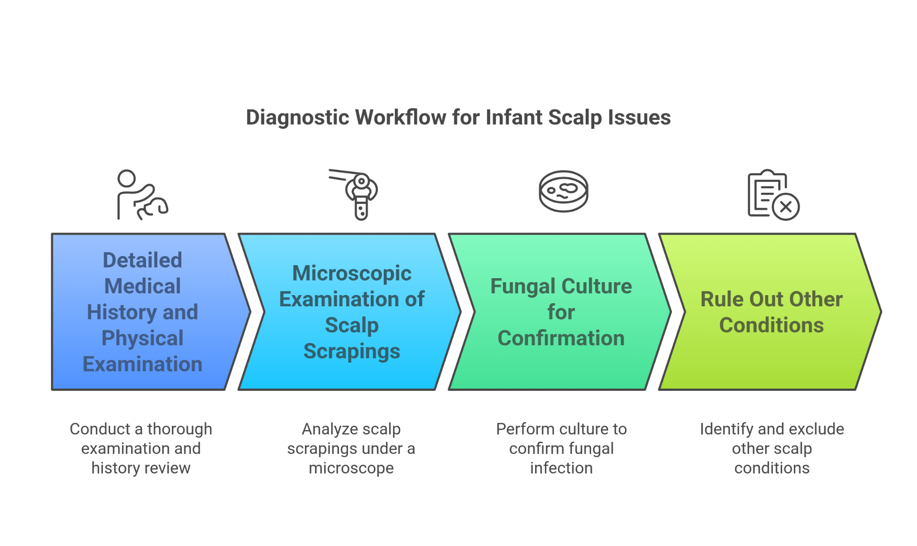

#### **Investigations**

1. Detailed medical history and thorough physical examination.
2. Microscopic examination of scalp scrapings to identify fungal elements.
3. Fungal culture of scalp scrapings to confirm the type of fungal infection.
4. Review of previous treatments and their effectiveness.

#### **Differential Diagnosis**

* **Dandruff (Seborrheic Dermatitis)**
  + Ruled out due to lack of improvement with dandruff shampoos and the presence of hair loss patches.
* **Dry Scalp**
  + Ruled out due to the severity of scaling and associated symptoms such as hair loss and persistent itching.
* **Psoriasis**
  + Ruled out as the scales were not silver and there was no family history of psoriasis.
* **Fungal Infection (Tinea Capitis)**
  + Confirmed by positive microscopic examination and fungal culture showing the presence of fungal elements.

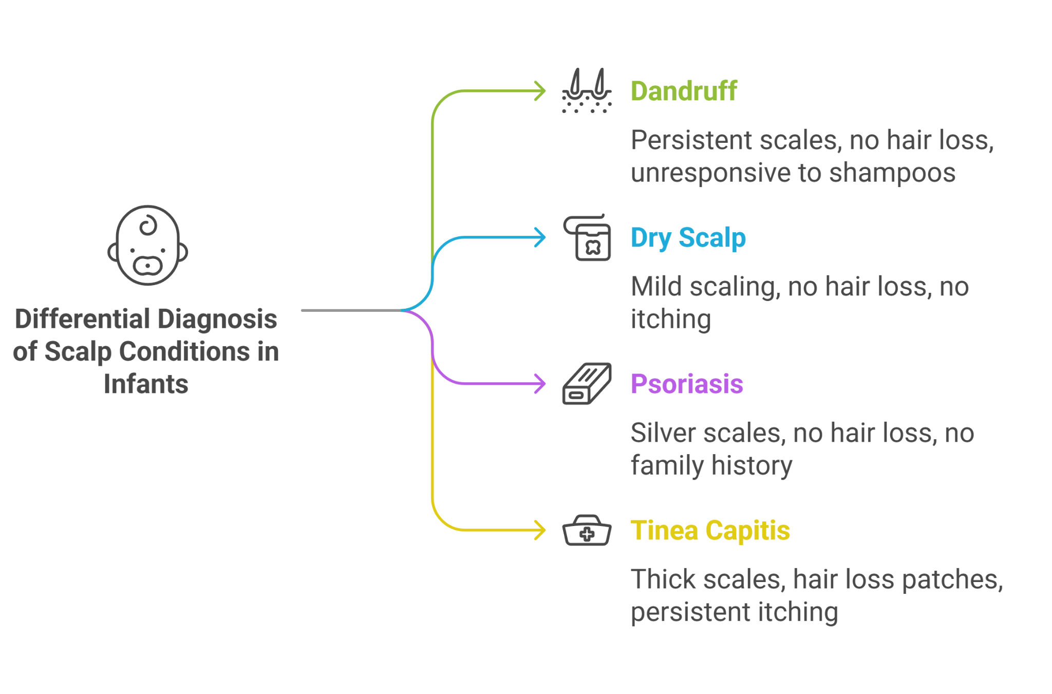

#### **Final Diagnosis**

Tinea capitis (scalp fungal infection) confirmed by clinical presentation and laboratory findings.

#### **Treatment and Management**

1. **Antifungal Therapy**
   * Prescribed oral antifungal medication (griseofulvin) to treat the fungal infection.
   * Recommended antifungal shampoo (ketoconazole) to be used twice a week to reduce fungal load on the scalp.
2. **Supportive Care**
   * Advised gentle scalp care to avoid further irritation.
   * Suggested avoiding sharing personal items like hats and hairbrushes to prevent the spread of the infection.
3. **Hygiene Practices**
   * Recommended regular washing of bedding and clothing to eliminate fungal spores.
   * Advised maintaining good scalp hygiene by keeping the scalp clean and dry.
4. **Monitoring and Follow-Up**
   * Scheduled follow-up appointments to monitor the response to treatment and ensure the infection is fully resolved.
5. **Education**
   * Educated parents on the signs of fungal infections and the importance of completing the full course of antifungal treatment.
   * Provided guidance on preventing future fungal infections and maintaining scalp health.

#### **Follow-Up**

At the 4-week follow-up, Rohan's scalp condition had significantly improved. The scaling and hair loss patches had reduced, and he showed less irritability and scratching. Continued use of antifungal therapy and good hygiene practices were emphasized to prevent recurrence.

#### **Conclusion**

This case underscores the importance of distinguishing between common scalp conditions and more serious issues like fungal infections in infants. Early identification and appropriate treatment of fungal infections are crucial for preventing complications and ensuring effective management. Healthcare providers should remain vigilant and consider fungal infections in differential diagnoses when treating persistent scalp conditions in infants.

### **Case Study: Flakes and All: Managing Seborrheic Dermatitis in Infants**

#### **Introduction**

Seborrheic dermatitis, commonly known as cradle cap when it affects the scalp of infants, is a common condition that presents with flaky, greasy scales. This case study explores effective management strategies for seborrheic dermatitis on the infant scalp, emphasizing proper diagnosis and treatment to prevent complications.

#### **Background**

Seborrheic dermatitis in infants typically manifests as thick, yellowish scales on the scalp, and while it is usually benign and self-limiting, appropriate management can alleviate symptoms and prevent secondary infections. Differentiating this condition from other scalp issues such as fungal infections or psoriasis is crucial for effective treatment.

#### **Presenting Symptoms**

A 6-month-old girl named Aisha was brought to the clinic with persistent flaky and greasy scales on her scalp. Her parents had tried various over-the-counter dandruff shampoos and moisturizing treatments with little improvement. Aisha also had mild redness in the affected areas but showed no signs of discomfort or itching.

#### **Investigations**

1. Detailed medical history and thorough physical examination.
2. Examination of the scalp scales under a microscope to rule out fungal elements.
3. Review of the infant’s skincare routine and previous treatments.

#### **Differential Diagnosis**

* **Dandruff (Seborrheic Dermatitis)**
  + Considered due to the presentation of greasy, yellowish scales and mild redness.
* **Dry Scalp**
  + Ruled out due to the presence of greasy scales and persistent symptoms despite moisturizing.
* **Psoriasis**
  + Ruled out as there were no thick, silvery scales or family history of psoriasis.
* **Fungal Infection (Tinea Capitis)**
  + Ruled out based on negative microscopic examination for fungal elements.

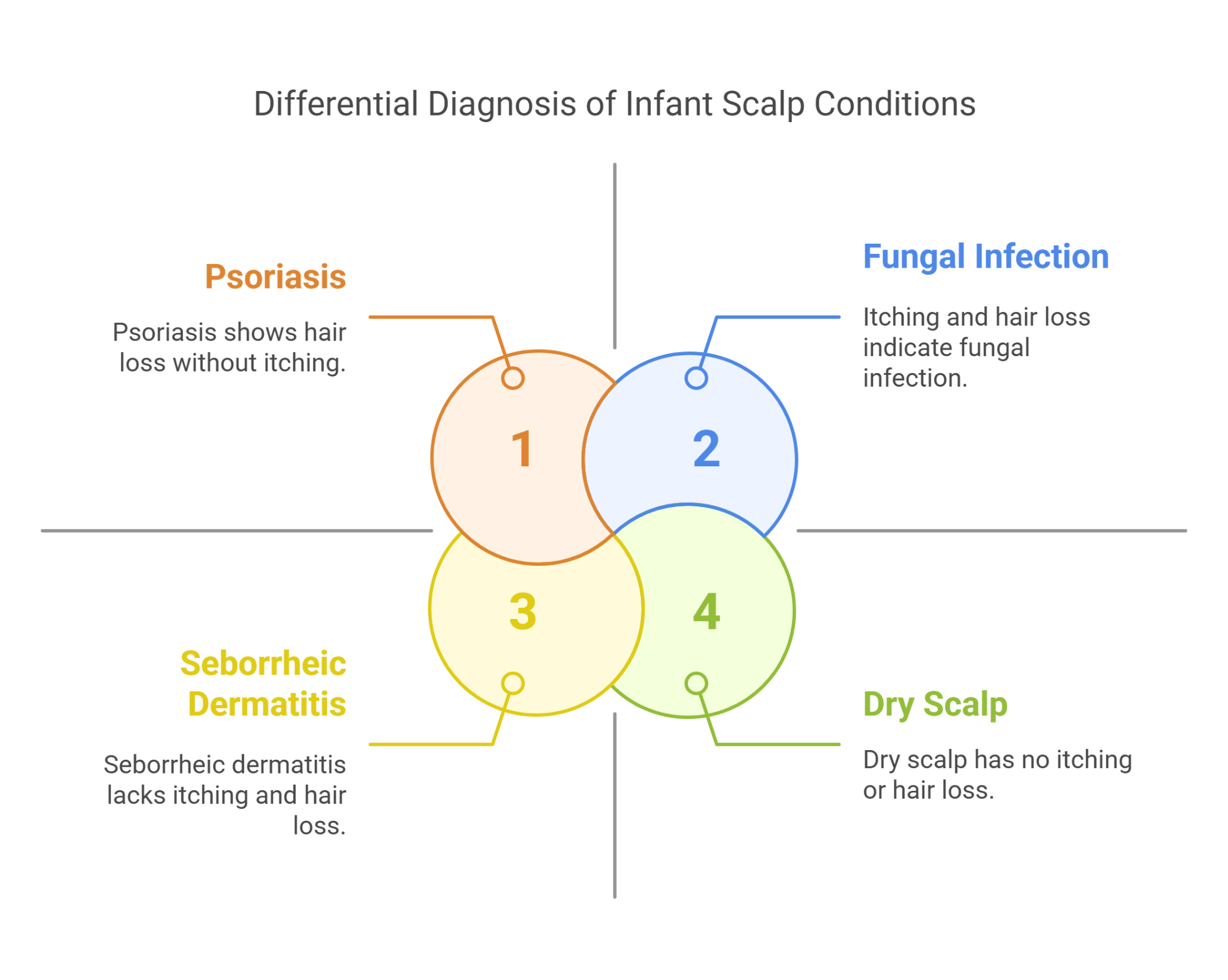

#### **Final Diagnosis**

Seborrheic dermatitis confirmed by clinical presentation and exclusion of other conditions.

#### **Treatment and Management**

1. **Topical Treatments**
   * Prescribed an antifungal shampoo (ketoconazole) to be used twice a week to reduce the yeast component of seborrheic dermatitis.
   * Recommended the use of mild, non-medicated baby shampoo for daily use.
2. **Emollients**
   * Suggested applying mineral oil or petroleum jelly to the scalp before shampooing to help loosen the scales.
   * Advised gentle brushing of the scalp with a soft brush to remove loosened scales.
3. **Hydration and Skincare**
   * Encouraged regular scalp washing to maintain cleanliness and prevent scale buildup.
   * Recommended avoiding harsh soaps and shampoos that can irritate the skin.

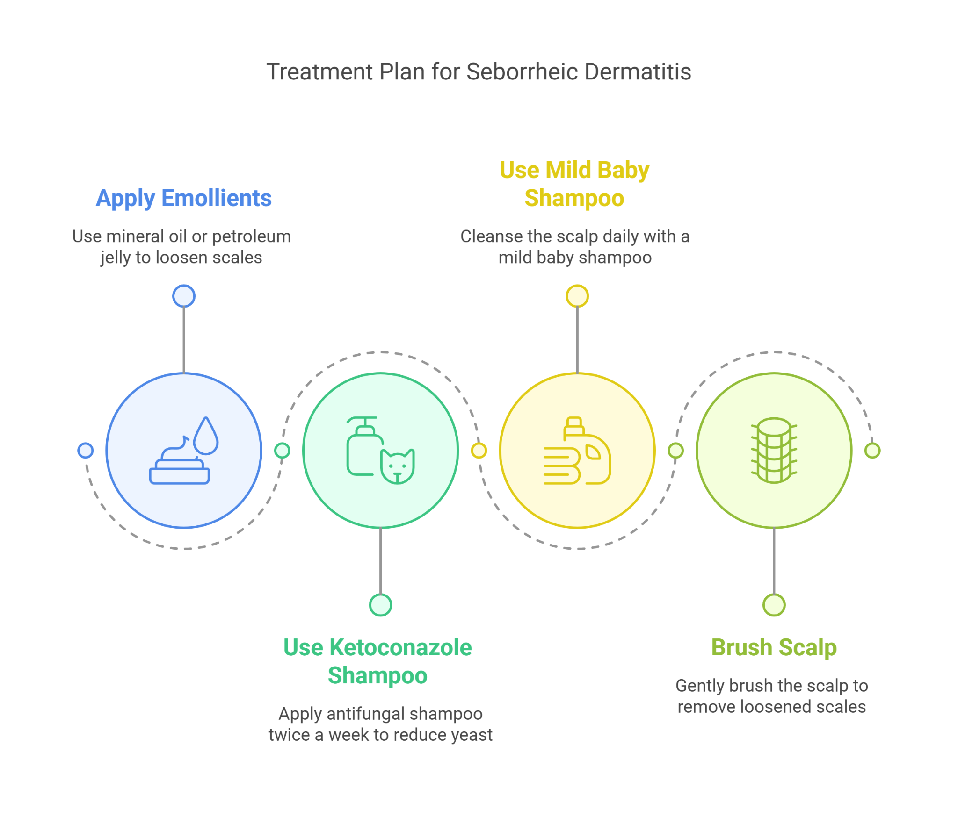

1. **Monitoring and Follow-Up**
   * Scheduled follow-up appointments to monitor the effectiveness of the treatment and adjust as needed.
2. **Education**
   * Educated parents on the chronic nature of seborrheic dermatitis and the importance of regular scalp care.
   * Provided guidance on recognizing signs of secondary infections and when to seek further medical advice.

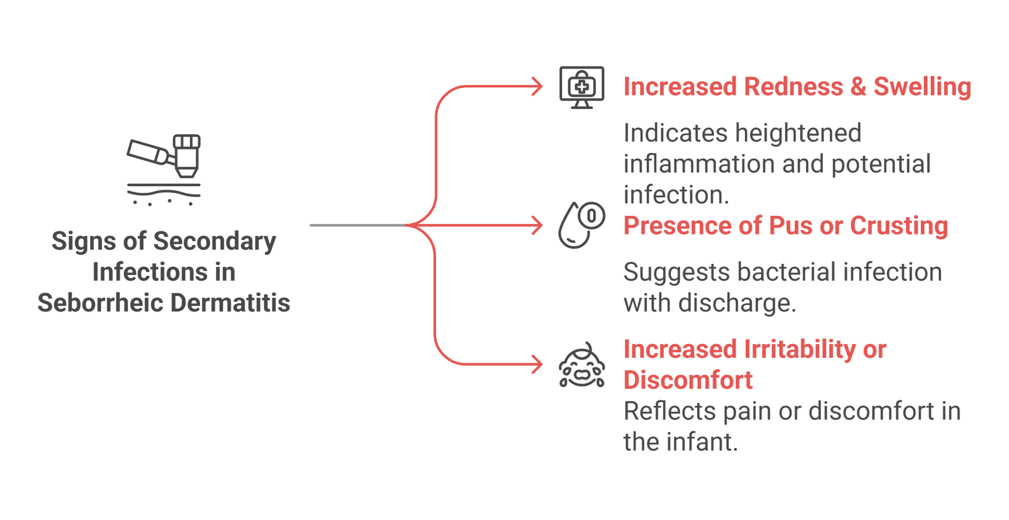

#### **Follow-Up**

At the 4-week follow-up, Aisha's scalp condition had significantly improved. The scales were less prominent, and the redness had diminished. The parents reported satisfaction with the treatment regimen and were advised to continue the current skincare routine to maintain the improvement.

#### **Conclusion**

This case highlights the importance of proper diagnosis and management of seborrheic dermatitis in infants. Effective treatment strategies, including the use of antifungal shampoos and emollients, can significantly alleviate symptoms and prevent complications. Healthcare providers should educate caregivers on maintaining regular scalp care and recognizing potential signs of secondary infections to ensure comprehensive management of seborrheic dermatitis.

### **Case Study: A Head Start: Preventive Care for Baby Scalp Health**

#### **Introduction**

Maintaining a healthy scalp in infants is essential to prevent common conditions like dandruff, dry skin, and fungal infections. This case study explores preventive strategies to ensure scalp health and avoid potential scalp conditions.

#### **Background**

Infant scalp conditions can range from mild dandruff and dry skin to more serious fungal infections. Early intervention and preventive care can significantly reduce the risk of these conditions, ensuring the infant's comfort and health. Understanding and implementing proper scalp care routines are crucial for parents and caregivers.

#### **Presenting Symptoms**

A 9-month-old boy named Aarav presented with mild flaky patches on his scalp. His parents were concerned about the potential for more severe conditions, such as fungal infections or persistent dandruff, and sought advice on preventive care measures. Aarav's scalp showed no signs of redness, swelling, or oozing, and he did not exhibit any discomfort or itching.

#### **Investigations**

1. Detailed medical history and thorough physical examination.
2. Review of the infant's daily skincare and scalp care routine.
3. Microscopic examination of scalp flakes to rule out fungal elements.
4. Evaluation of the infant's environment and exposure to potential irritants.

#### **Differential Diagnosis**

* **Simple Dandruff**
  + Considered due to the presence of mild flaky patches without other symptoms.
* **Dry Scalp**
  + Considered due to the mild nature of the flakiness and absence of other symptoms.
* **Seborrheic Dermatitis**
  + Ruled out due to lack of greasy scales and redness.
* **Fungal Infection (Tinea Capitis)**
  + Ruled out based on negative microscopic examination for fungal elements.
* **Psoriasis**
  + Ruled out due to the absence of thick, silvery scales and family history.

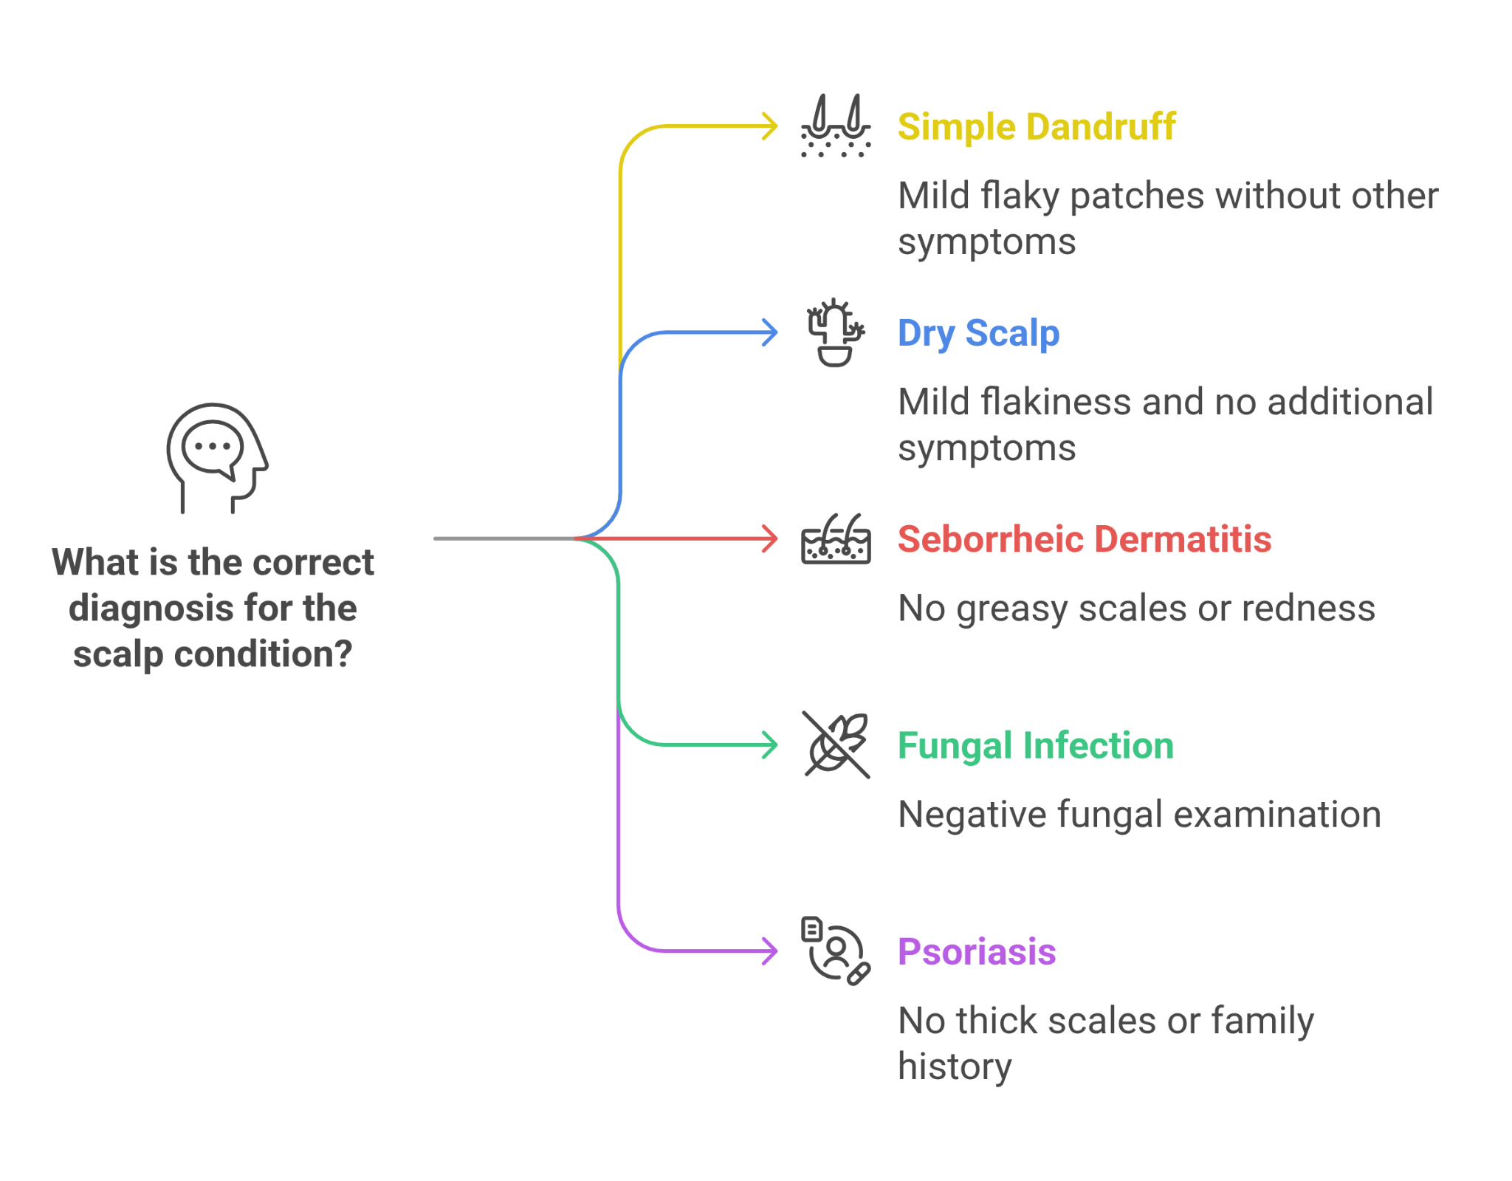

#### **Final Diagnosis**

Simple dandruff confirmed by clinical presentation and exclusion of other conditions.

#### **Treatment and Management**

1. **Regular Scalp Hygiene**
   * Recommended washing Aarav's scalp regularly with a mild, non-medicated baby shampoo.
   * Advised gentle brushing of the scalp with a soft brush to remove flakes.
2. **Moisturization**
   * Suggested applying a light moisturizer or baby oil to the scalp to prevent dryness.
   * Advised using hypoallergenic and fragrance-free products.
3. **Environmental Control**
   * Recommended keeping Aarav's living environment clean and free of potential irritants such as dust and smoke.
   * Advised using a humidifier to maintain optimal humidity levels, especially in dry climates.
4. **Diet and Hydration**
   * Encouraged a balanced diet rich in essential fatty acids to support skin health.
   * Emphasized the importance of adequate hydration.

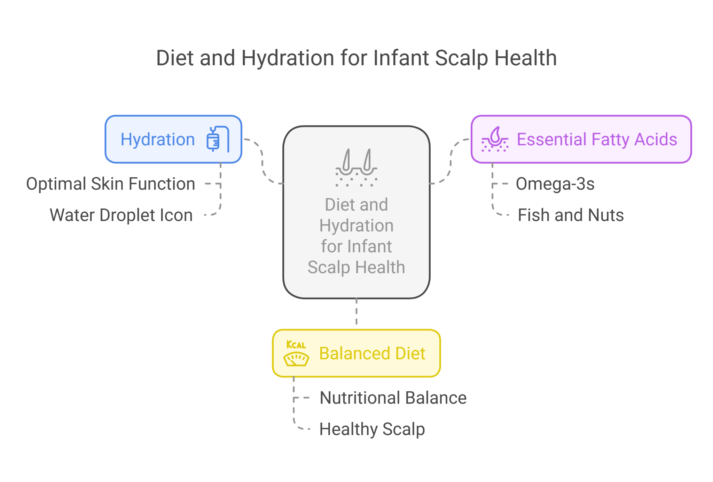

1. **Monitoring and Follow-Up**
   * Scheduled follow-up appointments to monitor scalp health and make necessary adjustments to the care routine.
2. **Education**
   * Educated parents on the importance of regular scalp care and recognizing early signs of potential scalp conditions.
   * Provided guidance on preventive measures and when to seek further medical advice.

#### **Follow-Up**

At the 4-week follow-up, Aarav's scalp health had improved, with fewer flakes and no signs of dryness or irritation. The parents reported satisfaction with the preventive care routine and were advised to continue the current regimen to maintain scalp health.

#### **Conclusion**

This case highlights the importance of preventive care in maintaining infant scalp health. Regular hygiene, proper moisturization, environmental control, and balanced nutrition are key strategies in preventing common scalp conditions. Educating caregivers on these preventive measures ensures early intervention and promotes overall scalp health in infants.