### **Case Study: Comprehensive Nutritional Management in a Vegan Child with B12 and Iron Deficiencies**

#### **Introduction**

This case study explores the challenges and strategies for managing multiple nutritional deficiencies, including B12 and iron, in a vegan child, emphasizing the importance of a balanced diet and supplementation.

#### **Background**

Vegan diets can lead to nutritional deficiencies if not properly managed, especially in children who have higher nutritional needs for growth and development. Vitamin B12 is naturally found in animal products, and its deficiency is common in strict vegans. Iron deficiency is also prevalent due to the lower bioavailability of plant-based iron.

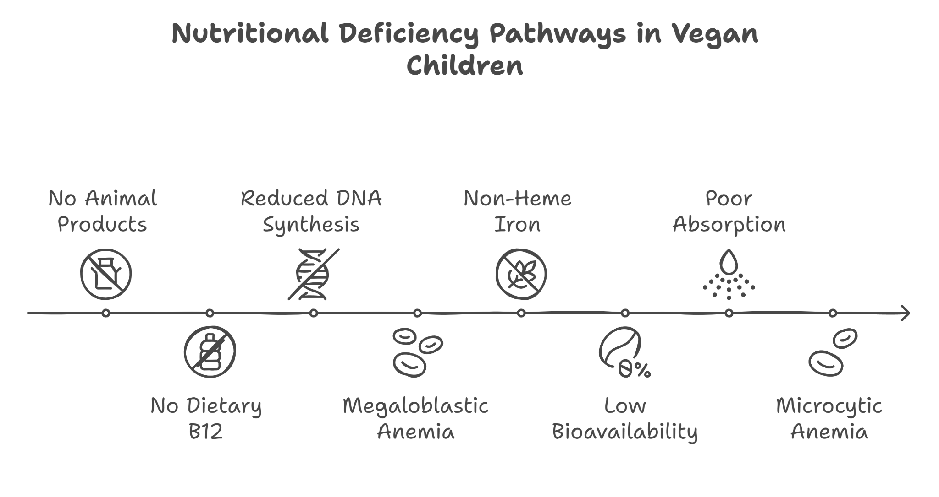

#### **Presenting Symptoms**

Ravi, an 8-year-old vegan child, presented with:

* General fatigue and paleness.
* Frequent headaches and dizziness.
* Difficulty concentrating and irritability.
* Muscle weakness and abnormal tiredness after minimal physical activity.
* Delayed healing of minor wounds and bruises.

#### **Investigations**

* Complete Blood Count (CBC) showing microcytic anemia.
* Serum B12(normal range: 200- 900 pg/mL ) and iron (normal range: 50-120 mcg/dL) levels are both significantly below normal ranges.
* Dietary assessment confirming a strict vegan diet with inadequate sources of B12 and iron.
* Red Cell Distribution Width (RDW): Increased, indicating a variation in red cell size, which is typical in cases of iron deficiency anemia.
* Bone marrow biopsy to rule out other causes of anemia was considered but deemed unnecessary based on clear dietary history and lab results.

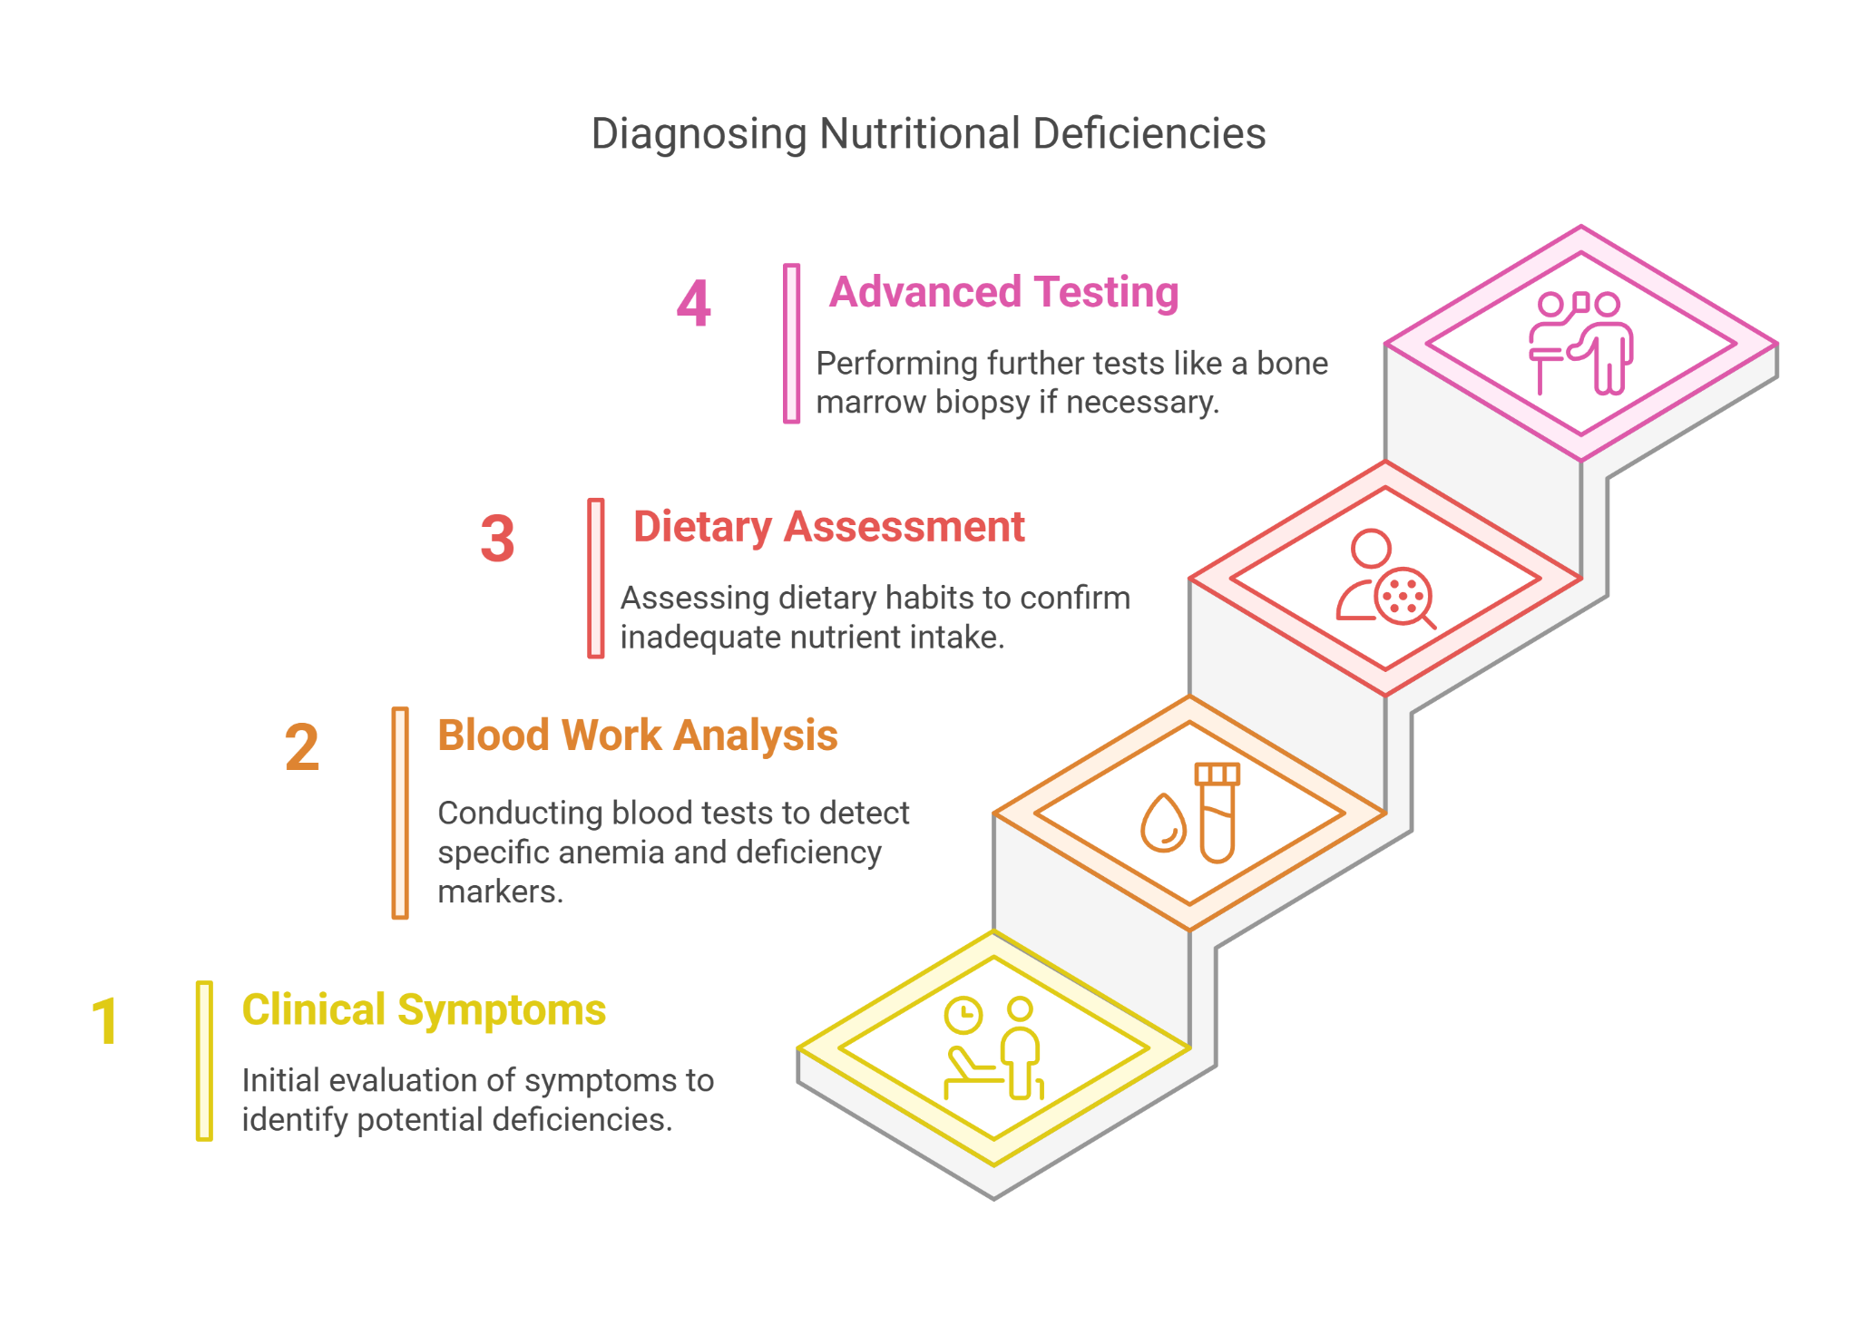

#### **Differential Diagnosis**

* **Chronic Disease Anemia**: Considered due to symptoms of fatigue and paleness, but lack of other chronic symptoms and specific lab findings directed towards nutritional causes.
* **Folate Deficiency**: Can cause similar symptoms; however, serum folate levels were within the normal range.
* **Celiac Disease**: Considered due to potential malabsorption; negative for transglutaminase antibodies.

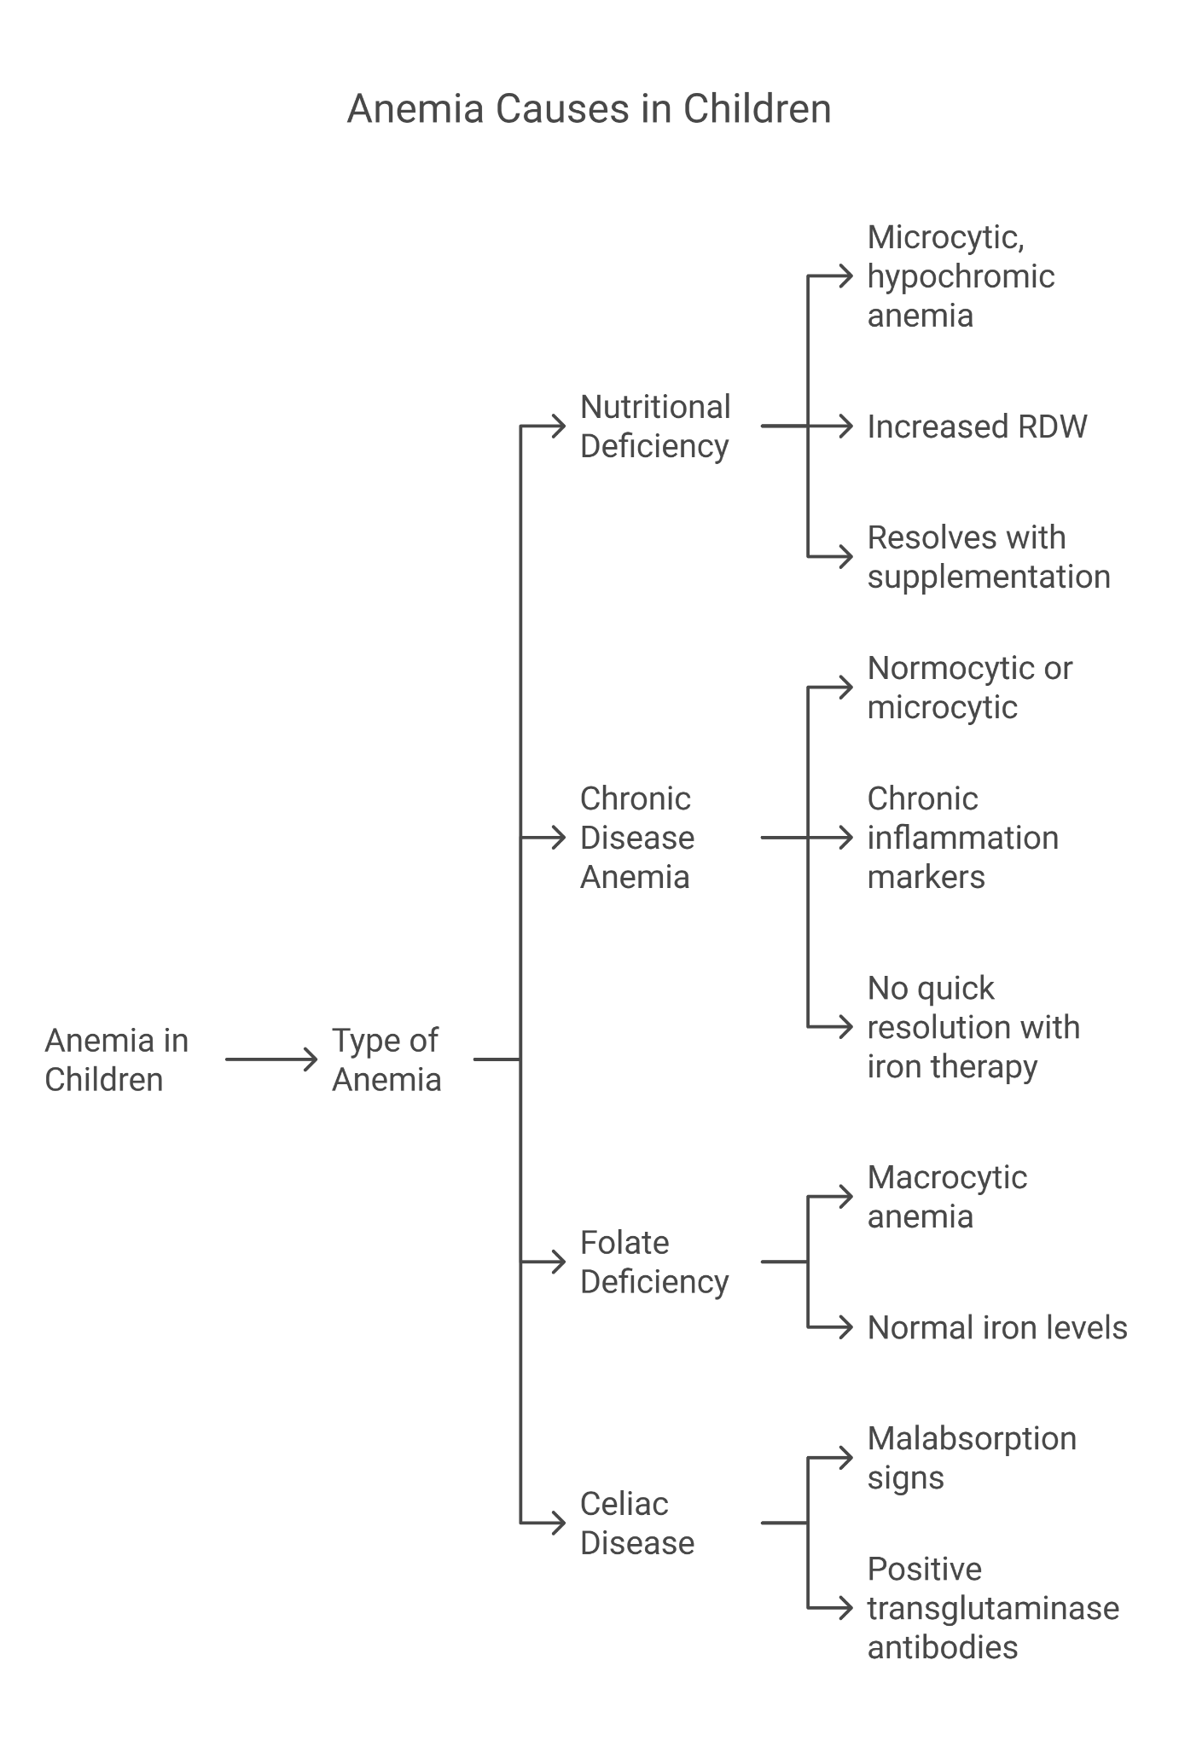

#### 

#### **Final Diagnosis**

Nutritional deficiencies related to a vegan diet, specifically Vitamin B12 and Iron Deficiency Anemia characterized as microcytic hypochromic with increased RDW.

#### **Treatment and Management**

* Initiated oral supplementation of vitamin B12 and iron.As per Anemia Mukt Bharat, the therapeutic dose of iron is 3 mg/kg per day.
* Nutritional counseling to include iron-rich plant foods like lentils, chickpeas, and fortified cereals, and B12-fortified products such as fortified rice kernel and double fortified rice with iron and iodine to address both deficiencies.
* Regular follow-up appointments for blood tests to monitor B12 and iron levels and adjust supplementation as needed.
* Educational sessions with the family on the importance of a balanced vegan diet, especially in children.

#### **Follow-up**

Ravi’s follow-up visits at one month and then every three months showed gradual improvement in hemoglobin and B12 levels. Symptoms of fatigue and concentration difficulties decreased significantly, and his overall well-being improved.

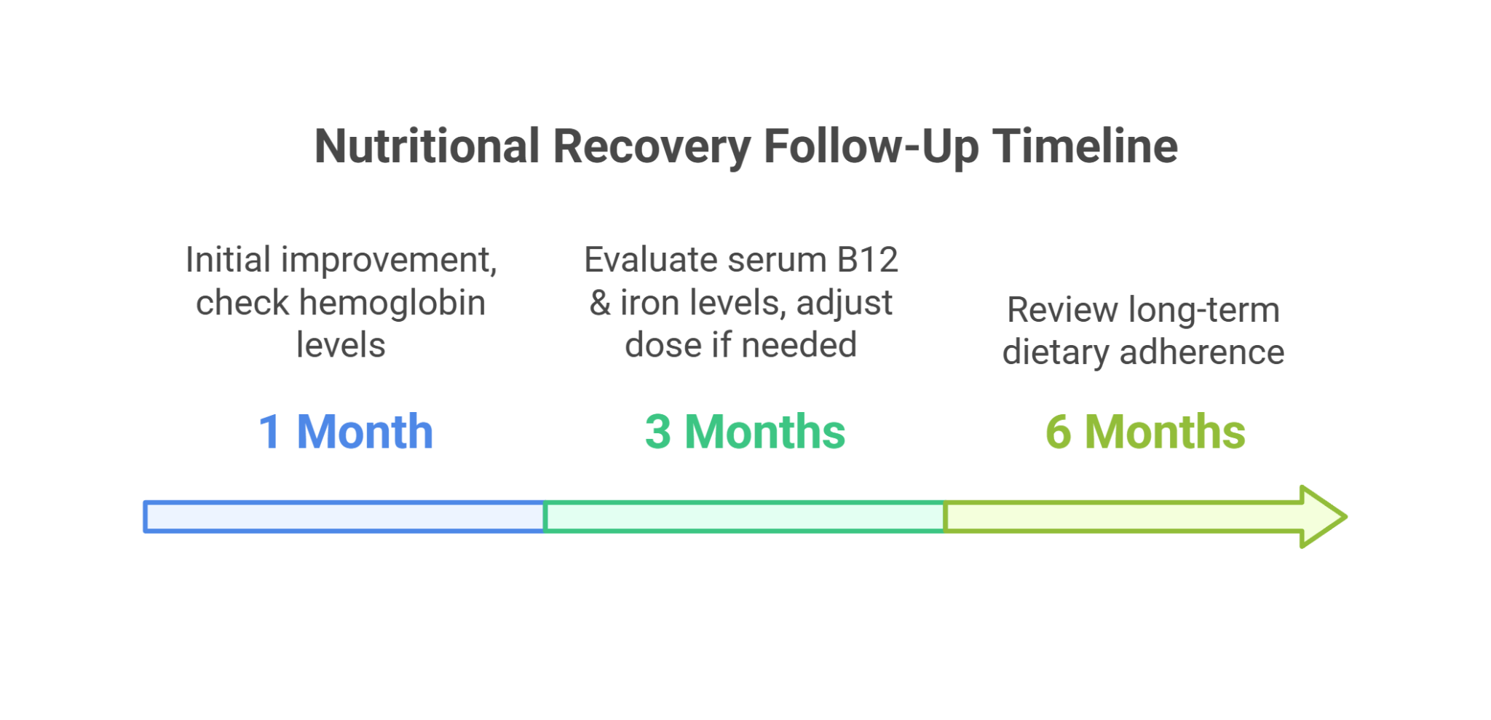

#### **Conclusion**

This case underscores the need for careful dietary planning and monitoring in children on vegan diets to prevent nutritional deficiencies. Early intervention with dietary counseling and appropriate supplementation can prevent the long-term consequences of such deficiencies and support healthy growth and development in vegan children.

### **Case Study: Dual Challenge of Iron and Vitamin A Deficiencies in a Child with Night Blindness**

#### **Introduction**

This case study focuses on a child presenting with night blindness associated with Vitamin A deficiency, compounded by iron deficiency anemia. It highlights the complexities of diagnosing and managing multiple micronutrient deficiencies.

#### **Background**

Vitamin A is crucial for maintaining vision, particularly in low light. Iron is essential for oxygen transport in the blood. Both deficiencies are common in areas with poor dietary diversity and can affect children's overall health and development.

#### **Presenting Symptoms**

Kiran, a 9-year-old child, presented with:

* Difficulty seeing in low light environments, progressing to night blindness.
* Complaints of fatigue and shortness of breath during physical activities.
* Pale skin and brittle nails.
* Recurrent infections, indicating a possible compromise in immune function.

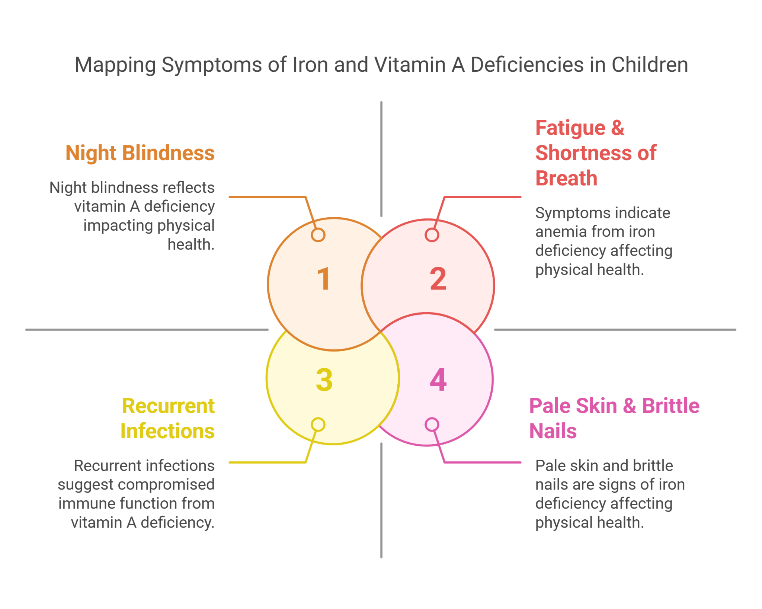

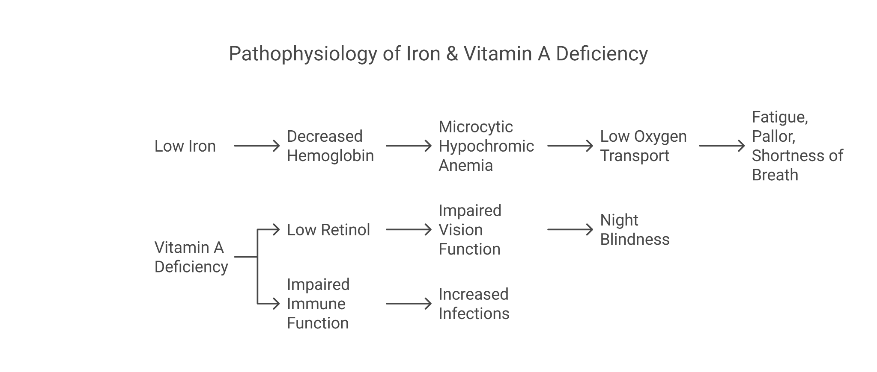

#### **Investigations**

* **Ophthalmic Examination**: Fundus examination conducted by an ophthalmologist revealed signs consistent with night blindness and slight dryness of the cornea.
* Blood tests showing following results:
  + Hemoglobin: 9 g/dL (normal: 11.5-15.5 g/dL for children)
  + Serum Ferritin: 12 ng/mL (normal: 15-150 ng/mL)
  + Serum Retinol: 0.2 µmol/L (normal: 0.3-1.2 µmol/L)
  + Iron Levels: Below normal, confirming iron deficiency.
* Serum retinol levels significantly below the normal range.
* Dietary review revealing a lack of sufficient iron and vitamin A sources.

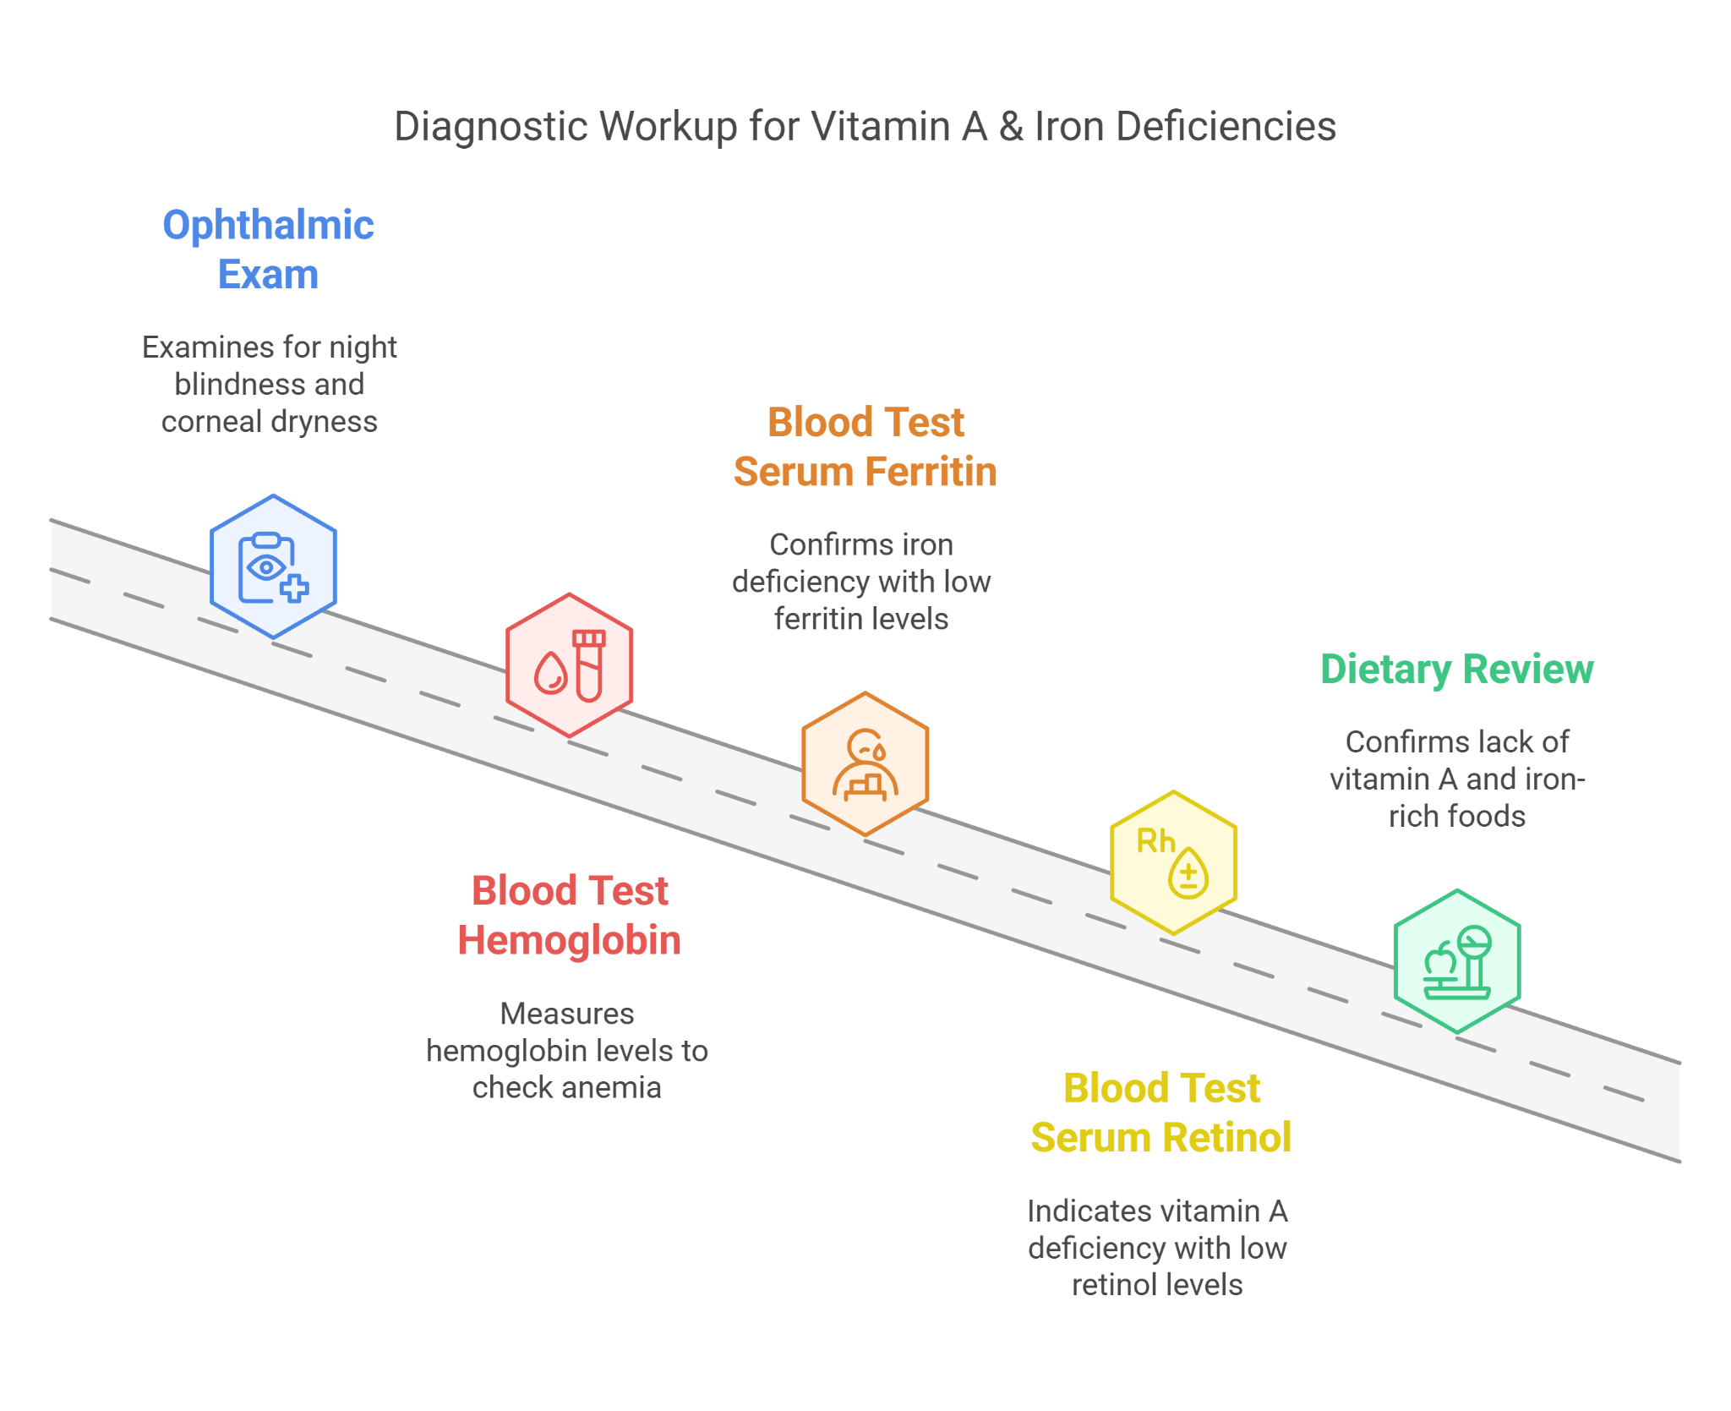

#### **Differential Diagnosis**

* **Zinc Deficiency**: Can mimic and exacerbate Vitamin A deficiency; serum zinc was within normal limits.
* **Retinitis Pigmentosa**: Genetic condition causing night blindness; ruled out based on clinical examination and lack of family history.
* **Lead Poisoning**: Can cause anemia and developmental issues; blood lead levels were normal.
* **Chronic Digestive Disorders**: Such as Crohn's disease could cause malabsorption of nutrients; gastrointestinal symptoms were absent, ruling this out.

#### 

#### **Final Diagnosis**

Iron Deficiency Anemia and Vitamin A Deficiency.

#### **Treatment and Management**

* Initiated high-dose vitamin A supplementation as per WHO guidelines.
* Oral iron supplementation initiated at a therapeutic dose of 3 mg/kg per day as per Anemia Mukt Bharat guidelines.
* Dietary Modifications: Inclusion of vitamin A-rich foods such as carrots, sweet potatoes, and dark leafy greens, along with iron-rich foods and iron-fortified products like fortified rice kernel and double fortified rice with iron and iodine. and vitamin A sources (such as carrots, sweet potatoes, and liver).
* Regular monitoring of visual function, iron levels, and overall nutritional status.

#### **Follow-up**

Kiran was monitored through bi-monthly follow-up visits. Improvements in night vision were noted within a few weeks, and iron levels normalized over several months with ongoing supplementation and dietary adjustments.

According to the Anemia Mukt Bharat guidelines for a 9-year-old, the following specific follow-up actions were recommended:

* Continued monitoring of hemoglobin and serum ferritin levels to ensure that the iron supplementation is effective.
* Repeat vitamin A dosing annually, as recommended, to sustain adequate vitamin A levels and prevent recurrence of night blindness.
* Regular dietary assessments to ensure sustained intake of diverse and nutrient-rich foods, emphasizing the importance of maintaining dietary variety to support overall nutritional status.

Improvements in night vision and general vitality were noted within six months.

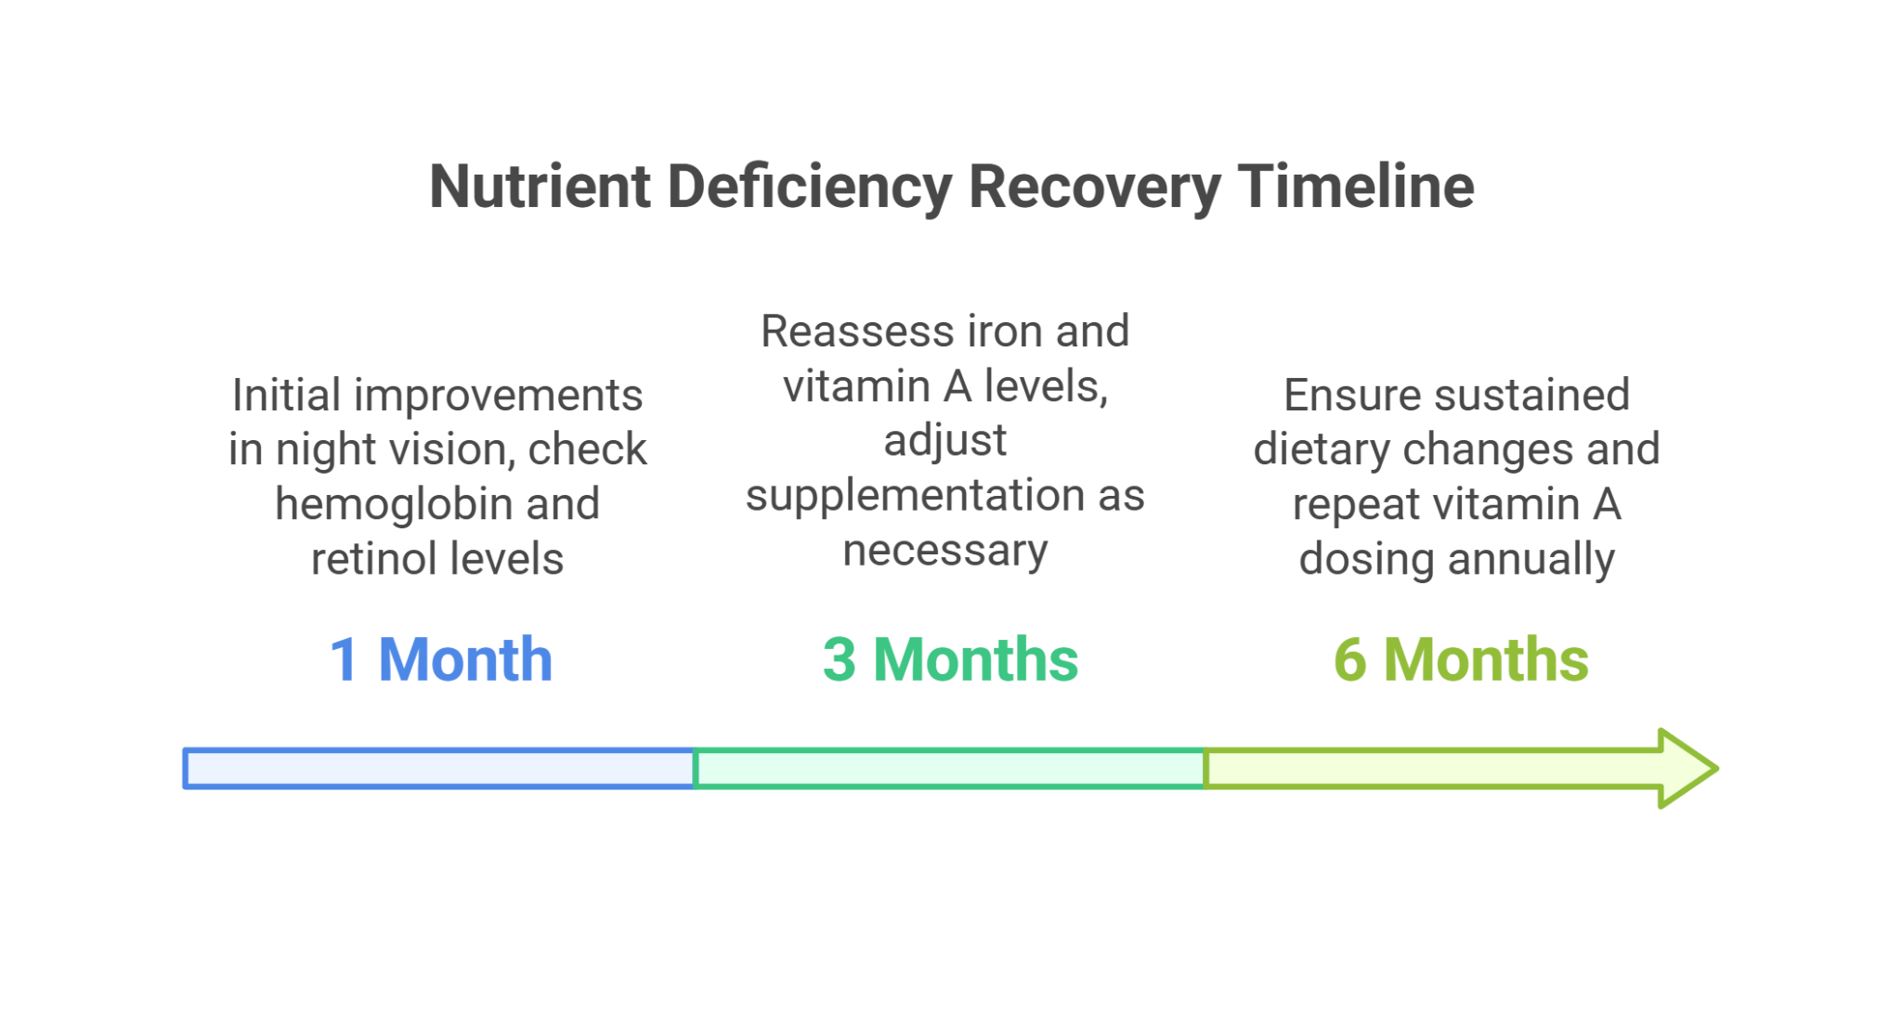

#### **Conclusion**

This case illustrates the importance of recognizing and treating multiple micronutrient deficiencies in children. Comprehensive dietary assessment and tailored supplementation are key to addressing specific nutritional gaps, thereby improving quality of life and preventing long-term health consequences.