### **Case Study: "Persistent Diarrhoea in an Immunocompromised Child"**

**Introduction**

We explore a challenging case of persistent diarrhoea in an immunocompromised child from India, emphasising the complexities of diagnosis and management in a setting of compromised immune function.

**Background**

In immunocompromised children, such as those with underlying chronic illnesses or on immunosuppressive therapy, diarrhoea can be persistent and severe, posing significant diagnostic and therapeutic challenges due to the wide range of potential infectious and non-infectious causes.

**Presenting Symptoms**

A 6-year-old male with a history of acute lymphoblastic leukaemia, currently in remission but on maintenance chemotherapy, presented with a 4-week history of persistent, watery diarrhoea, abdominal pain, and weight loss. The child also exhibited signs of mild dehydration.

**Investigations**

**Stool Analysis and Culture:** Negative for common bacterial and viral pathogens.

**PCR Testing for Pathogens:** Identified Cryptosporidium species.

**Complete Blood Count (CBC):** Showed leukopenia, likely secondary to chemotherapy.

**Serum Electrolytes:** Indicated dehydration and electrolyte imbalances.

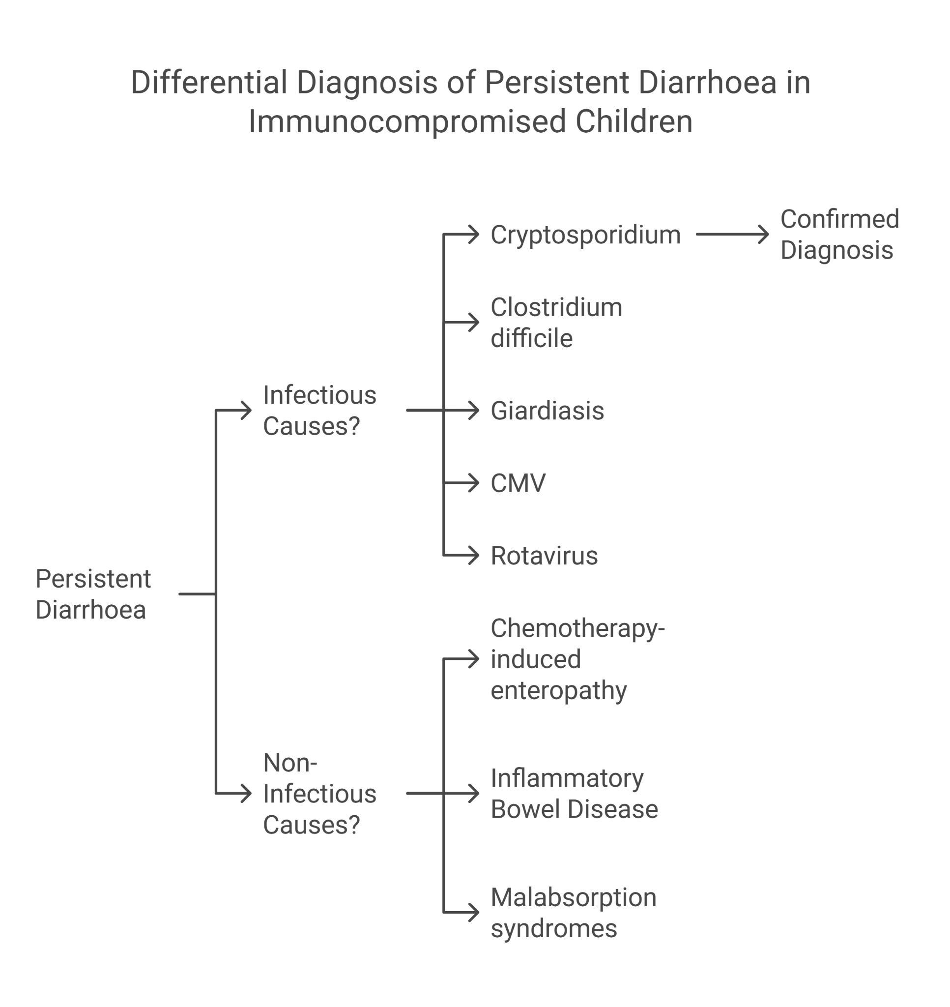

Differential Diagnosis

**Cryptosporidium Infection:** Strongly suggested by PCR results and the child's immunocompromised status.

**Clostridium difficile Infection:** Considered due to antibiotic exposure but ruled out by negative testing.

**Inflammatory Bowel Disease (IBD):** Included due to chronic diarrhoea and abdominal pain but less likely in the context of identified Cryptosporidium.

**Giardiasis:** Another potential cause of persistent diarrhoea in immunocompromised patients but ruled out by specific PCR testing.

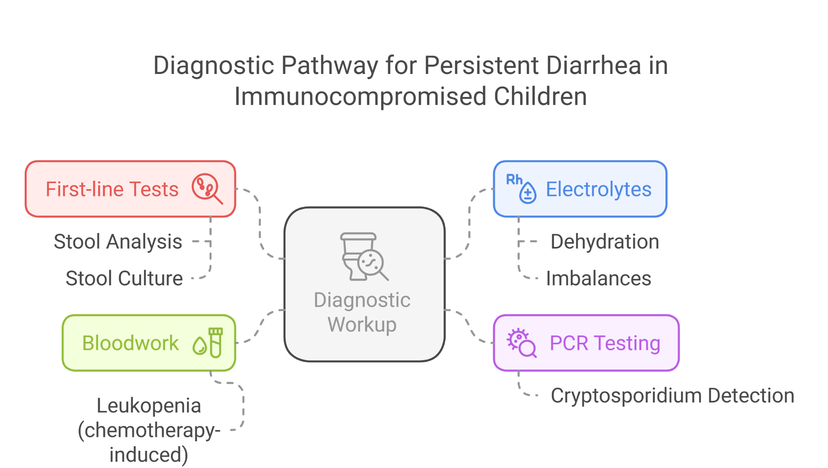

**Final Diagnosis**

The final diagnosis was Cryptosporidium infection, supported by PCR testing and the clinical context of immunosuppression.

**Treatment and Management**

Management included nitazoxanide, the treatment of choice for Cryptosporidium in immunocompetent children. However, its efficacy in immunocompromised patients can be limited, necessitating supportive care with oral rehydration solutions (ORS) and nutritional support to manage dehydration and prevent further weight loss. The oncology team was consulted to adjust the chemotherapy regimen temporarily to mitigate immunosuppression.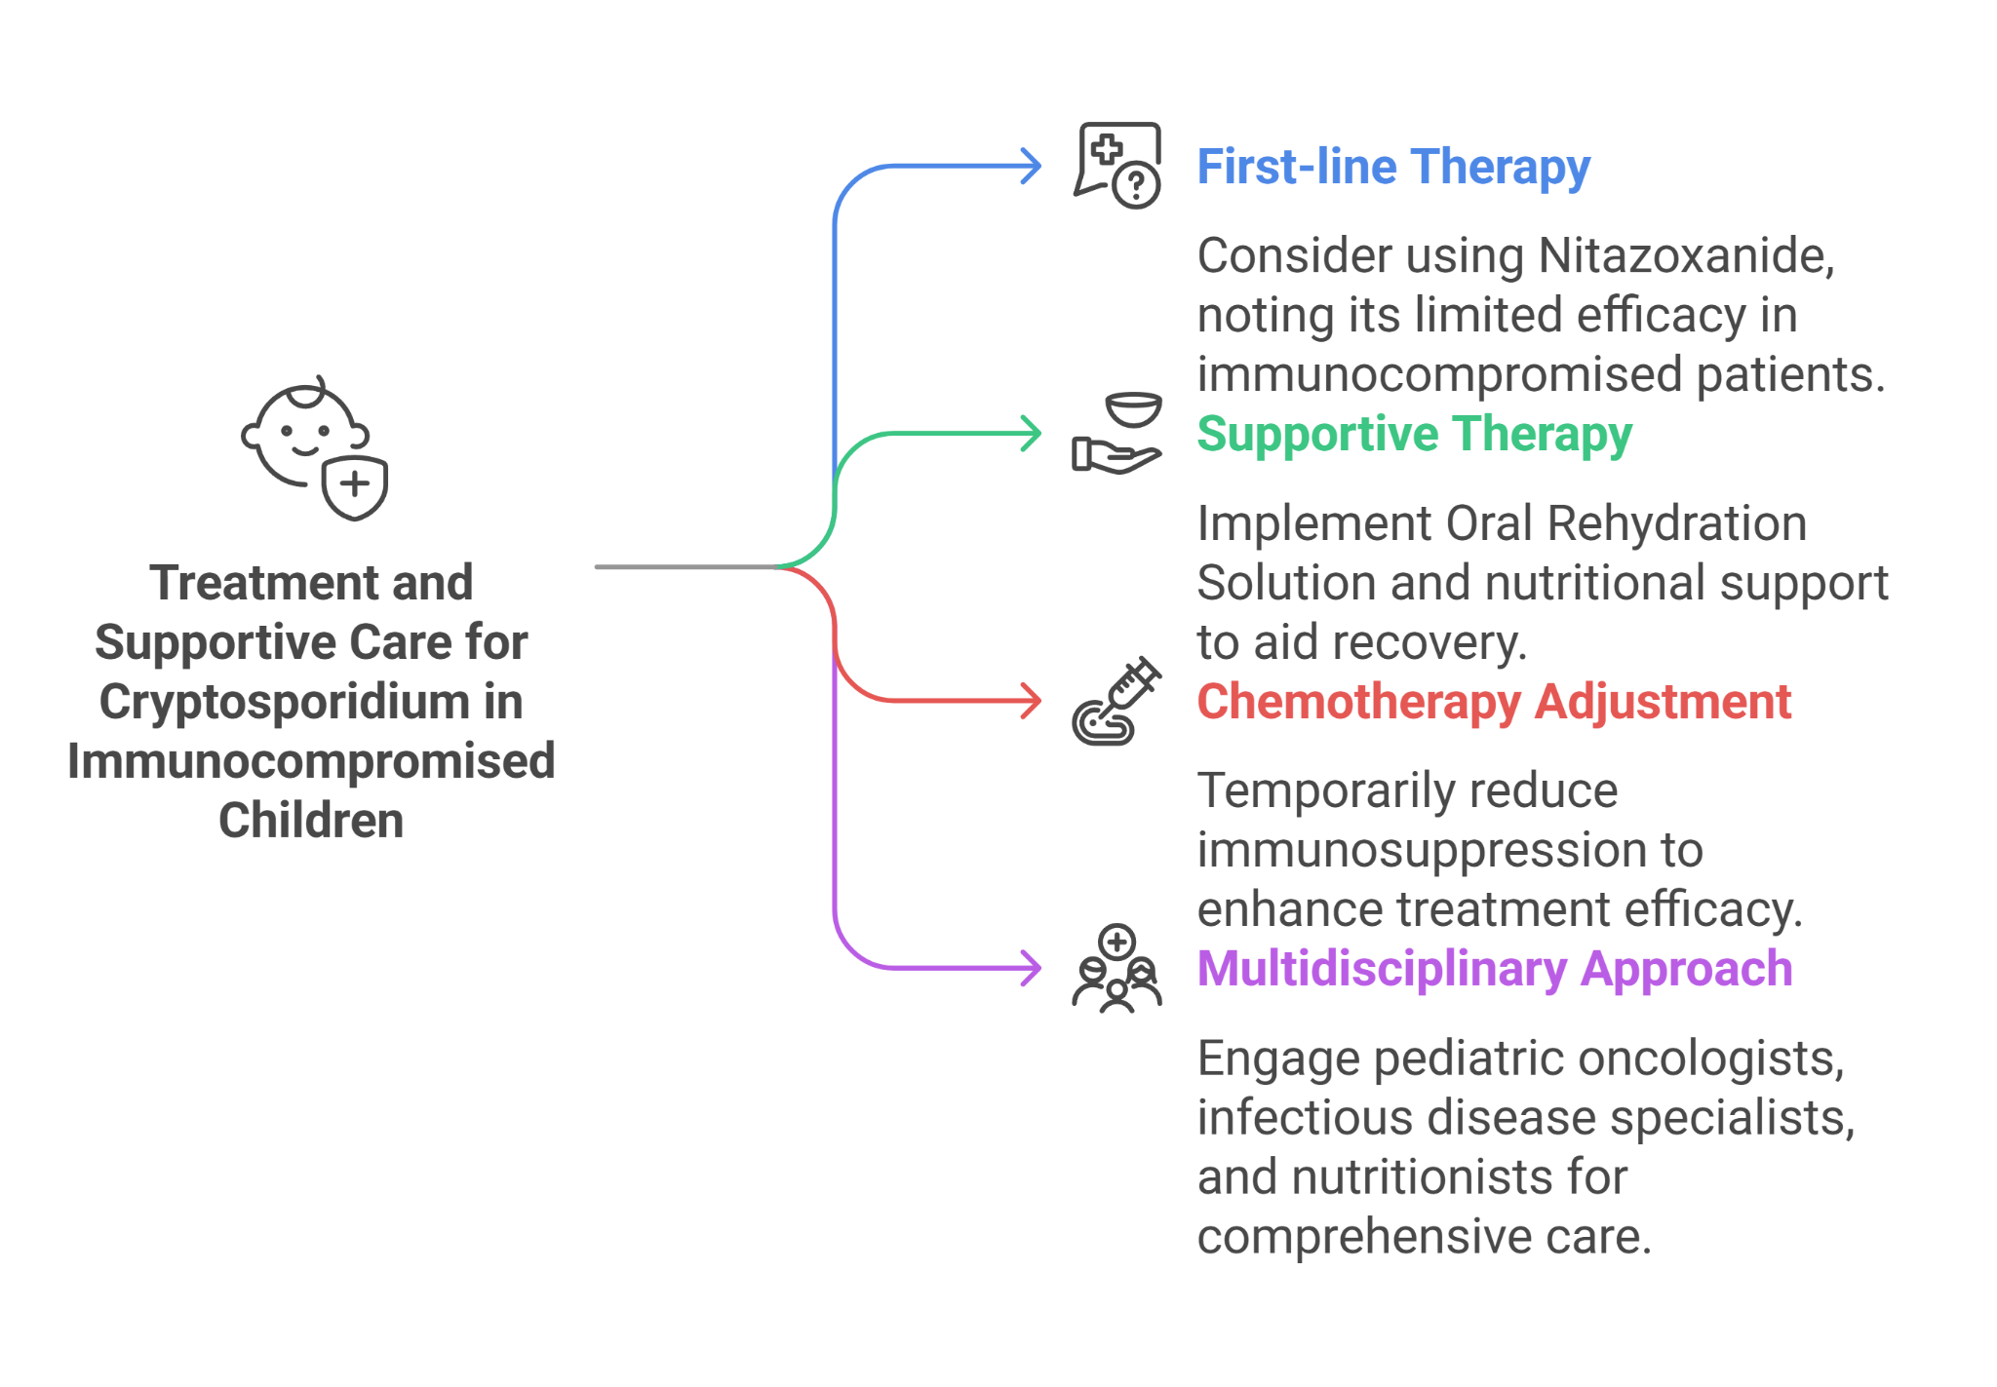

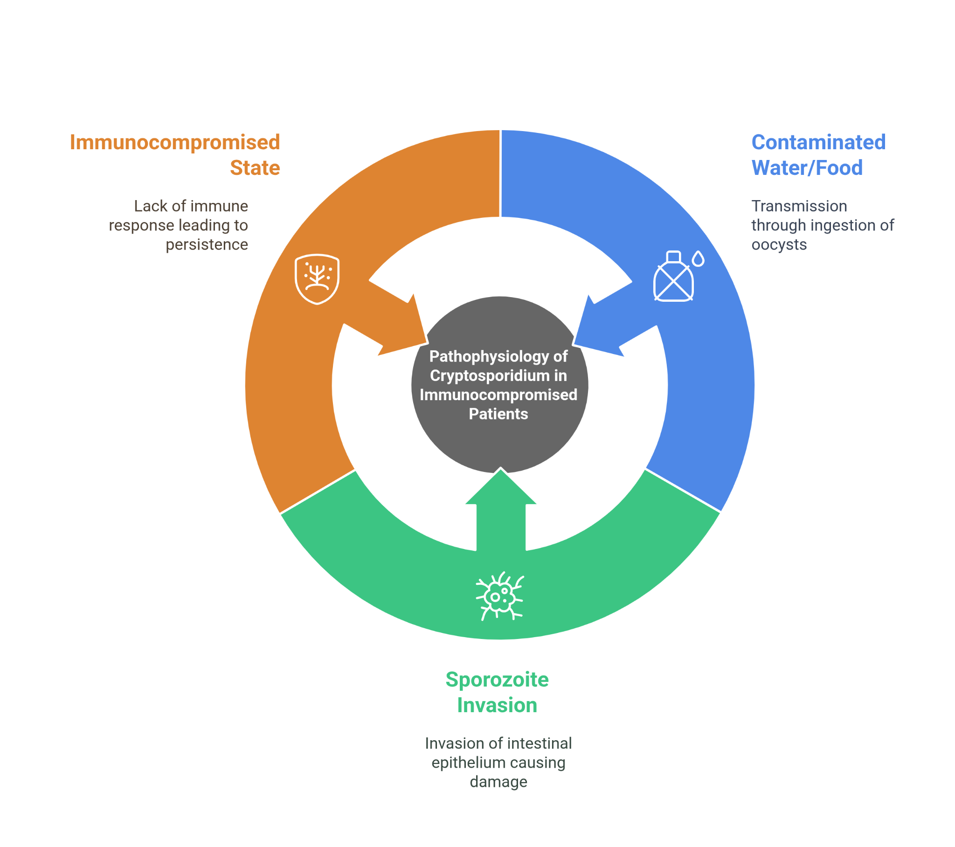

**Follow-Up**

Despite initial challenges, the child showed gradual improvement with the treatment regimen. Follow-up appointments focused on monitoring hydration status, nutritional recovery, and assessing for potential recurrence of infection. Discussions on preventive measures, including water treatment and hand hygiene, were emphasised to reduce the risk of re-infection.

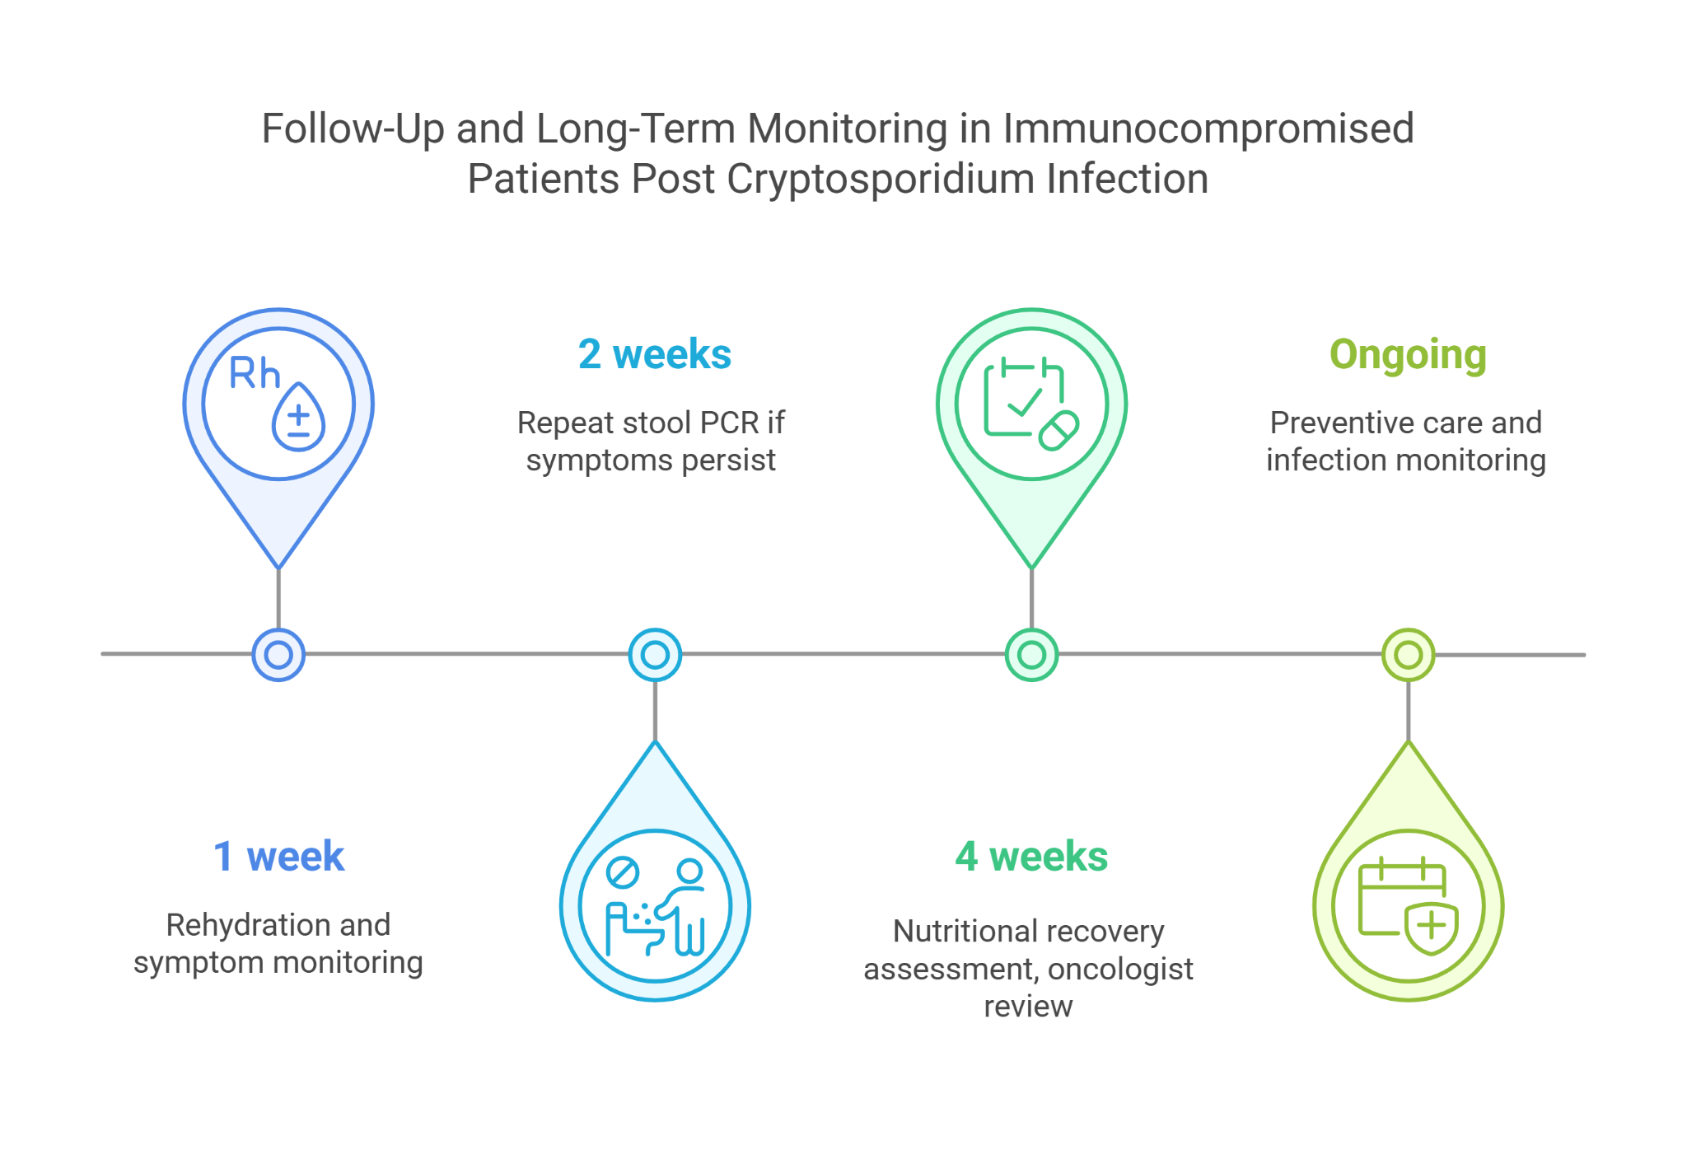

**Conclusion**

This case underscores the importance of considering opportunistic pathogens like Cryptosporidium in immunocompromised children presenting with persistent diarrhoea. It highlights the need for comprehensive diagnostic approaches and tailored management strategies that address both the infection and the underlying immune compromise, demonstrating the critical role of multidisciplinary care in managing complex pediatric cases.

### **Case Study: "Diarrhea and Cyanosis in an Infant: Congenital Heart Disease Link"**

**Introduction**

This case involves a nuanced presentation of diarrhea and cyanosis in an infant, unveiling an underlying congenital heart disease, a scenario demanding a multidisciplinary diagnostic and therapeutic approach, particularly within the Indian healthcare context.

**Background**

While diarrhea in infants is commonly attributed to gastrointestinal disorders, systemic illnesses like congenital heart disease (CHD) **can present with gastrointestinal symptoms due to compromised circulation and oxygenation, illustrating the complexity of pediatric diagnostics.(not very sure of this. Statement, if TOF can lead to diarrhoea.) However, any AGE or diarrhoea can complicate in TOF patients and dehydration can trigeer cyanotic spell.**

**Presenting Symptoms**

A 4-month-old female, born at term with no immediate postnatal complications, was referred to a tertiary care center in India with a 2-week history of frequent, watery stools and progressive cyanosis noted during feeding and crying noticed since how many days of life. The infant had poor weight gain since birth.

**Clinical Examination:** Revealed central cyanosis, clubbing, and a systolic murmur.

**Investigations**

**Stool Analysis:** Non-specific, showing no pathogenic bacteria, viruses, or parasites.

**Chest X-ray and ECG:** Confirmed structural heart abnormalities and right ventricular hypertrophy.

**Echocardiography:** Demonstrated Tetralogy of Fallot (TOF), a type of CHD characterized by four cardiac defects that affect blood flow and oxygenation.

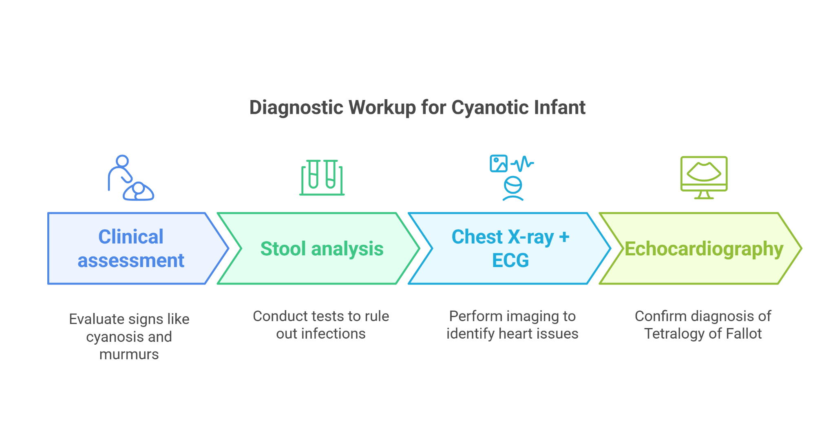

**Differential Diagnosis**

**Gastrointestinal Infection:** Initially considered due to diarrhea but lacked corroborative laboratory findings.

**Congenital Heart Disease:** The presence of cyanosis, clubbing, and a heart murmur alongside echocardiographic findings pointed towards CHD as the underlying cause.

**Cyanotic Spells Related to CHD:** The episodes of increased cyanosis during crying or feeding suggested cyanotic spells, typical in conditions like TOF.

**Metabolic Disorders:** Included due to poor weight gain and systemic symptoms but unlikely considering specific cardiac findings.

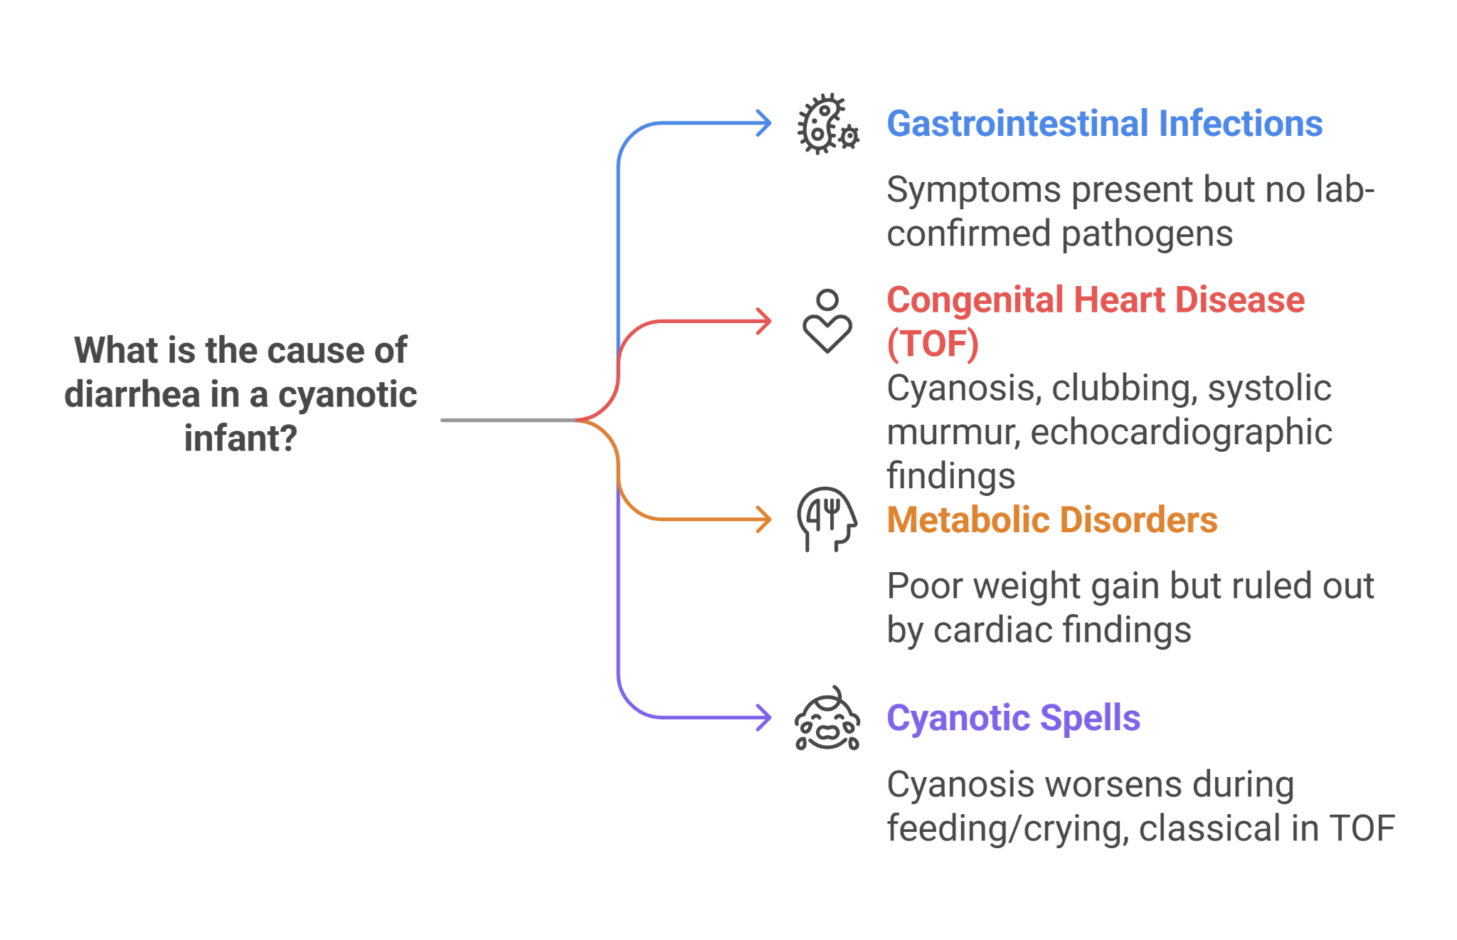

**Final Diagnosis**

The diagnosis was Tetralogy of Fallot, with diarrhea likely resulting from episodes of decreased intestinal perfusion during cyanotic spells,(maybe we can quote the evidence) emphasizing the systemic impact of the congenital heart defect.

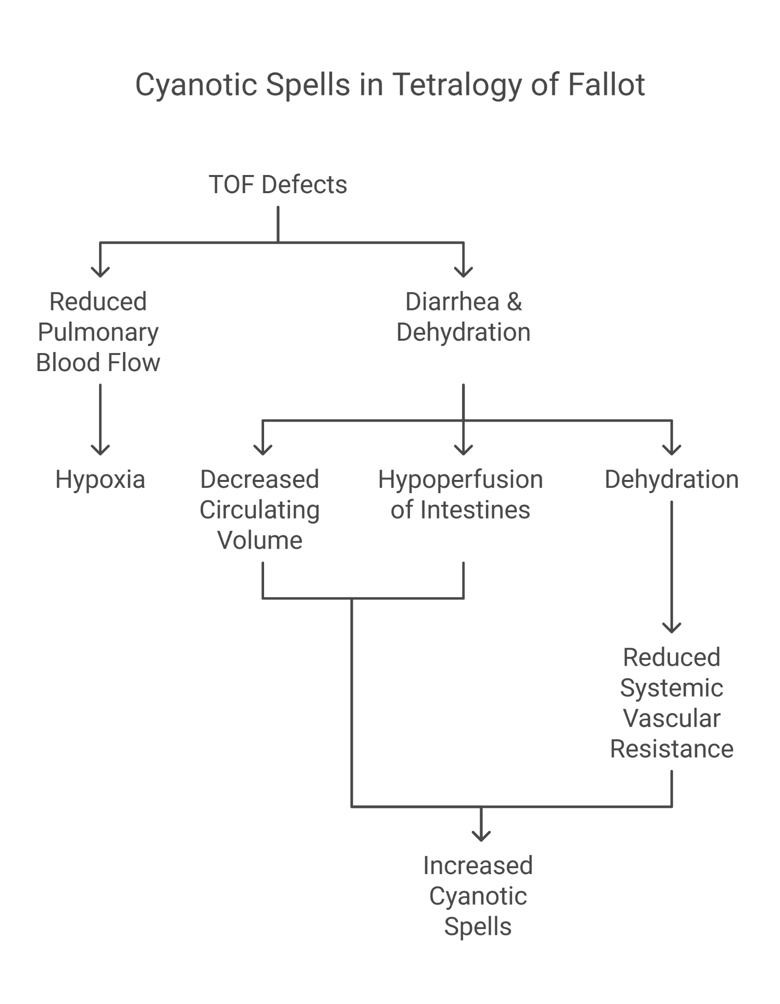

**Treatment and Management**

The management plan included immediate stabilization of the infant’s oxygen levels and addressing dehydration caused by diarrhea. Prostaglandin E1 infusion was initiated to maintain ductal patency and improve systemic oxygenation. Surgical consultation was sought for corrective heart surgery, planned as a staged repair given the infant's condition and age.

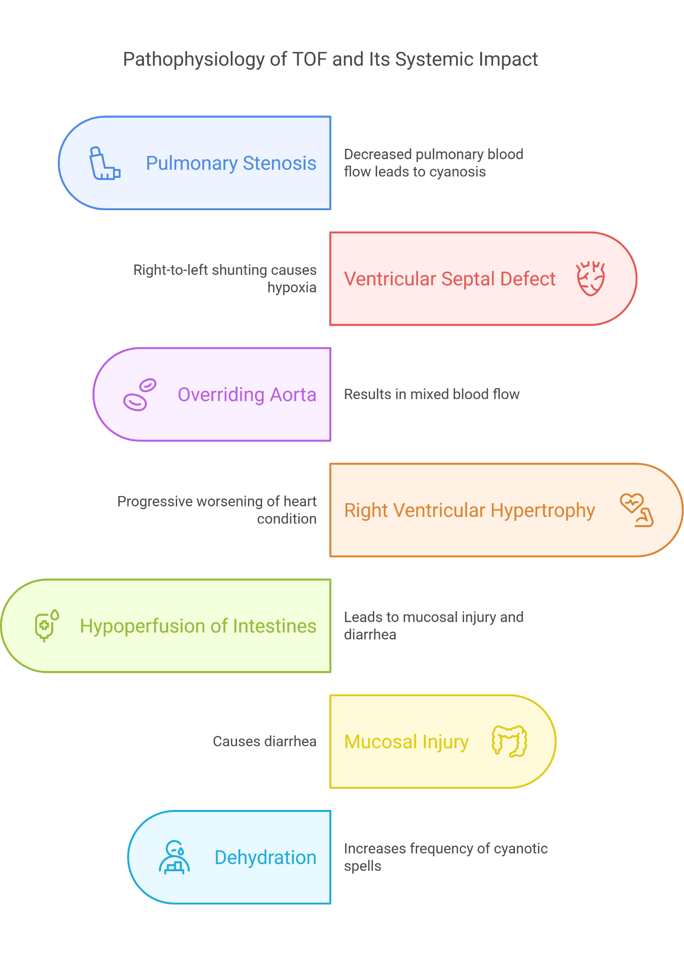

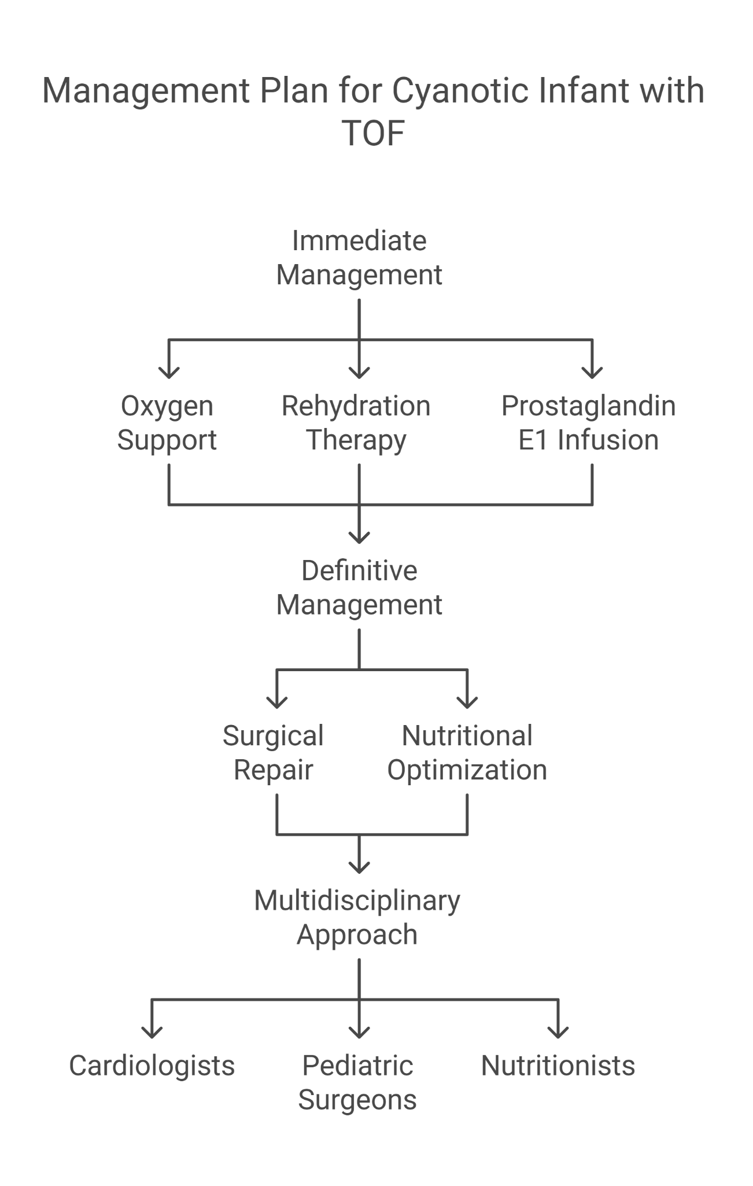

**Follow-Up**

Pre-operative care focuses on nutritional support to improve weight and general health, optimizing the infant for surgery. Post-surgical follow-up emphasized monitoring for complications, assessing cardiac function, and supporting developmental needs, with regular cardiology and pediatric reviews to ensure optimal recovery and growth.

**Conclusion**

This case highlights the critical importance of a holistic approach to pediatric care, where systemic symptoms such as diarrhea in a cyanotic infant warrant consideration **of non-gastrointestinal causes, including congenital heart disease.** (diarrhoea. As manifestation of cyanotic heart disease , I am not. Sure) Early diagnosis and intervention in CHD can significantly impact the prognosis, underscoring the need for vigilance and comprehensive evaluation in atypical presentations.

### **Case Study: "Acute Bloody Diarrhea and Shock: Hemolytic Uremic Syndrome"**

**Introduction**

A detailed evaluation of a serious pediatric case presenting with acute bloody diarrhea followed by the rapid development of anuria, leading to a diagnosis of Hemolytic Uremic Syndrome (HUS), in the context of Indian healthcare settings.

**Background**

Hemolytic Uremic Syndrome, a critical condition characterized by the triad of reanl insufficiency, , microangiopathic hemolytic anemia, and thrombocytopenia, often follows gastrointestinal infections in children. Its swift progression demands urgent recognition and management to prevent life-threatening complications and even death.

**Presenting Symptoms**

A 3-year-old male from a rural region in India was admitted to a hospital with a 3-day history of bloody diarrhea, vomiting, and decreased urine output. Within 24 hours of admission, the child developed signs of shock, including lethargy, significant pallor, tachycardia, and hypotension despite dehydration correction.

**Investigations**

**Complete Blood Count (CBC):** Revealed hemolytic anemia and thrombocytopenia. With reticulocytosis

**Blood Smear:** Showed schistocytes, indicating microangiopathic hemolytic anemia.

**Renal Function Tests:** Indicated acute kidney injury with elevated creatinine and blood urea nitrogen (BUN) levels.

**Stool Culture:** Positive for Escherichia coli O157:H7.

**Coagulation Profile:** Within normal limits, ruling out disseminated intravascular coagulation.

**Differential Diagnosis**

**Bacterial Gastroenteritis:** Initially suspected due to bloody diarrhea but the subsequent development of renal failure and hematologic abnormalities pointed towards a more severe condition.

**Shigellosis:** Considered because of bloody diarrhea but lacked the renal and hematologic complications characteristic of HUS. In Asia, shigella dysenteriea type 1 is the most common cause of diarrhoea associated HUS.

**Hemolytic Uremic Syndrome (HUS):** Diagnosis confirmed by the combination of acute kidney injury, microangiopathic hemolytic anemia, and thrombocytopenia following a bloody diarrhea episode.

**Septic Shock:** The rapid onset of shock necessitated consideration; however, the specific triad of symptoms aligned more closely with HUS.

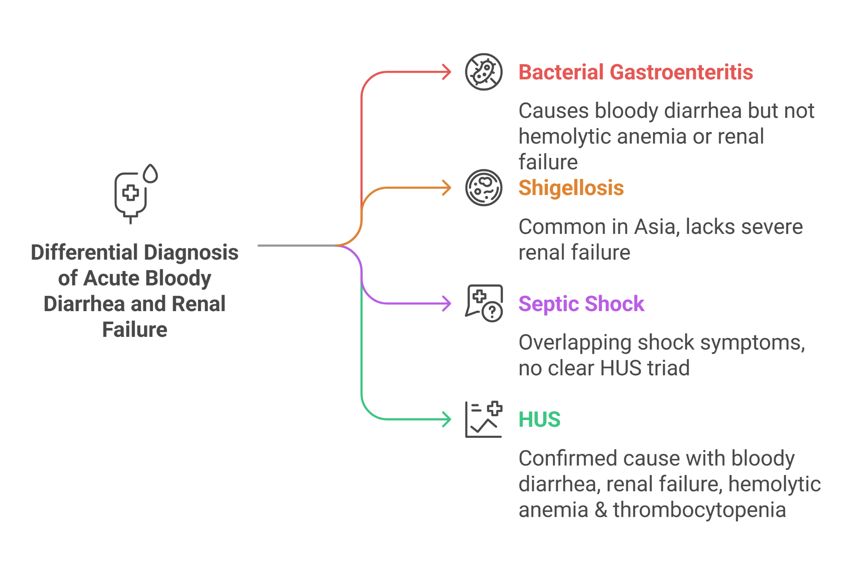

### **Final Diagnosis**

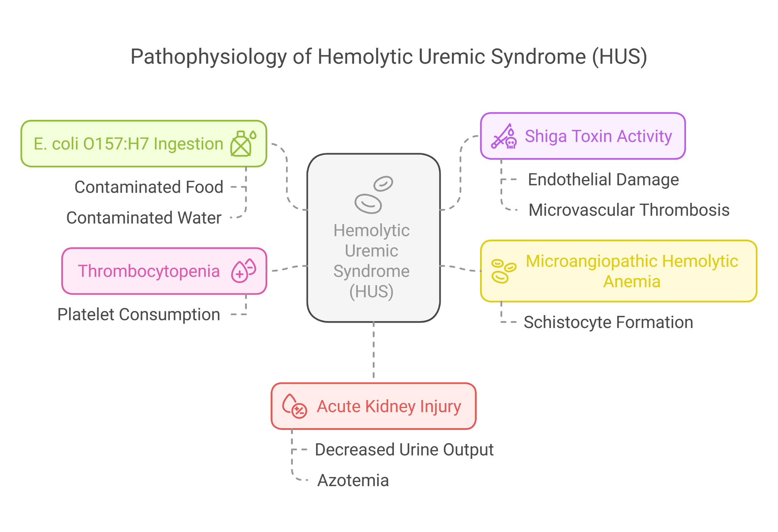

The final diagnosis was Hemolytic Uremic Syndrome (HUS), triggered by infection with Escherichia coli O157:H7, as evidenced by the stool culture and clinical triad of azotemia, thrombocytopenia and hemolytic anemia.

**Treatment and Management**

The child was managed in the intensive care unit (ICU) with supportive care, including fluid management to address shock and careful electrolyte monitoring. Renal replacement therapy (dialysis) was initiated due to oliguria and worsening renal function. Antibiotic therapy was avoided to prevent exacerbating HUS. Blood transfusions were administered to manage anemia and thrombocytopenia.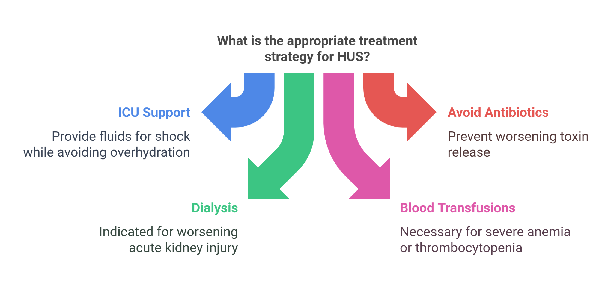

**Follow-Up**

The child's condition gradually improved with supportive care. Renal function returned to baseline after two weeks of dialysis, and hematologic parameters normalized. Follow-up care focused on monitoring renal function and overall recovery, with nutritional support to aid in regaining strength and weight lost during the illness.

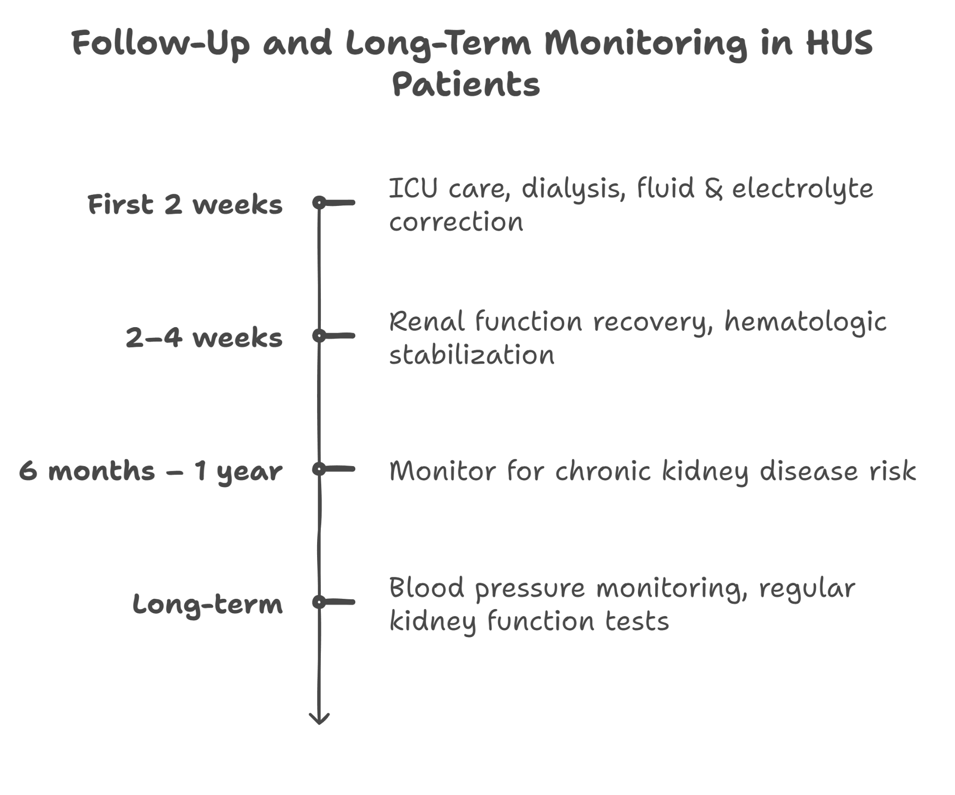

**Conclusion**

This case of Hemolytic Uremic Syndrome highlights the critical importance of early recognition and intervention in pediatric patients presenting with acute bloody diarrhea and renal failure in the absence of dehydration. Understanding the linkage between certain bacterial infections and HUS can guide timely, life-saving interventions, emphasizing the need for integrated care and vigilant monitoring to navigate this severe complication successfully.