### **Publication 3: Diaper Dermatitis: From Prevention to Treatment**

### **Case Study: The Stubborn Rash: Yeast Infection in Disguise**

#### **Introduction**

Diaper rash is a common issue in infants, often attributed to irritation from wet or soiled diapers. However, persistent diaper rash unresponsive to conventional treatments may indicate a yeast infection or an underlying systemic issue. This case study focuses on identifying and treating candidal diaper dermatitis.

#### **Background**

Candidal diaper dermatitis is a type of diaper rash caused by Candida albicans, a yeast that thrives in warm, moist environments. It is crucial to distinguish this condition from other forms of diaper rash to ensure appropriate treatment and prevent complications.

#### **Presenting Symptoms**

A 10-month-old girl named Anaya was brought to the pediatric clinic with a persistent diaper rash that had not improved despite frequent diaper changes, air drying, and the use of barrier creams. The rash had been present for over three weeks and was accompanied by intense redness, satellite lesions, and discomfort during diaper changes.

#### **Investigations**

1. Detailed medical history and physical examination.
2. Skin swab from the affected area for fungal culture to identify Candida species.
3. Blood tests to rule out underlying systemic issues, such as immunodeficiency.

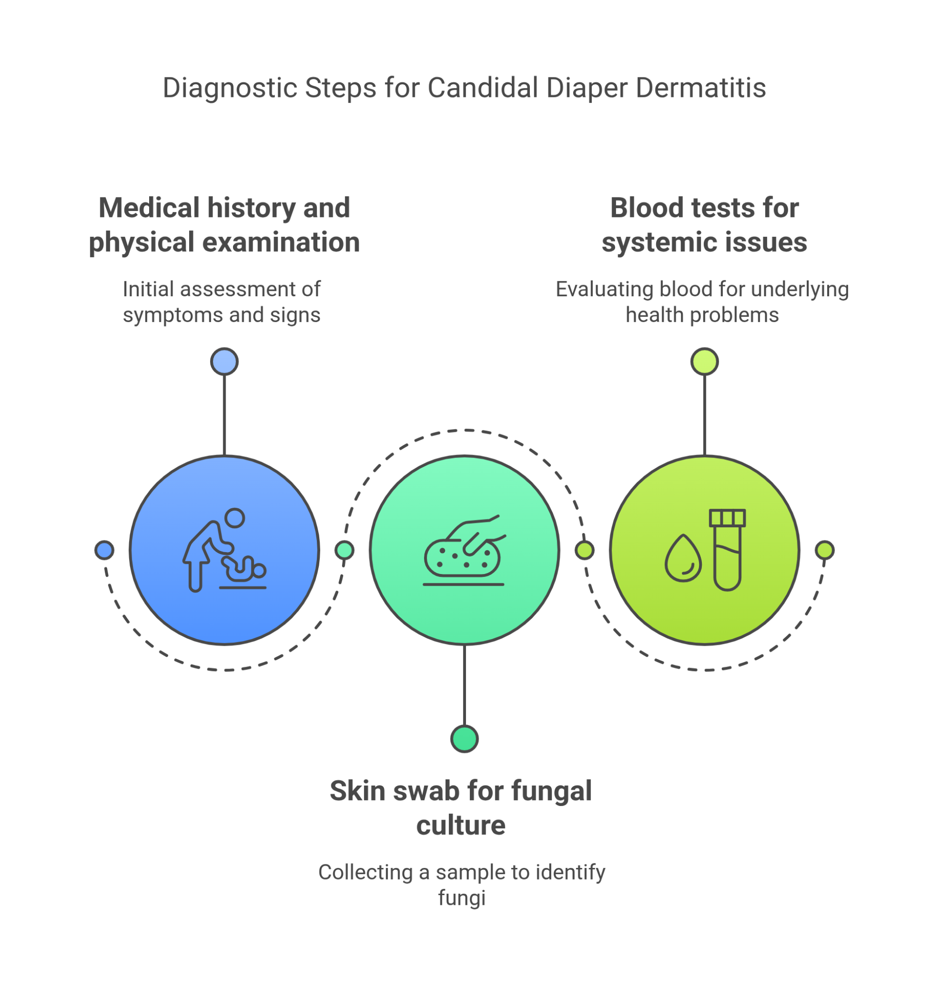

#### **Differential Diagnosis**

* **Irritant Diaper Dermatitis**
  + Ruled out due to the lack of improvement with standard care and the presence of satellite lesions typical of yeast infection.
* **Allergic Contact Dermatitis**
  + Ruled out as there was no recent introduction of new diaper brands or wipes, and the rash did not improve with elimination of potential allergens.
* **Seborrheic Dermatitis**
  + Ruled out because of the distinct appearance and location of the rash, and its lack of response to moisturizing treatments.
* **Psoriasis**
  + Ruled out based on the absence of thick, silvery scales and the infant's age.
* **Bacterial Infection**
  + Ruled out after skin swab and culture showed no bacterial growth.

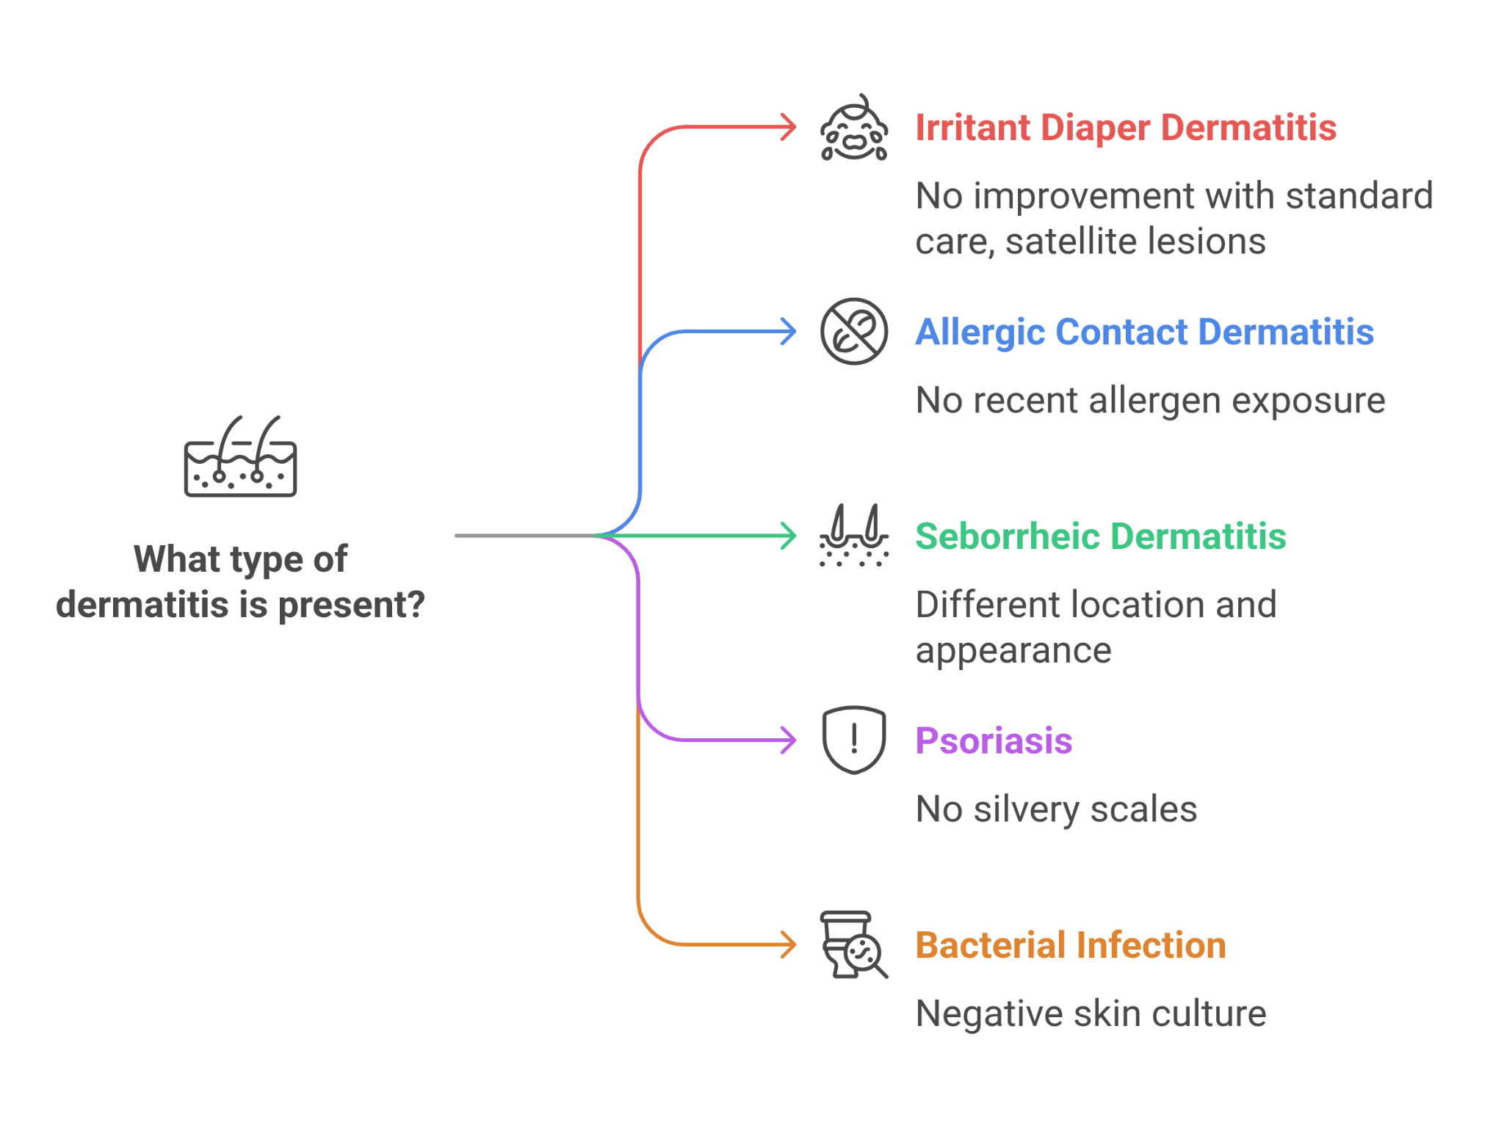

#### **Final Diagnosis**

Candidal diaper dermatitis confirmed by positive fungal culture for Candida albicans.

#### **Treatment and Management**

1. **Antifungal Treatment**
   * Prescribed topical antifungal cream (clotrimazole) to be applied to the affected area twice daily.
2. **Supportive Care**
   * Continued use of barrier creams to protect the skin.
   * Advised frequent diaper changes and allowing the skin to air out as much as possible.
3. **Hygiene Practices**
   * Recommended gentle cleaning of the diaper area with water and a soft cloth, avoiding harsh wipes and soaps.
4. **Education**
   * Educated parents on the importance of maintaining dryness and cleanliness to prevent future occurrences.
   * Provided instructions on recognizing signs of yeast infections and when to seek medical advice.

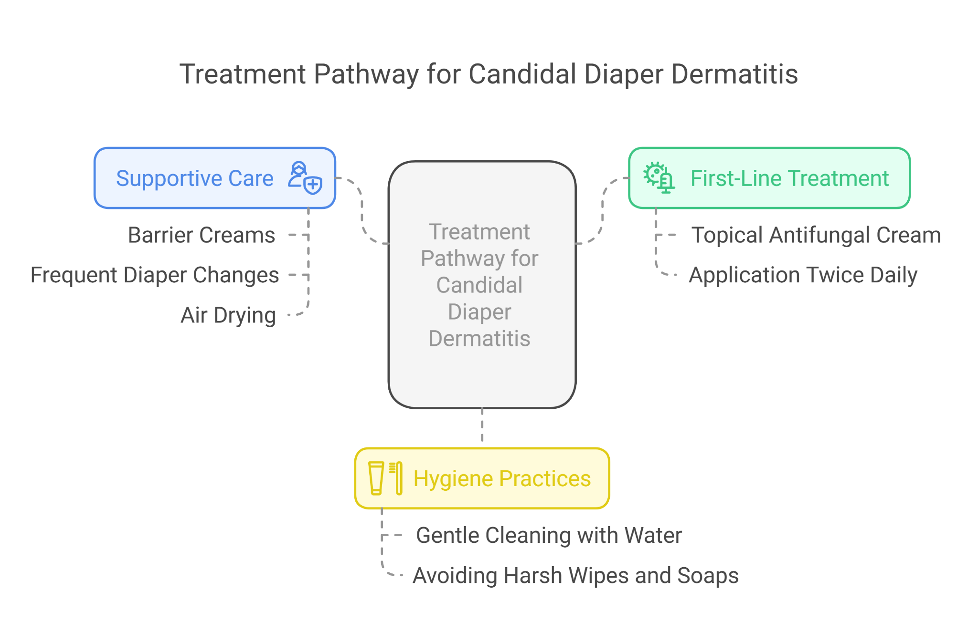

#### **Follow-Up**

At the 2-week follow-up, Anaya's rash had significantly improved, with a marked reduction in redness and discomfort. The antifungal treatment was effective, and the parents were satisfied with the results. Continued hygiene and care practices were emphasized to prevent recurrence.

#### **Conclusion**

This case highlights the importance of recognizing persistent diaper rash as a potential indicator of candidal infection. Prompt identification and appropriate antifungal treatment can lead to rapid resolution of symptoms and prevent complications. Healthcare providers should consider yeast infections in the differential diagnosis of persistent diaper rash to ensure comprehensive and effective care.

**Case Study: Beyond the Diaper: Systemic Symptoms Masked by Diaper Rash**

**Introduction**Diaper rash is a common issue in infants, often attributed to simple irritants. However, persistent diaper rash can sometimes be an indicator of a broader systemic condition. This case study explores the identification of diaper rash as a symptom of underlying systemic issues such as zinc deficiency, immunodeficiency, and Langerhans Cell Histiocytosis (LCH).

**Background**Persistent diaper rash can signal more than just a topical problem. Systemic conditions like zinc deficiency (acrodermatitis enteropathica), immunodeficiency, and LCH can manifest through chronic skin issues, including stubborn diaper rash. Recognizing these conditions early is crucial for effective treatment and preventing complications.

**Presenting Symptoms**A 10-month-old boy named Aarav presented with a persistent and severe diaper rash that had not improved despite frequent diaper changes, air drying, and various barrier creams. The rash had been present for over two months and was accompanied by other symptoms such as poor growth, frequent infections, and irritability.

**Investigations**

* Comprehensive medical history and detailed physical examination.
* Blood tests to check for zinc levels, complete blood count (CBC), and immune function tests.
* Skin swab for culture to rule out secondary infections.
* Dietary assessment to evaluate nutritional intake.
* Genetic testing (BRF gene study) to assess for LCH.

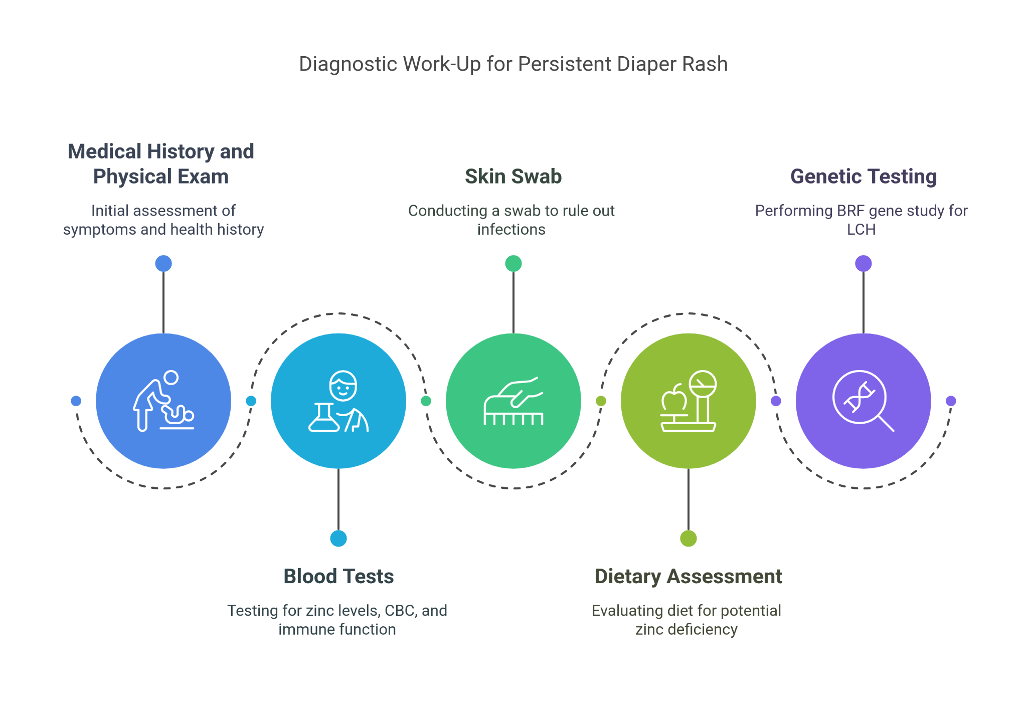

**Differential Diagnosis**

1. **Irritant Diaper Dermatitis**
   * Ruled out due to lack of response to standard treatments and the presence of systemic symptoms.
2. **Candidal Diaper Dermatitis**
   * Ruled out based on negative fungal culture results.
3. **Allergic Contact Dermatitis**
   * Ruled out as eliminating potential allergens did not improve the condition.
4. **Seborrheic Dermatitis**
   * Ruled out because the rash's location and appearance did not match typical seborrheic dermatitis.
5. **Psoriasis**
   * Ruled out due to the absence of characteristic plaques and the age of the patient.
6. **Langerhans Cell Histiocytosis (LCH)**
   * Considered due to persistent rash resistant to treatment and systemic symptoms such as poor growth and recurrent infections.
   * Confirmed by BRF gene study and histological examination.

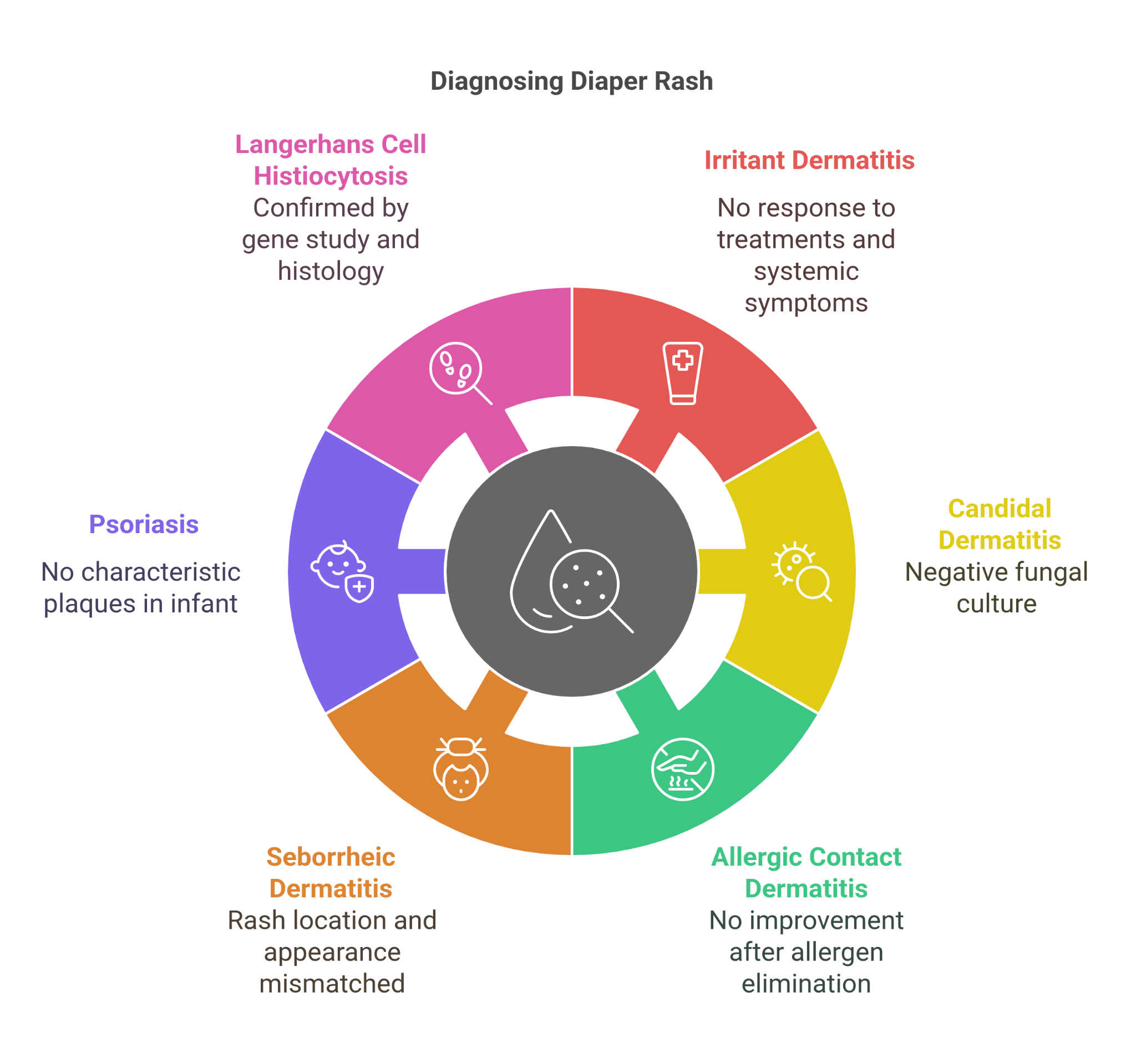

**Final Diagnosis**Zinc deficiency (acrodermatitis enteropathica) confirmed by low serum zinc levels and clinical presentation.

**Treatment and Management**

* **Nutritional Supplementation**
  + Prescribed oral zinc supplements to correct the deficiency.
* **Topical Treatments**
  + Continued use of barrier creams to protect the skin while the underlying issue was addressed.
* **Dietary Modifications**
  + Advised parents on incorporating zinc-rich foods into the child's diet, such as meat, dairy, and legumes.
* **Supportive Care**
  + Monitored for and treated any secondary infections that may have arisen due to the compromised skin barrier.
* **Education and Counseling**
  + Educated the parents on the importance of zinc in the diet and how to prevent future deficiencies.
  + Provided information on recognizing symptoms of zinc deficiency and when to seek medical help.
  + Emphasized the importance of further evaluation if symptoms persisted, including screening for LCH if diaper rash remained treatment-resistant.

**Follow-Up**At the 1-month follow-up, Aarav's rash had significantly improved, with the skin healing well and a notable decrease in irritability and infections. His growth parameters began to normalize, indicating a positive response to the zinc supplementation. Continued follow-up visits were scheduled to ensure sustained improvement and adjust treatment as necessary.

**Conclusion**This case highlights the importance of considering systemic conditions when faced with persistent diaper rash. Early recognition and treatment of underlying issues such as zinc deficiency and LCH can lead to significant improvements in the patient's overall health. Healthcare providers should adopt a holistic approach, considering both local and systemic factors, to ensure comprehensive care and effective management of persistent diaper rash.

**Case Study: The Rash that Won't Quit: When to Consider Alternative Diagnoses**

**Introduction**Diaper rash is a frequent concern among infants, commonly managed with straightforward interventions. However, when a diaper rash persists despite conventional treatments, it warrants consideration of less common causes. This case study focuses on identifying and treating persistent diaper rash by exploring alternative diagnoses, including bacterial infections and rare dermatoses.

**Background**Diaper dermatitis often responds well to standard care involving frequent diaper changes, air exposure, and barrier creams. Persistent cases may suggest more complex etiologies such as bacterial infections, immunodeficiency, or rare skin conditions. Recognizing these possibilities is vital for effective management and alleviating discomfort in infants.

**Presenting Symptoms**A 9-month-old girl named Sanya presented with a persistent diaper rash unresponsive to conventional treatments over six weeks. The rash was characterized by red, inflamed skin with areas of oozing and crusting. Sanya also exhibited irritability and intermittent low-grade fever.

**Investigations**

* Detailed medical history and thorough physical examination.
* Skin swab and culture from the affected area to identify bacterial or fungal pathogens.
* Blood tests, including complete blood count (CBC) and inflammatory markers.
* Skin biopsy to rule out rare dermatoses if initial investigations were inconclusive.

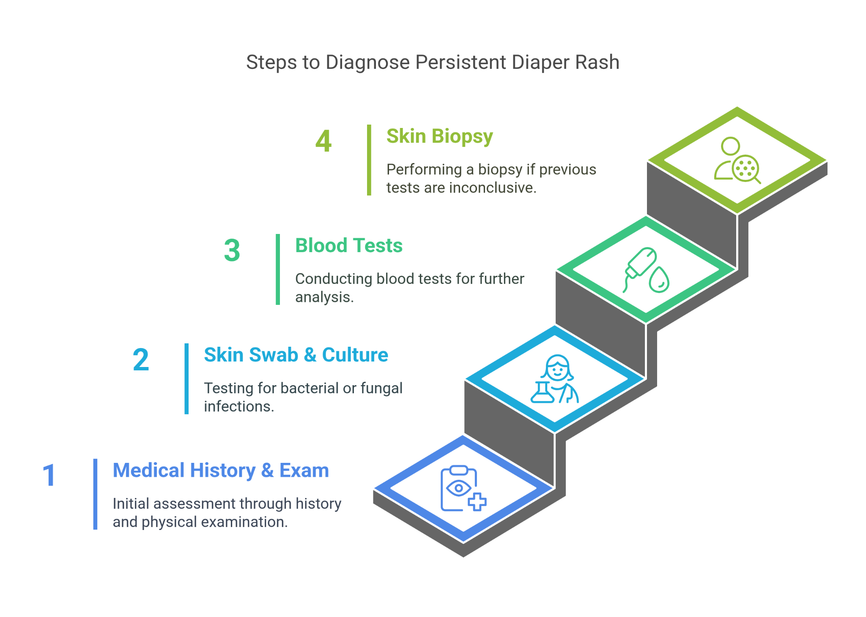

**Differential Diagnosis**

1. **Irritant Diaper Dermatitis**
   * Ruled out due to lack of response to standard care and the presence of systemic symptoms.
2. **Candidal Diaper Dermatitis**
   * Ruled out after antifungal treatments failed and fungal cultures were negative.
3. **Allergic Contact Dermatitis**
   * Ruled out as eliminating potential allergens did not improve the condition.
4. **Seborrheic Dermatitis**
   * Ruled out due to the rash's extensive and severe nature, which was not typical of seborrheic dermatitis.
5. **Psoriasis**
   * Ruled out based on the absence of characteristic plaques and a negative family history.

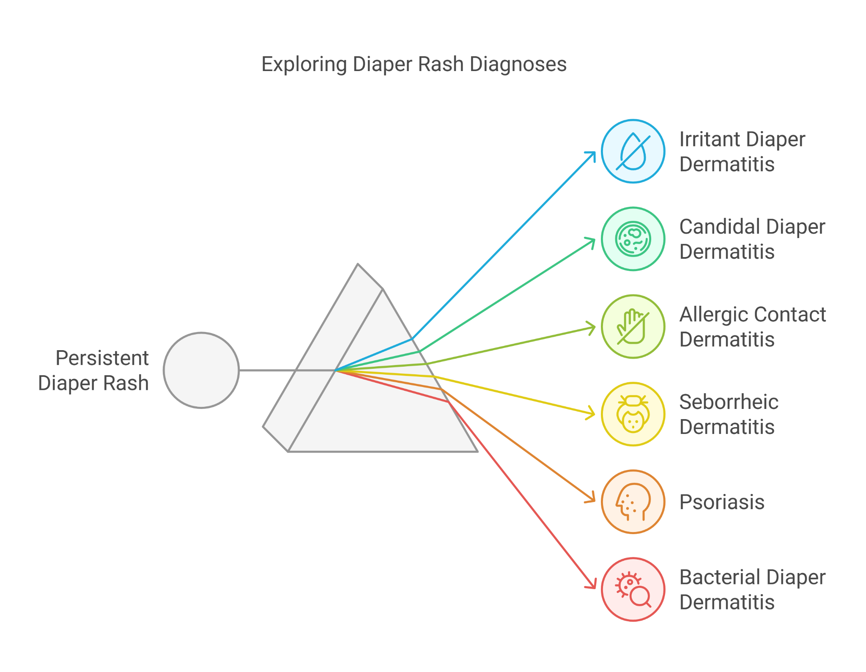

**Final Diagnosis**Bacterial diaper dermatitis confirmed by positive culture for Staphylococcus aureus.

**Treatment and Management**

* **Antibiotic Treatment**
  + Prescribed a course of oral antibiotics (cephalexin) to treat the bacterial infection.
  + Recommended topical antibiotic ointment (mupirocin) for localized application.
* **Zinc Oxide Application**
  + Advised parents to apply zinc oxide paste after every diaper change to help build a protective barrier, prevent the spread of infection, and support skin healing.
  + Educated parents on the availability of zinc oxide as an application paste for ease of use.
* **Supportive Care**
  + Advised parents to continue frequent diaper changes and air drying.
  + Recommended the use of gentle, non-irritating cleansers and avoidance of harsh wipes.

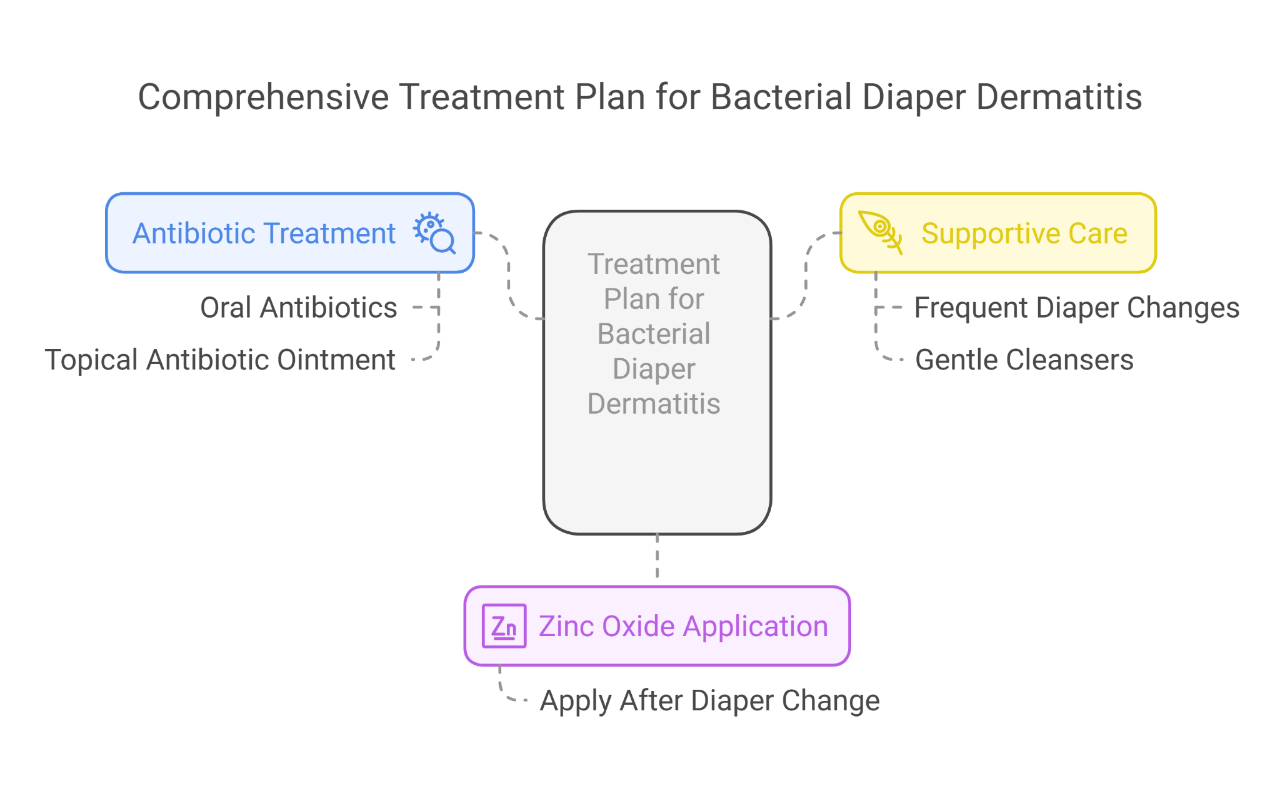

**Monitoring and Follow-Up**

* Scheduled follow-up appointments to monitor the response to treatment and ensure complete resolution of the infection.

**Education**

* Educated the parents on recognizing signs of bacterial infection and the importance of completing the antibiotic course.
* Provided guidance on maintaining good hygiene practices to prevent recurrence.
* Emphasized the role of zinc oxide in protecting the skin and aiding in healing.

**Follow-Up**At the 2-week follow-up, Sanya's rash had significantly improved, with reduced inflammation and healing of the affected skin. Her fever had subsided, and she was notably less irritable. The parents were advised to complete the antibiotic course and continue with recommended hygiene practices, including the regular application of zinc oxide paste. Further follow-up confirmed the complete resolution of the rash.

**Conclusion**This case highlights the importance of considering alternative diagnoses in persistent diaper rash, including bacterial infections. Timely identification and appropriate treatment of underlying causes can lead to rapid improvement and prevent complications. Healthcare providers should maintain a broad differential diagnosis and consider less common causes when standard treatments fail to resolve diaper rash. The inclusion of zinc oxide in daily care is crucial for skin barrier protection, preventing recurrence, and expediting healing.