### **Case Study: "Diarrhea with Seizure: Hyponatremic Dehydration"**

**Introduction**

A detailed case analysis of a pediatric patient in India presenting with diarrhea followed by an alarming episode of seizure, leading to the identification of hyponatremic dehydration as the underlying cause.

**Background**

Hyponatremic dehydration, characterized by a significant decrease in sodium levels due to excessive electrolyte loss, can manifest with neurological symptoms, including seizures, in severe cases. This condition often complicates prolonged or severe episodes of diarrhea in children, necessitating prompt diagnosis and management.

**Presenting Symptoms**

A 5-year-old female from a suburban area in India was brought to the emergency department after experiencing a generalized tonic-clonic seizure at home. She had a history of watery diarrhea and vomiting for 5 days prior, with reduced oral intake and no prior history of seizures.

**Investigations**

**Serum Electrolytes:** Revealed severe hyponatremia with sodium levels significantly below the normal range.

**Complete Blood Count (CBC):** Indicated hemoconcentration, suggestive of dehydration.

**Blood Glucose:** Within normal limits, ruling out hypoglycemia as a cause of seizure.

**Urine Specific Gravity:** Elevated, consistent with dehydration.

**Brain MRI and EEG:** Conducted to rule out central nervous system infections or epilepsy; both were normal.

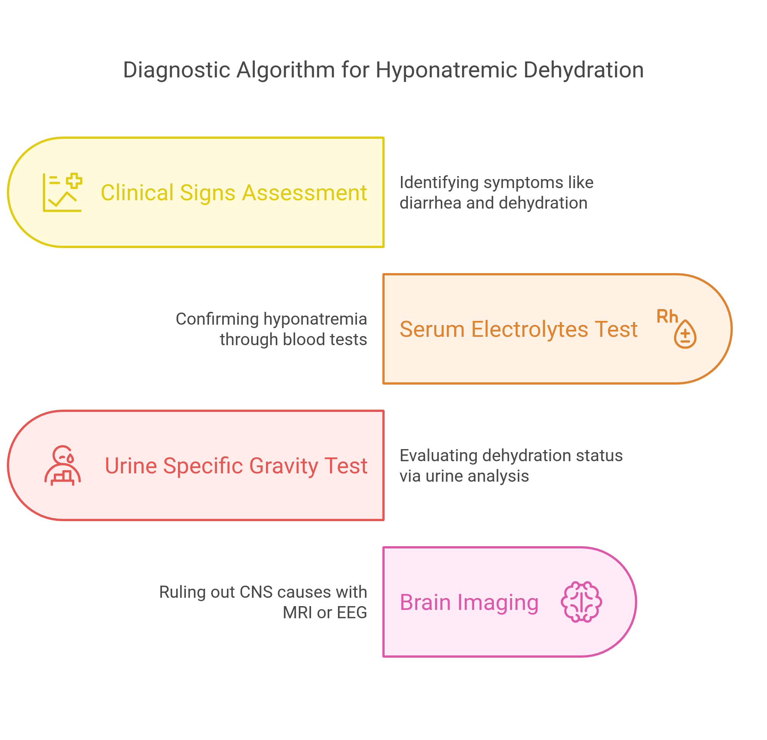

**Differential Diagnosis**

**Hyponatremic Dehydration:** The presence of diarrhea, vomiting, seizure, and laboratory findings of low sodium levels strongly suggested this diagnosis.

**Infectious Gastroenteritis:** The initial cause of fluid and electrolyte loss, contributing to hyponatremia. Absence of blood in stools rules out Shigellosis as a cause of seizure.

**Central Nervous System Infection:** Considered due to the seizure but ruled out by normal imaging and EEG.

**Epilepsy:** A potential consideration given the seizure but less likely in the absence of previous episodes and with normal EEG findings.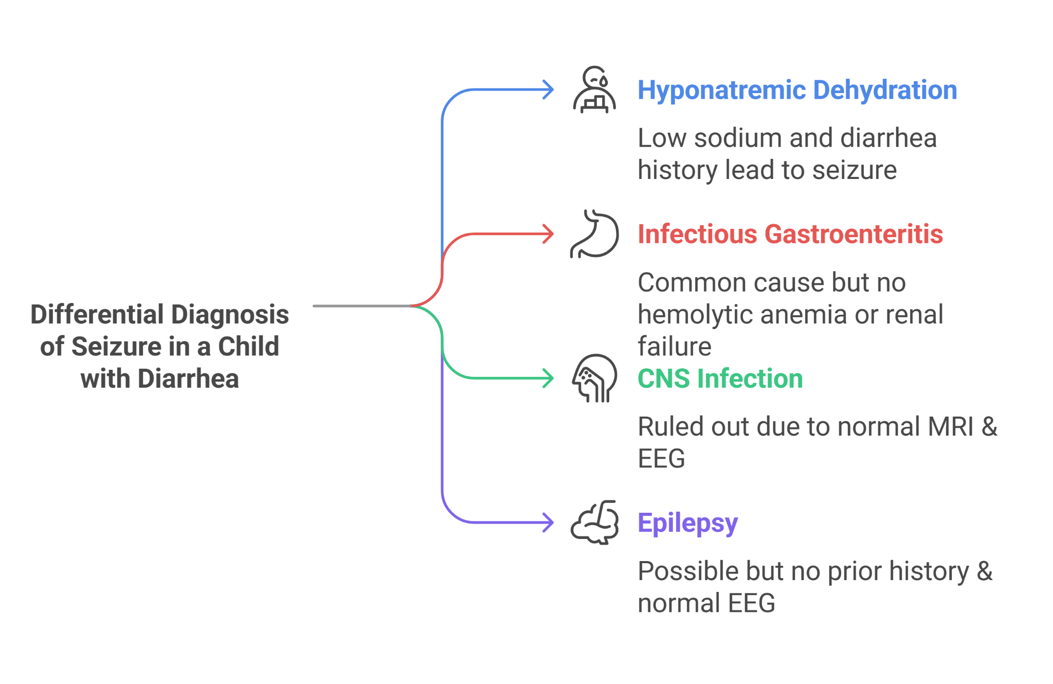

**Final Diagnosis**

The final diagnosis was hyponatremic dehydration secondary to prolonged diarrhea and vomiting, leading to an acute seizure episode due to the rapid decrease in serum sodium levels.

**Treatment and Management**

Immediate management involved controlled intravenous rehydration with isotonic saline to gradually correct the hyponatremia, closely monitoring serum sodium levels to avoid rapid changes that could risk central pontine myelinolysis. Antiepileptic drugs were not indicated as the seizure was deemed a direct result of the acute electrolyte imbalance. Education on the importance of adequate rehydration during episodes of diarrhea and vomiting was provided to the caregivers.

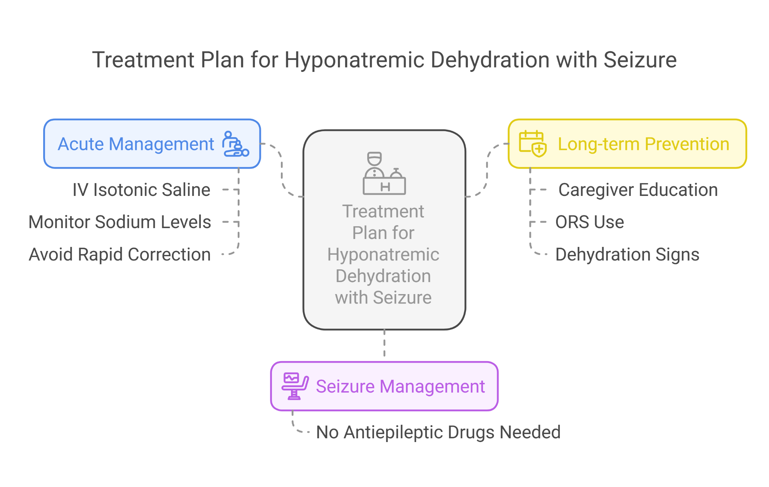

**Follow-Up**

The child showed significant improvement with correction of the hyponatremia, and no further seizures were reported. Follow-up visits emphasized the evaluation of overall hydration status, growth monitoring, and ensuring a complete recovery from the episode. The family received additional counseling on recognizing signs of dehydration and the importance of seeking prompt medical care.

**Conclusion**

This case of hyponatremic dehydration leading to a seizure underscores the critical importance of recognizing and treating electrolyte imbalances in children with severe diarrhea. It highlights the necessity for careful management of dehydration to prevent serious complications like seizures, demonstrating the interconnectedness of gastrointestinal and neurological health in pediatric patients.

### **Case Study: "Rapidly Worsening Diarrhea in a Child: Intussusception Alert"**

**Introduction**

This case study examines a rapidly deteriorating scenario of diarrhea in a child, leading to the diagnosis of intussusception, emphasizing the urgency of recognition and intervention in such critical pediatric conditions within the Indian healthcare context.

**Background**

Intussusception is a serious condition in which a part of the intestine telescopes into an adjacent section, causing a blockage. It's a common cause of acute abdomen in children and can present with symptoms including diarrhea, abdominal pain, and, in later stages, the passage of blood and mucus resembling red currant jelly.

**Presenting Symptoms**

A 2-year-old male from a small town in India presented to the hospital with a 24-hour history of intermittent abdominal pain, vomiting, and diarrhea. The parents noted the child crying and drawing his legs up toward his abdomen. Initially, the diarrhea was watery, but it soon contained streaks of blood.

**Investigations**

**Abdominal Ultrasound:** Revealed the “target sign,” suggestive of intussusception.

**Blood Tests:** Indicated mild dehydration and leukocytosis.

**X-ray abdomen:** Showed signs of bowel obstruction without free air under the diaphragm.

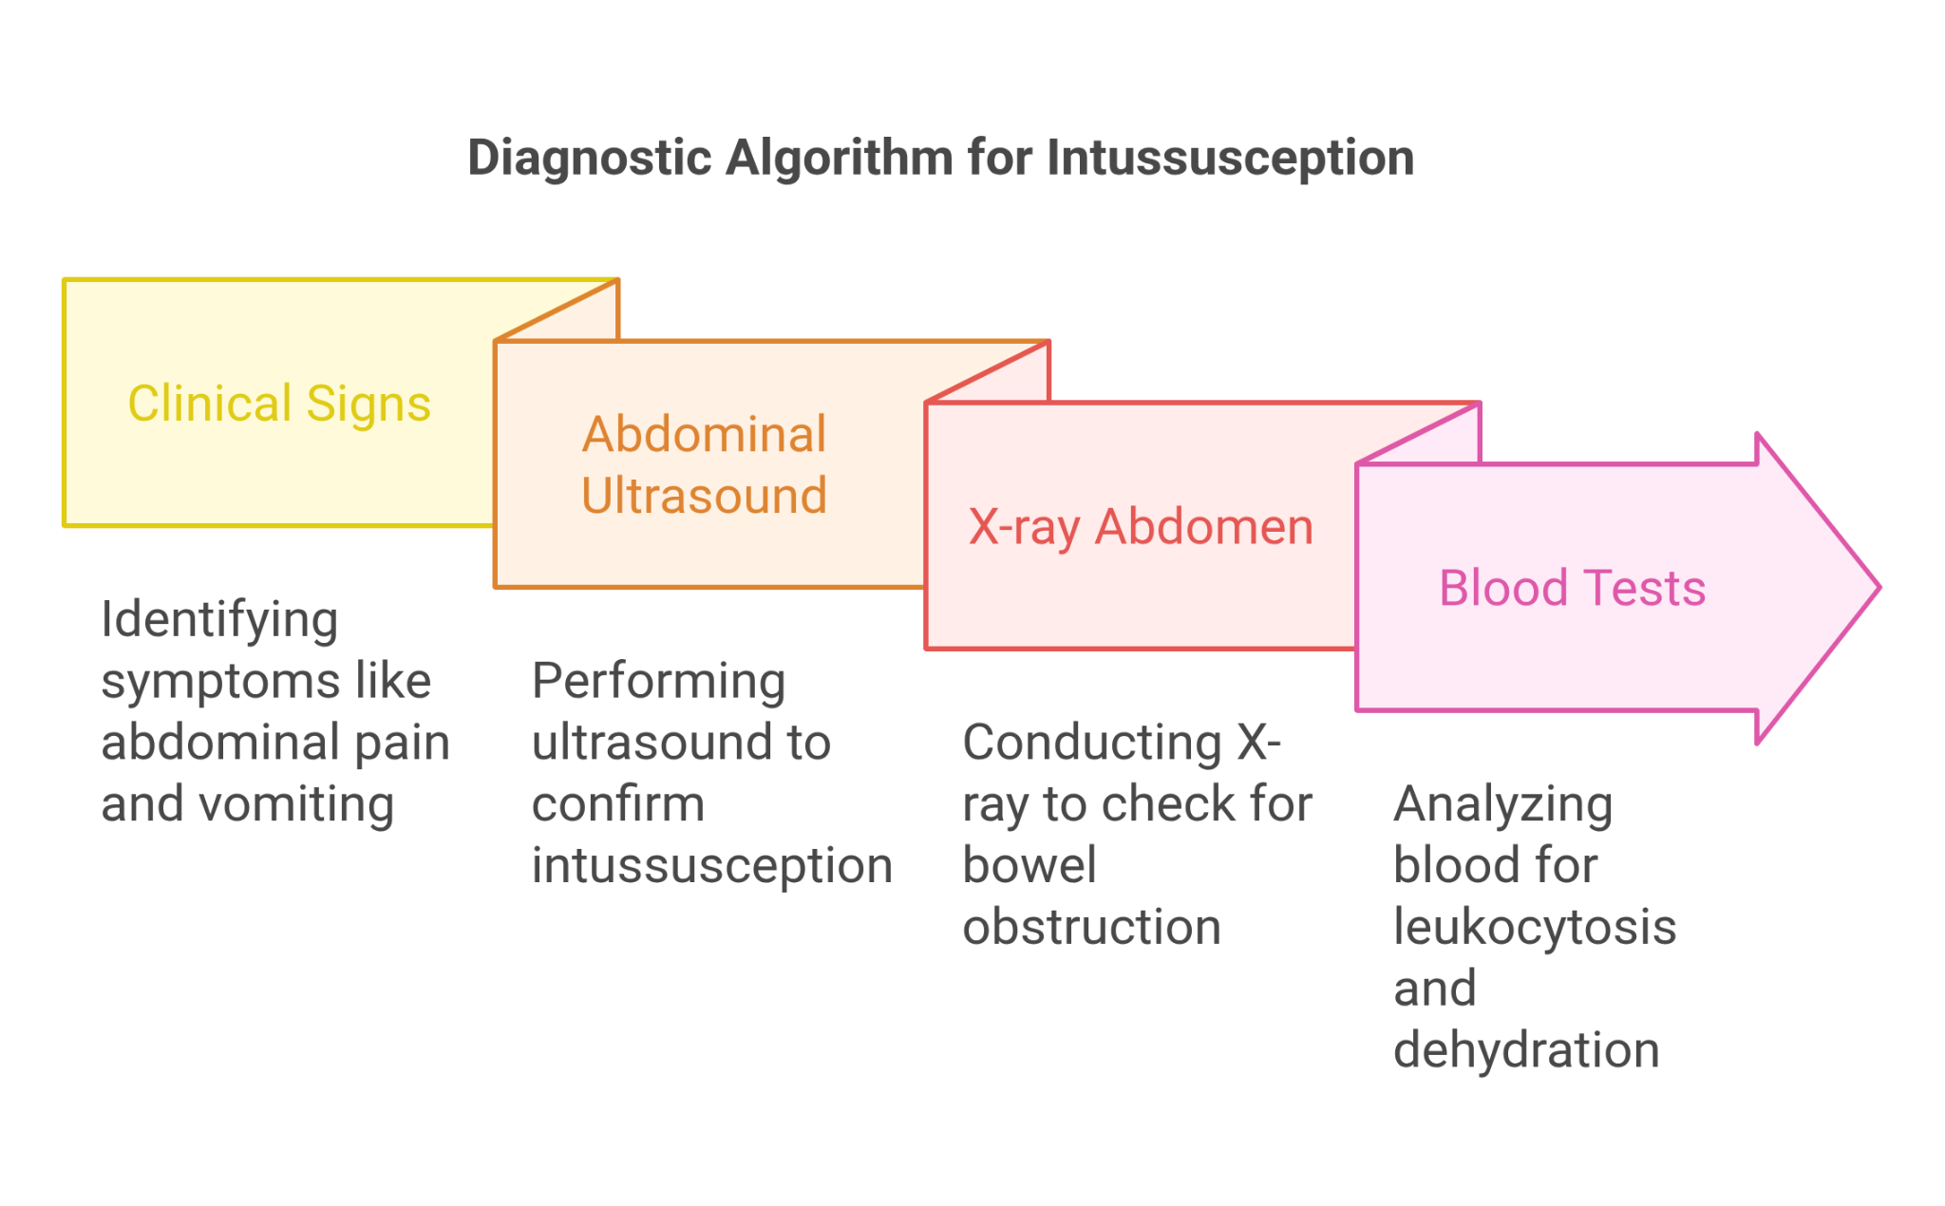

**Differential Diagnosis**

**Gastroenteritis:** Initially suspected due to vomiting and diarrhea but the presence of blood and typical abdominal pain pointed toward a more severe condition.

**Intussusception:** The sudden onset of abdominal pain, bloody diarrhea, and ultrasound findings strongly indicated this diagnosis.

**Appendicitis:** Considered due to the acute abdomen presentation but less likely given the child’s age and ultrasound findings.

**Inflammatory Bowel Disease (IBD):** A potential consideration for bloody diarrhea, but the acute presentation and ultrasound results favored intussusception.

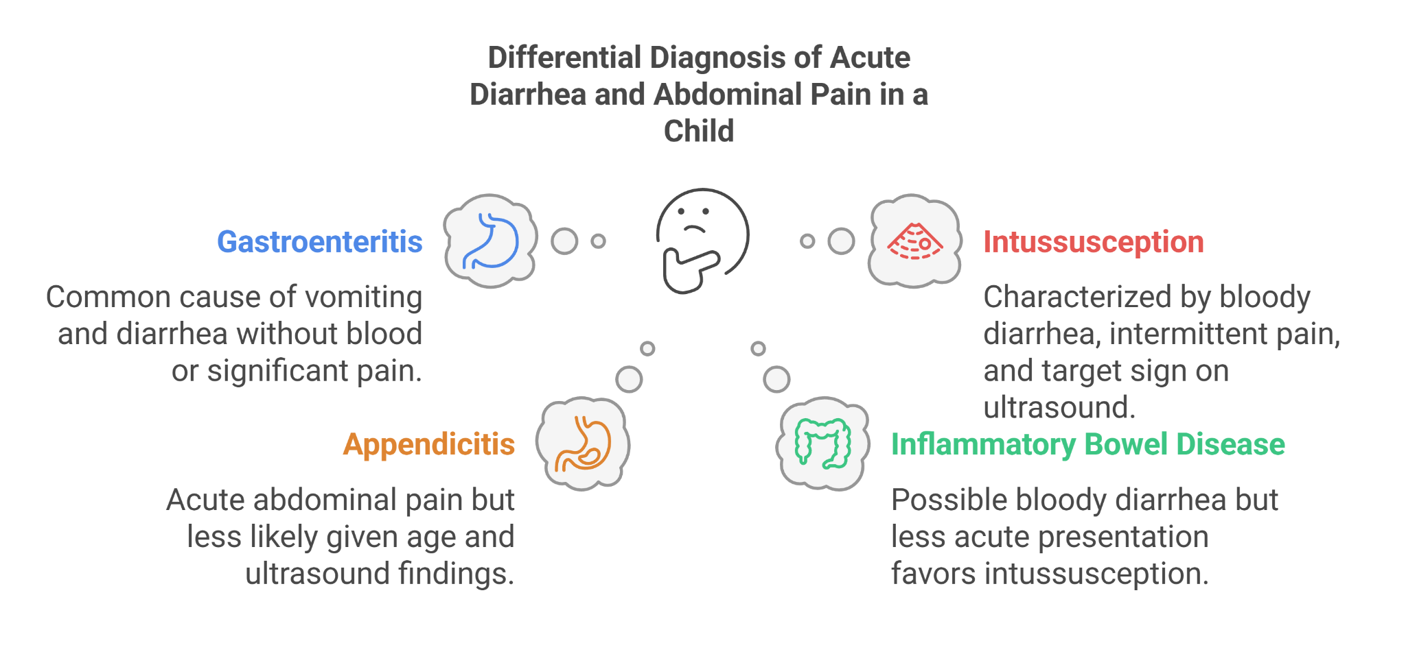

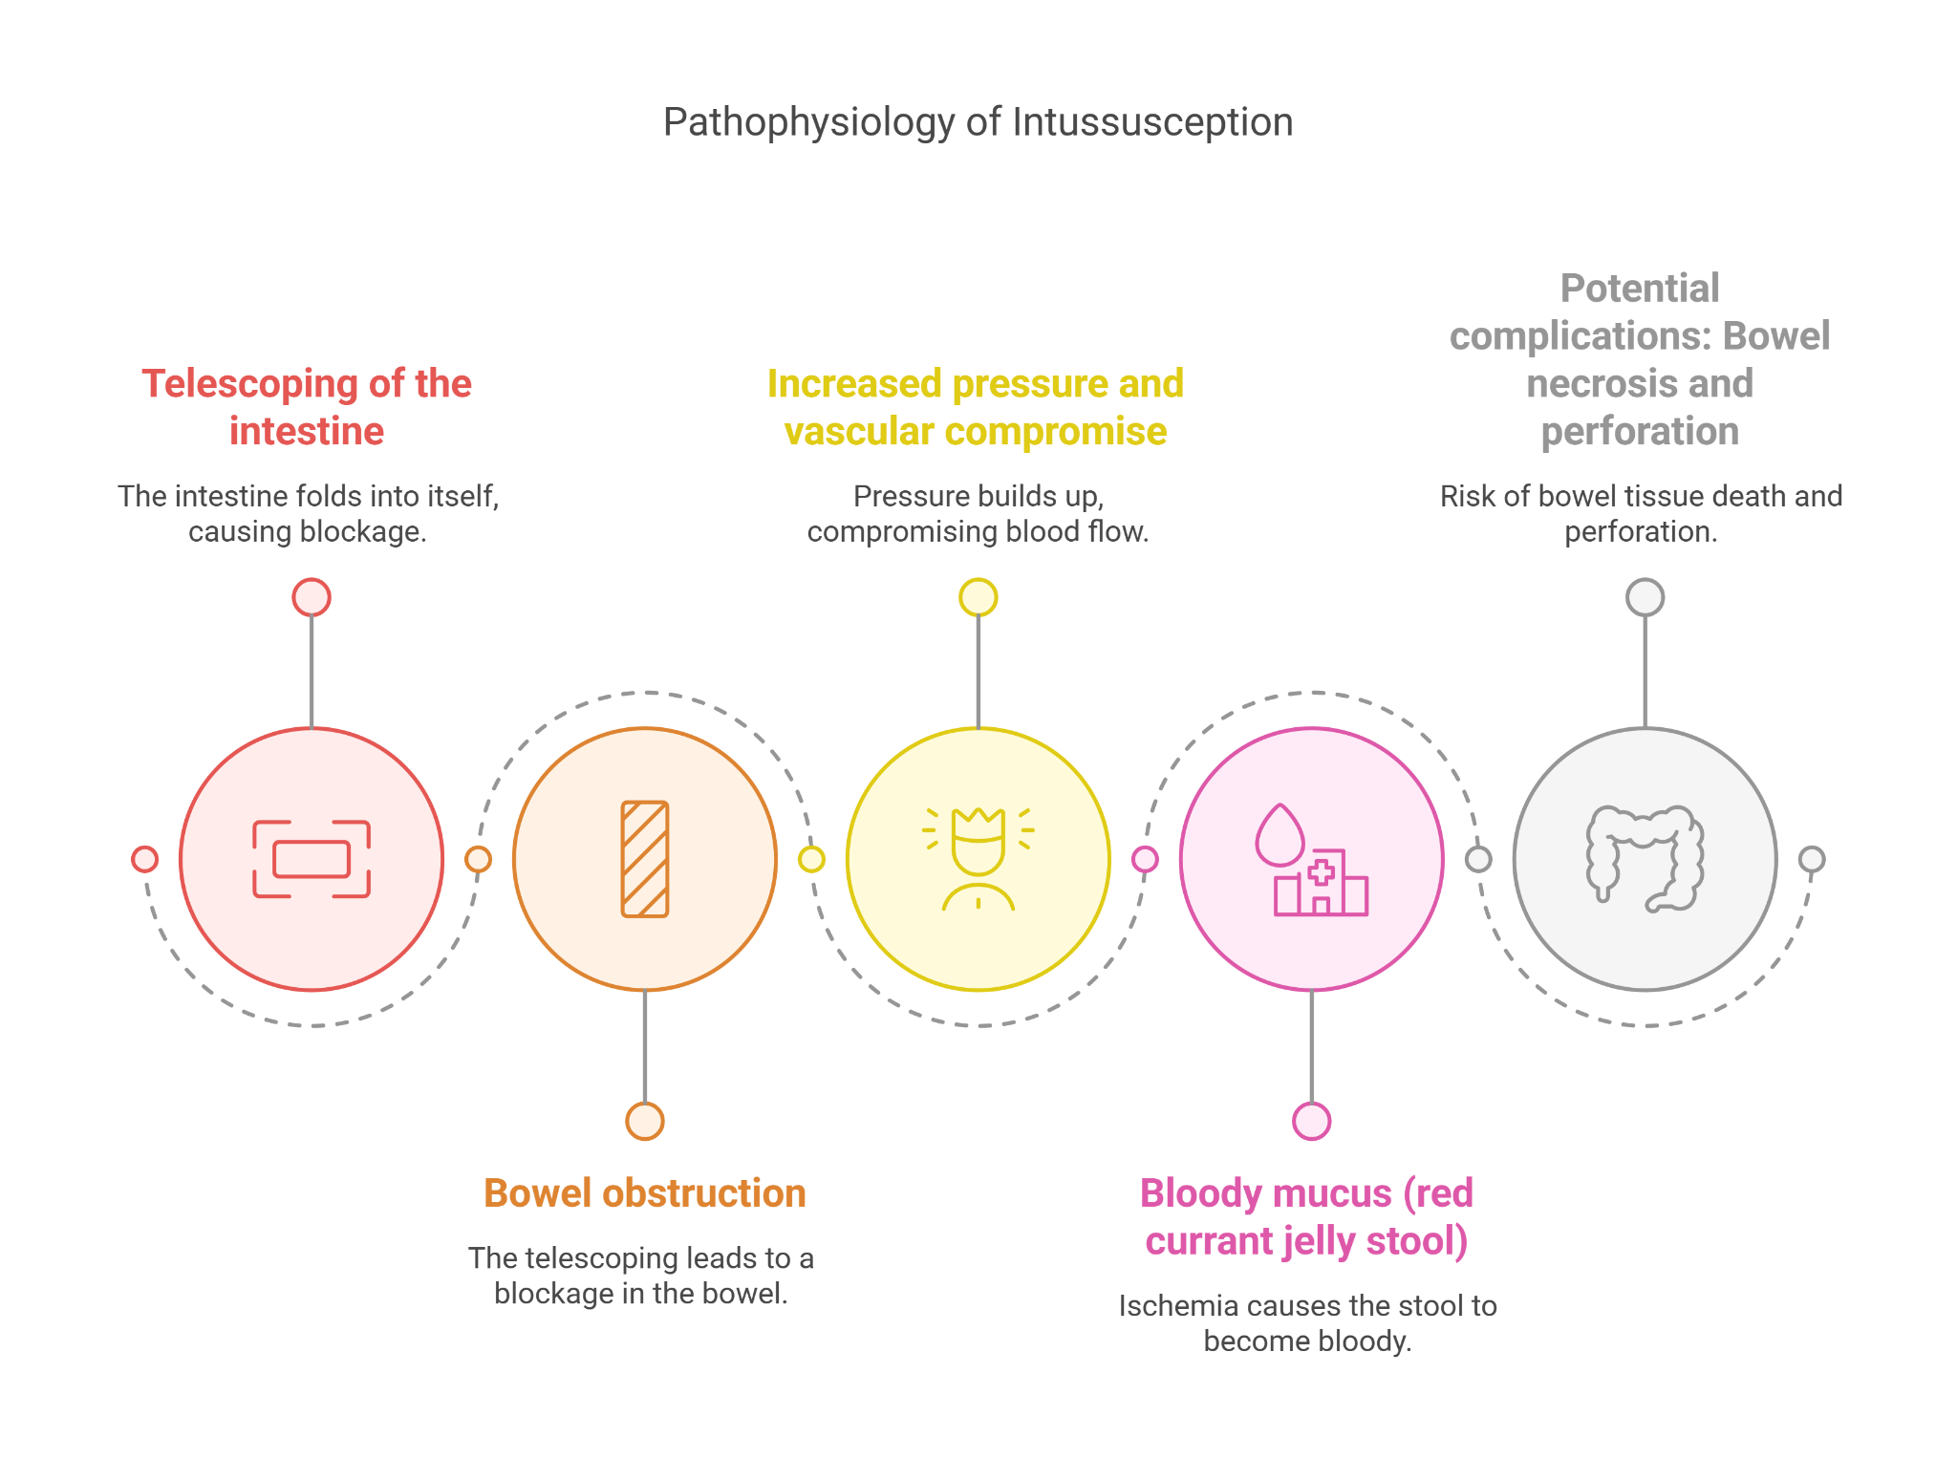

**Final Diagnosis**

Intussusception was confirmed based on clinical presentation and diagnostic imaging, particularly the ultrasound findings.

**Treatment and Management**

Immediate management involved fluid resuscitation to address dehydration and preparation for air enema reduction under fluoroscopic guidance, which successfully reduced the intussusception without the need for surgery. Antibiotic therapy was administered to prevent secondary infections following the procedure.

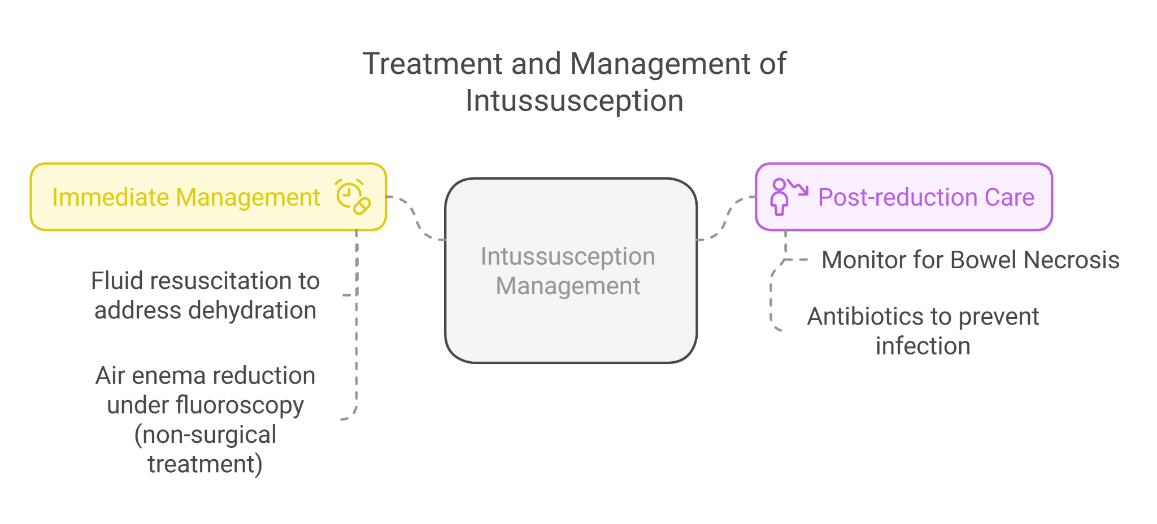

**Follow-Up**

The child was monitored for recurrence of intussusception and signs of bowel necrosis post-reduction. No further episodes were reported, and the child made a complete recovery. Follow-up visits were scheduled to monitor the child’s growth and development and to provide reassurance to the parents.

**Conclusion**

This case underscores the importance of considering intussusception in children presenting with acute diarrhea and abdominal pain. Early diagnosis and prompt intervention are crucial to avoid serious complications such as bowel necrosis and perforation. It highlights the essential role of ultrasound in the diagnosis and the effectiveness of non-surgical reduction techniques, demonstrating successful outcomes in managing intussusception in pediatric patients.