**The Impact of Allergic Rhinitis on Olfactory and Gustatory Function in Children: A Review of Pathophysiology, Diagnosis, and Management**

**Introduction**

Allergic rhinitis (AR) is a common chronic inflammatory condition of the nasal mucosa, driven by an IgE-mediated response to allergens. It affects a significant portion of the pediatric population globally, with estimates ranging from 10-40% depending on the region [1, 2]. In India, studies show a substantial burden of AR [2]. Classic symptoms include nasal congestion, rhinorrhea, sneezing, and pruritus, but the impact on olfaction (smell) and gustation (taste) is often overlooked [3]. Research shows that 20-40% of AR patients experience olfactory dysfunction (hyposmia or anosmia) [4], often leading to secondary taste alterations (hypogeusia or dysgeusia) due to the crucial role of smell in flavor perception [5]. This sensory loss can affect dietary habits, nutritional status, safety (e.g., detecting smoke or spoiled food), and overall quality of life [5, 6]. Proactively addressing these often overlooked symptoms is vital for comprehensive pediatric AR care.

**Pathophysiology**

The mechanisms behind olfactory and gustatory dysfunction in pediatric AR are complex, primarily due to the type 2 inflammatory cascade in the nasal mucosa following allergen exposure [5, 7]. Key factors include:

* **Nasal Obstruction (Conductive Olfactory Loss)**: IgE-mediated mast cell degranulation releases histamine, leukotrienes, and cytokines, causing vasodilation, mucosal edema, and mucus hypersecretion, which obstruct nasal passages and prevent odorants from reaching the olfactory neuroepithelium [5, 7, 8, 9].
* **Inflammatory Mediator Effects (Sensorineural Olfactory Loss)**: Pro-inflammatory mediators (e.g., histamine, TNF-α) and cytokines may alter olfactory receptor neuron function, contributing to dysfunction. Severe nasopharyngeal inflammation may also impact taste perception [7, 10, 5].
* **Epithelial Remodeling and Damage**: Chronic inflammation can lead to goblet cell hyperplasia and damage to the olfactory neuroepithelium, causing persistent olfactory loss [8, 10].
* **Cytokine Involvement**: Type 2 cytokines, particularly IL-4 and IL-13, are key in modulating olfactory function. These cytokines can directly affect olfactory sensory neuron activity and contribute to dysfunction severity, making them potential therapeutic targets [9, 10].

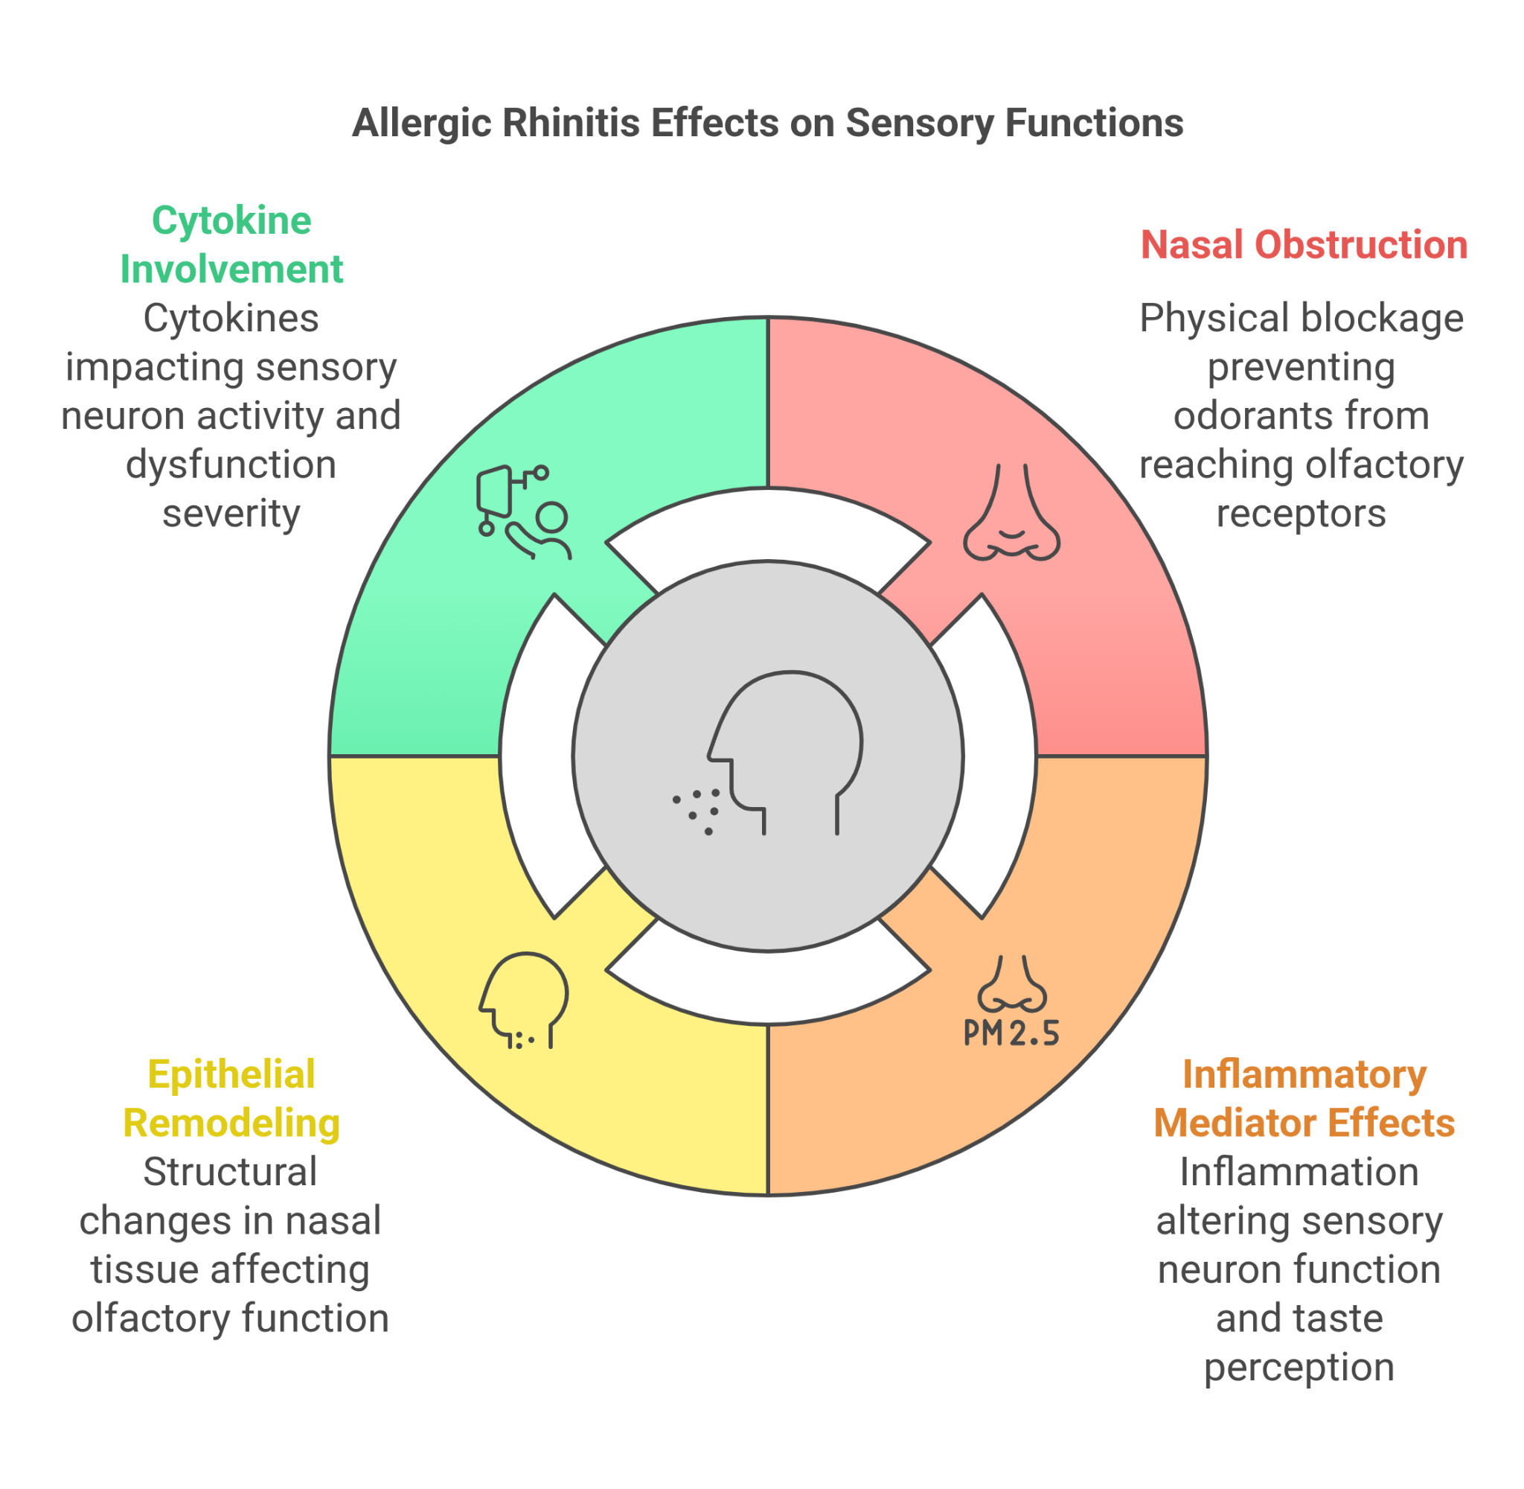

**Clinical Presentation and Diagnosis**

Children with AR-related chemosensory loss may describe smells as "weaker" or food as "bland" [3, 8]. These complaints often occur alongside typical AR symptoms, necessitating a high index of suspicion, especially with persistent or severe nasal issues [9].

**Diagnostic Workup**: A systematic approach includes [11]:

* **Detailed History**: Assess the nature, onset, and severity of sensory changes; allergies/seasonality; full AR symptom profile; impact on eating/safety; history of infections (e.g., post-viral/COVID-19), trauma, and medications [8, 11].
* **Clinical Examination**: Examine nasal congestion, turbinate appearance (pale, boggy), and rhinorrhea; rule out polyps and significant adenoid hypertrophy [11, 14].
* **Objective Chemosensory Testing**:  
  + **Olfactometry**: Use validated tests like "Sniffin' Sticks" or pediatric-adapted UPSIT to quantify olfactory function, feasible for children as young as 5-6 years [10, 12].
  + **Gustatory Testing**: Use standardized taste strips ("Taste Strips") to assess basic taste function, if needed [10].
* **Emerging Technologies**: Research is ongoing on accessible tools like smartphone apps, though standardized validation is essential [13].

**Case Study**

**Patient Overview**:

* A 10-year-old girl with moderate-persistent seasonal allergic rhinitis (AR) presented with parental concerns about poor appetite and complaints of food "tasting boring."
* She also reported difficulty smelling garden flowers.

**Symptoms and Examination**:

* Her AR symptoms persisted despite intermittent antihistamine use.
* Examination revealed significant bilateral inferior turbinate hypertrophy with pale, boggy mucosa.

**Objective Testing**:

* Objective olfactometry using Sniffin' Sticks confirmed moderate hyposmia (TDI score below age norm).
* Basic taste strip testing was normal.

**Treatment Plan**:

* Treatment was optimized following current guidelines [14, 15], which included:
  + Initiating daily intranasal corticosteroid (INCS) spray (mometasone furoate) with education on proper technique.
  + Continuing a daily second-generation oral antihistamine.
  + Recommending saline nasal irrigation.

**Follow-up and Outcome**:

* After four weeks, the patient reported improved nasal breathing, restored flavor perception, and regained the ability to detect odors.
* Repeat olfactometry showed significant improvement.

**Key Takeaways**:

* This case illustrates the link between uncontrolled AR and olfactory loss.
* It also highlights the effectiveness of guideline-based anti-inflammatory therapy in managing AR and related symptoms [14, 16].

**Differential Diagnosis**

While AR is common, other causes of chemosensory loss in children must be excluded [11, 23]:

* **Chronic Rhinosinusitis (CRS):** Persistent sinonasal inflammation, with/without polyps (CRSwNP highly linked to olfactory loss). May have purulent discharge, facial pain [9, 24]. Prevalence estimated around 6-13% in young children [21].
* **Post-Infectious Olfactory Dysfunction (PIOD):** Common after viral URIs, including SARS-CoV-2, often transient but can persist [22, 25]. History is key.
* **Adenoid Hypertrophy:** Common cause of obstruction/mouth breathing in young children [11, 25].
* **Other Causes:** Head trauma, congenital anosmia (rare), structural issues, toxins, medications, neurological conditions [23,25]..

Thorough history, exam (±endoscopy), and sometimes imaging help differentiate [11, 24].

**Management Strategies**

Management focuses on controlling inflammation and obstruction [11, 14]. A stepwise approach, guided by ARIA guidelines, is recommended.

**Non-Pharmacologic Measures**:

* **Environmental Control & Allergen Avoidance**: Crucial first step based on identified triggers [11, 14, 15].
* **Saline Nasal Irrigation**: Regular use helps clear secretions and allergens, enhancing medication efficacy [14, 20].
* **Patient/Caregiver Education**: Essential for adherence and proper technique [11].

**Pharmacologic Approaches**:

* **Antihistamines**: Oral second-gen agents for itch/sneeze/runny nose; intranasal for rapid relief of some congestion [15]. Limited impact on established olfactory loss.
* **Intranasal Corticosteroids (INCS)**: First-line for persistent/moderate-severe AR, reducing inflammation and improving nasal patency. INCS show significant improvement in nasal symptoms [16], though further evidence is needed for consistent improvement in olfactory function [17]. Examples: fluticasone, mometasone, budesonide. Combination INCS/antihistamine sprays are available [15].
* **Adjunctive Therapies**:
* **LTRAs**: Montelukast, especially in cases with asthma [15].
* **Decongestants**: Provide temporary relief; limit topical use to 3-5 days [14, 15].
* **Oral Corticosteroids**: Short courses for severe flares only [11].
* **Intranasal Cromolyn/Ipratropium**: Less common options [15].

| **Non-Pharmacologic Measures** | **Pharmacologic Approaches** |
| --- | --- |
| Environmental Control & Allergen Avoidance: Crucial first step based on identified triggers [11, 14, 15]. | Antihistamines: Oral second-generation agents help manage itch, sneezing, and runny nose; intranasal agents offer rapid relief from congestion [15]. |
| Saline Nasal Irrigation: Helps clear secretions and allergens, improving medication efficacy [14, 20]. | Intranasal Corticosteroids (INCS): First-line for persistent/moderate-severe AR; reduces inflammation and nasal obstruction. Examples: fluticasone, mometasone, budesonide [1, 15]. |
| Patient Education: Essential for adherence and proper technique [11]. | Adjunctive Therapies: Montelukast (for asthma), decongestants (short-term relief), oral corticosteroids (for flare-ups) [15]. |

**Emerging Treatments**:

* **Biologic Therapies**: Anti-IgE (omalizumab) or anti-IL-4/IL-13 (dupilumab) for severe, refractory type 2 inflammation show promise for both nasal symptoms and olfaction [10, 18].
* **Allergen Immunotherapy (AIT)**: SCIT/SLIT modifies the allergic response long-term, potentially improving symptoms and nasal patency [15, 19], requiring allergist evaluation.

**Conclusion and Clinical Recommendations**

Impaired smell and taste are significant, under-recognized comorbidities of pediatric AR, impacting quality of life, nutrition, and safety [5, 6]. Routine inquiry about chemosensory symptoms is warranted, especially with persistent nasal complaints. Diagnosis involves clinical assessment, possibly aided by objective testing. Guideline-based management focusing on allergen control and consistent anti-inflammatory therapy (primarily INCS) is crucial [1, 14, 15]. Integrating smell/taste assessment into routine AR care facilitates earlier detection and targeted management, improving overall well-being. Consulting the latest guidelines and research is essential.

**References**

###### Brożek Prevalence and risk factors associated with allergic rhinitis in Mexican school children: Global Asthma Network Phase I,World Allergy Organization Journal,Volume 14, Issue 1,2021,100492,ISSN1939-4551,<https://doi.org/10.1016/j.waojou.2020.100492.(https://www.sciencedirect.com/science/article/pii/S1939455120303951)>

###### Patil P, Yadav T. To Study the Correlation Between Allergic Rhinitis and Respiratory Endurance in Children. J Ecophysiol Occup Health. 2024;24(1):105–109.

###### Schlosser RJ, et al. Rhinitis symptoms and quality of life... *Int Forum Allergy Rhinol*. 2012;2(5):363-368.

##### Stuck BA, Hummel T. Olfaction in allergic rhinitis: A systematic review. J Allergy Clin Immunol. 2015 Dec;136(6):1460-1470. doi: 10.1016/j.jaci.2015.08.003. Epub 2015 Sep

##### 26. PMID: 26409662,<https://www.worldallergyorganizationjournal.org/article/S1939-4551(23)00084-4/fulltext#:~:text=Allergic%2520rhinitis%2520is%2520a%2520significant%2520public%2520health,in%2520adults%2520and%2520over%252040%25%2520in%2520children.&text=Globally%252C%2520allergic%2520rhinitis%2520affects%2520more%2520than%2520400,among%2520adults%2520and%2520over%252040%25%2520among%2520children>.

1. Remedy Publications LLC. Allergic Rhinitis: Impact on Quality of Life. 2024. Available at: [Insert URL from search result - <https://www.remedypublications.com/open-access/allergic-rhinitis-impact-on-quality-of-life-10136.pdf>].
2. Allergic rhinitis: MedlinePlus Medical Encyclopedia. (n.d.). https://medlineplus.gov/ency/article/000813.htm
3. Small P, Keith PK, Kim H. Allergic rhinitis. *Allergy Asthma Clin Immunol*. 2018;14(Suppl 2):51.
4. Scadding GK, Kariyawasam HH, Scadding G, et al. BSACI guideline for the diagnosis and management of allergic and non-allergic rhinitis (Revised Edition2 2017...). *Clin Exp Allergy*. 2017;47(7):856-889.3
5. Ordovas-Montanes J, et al. The interleukin-4/interleukin-13 pathway in type 2 immunity. *Front Immunol*. 2024;15:1356298.
6. Doty RL, Tourbier IA. Olfactory dysfunction in chronic rhinosinusitis. *Laryngoscope Investig Otolaryngol*. 2019;4(2):281-288.
7. Dykewicz MS, Wallace DV, Tilles S, et al. Drug Allergy: A 2022 Practice Parameter Update. *J Allergy Clin Immunol*. 2022;150(5):1018-1093.
8. Hugh SC, et al. Olfactory testing in children using objective tools: Comparison of Sniffin' Sticks and University of Pennsylvania Smell Identification Test (UPSIT).4 *J Otolaryngol Head Neck Surg*.52015;44:10. OR Schriever VA, et al. The “Sniffin' Kids” Test - A 14-Item Odor Identification Test for Children. *PLoS One*. 2014;9(6):e99363.
9. Sousa-Pinto B, Anto A, Berger M, Dramburg S, Pfaar O, Klimek L, Jutel M, Czarlewski W, Bedbrook A, Valiulis A, Agache I, Amaral R, Ansotegui IJ, Bastl K, Berger U, Bergmann KC, Bosnic-Anticevich S, Braido F, Brussino L, Cardona V, Casale T, Canonica GW, Cecchi L, Charpin D, Chivato T, Chu DK, Cingi C, Costa EM, Cruz AA, Devillier P, Durham SR, Ebisawa M, Fiocchi A, Fokkens WJ, Gemicioğlu B, Gotua M, Guzmán MA, Haahtela T, Ivancevich JC, Kuna P, Kaidashev I, Khaitov M, Kvedariene V, Larenas-Linnemann DE, Lipworth B, Laune D, Matricardi PM, Morais-Almeida M, Mullol J, Naclerio R, Neffen H, Nekam K, Niedoszytko M, Okamoto Y, Papadopoulos NG, Park HS, Passalacqua G, Patella V, Pelosi S, Pham-Thi N, Popov TA, Regateiro FS, Reitsma S, Rodriguez-Gonzales M, Rosario N, Rouadi PW, Samolinski B, Sá-Sousa A, Sastre J, Sheikh A, Ulrik CS, Taborda-Barata L, Todo-Bom A, Tomazic PV, Toppila-Salmi S, Tripodi S, Tsiligianni I, Valovirta E, Ventura MT, Valero AA, Vieira RJ, Wallace D, Waserman S, Williams S, Yorgancioglu A, Zhang L, Zidarn M, Zuberbier J, Olze H, Antó JM, Zuberbier T, Fonseca JA, Bousquet J. Real-world data using mHealth apps in rhinitis, rhinosinusitis and their multimorbidities. Clin Transl Allergy. 2022 Nov;12(11):e12208. doi: 10.1002/clt2.12208. PMID: 36434742; PMCID: PMC9673175.
10. Brożek JL, et al. Allergic Rhinitis and its Impact on Asthma (ARIA) Guidelines-2016 Revision. *J Allergy Clin Immunol*. 2017;140(4):950-958.6
11. Wallace DV, Dykewicz MS, Oppenheimer J, et al. Pharmacologic Treatment of Seasonal Allergic Rhinitis: Synopsis of Guidance From the 2017 Joint Task Force on Practice7 Parameters. *Ann Intern Med*. 2017;167(12):876-881.8
12. Charoenngam N, et al. Comparative efficacy and acceptability of licensed dose intranasal corticosteroids for moderate-to-severe allergic rhinitis: a systematic review and network meta-analysis. *Front Pharmacol*. 2023;14:1184552.9 OR Wang Y, et al. Nasal saline or intranasal corticosteroids to treat allergic rhinitis in children. *J Pediatr Pharmacol Ther*. 2016;21(3):244-51.
13. Hoang, M., Chitsuthipakorn, W., Seresirikachorn, K., & Snidvongs, K. (2022). As-needed intranasal corticosteroid spray for allergic rhinitis: a systematic review and meta-analysis. *Rhinology Journal*, *0*(0), 0. https://doi.org/10.4193/rhin21.355
14. Casale TB, Canonica GW, Mullol J, et al. Recommendations for the Management of Severe Allergic Rhinitis: A GEMA/ARIA Perspective. *J Allergy Clin Immunol Pract*. 2020;8(6):1821-1831.e2.
15. Dhami S, Nurmatov U, Arasi S, et al. Allergen immunotherapy for allergic rhinoconjunctivitis: A systematic review and meta-analysis. *Allergy*. 2017;72(11):1597-1631.10
16. Head K, Snidvongs K, Glew S, et al. Saline irrigation for allergic rhinitis. *Cochrane Database Syst Rev*. 2018;6(6):CD012597.
17. Rudmik L, Soler ZM. Medical Management of Chronic Rhinosinusitis. *Med Clin North Am*. 2015;99(1):169-84.
18. Martel MJ, et al. Olfactory Dysfunction in Children: A Scoping Review. *Ear Nose Throat J*. 2023 Jul 14:1455613231187993.
19. Boesveldt S, Postma EM, Boak D, et al. Anosmia-A Clinical Review. *Chem Senses*. 2017;42(7):513-523.
20. Fokkens WJ, Lund VJ, Hopkins C, et al. European Position Paper on Rhinosinusitis and Nasal Polyps 2020. *Rhinology*. 2020;58(Suppl S29):1-464.11
21. Pinto JM, et al. Olfactory and Gustatory Dysfunction in COVID-19: An Update. *Curr Treat Options Allergy*. 2023;10(2):149-166