**Case Study: Post-Viral Persistent Dry Cough in a 7-Year-Old Child: A Focus on Growth, Development, and Management**

### **Introduction**

Respiratory illnesses are common in children and can significantly impact their growth, development, and quality of life. Post-viral cough is a frequent sequela following upper respiratory infections, often causing parental anxiety. This case study highlights the clinical presentation, diagnostic process, and management strategies for a 7-year-old child with a persistent dry cough.

### **Background**

Aarav, a healthy 7-year-old boy with normal growth and development, presented with a persistent dry cough following an upper respiratory infection. He has no significant medical history and is fully immunized. While his initial symptoms, including fever and nasal congestion, resolved within a week, the dry cough persisted, causing concern. Aarav lives in an urban area with occasional exposure to air pollution and passive smoking, which warranted further evaluation to rule out underlying conditions and ensure his well-being.

### **Presenting Symptoms**

* Persistent dry cough for 2 weeks.
* Initial symptoms included fever, nasal congestion, and sore throat that resolved within a week.
* No wheezing, difficulty in breathing, or fever recurrence.
* Normal appetite and energy levels but occasional nighttime coughing.

### **Investigations**

1. **Chest X-ray:** Normal; no signs of consolidation or pneumothorax.
2. **Complete Blood Count:** Mild lymphocytosis suggestive of recent viral infection.
3. **C-Reactive Protein (CRP):** Within normal range, indicating no active bacterial infection.
4. **Pulmonary Function Test (PFT):** Normal spirometry results.
5. **Allergy Testing:** Negative for common environmental allergens.

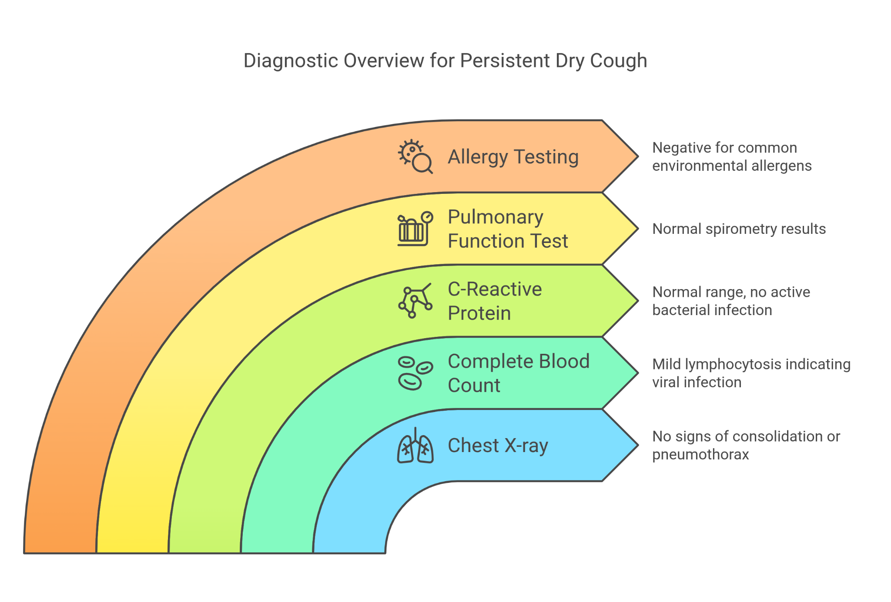

### 

### **Differential Diagnosis**

1. **Asthma:** Ruled out due to the absence of wheezing, episodic nature, and normal PFT results.
2. **Pertussis (Whooping Cough):** Ruled out based on vaccination history and lack of characteristic "whooping" sound.
3. **Allergic Rhinitis with Postnasal Drip:** Ruled out due to negative allergy testing and absence of nasal symptoms during the persistent cough phase.
4. **Post-Viral Cough:** Final diagnosis supported by recent viral infection, dry cough lasting more than a week, and absence of other pathological findings.

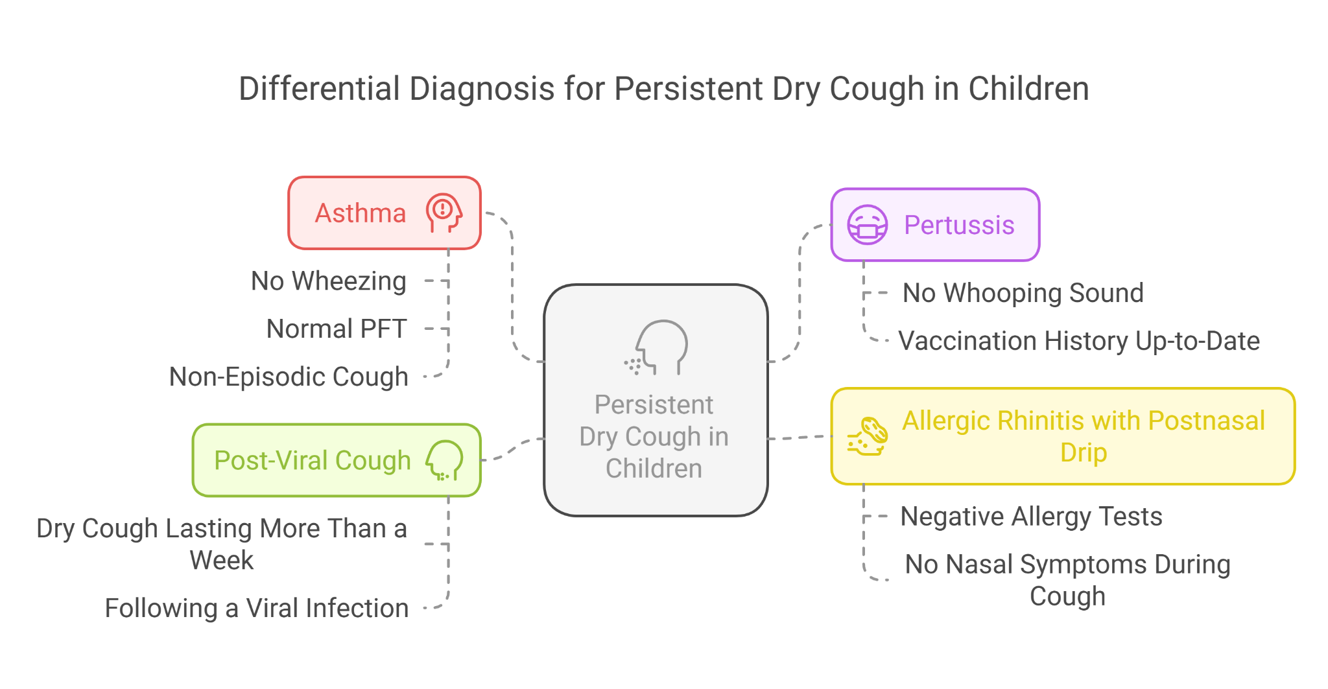

### **Final Diagnosis**

**Post-Viral Persistent Dry Cough**

### **Treatment and Management**

1. **Reassurance to Parents:** Educating the family about the benign nature of the condition and its self-limiting course.
2. **Symptom Relief:**
   * **Hydration:** Encouraging fluid intake to soothe throat irritation.
   * **Honey:** Administering honey (in children older than 1 year) to reduce nighttime cough episodes.
3. **Avoidance Measures:** Limiting exposure to environmental irritants such as air pollution and passive smoking.
4. **Growth and Development Monitoring:** Regular assessments to ensure that the child's cough does not impact nutrition, physical activity, or psychosocial well-being.

### **Follow-Up**

* **Two Weeks Later:** Cough significantly reduced; no new symptoms reported. Normal growth and activity levels.
* **Four Weeks Later:** Complete resolution of symptoms. No recurrence reported. Continued monitoring of weight, height, and developmental milestones..

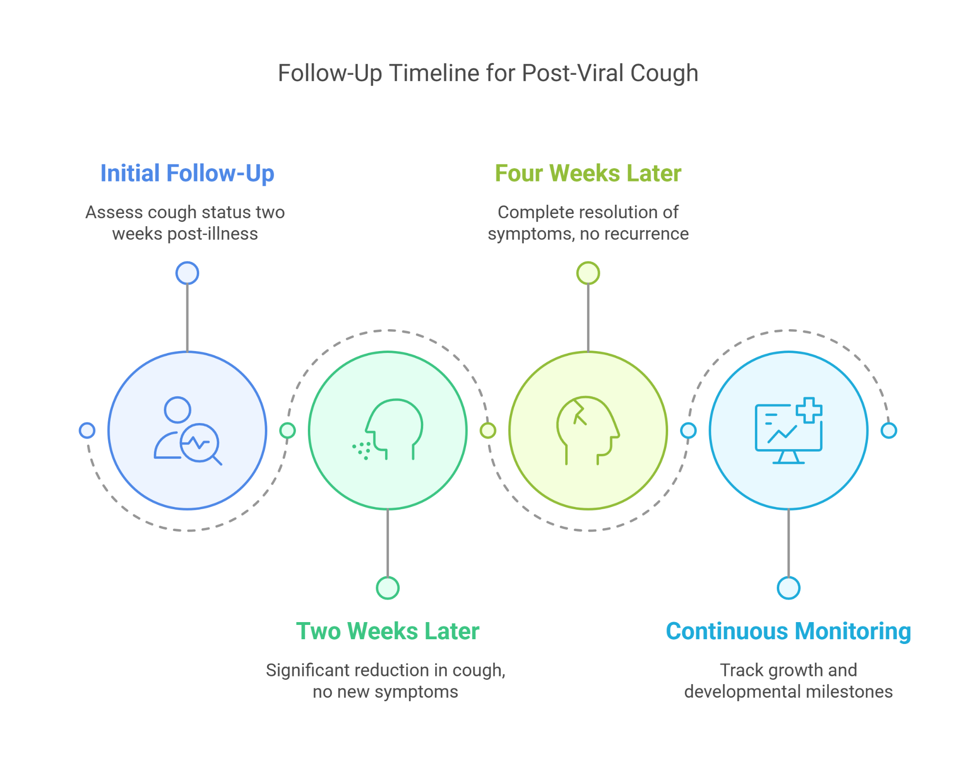

### **Conclusion**

Post-viral cough is a common yet benign condition in pediatric practice. It requires a thoughtful approach to diagnosis, emphasizing the exclusion of other causes and reassuring the caregivers. Aarav’s case illustrates the importance of considering growth and development during the management of persistent respiratory symptoms. Long-term follow-up is essential to ensure the child’s health and well-being are not compromised.

**Case Study: A 4-Year-Old with Nocturnal Dry Cough and Eczema: Considering Protracted Bacterial Bronchitis (PBB) as a Differential Diagnosis**

### **Introduction**

Chronic cough in young children can have various underlying causes, ranging from allergic conditions like asthma to persistent bacterial infections such as protracted bacterial bronchitis (PBB). Early differentiation between these conditions is essential for appropriate management. This case study discusses a 4-year-old presenting with a persistent nocturnal dry cough and a history of eczema, exploring the possibility of PBB as a diagnosis.

### **Background**

Diya, a 4-year-old girl, presented with a persistent dry cough, predominantly at night, over the past two weeks. She has a history of eczema diagnosed at the age of two, managed with topical treatments. Her growth and developmental milestones are age-appropriate, and her immunizations are up to date. Diya lives in a semi-urban setting with occasional exposure to environmental allergens such as dust and pollen. She has no prior history of wheezing or respiratory distress but has recently been waking up at night due to coughing, causing parental concern and disruption of her daily routine.

### **Presenting Symptoms**

* Persistent dry cough, mainly nocturnal, for two weeks.
* No associated fever, nasal congestion, or sore throat.
* Disturbed sleep due to frequent coughing episodes at night.
* Mild chest tightness reported during play but no significant limitation of activities.

### **Investigations**

* **Chest X-ray:** Normal; no signs of infection or structural abnormalities.
* **Spirometry:** Normal peak expiratory flow rate, ruling out significant airway obstruction.
* **Skin Prick Test:** Positive for house dust mites and pollen allergens.
* **Total IgE Levels:** Elevated, consistent with atopy.
* **Induced Sputum Culture (if available):** Pending; potential detection of *Moraxella catarrhalis, Haemophilus influenzae*, or *Streptococcus pneumoniae*.
* **Oxygen Saturation:** Normal at rest and during exertion.

### **Differential Diagnosis**

* **Asthma:** Initially suspected due to nocturnal cough and atopy, but spirometry findings are normal, and no prior wheezing episodes have been noted.
* **Upper Airway Cough Syndrome (Postnasal Drip):** Ruled out due to the absence of nasal symptoms or throat clearing.
* **Gastroesophageal Reflux Disease (GERD):** Unlikely as there were no symptoms of regurgitation, heartburn, or feeding difficulties.
* **Viral Bronchiolitis:** Ruled out due to the chronic nature of symptoms and absence of fever or acute respiratory distress.
* **Protracted Bacterial Bronchitis (PBB):** Final diagnosis based on persistent cough, absence of viral symptoms, history of atopy, and potential presence of bacterial colonization.

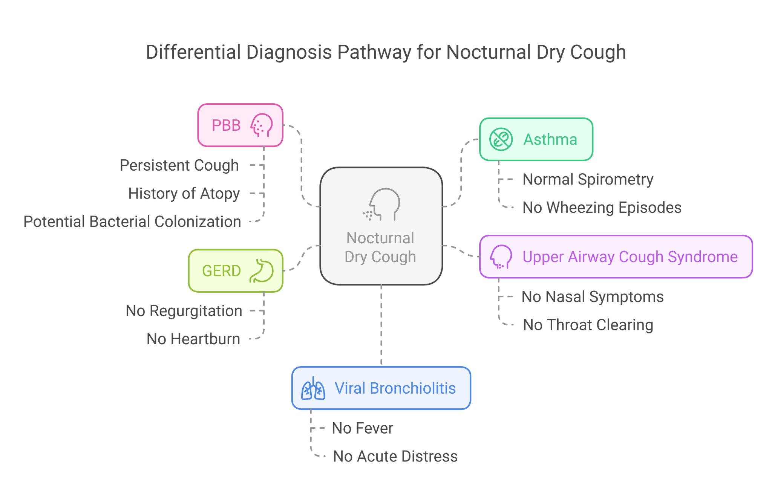

### **Final Diagnosis**

**Protracted Bacterial Bronchitis (PBB) with an Atopic Background**

### **Treatment and Management**

#### **Pharmacological Management:**

* **Antibiotic Therapy:** Amoxicillin-clavulanate for two weeks to target bacterial colonization.
* **Antihistamines:** For controlling allergic symptoms related to environmental triggers.
* **Bronchodilators:** Trial of short-acting beta-agonists (SABA) if transient airway hyperresponsiveness is suspected.

#### **Environmental Modifications:**

* Dust mite control measures (e.g., using allergen-proof mattress covers, frequent cleaning).
* Reducing exposure to pollen and other identified allergens.

#### **Airway Clearance Support:**

* Ensuring adequate hydration.
* Encouraging nasal saline irrigation to minimize postnasal drip.
* Physiotherapy techniques such as postural drainage if a wet cough develops.

#### **Growth and Development Monitoring:**

* Regular assessments of height, weight, and developmental milestones to ensure that symptoms and their treatment do not impact overall well-being.
* Support for participation in age-appropriate physical activities with proper symptom control.

#### **Parent Education:**

* Understanding the importance of completing the antibiotic course.
* Recognizing signs that suggest a worsening condition, such as persistent symptoms beyond antibiotic therapy or increased coughing with sputum production.

### **Follow-Up**

* **Two Weeks Later:** Significant improvement in nocturnal cough; better sleep quality. Parents report ease in managing symptoms with prescribed medication.
* **One Month Later:** Complete resolution of nighttime symptoms, and Diya is active and engaging in play without difficulty. Height and weight continue to track along normal percentiles.
* **Three Months Later:** Regular follow-up to assess for recurrent symptoms. If repeated episodes occur, further workup, including flexible bronchoscopy, may be considered to rule out underlying conditions such as persistent bacterial colonization or airway anomalies.

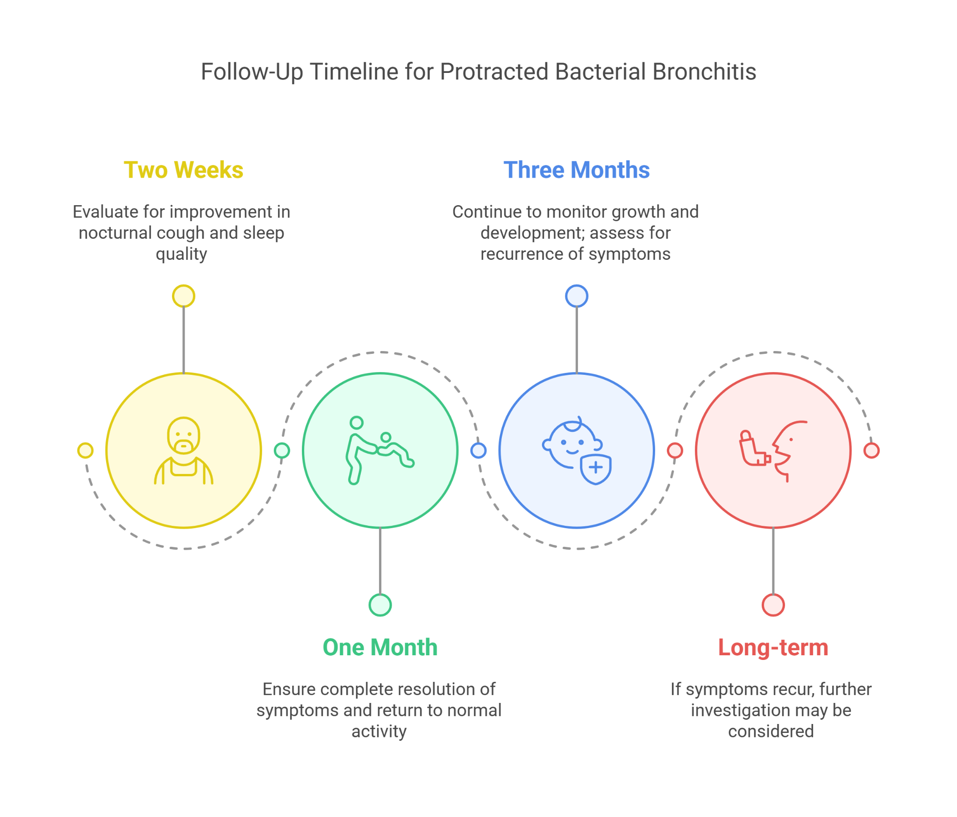

### **Conclusion**

This case highlights the importance of considering protracted bacterial bronchitis (PBB) in children presenting with persistent cough, especially when atopic features are present. While asthma remains a common diagnosis, misattributing chronic cough to asthma without trialing antibiotic therapy may lead to prolonged symptoms. Early recognition and targeted treatment of PBB can prevent unnecessary long-term steroid use and ensure optimal respiratory health outcomes in pediatric patients.