### **Case Study: Managing Early Signs similar to Type 2 Diabetes and Chromium Deficiency in a Pediatric Patient**

#### **Introduction**

This case study examines the rare but significant issue of chromium deficiency in a pediatric patient presenting with early signs similar to type 2 diabetes, highlighting the role of micronutrients in glucose regulation.

#### **Background**

Chromium is an essential trace mineral that enhances the action of insulin and is crucial for maintaining normal glucose metabolism. Deficiency can exacerbate or even mimic the symptoms of type 2 diabetes, particularly in children who are already at risk due to other factors such as obesity or family history.

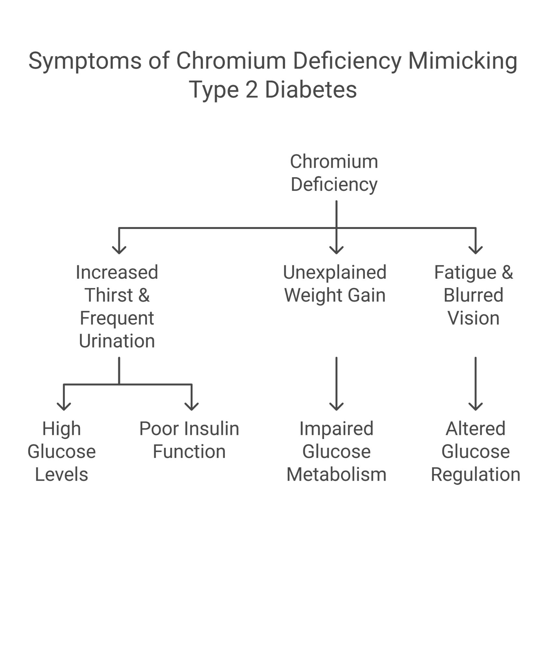

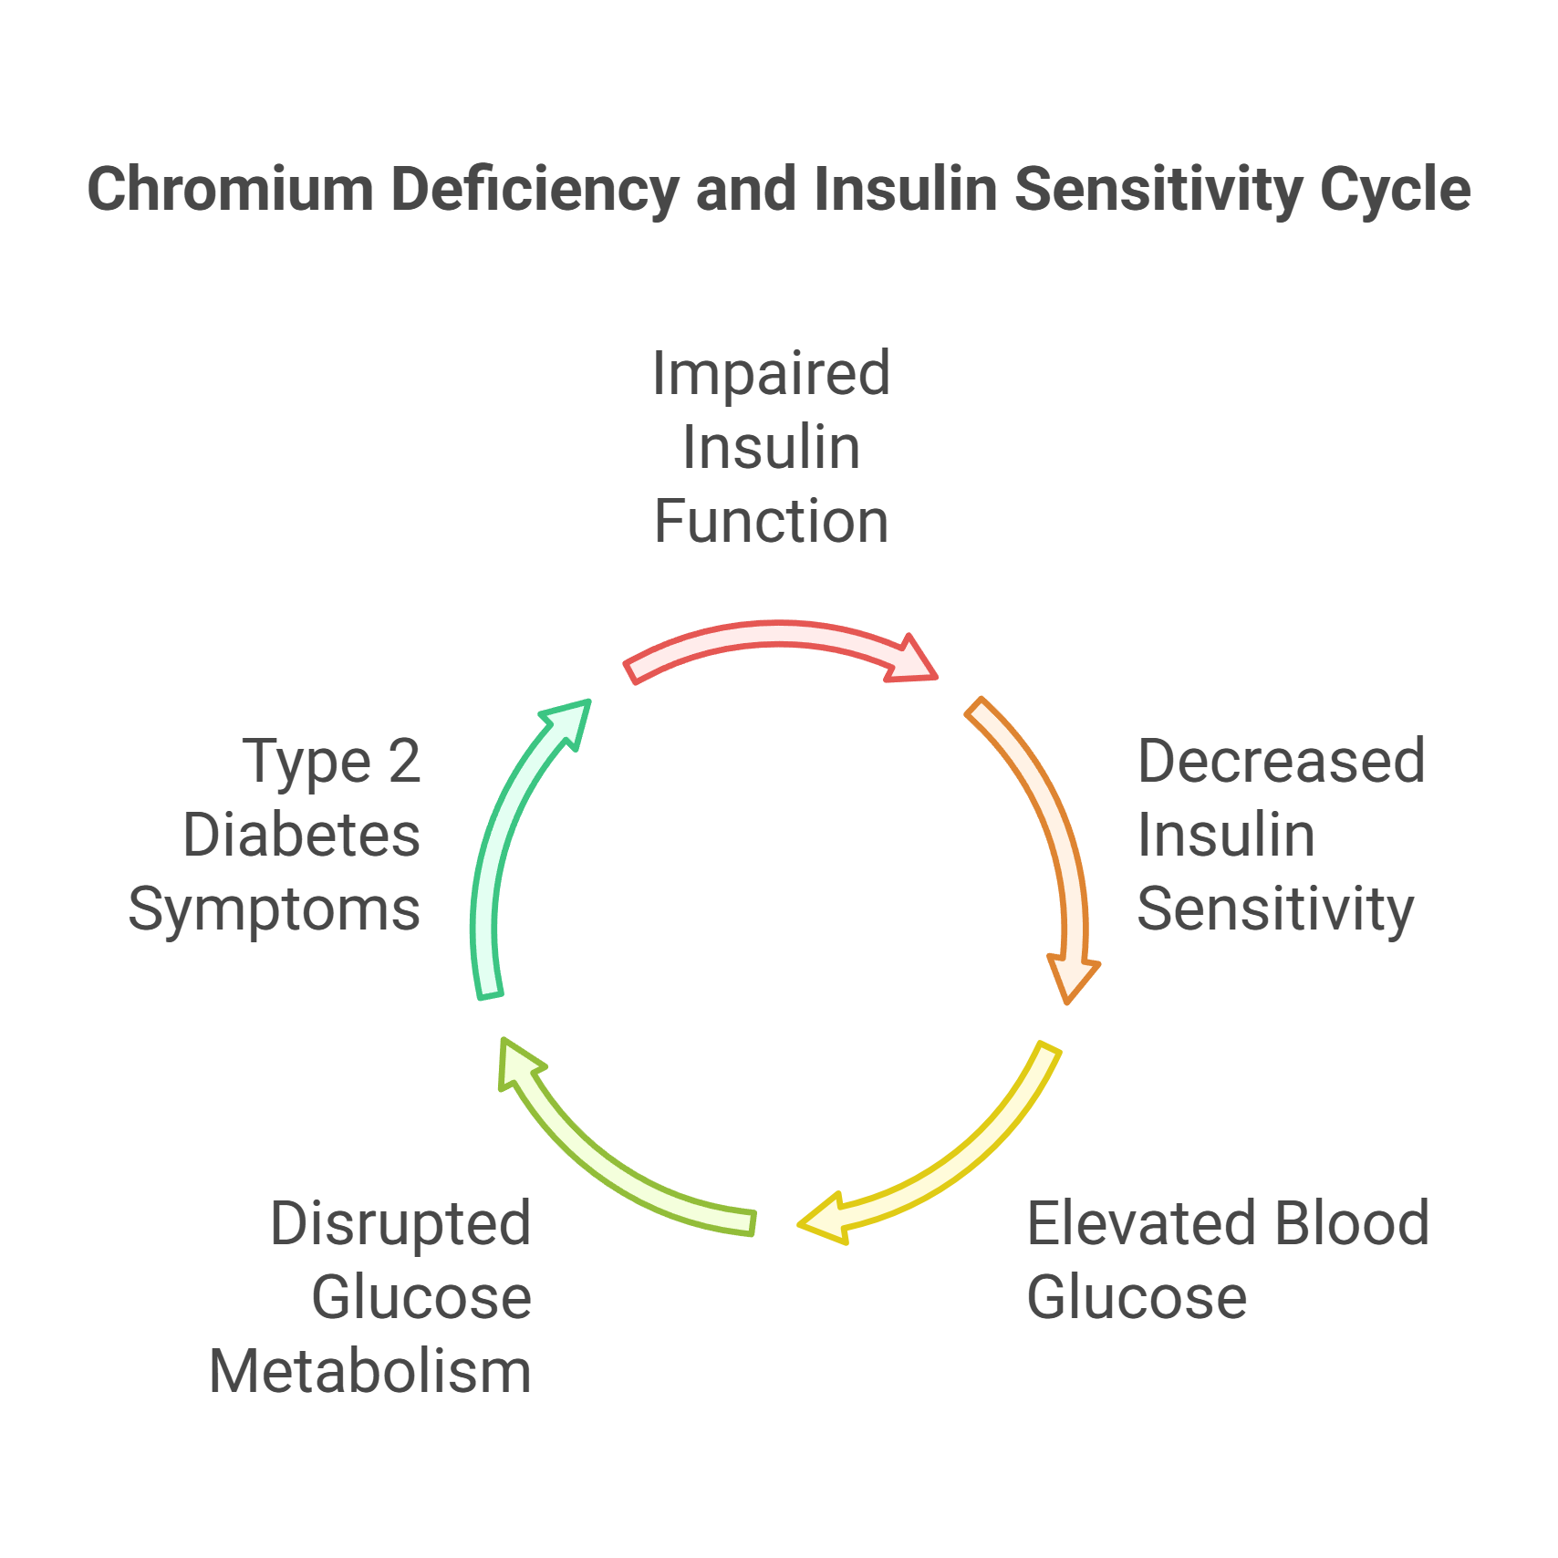

#### **Presenting Symptoms**

Kabir, a 10-year-old boy, presented with:

* Increased thirst and frequent urination.
* Unexplained weight gain despite normal eating habits.
* Fatigue and blurred vision.

#### **Investigations**

* **Fasting Blood Glucose Test**: Showed elevated glucose levels.
* **HbA1c Test**: Indicated poor glucose control over the last three months.
* **Serum Chromium Levels**: Significantly lower than normal, suggesting a deficiency.
* **Dietary Review**: Revealed insufficient intake of chromium-rich foods.

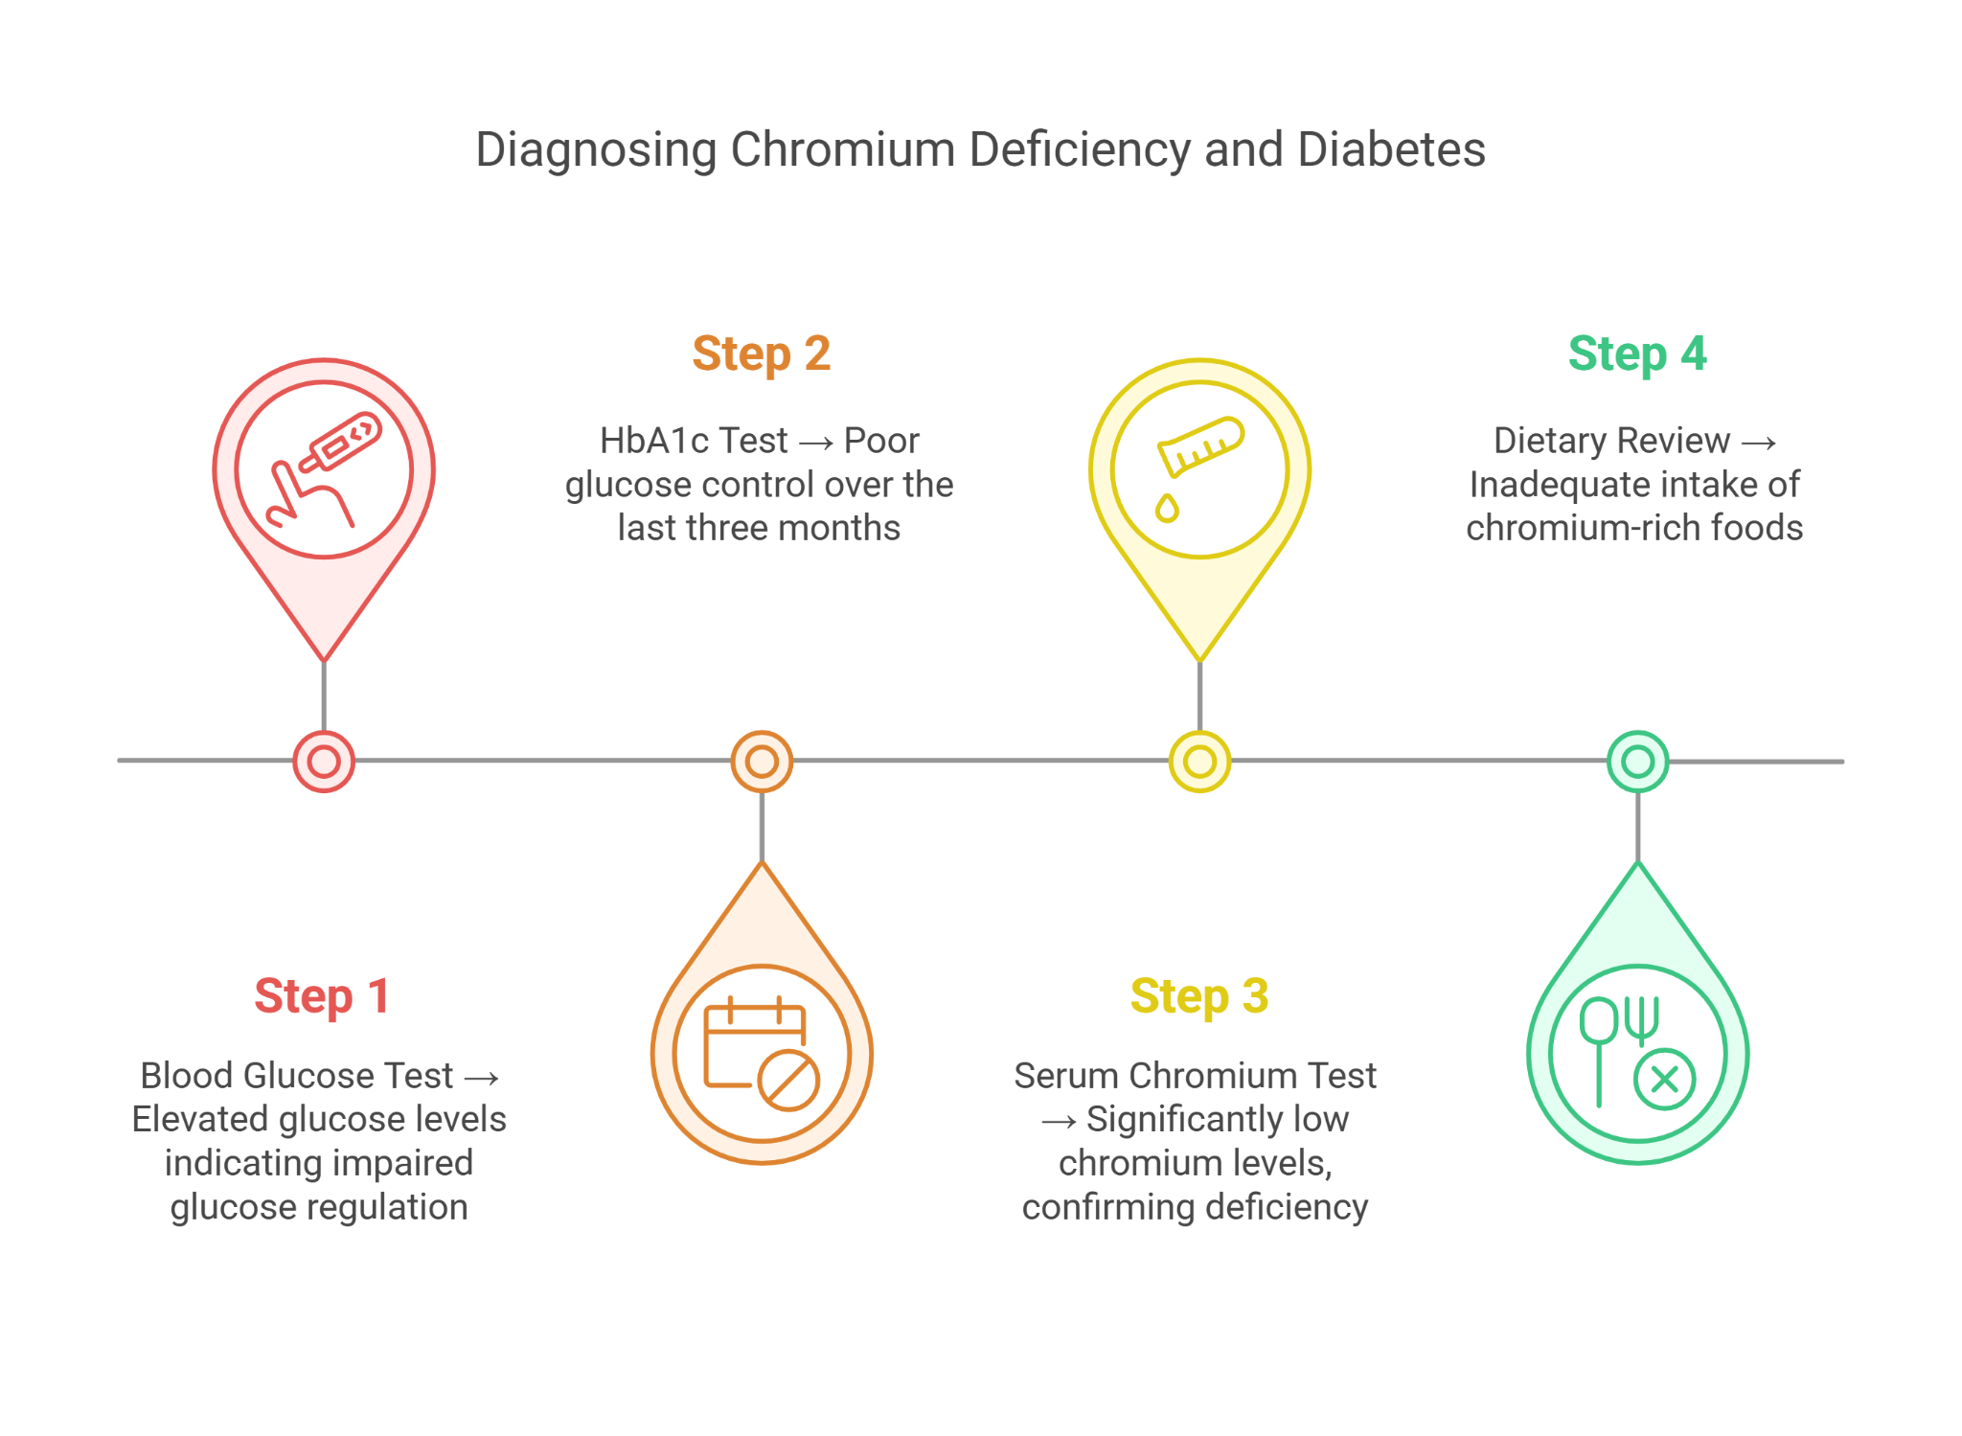

#### **Differential Diagnosis**

* **Type 2 Diabetes**: Indicated by symptoms and confirmed by glucose tests but needed further investigation into contributing factors.
* **Type 1 Diabetes**: Considered due to the acute onset of symptoms; C-peptide and autoantibodies tests were normal, ruling this out.
* **Insulin Resistance**: A precursor to diabetes; confirmed by elevated fasting insulin levels.
* **Other Micronutrient Deficiencies**: Such as vitamin D or magnesium, which could also affect insulin function; tests showed only chromium was deficient.

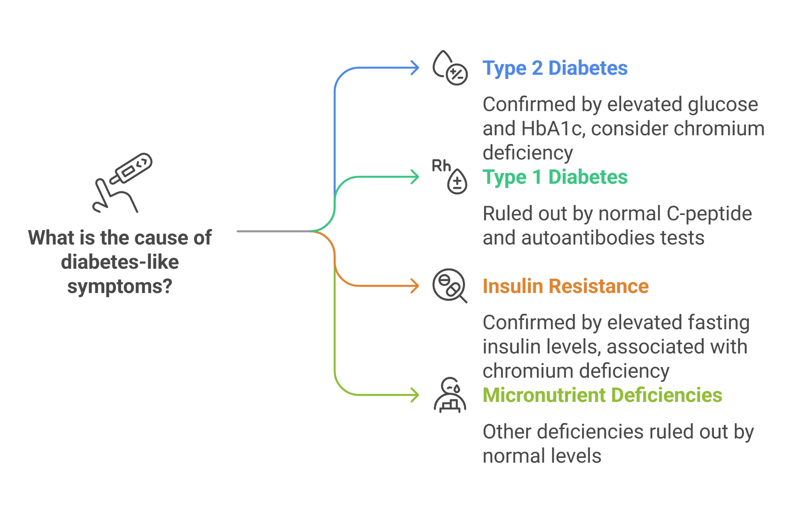

#### **Final Diagnosis**

Early signs of type 2 diabetes (associated with obesity) exacerbated by chromium deficiency.

#### **Treatment and Management**

* **Chromium Supplementation**: Initiated to correct the deficiency and potentially improve insulin sensitivity.
* **Dietary Modifications**: Counseled to increase intake of chromium-rich foods such as broccoli, whole grains, and meats.
* **Lifestyle Interventions**: Recommended regular physical activity and weight management strategies to improve overall metabolic health.
* **Regular Monitoring**: Scheduled follow-ups every three months to assess blood glucose levels, HbA1c, and chromium status, adjusting treatment as necessary.

#### **Follow-up**

Kabir showed gradual improvements in glucose regulation and symptoms with the introduction of chromium supplementation and lifestyle changes. His follow-up tests indicated better controlled blood sugar levels and normalization of chromium levels.

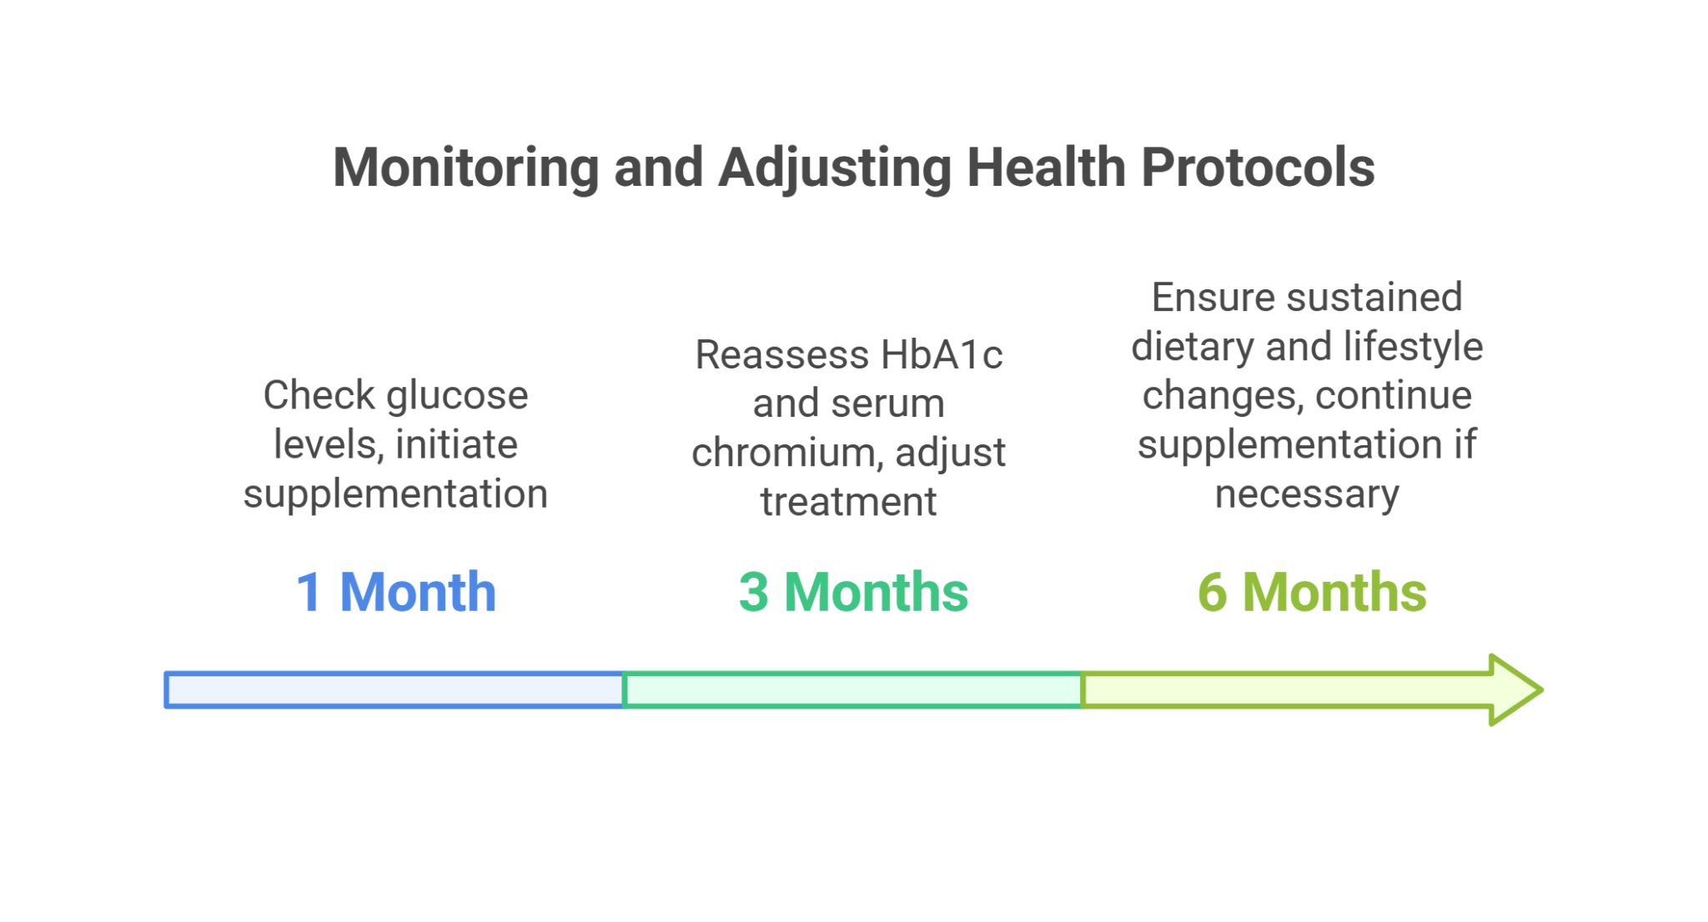

#### **Conclusion**

This case highlights the critical role of micronutrients like chromium in managing glucose metabolism, especially in children showing early signs of diabetes. Adequate dietary intake and appropriate supplementation can significantly impact the management and prognosis of diabetes in pediatric patients.

### **Case Study: Addressing Metabolic Syndrome and Nutritional Deficiencies in a Young Child**

#### **Introduction**

This case study explores the management of metabolic syndrome in a 7-year-old child, emphasizing the impact of poor nutritional intake and potential micronutrient deficiencies, including chromium, which can significantly affect glucose regulation.

#### **Background**

Metabolic syndrome in children is a complex disorder characterized by a cluster of conditions that increase the risk of developing heart disease and diabetes. Nutritional factors, especially deficiencies in essential micronutrients like chromium, play a crucial role in exacerbating these conditions.

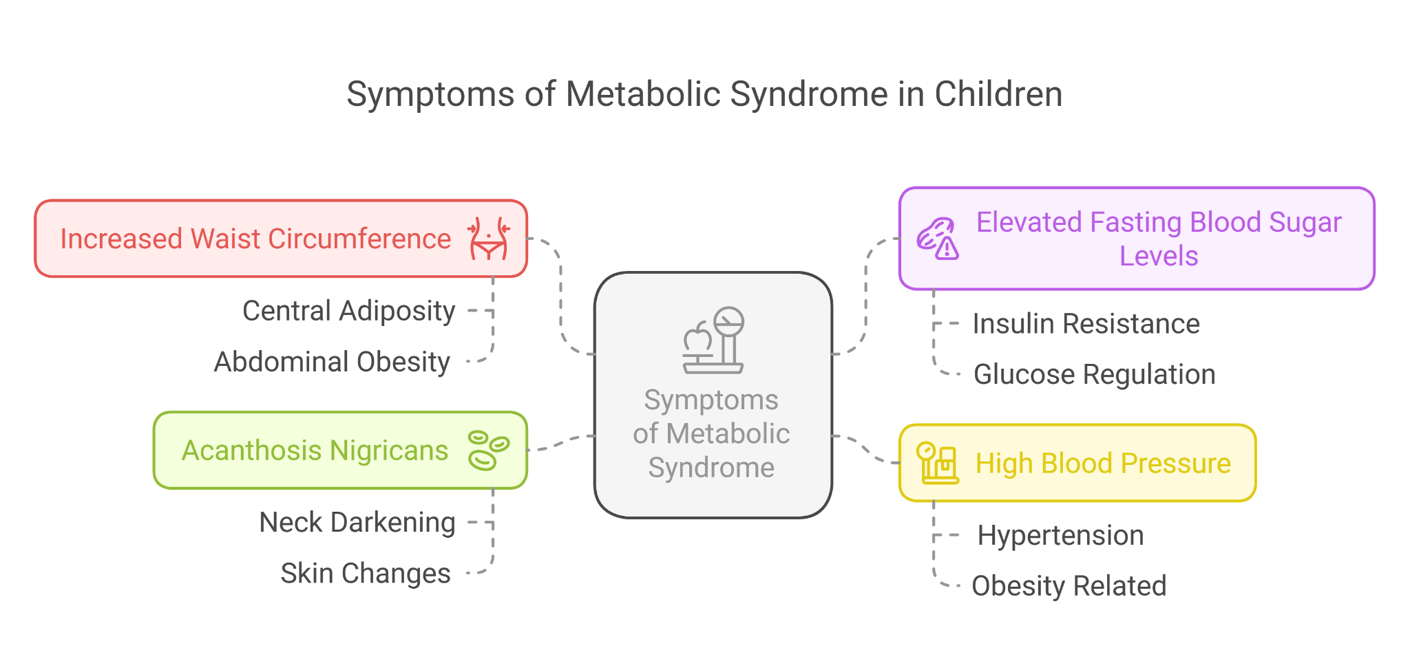

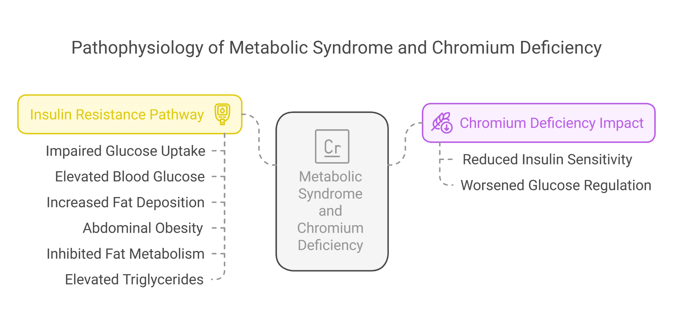

#### **Presenting Symptoms**

Anika, a 7-year-old girl, presented with:

* Increased waist circumference and signs of abdominal obesity.
* Elevated fasting blood sugar levels.
* High blood pressure noted during routine checks.
* Signs of acanthosis nigricans around her neck, indicative of insulin resistance.

#### **Investigations**

* **Blood Glucose and Insulin Levels**: Indicated insulin resistance.
* **Lipid Profile**: Showed elevated triglycerides and low HDL cholesterol.
* **Blood Pressure Measurement**: Consistently recorded above the 90th percentile for her age and height.
* **Serum Chromium Levels**: Revealed a deficiency, which could be contributing to poor glucose regulation.
* **Dietary Assessment**: Indicated a high intake of processed foods and sugary drinks with low consumption of fruits, vegetables, and whole grains.

#### **Differential Diagnosis**

* **Type 2 Diabetes**: Considered due to elevated glucose levels; however, not fully developed, as indicated by glycemic control measures.
* **Primary Hypertension**: Uncommon in children without underlying conditions; determined to be secondary to obesity.
* **Hypothyroidism**: Can contribute to weight gain; ruled out with normal thyroid function tests.
* **Chromium Deficiency**: Directly impacting glucose metabolism; confirmed by low serum levels.

#### **Final Diagnosis**

Metabolic Syndrome exacerbated by Chromium Deficiency and poor nutritional intake.

#### **Treatment and Management**

* **Nutritional Counseling**: Implemented a diet plan focusing on increasing intake of chromium-rich foods such as broccoli, whole grains, and meats, and reducing high-calorie, nutrient-poor foods.
* **Chromium Supplementation**: Started to correct the deficiency and improve insulin sensitivity.
* **Exercise Recommendation**: Encouraged regular physical activity tailored to her age to help manage weight and improve metabolic health.
* **Regular Monitoring**: Scheduled follow-up appointments every three months to monitor changes in metabolic syndrome parameters and dietary adherence.

#### **Follow-up**

Improvements in Anika’s blood sugar levels and blood pressure were observed during the follow-up period. Her overall health showed significant improvement with changes in diet and activity level, along with chromium supplementation.

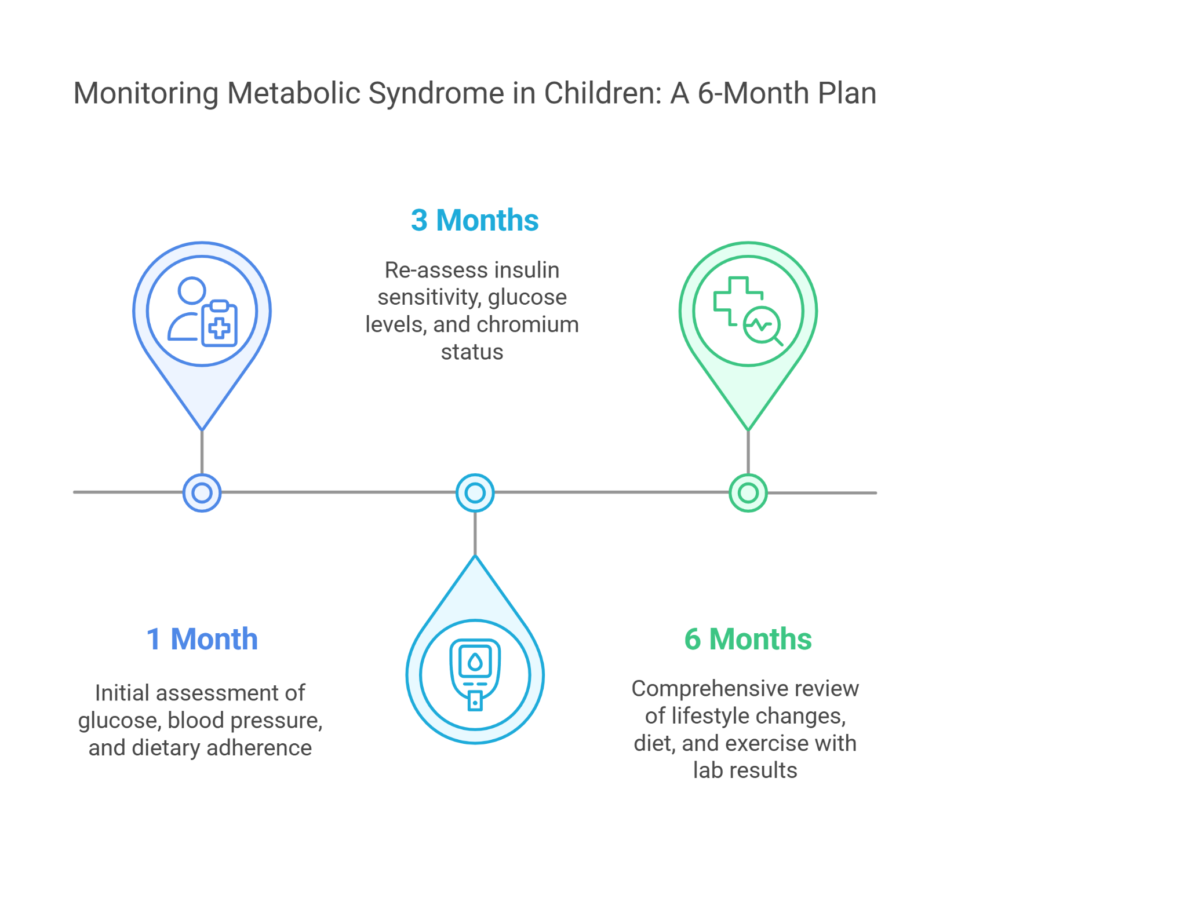

#### **Conclusion**

This case underscores the importance of recognizing and addressing dietary and micronutrient deficiencies in the management of metabolic syndrome in children. Early intervention with dietary management, appropriate supplementation, and lifestyle changes can mitigate the progression of metabolic disorders and improve long-term health outcomes.