使用MyBatis_Generator生成Dto、Dao、Mapping
（Version1.0）

2014年11月

生成配置文件
新建一个空的XML配置文件，名称可以随便取，这里以generatorConfig.xml为名。最好将这个文件放在下载后的lib目录中，如图：
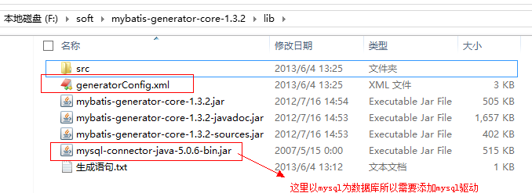
其中mysql的驱动可以随便放在非中文路径的地方，这里为了方便就放在lib目录下。
自动生成最重要的就是配置文件的书写，现在就开始介绍generatorConfig.xml这个文件的具体内容：
[html] view plaincopy
<?xml version="1.0" encoding="UTF-8"?>
<!DOCTYPE generatorConfiguration
PUBLIC "-//mybatis.org//DTD MyBatis Generator Configuration 1.0//EN"
"http://mybatis.org/dtd/mybatis-generator-config_1_0.dtd">
<generatorConfiguration>
<!-- 数据库驱动-->
<classPathEntry location="mysql-connector-java-5.0.6-bin.jar"/>
<context id="DB2Tables" targetRuntime="MyBatis3">
<commentGenerator>
<property name="suppressDate" value="true"/>
<!-- 是否去除自动生成的注释 true：是 ： false:否 -->
<property name="suppressAllComments" value="true"/>
</commentGenerator>
<!--数据库链接URL，用户名、密码 -->
<jdbcConnection driverClass="com.mysql.jdbc.Driver" connectionURL="jdbc:mysql://localhost/test" userId="test" password="test">
</jdbcConnection>
<javaTypeResolver>
<property name="forceBigDecimals" value="false"/>
</javaTypeResolver>
<!-- 生成模型的包名和位置-->
<javaModelGenerator targetPackage="test.model" targetProject="src">
<property name="enableSubPackages" value="true"/>
<property name="trimStrings" value="true"/>
</javaModelGenerator>
<!-- 生成映射文件的包名和位置-->
<sqlMapGenerator targetPackage="test.mapping" targetProject="src">
<property name="enableSubPackages" value="true"/>
</sqlMapGenerator>
<!-- 生成DAO的包名和位置-->
<javaClientGenerator type="XMLMAPPER" targetPackage="test.dao" targetProject="src">
<property name="enableSubPackages" value="true"/>
</javaClientGenerator>
<!-- 要生成哪些表-->
<table tableName="about" domainObjectName="AboutDto" enableCountByExample="false" enableUpdateByExample="false" enableDeleteByExample="false" enableSelectByExample="false" selectByExampleQueryId="false"></table>
<table tableName="user" domainObjectName="UserDto" enableCountByExample="false" enableUpdateByExample="false" enableDeleteByExample="false" enableSelectByExample="false" selectByExampleQueryId="false"></table>
<table tableName="syslogs" domainObjectName="SyslogsDto" enableCountByExample="false" enableUpdateByExample="false" enableDeleteByExample="false" enableSelectByExample="false" selectByExampleQueryId="false"></table>
</context>
</generatorConfiguration>
1、其中需要注意的有数据库驱动、数据库URL、用户名、密码、生成模型的包名和位置、生成映射文件的包名和位置、生成DAO的包名和位置以及最后需要生成的表名和对应的类名。

四、运行
需要通过CMD命令行方式来运行，首先可以先准备一个运行的脚本，这里使用的脚本是：java -jar mybatis-generator-core-1.3.2.jar -configfile generatorConfig.xml -overwrite
需要注意的是：mybatis-generator-core-1.3.2.jar为下载的对应版本的jar，generatorConfig.xml 为配置文件名，如果不为这个可以在这里进行修改。
启动cmd进入到“F:\soft\mybatis-generator-core-1.3.2\lib”这个目录下，如图：
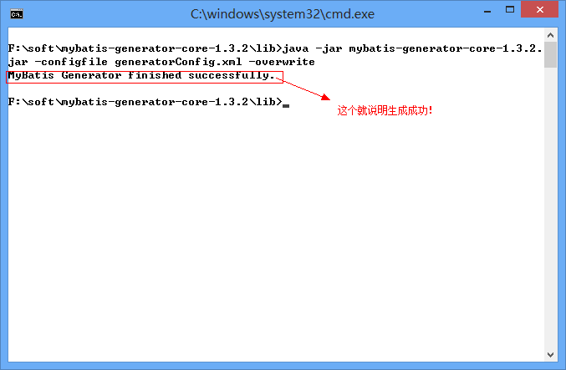
生成成功后进到src目录下，可以看到已经生成了对应的model、dao、mapping，如图：
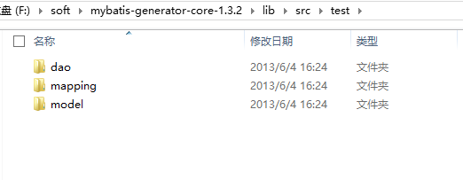
下面可以看看生成后的UserMapper.xml
[html] view plaincopy
<?xml version="1.0" encoding="UTF-8" ?>
<!DOCTYPE mapper PUBLIC "-//mybatis.org//DTD Mapper 3.0//EN" "http://mybatis.org/dtd/mybatis-3-mapper.dtd" >
<mapper namespace="test.dao.UserDtoMapper" >
<resultMap id="BaseResultMap" type="test.model.UserDto" >
<id column="id" property="id" jdbcType="VARCHAR" />
<result column="username" property="username" jdbcType="VARCHAR" />
<result column="password" property="password" jdbcType="VARCHAR" />
<result column="email" property="email" jdbcType="VARCHAR" />
<result column="name" property="name" jdbcType="VARCHAR" />
<result column="sex" property="sex" jdbcType="VARCHAR" />
<result column="birthday" property="birthday" jdbcType="VARCHAR" />
<result column="address" property="address" jdbcType="VARCHAR" />
<result column="tel" property="tel" jdbcType="VARCHAR" />
<result column="qq" property="qq" jdbcType="VARCHAR" />
<result column="image" property="image" jdbcType="VARCHAR" />
<result column="sfjh" property="sfjh" jdbcType="VARCHAR" />
<result column="sfzx" property="sfzx" jdbcType="VARCHAR" />
<result column="sfhf" property="sfhf" jdbcType="VARCHAR" />
<result column="sfpl" property="sfpl" jdbcType="VARCHAR" />
<result column="sffx" property="sffx" jdbcType="VARCHAR" />
</resultMap>
<sql id="Base_Column_List" >
id, username, password, email, name, sex, birthday, address, tel, qq, image, sfjh,
sfzx, sfhf, sfpl, sffx
</sql>
<select id="selectByPrimaryKey" resultMap="BaseResultMap" parameterType="java.lang.String" >
select
<include refid="Base_Column_List" />
from user
where id = #{id,jdbcType=VARCHAR}
</select>
<delete id="deleteByPrimaryKey" parameterType="java.lang.String" >
delete from user
where id = #{id,jdbcType=VARCHAR}
</delete>
<insert id="insert" parameterType="test.model.UserDto" >
insert into user (id, username, password,
email, name, sex, birthday,
address, tel, qq, image,
sfjh, sfzx, sfhf, sfpl,
sffx)
values (#{id,jdbcType=VARCHAR}, #{username,jdbcType=VARCHAR}, #{password,jdbcType=VARCHAR},
#{email,jdbcType=VARCHAR}, #{name,jdbcType=VARCHAR}, #{sex,jdbcType=VARCHAR}, #{birthday,jdbcType=VARCHAR},
#{address,jdbcType=VARCHAR}, #{tel,jdbcType=VARCHAR}, #{qq,jdbcType=VARCHAR}, #{image,jdbcType=VARCHAR},
#{sfjh,jdbcType=VARCHAR}, #{sfzx,jdbcType=VARCHAR}, #{sfhf,jdbcType=VARCHAR}, #{sfpl,jdbcType=VARCHAR},
#{sffx,jdbcType=VARCHAR})
</insert>
<insert id="insertSelective" parameterType="test.model.UserDto" >
insert into user
<trim prefix="(" suffix=")" suffixOverrides="," >
<if test="id != null" >
id,
</if>
<if test="username != null" >
username,
</if>
<if test="password != null" >
password,
</if>
<if test="email != null" >
email,
</if>
<if test="name != null" >
name,
</if>
<if test="sex != null" >
sex,
</if>
<if test="birthday != null" >
birthday,
</if>
<if test="address != null" >
address,
</if>
<if test="tel != null" >
tel,
</if>
<if test="qq != null" >
qq,
</if>
<if test="image != null" >
image,
</if>
<if test="sfjh != null" >
sfjh,
</if>
<if test="sfzx != null" >
sfzx,
</if>
<if test="sfhf != null" >
sfhf,
</if>
<if test="sfpl != null" >
sfpl,
</if>
<if test="sffx != null" >
sffx,
</if>
</trim>
<trim prefix="values (" suffix=")" suffixOverrides="," >
<if test="id != null" >
#{id,jdbcType=VARCHAR},
</if>
<if test="username != null" >
#{username,jdbcType=VARCHAR},
</if>
<if test="password != null" >
#{password,jdbcType=VARCHAR},
</if>
<if test="email != null" >
#{email,jdbcType=VARCHAR},
</if>
<if test="name != null" >
#{name,jdbcType=VARCHAR},
</if>
<if test="sex != null" >
#{sex,jdbcType=VARCHAR},
</if>
<if test="birthday != null" >
#{birthday,jdbcType=VARCHAR},
</if>
<if test="address != null" >
#{address,jdbcType=VARCHAR},
</if>
<if test="tel != null" >
#{tel,jdbcType=VARCHAR},
</if>
<if test="qq != null" >
#{qq,jdbcType=VARCHAR},
</if>
<if test="image != null" >
#{image,jdbcType=VARCHAR},
</if>
<if test="sfjh != null" >
#{sfjh,jdbcType=VARCHAR},
</if>
<if test="sfzx != null" >
#{sfzx,jdbcType=VARCHAR},
</if>
<if test="sfhf != null" >
#{sfhf,jdbcType=VARCHAR},
</if>
<if test="sfpl != null" >
#{sfpl,jdbcType=VARCHAR},
</if>
<if test="sffx != null" >
#{sffx,jdbcType=VARCHAR},
</if>
</trim>
</insert>
<update id="updateByPrimaryKeySelective" parameterType="test.model.UserDto" >
update user
<set >
<if test="username != null" >
username = #{username,jdbcType=VARCHAR},
</if>
<if test="password != null" >
password = #{password,jdbcType=VARCHAR},
</if>
<if test="email != null" >
email = #{email,jdbcType=VARCHAR},
</if>
<if test="name != null" >
name = #{name,jdbcType=VARCHAR},
</if>
<if test="sex != null" >
sex = #{sex,jdbcType=VARCHAR},
</if>
<if test="birthday != null" >
birthday = #{birthday,jdbcType=VARCHAR},
</if>
<if test="address != null" >
address = #{address,jdbcType=VARCHAR},
</if>
<if test="tel != null" >
tel = #{tel,jdbcType=VARCHAR},
</if>
<if test="qq != null" >
qq = #{qq,jdbcType=VARCHAR},
</if>
<if test="image != null" >
image = #{image,jdbcType=VARCHAR},
</if>
<if test="sfjh != null" >
sfjh = #{sfjh,jdbcType=VARCHAR},
</if>
<if test="sfzx != null" >
sfzx = #{sfzx,jdbcType=VARCHAR},
</if>
<if test="sfhf != null" >
sfhf = #{sfhf,jdbcType=VARCHAR},
</if>
<if test="sfpl != null" >
sfpl = #{sfpl,jdbcType=VARCHAR},
</if>
<if test="sffx != null" >
sffx = #{sffx,jdbcType=VARCHAR},
</if>
</set>
where id = #{id,jdbcType=VARCHAR}
</update>
<update id="updateByPrimaryKey" parameterType="test.model.UserDto" >
update user
set username = #{username,jdbcType=VARCHAR},
password = #{password,jdbcType=VARCHAR},
email = #{email,jdbcType=VARCHAR},
name = #{name,jdbcType=VARCHAR},
sex = #{sex,jdbcType=VARCHAR},
birthday = #{birthday,jdbcType=VARCHAR},
address = #{address,jdbcType=VARCHAR},
tel = #{tel,jdbcType=VARCHAR},
qq = #{qq,jdbcType=VARCHAR},
image = #{image,jdbcType=VARCHAR},
sfjh = #{sfjh,jdbcType=VARCHAR},
sfzx = #{sfzx,jdbcType=VARCHAR},
sfhf = #{sfhf,jdbcType=VARCHAR},
sfpl = #{sfpl,jdbcType=VARCHAR},
sffx = #{sffx,jdbcType=VARCHAR}
where id = #{id,jdbcType=VARCHAR}
</update>
</mapper>
接下来就可以将这三个目录拷贝到对应项目的目录中，如果需要新增自己的方法可以修改dao类。

