**🎯 Video Title:**

**HTML Basics in Hindi 🔥 | What is HTML, Tags, Elements, HTML5 & Semantic Tags Explained**

**🖼️ Thumbnail Text (Bold & Eye-Catching):**

**HTML vs HTML5**  
**Tags, Elements & Semantics Explained!**  
(Hindi-English)

💡 *Bonus Tip:* Use vibrant colors, code snippet graphics, and maybe a "shocked emoji 😲" for extra attention.

**📝 Video Description:**

📌 **Welcome to this beginner-friendly HTML tutorial in Hindi-English mix!**  
In this video, we’re diving into the fundamentals of **HTML and HTML5**, exploring topics like:

* What is HTML?
* What are HTML Tags and Elements?
* Difference between HTML and HTML5
* Semantic Elements in HTML5

We’ve also added funny punchlines and small code snippets to keep things light and engaging. Perfect for complete beginners and those who want to refresh their basics.

🎥 **This is the first video in our HTML YouTube series**, so stay tuned for more amazing tutorials on web development!

🔗 **Time Stamps:** 00:00 – Introduction  
00:30 – What is HTML?  
02:30 – HTML Tags & Elements  
05:30 – HTML vs HTML5  
08:00 – Semantic Elements in HTML5  
11:00 – Summary & Outro

👇 **Don’t forget to:** 👍 Like | 💬 Comment | 🔔 Subscribe for more web development videos!

**🔥 Trending Hashtags (Use in Description & Comments):**

less

CopyEdit

#HTML #HTML5 #WebDevelopment #LearnHTML #HTMLTutorial #WebDesign #FrontendDevelopment #HTMLInHindi

Great! Here's a **10-15 minute YouTube video script** in **Hindi-English mix** style, perfect for explaining the basics of HTML to beginners while keeping the tone **fun, engaging, and educational**. It includes **short examples, theory, and light humor** to retain viewer interest.

**🎬 [Intro - 0:00 - 0:30]**

🎤  
**"Namaste doston! Swagat hai aapka ek aur dhamakedaar HTML video mein.**  
Aaj ke video mein hum baat karne wale hain HTML ke basics ke baare mein – kya hai HTML, tags aur elements kya hote hain, HTML aur HTML5 mein kya farak hai, aur kuch special – semantic elements ke baare mein bhi jaanenge.  
Toh video ko end tak zarur dekhna, warna HTML samajhne ke bajaye confusion ka <div> ban jaayega!" 😄

**🧱 1. What is HTML? [0:30 - 2:30]**

🎤  
"Sabse pehle sawal – **HTML kya hai?**

HTML ka full form hota hai – **HyperText Markup Language**. Ye ek markup language hai jo web pages ko design karne ke liye use hoti hai.

Socho HTML ek **skeleton** hai, jo web page ka structure banata hai. Jaise insaan ke body ka structure hota hai, waise hi HTML web page ka framework set karta hai.

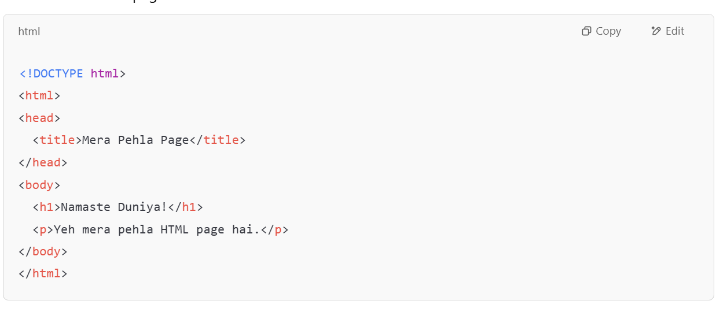🗯️  
**Funny Punch**:  
“HTML bina CSS aur JavaScript ke waise hi hai jaise pizza bina cheese ke – structure toh hai, par mazaa nahi!” 🍕

**🏷️ 2. What are HTML Tags and Elements? [2:30 - 5:30]**

🎤  
"Ab baat karte hain HTML tags aur elements ki.  
HTML ke building blocks hote hain **tags**. Har tag kuch na kuch define karta hai – jaise heading, paragraph, image, link, etc.

Tags usually hote hain angle brackets < > ke andar:

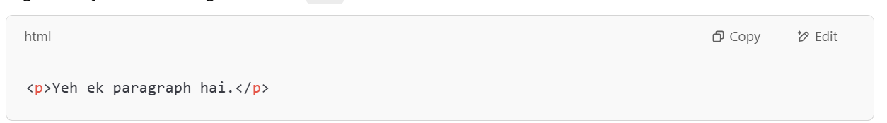

Yahan <p> hai opening tag, </p> hai closing tag, aur beech ka content milke banata hai **HTML Element**.

💡 Tip:  
**Element = Opening Tag + Content + Closing Tag**

Aur kuch tags self-closing bhi hote hain:

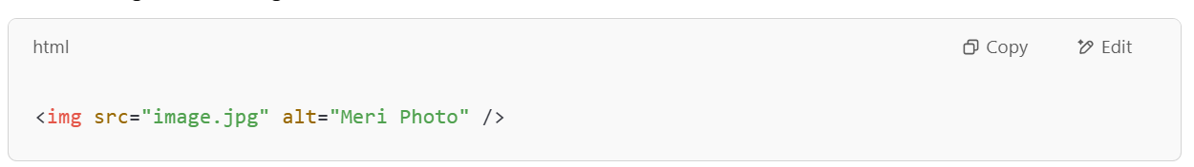🗯️  
**Funny Punch**:  
“HTML tags ke bina webpage waise hi dikhega jaise pani ke bina chai – sab kuch bland bland lagega.” ☕

**🆚 3. What's the Difference Between HTML and HTML5? [5:30 - 8:00]**

🎤  
"Chaliye ab dekhte hain **HTML vs HTML5** ka yeh epic match! 🥊

**HTML** ek older technology hai, jise pehli baar 1993 mein introduce kiya gaya tha.  
**HTML5** uska latest version hai – aur yeh kaafi smart hai.

| **Feature** | **HTML** | **HTML5** |
| --- | --- | --- |
| Multimedia support | Nahi tha | Built-in <audio> and <video> tags |
| Doctype | Complicated | Simple: <!DOCTYPE html> |
| Storage | Limited | Web Storage (localStorage, sessionStorage) |
| Tags | Basic | Semantic tags: <header>, <footer>, <section> |
| Form controls | Basic | New input types like date, range, email, etc. |

Example – HTML5 video:

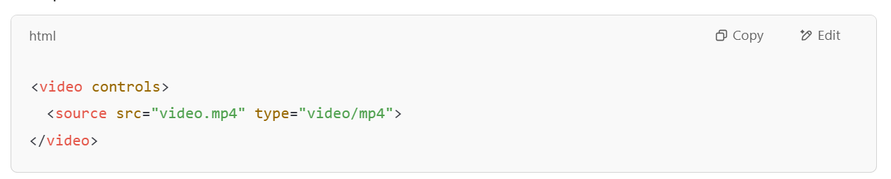🗯️  
**Funny Punch**:  
"HTML aur HTML5 mein farak waise hi hai jaise phone aur smartphone mein – dono se call hoti hai, par smartphone mein Netflix bhi chalta hai!" 📱🍿

**🧠 4. What are Semantic Elements in HTML5? [8:00 - 11:00]**

🎤  
"Semantic ka matlab hota hai – meaningful.  
HTML5 ne introduce kiye kuch **semantic tags** jo batate hain ki content ka purpose kya hai.

Example tags:

* <header> – Page ka top section
* <footer> – Page ka bottom section
* <article> – Independent content
* <section> – Page ka section
* <nav> – Navigation links

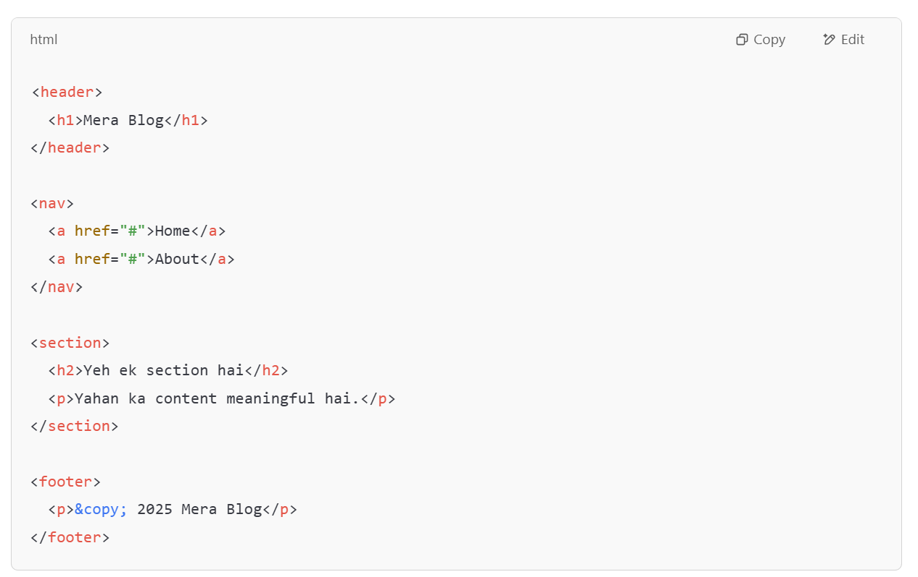🗯️  
**Funny Punch**:  
“Semantic elements web page ko grammar sikha dete hain – jahan full stop hona chahiye wahan full stop, jahan comma wahan comma!” ✍️

🧠 Bonus:  
Search engines jaise Google in semantic elements ko samajh kar aapke page ko better rank dete hain. SEO ke liye bhi mast hai ye!

**🎯 Closing - Summary and Outro [11:00 - 12:30]**

🎤  
“Toh doston, aaj humne jaana:

* HTML kya hota hai
* Tags aur elements ka matlab
* HTML aur HTML5 ka comparison
* Aur semantic elements ka magic!

Agar aapko video pasand aaya ho toh ek **LIKE** thok do,  
Comment karke batao aapko sabse interesting part kya laga,  
Aur **channel ko subscribe** karna na bhoolna kyunki agle videos mein aur bhi amazing topics aane wale hain!

Aur haan, agar HTML sikh liya toh samajh lo aapne web development ki building ka pehla floor complete kar liya hai. 🏗️

Milte hain next video mein, tab tak ke liye –

**Code karo, chill karo – aur browser khush rakho!** 😄  
**Bye bye and Happy Coding!** 👋”

Would you like a matching **thumbnail text, title, and description** for the video too?