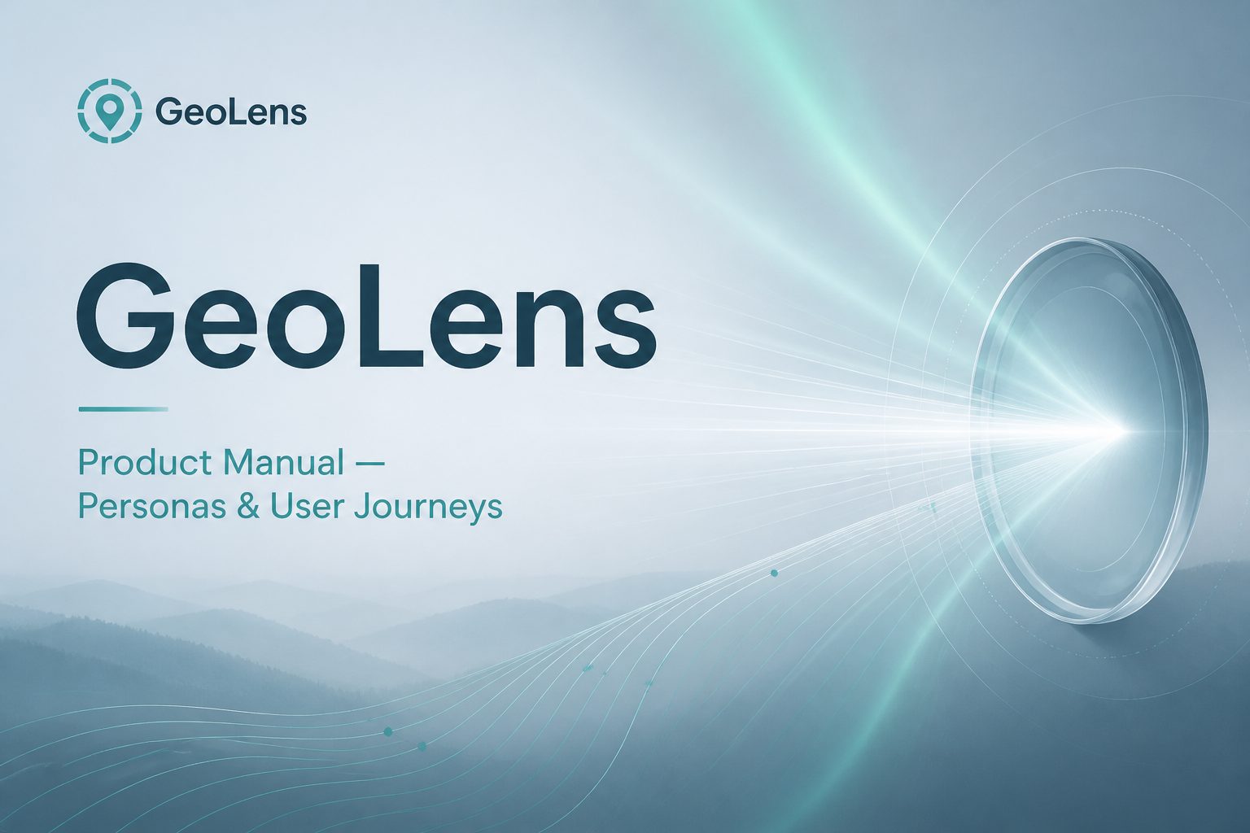
Product Manual
Personas, User Journeys & Feature Guide
AI Search / GEO Analytics Platform
Audience: Product · Customer Success · Sales · New Users
Demo: /prj_demo/overview · Version 1.0

1. What GeoLens is
People increasingly ask AI assistants (“What’s the best CRM for a 20-person agency?”) instead of searching keywords. GeoLens measures that channel and turns it into an operating system for marketers.
- You define prompts — natural-language questions you want to be found for.
- GeoLens runs them across AI engines / model channels (and countries).
- Every answer becomes a chat — brands mentioned, order, sentiment, sources, citations, fanouts, ads, products.
- Chats roll up into visibility, share of voice, position, sentiment, plus source and shopping metrics.
- Gaps become ranked Actions; Perception and Fact-checking show how AI describes you; Agent analytics show crawl access and AI referral traffic.
GeoLens is not a content writer, a classic SEO rank tracker, or an LLM observability tool. It recommends what to fix and where to show up — it does not write or publish content for you.

2. Core concepts
Term | Meaning
Chat | One prompt × one engine × one country × one day → one AI answer. Every metric drills back to chats.
Prompt | A conversational question you track (not a keyword). Has topic, tags, country, lifecycle.
Model channel | Stable surface ID (e.g. ChatGPT), independent of model version churn.
Source vs citation | Source = URL retrieved. Citation = URL shown in the answer.
Brand vs source visibility | Named in the answer vs your domain retrieved/cited.
Fanout | Background search the model runs while answering.
Gap | A domain/URL that helps competitors and never names you. Fuel for Actions.
Surface kind | simulator / api / ui — API data is honest but not identical to consumer UI.

3. Who uses GeoLens (personas)
Seven primary personas span brand, agency, ecommerce, platform, and executive stakeholders.
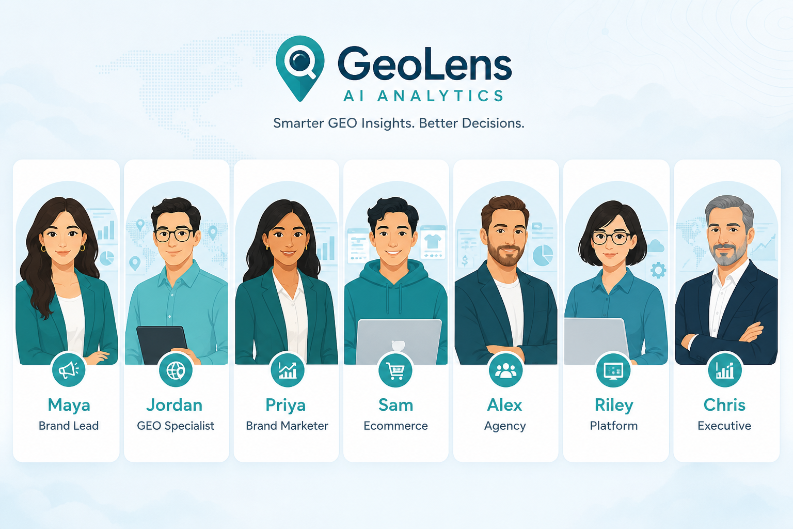
Figure 1 — GeoLens user personas

3.1 Maya — Brand marketing lead
- Goal: Prove AI search is a channel; grow visibility and share of voice.
- Cares about: Overview, Insights, Channels, Competitors, Actions, Impact, Perception.
- Success: Weekly visibility up on priority topics; Actions completed with Impact markers.

3.2 Jordan — Content / SEO / GEO specialist
- Goal: Close source gaps; get cited; fix crawl blocks.
- Cares about: Sources, Gap Analysis, Domains/URLs, Fanouts, Crawlability, Crawl Insights, Action briefs.
- Success: Gap list shrinking; robots.txt allows AI bots; crawled URLs become citations.

3.3 Priya — Brand / product marketer
- Goal: Control narrative — attributes, objections, factual accuracy.
- Cares about: Perception, Fact-checking, Brand profile, Chats.
- Success: Perception gaps documented; contradicted claims fixed and re-checked.

3.4 Sam — Ecommerce / merchandising
- Goal: SKU visibility and correct pricing in shopping-style AI answers.
- Cares about: Shopping catalog, win rate, price drift, demand queries.
- Success: Catalog matched; price drift actioned; win rate up on hero SKUs.

3.5 Alex — Agency strategist
- Goal: Pitch and retain clients; allocate credits across projects.
- Cares about: Pitch → customer conversion, Billing, Share links, client-safe views.
- Success: Pitch converts with history preserved; clients see reports without Actions strategy.

3.6 Riley — Technical / RevOps / platform
- Goal: Wire data into BI, agents, and SSO; keep quotas clean.
- Cares about: API keys, MCP, SSO/SAML, Billing quotas.
- Success: Dashboard = API = MCP numbers; SSO for enterprise users.

3.7 Chris — Executive / stakeholder (often read-only)
- Goal: High-level trend without operating the tool daily.
- Cares about: Overview, shared views (/share/...), Impact narrative.
- Success: Shared link in board pack; no login required for read-only share.

4. Roles & access (RBAC)

Org roles
Role | Can do
Owner | Everything: billing, API keys, SSO, all writes (including API/MCP).
Admin | All projects and configuration; no billing.
Member | Read/write across projects; sees Actions.
Guest | Only projects explicitly granted.

Project roles (agency client seats)
Role | Can do
Editor | Edit that project’s configuration.
Viewer | Read-only reporting.
Important: Actions (competitive strategy) are for org owner / admin / member — not project-only guests or viewers.

5. Application map
Use the left sidebar. Top bar: date range, channel/model filter, and ⌘K / Ctrl+K search.
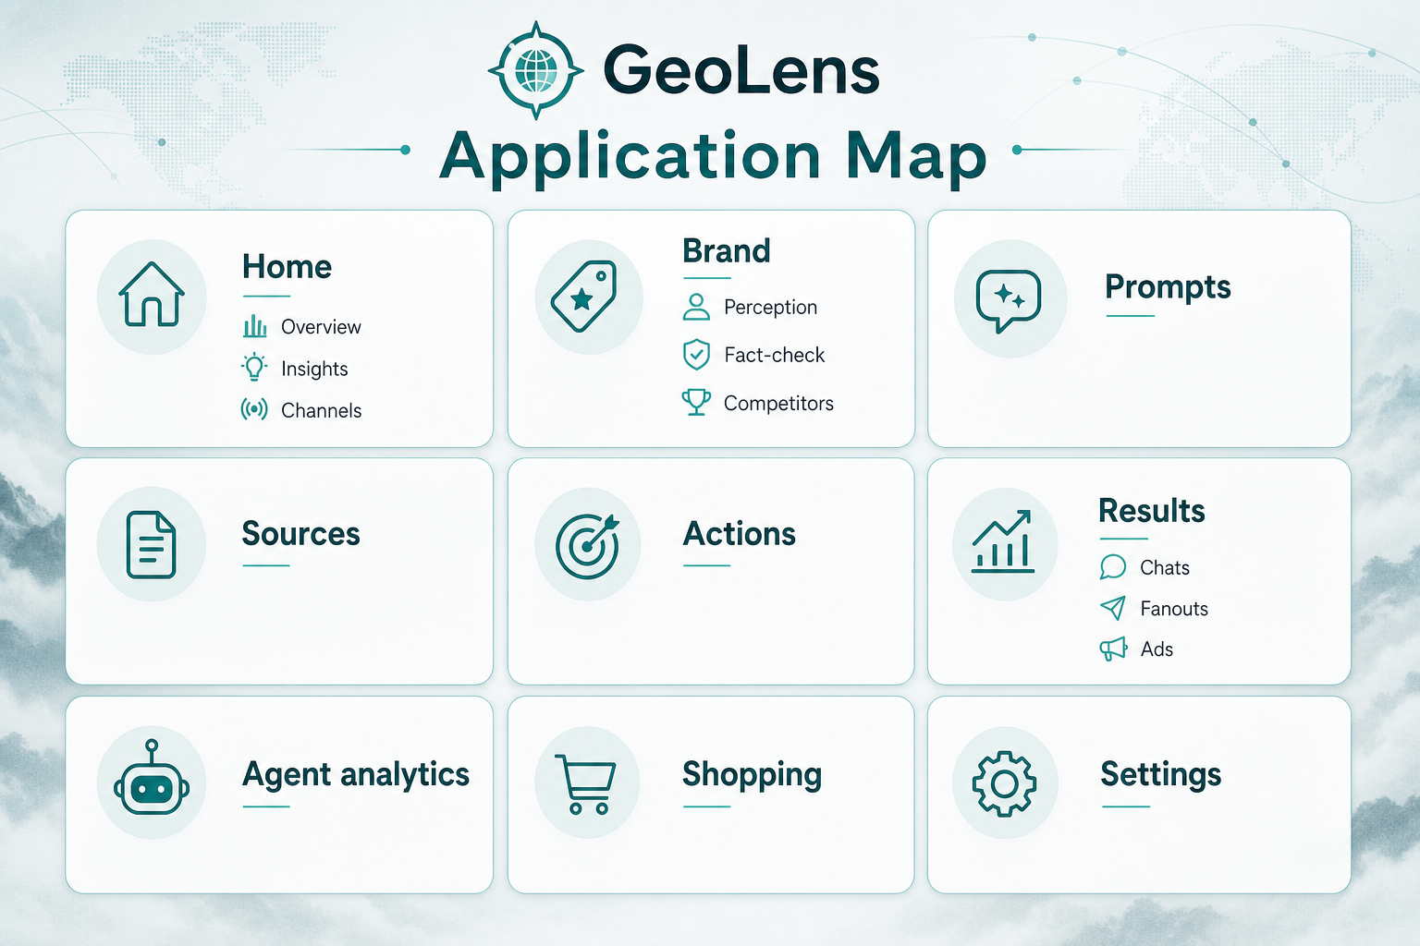
Figure 2 — GeoLens application map
Area | Pages | User outcome
Home | Overview, Brand Insights, Channels | Health of visibility + where you win/lose
Brand | Perception, Fact-checking, Competitors, Profile | Narrative, accuracy, competitor set
Prompts | All prompts, Discovery, Topics | What you track and coverage
Sources | Gaps, Domains, URLs | Citation / retrieval optimization
Actions | Actions, Impact | Prioritized work + measurement
Results | Chats, Fanouts, Ads | Evidence and ad landscape
Agent | Crawlability, Crawl Insights, Referrals | Bot access + AI traffic
Shopping | Shopping | Catalog / SKU AI visibility
Settings | Billing, API keys, SSO | Commercial + platform

6. End-to-end user journeys

Journey A — First-time brand setup (Maya + Jordan)
Goal: From zero to a trusted weekly dashboard in one sitting.
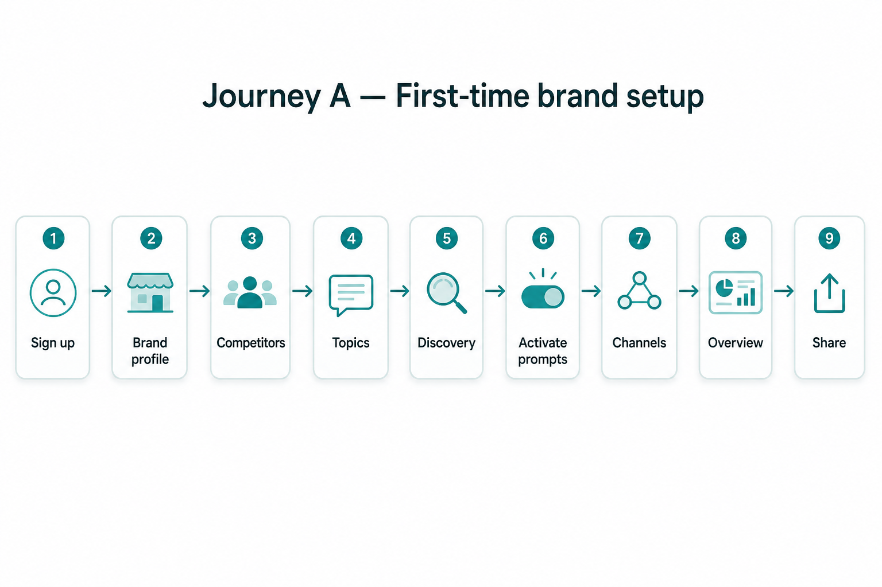
Figure 3 — Journey A: First-time setup
Step | Where | What the user does
1 | Signup | Create account; land in first project Overview.
2 | Brand profile | Confirm identity fields; save as reviewed.
3 | Competitors | Track or reject suggestions.
4 | Topics | Add topics/tags; optional CSV import.
5 | Discovery | Wizard → coverage → activate prompts.
6 | All prompts | Activate/pause/archive; set countries.
7 | Channels | Confirm engines collecting and adapter mode.
8 | Overview | Read KPIs, trend, chats, top actions/domains.
9 | Share | Create read-only share link for execs.
Definition of done: Visibility / SoV / position / sentiment show numbers; opening a chat proves the pipeline.

Journey B — Weekly GEO operating rhythm (Jordan)
Goal: Continuous improvement loop.
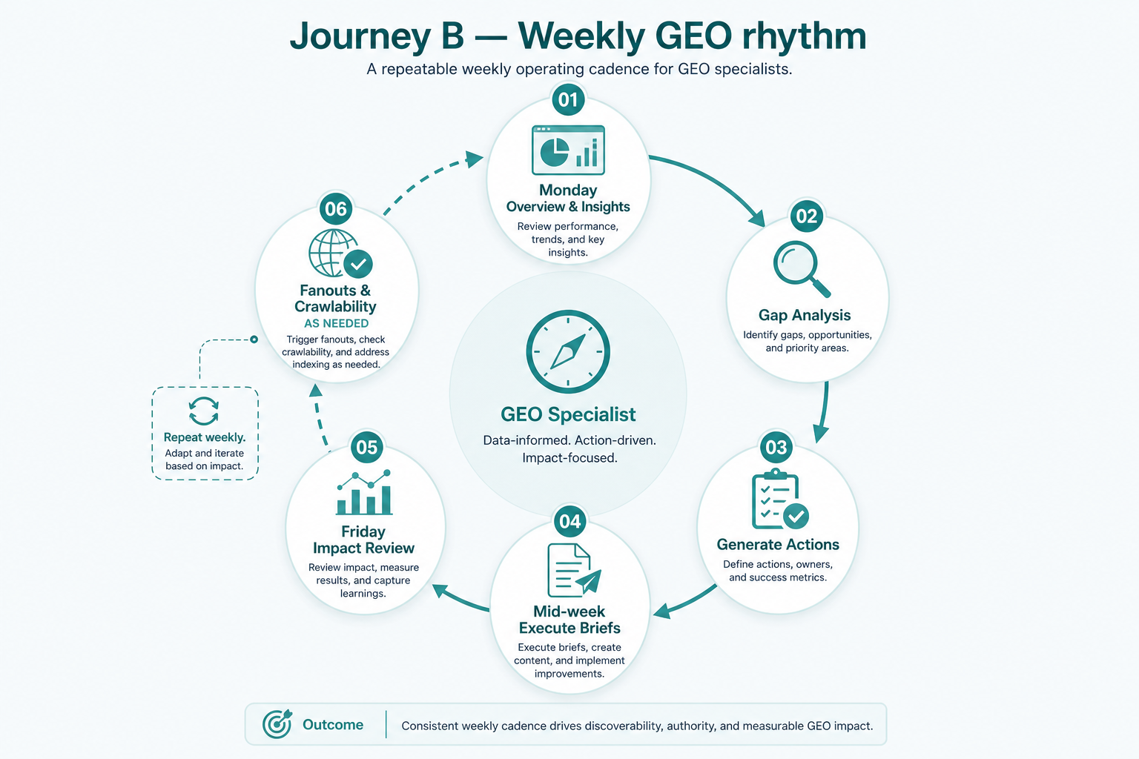
Figure 4 — Journey B: Weekly GEO rhythm
Cadence | Steps
Monday | Overview + Insights; filter last 7 days.
Same day | Gap Analysis → bookmark priorities.
Same day | Actions → Generate → Accept top opportunities.
Mid-week | Execute briefs outside GeoLens; mark steps complete.
Friday | Impact: visibility sparkline + markers (directional, not causal).
As needed | Fanouts refine prompts; Crawlability fixes robots.txt.

Journey C — Narrative & trust (Priya)
Goal: AI describes the brand accurately.
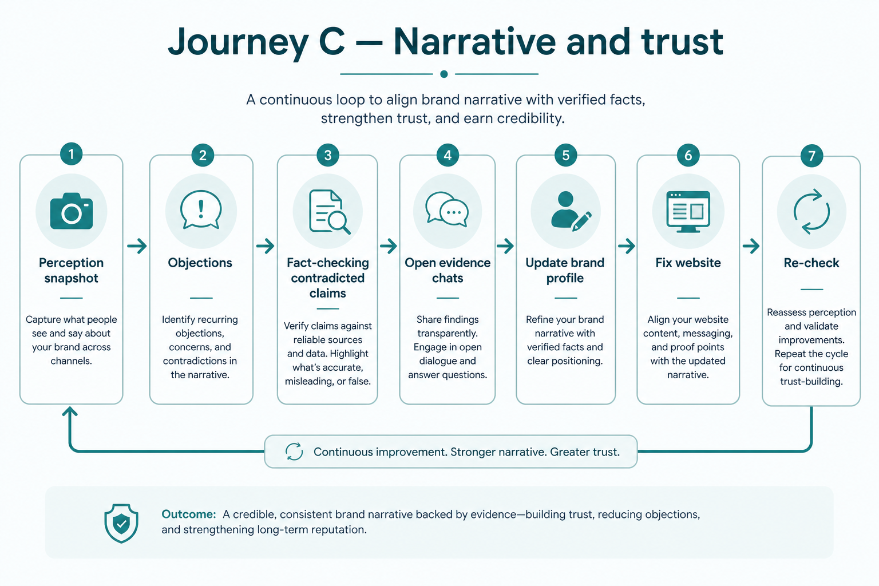
Figure 5 — Journey C: Narrative & trust
- Perception: association vs prominence; biggest gap; objections.
- Fact-checking: Contradicted / By fact / By category.
- Open evidence Chats behind bad claims.
- Update Brand profile; fix website/docs off-product.
- Wait for next collection cycle; re-check Fact-checking.

Journey D — Close a competitive gap (Maya + Jordan)
Goal: Turn a Gap into a completed Action with Impact.
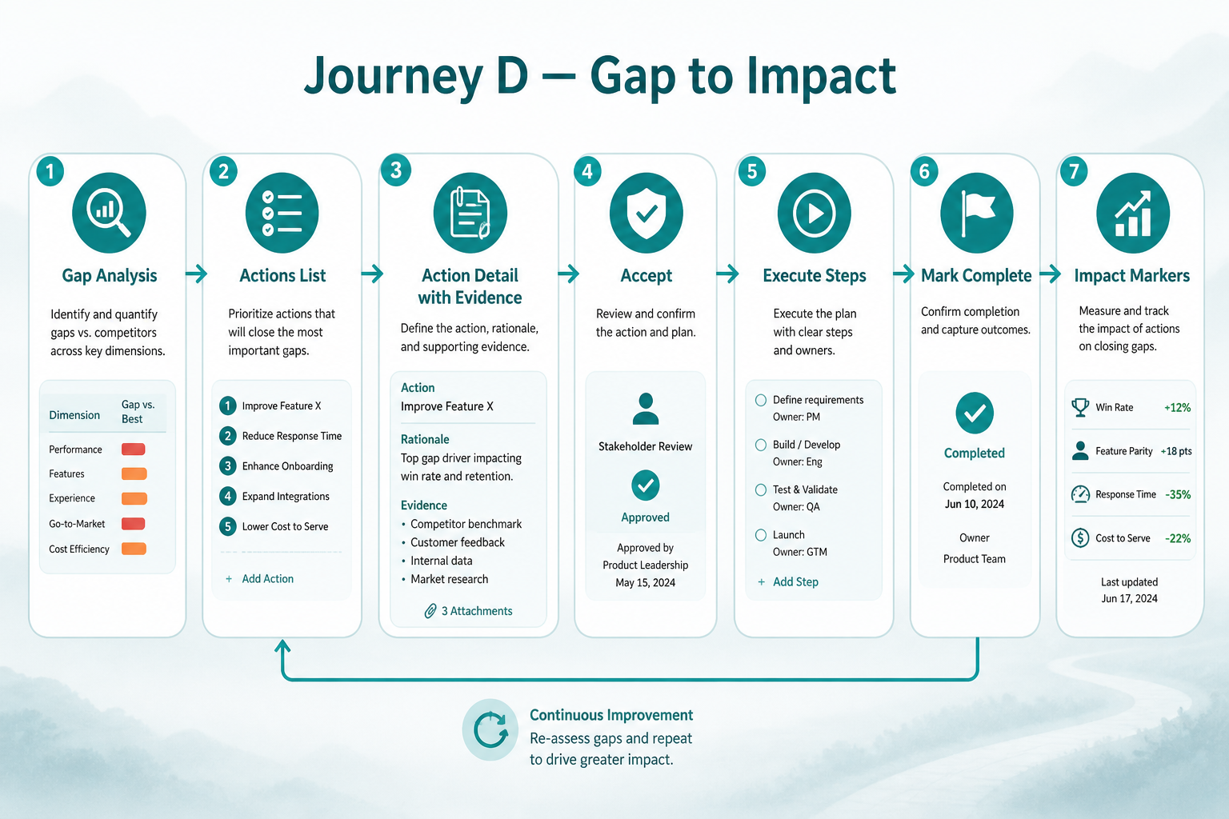
Figure 6 — Journey D: Gap → Action → Impact
- Find: Gap Analysis shows high gap score domains/URLs.
- Prioritize: Actions table by opportunity score and evidence.
- Decide: Open action brief; Accept or Decline.
- Execute: Toggle steps as external work finishes.
- Measure: Complete → Impact chart shows marker.

Journey E — Ecommerce shopping visibility (Sam)
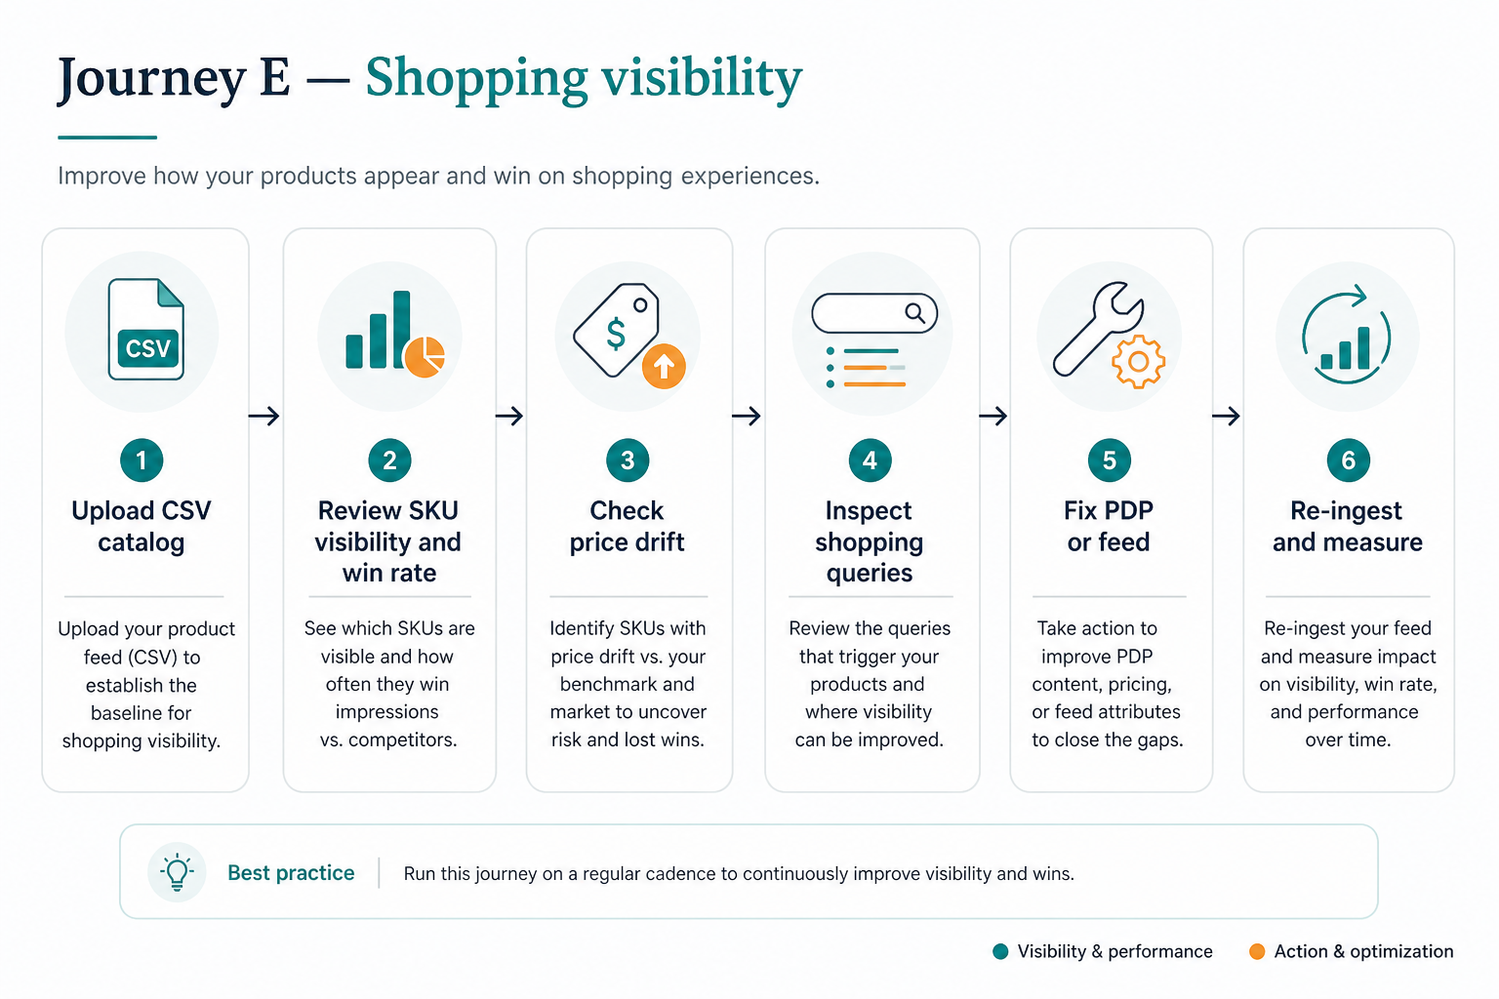
Figure 7 — Journey E: Shopping visibility
- Upload / ingest CSV catalog on Shopping.
- Review product visibility, win rate, position, price drift.
- Filter all products vs catalog-matched.
- Inspect shopping queries / demand.
- Confirm wrong prices in Fact-checking / Chats if present.
- Fix feed/PDP; re-ingest; watch win rate and drift.

Journey F — Agency pitch → retained client (Alex)
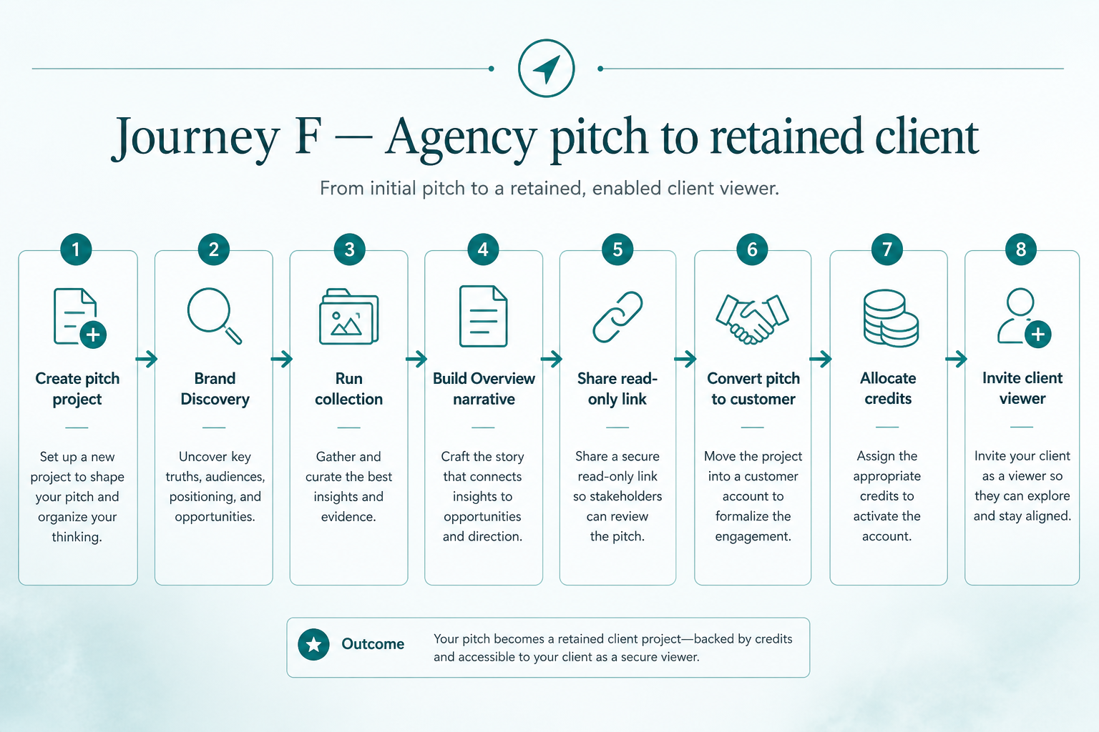
Figure 8 — Journey F: Agency pitch to client
- Create pitch project with limited prompt allowance.
- Seed brand profile + Discovery for prospect domain.
- Run collection (simulator or live APIs).
- Build narrative: Overview + Insights + one strong Action.
- Share read-only link with prospect.
- On win: convert pitch → customer in place (history preserved).
- Allocate credits; invite client as project viewer.
- Billing: monitor usage; pause only with eyes open (paused period data is lost).

Journey G — Platform integration (Riley)
- API keys: create (shown once), use x-api-key on /customer/v1/*.
- External tools pull same metrics as dashboard (parity promise).
- MCP: connect assistants with same authz as the user.
- SSO: configure IdP, test redirect, distribute SP metadata.
- Crawl Insights + AI Referrals: connect Cloudflare / GA-style data.

Journey H — Executive check-in (Chris)
- Opens shared link — no login.
- Reads own-brand KPIs and brand comparison table.
- Asks Maya: “What are we doing about the gap?” — Maya uses Actions/Impact.

7. Feature manual (by module)

7.1 Overview
Headline brand metrics, trend/rank visuals, recent chats, top actions, top domains; share a view; jump via ⌘K.

7.2 Brand Insights
Topic × channel performance; strongest/weakest channel — answer “we win on ChatGPT but lose on Perplexity for topic X.”

7.3 Channels
Per-engine health, visibility, chat volume, surface kind, collection mode / API key status.

7.4–7.5 Brand profile & Competitors
Edit identity and mark reviewed. Accept/reject suggested competitors. Position ranks include untracked brands by design.

7.6 Perception
Market attributes, objections, biggest gap cards — for messaging and positioning.

7.7 Fact-checking
Tabs: Contradicted / By fact / By category. Claims from AI chats judged against your asserted facts.

7.8 Prompts, Topics, Discovery
Create/edit/activate prompts; organize with topics/tags; CSV import; Discovery wizard with coverage report.

7.9 Sources & Gap Analysis
Domains/URLs metrics, classify, bookmark; Gap Analysis ranks pages that name competitors but not you.

7.10 Actions & Impact
Generate opportunity-scored recommendations; accept/decline/complete; Impact markers are correlational, not causal.

7.11 Chats, Fanouts, Ads
Atomic evidence runs; background queries; advertiser landscape when ads appear.

7.12 Agent analytics
Crawlability (robots.txt), Crawl Insights (bot visits), AI Referrals (floor, not total).

7.13 Shopping
Catalog ingest, SKU visibility / win rate / position / price drift.

7.14 Billing, API keys, SSO
Plan & usage; upgrade; pause with data-loss warning; API key lifecycle; enterprise SAML.

8. Persona → screens cheat sheet
Persona | Start here | Deep work | Prove value
Maya | Overview | Insights, Actions | Impact, Share
Jordan | Gaps | Domains/URLs, Fanouts, Crawl | Actions complete
Priya | Perception | Fact-checking, Chats | Cleared contradictions
Sam | Shopping | Price drift, catalog | Win rate
Alex | Billing / projects | Pitch Discovery | Shared client view
Riley | API keys / SSO | MCP, Crawl ingest | Parity checks
Chris | Share link | — | Impact story from Maya

9. Recommended first 30 days
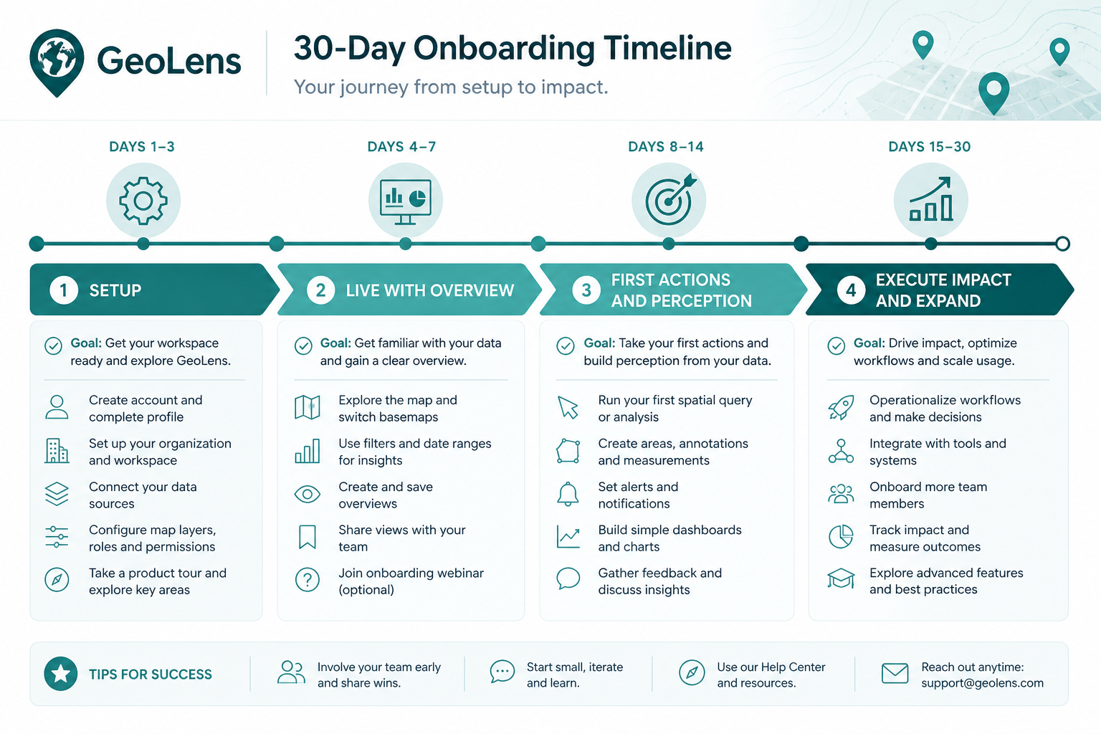
Figure 9 — First 30 days onboarding
Days | Focus
1–3 | Profile, competitors, Discovery, activate prompts, confirm Channels.
4–7 | Live with Overview + Chats; fix crawl blocks; bookmark top gaps.
8–14 | First Actions cycle; Perception + Fact-checking; Shopping catalog if ecom.
15–21 | Execute accepted actions; Fanouts refine prompts; Share stakeholder link.
22–30 | Impact review; API/MCP if needed; Billing quota hygiene; expand carefully.

10. Metrics glossary
Metric | Plain language
Visibility | How often your brand is named in answers.
Share of voice (SoV) | Your mention share vs other brands.
Position | Average rank among all brands named (including untracked).
Sentiment | How positively you are described when named.
Retrieval / citation | Your pages found vs explicitly cited.
Gap score | How often a source helps competitors and not you.
Win rate (Shopping) | How often your SKU wins vs alternatives.
Price drift | AI-stated price diverges from your catalog.

11. Plans, credits, and pausing
- Brand plans gate prompts, channels, projects, countries, frequency, and features (API, MCP, SSO).
- Agency plans use credits as allocation slots from prompts × models × run days — not a monthly spend wallet.
- Pitch projects have smaller allowance; convert to customer without losing history.
- Pause stops collection and frees allocation; data for the paused period is not recoverable.

12. Integrations
Surface | Who | Purpose
Web dashboard | All personas | Primary UX
Share links | Execs / clients | Read-only KPIs
Customer REST API | Riley | Automation, BI, custom apps
MCP | Riley / power users | Assistants querying GeoLens data
CSV | Jordan / Sam | Prompt import, catalog, log samples
SAML SSO | Enterprise | Corporate login
Cloudflare / GA-style | Riley / Jordan | Crawl Insights & AI Referrals

13. Honesty & limitations
- Simulator / API / UI surfaces differ — label collection mode in Channels.
- Impact is correlational — markers show when you worked, not proof of causation.
- AI Referrals are a floor — not all assistant traffic is measurable.
- Position includes untracked brands — rank can change when the market names someone new.
- Some UI affordances (Overview Export, full Brands CRUD, Project/tags filter chips) may be incomplete in a given build.

14. Demo & training path
- Marketing home → Open demo → /prj_demo/overview.
- Walk Overview → Insights → Channels.
- Open one Chat (prove atomic unit).
- Gap Analysis → one Action detail → Impact.
- Perception → Fact-checking.
- Crawlability → Shopping (if relevant).
- Settings: Billing quotas; API keys for technical buyers.

15. Document control
Field | Value
Title | GeoLens Product Manual
Formats | docs/PRODUCT_MANUAL.md + docs/GeoLens_Product_Manual.docx
Assets | docs/product-manual-assets/
Update when | Nav modules, personas, or commercial gates change
End of GeoLens Product Manual — Personas & User Journeys.

