VELLORE INSTITUTE OF TECHNOLOGY
SCHOOL OF COMPUTER SCIENCE AND ENGINEERING
COMPREHENSIVE MINI PROJECT REPORT
Weeks 1 to 4: Applied Data Science Analytics & Visual Intelligence Dashboards
Course: Programming for Data Science Lab (MACSE502) | Fall Semester 2026
Student Name | VEDANT NIMKAR
Registration Number | 26MML0045
Faculty In-Charge | Dr. Rajasekhara Babu M, Professor, School of CSE
Degree & Branch | M.Tech (Computer Science & Engineering)
Lab Modules Covered | Weeks 1 to 4 (Mini Project Extensions: Sl. No. 02, 04, 06, 08)
Submission Date | September 2026

Executive Summary & Architecture Scope
This laboratory mini-project report compiles a rigorous, four-phase data science engineering portfolio addressing complex, industry-aligned computational problem statements. Aligned with the MACSE502 syllabus and the official Lab Assessment Guidelines, each chapter implements the advanced Mini Project Extension prescribed for the respective week, elevating fundamental operations into fully functional data analytics engines.

Chapter 1: Week 1 Mini Project — E-Commerce Sales Analytics & BI Dashboard
An enterprise e-commerce platform monitors retail transaction velocity across 25 product lines. Beyond core pandas slicing and filtering, the Mini Project Extension develops a comprehensive Sales Analytics Dashboard that detects top-selling and lagging SKUs, evaluates category-wise revenue contribution, computes quarterly volume trends, and synthesizes automated executive business intelligence reports.
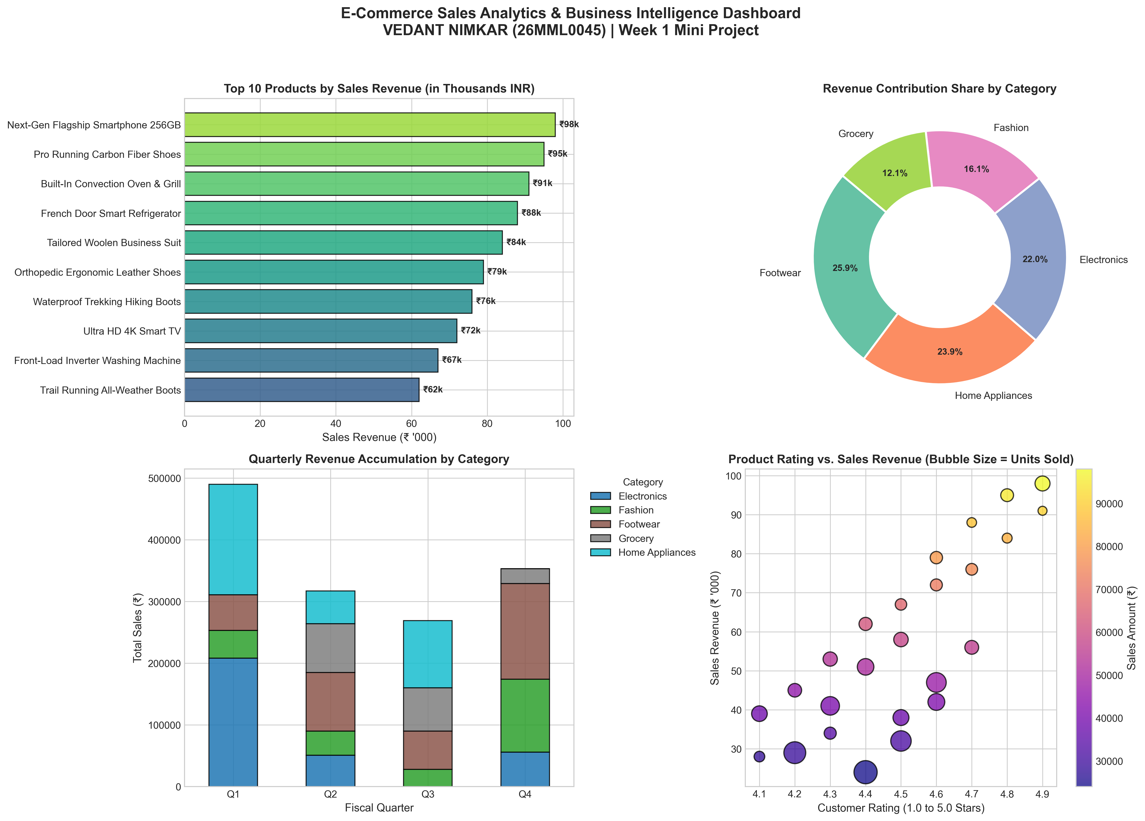
Figure 1.1: E-Commerce Sales Analytics & Business Intelligence Dashboard.

Chapter 2: Week 2 Mini Project — Smart Fleet Performance & Maintenance System
Commercial transportation networks face telemetry data degradation caused by sensor outages. This project implements mean imputation, dropping invalid identifiers, type conversion, and Min-Max scaling. The Mini Project Extension builds a Fleet Performance Monitoring System that detects fuel anomalies, audits route fuel expenditures, and computes a multi-attribute predictive maintenance urgency index.
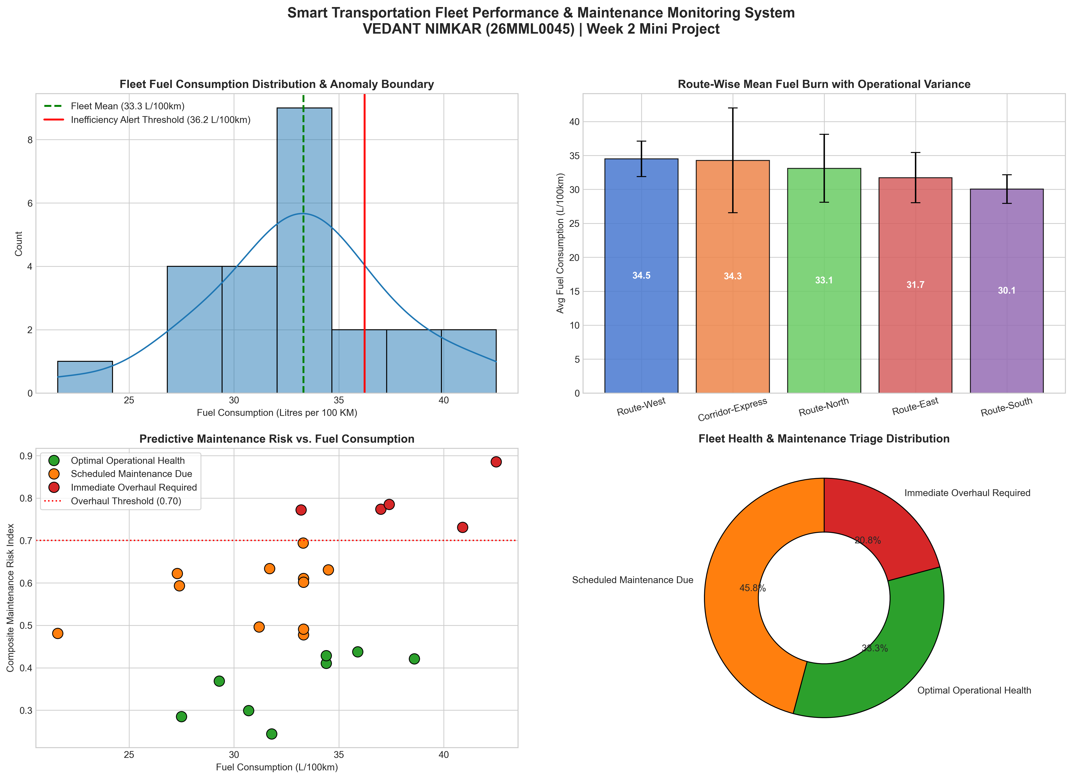
Figure 2.1: Smart Transportation Fleet Performance & Maintenance Dashboard.

Chapter 3: Week 3 Mini Project — Factory Production Analytics & Anomaly Detection
Industrial facilities track high-frequency production volume across multiple assembly lines and operating shifts. This project utilizes high-performance NumPy array operations to model a 4x5 production matrix. The Mini Project Extension implements Statistical Process Control (SPC), line capability calculations (Cp), shift bottleneck identification, and thermal/mechanical machine strain matrix modeling.
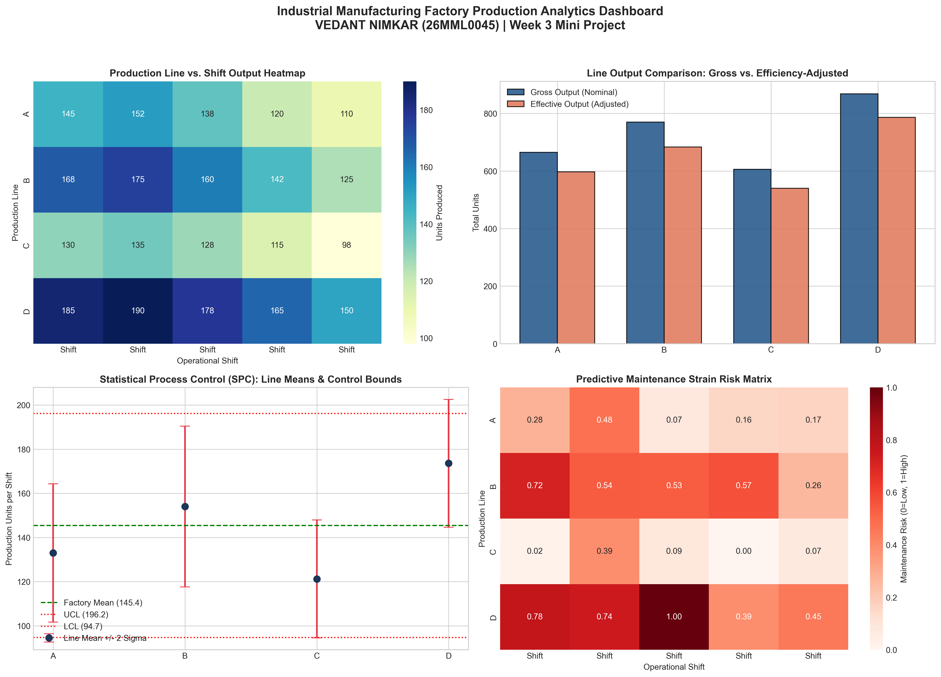
Figure 3.1: Industrial Manufacturing Factory Production Analytics Dashboard.

Chapter 4: Week 4 Mini Project — EdTech Student Success Prediction & Learning Analytics
Higher education institutions and EdTech platforms require early-warning systems to anticipate student academic attrition. This project engineers Log_StudyHours, discretizes quiz scores into performance tiers, calculates Pearson correlation matrices, and renders violin distribution plots. The Mini Project Extension designs the Composite Learner Engagement Index (CLEI), calibrates a logistic completion probability curve, segments students into retention risk tiers, and triggers automated personalized academic prescriptions.
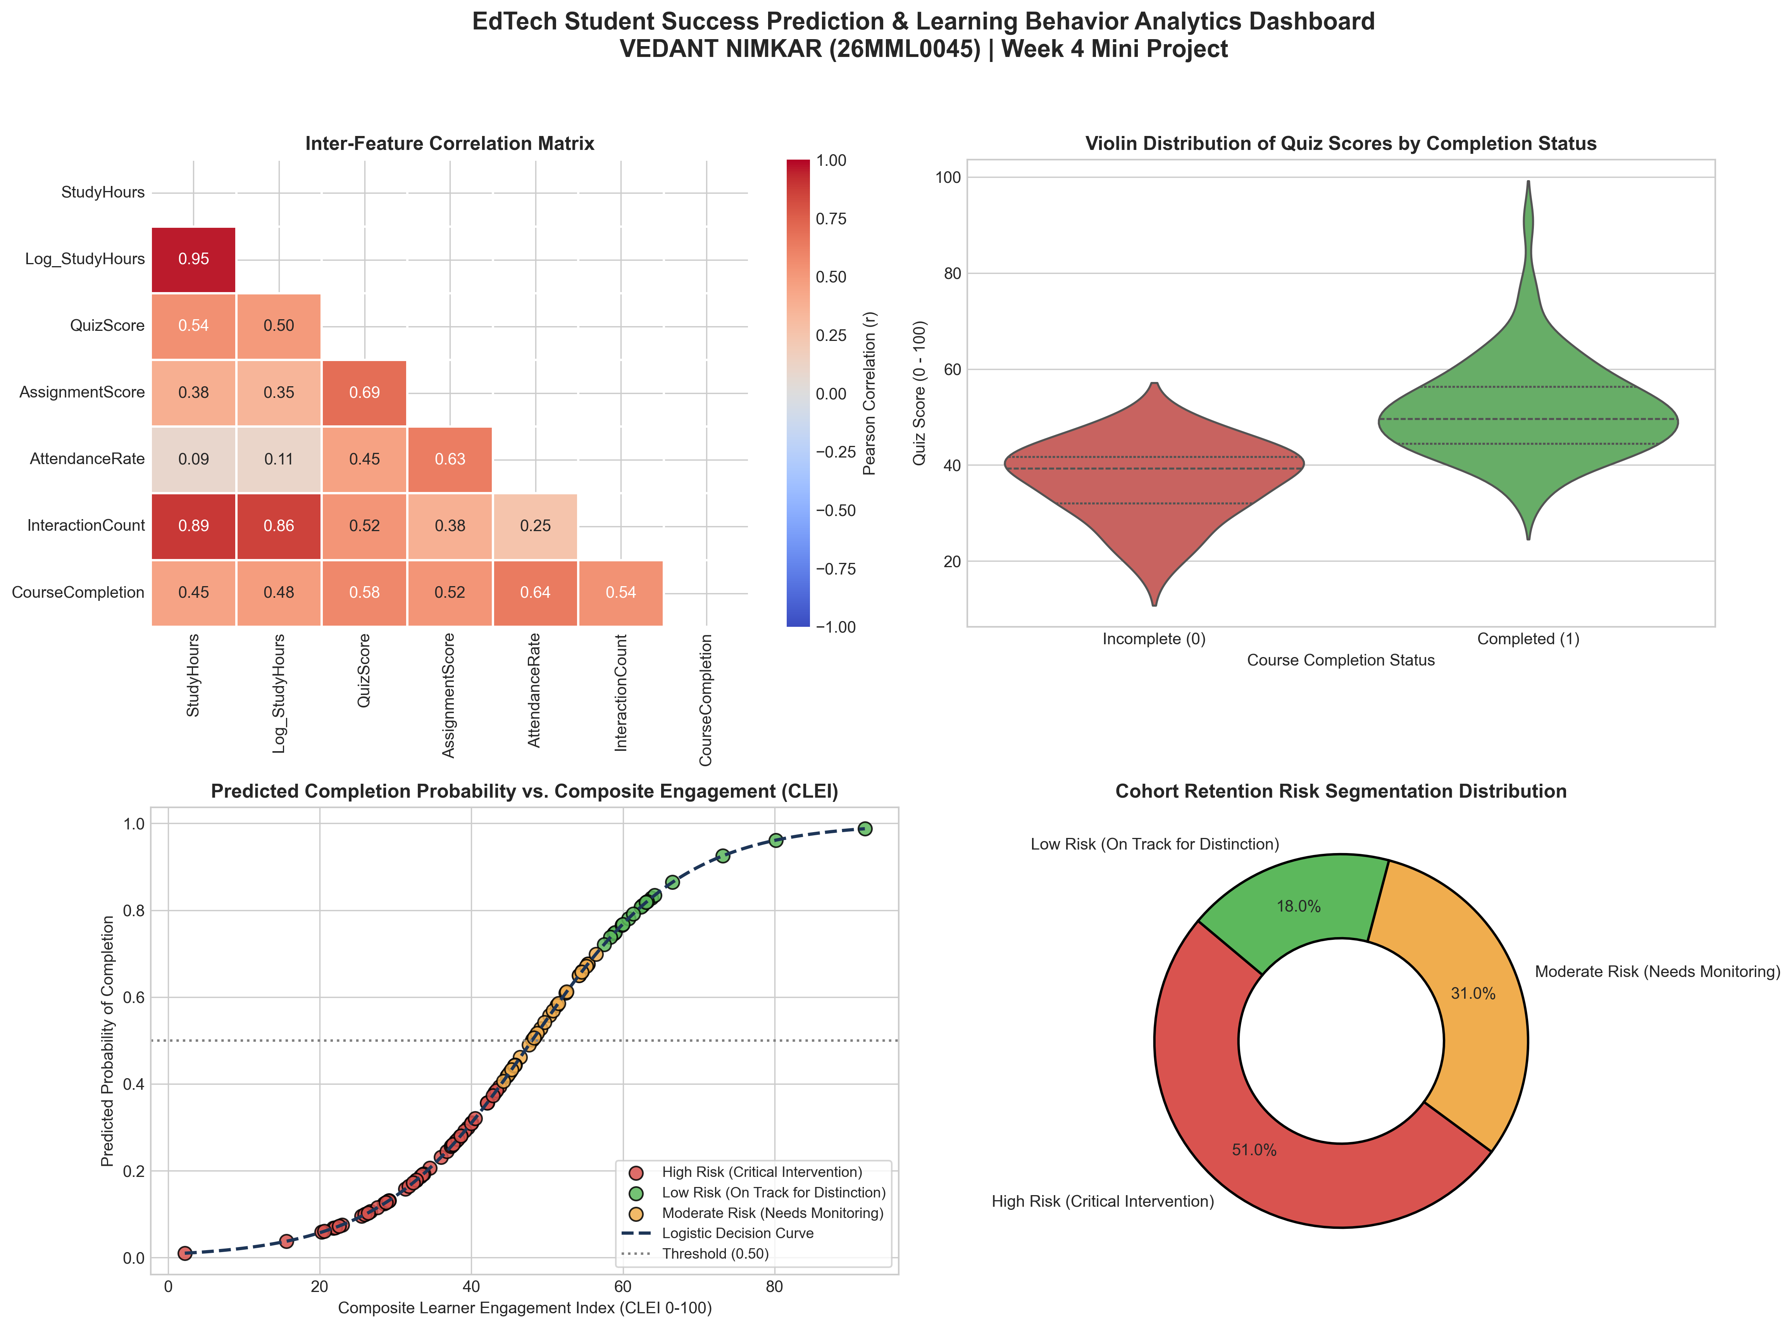
Figure 4.1: EdTech Student Success Prediction & Learning Analytics Dashboard.

Chapter 5: Cross-Cutting Synthesis & References
Across the four-week curriculum progression, each analytical tool builds upon prior foundational competencies: Pandas delivers high-level tabular transformations and multi-dimensional grouping; NumPy powers low-level vectorized matrix algebra and capability calculations; and Matplotlib/Seaborn provide the communication layer necessary to translate raw numerical results into actionable business intelligence dashboards.
- Wes McKinney, Python for Data Analysis, 3rd Edition, O'Reilly Media, 2022.
- Jake VanderPlas, Python Data Science Handbook, 2nd Edition, O'Reilly Media, 2023.
- Michael Freeman and Joel Ross, Programming Skills for Data Science, Addison-Wesley, 2018.
- Douglas C. Montgomery, Introduction to Statistical Quality Control, 8th Edition, John Wiley & Sons, 2019.
- Official Documentation: Pandas (https://pandas.pydata.org/docs/), NumPy (https://numpy.org/doc/stable/), Seaborn (https://seaborn.pydata.org/).
- Course Code Repository & Jupyter Notebooks: https://github.com/adminsharpcode/DataSciencesVTOP

