Digital Thread Analytics
Programming Frameworks for End-to-End Data Science Lifecycle Management
Design Document and Implementation Report
Durvesh M.
M.Tech — Project Design Study
20 September 2026
Case study: AI4I 2020 Predictive Maintenance Dataset

Contents

Abstract 3
1. Introduction 3
1.1 What a digital thread is 3
1.2 Why the data science lifecycle needs one 3
2. Related Work and the Gap 4
3. Problem Statement 4
4. Objectives 5
5. Reference Architecture 5
6. The Thread Ledger 6
6.1 Content-addressed identity 6
6.2 Append-only, enforced at the storage layer 6
6.3 One edge direction, following W3C PROV 7
6.4 Vocabulary 7
6.5 Interface 7
7. Technology Stack 8
8. Case Study: AI4I 2020 Predictive Maintenance 8
8.1 The data 9
8.2 Engineered features 9
9. Implementation Status 9
9.1 Model results 10
9.2 The feedback loop 10
10. Evaluation 11
10.1 Definitions 11
10.2 Results 11
10.3 Reading the overhead honestly 12
11. Phase-wise Plan 12
12. Deliverables 13
13. Limitations and Risks 13
13.1 Scale 13
13.2 Row-level provenance 13
13.3 Coverage depends on discipline 13
13.4 Dataset provenance in the present results 13
14. References 13

Abstract
Data science projects are routinely assembled from disconnected scripts and notebooks, with versioning applied inconsistently or not at all across data, features, code and models. The practical consequence is that a deployed model cannot be explained: nobody can state, with evidence, which rows of which dataset, transformed by which code, under which parameters, produced a given prediction. Reproducibility suffers, debugging becomes archaeology, and audit becomes impossible.
This project adapts the digital thread — the continuous, authoritative record that connects every representation of a product across its lifecycle in manufacturing — to the data science lifecycle. It designs and implements a lightweight, tool-agnostic lineage backbone in Python, the Thread Ledger, which captures and links artifacts across six lifecycle stages into one append-only graph that can be traversed in both directions. The framework is applied end to end to a predictive maintenance case study and evaluated against an equivalent pipeline carrying no thread.
A working implementation already exists and has been measured. Across five independent runs the framework achieves a 100 % reproducibility rate on content-addressed artifact identity and 100 % lineage completeness — every terminal artifact traces back to raw data. Provenance questions that a conventional pipeline cannot answer at all are answered in under half a millisecond. The instrumentation itself costs 1.9 % of pipeline runtime and 60 KB of storage.

1. Introduction

1.1 What a digital thread is
The term originates in defence and manufacturing engineering. It first appeared in the U.S. Air Force's Global Horizons report in 2013, and was refined academically by Singh and Willcox, who described a digital thread as a data-driven architecture serving as the primary or authoritative data and communication platform for a company's products. The essential claim is that product information should not live in per-department silos but in a continuous record that links every representation of the product — requirement, design, simulation, manufactured part, service history — so that any one of them can be traced to any other.
A digital thread is distinct from a digital twin, and the two are often conflated. The twin is a model of a thing; the thread is the connective record of how that thing came to be. The thread is the process, the twin is the technology built on top of it.

1.2 Why the data science lifecycle needs one
The analogy transfers almost directly. A machine learning model is a manufactured product: it is assembled from raw material (data), through a series of transformations (cleaning, feature engineering), by a documented process (code, parameters, environment), and then put into service where its behaviour is monitored. Each of those stages is well tooled in isolation. What is missing is the thread.
The cost of its absence is felt in four places. Reproducibility fails, because the exact combination of data version, code revision and environment that produced a result is not recorded. Debugging becomes archaeology, because explaining an anomalous production prediction means reconstructing a history nobody wrote down. Audit and compliance requests cannot be satisfied, because the evidence chain does not exist. And retraining is disconnected from monitoring, because the signal that a model has degraded has no recorded path back to the data that would fix it. A 2025 review in AI Magazine catalogues these barriers to reproducibility in machine-learning-based research, and the Princeton work on leakage and the reproducibility crisis documents how frequently published results do not survive replication.

2. Related Work and the Gap
The MLOps ecosystem is mature, and this project does not claim otherwise. What it claims is that the ecosystem's lineage capabilities are each scoped to one part of the lifecycle, and that no single record spans all of them.

Tool | What it records | Where it stops
MLflow 3 | Experiments, parameters, metrics, artifacts; dataset tracking links a logged dataset to a run and to a logged model | Scoped to its own tracking store; does not record data-validation outcomes, feature definitions, live serving events or drift observations as part of the same graph
DVC | Content-addressed versions of datasets and models, wired to Git | Versions files; does not express what the files mean to one another semantically
OpenLineage / Marquez | An open standard for job-and-dataset lineage in data pipelines | Data-engineering oriented; model training, promotion, serving and drift are not first-class
Great Expectations / Pandera | Data quality and schema validation results | The validation outcome is not linked forward to the model that was eventually trained on the data
Evidently | Drift and performance monitoring in production | The drift signal has no recorded edge back to the dataset or model that should be retrained
Feature stores | Feature definitions and serving consistency | Feature lineage is not joined to experiment and deployment lineage
Table 1 — Lineage coverage of the existing tooling, and where each one stops.
The gap is therefore not a missing tool but a missing join. Each system holds one segment of the provenance chain in its own vocabulary and its own store. The question “which raw rows, validated by which checks, transformed by which feature definitions, under which code revision, produced the model that generated this prediction, and what drift has since been observed on it?” crosses every one of those boundaries and can be answered by none of them. Closing that join is the contribution of this project.

3. Problem Statement
Data science projects are typically built as disconnected scripts and notebooks, with inconsistent or absent versioning across data, features, code and models. This breaks reproducibility, makes it hard to explain why a deployed model behaves as it does, and leaves audit and compliance requests unanswerable. This project designs and implements a digital thread framework — a lightweight, tool-agnostic lineage backbone in Python — that captures and links artifacts across the entire data science lifecycle into one append-only, bidirectionally traversable graph, and evaluates the reproducibility and traceability it provides against a conventional pipeline that carries no such record.

4. Objectives
The project is organised around five objectives, each producing something that can be inspected and argued about rather than merely asserted.

# | Objective | Evidence it produces
1 | Formalise the data science lifecycle through a digital-thread lens | A six-stage reference model with an explicit artifact and relation vocabulary
2 | Design a reference architecture with a central lineage ledger | Architecture and graph-schema specifications (Figures 1 and 2)
3 | Implement a working Python framework that captures and links artifacts automatically | A running codebase: the ledger, seven pipeline stages, a query interface and a visualiser
4 | Apply the framework end to end on a real case-study dataset | A complete traced pipeline on AI4I 2020, from raw file to drift report
5 | Evaluate the framework against a pipeline with no thread | Measured reproducibility, completeness, trace time and overhead
Table 2 — Objectives and the evidence each one is required to produce.

5. Reference Architecture
The architecture threads six lifecycle stages through a single shared record. The stages themselves are conventional; what is not conventional is that every stage both writes to and reads from a central ledger, and that an orchestrator wraps each stage in a ledger transaction so that nothing runs without leaving a trace.
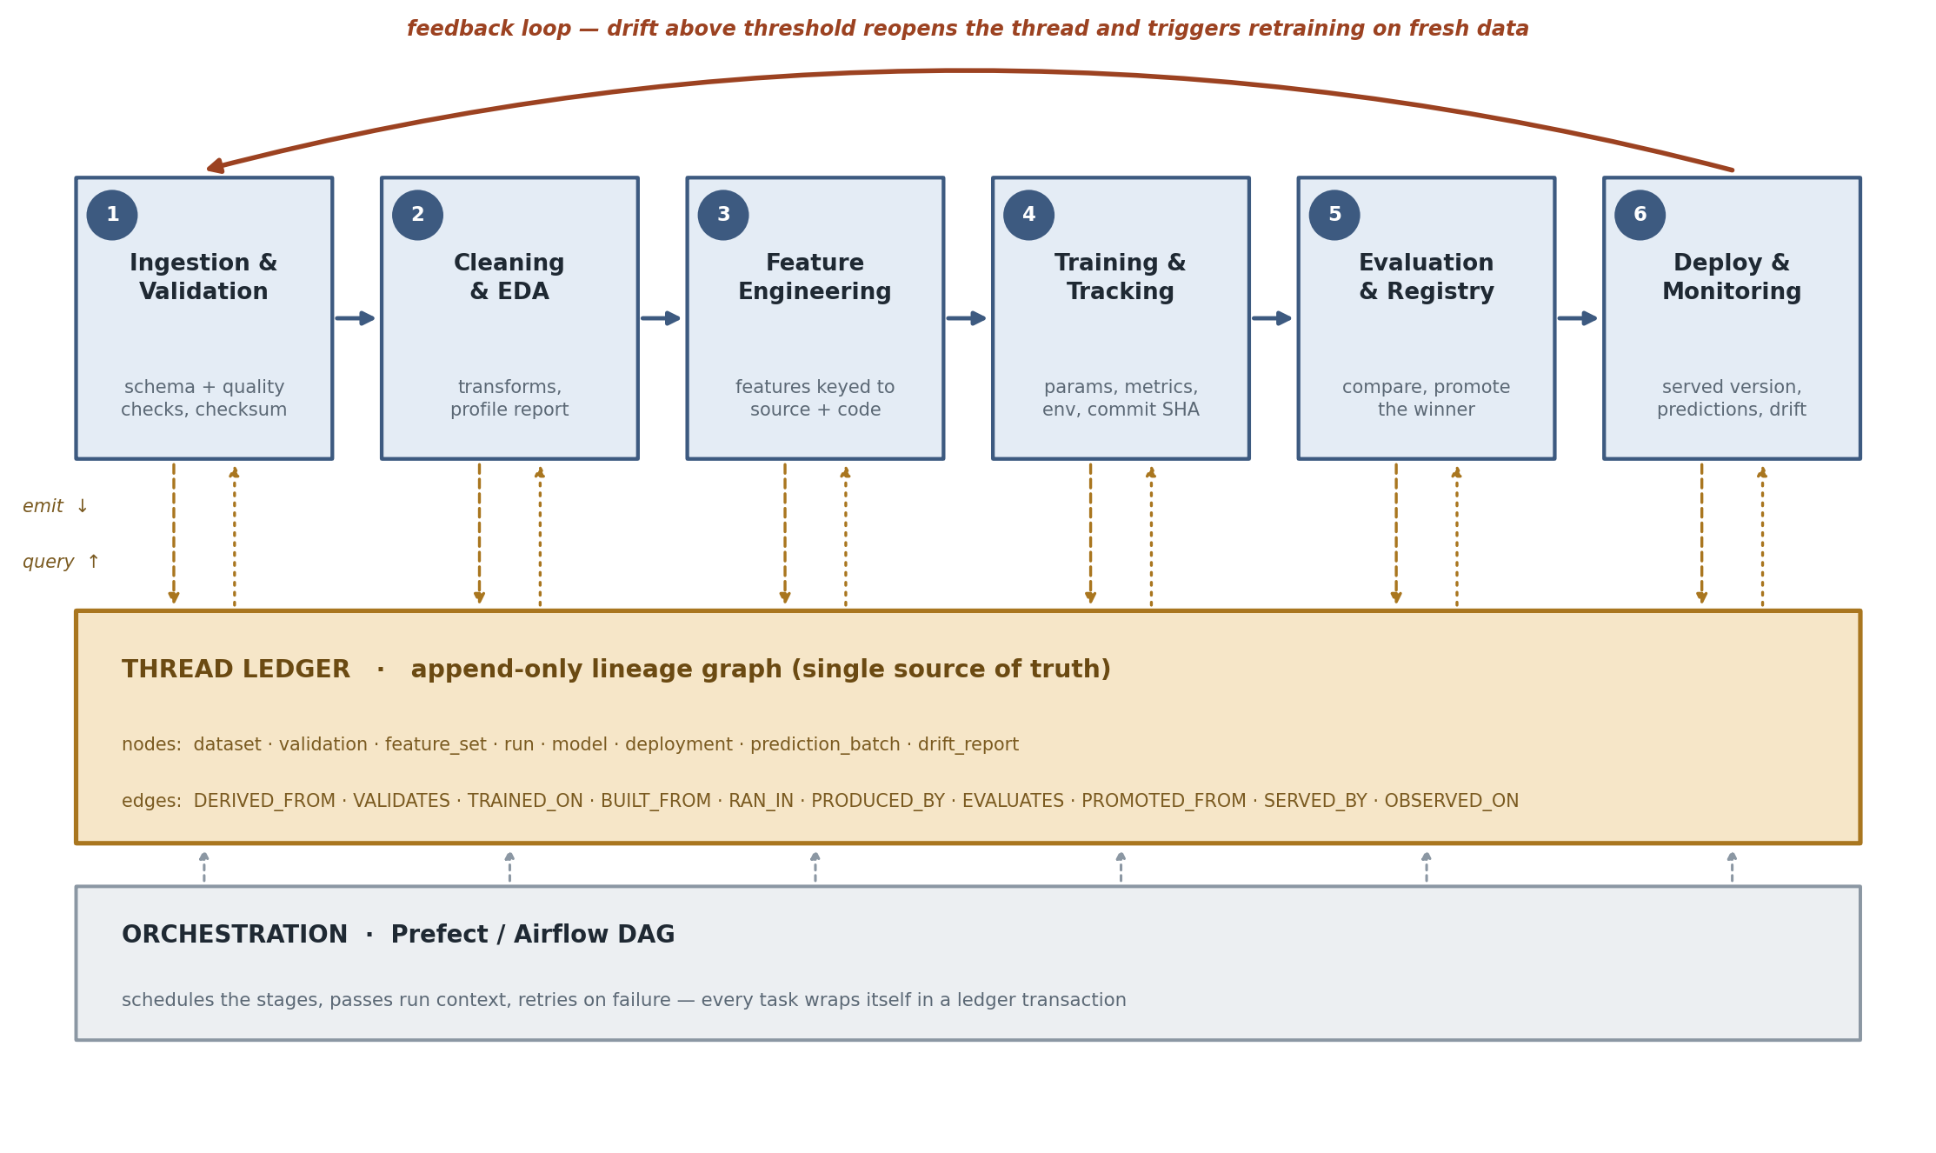
Figure 1 — Reference architecture. Six lifecycle stages threaded by a central append-only lineage ledger, with a feedback loop closing from monitoring back to ingestion.

Layer | Responsibility | Recorded in the ledger
1 · Ingestion & validation | Pull raw data, fingerprint it, run schema and quality expectations | dataset node with SHA-256 digest and row/column counts; validation node with every check and its verdict
2 · Cleaning & EDA | Drop identifiers and leakage columns, normalise, profile | A new dataset node linked DERIVED_FROM the raw one; the profile is an attribute, not a replacement
3 · Feature engineering | Build domain features, encode categoricals | feature_set node carrying the definition of every feature, not merely the output file
4 · Training & tracking | Train candidates, log parameters, metrics, environment | One run node per candidate, linked to its feature set, code revision and environment; a model node per result
5 · Evaluation & registry | Rank candidates, apply a promotion gate, promote the winner | evaluation nodes per candidate; a deployment node linked PROMOTED_FROM the winning model
6 · Deployment & monitoring | Serve predictions, compute drift, trigger retraining | prediction_batch and drift_report nodes; a TRIGGERS_RETRAIN edge back to the dataset when drift exceeds threshold
Table 3 — The six layers and what each one contributes to the thread.
The orchestration layer — Prefect or Airflow — schedules the stages and passes run context between them. It is deliberately kept outside the lineage code: the stage functions are plain functions of configuration and ledger, so swapping the scheduler changes nothing about what is recorded. The implementation ships both a plain-Python flow and an optional Prefect flow over the identical functions.

6. The Thread Ledger
The ledger is the contribution. It is a small append-only graph store with a tool-agnostic vocabulary, deliberately simple enough to be read and audited in an afternoon. Three design decisions carry it.

6.1 Content-addressed identity
A node's identifier is a digest of its type, name, version and content digest. Re-running an unchanged stage therefore produces the same identifier rather than a duplicate node. This is what makes the reproducibility measurement meaningful rather than circular: two runs are identical precisely when they land on the same identifiers, and identity is computed from content rather than asserted by the code that writes it.

6.2 Append-only, enforced at the storage layer
Lineage that can be quietly rewritten is not evidence. SQLite triggers reject UPDATE and DELETE on both the node and edge tables, so the constraint holds against any client, not merely against well-behaved framework code. One consequence shapes the design throughout: a run's status cannot be patched onto its node when the stage finishes. Instead a separate outcome node is written and linked, carrying the status and the wall-clock duration. The evaluation later reads per-stage timings back out of those outcome nodes — the ledger measuring itself.

6.3 One edge direction, following W3C PROV
Every edge points backwards in time, from an artifact to whatever it depended on. This mirrors the W3C PROV convention, in which wasDerivedFrom, wasGeneratedBy and used all point towards the past. Because the direction is uniform across the whole vocabulary, one traversal function is correct for the entire graph: follow edges outward to obtain provenance, follow them inward to obtain impact. An early version of this implementation mixed the two conventions, and the resulting traversal silently reached only a single node — a reminder that the value of a lineage graph collapses entirely if its semantics are not uniform.
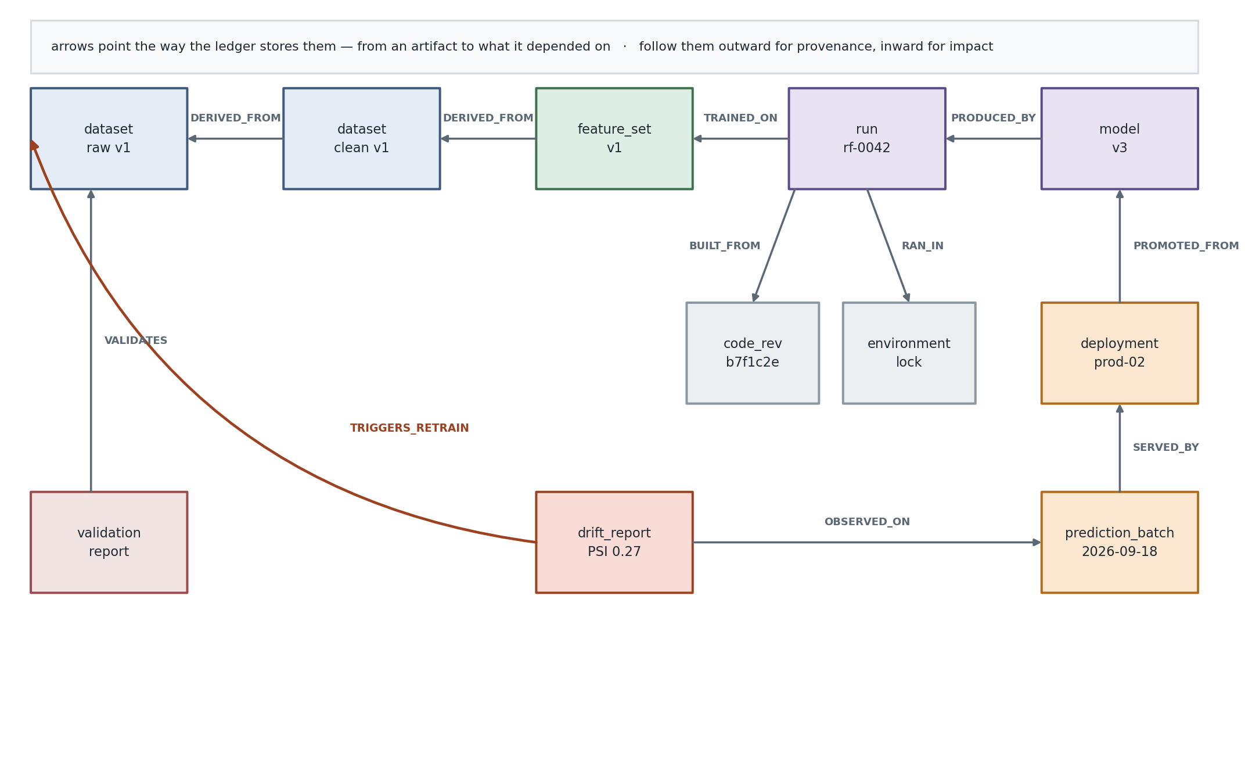
Figure 2 — Ledger graph schema: node types and typed edges recorded across one full pass of the lifecycle.

6.4 Vocabulary

Node types | dataset · validation · feature_set · code_rev · environment · run · model · evaluation · deployment · prediction_batch · drift_report
Edge types | DERIVED_FROM · VALIDATES · TRAINED_ON · BUILT_FROM · RAN_IN · PRODUCED_BY · EVALUATES · PROMOTED_FROM · SERVED_BY · OBSERVED_ON · TRIGGERS_RETRAIN
Table 4 — The complete vocabulary. Eleven node types and eleven relations cover the whole lifecycle.

6.5 Interface
A stage opens a run, attaches what it used and what it produced, and the ledger does the rest. The API a stage author sees is four calls wide:
with ThreadLedger("artifacts/thread_ledger.db") as led:
with led.run("train", code_rev=rev, environment=env, seed=42) as run:
run.used(feature_set_id, "TRAINED_ON")
model = run.node("model", "random_forest", digest=d, roc_auc=0.96)
run.produced(model)

led.upstream(model) # everything it depends on
led.downstream(raw) # everything raw data affects
led.trace(model) # grouped provenance bundle
Tool integration is by attribute rather than by dependency. MLflow run identifiers, DVC hashes and file paths are stored as plain attributes on the relevant nodes, so the ledger points at those tools without requiring any of them to be installed. That is the property that makes it a layer over the ecosystem rather than another competitor within it.

7. Technology Stack
Versions below are those current at the time of writing; the framework itself depends only on the core column.

Concern | Choice | Notes
Core | Python 3.10+, pandas, NumPy, scikit-learn, PyYAML | The only hard dependencies of the framework and pipeline
Lineage store | SQLite (standard library) | No server, no service; the ledger is a single portable file
Data validation | Built-in expectation suite; Pandera or Great Expectations as drop-in replacements | The ledger records the outcome in a tool-independent shape either way
Experiment tracking | MLflow 3.x, detected at import | Run identifiers stored as node attributes; the pipeline runs without it
Data versioning | Git + DVC 3.x | dvc.yaml defines the same stages the Python flow calls
Orchestration | Prefect 3.x or Apache Airflow 3.x | Both wrap the same orchestrator-agnostic stage functions
Serving | FastAPI + Uvicorn, Docker | Every response carries the deployment version and model digest
Monitoring | Built-in PSI; Evidently for richer reports | PSI thresholds configurable per deployment
Visualisation | Self-contained HTML with inline SVG | No CDN and no runtime dependency; the page is portable evidence of a run
Table 5 — Technology choices. Everything outside the core row is optional and detected at import time.

8. Case Study: AI4I 2020 Predictive Maintenance
The case study is deliberately chosen to sit close to the digital thread's industrial origins. The AI4I 2020 Predictive Maintenance Dataset from the UCI repository describes a milling machine over 10 000 process observations, with a binary machine-failure target and five documented independent failure mechanisms. It is small enough to iterate on quickly, severely imbalanced enough to make evaluation non-trivial, and — crucially for this project — it has a natural drift-and-retrain story, which makes the feedback loop concrete rather than theoretical.

8.1 The data

Field | Type | Role
Air temperature [K] | continuous | Process variable; with process temperature drives heat-dissipation failure
Process temperature [K] | continuous | Process variable
Rotational speed [rpm] | integer | Process variable; with torque determines power
Torque [Nm] | continuous | Process variable; drives power and overstrain failure
Tool wear [min] | integer | Accumulated wear; drives tool-wear and overstrain failure
Type (L / M / H) | categorical | Product quality variant; sets the overstrain threshold
Machine failure | binary | Target — 3.39 % positive
TWF, HDF, PWF, OSF, RNF | binary | Per-mechanism flags; dropped from the feature set as target leakage
Table 6 — The AI4I 2020 schema, and how each field is used.
Dropping the five per-mechanism flags is not incidental housekeeping. Each flag is a component of the target, so leaving any of them in the feature matrix produces a near-perfect model that has learned nothing. The decision is recorded on the cleaned dataset node as a dropped_columns attribute, which means the thread carries the reasoning, not just the result.

8.2 Engineered features
Three features are engineered directly from the documented failure physics, which is what makes them worth versioning as definitions rather than as an anonymous output file.

Feature | Definition | Mechanism it encodes
temp_diff_K | process_temp_K − air_temp_K | Heat-dissipation failure occurs below a 8.6 K difference with low rotational speed
power_W | torque_Nm × rot_speed_rpm × 2π/60 | Power failure occurs outside the 3500–9000 W band
wear_torque | tool_wear_min × torque_Nm | Overstrain failure occurs above a quality-dependent threshold
Table 7 — Engineered features and the documented failure mechanism each one encodes.

9. Implementation Status
The framework is implemented and running. Seven stages execute end to end, fifteen tests pass, and a full pass over the case study writes 32 nodes and 50 edges into the ledger in roughly two seconds.

Component | State
thread/ledger.py | Complete — append-only SQLite graph, content-addressed identity, run context manager, bidirectional traversal, cycle-safe
thread/context.py | Complete — dataset, code-revision and environment fingerprinting with instrumented timing
thread/query.py | Complete — command-line interface: stats, show, trace, impact, explain-model, export
thread/viz.py | Complete — layered self-contained HTML render of the graph, plus Graphviz export
pipeline/s1–s7 | Complete — ingestion and validation, cleaning and profiling, features, training, promotion, serving, monitoring
baseline/ | Complete — the control condition: identical models, no lineage
experiments/ | Complete — the four-part comparative evaluation
Orchestration | Plain-Python flow complete; Prefect flow written and activates when Prefect is installed; Airflow DAG outstanding
Serving | FastAPI service with /predict, /health and /lineage complete; containerisation outstanding
Dashboard | HTML lineage visualiser complete; interactive Streamlit dashboard outstanding
Table 8 — Implementation status by component.

9.1 Model results
Two candidates are trained and compared on average precision, which is the right primary metric for a positive class of roughly three per cent — ROC-AUC is misleadingly flattering at this level of imbalance.

Model | PR-AUC | ROC-AUC | F1 | Precision | Recall
Logistic regression | 0.269 | 0.824 | 0.168 | 0.094 | 0.794
Random forest (promoted) | 0.734 | 0.960 | 0.727 | 0.830 | 0.647
Table 9 — Candidate comparison. The random forest is promoted automatically by the configured gate.
The contrast between the two rows is itself instructive. Logistic regression with balanced class weights achieves high recall by flagging far too much: a precision of 0.094 means roughly nine false alarms for every true one. The random forest trades some recall for a precision of 0.83, and on average precision — the metric the promotion gate actually reads — it is better by a factor of nearly three.

9.2 The feedback loop
Drift is exercised by ageing the monitored batch: sixty additional minutes of tool wear and eight per cent more torque, applied only to the served batch and never to the training data, with the shift parameters recorded on the drift report so the experiment is honest about being simulated. The resulting Population Stability Index reaches 2.56 on tool wear and 1.06 on the derived wear-torque feature, far above the 0.20 threshold. The monitor writes a TRIGGERS_RETRAIN edge from the drift report back to the raw dataset node, which is the single edge that closes the thread into a loop.

10. Evaluation
The comparative study defines four measurements, each specified tightly enough that the resulting number can be defended rather than merely quoted.

10.1 Definitions

Measure | Definition
Reproducibility rate | Run the threaded pipeline R times into fresh ledgers and compare the content-addressed identities of the raw dataset, the cleaned dataset, the feature set and every model. A run counts as reproducible only when all of those identities match the first run's.
Lineage completeness | The fraction of terminal artifacts — models, deployments, prediction batches, drift reports — from which an upstream traversal reaches a raw dataset node. Anything below 1.0 means the thread is broken somewhere.
Trace time | Median wall clock over twenty trials to answer “which raw data, code revision and parameters produced this?” for a given artifact.
Overhead | Reported two ways: the time spent inside ledger writes as a share of comparable-stage runtime, and an end-to-end comparison against the no-thread baseline script restricted to the stages both perform.
Table 10 — How each measure is defined.

10.2 Results

Measure | With the thread | Baseline (no thread)
Reproducibility rate | 100 % over 5 runs (5 artifacts compared) | Not measurable — no artifact identity is recorded
Lineage completeness | 100 % (6 of 6 terminal artifacts) | 0 % — no lineage exists
Trace a deployed model | 0.18 ms, 9 nodes reached | Manual reconstruction from code
Trace a prediction batch | 0.26 ms, 13 nodes reached | Manual reconstruction from code
Trace a drift report | 0.31 ms, 15 nodes reached | Manual reconstruction from code
Ledger writes | 82 writes costing 0.037 s | —
Instrumentation cost | 1.9 % of comparable runtime | —
Content fingerprinting | 0.3 % of comparable runtime (212 digests) | —
End-to-end, like for like | 2.01 s (+23.8 %) | 1.62 s
Storage footprint | 60 KB for 32 nodes and 50 edges | —
Table 11 — Measured results, thread against baseline.

10.3 Reading the overhead honestly
The two overhead figures in Table 11 say different things, and reporting only one of them would be misleading. Writing lineage costs 1.9 per cent of runtime and fingerprinting a further 0.3 per cent; together that is the cost of the thread itself. The end-to-end difference of 23.8 per cent is larger because the threaded pipeline also persists intermediate artifacts, profiles and feature specifications that the baseline script holds in memory and then discards. That persistence is a precondition of traceability rather than an accident of implementation, so it belongs in the accounting — but it should be named for what it is rather than attributed to the ledger.
The comparison is also deliberately restricted. The threaded pipeline serves two prediction batches and computes a drift report; the baseline does none of that. Timing the whole flow against the baseline would charge the thread for work the baseline never performed, so the comparison covers only the six stages both execute, with per-stage durations read back out of the ledger's own outcome nodes.
The asymmetry in the first three rows is the result that matters. Overhead is a difference of degree — a fifth again on a two-second pipeline. Traceability is a difference of kind: the baseline scores zero not because it is slower at answering provenance questions but because it cannot answer them at all.

11. Phase-wise Plan
A sixteen-week schedule. Phases one through four are substantially complete; the remainder covers orchestration, the dashboard, scale testing and write-up.

Phase | Weeks | Work | Deliverable
1 | 1–2 | Literature review, gap analysis, architecture and schema design | This design document
2 | 3–4 | Environment, dataset acquisition, ledger core, ingestion and validation | Ledger package and stage 1, with tests
3 | 5–6 | Cleaning, profiling, feature engineering with recorded definitions | Stages 2–3 linked into the thread
4 | 7–8 | Training, experiment tracking, evaluation, promotion gate | Stages 4–5; candidate comparison recorded
5 | 9–10 | Serving, batch scoring, drift monitoring, feedback edge | Stages 6–7; FastAPI service; loop closed
6 | 11–12 | Airflow DAG, containerisation, Streamlit lineage dashboard | Orchestrated, deployable pipeline
7 | 13–14 | Scale testing on a larger dataset; MLflow and DVC integration hardening | Scalability results; integration notes
8 | 15–16 | Full comparative evaluation, ablations, report and presentation | Final report, results, presentation
Table 12 — Sixteen-week phase plan.

12. Deliverables
The project produces a codebase implementing the framework and the case-study pipeline; this design document; the architecture and schema specifications; a traced end-to-end pipeline on AI4I 2020 with recorded results; an HTML lineage visualiser and a planned interactive dashboard; the comparative study of thread against no-thread; and a final report with presentation.

13. Limitations and Risks

13.1 Scale
The results reported here come from a 10 000-row dataset and a graph of 32 nodes. SQLite and in-memory breadth-first traversal are comfortable at that size and will remain so for a long time, but the framework has not been tested at the scale where a graph database would earn its place. Establishing where SQLite stops being adequate is scheduled for phase seven, and it is the most likely source of an unwelcome result.

13.2 Row-level provenance
Lineage is currently recorded at artifact granularity: this dataset version, this feature set, this model. The framework can state which dataset version produced a prediction; it cannot yet state which rows within it were influential. Row-level provenance is a substantially harder problem and is explicitly out of scope, but it should be named rather than glossed over, because it is the first question a sceptical examiner will ask.

13.3 Coverage depends on discipline
The thread records what the stages tell it. A stage that performs an undeclared transformation produces a gap that the completeness metric will not detect, because the metric verifies that a path to raw data exists, not that the path is exhaustive. Orchestrator-level enforcement — refusing to run a task that does not open a ledger transaction — is the intended mitigation and is not yet implemented.

13.4 Dataset provenance in the present results
The results in Section 10 were produced on a machine whose network could not reach the UCI repository. The pipeline therefore fell back to a replica generated from the dataset's published description: the documented marginal distributions of the process variables, the five failure mechanisms, and the documented 3.39 per cent failure rate. The replica is not the dataset, and the ingestion stage records which of the two was used as an origin attribute on the dataset node. Results intended for publication must be regenerated against the real file with the fallback disabled. That this limitation is visible in the ledger rather than buried in a footnote is, in a small way, the entire argument of the project.

14. References
[1] U.S. Air Force Global Science and Technology Vision Task Force. Global Horizons: United States Air Force Global Science and Technology Vision. 2013. The report in which the term “digital thread” first appears.
[2] Singh, V. and Willcox, K. E. Engineering with a Digital Thread. AIAA Journal, 2018. Defines the digital thread as a data-driven architecture serving as the authoritative data and communication platform for a company's products.
[3] Matzka, S. AI4I 2020 Predictive Maintenance Dataset. UCI Machine Learning Repository, 2020. DOI 10.24432/C5HS5C. https://archive.ics.uci.edu/dataset/601/ai4i+2020+predictive+maintenance+dataset
[4] Semmelrock, H. et al. Reproducibility in Machine-Learning-Based Research: Overview, Barriers and Drivers. AI Magazine, 2025. https://onlinelibrary.wiley.com/doi/10.1002/aaai.70002
[5] Kapoor, S. and Narayanan, A. Leakage and the Reproducibility Crisis in ML-based Science. Princeton University. https://reproducible.cs.princeton.edu/
[6] Moreau, L. and Missier, P. (eds.). PROV-DM: The PROV Data Model. W3C Recommendation, 2013. The provenance model whose edge-direction convention this framework follows.
[7] MLflow Documentation — Dataset Tracking and Logged Models. https://mlflow.org/docs/latest/ml/dataset/
[8] OpenLineage — An Open Standard for Lineage Metadata Collection. https://openlineage.io/
[9] DVC — Data Version Control. https://dvc.org/
[10] Evidently AI — ML Model Monitoring and Drift Detection. https://www.evidentlyai.com/

