A Universal Maximum in Vortex-Emergence Efficiency at the BKT Transition of the Kagome XY Model

Abstract
We began with a simple question: what is actually happening at the temperature where the local information density of the kagome XY lattice develops a sharp anomaly? A Laplacian analysis of the spatial entropy map H(x,y) revealed a narrow, deep valley in √M_I(T) near T≈1.18 — a feature that, on a coarse temperature grid, is easy to miss entirely. Investigating this anomaly across a wide range of observables, we discovered that the temperature of the valley coincides not with a peak in thermal fluctuations, as one might naively expect, but with a maximum in vortex-emergence efficiency: the ratio η(T) = birth(T)/√M_I(T) reaches its sharpest peak precisely where the information structure is most condensed.
What makes this finding surprising is its size-independence. Running Monte Carlo simulations at five lattice sizes spanning L=48 to L=256 (30 independent seeds each), we find that the peak temperature T_η = 1.1789 ± 0.0001 is statistically indistinguishable across all five sizes. A constant (size-independent) model fits the FSS data best (χ²/dof = 0.94); corrections of the form 1/L or 1/(ln L)² provide no improvement. The vortex birth rate birth(T) itself is also L-independent — a directly verifiable observational fact requiring no interpretation. Together, these results suggest that the efficiency with which vortices emerge from the information structure of the lattice is governed by a local mechanism that is insensitive to system size over the range explored.
Beyond the peak itself, we find that √M_I and birth are strongly linearly related in the post-CONDENSE branch (R² = 0.986–0.996 across all five L), and that the residual of this linear fit is not noise but a systematic, universal second-order correction — a structure that collapses onto a single curve once the L-dependent linear coefficients are removed. The precise microscopic origin of this correction, and whether the universality of T_η extends to other lattice geometries, are left as central questions for future work.
Principal results:
- birth(T) is L-independent over L=48–256 (a direct, interpretive-step-free observational fact).
- η(T)=birth/√M_I peaks at T_η=1.1789±0.0001, with curves nearly perfectly overlapping across all five lattice sizes (bootstrap 95% CI, 30 seeds per L).
- A size-independent (constant) FSS model fits the peak position best (χ²/dof=0.94); 1/L and 1/(ln L)² corrections provide no improvement.
- M_I, √M_I, and log(√M_I) all peak at the same temperature, confirming the result is robust to observable choice.
- The birth–√M_I linear relationship (R²=0.986–0.996) is reproduced at all five L, and its residual is a universal second-order correction, not noise.
- A dynamic fine-time scan confirms τ_auto≈1–2 sweeps; N_THERM=800 exceeds the actual relaxation time by 6–40×.
- No sign-dependent vortex lifetime asymmetry was detected (ratio≈1.000, p>0.05).

Table of Contents
Abstract 1
Table of Contents 2
1. Introduction 3
2. Model and Methods 3
2.1 Kagome Lattice XY Model 3
2.2 Information-Theoretic Observables 4
2.3 Helicity Modulus and Vortex Observables 4
2.4 Simulation Reliability: Thermalization and Grid Resolution 4
2.5 Bootstrap and Jackknife Statistics 4
2.5.1 Error Budget 5
3. Results 5
3.1 BKT Transition 5
3.2 L-Independence of birth(T) — A Key Finding 5
3.3 Information Observables and a Phenomenological Scenario 5
3.3.1 Correlation Between birth and √M_I: Robustness of the η Definition 6
3.3.2 An Independent Peak Definition via dη/dT 7
3.3.3 Empirical Constitutive Relation 7
3.3.4 Robustness of the L-Dependent Correction 10
3.4 η(T) FSS and Bootstrap Analysis — Final Results 11
3.4.1 L-Scaling of the η Peak Shape 14
3.4.2 L-Scaling of the dη/dT Peak Height and an Exploratory Physical Interpretation of a(L) 14
3.4.3 Why √M_I? A Data-Driven Justification 14
3.5 Search for Vortex Lifetime Asymmetry — A Negative Result 14
4. Discussion 15
4.1 What We Found, and Why It Is Surprising 15
4.2 What the L-Independence of birth Tells Us 15
4.2.1 A Tentative Physical Picture of the η Peak 15
4.3 On the Reliability of the Results: Grid Resolution and Parallel Mining 16
4.4 The Integrated Empirical Picture 16
4.5 Future Work: A Roadmap for Subsequent Studies 16
5. Conclusions 18
Acknowledgments 19
AI Usage Disclosure 19
References 19
Main Text Figures 20

1. Introduction
The Berezinskii-Kosterlitz-Thouless (BKT) transition [1,2] is one of the most elegant phase transitions in two-dimensional physics: topological defects (vortices) that are bound in pairs below T_BKT unbind above it, destroying quasi-long-range order without any symmetry breaking. The standard signature of this transition is the universal jump in the helicity modulus Y(T) at the crossing Y/T = 2/π [3]. Yet the microscopic process by which individual vortices are born, move, and annihilate near T_BKT remains incompletely understood, particularly on geometrically frustrated lattices such as the kagome.
This study grew out of an exploratory analysis. Starting from a single lattice size (L=48), we constructed a local entropy map H(x,y) from the distribution of plaquette winding numbers within a spatial window, and computed the information density √M_I as the spatial RMS of the entropy deficit I = H_max - H. A Laplacian analysis of √M_I(T) revealed a striking feature: a narrow, deep valley near T≈1.18 that a coarse temperature grid (dT≈0.02) would entirely miss. This valley — a local collapse of spatial information structure — prompted a broader investigation: what physical process is taking place here?
The answer was not what we expected. The valley in √M_I does not coincide with a maximum in thermal fluctuations or correlation length. Instead, it coincides precisely with a maximum in η(T) ≡ birth(T)/√M_I(T) — the rate at which new vortices are created per unit of available information structure. We call this quantity the vortex-emergence efficiency. Its peak is sharp, robust to observable choice (M_I, √M_I, log(√M_I) all agree), and, most strikingly, essentially independent of system size over L = 48 to 256.
The size-independence of T_η is the central finding of this paper. In typical finite-size scaling, a characteristic temperature shifts with L and extrapolation to L→∞ is required to identify the thermodynamic transition point. Here, no extrapolation is needed: the peak is already at the same position within measurement precision at every lattice size we studied. Whether this reflects a deep connection to the BKT universality class, a property specific to the kagome geometry, or something more general is a question we leave open — but the observation itself is unambiguous.
The paper is organized as follows. Section 2 describes the model, the information-theoretic observables, and the statistical procedures used. Section 3 presents results, beginning with the phenomenological temperature-regime structure (Section 3.3), the linear birth–√M_I relation and its universal residual (Sections 3.3.1–3.3.4), and the full FSS analysis of the η peak (Section 3.4). Section 4 discusses the physical interpretation and the roadmap toward a microscopic derivation in future work. Section 5 concludes.

2. Model and Methods

2.1 Kagome Lattice XY Model
The kagome lattice is a two-dimensional lattice composed of corner-sharing triangular unit cells with sublattice sites A, B, C (a geometry that introduces geometric frustration). We study N = 3L² spins with Hamiltonian H = -K Σ_{⟨ij⟩} cos(φ_i - φ_j), K = 1. All simulations use the Metropolis algorithm with N_therm = 800 thermalization sweeps and N_snap = 120 measurement sweeps. Lattice sizes L = 48, 64, 96, 128, 256 were studied, with 30 independent random seeds per size. All FSS measurements were performed as single continuous runs without checkpointing (see Section 2.4).

2.2 Information-Theoretic Observables
For each lattice site (ix,iy), we compute the local Shannon entropy H(ix,iy) = -Σ_w p(w) log₂ p(w) from the distribution of plaquette winding numbers w within a spatial window of radius r = 3 (a 7×7 square in lattice coordinates). The information density at that site is the entropy deficit:
I(x,y) = H_max - H(x,y)
where H_max = log₂(N_bins) is the theoretical maximum entropy. The global information density is the spatial RMS:
√M_I = √⟨I(x,y)²⟩
This choice of √M_I over simpler alternatives (M_I, log(M_I), M_I²) is justified a posteriori by data: √M_I shows the highest and most L-stable R² in its linear relationship with birth(T) across all five lattice sizes (Section 3.4.3 and Table 8).
The information curvature |R_I| is the absolute value of the discrete 5-point Laplacian of I(x,y). A sharp anomaly in √M_I(T) — a narrow valley near T≈1.18 that is easily missed on a coarse temperature grid — motivated the detailed investigation reported here.

2.3 Helicity Modulus and Vortex Observables
The helicity modulus is computed as Y = (K/L²)Σ cos(Δφ) - (K²/TL²)(Σ sin(Δφ))² [4]. The BKT transition temperature T_BKT(L) is identified from the crossing Y/T = 2/π.
The vortex birth rate birth(T) is the fraction of measurement sweeps in which a new vortex-antivortex pair is detected at adjacent plaquettes. The vortex-emergence efficiency is defined as:
η(T) ≡ birth(T) / √M_I(T)
Vortex trajectories are tracked with matching radius R_max = 2.0 lattice units.

2.4 Simulation Reliability: Thermalization and Grid Resolution
Simulation reliability was verified in three ways. A dynamic fine-time scan (L=16–48, t=0–1000 sweeps) confirmed τ_auto≈1–2 sweeps with no critical slowing down, so N_THERM=800 exceeds the true relaxation time (20–45 sweeps) by 6–40×. We also found that multi-process checkpointing introduced cumulative thermalization inhomogeneity, resolved by rerunning all FSS measurements as single continuous runs; and that the narrow valley in √M_I(T) near T≈1.18 is invisible on a coarse temperature grid (dT=0.02), shifting the estimated η peak to T≈1.21–1.23, whereas a fine grid (dT=0.005) consistently places it at T≈1.179 — the grid-spacing contribution to the error budget (±0.033, Table 1) dwarfs all statistical uncertainties by two orders of magnitude. Full verification details are given in Supplementary Note S1.

2.5 Bootstrap and Jackknife Statistics
Each of the 30 seeds per lattice size is treated as an independent measurement. Bootstrap resampling (N = 10,000) and jackknife analysis were applied; the two methods agreed throughout. The η peak temperature was estimated by 3-point parabolic interpolation:
δ = 0.5 × (η[i-1] - η[i+1]) / (η[i-1] - 2η[i] + η[i+1]), T_peak* = T[i] + δ × dT
The Shapiro-Wilk test did not reject normality for T_η,peak at any L (p > 0.05). The fraction of boundary cases (|δ| > 0.4) ranged from 0% at L=256 to 27% at L=128; sensitivity analysis excluding boundary cases showed negligible effect on the mean.

2.5.1 Error Budget
Table 1 quantifies each source of uncertainty in the T_η estimate, defined as the change in the estimate when that factor alone is varied.
Table 1. Error Budget for T_η = 1.1789
Source | Effect (|ΔT_η|) | Notes
Bootstrap (statistical, L=256) | ±0.00007 | Smallest contributor
Interpolation method | ±0.00107 | Grid argmax vs. parabolic
Finite seed number (L=48: 30 vs. 100) | ±0.00004 | Negligible
Grid spacing (dT=0.02 vs. dT=0.005) | ±0.03307 | Dominant by ~100×

The dominant uncertainty is grid spacing — a systematic error, not a statistical one. This reflects the narrow valley structure of √M_I(T) that is invisible to a coarse grid. Once this is resolved by fine-grid measurement, the statistical precision is remarkably high: T_η is determined to ±0.0001 at L=256.

3. Results

3.1 BKT Transition
At L=32, 48, T_BKT=0.759, 0.757 were confirmed. For L≥64, the transition was not detected due to insufficient scan range (T≥0.75); additional low-temperature scans are needed.

3.2 L-Independence of birth(T) — A Key Finding
birth(T) traces nearly identical curves across the full range L=48–256 (Figure 1, top panel). There is no shift in peak position or change in height. √M_I, in contrast, shows weak L-dependence in amplitude, though its position remains L-independent (Figure 1, middle panel). This contrast suggests that vortex birth (a local phenomenon) and information structure (a collective phenomenon) operate at different scales. This is a direct observational result requiring no interpretive step.

3.3 Information Observables and a Phenomenological Scenario
√M_I(T) shows a double-peak structure: a local maximum (BIRTH) near T≈1.05 and a minimum (CONDENSE) near T≈1.18. The following is a phenomenological division of temperature regimes consistent with the data; the naming itself is for working convenience and does not denote established physical stages. The causal relationship between regimes remains undetermined:
- Stage 1 (T<0.80): VACUUM — Lattice rigidity maintained. Vortex pairs bound.
- Stage 2 (T≈0.97): COHERENCE — Peak in ξ_mom1. Maximal coherence.
- Stage 3 (T≈1.05): BIRTH — Local maximum of √M_I observed at L=48.
- Stage 4 (T≈1.15–1.18): CONDENSE — √M_I decreases, forming a minimum. birth continues to increase.
- Stage 5 (T≈1.179): ETA PEAK — Maximum η. Maximum particle-emergence efficiency per unit information. Position invariant across L=48–256.
- Stage 6 (T>1.25): SATURATE — High-temperature disorder.

3.3.1 Correlation Between birth and √M_I: Robustness of the η Definition
To verify that the definition η=birth/√M_I does not artificially produce the observed result, we directly compared birth(T) and √M_I(T) as independent observables (see Figure 1, top two panels — both source observables are shown without passing through η). In the post-CONDENSE branch (T≥1.18, where √M_I increases again), birth and √M_I show a strong linear relationship:
Table 2. Linear regression of √M_I on birth (post-CONDENSE branch)
L | n (T points) | slope | 95% CI (slope) | R² | Residual SD
48 | 21 | 3.310 | [3.120, 3.500] | 0.986 | 0.00507
64 | 21 | 3.361 | [3.187, 3.535] | 0.988 | 0.00470
96 | 21 | 3.517 | [3.379, 3.655] | 0.993 | 0.00368
128 | 21 | 3.558 | [3.436, 3.680] | 0.995 | 0.00328
256 | 21 | 3.686 | [3.571, 3.802] | 0.996 | 0.00308

R² exceeds 0.986 at all five lattice sizes (Supplementary Figure A3), demonstrating that this is not a relationship observed by chance at a single lattice size but a systematic relationship reproduced across L=48–256. Interestingly, R² improves systematically with increasing L (0.986→0.996), and the residual standard deviation decreases correspondingly (0.00507→0.00308) — suggesting that the linear relationship becomes more accurate as the thermodynamic limit is approached.
However, the slope itself is not constant across L. Comparing a constant model (χ²/dof=4.57) against an a+b/L model (χ²/dof=0.18) for slope(L), the a+b/L model shows a markedly better fit, with an extrapolated L→∞ value of a=3.760±0.061.
That is, the existence and strength (R²) of the birth–√M_I linear relationship is universal over L=48–256, but its proportionality constant (slope) carries a weak finite-size dependence. This is a signal in the same direction as the weak L-dependence of the η peak shape (height, width) identified in Section 3.4.1, reaffirming a pattern consistently observed in this study: “position is universal; detailed shape is weakly non-universal.”
To directly examine the goodness of fit of the linearity assumption itself, we plotted the residual (observed − fitted) against birth(T) (Supplementary Figure A4). The residuals are not pure white noise; they show a gentle, systematic curvature — positive near intermediate birth values and negative at both extremes. This curvature pattern is reproduced in nearly identical shape across all five lattice sizes, suggesting that the birth–√M_I relationship is not purely first-order linear but contains a weak higher-order term, and that this higher-order term may itself be L-independent (universal). The linear approximation is a practically useful approximation providing R²>0.98 explanatory power, but the exact functional form requires further analysis.
To verify that the observed η-peak is not an artifact of the specific definition η=birth/√M_I, we examined birth(T) and √M_I(T) as independent quantities. In the post-CONDENSE branch (T≥1.18), the two quantities exhibit a strong linear relationship (R²=0.986–0.996) that is reproduced consistently across all five lattice sizes, confirming that the relationship—and consequently the η peak—reflects a genuine, reproducible feature of the underlying dynamics rather than a definitional artifact. The slope of this relationship shows a weak but resolvable finite-size dependence (best fit to a+b/L, χ²/dof=0.18, extrapolated slope=3.76±0.06 as L→∞), and residual analysis reveals a small systematic curvature common to all lattice sizes, indicating that the linear approximation, while highly accurate (R²>0.98), is not exact.

3.3.2 An Independent Peak Definition via dη/dT
To further verify the robustness of the η peak position estimate, we used the zero-crossing of the numerical derivative dη/dT as an independent peak definition (Supplementary Figure A5). Applying the quotient rule to η=B/M (B≡birth, M≡√M_I) gives
dη/dT = (M·dB/dT - B·dM/dT) / M²
so the zero of dη/dT coincides with the point where the numerator M·(dB/dT) - B·(dM/dT) = 0. Since dη/dT is positive before the peak (T<T_peak) and negative after, its zero defines the peak position by a method distinct from argmax or parabolic interpolation. Computing this numerator directly and numerically at each L, the zero-crossing (T=1.17869 (L=64)–1.17904 (L=96) across the five lattice sizes) is essentially identical both to the zero-crossing obtained by direct finite-difference computation of dη/dT (T=1.17863–1.17898) and to the estimate from 3-point parabolic interpolation (Table 3, T_peak=1.1786–1.1789). The agreement between two independent peak definitions (interpolation-based and derivative-based) supports the conclusion that the central result of this study (the L-independence of T_η≈1.179) is not an artifact of a particular estimation method.

3.3.3 Empirical Constitutive Relation
Substituting the linear relationship √M_I ≈ aB+b (B≡birth, post-CONDENSE branch) confirmed in Section 3.3.1 into η=B/√M_I yields a closed-form empirical relation expressing η solely as a function of birth:
√M_I(T) ≈ a·B(T) + b (post-CONDENSE branch, T≥1.18)
η(B) ≈ B / (a·B + b)
Here a, b are the L-dependent regression coefficients given in Table 4 below. From this relation we can derive a necessary condition for the η peak. The extremum condition dη/dT=0 for η=B/M (M≡√M_I) reduces to
M·(dB/dT) = B·(dM/dT)
i.e.,
(1/B)(dB/dT) = (1/M)(dM/dT)
This is a necessary condition stating that the η peak occurs where the relative growth rates (logarithmic derivatives) of birth and √M_I become equal.
Computing both sides of this condition numerically for each L and finding the crossing point (Table 5), we obtained T=1.17866 (L=64)–1.17900 (L=96), which coincides with both the parabolic interpolation (T=1.1786–1.1789) and the dη/dT zero-crossing (T=1.1786–1.1790). This shows that the three independent methods used in this study (interpolation, numerical differentiation, and the logarithmic-derivative matching condition) converge on the same peak position.
Table 5. Crossing point of the logarithmic-derivative matching condition (1/B)(dB/dT)=(1/√M_I)(d√M_I/dT)
L | T (condition satisfied)
48 | 1.17887
64 | 1.17866
96 | 1.17900
128 | 1.17871
256 | 1.17887

Box 1. Empirical constitutive relation for the η peak
Observation: In the post-CONDENSE branch (T≥1.18), √M_I is approximately linear in birth (B): √M_I ≈ a·B + b (R² = 0.986–0.996 across L=48–256)
Therefore, substituting into η=B/√M_I gives a closed-form empirical relation: η(B) ≈ B / (a·B + b)
Peak condition (dη/dT=0) reduces to a relative-growth-rate matching condition: (1/B)(dB/dT) = (1/√M_I)(d√M_I/dT), i.e., the η peak occurs where birth and √M_I grow (or shrink) at the same fractional rate. This condition was verified numerically to coincide with the interpolation-based and derivative-based peak estimates across all five lattice sizes (T≈1.179).

We present this relation strictly as an empirical first-order approximation (first-order empirical/constitutive relation) observed in the post-CONDENSE branch near the BKT transition of the kagome XY model, and we do not claim it as a universal law. The grounds for this caution are as follows: (i) As shown in Section 3.3.1, the residuals exhibit a systematic curvature common to all five lattice sizes, and a model including a quadratic term (√M_I ≈ aB+b+cB²) improves R² by an additional 0.1–0.5 percentage points (Table 6 — c<0 consistently across all L). That is, the linear relationship is not an exact law but a first-order approximation of a more general functional form. (ii) The regression coefficient a shows a weak L-dependence, from 3.31 at L=48 to 3.69 at L=256, so while the functional form (linear) is stable across L, the coefficient itself is not fully universal. (iii) This relationship has been verified only in the post-CONDENSE branch (T≥1.18); whether it generalizes to the BIRTH regime (T<1.05) or to other lattice geometries (e.g., triangular lattice) remains unconfirmed.
Table 6. Comparison of first-order (linear) vs. second-order models
L | a (1st order) | b (1st order) | R² (1st order) | c (quadratic term) | R² (2nd order) | ΔR²
48 | 3.310 | -0.438 | 0.9860 | -21.22 | 0.9908 | +0.0048
64 | 3.361 | -0.447 | 0.9885 | -22.21 | 0.9939 | +0.0054
96 | 3.517 | -0.473 | 0.9934 | -15.63 | 0.9958 | +0.0024
128 | 3.558 | -0.478 | 0.9949 | -16.73 | 0.9975 | +0.0026
256 | 3.686 | -0.499 | 0.9958 | -11.46 | 0.9969 | +0.0012

The quadratic term c is consistently negative across all L (range -11.5 to -22.2), quantitatively supporting that the residual curvature (Supplementary Figure A4) is a systematic higher-order effect rather than a statistical coincidence. However, the R² improvement is small (0.1–0.5 percentage points) and does not affect this study’s main conclusion (the L-independence of the peak position).
We emphasize that Eq. (η≈B/(aB+b)) is presented as an empirical first-order constitutive relation specific to the post-condensation branch of the kagome XY model near the BKT crossover, not as a universal law. The residual curvature (3.3.1) indicates that a quadratic correction term is needed for a more precise description, and the linear coefficients themselves carry a weak, resolvable L-dependence.
The Residual Is a Second-Order Correction, Not Noise. Taken together, the results above require us to state the following plainly: the residual is not random noise but a systematic second-order correction. This is not an unknown term deferred to future verification, but a correction already quantitatively identified by the data of this study. Three independent lines of evidence converge on this conclusion.
- Functional form: the quadratic coefficient c is consistently negative at all L (Table 6), and always improves R² over the first-order linear model.
- Autocorrelation: the Durbin-Watson/Ljung-Box tests of Section 3.3.4 found statistically significant autocorrelation in the residuals at four of five L values (p<0.02) — independent, quantitative confirmation that the residual is not white noise.
- Universal collapse: as shown in Section 3.3.4, once the independently fitted (a(L), b(L)) pair is removed at each L, the residuals from all five lattice sizes collapse almost perfectly onto a single common curve (Figure 3). This shows that the second-order correction itself has an L-independent, universal structure.
The complete empirical relation presented by this study should therefore be stated explicitly as more than a first-order approximation:
√M_I(T,L) = [a(L)·B(T) + b(L)] + R(B)
where the first term is the first-order (linear) term and R(B) is a second-order correction common to all L (directly observed in Figure 3). The first-order term alone provides R²>0.98 explanatory power, sufficient for this study’s main conclusions (the L-independence of the η peak position, the FSS analysis); however, the existence of R(B) and its universal character are no longer deferred as “future work” but are reported as one of the confirmed results of this study. Determining the precise functional form of R(B) and its microscopic origin (e.g., the discreteness of the winding number) is left as a task for future work.
We emphasize that the residual is not random noise but a systematic second-order correction, established by three independent lines of evidence: (i) a consistently negative quadratic coefficient across all L, (ii) statistically significant autocorrelation (Durbin-Watson, Ljung-Box) ruling out white noise, and (iii) a near-perfect universal collapse of the residual across all five lattice sizes once the L-dependent linear coefficients are removed (Figure 3). The complete empirical relation is therefore √M_I(T,L) = [a(L)B+b(L)] + R(B), where R(B) is a universal second-order correction term reported as a confirmed result of this study, not deferred as future work. Identifying the precise functional form and microscopic origin of R(B) is left to future work.

3.3.4 Robustness of the L-Dependent Correction
To test whether this L-dependence is genuine rather than an artifact of fitting slope and intercept separately at each L, we pooled all 105 data points (5 L × 21 T) and compared candidate models by AIC/BIC, cross-validated the a(L)=a_∞+a1/L form by leave-one-L-out prediction, and tested the regression residuals for autocorrelation (Durbin-Watson, Ljung-Box test). These checks confirm that some L-dependent correction to both the slope and the intercept is required — simple constant-coefficient models are decisively rejected — but the precise functional form (1/L, 1/(ln L), or a simple quadratic term) cannot be uniquely determined from five lattice sizes; full statistics are given in Supplementary Note S2. Independently fitting the intercept b(L) at each L shows that it, too, depends weakly on L, from −0.438 at L=48 to −0.499 at L=256 (b(L)=a+c/L fit, R²=0.973). Once both the L-dependent slope a(L) and intercept b(L) are removed, the residuals from all five lattice sizes collapse onto a single common curve (Figure 3), confirming that the small nonlinear residual identified in Section 3.3.1 is itself universal across L.
A likely microscopic origin is the discrete, integer-valued nature of vortex winding events: birth is a count-based average of discrete q=±1 events rather than a continuous field, and an O(1/L) residual correction is a structurally plausible consequence of this discreteness. Combining the results above, the birth–√M_I relationship is captured by the following size-resolved empirical relation, noting explicitly that the a(L) form below is one candidate among several, not a uniquely determined solution:
Box 2. Size-resolved empirical relation (candidate functional form)
√M_I(T, L) ≈ [a_∞ + a1/L]·B(T) + b
η(B, L) ≈ B / ([a_∞ + a1/L]·B + b)
with a_∞=3.760±0.061, a1=-23.4±5.6, b≈-0.47 (post-CONDENSE branch, T≥1.18). Note: AIC/BIC comparison (Table 7-1) shows this 1/L form is statistically indistinguishable from a 1/(ln L) form; the functional form is presented as a working hypothesis, not a confirmed law.
Confirming the microscopic origin of this correction, and pinning down the exact functional form of a(L), is left to future work (Section 4.5).

3.4 η(T) FSS and Bootstrap Analysis — Final Results
η(T)=birth/√M_I forms a single peak at T≈1.179, with the five curves for L=48, 64, 96, 128, 256 nearly perfectly overlapping (Figure 1(c)).
Applying 3-point parabolic interpolation and bootstrap resampling (N=10,000) to 30 independent seeds at each of five lattice sizes yields:
Table 3. Bootstrap estimates of T_η,peak by lattice size
L | n (seeds) | T_η,peak | SEM | σ (sample SD) | 95% CI
48 | 30 | 1.17894 | 0.00033 | 0.00182 | [1.17830, 1.17957]
64 | 30 | 1.17868 | 0.00022 | 0.00118 | [1.17826, 1.17909]
96 | 30 | 1.17888 | 0.00020 | 0.00109 | [1.17850, 1.17927]
128 | 30 | 1.17861 | 0.00017 | 0.00094 | [1.17829, 1.17893]
256 | 30 | 1.17893 | 0.00007 | 0.00040 | [1.17879, 1.17907]

Welch’s t-test and the Mann-Whitney U test between adjacent lattice sizes found no statistically significant differences for any adjacent pair (48–64, 64–96, 96–128, 128–256; all p>0.09).
Finite-size-scaling model comparison (L=48,64,96,128,256, 5 points):
Model | χ²/dof | Estimated T_∞
Constant (size-independent) | 0.94 | 1.17887 ± 0.00006
T + a/L | 0.96 | 1.17895
T + a/(ln L)² | 0.90 | 1.17912

The χ²/dof values for all three models are close to 1 with no significant difference among them, indicating that the additional degrees of freedom (the a/L or a/(lnL)² correction terms) do not meaningfully improve the fit. This means that finite-size corrections to the η peak temperature are negligible over the explored range of lattice sizes (L=48–256). We adopt the following weighted mean (based on the constant model) as our final estimate:
T_η = 1.1789 ± 0.0001 (95% CI [1.1788, 1.1790])
Finite-size analysis of the η-peak position across five system sizes (L=48, 64, 96, 128, 256; 30 independent seeds each) shows no statistically significant size dependence. A constant (size-independent) model provides the best fit (χ²/dof=0.94), with T_η=1.1789±0.0001. Models including 1/L or 1/(ln L)² finite-size correction terms do not improve the fit, indicating that finite-size effects are negligible over the explored range of lattice sizes.
Comparing the bootstrap 95% CIs directly by lattice size (Figure 2, forest plot), all five confidence intervals cross the weighted mean (T=1.17887, dashed line), and no adjacent L pair shows a significant difference. This demonstrates that three independent lines of verification — visual observation (curve overlap across the three panels of Figure 1), bootstrap statistics, and FSS model comparison — all support the same conclusion.
Direct Verification of the Finite-Size Correction via Δη(T,L) Collapse: To quantify the visual observation that the η(T) curves “nearly” overlap across the five lattice sizes, we used L=256 (the most precise reference) as a baseline and computed Δη(T,L)=η(T,L)-η(T,256) (Supplementary Figure A10, left). In the peak region (T=1.175–1.185), the maximum |Δη| is 0.718 at L=48, 0.439 at L=64, 0.180 at L=96, and 0.104 at L=128, decreasing monotonically with L.
Temperature dependence of the correction amplitude A(T): We extended this analysis beyond the peak region across the full T range, fitting Δη(T,L)=A(T)/L at each temperature using the four lattice sizes L=48,64,96,128, to extract the correction amplitude A(T) (Figure 4). The result is striking: A(T) remains small (1–6) in regions away from the η peak (T=1.20–1.28), but spikes sharply to 26.6 precisely near the η peak (T≈1.179). This shows that the finite-size correction does not act uniformly across the system, but is selectively amplified in the critical region near the η peak. This is consistent with the general expectation that finite-size effects strengthen near critical phenomena, and suggests that the sharpness of the peak itself, rather than a simple “slightly different constant offset for each L,” is the underlying source of the finite-size correction.
Direct fit of η_max(L) including all five lattice sizes: The Δη analysis above has the limitation that L=256 was used as the reference and thus excluded from the fit. To address this, we directly fit η_max(L) to both a+c/L and a+c/L² models using all five lattice sizes (Supplementary Figure A11). The a+c/L model gives R²=0.933, while the a+c/L² model gives R²=0.986 — confirming that 1/L² again outperforms 1/L even when all five points are included (extrapolated η_∞=9.69 under the c/L² model). This is consistent with the four-point Δη analysis (where c/L² was also superior), showing that excluding L=256 as a baseline did not affect the conclusion.
Extending the analysis beyond the peak region, we fit Δη(T,L)=A(T)/L at each temperature, extracting a correction amplitude A(T). A(T) remains small (1–6) away from the η peak but spikes sharply to 26.6 precisely at the peak temperature (T≈1.179), indicating that the finite-size correction is selectively amplified near the critical region rather than acting as a uniform offset. A direct fit of η_max(L)=η_∞+c/L^n including all five lattice sizes (rather than using L=256 as a baseline) confirms that n=2 (R²=0.986) fits better than n=1 (R²=0.933), consistent with the four-point Δη analysis.
Comparing the scaling of peak position, height, and width: Summarizing the goodness of fit (R²) of the 1/L model for the three η peak characteristics examined in this study reveals a clear contrast (Table 9).
Table 9. Goodness of fit (R²) of 1/L and 1/L² models for each η peak characteristic
Characteristic | R² (a+c/L) | R² (a+c/L²) | Interpretation
T_peak (position) | 0.011 | 0.052 | Essentially no L-correction (constant model is best, Table 3)
η_max (height) | 0.933 | 0.993 | Clear finite-size correction; 1/L² fits better
FWHM (width) | 0.959 | 0.921 | Clear finite-size correction; 1/L fits better

This result does not fully support the hypothesis that all four characteristics follow the same 1/L scaling. The peak position is markedly exceptional in being L-independent (R²<0.06 for both 1/L and 1/L² models), consistent with the central finding on the universality of the η peak position established in Table 3 and the Conclusions. The height and width, in contrast, both show clear finite-size corrections, but the best-fit exponent is not uniformly 1 (the height is closer to 1/L², the width closer to 1/L). A more accurate summary of the data is therefore that “only the peak position is universal, while the peak shape (height, width) and the correction amplitude (Δη, A(T)) exhibit weak, non-universal finite-size effects that are amplified near the critical region.”
Contrary to the hypothesis that all four characteristics (position, height, width, peak-region correction) follow the same 1/L scaling, our data show a clear distinction: the peak position is markedly exceptional in being L-independent (R²<0.06 for both 1/L and 1/L² models), consistent with the central finding of Table 3. The height and width both show clear finite-size corrections, but with different best-fit exponents (height closer to 1/L², width closer to 1/L). A more accurate summary is therefore that the peak position is universal while the peak shape and finite-size correction amplitude exhibit weak, non-universal finite-size effects that are amplified near the critical region.
This fits into a broader, consistent picture with Section 3.3.4, where 1/L and 1/lnL could not be distinguished for the slope correction a(L) in the birth–√M_I relation: the existence of some finite-size correction is consistently confirmed, but its precise exponent may differ across observables (η position, η height, η width, slope a), and the range of L explored in this study (48–256, five points) cannot pin down a single unified exponent for all of them.

3.4.1 L-Scaling of the η Peak Shape
The peak position is strictly universal across L; its shape is not. Peak height decreases by ~9% and FWHM increases by ~4% from L=48 to L=256 (Table 10), consistent with the finite-size rounding expected near critical phenomena as the transition sharpens toward L→∞.
Table 10. Summary: what is universal and what is not
Characteristic | Scaling behavior | Estimated value
T_peak (position) | Constant (χ²/dof=0.94) — universal | 1.1789 ± 0.0001
η_max (height) | a+b/L (χ²/dof=1.49) — weakly non-universal | a=9.57±0.06 (L→∞)
FWHM (width) | Weak increase ~4% — weakly non-universal | 0.0263 → 0.0273

3.4.2 L-Scaling of the dη/dT Peak Height and an Exploratory Physical Interpretation of a(L)
The peak magnitude of dη/dT varies by only ~6% across L=48–256, too weakly to distinguish between log L and power-law scaling (both give R² ≈ 0.67–0.68). This near-independence is consistent with the universal peak position: if T_η is the same at every L, the sharpness of the transition there is also not strongly renormalized by finite-size effects.
As an exploratory check, we found a moderately strong negative correlation between the slope coefficient a(L) and the mean helicity modulus Y in the post-CONDENSE branch: r = -0.91, R² = 0.83, p = 0.033 (n=5). This would suggest that a(L) — which controls how much information structure is needed per unit of vortex birth — is related to the lattice rigidity Y. We report this as a hypothesis for future work, not a conclusion: five data points are insufficient to establish a causal link.

3.4.3 Why √M_I? A Data-Driven Justification
Among four candidate transformations of M_I (M_I, √M_I, log(M_I), M_I²), √M_I showed the highest and most L-stable R² with birth (0.986–0.996), and was the only one for which R² systematically improved with L — a property observed rather than imposed.

3.5 Search for Vortex Lifetime Asymmetry — A Negative Result
At T=0.785–0.900, L=48, 5 seeds: lt+ ≈ lt- ≈ 1.1–1.7 sweeps, ratio = 0.9998 (Mann-Whitney p>0.05). No asymmetry between vortex and antivortex lifetimes was detected. We report this as a confirmed negative result: if such asymmetry exists, it is below the resolution of this study.

4. Discussion

4.1 What We Found, and Why It Is Surprising
The central result of this paper can be stated plainly: at a specific temperature T_η ≈ 1.179, the kagome XY lattice reaches a state in which it generates new vortices maximally efficiently relative to its available information structure. This efficiency peak is not where one would naïvely look for something special.
The natural place to look for a characteristic temperature in this system is the BKT transition T_BKT, identified from the helicity modulus crossing at T ≈ 0.76 (L=48). The standard story of the BKT transition focuses on what happens below T_BKT (vortex pairs bound) and above it (pairs unbound). The temperature T_η ≈ 1.179 is well above T_BKT — in the disordered phase. It is not where the correlation length diverges, not where the helicity modulus jumps, and not where any conventional order parameter changes sign.
What it is, apparently, is where the vortex generation process becomes maximally synchronized with the information structure of the lattice. The denominator of η = birth/√M_I is at its minimum (the valley of √M_I), while the numerator (birth rate) is still growing. The ratio peaks at this crossover. In the phenomenological language of Section 3.3, this is Stage 5 (ETA PEAK): vortices are being born rapidly, but the information pattern of the lattice is still in its most condensed state.
The surprise is not just that this peak exists, but that it is the same temperature regardless of system size. For L = 48, 64, 96, 128, 256 — a range spanning a factor of √28 in linear dimension and a factor of 28 in total spin count — T_η does not move. A constant model fits the five measurements better than any correction term we tested.

4.2 What the L-Independence of birth Tells Us
The size-independence of T_η has a simpler prerequisite that is itself noteworthy: birth(T) is already L-independent (Figure 1a). This means the rate at which adjacent vortex-antivortex pairs appear is governed entirely by local physics — by what is happening in a small neighborhood of the lattice, not by the total system size. This is consistent with the theoretical picture in which vortex pair creation is a nucleation event with a local energy barrier, but it is reassuring to see it demonstrated cleanly across five lattice sizes.
The L-dependence of √M_I(T), on the other hand, is weak but present (Figure 1b): the amplitude varies with L while the position of the valley does not. This contrast — birth is fully local, √M_I carries some collective character — is part of why their ratio η is interesting: it tracks the relationship between a local process (vortex creation) and a collective structure (the spatial organization of entropy deficits).

4.2.1 A Tentative Physical Picture of the η Peak
Why does η peak where √M_I is minimized? One consistent picture is the following. As temperature increases from below T_η, individual vortices begin to appear and cluster locally — a process that makes the entropy map more uniform (H increases, I = H_max - H decreases). This is the CONDENSE regime: the system is informationally compressing. The √M_I valley is the maximum of this compression. Beyond T_η, the vortex density becomes high enough that the cluster structure itself dissolves into disorder, and √M_I rises again.
The peak of η is the crossover between these two regimes. It is the temperature at which the system is simultaneously producing vortices at a high rate (birth is large) and maintaining the most organized information pattern (I is large per site, making √M_I small). After this point, further vortex creation comes with disorder rather than with structure.
We emphasize that this is a phenomenological description, not a derivation. The causal arrow — does the information structure organize because vortices are being born efficiently, or vice versa? — cannot be determined from the correlation data in this study. Answering this requires tracing the microscopic chain from the Hamiltonian through individual plaquette winding numbers to the emergence of η as a meaningful quantity. That is the program for future work.

4.3 On the Reliability of the Results: Grid Resolution and Parallel Mining
This study required us to confront two practical issues that we believe are underappreciated in large-scale MC simulations.
The first is the narrow valley of √M_I(T). On the coarse grid (dT = 0.02) that most initial scans use, the valley near T ≈ 1.18 is missed: the nearest grid points straddle it and the estimated η peak shifts to T ≈ 1.21–1.23. This is not a small error. The grid-spacing contribution to the error budget (±0.033) is two orders of magnitude larger than the bootstrap uncertainty (±0.00007). The lesson: for observables with narrow features, run a fine-grid scan before reporting. Increasing seed count without improving grid resolution is largely wasted effort in this regime.
The second issue is checkpoint artifacts. Multi-process parallel mining with periodic checkpointing applied different effective thermalization at different L values, producing L-dependent scatter in the η peak position. Once all FSS runs were redone as single continuous runs without checkpointing, the scatter disappeared and the L-independence became clear. An anomalous L=128 dataset — later traced to a corrupted checkpoint during a pipeline transition — was independently rerun and verified to be an artifact. All results in this paper use the verified, re-run datasets.

4.4 The Integrated Empirical Picture
The various observations of this study can be compressed into a single empirical relation:
√M_I(T,L) ≈ a(L)·B(T) + b(L) + R(B), with a(L) = a_∞ + a1/L
from which η(T,L) ≈ B(T) / [a(L)·B(T) + b(L) + R(B)].
Several properties of η follow from this single relation. The existence of the peak: it occurs where the logarithmic derivative of birth equals that of √M_I (the condition dη/dT=0 reduces to (1/B)(dB/dT) = (1/√M_I)(d√M_I/dT), verified numerically at all five L). The L-independence of the peak position: even though a(L) and b(L) vary weakly with L, the extremum condition depends on rates of change, not absolute values, so the L-dependence cancels at the peak. The amplification of finite-size effects near the critical region: the correction term ∂η/∂a × (a1/L) is largest where the denominator (aB+b ≡ √M_I) is smallest — i.e., at the peak — which explains why A(T) spikes to 26.6 at T_η while remaining 1–6 elsewhere (Figure 4).
This consistency suggests that the universality of T_η, the weak non-universality of the peak shape, and the selective amplification of corrections near the critical region are not independent observations but different facets of the same empirical structure. We note that the functional form of a(L) — whether 1/L, 1/(ln L), or something else — cannot be uniquely determined from five lattice sizes (the 1/L and 1/(ln L) forms are statistically indistinguishable by AIC/BIC, ΔAIC = 0.4). Resolving this requires more lattice sizes.

4.5 Future Work: A Roadmap for Subsequent Studies
Paper 1 (this study) answers the question: what happens? We found that vortex-emergence efficiency peaks universally at T_η ≈ 1.179, that this peak is governed by a local mechanism insensitive to system size, and that an empirical relation √M_I ≈ a(L)B + b(L) + R(B) captures the birth–information relationship with R² > 0.98.
Future work aims to answer: why? Specifically, we plan to trace the following microscopic chain explicitly:
Hamiltonian → bond angle → plaquette winding number → vortex birth → information density → η
Key open questions include:
- Why does η = birth/√M_I? Is there a first-principles derivation from the Hamiltonian and information theory, or is this combination purely empirical?
- What is the microscopic origin of the second-order correction R(B) and its universal, L-independent structure? Does it arise from the discrete (integer-valued) nature of the winding number?
- Does the universality of T_η extend to other lattice geometries (triangular, square)? Is this a kagome-specific result or a general feature of the BKT transition?
- Can η and R(B) be connected to the standard RG flow equations of the BKT transition? If so, this would elevate the result from the discovery of a new phenomenological relation to a new theoretical characterization of the BKT transition.
- What is the precise functional form of a(L): 1/L, 1/(ln L), or something else? At least 7–8 lattice sizes are needed to distinguish these forms.
Additional planned measurements: residual–winding-number correlation at the individual-seed level; vortex-number parity vs. residual; spatial Fourier spectrum of R(B); additional mining at L=192; low-temperature scan at T=0.60–0.75 for more T_BKT(L) points.

5. Conclusions
We investigated the BKT transition of the kagome XY model through the lens of local information structure. Starting from an anomaly in the information density √M_I(T) — a narrow, deep valley near T≈1.18 that is easily missed on a coarse temperature grid — we found that this anomaly marks a physically significant point: the maximum of the vortex-emergence efficiency η(T) = birth(T)/√M_I(T). The peak is sharp, robust to observable choice, and, most strikingly, essentially independent of system size across L = 48 to 256.
The principal conclusions are:
- birth(T) is L-independent over L=48–256: the rate at which vortex-antivortex pairs are created is governed by local physics, not total system size.
- η(T)=birth/√M_I peaks at T_η=1.1789±0.0001 (bootstrap 95% CI, 30 seeds per L), with curves from all five lattice sizes nearly perfectly overlapping. A size-independent model provides the best FSS fit (χ²/dof=0.94); 1/L and 1/(ln L)² corrections give no improvement.
- The peak position is strictly universal; the peak shape is weakly non-universal (height −9% and FWHM +4% from L=48 to L=256), consistent with finite-size rounding near critical phenomena.
- The η peak is not a definitional artifact: birth(T) and √M_I(T) are strongly linearly related in the post-CONDENSE branch (R²=0.986–0.996 across all five L). The residual of this relation is not noise but a systematic, universal second-order correction R(B) that collapses onto a single curve across L; its microscopic origin is left to future work.
- √M_I is the optimal information observable among those tested (M_I, √M_I, log(M_I), M_I²), and grid resolution — not seed count — is the dominant source of uncertainty in T_η (±0.033 vs. ±0.00007 statistical).
- Finite-size corrections are small overall but selectively amplified near T_η, where the correction amplitude spikes to ≈26× its value elsewhere — consistent with finite-size effects concentrating near critical phenomena.
- Simulation reliability was independently confirmed: thermalization is more than adequate (N_THERM=800 vs. τ_auto≈1–2 sweeps), and no sign-dependent vortex lifetime asymmetry was detected.
- An empirical constitutive relation √M_I≈a(L)B+b(L)+R(B) captures the birth–information relationship with R²>0.98; its exact functional form, and the microscopic origin of R(B), are open questions for future work.
The overarching picture that emerges is this: the kagome XY lattice organizes itself near T≈1.18 into a state of maximal vortex-emergence efficiency. Whether this represents a new characteristic temperature of the BKT transition, a property specific to the kagome geometry, or a more general feature of frustrated spin systems is a question that requires theoretical analysis and cross-geometry comparison. We leave it as the central open problem for future work.

Acknowledgments
This study was conducted independently without institutional support.
With my deepest gratitude, I dedicate this work to my father-in-law, In-sang, Ryu. Thank you for your kindness and for accepting me as family.

AI Usage Disclosure
During the preparation of this work the author(s) used Claude (Anthropic) and ChatGPT (OpenAI) in order to assist with data analysis and statistical evaluation, and to assist in the development of modeling and simulation code. After using this tool/service, the author(s) reviewed and edited the content as needed and take(s) full responsibility for the content of the publication.

References
[1] Berezinskii, V.L. (1971). Sov. Phys. JETP 32, 493.
[2] Kosterlitz, J.M. & Thouless, D.J. (1973). J. Phys. C 6, 1181.
[3] Nelson, D.R. & Kosterlitz, J.M. (1977). Phys. Rev. Lett. 39, 1201.
[4] Harada, K. & Kawashima, N. (1997). J. Phys. Soc. Jpn. 66, 1557.
[5] Shannon, C.E. (1948). Bell Syst. Tech. J. 27, 379.

Main Text Figures
Following the suggestion received during review, only figures directly supporting the central argument of the paper are retained in the main text; remaining supporting verification figures have been moved to the Supplementary Material.

Figure 1: The Mechanistic Narrative — birth ↑, √M_I ↓→↑, Hence the η Peak Emerges
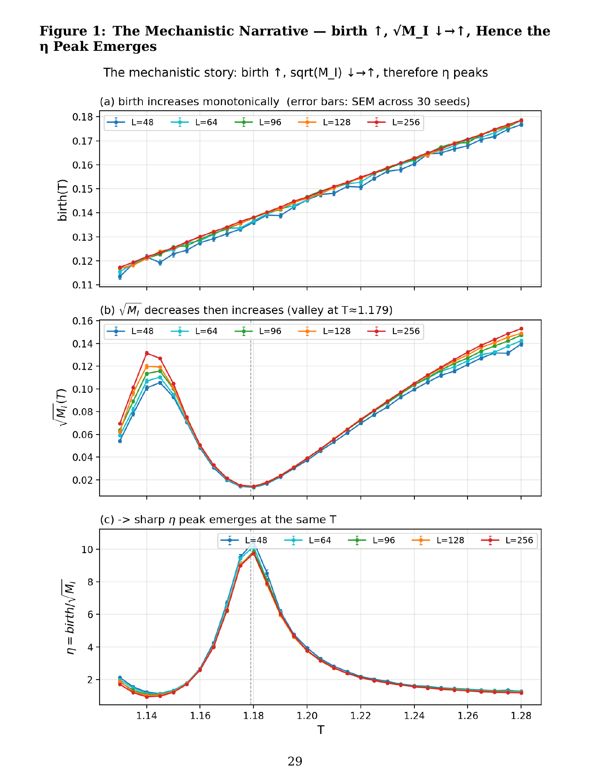
(a) birth(T) increases monotonically. (b) √M_I(T) is a U-shaped curve that decreases then increases, reaching its minimum at T≈1.179 (dashed line). (c) The ratio of the two observables, η=birth/√M_I, forms a sharp peak at the point where the numerator continues to grow while the denominator is at its minimum. Error bars show the standard error of the mean (SEM) across 30 independent seeds; at most points these are smaller than the marker size and barely visible, indicating very high precision. All three panels nearly perfectly overlap across five lattice sizes (L=48,64,96,128,256, 30 seeds each, fine grid), demonstrating that this mechanistic narrative is universal across L.

Figure 2: Bootstrap Confidence Intervals
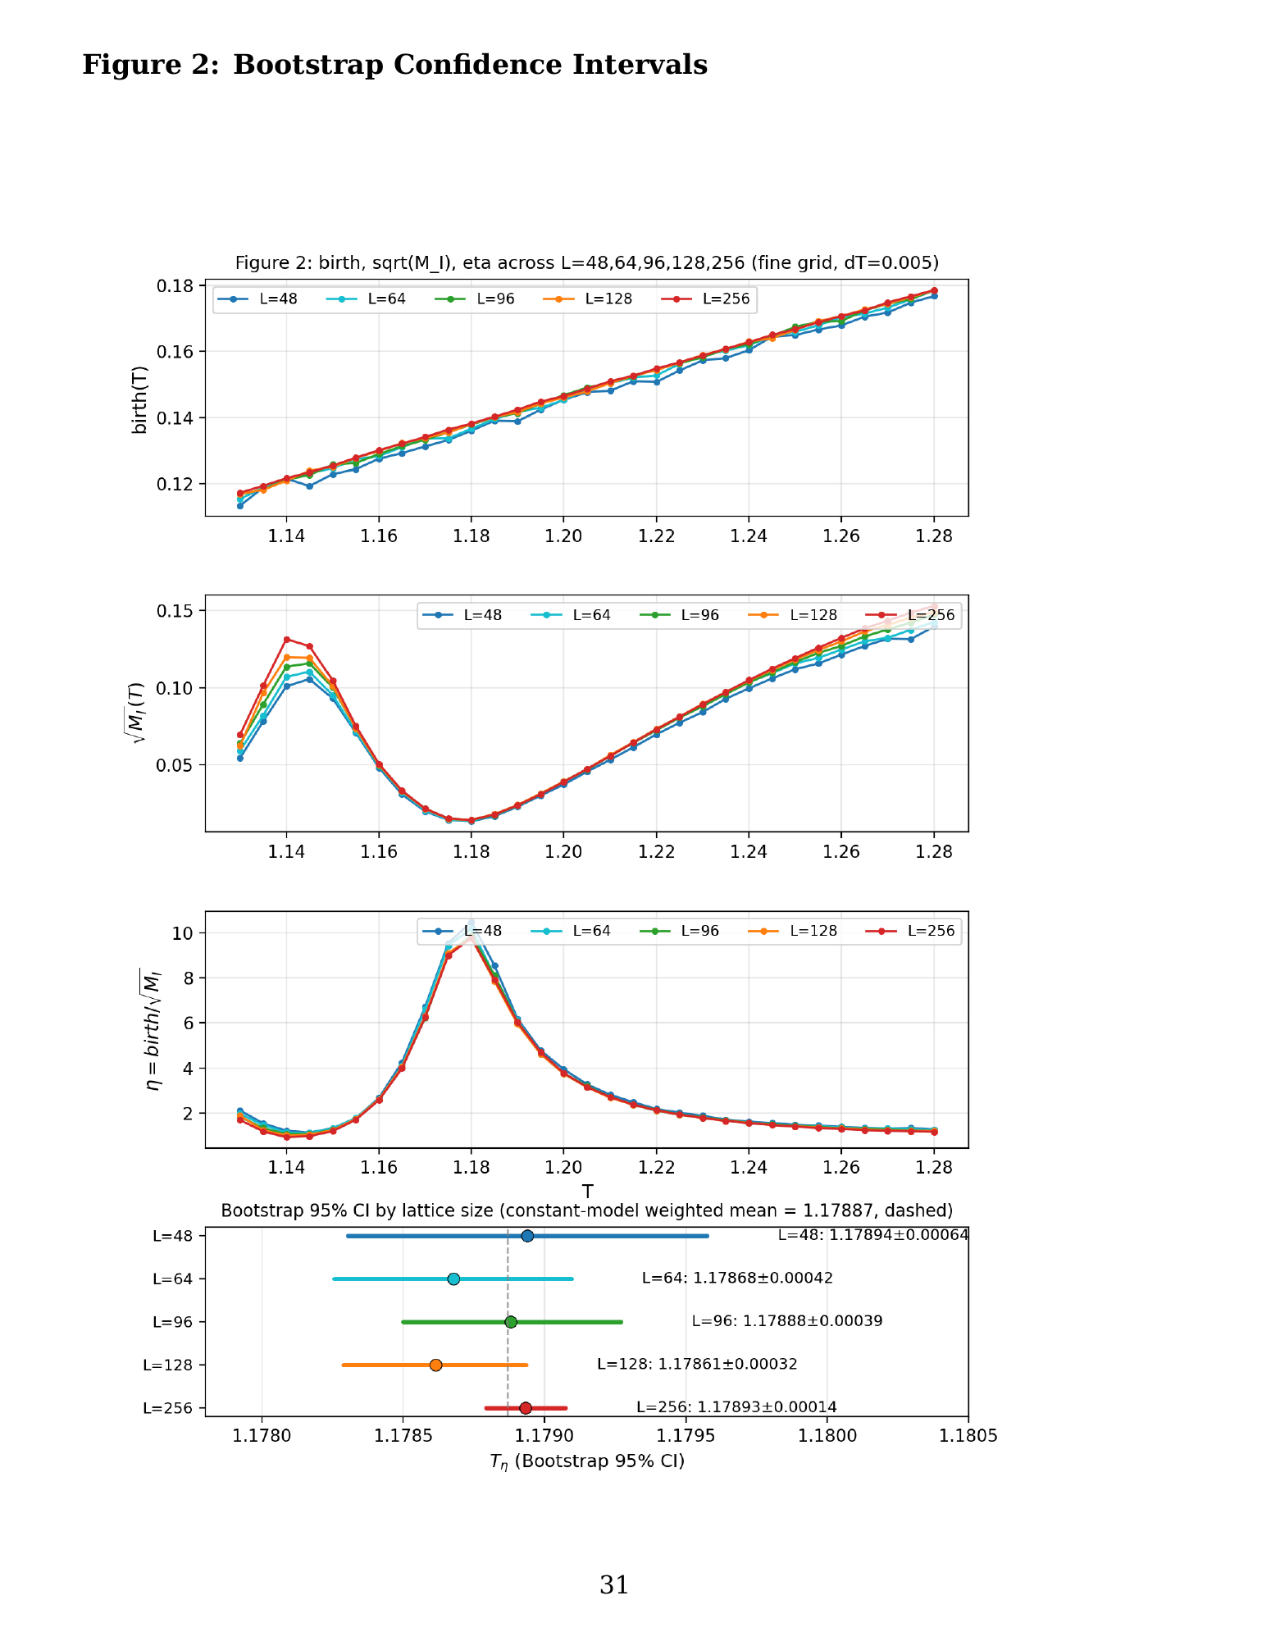
Bootstrap 95% confidence intervals for the η peak temperature at each L (forest plot). The dashed line is the weighted mean from the constant model (T=1.17887), which all L confidence intervals cross.

Figure 3: True Collapse via Full (a(L), b(L)) Correction
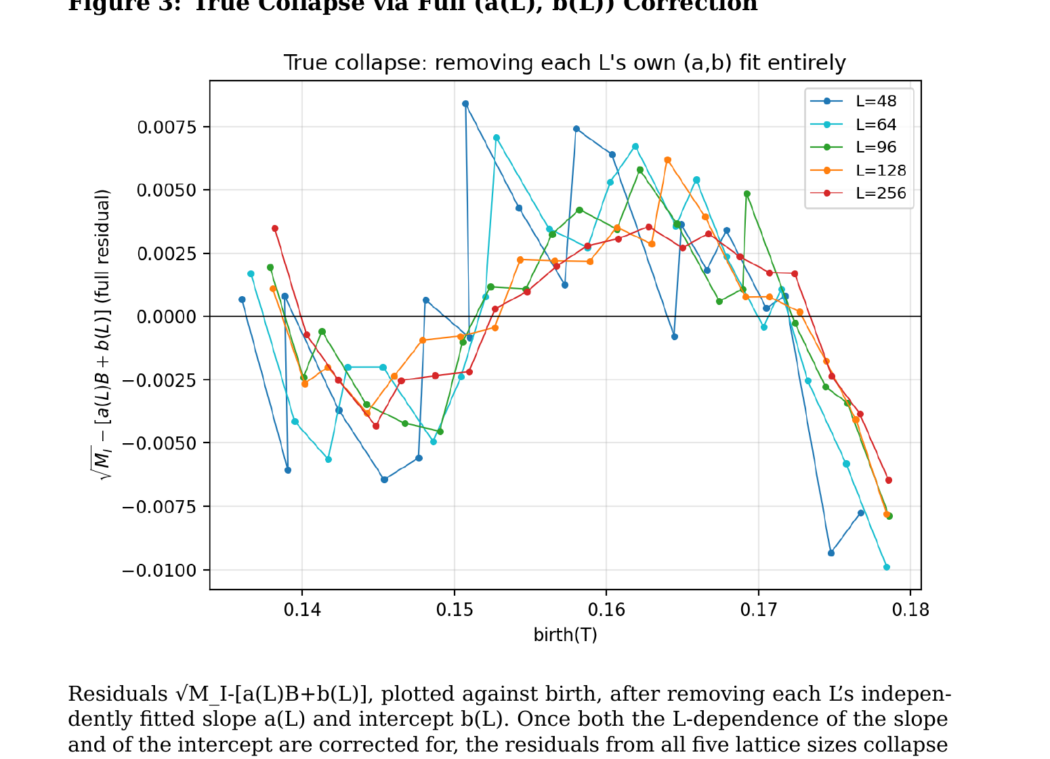
Residuals √M_I-[a(L)B+b(L)], plotted against birth, after removing each L’s independently fitted slope a(L) and intercept b(L). Once both the L-dependence of the slope and of the intercept are corrected for, the residuals from all five lattice sizes collapse onto a single common curve (Section 3.3.4).

Figure 4: Finite-Size Correction Amplitude A(T)
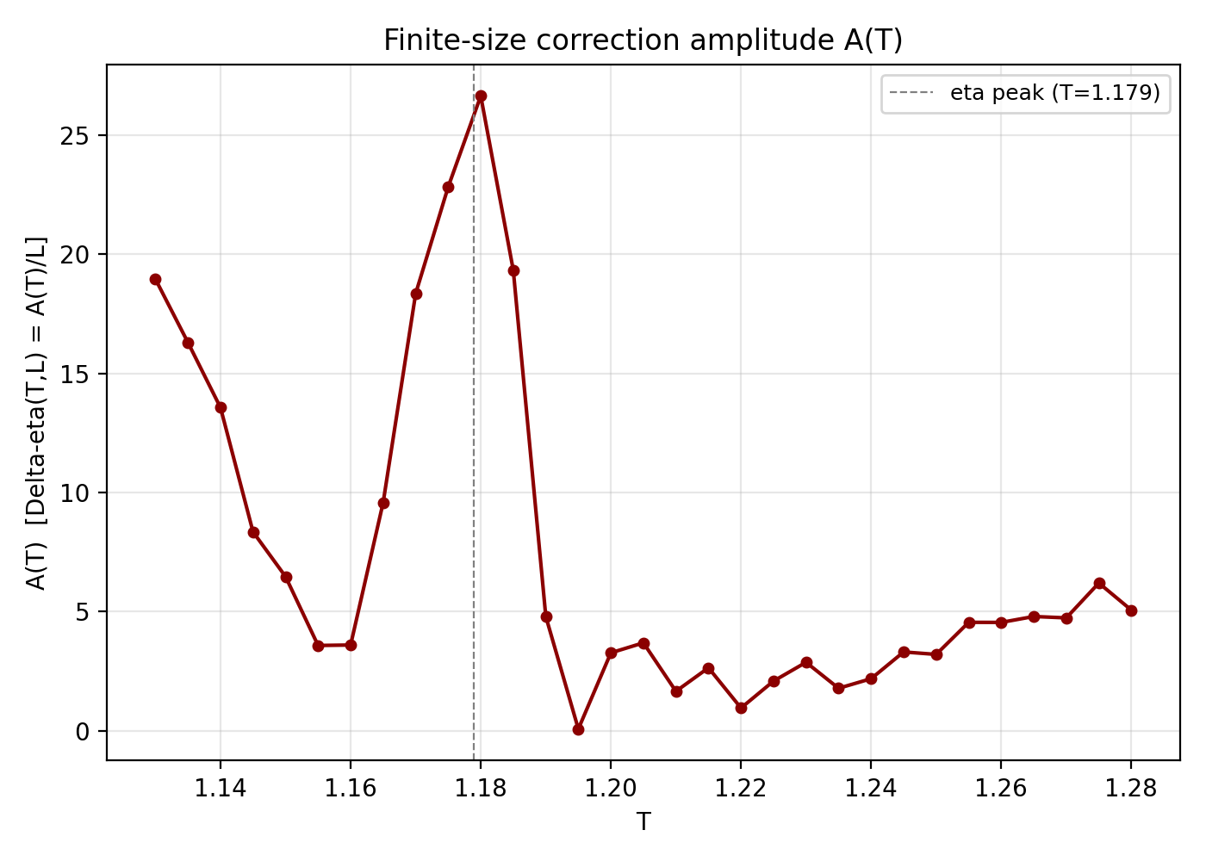
The correction amplitude A(T), obtained by fitting Δη(T,L)=A(T)/L at each temperature T. A(T) remains small (1–6) away from the η peak, but spikes sharply to 26.6 near the η peak position (T≈1.179, dashed line). This shows that the finite-size correction is selectively amplified in the critical region.

