VisionAssist
Lost & Found AI
A Comprehensive Technical Guide Book
Architecture · UML Design · Implementation · AWS Deployment & MLOps
Voice-activated assistant + computer vision · Python · FastAPI · Streamlit · YOLOv8
Capstone Project — Technical Reference

Document Control
Field | Value
Title | VisionAssist - Lost & Found AI: Technical Guide Book
Version | 1.0
Date | 2026-06-28
Status | Final
Audience | Engineers, reviewers, and operators
Applies to | VisionAssist scaffold (FastAPI + Streamlit) on AWS (EKS + SageMaker)

Table of Contents

(In Word, right-click the Table of Contents above and choose “Update Field” to populate page numbers.)

List of Figures
Figure 1. Layered system architecture (client, API, services, data).
Figure 2. Local development deployment (Docker Compose).
Figure 3. AWS production infrastructure (Amazon EKS + SageMaker).
Figure 4. Use case diagram.
Figure 5. Class diagram (Camera-scoped data model) with future entities.
Figure 6. Authentication sequence (register, login, protected request).
Figure 7. Item & zone registration sequence.
Figure 8. Voice locate query - the Where is my phone? flow.
Figure 9. On-demand scan (worker-less detection path).
Figure 10. Continuous detection and move-alert (alerts via polling).
Figure 11. Reminders - create and due-notification.
Figure 12. Activity diagram - assistant intent routing.
Figure 13. State diagrams for Reminder, Alert, and item tracking.
Figure 14. Observability & SRE pipeline (sources, collectors, backends, consumers).

List of Tables
Table 1. VisionAssist technology stack
Table 2. How the book maps to the evaluation rubric
Table 3. Core data entities
Table 4. Local development vs AWS service mapping
Table 5. Service-level indicators and objectives
Table 6. REST API reference
Table 7. Configuration - environment variables
Table 8. Top-level project layout
Table 9. Glossary of terms
Table 10. Common issues and fixes

1. Introduction

1.1 Problem & Vision
People routinely misplace everyday belongings — keys, phones, wallets, bags. VisionAssist is a voice-activated "Lost & Found" assistant that continuously watches a space with a camera, records where each registered belonging was last seen, and answers natural-language questions such as "Where are my keys?" by speaking the item's last known location and time.
Beyond locating items, the assistant answers the time and date, sets spoken reminders, and raises real-time alerts when a tracked item leaves the area it is supposed to stay in. The system is multi-user and is designed to run from a laptop in development and on AWS in production.

1.2 Core Capabilities
- Voice interaction: speech-to-text for questions and text-to-speech for spoken replies.
- Item registration: map a friendly name ("my house keys") to a detectable object class.
- Computer-vision tracking: detect objects per camera frame and tag each with a named zone.
- Location reporting: answer "where is X?" from the most recent sighting.
- Reminders and time/date queries.
- Multi-user isolation, move alerts, and an optional LLM for general questions.

1.3 Technology Stack
Table 1. VisionAssist technology stack
Layer | Technology
Frontend | Streamlit (Python) — server-rendered UI
Backend | FastAPI (Python), JWT auth, SQLAlchemy ORM
Computer vision | Ultralytics YOLOv8 (local) or Amazon SageMaker endpoint
Voice | streamlit-webrtc / st.audio_input · SpeechRecognition (STT) · gTTS (TTS)
Data | PostgreSQL (RDS) · Redis (ElastiCache) · S3 · Kinesis/MSK
Cloud | Amazon EKS + SageMaker, Terraform, GitHub Actions, ArgoCD

1.4 How this book maps to the evaluation rubric
Table 2. How the book maps to the evaluation rubric
Rubric area | Where it is covered
Implementation (35%) | Chapters 7–10 (behavior + implementation)
Design & architecture (10%) | Chapters 2–6
Integration (15%) | Chapters 2, 7 (REST, polling, vision, voice)
Documentation (15%) | This book + in-repo guides (GUIDE.md, docs/)
Innovation (15%) | Multi-user, alerts, reminders, MLOps loop (Ch 11–12)
Presentation (10%) | Companion slide deck + Ch 4 narration

2. System Architecture
VisionAssist is organized into four decoupled layers. Each layer has a single responsibility and communicates with its neighbors through well-defined channels, which is what makes the system testable, replaceable, and scalable.
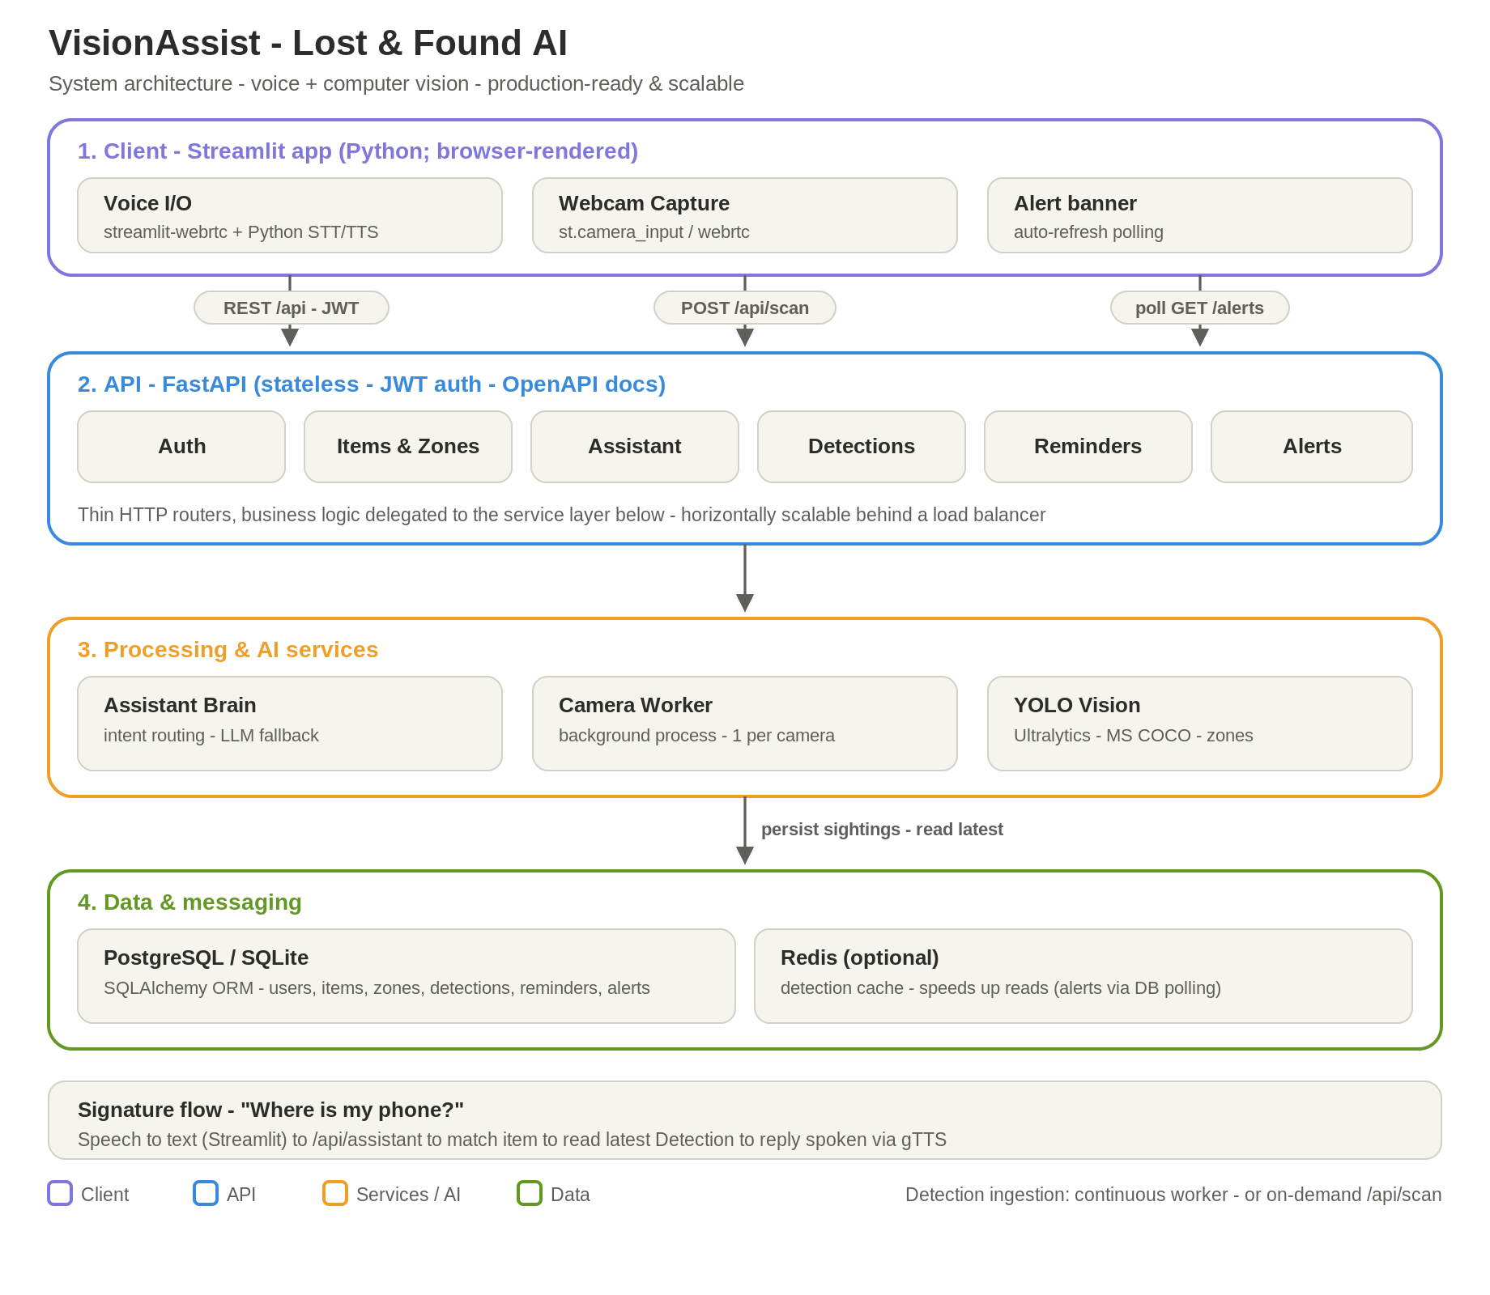
Figure 1. Layered system architecture (client, API, services, data).

2.1 The four layers
- Client (Streamlit, Python; browser-rendered): voice I/O, webcam capture, and an auto-refresh alert banner.
- API (FastAPI, stateless, JWT-authenticated): thin HTTP routers — auth, items, cameras & zones, assistant, detections, reminders, alerts.
- Processing & AI services: the assistant "brain" (intent routing + optional LLM), the background camera worker, and the YOLO vision service.
- Data & messaging: PostgreSQL/SQLite for the system of record and Redis for caching.

2.2 The signature flow
"Where is my phone?" travels through every layer: speech becomes text in the client, the API routes it to the assistant brain, the brain matches the registered item and reads its latest detection from the database, and the spoken reply returns to the client. Because each layer is decoupled, any one of them can scale or be swapped independently.

3. Deployment Topology (Local Development)
For development, the entire system runs with a single command — docker compose up — which starts four containers. This mirrors production component-for-component while staying lightweight.
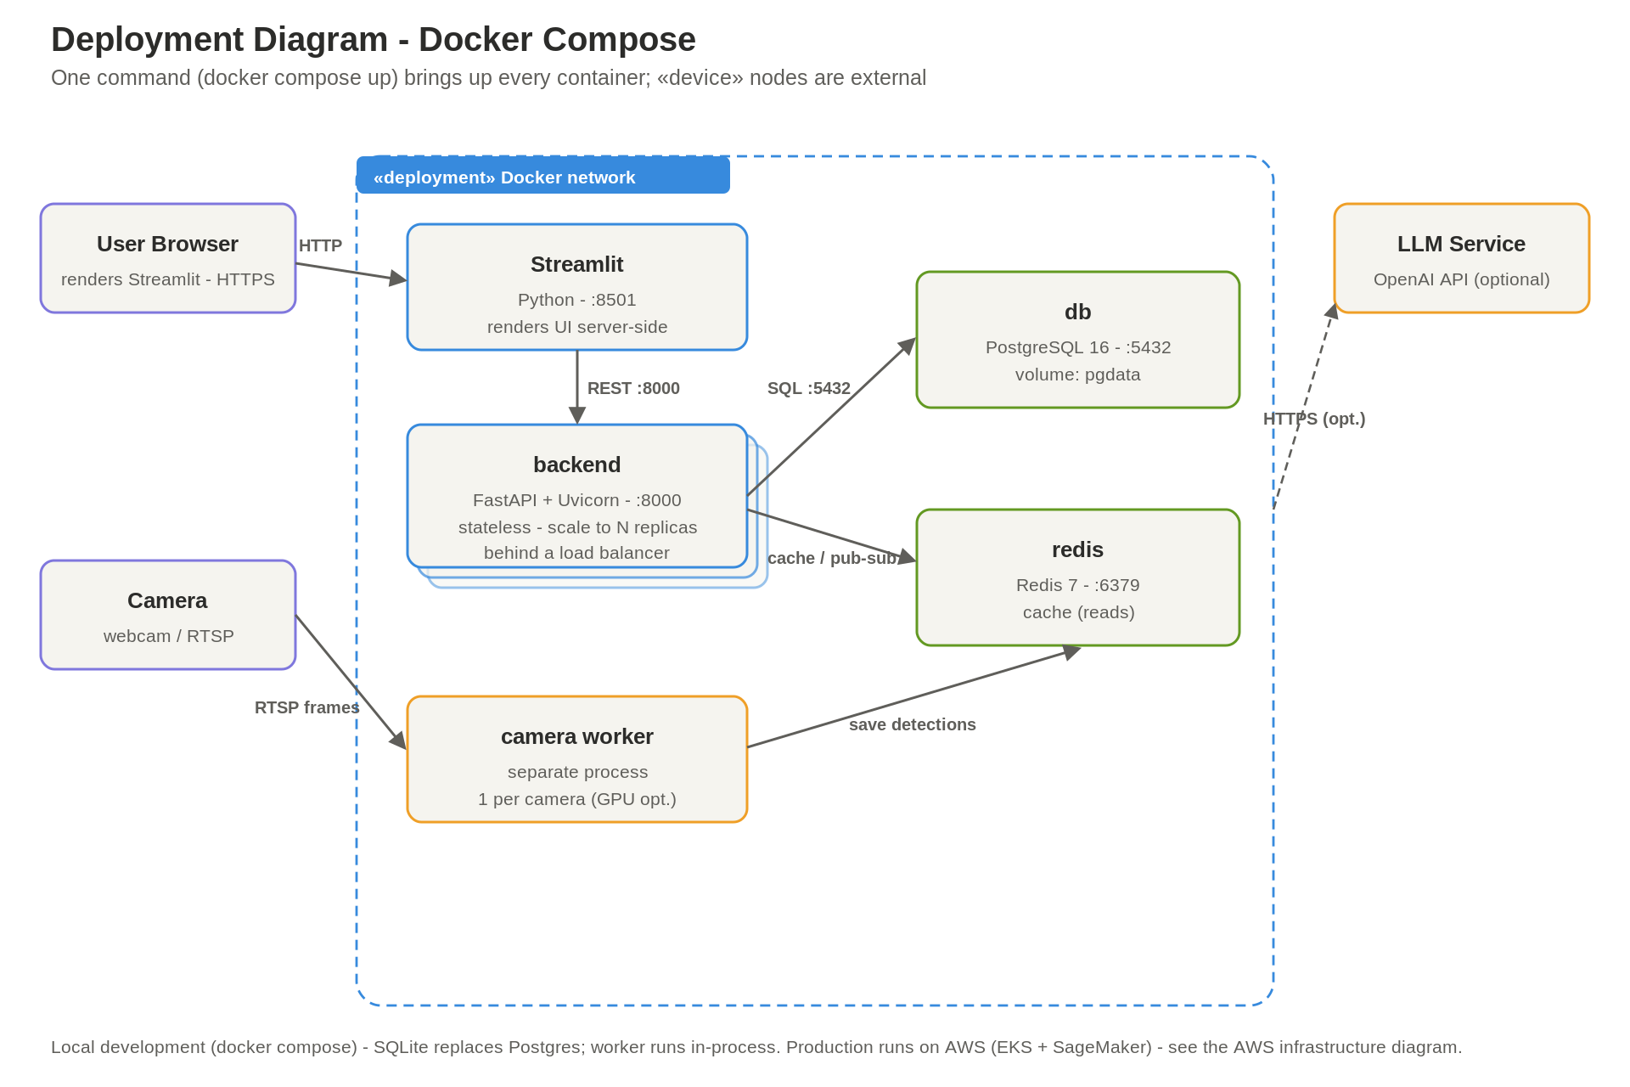
Figure 2. Local development deployment (Docker Compose).
- Streamlit (Python, :8501) — the UI tier; the browser talks only to this.
- Backend (FastAPI + Uvicorn, :8000) — stateless, horizontally scalable.
- db — PostgreSQL (SQLite is used as an even simpler local fallback).
- redis — cache.
The camera worker runs inside the backend as a background thread locally, and as its own process — one per camera — in production. Production runs on AWS (Amazon EKS + SageMaker) — see Chapter 4.

4. AWS Infrastructure (Production)
The production target uses Amazon EKS for the application tier and Amazon SageMaker for the ML lifecycle and model serving, with managed AWS services for data, CI/CD, security, and observability. The diagram below is organized into six planes; the colored legend distinguishes synchronous requests, data/event flows, model promotion, CI/CD, and telemetry.
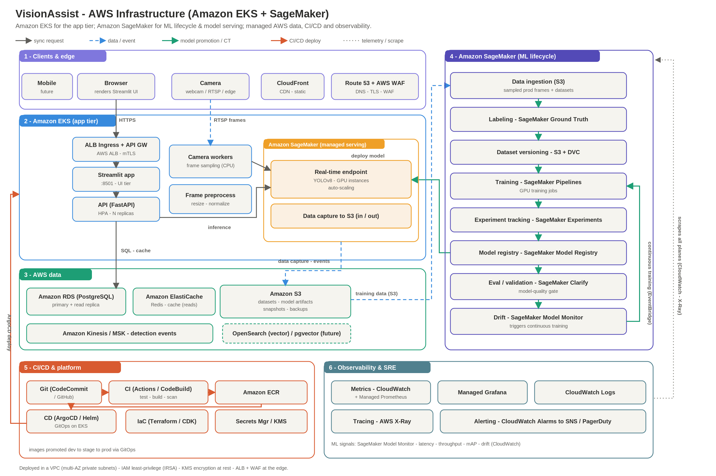
Figure 3. AWS production infrastructure (Amazon EKS + SageMaker).

4.1 Clients & edge
Browser and mobile clients reach the system through Amazon CloudFront (CDN), Route 53 (DNS), and AWS WAF (firewall, TLS termination). Cameras stream frames in.

4.2 Amazon EKS — application tier
A CPU node group runs the ALB Ingress + API gateway, the Streamlit UI, the autoscaled FastAPI API (HPA), and the camera workers / frame preprocessing. The cluster holds no GPUs — inference is delegated to SageMaker.

4.3 Amazon SageMaker — model serving
A managed real-time endpoint serves YOLOv8 on GPU instances with auto-scaling and data capture to S3. The API and camera workers call it for inference; new model versions are promoted onto it from the Model Registry.

4.4 AWS data
Amazon RDS (PostgreSQL, primary + read replica) is the system of record; ElastiCache (Redis) is the read cache; S3 stores datasets, model artifacts, snapshots, and backups; Kinesis/MSK carries detection events; OpenSearch/pgvector is a future addition for instance-level recognition.

4.5 Amazon SageMaker — ML lifecycle
The MLOps pipeline runs top to bottom: data ingestion (S3) → labeling (Ground Truth) → dataset versioning (S3 + DVC) → training (SageMaker Pipelines, GPU) → experiment tracking (Experiments) → model registry → evaluation/validation gate (Clarify) → drift monitoring (Model Monitor). Drift signals trigger continuous training via EventBridge, closing the loop.

4.6 CI/CD & platform
Git → CI (GitHub Actions / CodeBuild: test, build, scan) → Amazon ECR → CD (ArgoCD/Helm on EKS), with Terraform/CDK for infrastructure-as-code and Secrets Manager + KMS for secrets.

4.7 Observability & SRE
CloudWatch (with Managed Prometheus), Managed Grafana, CloudWatch Logs, AWS X-Ray tracing, and CloudWatch Alarms → SNS/PagerDuty. ML-specific signals (latency, throughput, mAP, drift) flow from SageMaker Model Monitor into CloudWatch.

4.8 Cross-cutting guarantees
Everything runs in a VPC across multi-AZ private subnets, with IAM least-privilege via IRSA, KMS encryption at rest, and ALB + WAF at the edge.

5. Functional Requirements — Use Case View
The use case diagram captures what the system does and who uses it, independent of implementation. The User is the primary actor; the Camera and an LLM service are supporting actors.
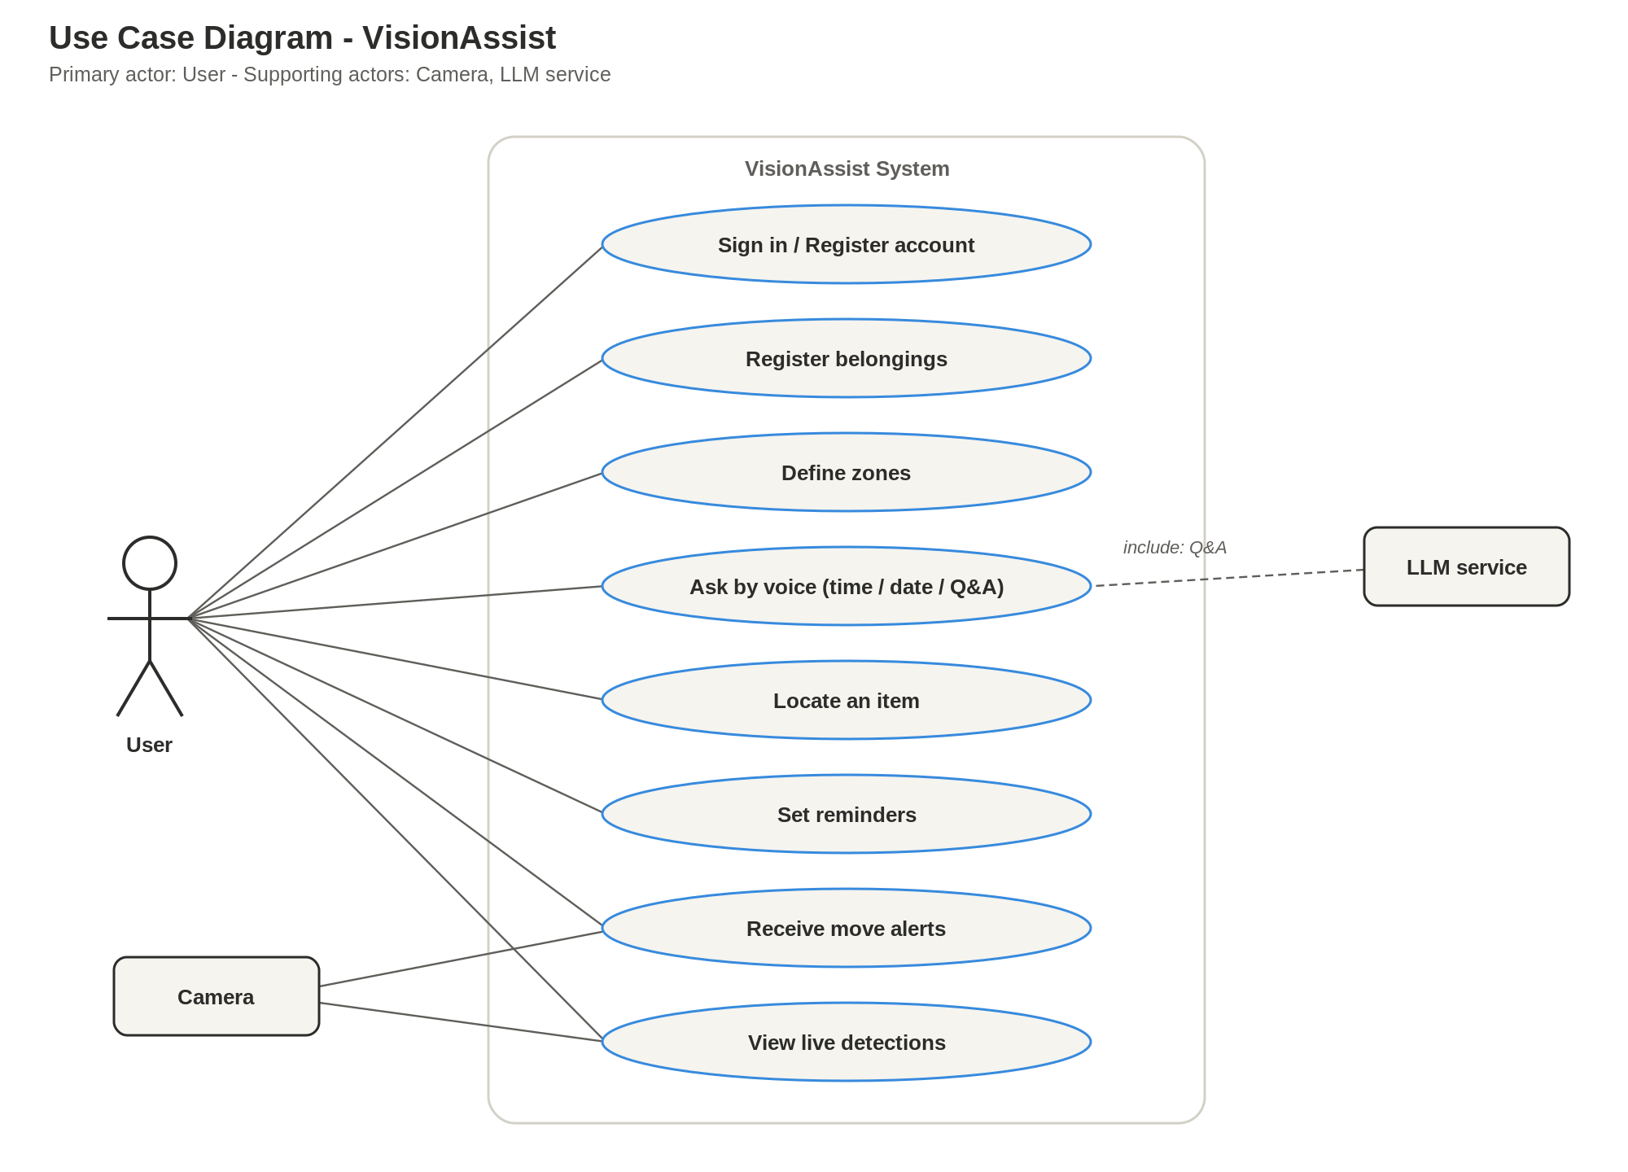
Figure 4. Use case diagram.
- Sign in / register account; register belongings; define zones.
- Ask by voice (time, date, general Q&A); locate an item.
- Set reminders; receive move alerts; view live detections.
- The Camera feeds live detections; the LLM service supports general Q&A («include»).

6. Data Model — Class Diagram
The data model is scoped per user. A User owns Items, Cameras, Reminders, and Alerts; a Camera owns Zones and Detections. This User → Camera → Zone/Detection chain gives clean multi-user isolation and supports a "one worker per camera" scaling model.
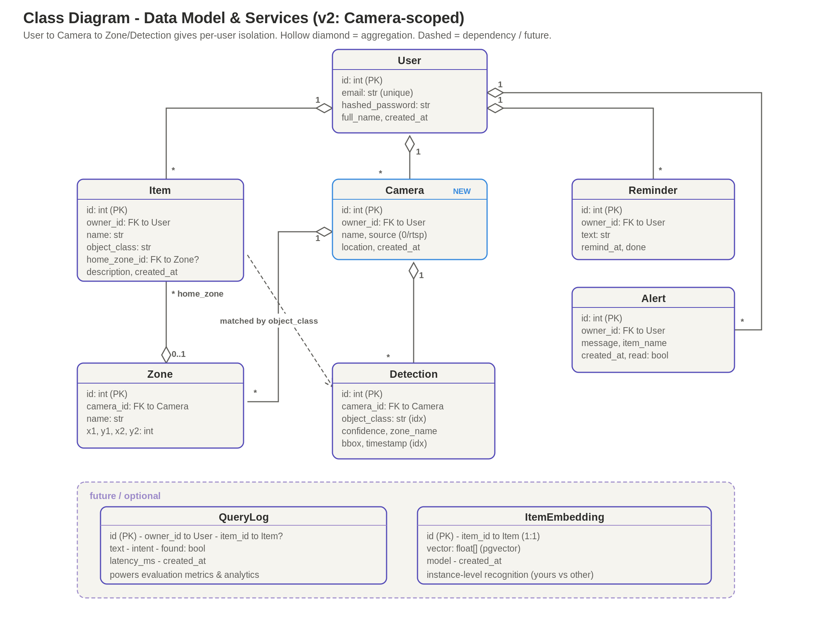
Figure 5. Class diagram (Camera-scoped data model) with future entities.

6.1 Entities
Table 3. Core data entities
Entity | Purpose
User | Account; owns items, cameras, reminders, alerts.
Camera | A physical/RTSP source; owns zones and detections.
Item | Maps a friendly name to a detectable object_class; optional home zone.
Zone | A named pixel region of a camera frame (move-alert boundary).
Detection | A single sighting: class, confidence, zone, bbox, timestamp.
Reminder | Text + remind_at + done flag.
Alert | Raised when an item leaves its home zone; read flag.

6.2 Future entities
Two entities are sketched for later: QueryLog (per-interaction logging that powers evaluation metrics) and ItemEmbedding (a reference vector enabling instance-level recognition — telling your backpack from another's — paired with pgvector).

7. Behavioral Design — Sequence Diagrams
Sequence diagrams show how participants exchange messages over time. Read top to bottom; solid arrows are calls, dashed arrows are returns, and pink "alt" frames are alternative (failure / branch) paths.

7.1 Authentication
Registration checks for an existing email (400 if taken), otherwise hashes the password and creates the user. Login verifies the bcrypt password and issues a JWT (or 401). Every protected request carries the JWT, which get_current_user validates (or 401). Tokens expire after 24 hours; there is no refresh flow yet. In the Streamlit client the token lives in st.session_state.
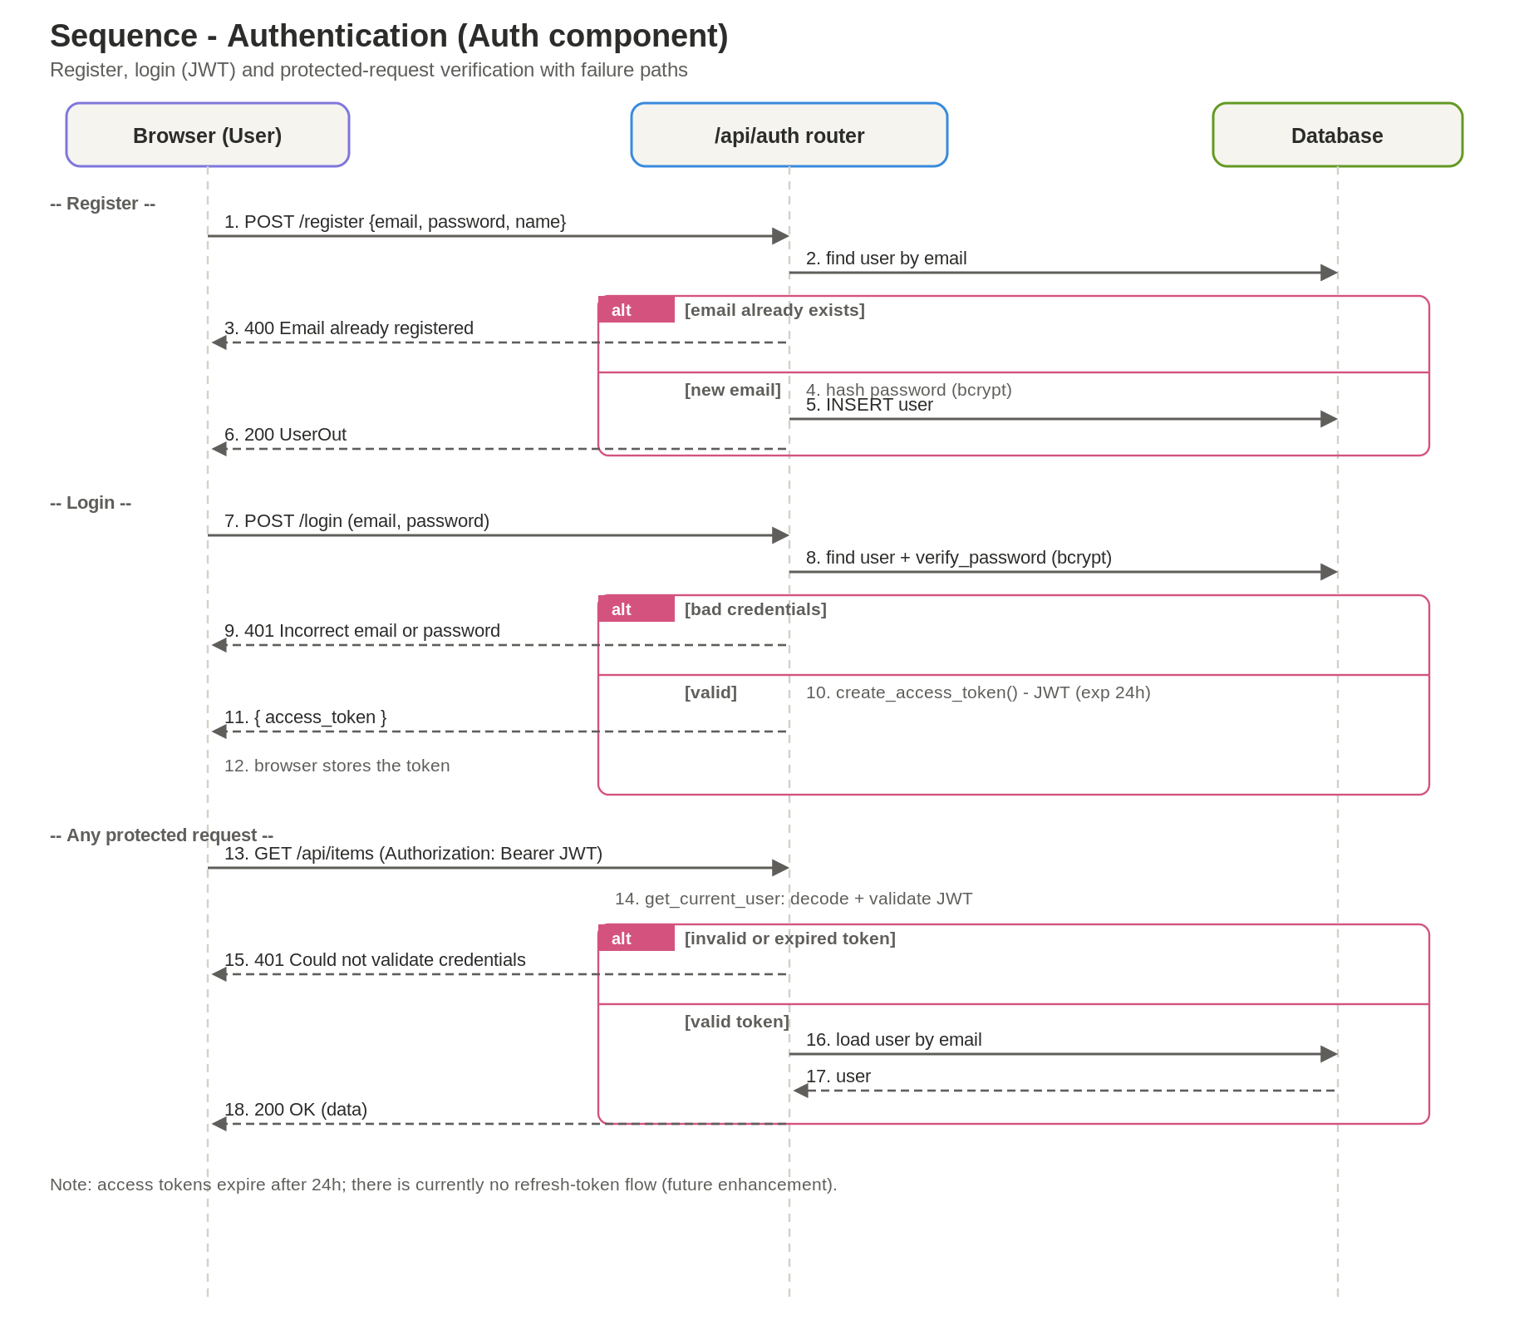
Figure 6. Authentication sequence (register, login, protected request).

7.2 Item Registration
The registration form first loads the available zones. The user names the item, picks a detectable object type, and optionally a home zone. The API validates the request, attaches the owner from the JWT, stores the item, and the list refreshes. The chosen object_class is exactly what YOLO will look for.
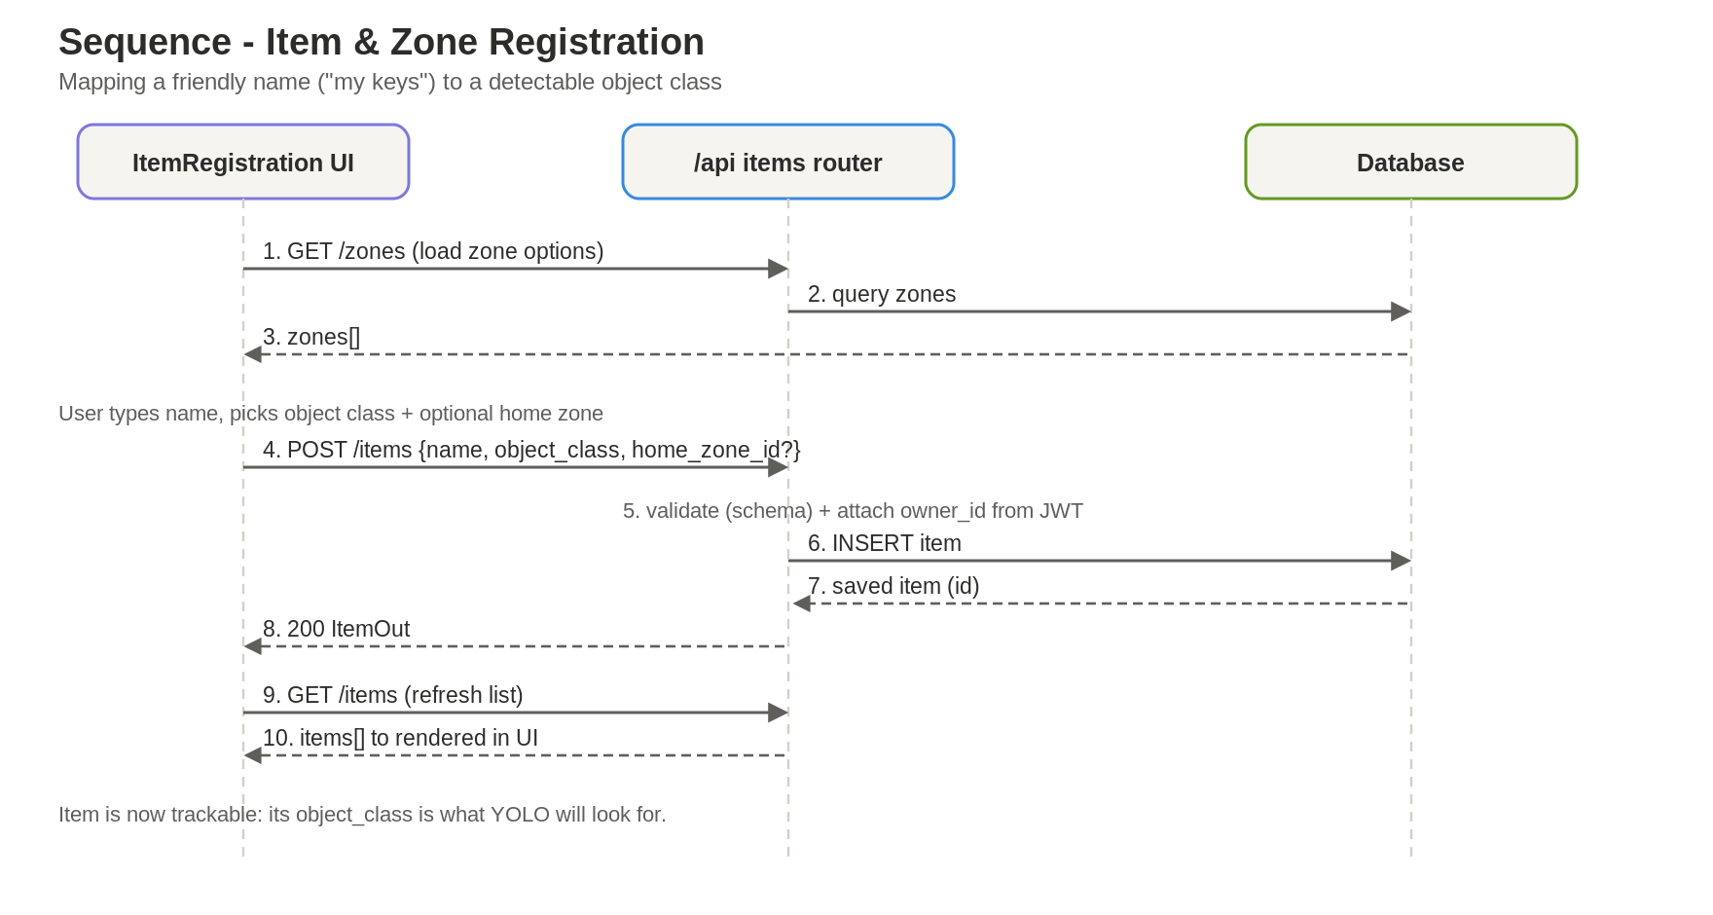
Figure 7. Item & zone registration sequence.

7.3 Voice Locate Query
The signature flow. The client captures the mic and transcribes it (Python STT); mic/STT errors stop early. The text is sent to /api/assistant; the brain detects the locate intent, matches the item, and reads its latest detection. General questions fall back to the LLM when configured. The reply is spoken via gTTS / st.audio.
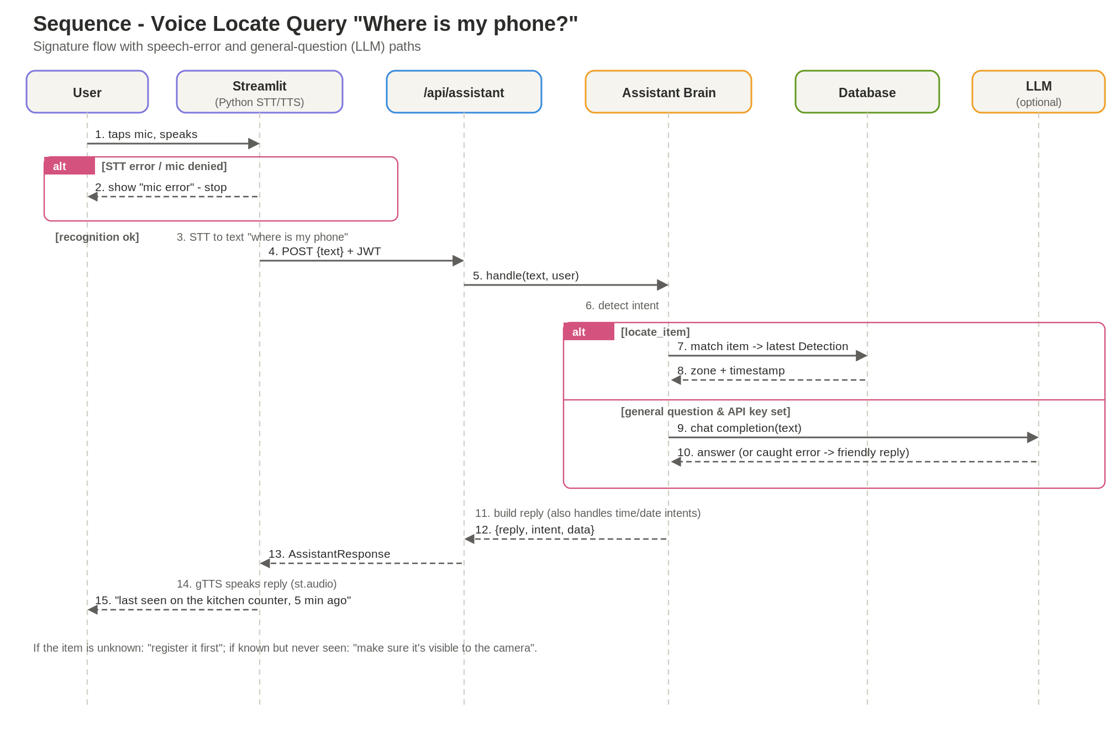
Figure 8. Voice locate query — the "Where is my phone?" flow.

7.4 On-demand Scan
When no continuous camera worker is running (for example, a cloud demo), the client captures a frame with st.camera_input and POSTs it to /api/scan. The endpoint runs the same YOLO detect-and-save logic as the worker, so detections persist and later "locate" queries still work.
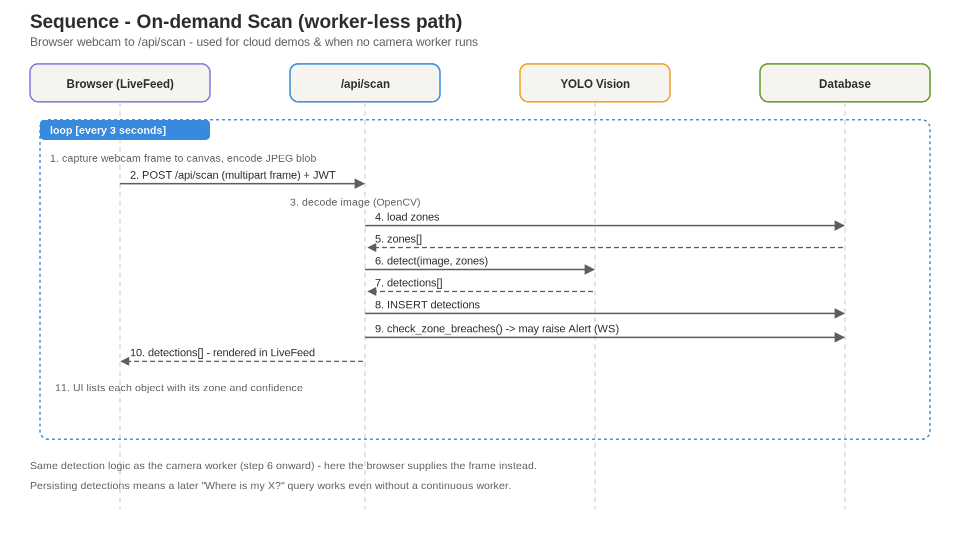
Figure 9. On-demand scan (worker-less detection path).

7.5 Detection & Move Alert
A background loop: the camera worker grabs a frame, YOLO detects objects and assigns zones, sightings are saved, and the alerts service checks whether any tracked item left its home zone. If so, an Alert is persisted. The Streamlit client surfaces alerts by polling /api/alerts/unread on an auto-refresh timer — which reads from the database and therefore works across API replicas with no WebSocket infrastructure.
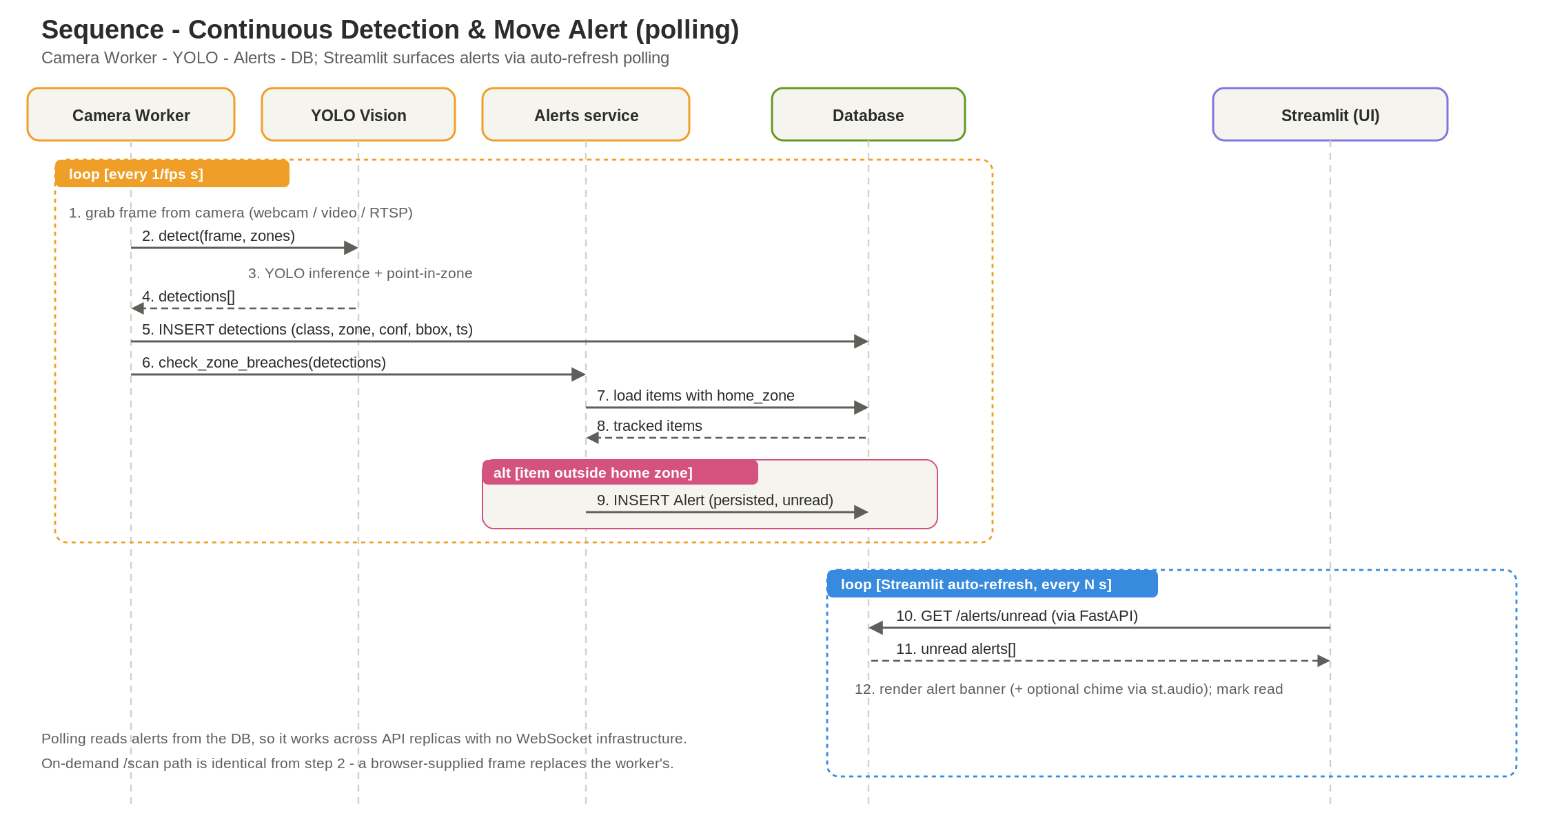
Figure 10. Continuous detection and move-alert (alerts via polling).

7.6 Reminders
Creating a reminder stores text + time against the user. A 30-second polling loop fetches due reminders and marks them done in the same call (guaranteeing each fires exactly once), then the client speaks each one aloud.
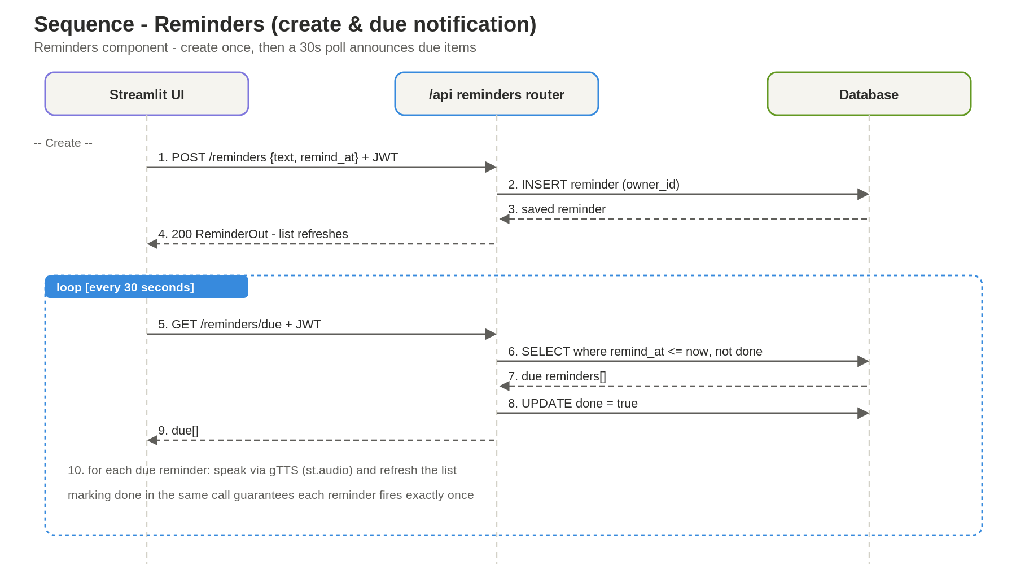
Figure 11. Reminders — create and due-notification.

8. Assistant Logic — Activity Diagram
The assistant brain turns a transcribed utterance into a reply. Fast, offline keyword rules detect the intent and branch to time, date, locate-item, or reminder acknowledgement; anything else falls back to an LLM (guarded by an error path) when an API key is configured. All branches merge into a single "build reply" step that the client speaks aloud.
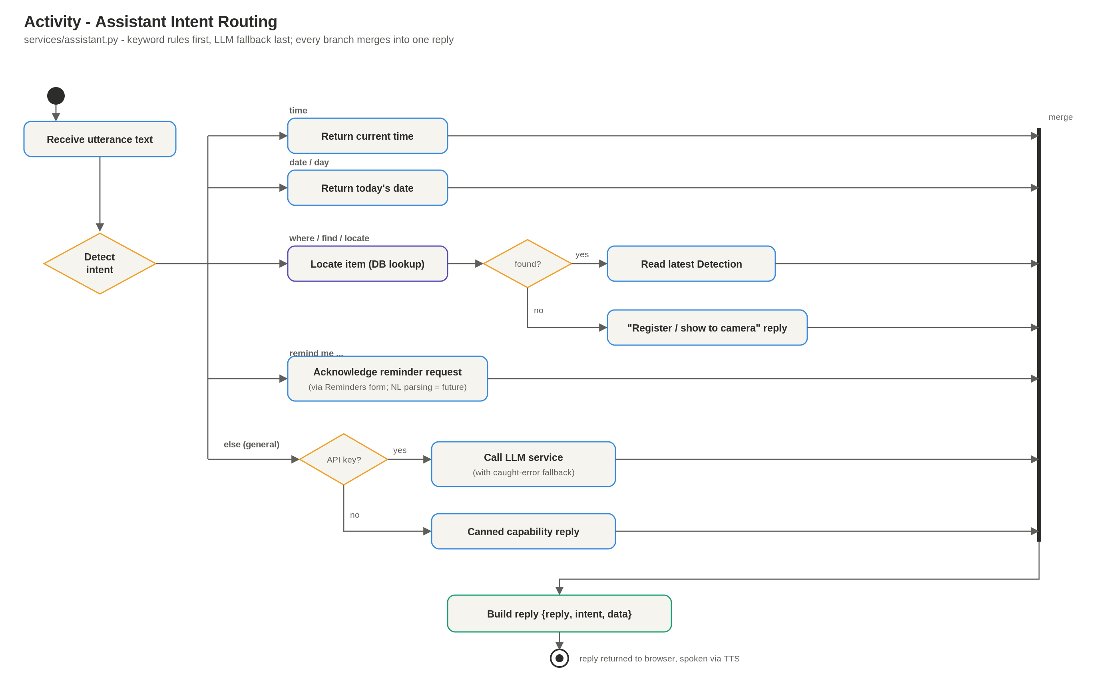
Figure 12. Activity diagram — assistant intent routing.
Note: reminders are currently created through the Reminders form (REST); natural-language reminder parsing is a planned enhancement, which the diagram reflects honestly.

9. Entity Lifecycles — State Diagrams
Three small state machines capture the lifecycle of the stateful entities.
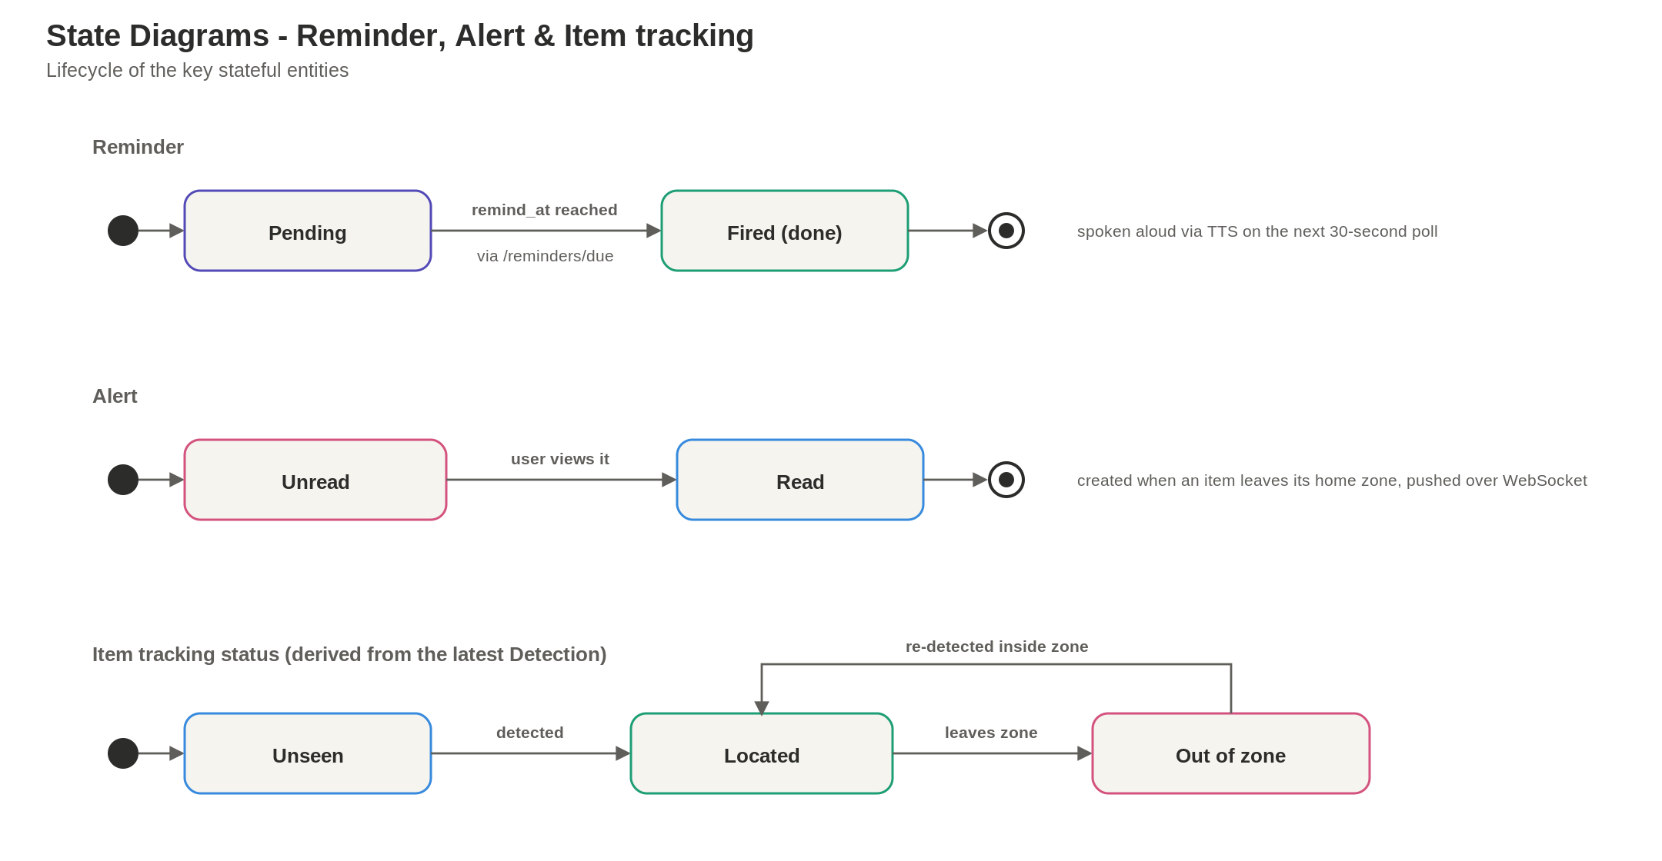
Figure 13. State diagrams for Reminder, Alert, and item tracking.
- Reminder: Pending → Fired when its time is reached (spoken on the next poll).
- Alert: Unread → Read once the user views it.
- Item tracking (derived from the latest Detection): Unseen → Located → Out-of-zone, and back when re-detected inside the zone.

10. Implementation

10.1 Backend (FastAPI)
The backend is a thin, layered FastAPI app. Routers handle HTTP only; business logic lives in services; data is in SQLAlchemy models; validation is in Pydantic schemas. Authentication uses bcrypt password hashing and JWT bearer tokens, with per-user data isolation enforced in every query.
- routers/: auth, items, cameras, detections, assistant, reminders, alerts, ws.
- services/: vision (YOLO/SageMaker), camera_worker, assistant (intent brain), alerts.
- Pluggable inference: INFERENCE_BACKEND=local runs YOLO in-process; =sagemaker calls a SageMaker endpoint via boto3.
- Alerts are exposed over REST (/api/alerts/unread, /api/alerts/read) for the Streamlit poll.

10.2 Frontend (Streamlit)
The Streamlit app (streamlit_app.py) is a pure-Python UI that calls the FastAPI backend over REST, keeping the JWT in st.session_state. It has four tabs — Assistant, Belongings, Live Camera, Reminders — plus a login gate and an auto-refresh alert banner.
- Voice: st.audio_input (default, works through a plain ALB) or streamlit-webrtc; SpeechRecognition for STT, gTTS for TTS.
- Live camera: st.camera_input posts frames to /api/scan.
- Alerts/reminders: st_autorefresh polls the backend on a timer.

10.3 Running locally
- Backend: create a venv, pip install -r requirements.txt, cp .env.example .env, python -m app.seed, uvicorn app.main:app --reload.
- Frontend: cd streamlit_app, pip install -r requirements.txt, set API_BASE_URL, streamlit run streamlit_app.py.
- Or run everything with: docker compose up --build.
- Log in with the demo account demo@visionassist.ai / demo1234.

10.4 Testing & Quality Assurance
The backend ships a pytest suite covering authentication, item CRUD, and the rule-based assistant against an in-memory SQLite database, so tests run fast without loading the YOLO model. The GitHub Actions workflow runs these tests on every push and pull request, gating the build before any image reaches ECR.
- Unit / API tests: tests/test_api.py (auth, item CRUD, assistant intents).
- CI gate: .github/workflows/ci-cd.yml runs pytest before build and deploy.
- Model evaluation: report precision, recall, mAP@0.5 and F1 from the SageMaker training job; track per release in SageMaker Experiments.
- Production quality: SageMaker Model Monitor watches drift; CloudWatch tracks latency and error rates.

11. AWS Deployment & MLOps

11.1 Service mapping
Table 4. Local development vs AWS service mapping
Component | Local dev | AWS production
Frontend | Streamlit container | Streamlit pod on EKS, behind ALB
Backend | FastAPI container | FastAPI pods on EKS (HPA)
Model serving | YOLO in-process | SageMaker real-time endpoint (GPU)
Database | SQLite / Postgres | Amazon RDS (Multi-AZ)
Cache | local Redis | Amazon ElastiCache
Images | local build | Amazon ECR
Secrets | .env | Secrets Manager + KMS
Observability | stdout | CloudWatch, X-Ray, Managed Grafana

11.2 Deployment assets in the repo
- infra/terraform/ — VPC, EKS, RDS, ElastiCache, S3, ECR, optional SageMaker endpoint.
- k8s/ — backend + streamlit Deployments/Services, ALB Ingress, backend HPA.
- .github/workflows/ci-cd.yml — tests, then build/push to ECR (OIDC) and roll EKS deployments.
- AWS_DEPLOYMENT.md — full mapping, IAM/IRSA, and the WebRTC-behind-ALB caveat.

11.3 Continuous training loop
Production frames are sampled back into the pipeline; the evaluation gate guards what reaches the Model Registry; promotion to the SageMaker endpoint is a controlled step; and SageMaker Model Monitor closes the loop by triggering retraining on drift via EventBridge.

12. Security & Privacy
Security and privacy are designed in, not bolted on. The system handles camera imagery and user accounts, so it minimizes what it stores and enforces least-privilege access throughout.

12.1 Authentication & authorization
Passwords are hashed with bcrypt; sessions use stateless JWT bearer tokens (24-hour expiry). Every API query is scoped to the authenticated user, so one user can never read another user's items, cameras, detections, reminders, or alerts.

12.2 Privacy by design
Camera frames are processed in memory; by default only detection metadata (object class, zone, confidence, timestamp) is persisted - not the images themselves. Where data capture is enabled (e.g. for SageMaker Model Monitor) it writes sampled records to a dedicated, encrypted S3 location rather than retaining full video.

12.3 Cloud security controls (AWS)
- Network: private subnets in a VPC; AWS WAF + TLS (ACM) at the ALB / CloudFront edge.
- Identity: IAM least-privilege via IRSA (e.g. sagemaker:InvokeEndpoint, scoped s3 object access).
- Secrets: AWS Secrets Manager injects DB / JWT / API keys; KMS encrypts data at rest (RDS, S3, EBS).
- Supply chain: ECR image scanning on push; GitHub OIDC means no long-lived AWS keys in CI.

12.4 Hardening checklist before go-live
- Rotate SECRET_KEY and replace all seeded / demo credentials.
- Add a JWT refresh-token flow and shorten the access-token lifetime.
- Restrict CORS to the production origin only.
- Enable audit logging (CloudTrail) and per-user rate limiting.

13. Observability & SRE
Observability is built on three pillars - metrics, logs, and traces - plus a fourth that matters for an AI product: model/ML observability. The pipeline below shows how telemetry flows from sources, through collectors, into AWS backends, and out to dashboards, alerts, and SLOs.
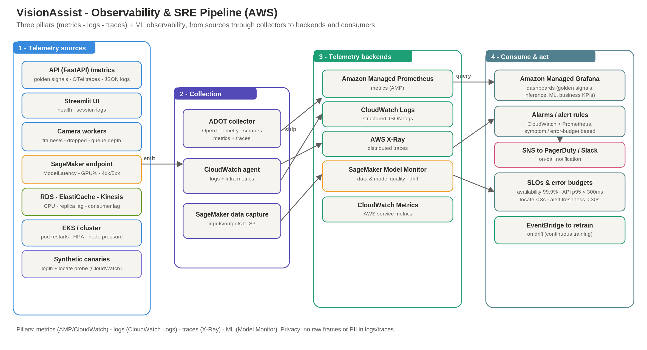
Figure 14. Observability & SRE pipeline (sources, collectors, backends, consumers).

13.1 What we instrument
- Golden signals per API endpoint: request rate, error rate, latency (p50/p95/p99), saturation.
- Structured JSON logs with a propagated request ID (Streamlit -> API -> SageMaker -> DB).
- SageMaker endpoint: ModelLatency, OverheadLatency, 4xx/5xx, GPU/CPU utilization.
- Camera-worker pipeline: frames/second, dropped frames, inference round-trip, queue depth.
- Data & platform: RDS connections/replica lag, ElastiCache hit rate, Kinesis consumer lag, EKS pod restarts/HPA.
- Business KPIs: locate success rate, end-to-end voice latency, alert freshness, STT success.

13.2 Implementation in the scaffold
The FastAPI app ships app/observability.py: a request-ID + access-log middleware, a Prometheus /metrics endpoint, structured JSON logging, optional OpenTelemetry trace export (active when OTEL_EXPORTER_OTLP_ENDPOINT is set), and custom counters (va_assistant_intents_total, va_locate_total, va_detections_total). On EKS the ADOT collector scrapes /metrics into Amazon Managed Prometheus and exports traces to AWS X-Ray.

13.3 Service-level objectives (SLOs)
Alert on symptoms and error-budget burn, not on every metric. Suggested targets:
Table 5. Service-level indicators and objectives
Service-level indicator (SLI) | Target (SLO)
API availability | >= 99.9% monthly
API latency (p95) | < 300 ms
End-to-end locate (speak to answer) | < 3 s
Alert freshness (detection to banner) | < 30 s
SageMaker ModelLatency (p95) | < 400 ms
Locate success rate | >= 80% of locate queries
Error rate (5xx) | < 1% of requests

13.4 Dashboards, alerts & on-call
Dashboards and alerts are shipped as code in observability/: a Grafana dashboard (golden signals, inference, ML, business KPIs), Prometheus alert rules, and a CloudWatch dashboard + alarms (Terraform). Alarms fan out via SNS to PagerDuty/Slack. Synthetic canaries run a login + locate probe so issues are caught before users report them.

13.5 ML observability & privacy
Amazon SageMaker Model Monitor watches data- and model-quality drift; a drop in mean detection confidence or a spike in the no-detection rate is an early warning. Drift triggers retraining via EventBridge. For privacy, raw frames and PII are never written to logs or traces; only detection metadata is persisted.

14. Evaluation & Future Work

12.1 Metrics to report
- Object detection: precision, recall, mAP@0.5, F1 (from the training run).
- System latency: time from spoken query to spoken answer.
- Locate accuracy: percentage of "where is X?" answered with the correct zone.

12.2 Future enhancements
- Instance-level recognition via image embeddings + a vector DB (pgvector / OpenSearch) — distinguish your item from a similar one.
- Natural-language reminders parsed by the LLM.
- QueryLog table feeding an analytics/eval dashboard.
- Multi-camera / household (Space) grouping for shared environments.
- Sensor fusion (BLE/UWB) for non-line-of-sight items.

Appendix A — API Reference
Table 6. REST API reference
Method & path | Purpose
POST /api/auth/register | Create an account
POST /api/auth/login | Obtain a JWT
GET /api/auth/me | Current user
GET/POST /api/items | List / create belongings
DELETE /api/items/{id} | Delete an item
GET/POST /api/cameras | List / create cameras
GET/POST /api/zones | List / create zones
POST /api/assistant | Ask the assistant (text in, reply out)
POST /api/scan | On-demand frame inference
GET /api/detections | Recent sightings
GET/POST /api/reminders, GET /api/reminders/due | Reminders + due poll
GET /api/alerts/unread, POST /api/alerts/read | Alerts poll + mark read
GET /api/health | Health check

Appendix B — Configuration
Table 7. Configuration - environment variables
Env var | Meaning
DATABASE_URL | SQLite (dev) or Postgres/RDS (prod)
REDIS_URL | Redis / ElastiCache (optional)
SECRET_KEY | JWT signing key
INFERENCE_BACKEND | local | sagemaker
SAGEMAKER_ENDPOINT_NAME / AWS_REGION | SageMaker serving
S3_BUCKET | Snapshots / data capture (optional)
OPENAI_API_KEY | Enables LLM Q&A (optional)
CAMERA_SOURCE | 0 / video path / rtsp:// / off
API_BASE_URL | Streamlit → backend URL

Appendix C — Project Structure
The repository separates concerns into the FastAPI backend, the Streamlit frontend, infrastructure-as-code, Kubernetes manifests, CI/CD, and documentation. The tree below shows the layout; the table that follows summarizes each top-level area.
visionassist/
├── backend/ FastAPI service
│ ├── app/
│ │ ├── main.py · config.py · database.py
│ │ ├── models.py · schemas.py · auth.py · seed.py · cameras_util.py
│ │ ├── routers/ auth, items, cameras, detections,
│ │ │ assistant, reminders, alerts, ws
│ │ └── services/ vision, camera_worker, assistant, alerts
│ ├── tests/
│ └── requirements.txt · Dockerfile · .env.example
├── streamlit_app/ Streamlit UI
│ ├── streamlit_app.py · api.py · voice.py
│ ├── .streamlit/config.toml
│ └── requirements.txt · Dockerfile
├── infra/terraform/ AWS IaC (VPC, EKS, RDS, ...)
├── k8s/ Deployments, Services, Ingress, HPA
├── .github/workflows/ci-cd.yml CI/CD pipeline
├── docs/ ARCHITECTURE.md, USER_MANUAL.md
├── AWS_DEPLOYMENT.md
├── GUIDE.md
└── docker-compose.yml

Table 8. Top-level project layout
Top-level | Purpose
backend/ | FastAPI API, services, SQLAlchemy models, tests
streamlit_app/ | Streamlit UI that calls the API; voice + camera_input
infra/terraform/ | AWS IaC: VPC, EKS, RDS, ElastiCache, S3, ECR, SageMaker
k8s/ | Kubernetes manifests: Deployments, Services, ALB Ingress, HPA
.github/workflows/ | CI/CD: test then build, push to ECR, deploy to EKS
docs/ | Architecture & user-manual references
GUIDE.md | Step-by-step implementation guide
AWS_DEPLOYMENT.md | EKS + SageMaker production runbook
docker-compose.yml | One-command local development stack

Appendix D — Glossary
Table 9. Glossary of terms
Term | Definition
ALB | Application Load Balancer — the AWS L7 load balancer / ingress.
ArgoCD | GitOps continuous-delivery tool that syncs Kubernetes manifests.
bcrypt | Password-hashing algorithm used to store credentials safely.
CI/CD | Continuous Integration / Continuous Delivery pipeline.
CloudFront | AWS content delivery network (CDN) for static assets.
CloudWatch | AWS metrics, logs and alarms service.
COCO | Common Objects in Context — the 80-class dataset YOLO is pre-trained on.
Detection | A recorded sighting of an object class in a zone at a time.
Drift | Degradation of model accuracy as real-world data shifts.
ECR | Elastic Container Registry — AWS Docker image registry.
EKS | Elastic Kubernetes Service — AWS managed Kubernetes.
ElastiCache | AWS managed Redis (used as the read cache).
FastAPI | Python web framework powering the backend API.
gTTS | Google Text-to-Speech — synthesizes spoken replies (MP3).
HPA | Horizontal Pod Autoscaler — scales Kubernetes pods on load.
IaC | Infrastructure as Code (Terraform / AWS CDK).
IRSA | IAM Roles for Service Accounts — least-privilege EKS pod permissions.
JWT | JSON Web Token — the stateless auth token issued at login.
Kinesis / MSK | AWS streaming services carrying detection events.
KMS | Key Management Service — encryption keys for data at rest.
mAP | mean Average Precision — object-detection accuracy metric.
OIDC | OpenID Connect — lets GitHub Actions assume an AWS role without static keys.
pgvector | PostgreSQL extension for vector similarity search (future).
Pydantic | Python validation library defining the API request/response schemas.
RDS | Relational Database Service — AWS managed PostgreSQL.
Redis | In-memory data store used for caching.
S3 | Simple Storage Service — AWS object storage.
SageMaker | AWS managed ML platform: training, model registry, endpoints, monitoring.
SQLAlchemy | Python ORM mapping the database tables to Python objects.
st_autorefresh | Streamlit helper that reruns the app on a timer (used for polling).
STT / TTS | Speech-to-Text / Text-to-Speech.
Streamlit | Python framework that renders the frontend UI.
Terraform | Infrastructure-as-code tool used to provision AWS.
VPC | Virtual Private Cloud — the isolated AWS network.
WAF | Web Application Firewall at the edge.
WebRTC | Browser real-time media transport (streamlit-webrtc mic capture).
YOLO | Real-time single-shot object-detection model (Ultralytics YOLOv8).
Zone | A named pixel region of a camera frame (move-alert boundary).

Appendix E - Troubleshooting & Limitations

E.1 Common issues
Table 10. Common issues and fixes
Symptom | Fix
YOLO weights download is slow or blocked | Pre-download yolov8n.pt into backend/ or bake it into the image.
Microphone does nothing | Use Chrome or Edge and allow mic permission; or type the command.
CORS error in the browser | Add the Streamlit origin (http://localhost:8501) to CORS_ORIGINS.
WebRTC mic fails behind the ALB | Use the default st.audio_input path, or run a STUN / TURN server.
Assistant says it has not spotted the item | Make sure the webcam is on and the item is visible to the camera.
psycopg2 build error | Use the provided Docker image or install Postgres client headers.

E.2 Known limitations
- Object classes are limited to MS COCO (80 classes); literal keys or sunglasses need fine-tuning.
- No instance-level recognition yet - two items of the same class are not distinguished (see ItemEmbedding / pgvector).
- Reminders are created via the form, not natural language (planned).
- No JWT refresh-token flow yet; access tokens last 24 hours.
- WebRTC voice behind an ALB needs sticky sessions + STUN / TURN; st.audio_input is the simpler default.

