20 epch

_________________________________________________________________

Layer (type) Output Shape Param #

=================================================================

input_4 (InputLayer) [(None, 128, 128, 3)] 0

conv2d_12 (Conv2D) (None, 128, 128, 32) 896

max_pooling2d_12 (MaxPoolin (None, 64, 64, 32) 0

g2D)

conv2d_13 (Conv2D) (None, 64, 64, 32) 9248

max_pooling2d_13 (MaxPoolin (None, 32, 32, 32) 0

g2D)

conv2d_14 (Conv2D) (None, 32, 32, 32) 9248

max_pooling2d_14 (MaxPoolin (None, 16, 16, 32) 0

g2D)

conv2d_15 (Conv2D) (None, 16, 16, 16) 4624

max_pooling2d_15 (MaxPoolin (None, 8, 8, 16) 0

g2D)

flatten_3 (Flatten) (None, 1024) 0

reshape_3 (Reshape) (None, 32, 32) 0

lstm_3 (LSTM) (None, 64) 24832

dense_9 (Dense) (None, 50) 3250

dense_10 (Dense) (None, 50) 2550

dense_11 (Dense) (None, 4) 204

=================================================================

Total params: 54,852

Trainable params: 54,852

Non-trainable params: 0

_________________________________________________________________

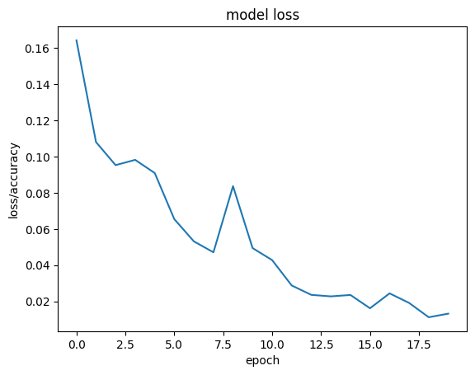

Pakai 50 epoch

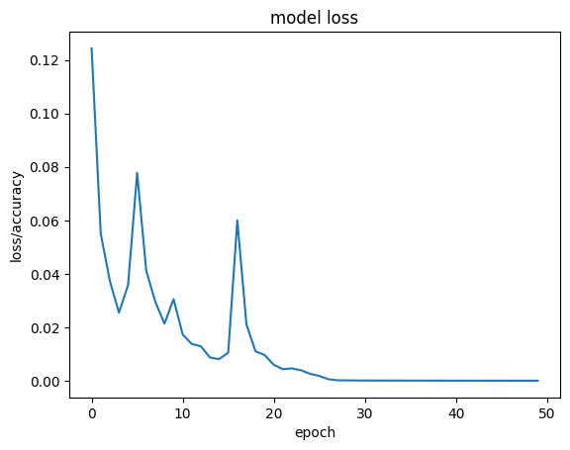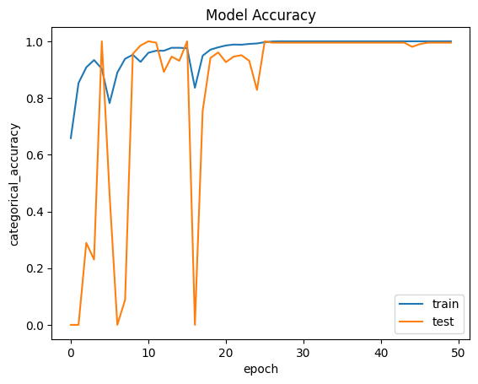Model: "model_1"

_________________________________________________________________

Layer (type) Output Shape Param #

=================================================================

input_2 (InputLayer) [(None, 128, 128, 3)] 0

conv2d_4 (Conv2D) (None, 128, 128, 32) 896

max_pooling2d_4 (MaxPooling (None, 64, 64, 32) 0

2D)

conv2d_5 (Conv2D) (None, 64, 64, 32) 9248

max_pooling2d_5 (MaxPooling (None, 32, 32, 32) 0

2D)

conv2d_6 (Conv2D) (None, 32, 32, 32) 9248

max_pooling2d_6 (MaxPooling (None, 16, 16, 32) 0

2D)

conv2d_7 (Conv2D) (None, 16, 16, 16) 4624

max_pooling2d_7 (MaxPooling (None, 8, 8, 16) 0

2D)

flatten_1 (Flatten) (None, 1024) 0

reshape_1 (Reshape) (None, 32, 32) 0

lstm_1 (LSTM) (None, 64) 24832

dense_3 (Dense) (None, 50) 3250

dense_4 (Dense) (None, 50) 2550

dense_5 (Dense) (None, 4) 204

=================================================================

Total params: 54,852

Trainable params: 54,852

Non-trainable params: 0

_________________________________________________________________