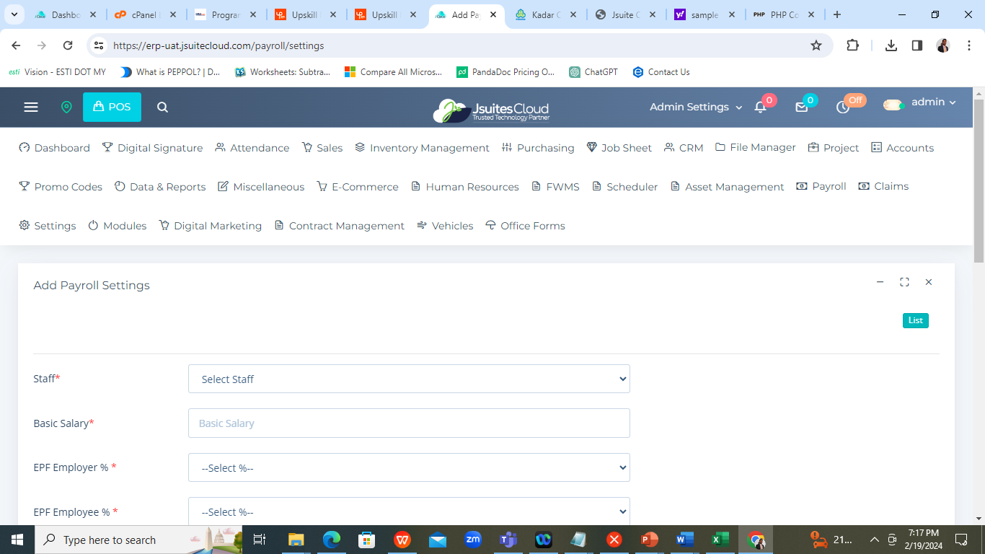

1. Once click the “ list “ Showint wrong listing. NOT FIX
2. Indonesia requirement missing. SA
3. Payment Voucher “ Payee “ ?? Admin Signature not display.

3a ) New Bugs

* 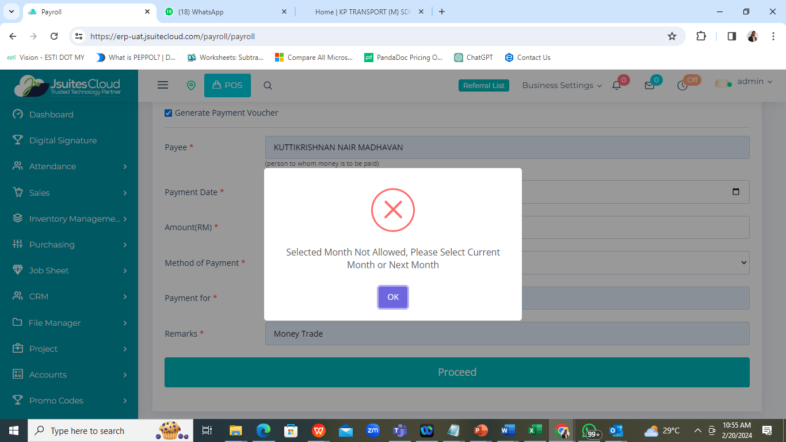

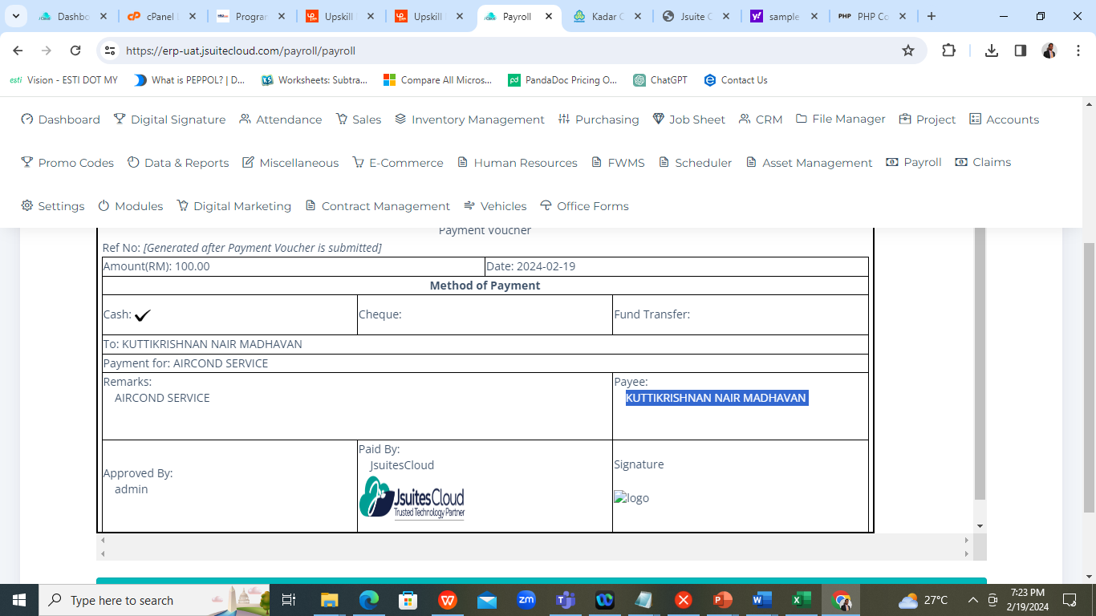

1. Employee Listing button is missing - FIXED

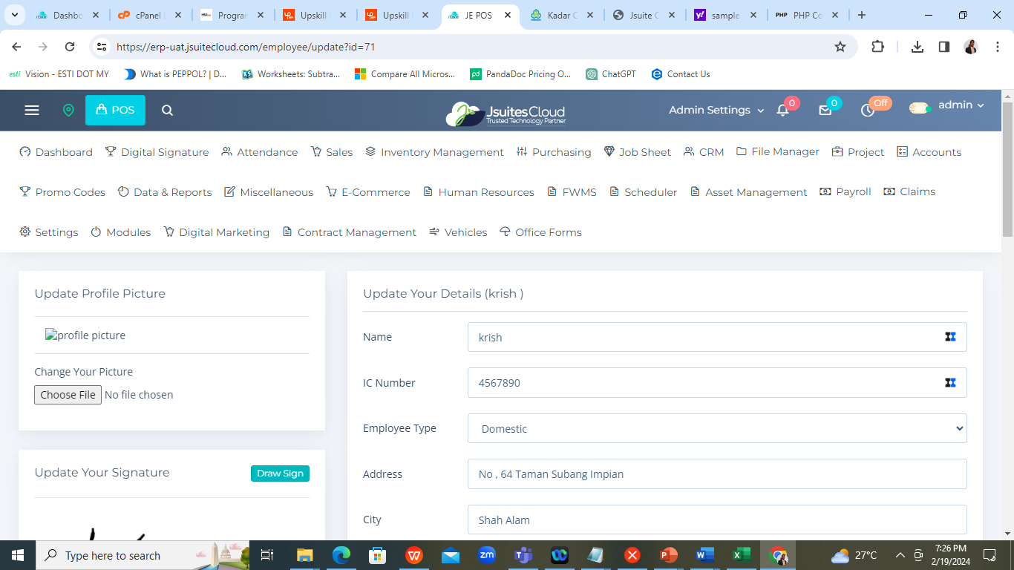

1. Company Stamp and Signature image upload @ signing place.

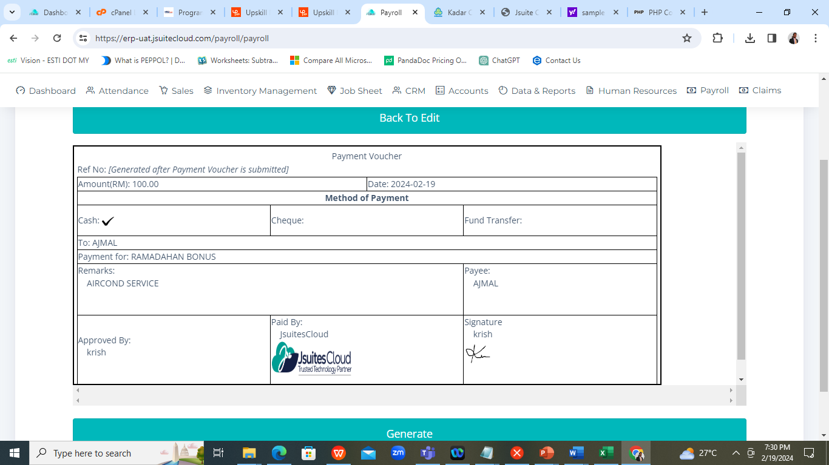

1. If no data should display “ – “ . no empty place. - FIXED

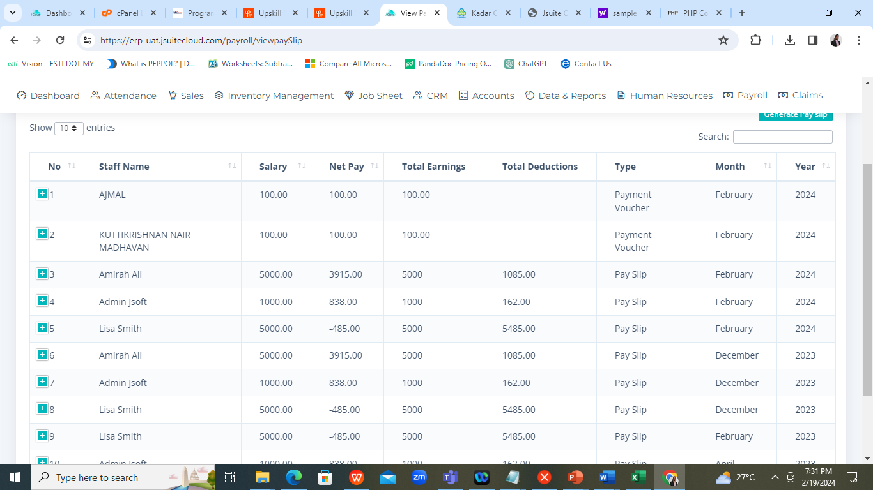

1. Display proper message “ Remove Dangers Word”.

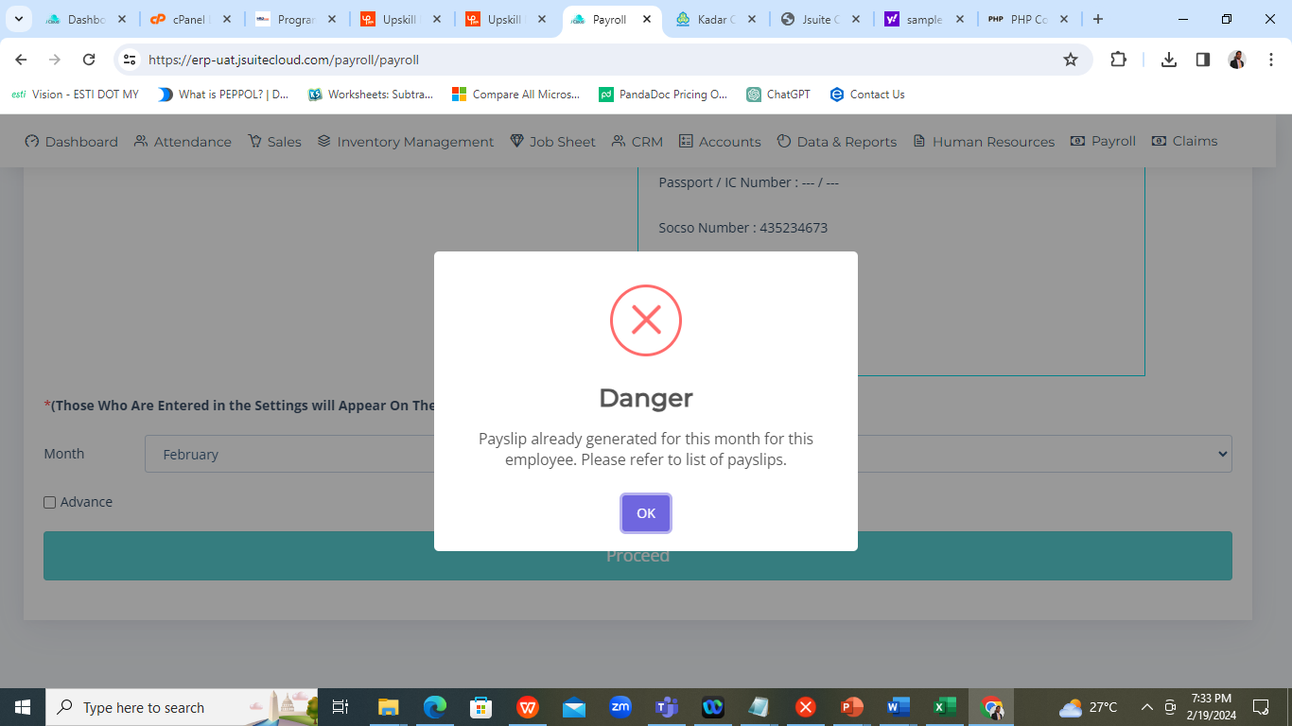

Still problem

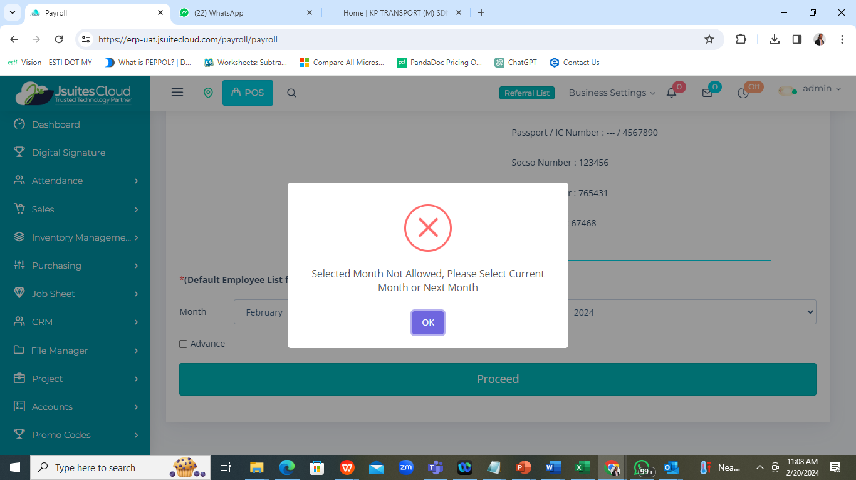

1. Change the message “ Default emp list from payroll setting configuration “. Fixed

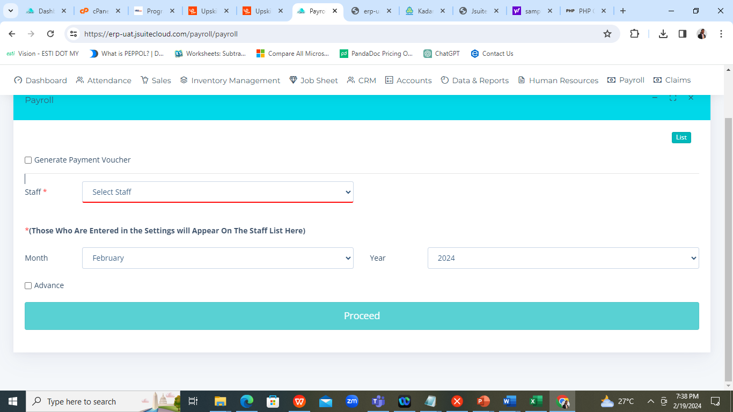

1. Unable to create a payslip for future month ,

9a) System should display alert message incase try to create for future month , let say before 20th each month alert the use with the condition of YES or NO and proceed for payroll creation.

1. The font are too small @ Address level. Design the pay slip in better look.

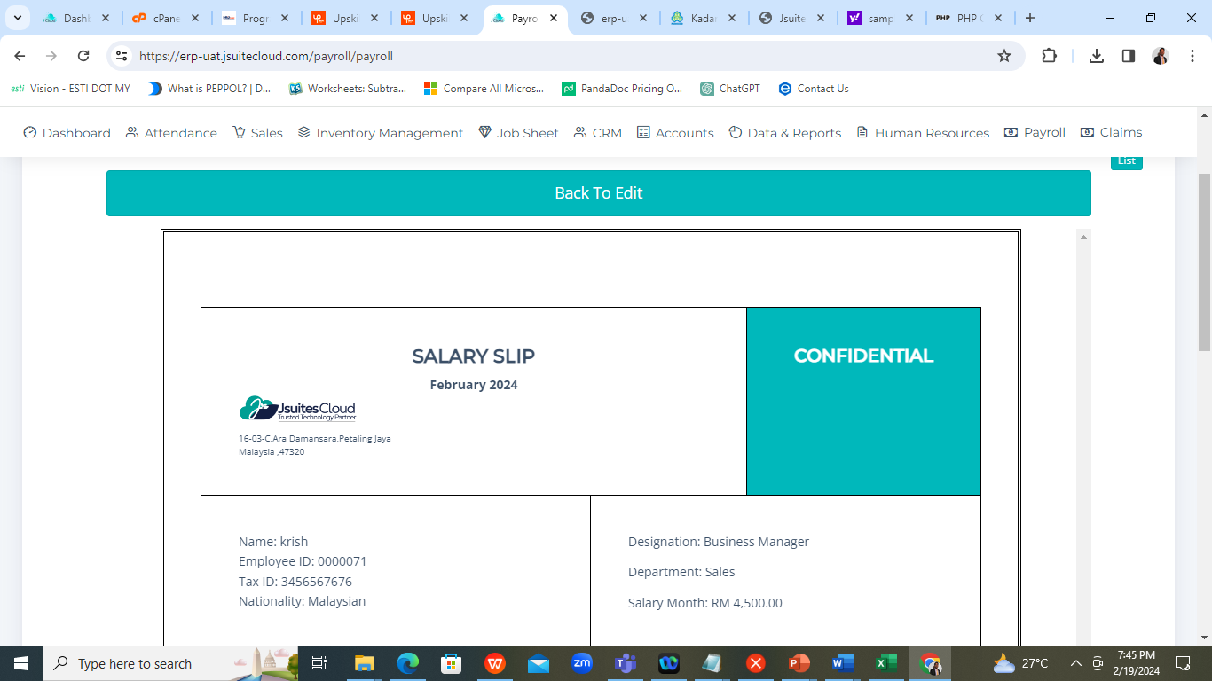

1. Displaying wrong NET pay @ Net pay column , should be after add all the allowances and others.

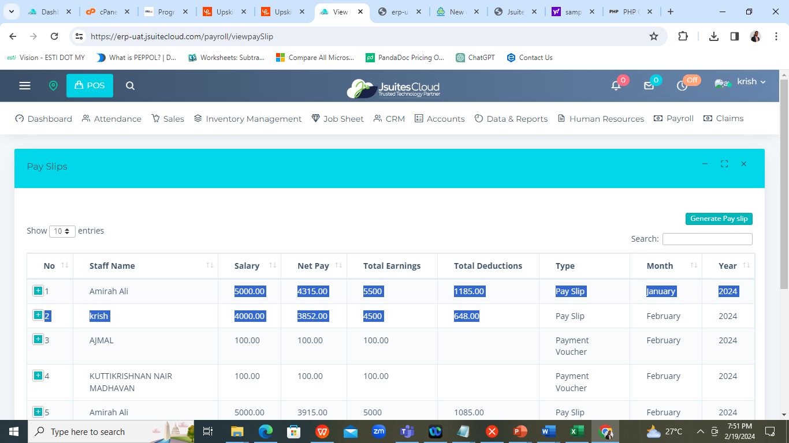

1. Title Not pay slip “ Generate the Pay slip “ .

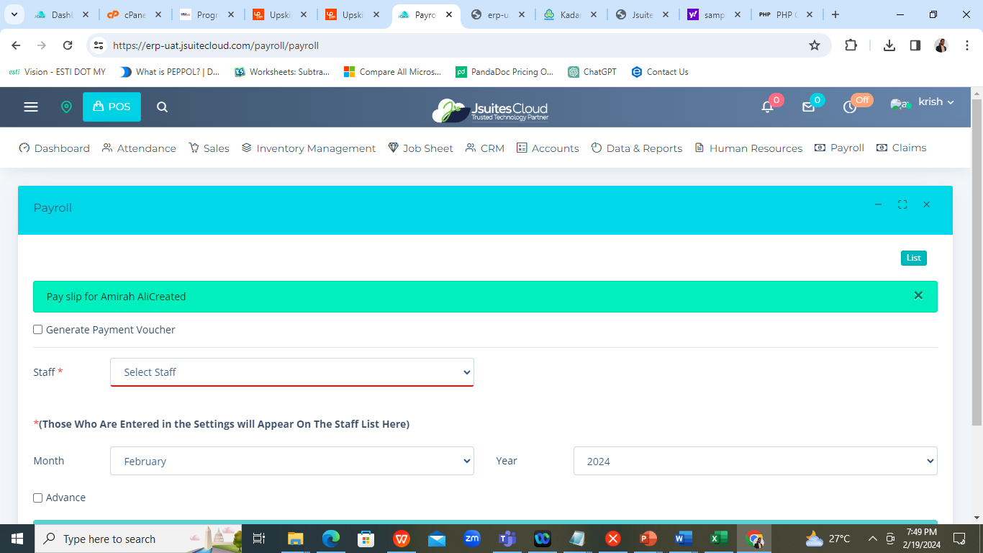

1. Remove the 9 % - done

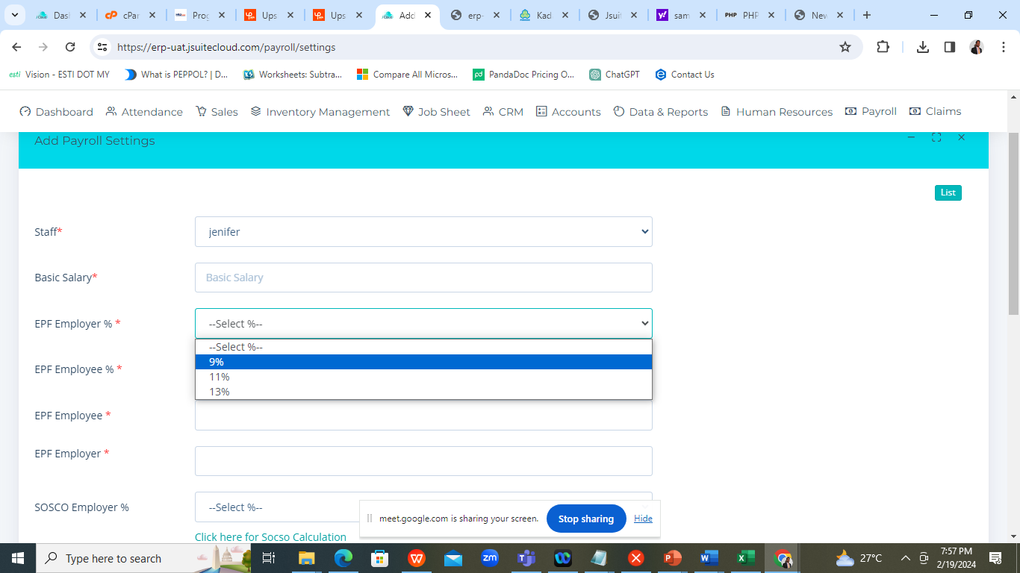

1. Employee EPF remove 9 % only 11 and 13 – done

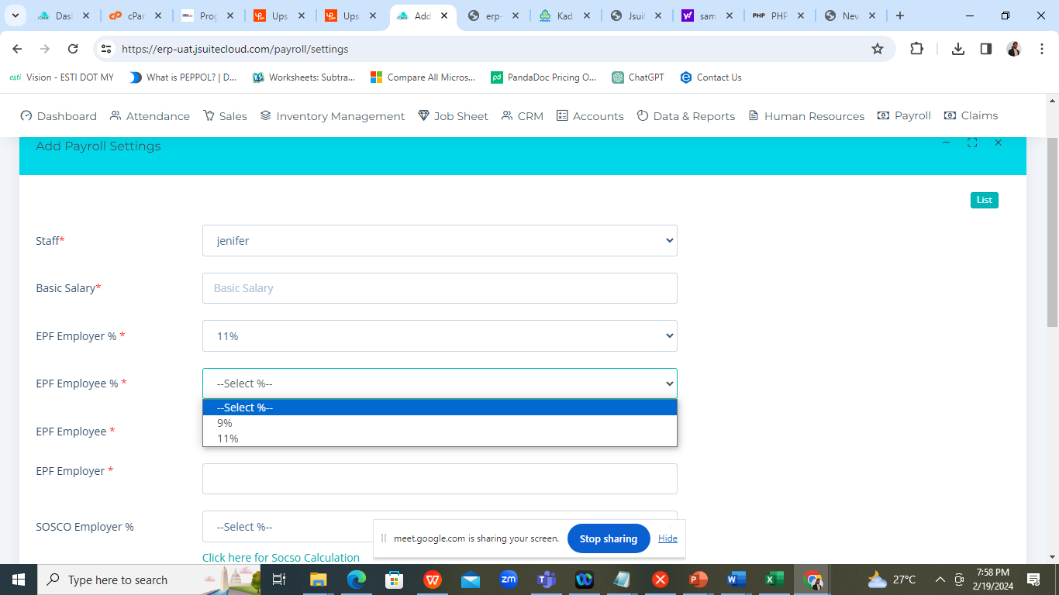

Change to text field – done

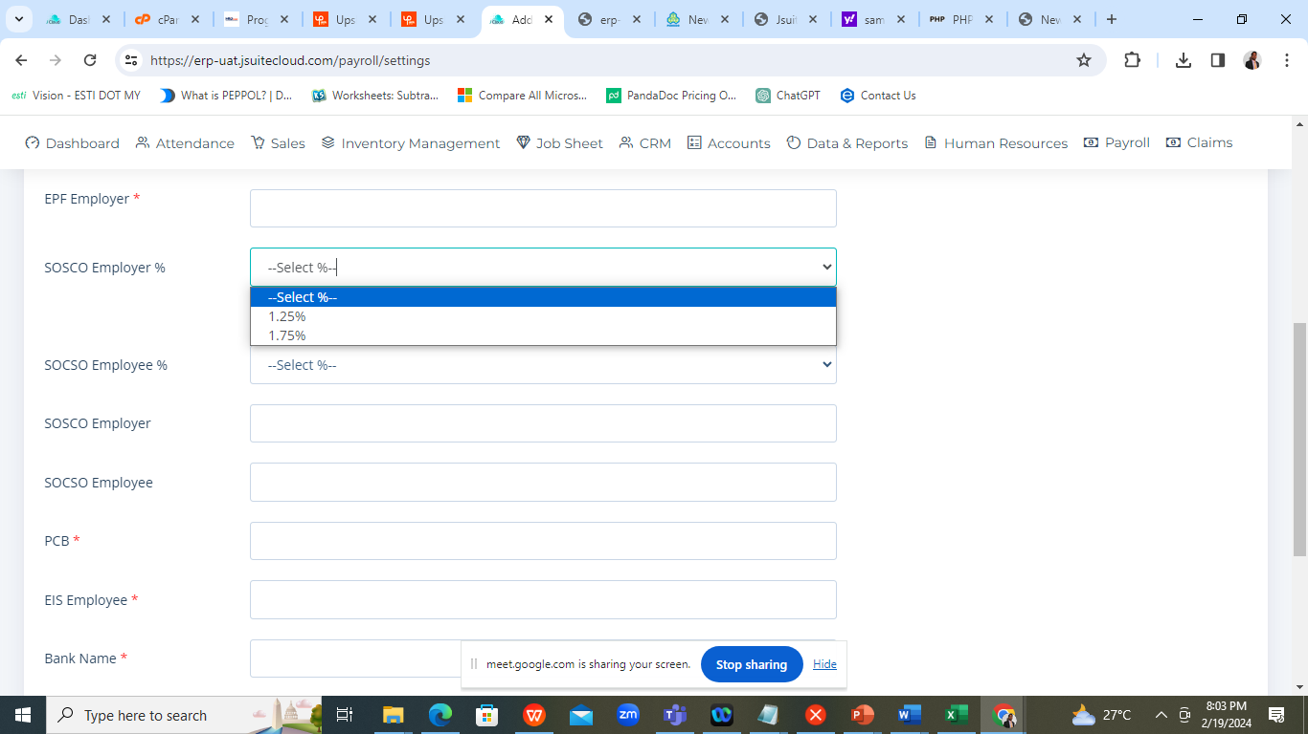

Not Applicable option for EPF @ drop down list. – done

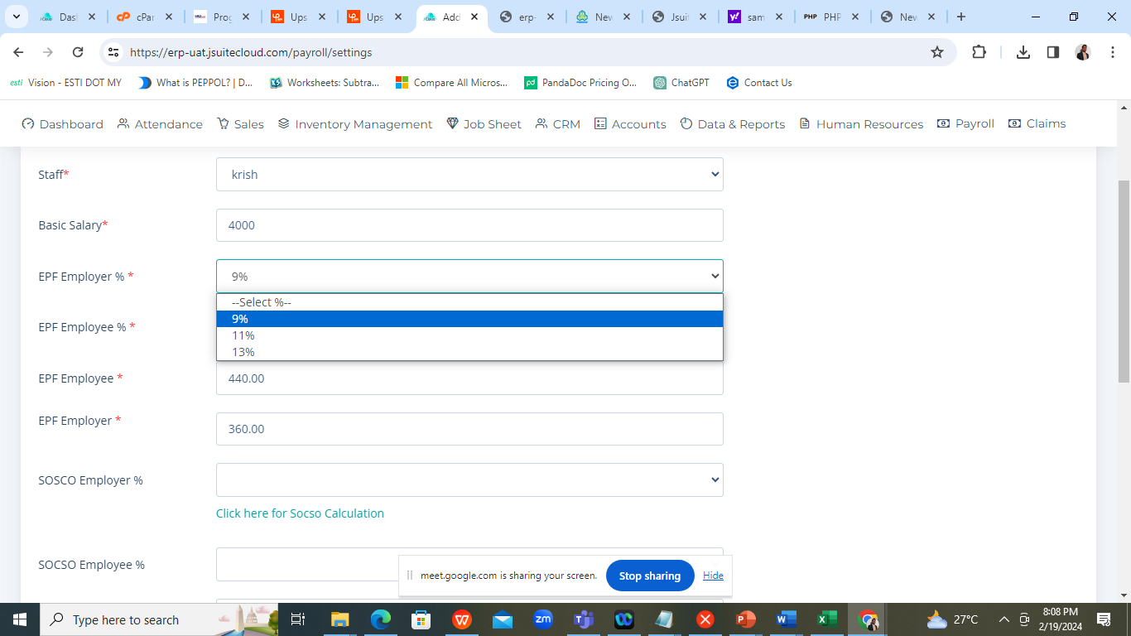

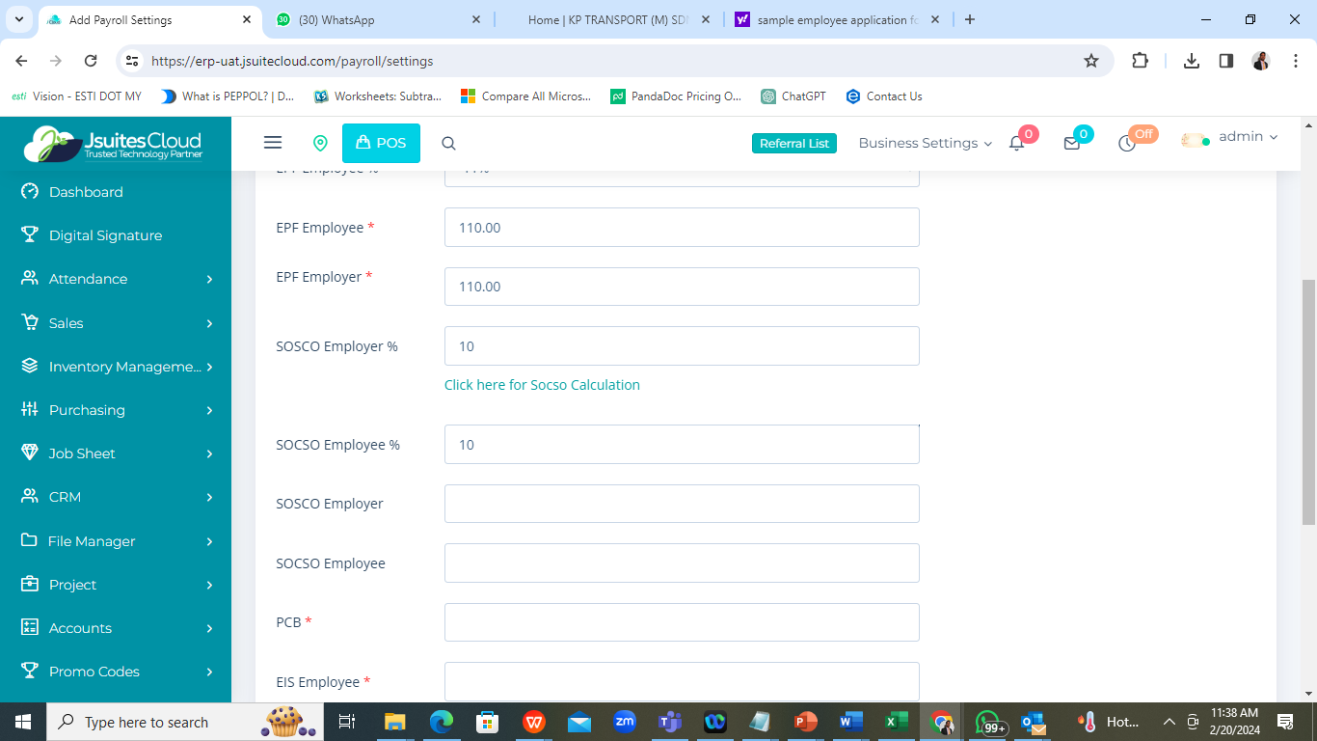

Remove the percentage field

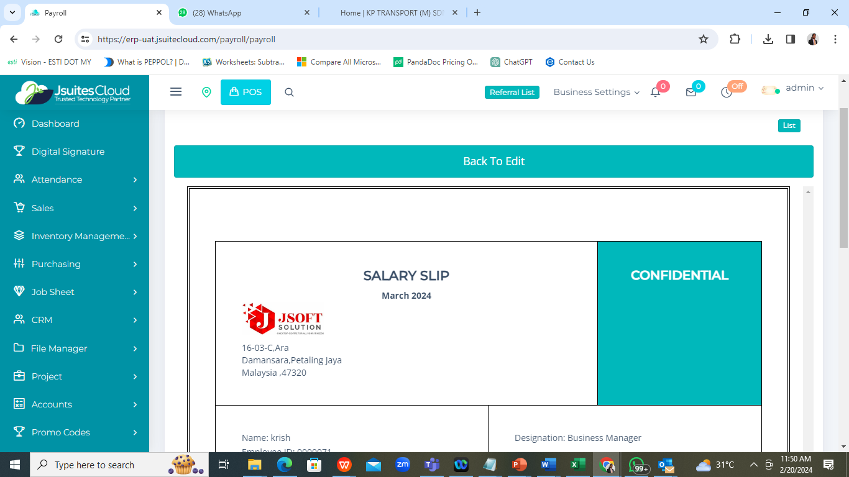

Design the logo and address

Craete a payslip for feb and delete and create again , system not allow to create the payslip for the same person

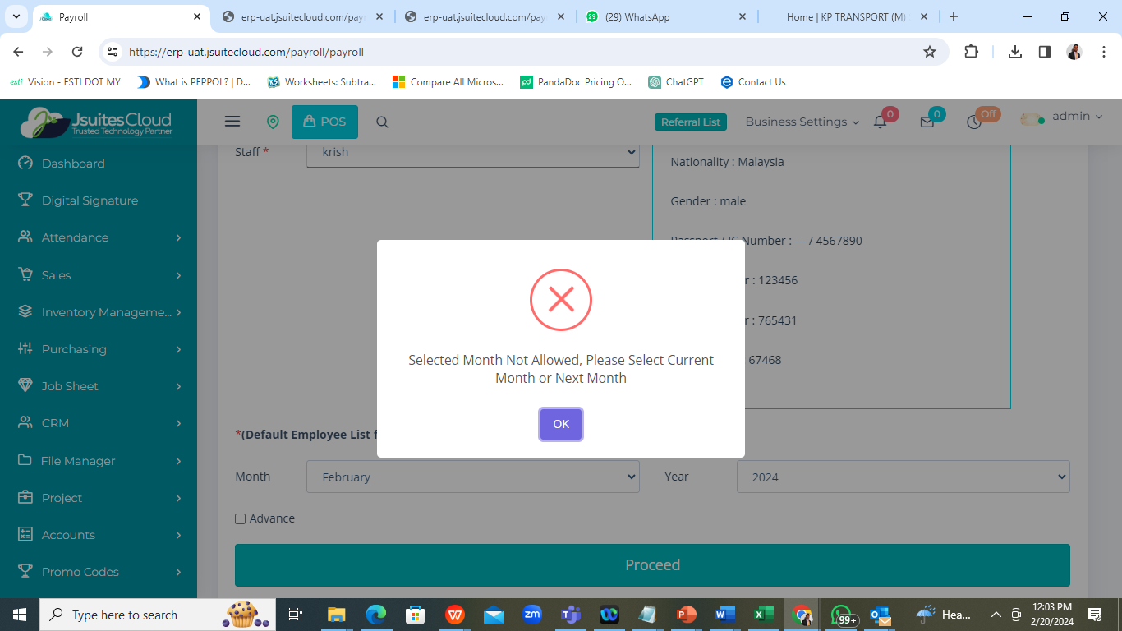

Unable to create the payment Voucher

