Attendance Report

1. **Filtering not Function Properly , When select the employee name “ Ajmal its show all the emp report “ .**

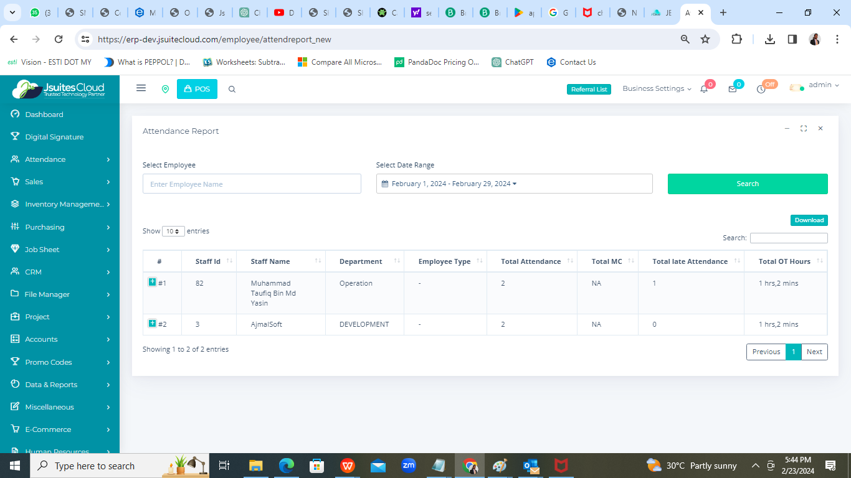

Expected Output ,

When select the employee name . add output field

Total working hours | Total Break Hours | Total Lunch Hours

2) Date Filtering not functioning. Since search by date :

Bring Clock in date | Clock out Date

1. 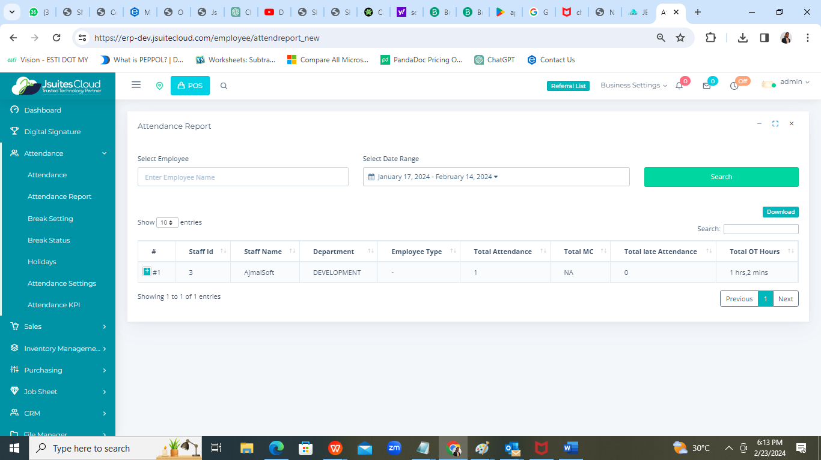

Change the menu Sequence

1. Manage Clock in / Clock out
2. Attendance Report
3. Break Status
4. Attendance KPI
5. Attendance > Setting
6. Break
7. Holidays
8. Attendance

1. Bring all the field @ Excel level . currently only display few field.



1. Attendance Change to “Manage Clock in / Clock out “

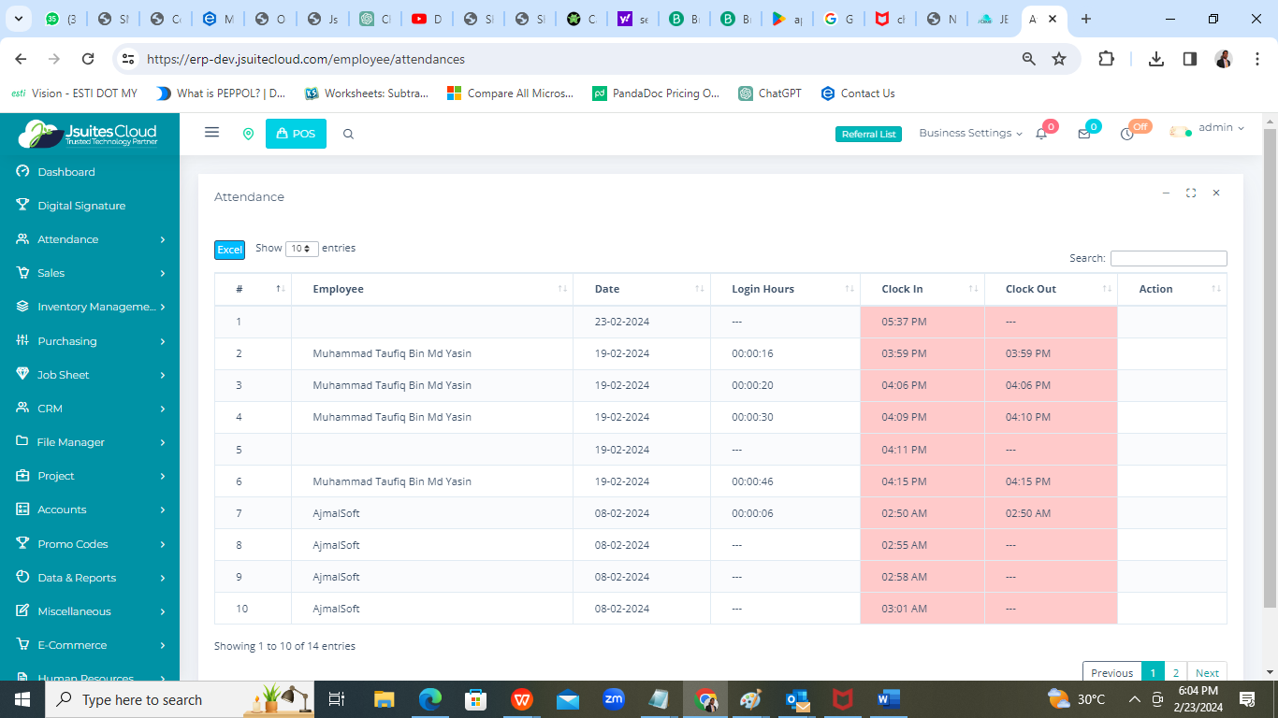

1. Single email to show
2. Late attendance by date .
3. Login out of the office zone by date.

Auto run @ 12am daily , and also base on the configuration time.