



**JSOFT SOLUTION SDN BHD**

**(COMPANY NO: 1057746H)**



**ATTENDANCE MODULE IMROVEMENT**

**C-3-16 CENTUM OASIS CORPORATE PARK,**

**NO 2 JALAN PJU 1A/2 OASIS DAMANSARA,**

**47301 PETALING JAYA, SELANGOR.**

1. **Attendance Report Page**

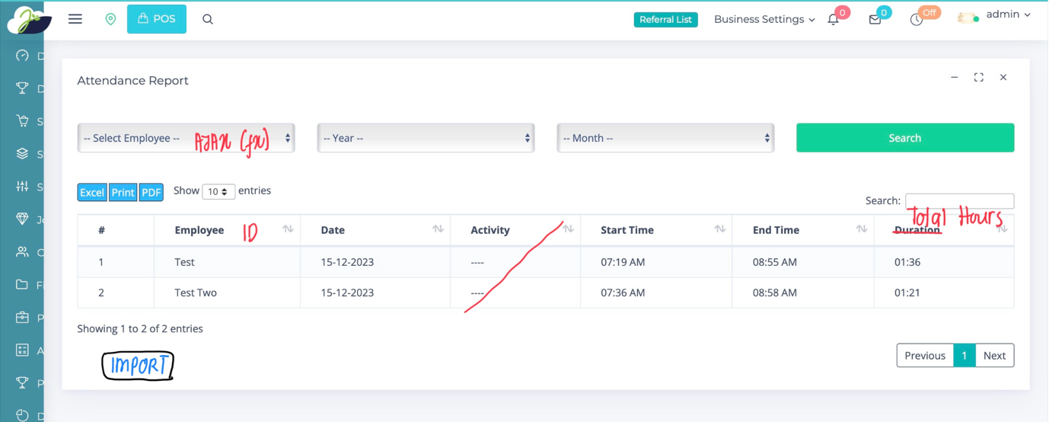

Improvement

1. Select Employee ID – use Ajax (fx)
2. Employee change to Employee ID
3. No need column for Activity
4. Add IMPORT button
5. **Employee Attendance Report Search Page**

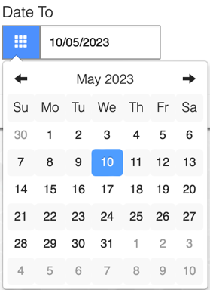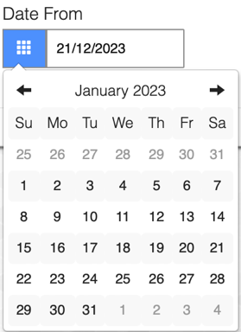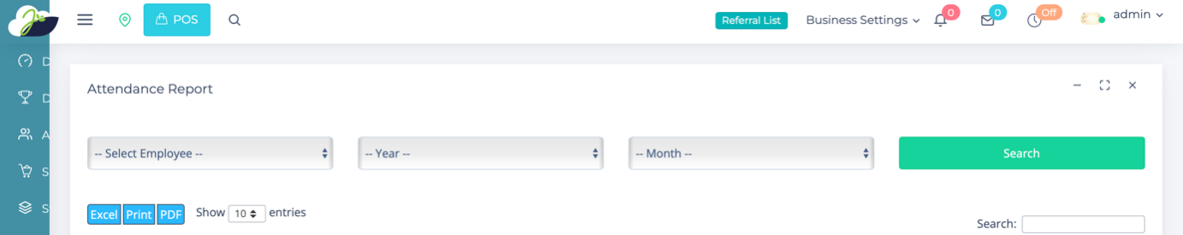

Improvement

1. Select Employee ID – use Ajax (fx)
2. Employee change to Employee ID
3. Year and month, change to Calendar
4. **Employee Attendance Listing Report Page**

**From 01/01/2023 To 01/03/2023**

**Employee ID Employee Name Position – Department**

|  |  |  |  |  |  |  |
| --- | --- | --- | --- | --- | --- | --- |
| **Date** | **First In** | **Last Out** | **Total Hours** | **OT** | **Allowance** | **Status** |
| 01/01/2023 | 0900 | 1800 | 8 | - | - | N/A |
| 02/01/2023 | 0900 | 1800 | 8 | - | - | N/A |
| 03/01/2023 | 0900 | 2200 | 12 | 4 | 80 | N/A |
| 04/01/2023 | 0900 | 1800 | 8 | - | - | N/A |
| 05/01/2023 | - | - | - | - | - | ***AL*** |
| 06/01/2023 | 0900 | 1800 | 8 | - | - | N/A |
| 07/01/2023 | - | - | - | - | - | ***PH*** |
| 08/01/2023 | 0900 | 1800 | 8 | - | - | N/A |

1. Those are not login until 11am , a email notification must send to employee and manager said their not reported to work.
2. Those are login after 930am , must be highlighted by colour and send a email to emp and Manager staff which is login late to work.