Recycling Rewards System
Project Management Documentation

1. Methodology
For the development of the Recycling Rewards System, we adopt the Agile Methodology using the Scrum Framework.

Why Agile/Scrum?
- Iterative Progress: The project is divided into short iterations (Sprints) lasting 2 weeks each, allowing regular delivery of functional software modules.
- Flexibility: Adapts quickly to evolving requirements, user feedback, and hardware/IoT integration challenges (e.g., smart bin sensors or QR code verifications).
- Transparency & Collaboration: Daily stand-up meetings and Sprint reviews maintain clear alignment among team members, project supervisors, and stakeholders.

2. Time Estimation
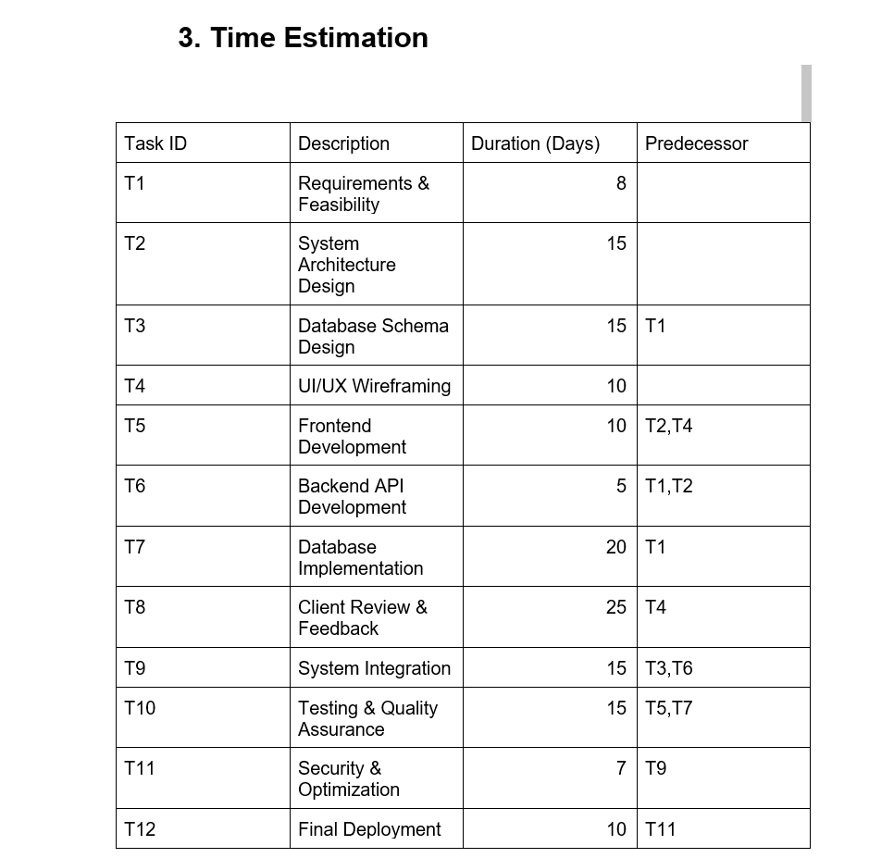

3. Case Study
The Recycling Rewards System is designed to encourage people to recycle waste by providing rewards for eligible recycling activities. The system organizes the main activities involved in recording recycling actions and managing the rewards associated with them.
The project requires planning and coordination of tasks such as requirements and feasibility, system architecture design, database schema design, UI/UX wireframing, frontend development, backend API development, database implementation, client review and feedback, system integration, testing and quality assurance, security and optimization, and final deployment.
The project schedule and task dependencies are represented in the Time Estimation table, PERT Chart, and Gantt Chart sections of this document.

4. PERT Chart
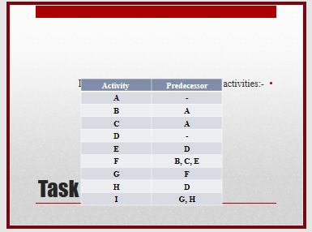
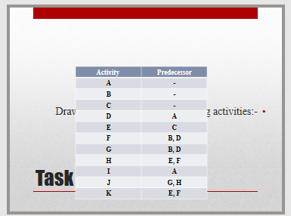
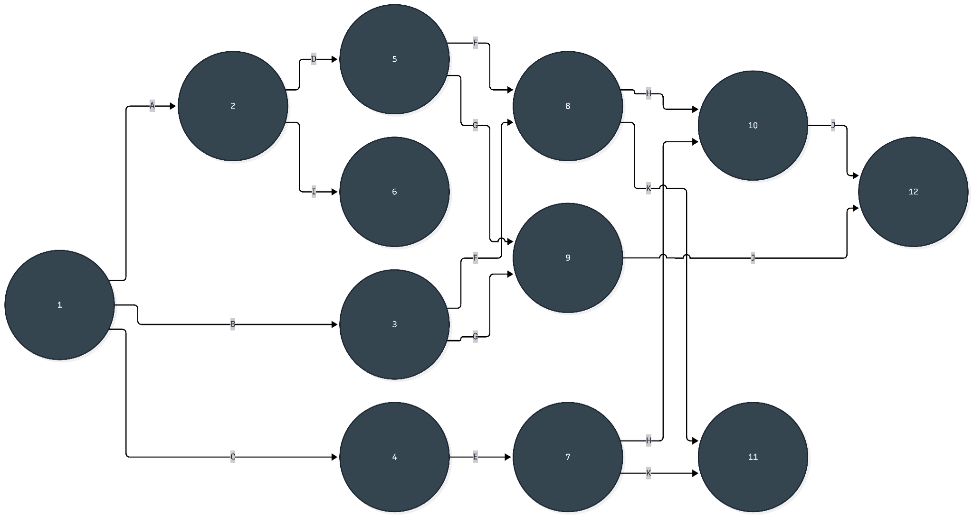
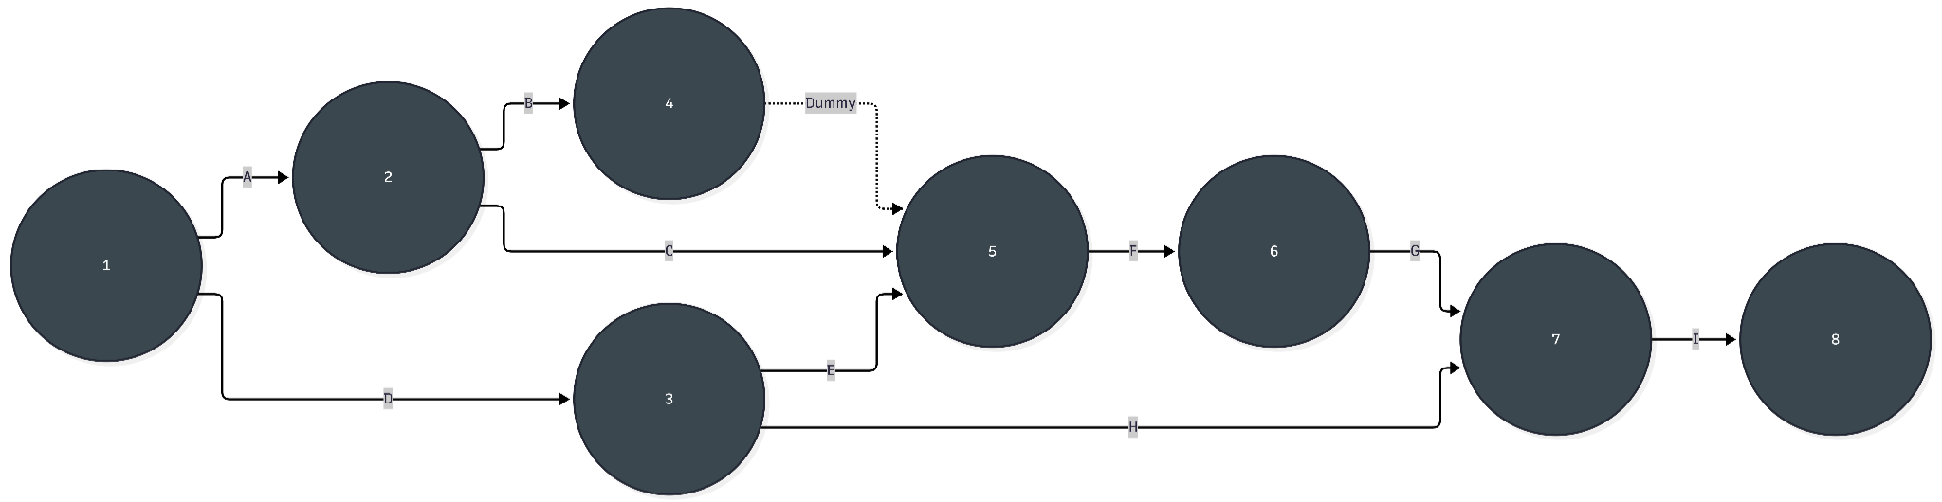
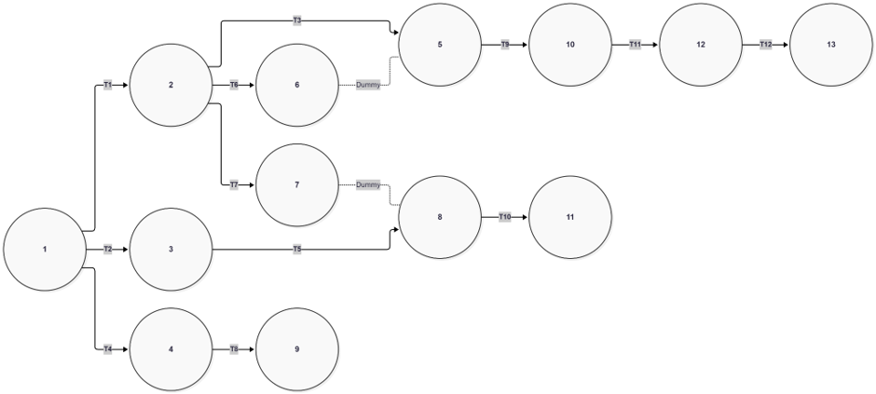

5. Gantt Chart
