***Installing Ranger Using Ambari***

Apache Ranger can be installed either manually using the Hortonworks Data Platform (HDP) or the Ambari User Interface (UI). Unlike the manual installation process, which requires you to perform a number of installation steps, installing Ranger using the Ambari UI is simpler and easier. The Ranger service option will be made available through the Add Service wizard after the HDP cluster is installed using the installation wizard.

Once Ambari has been installed and configured, you can use the Add Service wizard to install the following components:

* Ranger Admin
* Ranger UserSync
* Ranger Key Management Service

After these components are installed and started, you can enable Ranger plugins by navigating to each individual Ranger service

Step -1 -Installation Prerequisites

When using MySQL,

create the Ranger databases.

**CREATE** **USER** 'ranger'@'localhost' **IDENTIFIED** **BY** 'ranger'**;**

**GRANT** **ALL** **PRIVILEGES** **ON** **\*.\*** **TO** 'ranger'@'localhost'**;**

**CREATE** **USER** 'ranger'@'%' **IDENTIFIED** **BY** 'ranger'**;**

**GRANT** **ALL** **PRIVILEGES** **ON** **\*.\*** **TO** 'ranger'@'%'**;**

**GRANT** **ALL** **PRIVILEGES** **ON** **\*.\*** **TO** 'ranger'@'localhost' **WITH** **GRANT** **OPTION;**

**GRANT** **ALL** **PRIVILEGES** **ON** **\*.\*** **TO** 'ranger'@'%' **WITH** **GRANT** **OPTION;**

FLUSH **PRIVILEGES;**

Nex run the below command to set ambari setup for enabling ranger. This should be run in ambari server host.

**sudo ambari-server setup --jdbc-db=mysql --jdbc-driver=/usr/share/java/mysql-connector-java.jar**

Step - 2

Goto Ambari >> In the left navigation menu, click **Actions**, then select **Add Service**.

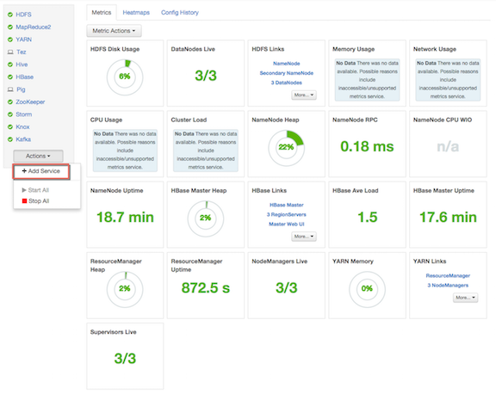

On the Choose Services page, select **Ranger**, then click **Next**.

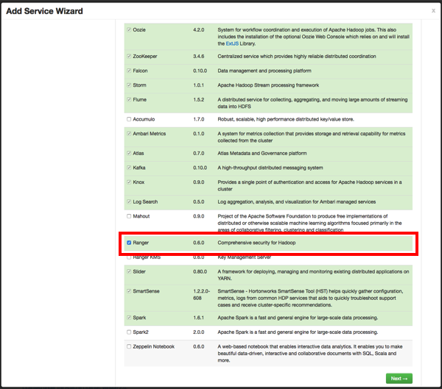

Installing Ranger - Ranger Requirements

we already completed this setup just click proceed

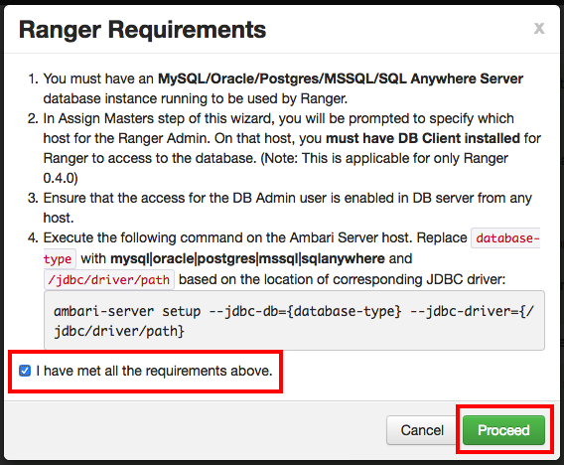

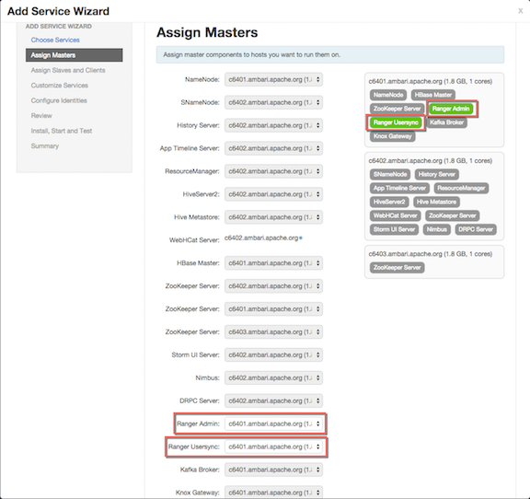

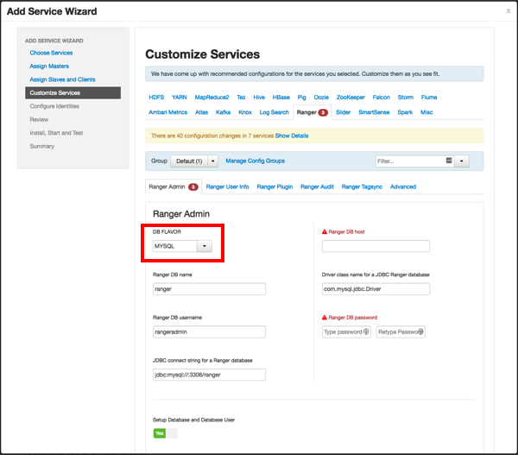

**once complete the installation restart the affected services.**

**verify the installation**

**Ambari >> ranger>>quicklinks>>ranger ui**

**username /pwd : admin /admin**

