

Site Specific Safety Plan
[CostCon: Job Name]
Job Number: [CostCon: Job Number]

Sansom Concrete Repairs Ltd
P O Box 9446
Newmarket
Auckland 1149
Ph. 09 352 9600
www.sansom.co.nz

TABLE OF CONTENTS
1. PROJECT INFORMATION 3
2. SITE SPECIFIC SAFETY PLAN 5
3. HEALTH AND SAFETY POLICY 7
4. RISK ASSESSMENT & CONTROLS 9
5. HIERARCHY OF CONTROLS 9
6. RISK REGISTER 11
7. EMERGENCY EVACUATION PLAN 37
8. EMERGENCY CONTACTS LIST 45
9. EMERGENCY RESPONSE PLAN (To be discussed, written up and agreed upon by crew on site) 46
10. NOTIFICATION OF PARTICULAR HAZARDOUS - CONSTRUCTION WORK 41
11. NOTIFIABLE EVENTS 49
12. HAZARD REPORT FORM 50
13. HAZARDOUS SUBSTANCE REGISTER 52
14. Safety Data information 47
15. ACCIDENT/INCIDENT REGISTER 54
16. INCIDENT REPORT FORM 55
17. INCIDENT REVIEW FORM Error! Bookmark not defined.
18. HSEQ - WEEKLY SITE SAFETY INSPECTION FORM 51
19. HSEQ - WEEKLY TOOLBOX MEETING FORM…………………………………………………………………………53
20. HSEQ - DAILY PRE-START ASSESSMENT FORM 61
21. REVIEWED TASK ANALYSIS 63
22. SANSOM TRAINING AND COMPETENCY REGISTER 64
23. SIGN OFF PAGE 65
24. ACKNOWLEDGEMENT AND AGREEMENT 66

PROJECT INFORMATION
Date: |  | Project/Site Location:
Main Contractor/Client Name: |  | Contact Phone:
Sansom  Project Manager: |  | CM Contact Phone:
Project Manager:
Louis Joubert

1st Aider:
Louis Joubert
Site Supervisor:
Louis Joubert
HSEQ Manager:
Shaun Petterson
Work Type(s): |  | Work Type(s):
  ☐ Baffle joints
  ☐ Coating
  ☐ Crack injection
  ☐ Floor repairs
  ☐ Grouting
  ☐ Joint sealant
  ☐ Tanking – under slab
  ☐ Torch on membrane
  ☐ Carbon fibre reinforcing
  ☐ Concrete repairs
  ☐ Fibre glass reinforcing
  ☐ Guidance cabling
  ☐ Helifix
  ☐ Seismic jointing system
  ☐ Tanking - Walls
  ☐ Warm Roof
Standards & Frequency: | Donesafe - HSEQ - Daily Pre-Start Assessment - completed daily | ☐ YES ☐N/A
Standards & Frequency: | Donesafe - HSEQ - Weekly Toolbox Meeting - held weekly, on site and all persons on site to attend | ☐ YES ☐N/A
Standards & Frequency: | Donesafe - HSEQ - Weekly Site Safety Inspection - completed weekly | ☐ YES ☐N/A
Standards & Frequency: | Quality assurance is completed when required | ☐ YES ☐N/A
Site Sign in programme: | Everyone coming onto the site is to sign in and sign out | ☐ YES ☐N/A

Personal Protective Equipment (PPE) to be used by everyone, with no exceptions:  (This is not a full list of PPE so each person or contractor is required to add PPE as determined by each task) | - Hardhat  - Hi-visibility outer clothing or long sleeve shirt  - Gloves (type and use as required)  - Safety Glasses  - Hearing Protection (type and use as required)  - Dust masks P2 (as required)  - Respirators (type and use as required)  - Safety footwear  - Fall arrest/restraint system (type and use as required) | ☐ YES ☐N/A
Parking: | - In the designated locations informed to you during the site induction. | ☐ YES ☐N/A
Smoking / Vaping: | - Only permitted in approved or designated areas. | ☐ YES ☐N/A
Behaviour: | - There could be other people working in the area, so all communication (language) is to be respectful, no swearing. | ☐ YES ☐N/A
Hygiene: | Good Hygiene Practices include but not limited to:  - Regularly washing hands (for at least 20 seconds with warm water rand soap and dry thoroughly)  - Covering your mouth and nose when you sneeze or cough (with crook of your arm)  - Staying home if you are sick  - Avoiding close contact with anyone | ☐ YES ☐N/A
First Aid Supplies | - All Sansom vehicles carry a First Aid kit  - Sansom Site Supervisor / First Aider is required to provide first aid supplies for Sansom’s use on site | ☐ YES ☐N/A

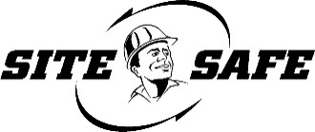
SITE-SPECIFIC SAFETY PLAN
General Information
Date
Project/Site
Sub-Contracted Works
Subcontractors | Subcontractors to PCBU 2 working on the site not covered by this agreement will supply their own SSSP | ☐ YES ☐N/A
Notifiable Works | There will be notifiable works that need to be reported to WorkSafe | ☐ YES ☐ N/A
Notifiable Works | WorkSafe has been notified of these works | ☐ YES ☐ N/A
Notifiable Works | A copy of the notification (or receipt from WorkSafe) is attached | ☐ YES ☐ N/A
Task Analysis | Task Analyses are required for some on-site activities | ☐ YES ☐ N/A
Task Analysis | Copies of these have been provided with this SSSP | ☐ YES ☐ N/A
Task Analysis | Emergency Response Plans have also been provided | ☐ YES ☐ N/A
Hazardous Products and Substances | There will be hazardous products/substances brought onto to site | ☐ YES ☐ N/A
Hazardous Products and Substances | These products are recorded on the hazardous substances register | ☐ YES ☐ N/A
Hazardous Products and Substances | The relevant material safety data sheets have been provided | ☐ YES ☐ N/A
Hazard and Risk Management | A hazard register for our activities on this site has been provided | ☐ YES ☐ N/A
Accident/Incident: Reporting, Investigation, Recording: | An Accident/Incident reporting/investigation system is in place, and an Accident Register is kept at Sansom’s office.
Accident/Incident: Reporting, Investigation, Recording: | (All notifiable events will be reported to Site Management along with a copy of the Accident Investigation Report)

Reporting
Serious injuries | ☒ Immediately  ☐ Within 24 hrs | Comments:
First aid injuries | ☒ Immediately  ☐ Within 24 hrs | Comments:
Near misses | ☐ Immediately  ☒ Within 24 hrs | Comments: If the risk of harm was high/notifiable, report immediately
Serious damage to property | ☒ Immediately  ☐ Within 24 hrs | Comments:

Communications
Toolbox talks | ☒ YES ☐ N/A | Frequency: Weekly through the Donesafe HSEQ Reporting Platform
Project pre-start briefings | ☒ YES ☐ N/A | Frequency: Daily Project Requirements
Daily pre-start briefings | ☒ YES ☐ N/A | Frequency: Daily per Donesafe HSEQ Reporting Platform
Progress meetings | ☒ YES ☐ N/A | Frequency: Regularly
Pack down check list | ☐ YES ☒ N/A | Frequency: If called for

Inspections
Pre-start site inspection | ☐ N/A  ☒ Before starting | Comments:
Site inspection | ☐ N/A  ☒ Weekly | Comments: Weekly through the Donesafe HSEQ Reporting Platform
MEWP | ☒ N/A  ☐ Daily | Comments:
Harness, ropes, rigging equipment, etc | ☒ N/A  ☐ Daily | Comments: Before any use, check over all height safety equipment

Staff
Training / Experience / Competency | Every worker under our control on site will have a current site safety card or booking confirmation. | ☒ YES ☐ N/A
Training / Experience / Competency | Every worker under our control on site will be inducted on site | ☒ YES ☐ N/A
Training / Experience / Competency | Every worker under our control will be suitably qualified, competent, or supervised | ☒ YES ☐ N/A
Training / Experience / Competency | Our competency register is attached | ☒ YES ☐ N/A

Environmental
 | Is there an environmental plan required for this site? | ☐ YES ☐ N/A
Control Details: | Will dust, fumes, or smoke be generated that could affect members of the public/others?  If yes explain how this will be controlled | ☐ YES ☐ N/A
Control Details: | Vacuums are used for all dust created
Control Details: | Will noise be generated that could affect members of the public or others?  If yes, explain how this will be controlled | ☐ YES ☐ N/A
Control Details: | Could your activity potentially cause dirty water or wash-down runoff, silt or other contaminants to be released?  If yes explain how this will be controlled | ☐ YES ☐ N/A

HEALTH AND SAFETY POLICY
Overview:

Sansom is committed to providing a healthy and safe workplace for all employees, visitors, contractors, sub-contractors, PCBU’s and any other individuals who may enter any of our sites, premises, work areas or may be affected by our operations. This policy is designed to ensure compliance with the Health and Safety at Work Act 2015, relevant regulations, codes of practise, legislation and ISO 45001:2018, which reflects our commitment to continuous improvement as we strive for excellence in health and safety practices and getting people home healthy and safe.

Sansom PCBU & Officer Responsibilities:
- Ensure an effective Health and Safety Management Plan and programme is developed and maintained to ensure that workplace risks and hazards are identified, and appropriate measures are taken to control these risks and hazards.
- Ensure the Management Plan and programme is reviewed and monitored regularly to take account of changing conditions and circumstances in the workplace, with records kept.
- Employees will be consulted and have the opportunity to participate in the development of health and safety practices through nominated representation on all health and safety matters that affect them.
- To respond promptly to any health and safety issues brought to their attention and provide feedback on the outcomes.
- All plant, equipment, substances, storage and safe work systems used are designed and maintained for the worker to use for their intended purposes.
- All incidents and accidents are accurately recorded and investigated, with appropriate action(s) taken to prevent recurrence.
- All employees, contractors, sub-contractors and PCBU’s are inducted, trained, supervised (as appropriate) and provided with the information to undertake their duties safely and made aware of their responsibilities to health and safety.
- Establish and support a safe and early return to work programme for injured employees.
- Develop and maintain effective emergency procedures including evacuation plans and first aid protocols, with regular drills conducted to ensure personnel are familiar with the procedures.
- Ensure effective Communication, Consultation and Co-operation with contractors.
- Ensure adequate facilities for the welfare of workers while carrying out the work for the business.
- Ensure that the health and safety of workers are continuously monitored to prevent injury or illness.

Responsibilities of Employees, Workers, Contractors, and Subcontractors:
- To carry out work and take reasonable care for their own health and safety and not adversely affect the health and safety of other workers or persons in the vicinity through action or inaction.
- To learn and understand all Sansom and site health and safety rules and follow them.
- To be certain they:
- understand all reasonable instructions given before starting work
- use safe working procedures and practices for the work
- To correctly use the relevant personal protective equipment and safety equipment/devices required for the work.
- To actively participate in training and workplace health and safety at all places of work.
- To stop and get further instructions from the supervisor or manager if in doubt of the safety of a task before continuing.
- To make sure they understand their responsibilities in an emergency situation.
- To report any unsafe behaviour, work conditions, equipment, near miss events, incidents, accidents, risks or hazards to your Health and Safety Representative, Supervisor, Manager or HSEQ team member immediately.

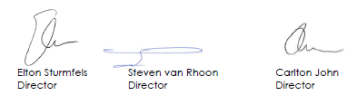

RISK ASSESSMENT & CONTROLS
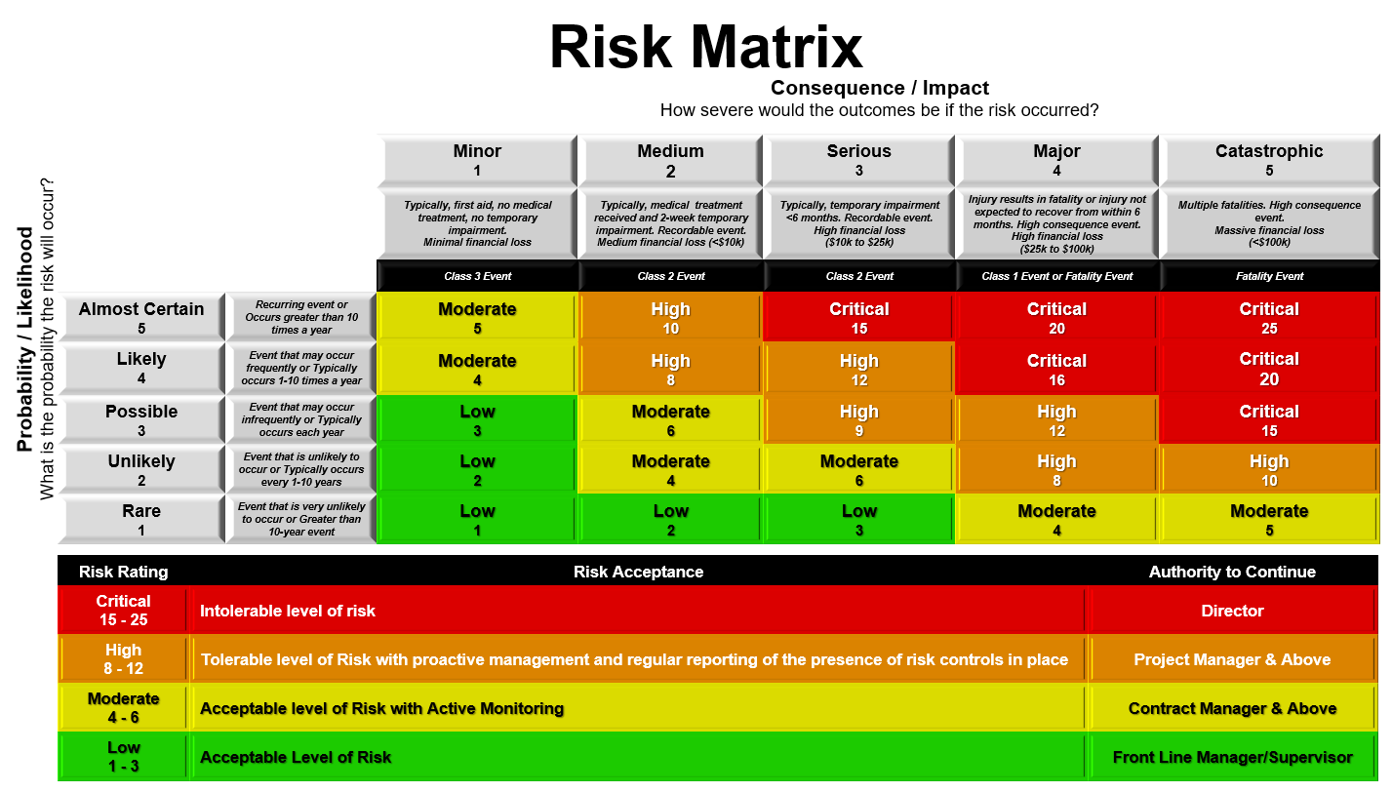
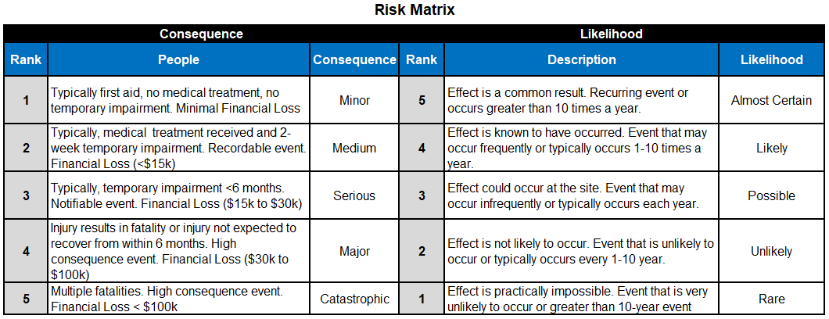

HIERARCHY OF CONTROLS
In accordance with the ‘Health and Safety at Work Act 2016’, Hierarchy of Control measures is in accordance with the Act if it is not reasonably practicable to eliminate the risk.

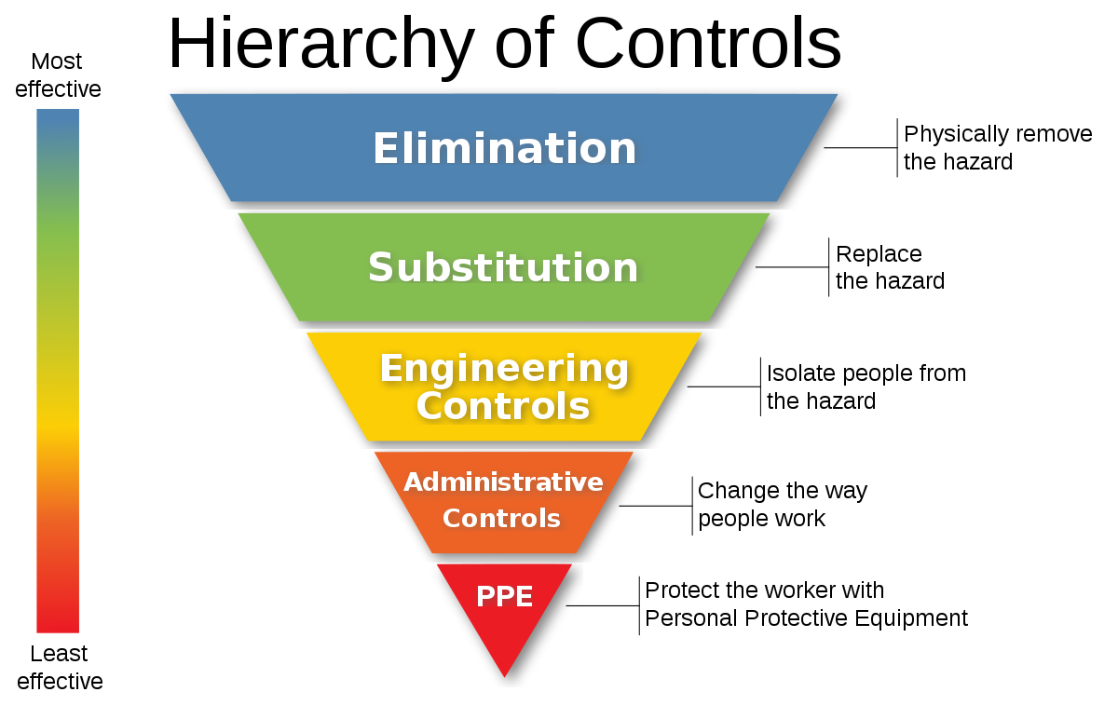

RISK REGISTER

Risk ID | Risk Title / Description | Potential Harm / Hazards | Critical Risk | Initial Likelihood | Initial Consequence | INITIAL RISK RATING | Mitigation Strategies / Controls | Residual Likelihood | Residual Consequence | RESIDUAL RISK RATING
 |  |  | (Is the risk considered critical?) |  |  |  | (Actions or plans to reduce the likelihood or impact of the risk)
001 | Adverse Weather Conditions | Extreme heat - hyperthermia, heat stroke, sun burn. Extreme cold - hypothermia, frostbite. Heavy rain - flooding, water pollution. Ice - slip trip fall. High winds - flying objects, building damage, affected working conditions. Electrical storms - lightening strike, electrocution. Fog - reduced visibility. Hail - vehicle/building damage, injury. UV Radiation - sunburn, cancer. Environmental damage | No | Likely (4) | Serious (3) | High 12 | - Monitor Weather Forecast.  - Emergency Response Plan.  - Extreme Heat: Regular hydration and breaks. Rotation of workers where appropriate. Use of cooling equipment. Ventilation. Use shade.  - Extreme Cold: Provision of appropriate PPE (jackets, gloves, coats etc). Regular breaks and rotation. Heating equipment. Reduce cold exposure as appropriate  - Heavy Rain: Use of waterproof PPE. Use of non-slip footwear. Postpone outdoor work as necessary. Cover Materials as appropriate. Do not walk in flood water. Move equipment and materials indoors and to higher ground as necessary. Ice: Analyse surface for ice conditions. Use appropriate PPE with appropriate grip. Postpone work. Use non-slip material.  - High Winds: Monitor wind speed. Avoid work at heights in high winds. Secure or Remove loose materials. Scrim removed/anchored on scaffolding or site fences. Housekeeping.  - Electrical Storms: Monitor lightning information. Postpone outdoor work. Work indoors where applicable. Avoid working near conductive materials. Fog: Appropriate lighting. Reduce speeds and increase spacing in vehicles. Postpone tasks that require clear visibility.  - Hail: Monitor weather reports. Cover Vehicles/Machinery/surfaces as appropriate. Work Indoors where appropriate.  - UV Radiation: Minimum 30spf sunscreen. Provision of appropriate sun protection PPE (sunglasses, long sleeve and long pants, hat). Install shade structures as required. | Unlikely (2) | Serious (3) | Moderate 6
002 | Asbestos Exposure | Impact upon health of personnel and surrounding public from exposure including: Asbestosis. Lung cancer. Mesothelioma. Pleural thickening. Pleural plaques. Respiratory and pulmonary conditions. Non-respiratory health risks. Environmental damage | No | Possible (3) | Major (4) | High 12 | - Survey/Sample for asbestos before work starts on pre 2000 buildings.  - Avoid working with or near asbestos.  - Asbestos removal area is demarcated and Isolated where ACM removal is taking place according to ACOP.  - Controlled access to work area and signage in place.  - Employ licenced contractors to establish safe access where required.  - Ensure ongoing monitoring where exposure is present.  - Follow Asbestos Management Plan where applicable.  - Asbestos awareness training. | Rare (1) | Major (4) | Moderate 4
003 | Chase cutter | Dust and particle matter. Electrical hazards. Noise exposure. Vibration hazards. Flying debris. Musculoskeletal strain. Cuts and abrasions. Fire hazard. Slips, trips, and falls. Equipment malfunction. | No | Likely (4) | Serious (3) | High 12 | - Training and competency.  - Safe work procedure.  - Use vacuum attachment or shadow vac to reduce dust.  - Select and use correct PPE - Gloves/Safety Glasses/Hearing protection/Dust Masks as required.  - Regular maintenance and inspection of equipment.  - Guards and handles are in place.  - Electrical Test and Tag in place and current.  - RCD in place as required.  - Take regular breaks to reduce stress.  - Correct use of blade.  - Restrict loose clothing.  - Hot Works Permit as required.  - Safety in design.  - Purchase cutter with all available safety features.  - Two hands on machine at all times. | Rare (1) | Serious (3) | Low 3
004 | Compressed Air | High pressure injuries - skin penetration, eye damage. Flying objects/debris. Noise. Hose whip. Respiratory hazards. Electrical Hazards. Oil mist inhalation. Organ Ruptures. Air Embolism. Equipment damage | No | Possible (3) | Major (4) | High 12 | - Trained and competent operators.  - Correct use of PPE - Gloves/Hearing Protection/Safety Glasses/Dust Mask as appropriate.  - Regular equipment inspections and maintenance.  - Pressure relief valves. Pressure Guages accurate.  - Adequate ventilation.  - Secured hoses and connections.  - Safe work procedures.  - Emergency shut-off systems.  - Signage.  - Electrical Test and Tag.  - Oil-free compressors.  - Never Use to clean clothes or body. | Rare (1) | Major (4) | Moderate 4
005 | Computer Workstations | Ergonomic injuries E.g. (RSI/OOS). Eye Strain and Vision problems. Workstation Set Up. Electrical Hazards. Poor Lighting. Poor Layout. Slips trips falls. Ventilation. Stress. Muscle discomfort. | No | Possible (3) | Medium (2) | Moderate 6 | - Electrical Equipment and wiring to be tied and isolated where applicable.  - Air Conditioning to regulate airflow and temperature.  - Fix Blinds to windows or tint to reduce glare.  - Test and Tag electrical equipment.  - Correct computer and workstation set up (checklist).  - Regular Micropauses and stretches.  - Ensure adequate lighting is available.  - Safe layout of office.  - Keep accessways clear.  - Correct Storage of office Materials.  - EAP as required.  - Wiring tied off and correctly covered where applicable. | Rare (1) | Medium (2) | Low 2
006 | Concrete Breaker | Untrained operator. Noise exposure. Vibration exposure. Musculoskeletal disorders. Flying debris. Falling debris. Electrical hazards. Dust/Silica. Fatigue. Slips, trips, and falls. Crush Injuries. Environmental. Equipment failure. | No | Likely (4) | Serious (3) | High 12 | - Training and competency.  - Safe work procedure.  - Select and use correct PPE (hearing protection, safety glasses and face sheilds, gloves, respirators as appropriate).  - Regular inspection and maintenance of equipment.  - Correct use of electrical equipment (tag and tested / RCD).  - Take regular breaks.  - Vibration controls.  - Noise  - Dampener where practicable.  - Mechanical aids where practicable.  - Appropriately sized equipment for task.  - Cycle workers using breakers regularly.  - Keep hands and feet clear of breaker bit.  - Dust suppression methods as appropriate (water, shadow vac).  - Guards where appropriate.  - Exclusion zones as appropriate.  - Kickboards to prevent falling material.  - Housekeeping - clean up material as you go.  - Two hands on machine at all times.  - Keep leads away from pick. | Unlikely (2) | Serious (3) | Moderate 6
007 | Concrete Works (inluding drilling, cutting and grinding) | Dust/Silica. Silicosis. Eye injury. Respiratory issues. Musculoskeletal disorders. Noise exposure. Cuts and abrasions. Falling objects. Flying objects. Crush injuries. Skin irritation. Environmental. Hand tools. Electrical equipment. Equipment failure | No | Likely (4) | Serious (3) | High 12 | - Dust extraction for tools.  - Wet down of dusty areas.  - Local extraction ventilation systems.  - Wet-cut attachments for saws.  - Pre-cut materials.  - Avoid sweeping dusty areas.  - Information, training, instruction, supervision.  - PPE - gloves, safety glasses, hearing, respiratory.  - Safe work procedures.  - Noise control.  - Equipment inspection and maintenance.  - Electrical test and tag. .  - Skin protection.  - Drain protection as necessary for slurry.  - Housekeeping.  - Kickboards and crash boards as appropriate.  - Exclusion Zones.  - Scrim on scaffold.  - Barriers in place as required.  - Battery operated tools where applicable. | Rare (1) | Serious (3) | Low 3
008 | Confined space entry | Oxygen deficiency. Toxic atmospheres. Flammable or Explosive atmospheres. Limited access and egress. Engulfment / entrapment hazards. Suffocation. Chemical inhalation. Intoxication. Poor ventilation. Communication challenges. Biological hazards. Psychological stress. Electrical hazards. Excessive noise. Poisoning. Drowning. Noxious Fumes. | Yes | Likely (4) | Catastrophic (5) | Critical 20 | - Training and competentcy for working in confined spaces.  - Adequate ventilation.  - Atmosphere monitoring - DO NOT enter if LEL and/or UEL are outside of safe zone, or if Oxygen levels are outside safe zone (19.5% - 23.5%).  - Stand-by rescue person.  - Gas monitor on person.  - Gas monitor calibrated and in date.  - Risk assessment and planning.  - Shoring/Battering as applicable.  - Confined space entry permit system.  - Emergency and rescue planning and training and equipment.  - PPE as appropriate such as Positive Pressure masks/Filters/Coveralls/Harnesses etc. Lockout / tagout procedures as applicable.  - Exclusion Zone.  - Safe entry and exit procedures.  - Signage and barrier controls.  - Adequate lighting.  - Medical fitness assessments.  - Regular inspections and maintenance. | Rare (1) | Catastrophic (5) | Moderate 5
009 | Drills (including core) | Dust/Silica. Flying particles and debris. Vibration. Noise hazards. Electrical hazards. Ergonomic hazards. Slips. Trips, and falls. Live Services. Manual handling injuries. Cuts & Punture wounds. Entanglement. Hazardous Materials. Drill kick back. Environmental. Slurry. Equipment failure | No | Likely (4) | Serious (3) | High 12 | - Trained and competent to operaters.  - Safe work procedure.  - Correct selection and use of PPE (Hearing, Eyes, Respiratory / Gloves).  - Correct selection of tool for job.  - Environmental controls.  - Dust control measures.  - Slurry control as necessary.  - Cover and protect drains as necessary.  - Test and Tag of electrical equipment.  - Regular inspection and maintenance of equipment.  - Implement ergonomic practices.  - Safety features used on drills.  - Employment of safe work procedures.  - Manual handling controls.  - Risk assessments.  - Guards/Covers/Handles as applicable in place.  - Dont raise or lower drill by power cord.  - Battery powered tools as appropriate.  - Replace damaged drill bit.  - Dont use excessive force to drill into material.  - No loose hair or clothing around open geared drills.  - Identify live service locations.  - Isolate services as applicable.  - 2 hands on tool where applicable. | Rare (1) | Serious (3) | Low 3
010 | Drugs and Alcohol | Intoxication. Impaired judgement and decision making. Decreased motor skills and coordination. Reduced productivity and performance. Poor Quality of workmanship. Increased absenteeism and staff turnover. Increased workplace accidents and injuries. Legal and liability issues. Conflict and aggressive behaviour. Negative impact of culture. Health consequences. | No | Likely (4) | Serious (3) | High 12 | - Personnel education and induction.  - Clear drug and alcohol policy.  - Drug and alcohol testing.  - Employee assistance program (EAP).  - Supportive work environment.  - Report to manager if suspecting someone under the influence.  - Access to rehabilitation and recovery programs.  - Monitoring and evaluation.  - Inform supervisor/manager if taking prescribed medication.  - Do not operate equipment if taking prescribed medication that can impair judgement. | Rare (1) | Serious (3) | Low 3
011 | Dust/Silica | Respiratory problems - Silicosis/COPD/Asthma. Reduced visibility. Eye irritation. Skin problems. Toxic effects. Slippery surfaces. Environmental contamination. | Yes | Almost Certain (5) | Major (4) | Critical 20 | - Dust extraction systems.  - General ventilation.  - Use of correct PPE and respirator - fit tested where applicable.  - Dust suppression - Wetting down of surface areas - Wet cutting - on tool vacuums - shadow vac - hoses/misters.  - Air Monitoring as applicable.  - Signage and barriers.  - Housekeeping.  - Scrim on fences/scaffold.  - Shrink Wrap scaffolding.  - Drain protection in place to prevent slurry run off into drains.  - H-class vacuums as appropriate with silica.  - Bag and dispose of silica dust according to local regulations.  - Avoid sweeping dust.  - Exclusion zones and signage as appropriate around work area.  - Schedule time to conduct work where applicable.  - Health monitoring.  - Training on risk of dust and silica. | Rare (1) | Major (4) | Moderate 4
012 | Electrical Equipment and Tools | Electrocution. Electrical Burns. Electrical Fire. Equipment blow out and failure. Poor maintenance. Slip trip fall. Untrained operators. Overloading. Arc Flash. Damaged tools and equipment. Live Services | No | Likely (4) | Serious (3) | High 12 | - Electrical test and tag of all electrical equipment.  - No leads in Water.  - Replace/Repair unsafe equipment.  - Tag out unsafe or expired electrical equipment - do not operate.  - Hang cords up out of way to eliminate trip hazards.  - RCD and/or lifeguard at electrical supply.  - Training and competency.  - Regular maintenance and inspection.  - Do not overload plugs with multi-boxes.  - Select correct tool for task.  - Avoid overloading circuits.  - Do not hold tool by lead.  - Substitute for battery operated tools where applicable.  - Safe Working Procedures/SOP.  - Identify live services as applicable.  - Isolate Power as applicable. | Unlikely (2) | Serious (3) | Moderate 6
013 | Environmental Damage | Air pollution. Water contamination. Soil contamination. Loss of biodiversity. Health risks from hazardous waste. Increased flooding and erosion. Noise pollution. Visual pollution. Extreme Temperature. Aquatic and Wildlife impact. | No | Likely (4) | Serious (3) | High 12 | - Substitute for Eco-friendly practices.  - Include environmental checks in regular audits.  - Spill kits and training.  - Drain protection.  - Correct storage for chemicals.  - Resource management.  - Environmental impact analysis.  - Waste reduction and recycling.  - Training and education.  - Emergency response plans and drills.  - Monitoring and reporting.  - Noise reducing practices.  - Dust controls.  - Environmental Policy.  - Correct stockpiling of material as appropriate.  - Cover materials such as soil to prevent leeching. | Rare (1) | Serious (3) | Low 3
014 | Equipment Failure | Injuries to personnel. Electrical hazards. Fire and explosions. Chemical spills. Workplace disruptions. Increased workload and stress. Damage to other equipment or property. | No | Likely (4) | Serious (3) | High 12 | - Regular Inspections and service maintenance.  - Training and competency on equipment usage.  - Regular testing and tagging of equipment.  - Quality control.  - Emergency procedures.  - Use of correct PPE.  - Risk assessments.  - Use of vendor and manufacture reference materials and support.  - Purchase of spare equipment.  - Equipment rental/hire accounts.  - Lock out tag out as necessary. | Rare (1) | Serious (3) | Low 3
015 | Falling Objects (DROPS) | Injuries and fatalities. Impalement and penetration injury. Crushing Injury. Cuts and abrasions. Damage to equipment and property. | Yes | Likely (4) | Major (4) | Critical 20 | - Training and competency on effective controls.  - Effective communication with other workers in the area.  - Exclusion zones and signage.  - Use of spotter where required.  - Use of tethering system for tools and materials.  - Kick boards or other barriers.  - Housekeeping.  - Strop/tie downs.  - Scrim or shrink wrap scaffolding and edge protectoin as required.  - Crash boards where applicable.  - Downsize materials where appropriate.  - Engineering - Ute canopies or covers where appropriate.  - Keep tools stored in appropriate vassal when not in use (bucket, bag, toolbox) | Rare (1) | Major (4) | Moderate 4
016 | Fall from Height | Serious Injuries and fatalities. Internal Organ damage. Broken Bones. Cuts and Abrasions. | Yes | Almost Certain (5) | Major (4) | Critical 20 | - Engineer - install handrails/midrails/barriers where there is a change of falling from one level to another.  - Training and Competency in Fall prevention.  - Eliminate need to work at heights where possible.  - Use of appropriate equipment correctly E.g. Scaffold, Swinging Stage, EWP, Platform Ladders.  - Heights and harness training as appropriate.  - Fall arrest or fall restraint systems as appropriate.  - Implement rescue plans as required.  - Conduct risk assessment.  - Use correct entry and egress routes.  - Monitor weather conditions.  - Heights gear and harnesses tested and tagged, and checked for faults daily before using.  - Housekeeping - accessways clear of material on scaffold.  - Kickboards/toeboards installed as appropriate.  - 3 points of contact as appropriate when accessing/egressing via ladders | Rare (1) | Major (4) | Moderate 4
017 | Fire and Explosion | Burns/Injury to personnel. Multiple Fatality or Permanently Disabling injury. Smoke inhalation. Toxic gases. Environmental damage. Catastrophic damage to building and surrounding properties. | Yes | Likely (4) | Catastrophic (5) | Critical 20 | - Emergency response planning.  - Evacuation plans/drills.  - Suitable fire fighting equipment as required, tested and tagged as appropriate (extinguishers/hoses/sprinklers).  - Hot Works Permits.  - Move all identified flammable/combustible material away from Hot Works Area.  - Cover material with fire blankets or shields if cannot be moved from work area.  - Accessways and exits kept clear.  - Never leave flame or heat unattended.  - Correct storage of flamabble/combustible materials and/or chemicals.  - Substitute different tools that do not generate flame where applicable.  - 60 Minute minimum fire watch.  - Trained fire wardens.  - Fire extinguisher training US03271 as required.  - First aid with burns kit available.  - If cutting, direct sparks away from combustible material.  - Hot works policy. | Rare (1) | Catastrophic (5) | Moderate 5
018 | Flammable rags | Fire hazard. Chemical exposure. Environmental contamination. | No | Possible (3) | Serious (3) | High 9 | - Safe work procedure.  - PPE - gloves, respirator as appropriate.  - Hang up rags out of direct sunlight to dry.  - Correct handling, transport, storage and use of chemicals.  - Correct storage of used rags to prevent ignition (covered in metal container filled with water and flame retardant).  - Correct disposal is accordance with regulations.  - Fire safety measures. | Rare (1) | Serious (3) | Low 3
019 | Forklift | Serious Injury. Fatality. Equipment damage. Tip-overs. Struck by hazards. Falling items/loads. Crushing hazards. Impalement. Emissions and ventilation. Falls from forklift. Noise pollution. Electrical hazards. Mechanical failures. Hazardous materials handling. Structural damage. Blind spots. | Yes | Likely (4) | Major (4) | Critical 16 | - Trained and competent operators (F-Endorsement where applicable).  - Traffic management.  - Exclusion zones.  - Equipment maintenance and inspection.  - Safe work procedure.  - PPE.  - Communication system.  - Ergonomic considerations.  - Spotters as appropriate.  - Do not lift above lifting capacity of machine.  - Do not lift persons on forks.  - Appropriate sized forklift for lift.  - Operate at safe speeds of 5km.  - Operate on flat ground.  - Appropriate wheels/tread.  - Wear seatbelt.  - Beacons/lights/indicators operational.  - ROPs FOPs TOPs installed.  - Lift items with appropriate lifting aids/trays/pallets that are fit for purpose.  - Wrap/Strap/Secure items on pallets/trays as appropriate.  - Be aware of surroundings at all times.  - Marked pedestrian walkways as appropriate.  - Travel with forks down low.  - Sound horn when reversing.  - WOF and Rego if applicable. | Rare (1) | Major (4) | Moderate 4
020 | Gas Bottles | Gas leakage and toxic fumes. Burns. Fire and explosion. Asphyxiation. Ergonomic considerations. Corrosion and aging of container. Inadequate labelling. Improper storage. Improper transportation. Inadequate training. Hazardous substance | Yes | Likely (4) | Major (4) | Critical 16 | - Safe Work Procedures.  - Clear labelling.  - Correct storage of bottles in storage container with ventilation per SDS.  - Correct and secure transportation of bottles on trolleys with chains where applicable.  - Regular testing and register of bottles.  - Leak detection and prevention.  - Fire presentation and control.  - Emergency response planning.  - Risk assessment.  - Tools and guages fit correctly and fit for purpose.  - Valves fully closed when not in use. | Rare (1) | Major (4) | Moderate 4
021 | Grinder / Disc Cutter use | Grinder wheel fracture. Flying debris. Fire and explosion. Electric shock. Noise exposure. Hand-arm vibration syndrome (HVAS). Inhalation of fumes and dust/silica. Sparks and hot works. Improper tool use. Inadequate PPE. Lack of guarding. Cuts/Lacerations. Serious injury. Electric Shock. Kick-back injuries. Equipment failure | No | Likely (4) | Serious (3) | High 12 | - Training and competency.  - Correct PPE - safety glasses, gloves, dust masks, hearing protection as appropriate.  - Use of RCDs as appropriate.  - Tested and tagged if electrical grinder.  - Correct guards in place at all times.  - Regular inspection and maintenance.  - Use of dust control systems (on tool, shadow vac).  - Emergency response planning.  - Safe work procedures.  - Fully charged batteries as appropriate.  - Correct tool/blade for task.  - Use tool with two hands to avoid kick-back.  - Do not over-reach.  - Hot works permit and controls as appropriate. | Unlikely (2) | Serious (3) | Moderate 6
022 | Handheld tools - (trowels, dog bars, hammers, chisels, scissors, crescents, screwdrivers, cutters, brushes/rollers, scrapers etc) | Hand injuries. Struck-by hazards. Overuse injuries. Noise. Pinch points. Vibration exposure. Crushing. Cuts/Lacerations. Dropped items from height. | No | Likely (4) | Medium (2) | Moderate 8 | - Trained and competent.  - Correct use of PPE - gloves.  - Regular inspection and maintenance.  - Use of tool tethers.  - Safe work procedures.  - Hands away from pinch points.  - Regular breaks if using continuously.  - Replace as necessary.  - Safe Storage when not in use.  - Supervision as appropriate.  - Select correct tool for the task. | Rare (1) | Medium (2) | Low 2
023 | Hazardous Substances | Chemical toxicity exposure (skin, eyes, ingestion, absorption). Poisoning. Fire and explosion. Chemical reactivity. Corrosivity. Carcinogens. Mutagens and teratogens. Allergens and sensitizers. Asphyxiants. Radiation. Biological hazards. Transportation risks. Fumes Environmental hazards. Manual handling and storage. Contamination. Respiratory illness. Neurological effects. Skin and eye damage. Spill and leakage. | Yes | Likely (4) | Major (4) | Critical 16 | - Trained and competent in the handling and storage of hazardous chemicals.  - Correct use of PPE.  - Understanding of SDS requirements.  - SDS available on site (printed and/or Donesafe).  - Risk assessment.  - Chemical management (Labelling, storage, segregation, register).  - Ventilation and containment per  - SDS and as appropriate.  - Emergency preparedness.  - Regulatory compliance.  - Regular monitoring.  - Regular Health Checks.  - Spill Kits in place.  - Bunding or secondary containment as required.  - Spill management and training.  - Safe Work Procedures with chemicals.  - Isolate area of exposure from other people and workers.  - Barriers and Signage.  - Only store the amounts required for the task as appropriate.  - Remove Ignition sources as appropriate. | Rare (1) | Major (4) | Moderate 4
024 | Heat gun | Ignition of flammable substances or vapours. Burns. Fire/Explosion. Flashover. Toxic fumes. Electric shock. Skin irritation. Inhalation of dust and particles. Noise hazard. Heat gun overheating. Electrical Hazards. Equipment failure | No | Likely (4) | Serious (3) | High 12 | - Training and competence to safely operate heat gun.  - PPE as required for task - gloves, safety glasses, respirators.  - Safe work procedures.  - Regular inspection and maintenance of equipment.  - Safe Working Procedures.  - Fire safety measures.  - Electrical safety measures.  - Noise control.  - Emergency response planning.  - Monitoring and supervision.  - Implementation of fire watch practices for up to 1 hour following heat gun use as appropriate.  - Hot Works permits as required.  - Ventilation as required.  - Allow heat gun to stand and cool before storing. | Rare (1) | Serious (3) | Low 3
025 | Hot Works | Ignition of flammable substances or vapours. Burns. Fire/Explosion. Flashover. Toxic fumes. Smoke. Skin irritation. Noise hazard. Overheating. Health Hazards. Catastrophic Damage to building. Loss of life. | Yes | Likely (4) | Catastrophic (5) | Critical 20 | - Hot Work Permits.  - Risk assessment.  - Tested and Tagged Fire extinguisher (min 4.5kg) available at the work site.  - Fire hose ready and available at the work site.  - Remove flammable/combustible material from Hot Works area where applicable including paper, wood, chemicals, dust/debris.  - Protect Material in Hot Work area that can’t be removed with fire blanket or welding screen as appropriate.  - Minimum 60 Min fire watch in place as required.  - Fire watch during and after work.  - Min 10m exclusion zone around Hot Work area were practicable (15m on lower areas if Hot Works is being conducted overhead).  - Erect barriers and signage around Hot Work area.  - No unauthorised persons in work area.  - Permit Issuers/Receivers training as required.  - Hot Work equipment maintained, checked and in good repair.  - Emergency Response Plan in place.  - Safe Work Procedures.  - Fire Extinguisher training as applicable.  - Fire Warden training as applicable.  - Ventilation in place as required.  - Fire resistant PPE as required - clothing, gloves, eye-protection, visors.  - Gas detectors as required.  - Remove glass from work area if practicable or Protect with overlapping sheets of non-combustible material.  - Never leave flame/heat unattended. | Rare (1) | Catastrophic (5) | Moderate 5
026 | (Poor) House Keeping | Slips, trips, and falls. Fire hazards. Falling objects. Hazardous waste accumulation. Insect and pest infestations. Health and hygiene risks. Clutter and obstructions. Tool and equipment misplacement. Cuts/Lacerations. Chemical spills. Ergonomic issues. Security issues | No | Likely (4) | Serious (3) | High 12 | - Risk assessment.  - Hazard identification & reporting.  - Conduct of weekly Work Area Inspection checklists.  - Clean up as you go.  - Ongoing monitoring of site conditions and clean up.  - Wearing of correct PPE for conditions.  - Appropriate signage and exclusion barriers.  - Manage slippery surfaces appropriately.  - Implement appropriate waste management practices to reduce waste in the area.  - Bins provided.  - Proper waste management.  - Correct storage of materials and chemicals.  - Use of signage and barriers.  - Designated Storage areas.  - Clean up Spills immediately.  - Plan deliveries to minimise the amount of materials on site.  - Safety in design - ergonomics. | Rare (1) | Serious (3) | Low 3
027 | Ladders | Slips trip falls. Fall from Height. Falling Material. Serious injury. Fatality. Incorrectly positioned ladders. Over-reaching. Contact with live electrical services. Unsecured ladders. Structural failure of ladder. | No | Possible (3) | Major (4) | High 12 | - Do the job from the ground where applicable.  - Substitute ladder for MEWP or Scaffold where applicable for more stable platform.  - Tie off ladder at top or foot of ladder at bottom where applicable. If ladder cannot be secured, have a second person provide footing by holding the ladder for added stability at the bottom.  - Ladder permits in place when required.  - Ladder angle 4m:1m.  - ACOP.  - Risk assessment.  - Checks and inspections that ladders are fit for purpose before use.  - Select correct size/type of ladder for task.  - Carry ladders horizontally, not vertically.  - Perform work off platform ladder, not straight ladder if required.  - Straight ladders only for access/egress where applicable.  - Use non-conductive ladders around electricity.  - 4m clear of powerlines.  - Do not exceed safe working load of ladder.  - Do not overreach.  - Carry tools on belt - do not place on steps or hang from rungs.  - Ladders to meet or exceed AS/NZS 1892 portable ladder standard.  - Clearly labelled and not covered in chemicals or other materials.  - Steps to face work activity.  - Avoid side on work where practicable (drilling through bricks or concrete).  - 3 Points of contact at all times - avoid holding items when climbing. | Rare (1) | Major (4) | Moderate 4
028 | Lighting | Reduced visibility. Glare/reflections. Shadows. Poor Contrast. Flickering or Stroboscopic effects. Slips, trips, and falls. Collisions. Strain and discomfort. Security risks. Increase in machinery operation risks. Serious Injury. Electric Hazards. Eye strain. Headaches. Disorientation. Struck by injuries. | No | Possible (3) | Major (4) | High 12 | - Avoid working in poor lite areas where practicable.  - Install appropriate lighting in areas of poor lighting.  - Ensure the light source does not cause other hazards E.g. power cords, glare, reflection.  - Use natural light where appropriate.  - Implement emergency lighting where appropriate.  - Hang electrical cords up where applicable.  - Test and tag of electrical lights before use where applicable.  - Issue head lamps and torches when appropriate.  - Check and replace bulbs if flickering or blown. | Rare (1) | Major (4) | Moderate 4
029 | Live Services - Electricity, Water, Gas, Telecommunications, Drains/waterways. | Electrical shock. Arc Flash and Arc Blast. High pressure hazards. Fire and explosion. Release of stored energy. Unauthorised access. Lack of verification of energy sources. Miscommunication. Business disruption. | Yes | Possible (3) | Catastrophic (5) | Critical 15 | - Live Service identification and mark up as appropriate.  - Lockout/tagout tags and locks.  - Energy isolation procedures.  - Conduct regular inspections and audits.  - Inclusion of temporary removal procedures.  - Establish clear communication and coordination channels.  - Permit to work procedure as necessary.  - Confirmation of Disconnections/Isolations/Terminations in place.  - Pre-work site assessments.  - Look up and live.  - Dial before you dig.  - 4m away from overhead powerlines.  - No flames near gas/sewer lines.  - Exclusion zones with barriers and signage where applicable. | Rare (1) | Catastrophic (5) | Moderate 5
030 | Leading Edges | Fall from height. Serious injury or death from fall. Suspension trauma. Unstable surfaces. Lack of guardrail and edge protection. Improper access and egress. Adverse Weather conditions. Falling objects. Equipment failure. Incorrect use of appropriate fall protection systems. Pendulum effects. | Yes | Likely (4) | Major (4) | Critical 16 | - Safety in Design.  - Install guardrails along the leading edge.  - Barriers and signage around floor openings.  - Cover floor opening and bolt down cover where applicable.  - Install safety nets under working area to catch falling workers or objects.  - Fall arrest or fall restraint systems where applicable.  - Heights and harness training.  - Self retracting lifelines as appropriate.  - Anchor points installed a suitable distance from leading edge.  - Anchor points above person where applicable.  - Steel lifelines where appropriate to prevent cutting on leading edge.  - Training in leading edge work.  - Job planning.  - Regular inspection and test and tag of fall protection gear.  - Toeboards, netting, lanyards to prevent tools and materials from dropping.  - Hard hats with straps on when working at leading edges. | Rare (1) | Major (4) | Moderate 4
031 | Lifting equipment and materials (with crane, hi-abs, etc) | Falling loads. Equipment failure. Crush and pinch points. Electrical hazards. Overturning or tipping loads. Struck-by hazards. Manual handling injuries. Slips, trips, and falls. Visibility issues. Communication challenges. Collision with objects and structures. Exposure to hazardous chemicals. Rollover of plant. Serious injury. Fatality. Adverse weather. | Yes | Likely (4) | Catastrophic (5) | Critical 20 | - Trained and competent Dogman / Rigger / Operator.  - Regular maintenance and inspection of lifting equipment - certified where appropriate.  - Crane lift plan where appropriate.  - Safe load management.  - Use of taglines on all crane loads.  - Select appropriate PPE (gloves when handling taglines).  - Establish Drop Zones and Exclusion zones including signage and barriers.  - Check for live services above and below ground.  - Ensuring lifting equipment is on stable and level ground.  - Establish effective communication systems when lift in progress (radios, hand signals, alarms).  - Implement emergency response planning as appropriate.  - Correct handling and management of hazardous substances.  - Do not attempt to crane loads in extreme weather or wind.  - Monitor weather.  - Correct sized lifting equipment/crane for task.  - Do NOT walk under suspended loads.  - No unauthorised persons.  - Do not stand in pinch/crush points.  - Loads correclty slung.  - Adequate set down area as appropriate.  - Outriggers used.  - ACOP.  - Do not hoist beyond capacity of lifting equipment.  - Allow sufficient clearance between load and buildings.  - Spotters. | Rare (1) | Catastrophic (5) | Moderate 5
032 | Manual Handling | Muscular strains and sprains. Cuts and abrasions. Fatigue. Crush Injuries. Repetitive motion injuries. Back strain. Slipped discs. Loss of balance. Obstructed vision. Pinch points. Crushing injuries. Overexertion. Heat stress. Falling objects. Inadequate shelving or storage space. Inadequate handling equipment. Lack of training and competence. Overreaching. Handling awkward loads. Incorrect use of PPE. Inadequate work design. Poor ergonomics. Inefficient handling procedures. Slip trip fall. Loss of grip/Dropped items. | Yes | Almost Certain (5) | Serious (3) | Critical 15 | - Training and competency on manual handling hazards and risk mitigation.  - Engineering controls or lifting aids such as pallet jack, trolleys, winch, handles etc where applicable.  - Job rotation.  - Task redesign.  - Individual weight limit (E.g. 20kgs).  - Team lifting.  - Correct use of PPE.  - Correct technique - Bend at knees, not at back - Keep loads close to body - Stretch/Warm up - Turn whole body in direction you want to go - minimise lifting above shoulders.  - Conduct risk assessment.  - Implement ergonomic workplace design.  - ACOP.  - Risk assessment.  - Plan activity beforehand.  - Musculoskeletal checks.  - Housekeeping.  - Adequate lighting and visibility in place.  - Regular breaks.  - Correct sized tool for task.  - Rotation of workers and workers fit for task.  - Downsize/Split loads to more managaeable sizes.  - Appropriate footwear.  - Lay non slip surfaces or grit as appropriate.  - Clean up spills/water where applicable in traffic areas. | Unlikely (2) | Serious (3) | Moderate 6
033 | Mobile Elevating Work Platforms (MEWP) | Falls from height. Tip-over and collapses. Overhead services - Electrocution. Falling objects. Entrapment. Equipment malfunction. Adverse Weather conditions. Unlevel ground. Collision. Overreaching or overloading. Limited access. Serious Injury. Fatality. Public Safety. Struck by injuries. Pinch points. Overhead and Ground Obstacles. Poor Housekeeping. Unauthorised personnel. Damage to property | Yes | Likely (4) | Major (4) | Critical 16 | - Trained and competent operator.  - Do not use in adverse weather, reschedule work as appropriate.  - Substitute EWP for Scaffold when practicable.  - Correct PPE.  - Regular equipment inspections (MEWP log book).  - Safe Work Plan and risk assessment.  - Safe work load limit adherence.  - Operate on stable level ground.  - Outriggers/Stabilisers used where applicable.  - Monitor weather conditions.  - Emergency response procedures.  - Drop Zone/Exclusion zones and signage as appropriate.  - Avoid overreaching.  - Spotters as applicable.  - Permit to Work for heights where appropriate.  - Heights trained operators in knuckle boom with tagged and tested harness/lanyards.  - Lanyards clipped to rated anchor points, not handrails where applicable.  - MEWP 6-month cert in date and service.  - Rescue Plan when applicable.  - Housekeeping.  - No lone workers in EWP.  - Move controllers to closest potential point of contact for full visibility.  - Select appropriate size/type of MEWP for task.  - Never Climb over handrails.  - Only exit extended scissor lift with approved Safe Work Plan.  - Beacons operational.  - Identify overhead obstacles. | Rare (1) | Major (4) | Moderate 4
034 | Mobile Phones | Distractions from task and safety. Slower reaction times. Impaired judgement. Decreased awareness of surroundings. Poor vehicle control. Increased risk of accidents. Legal consequences. Increased insurance premiums. Reputational damage. | No | Likely (4) | Serious (3) | High 12 | - Implementation and use of hand-free/Bluetooth devices when driving.  - Promotion of safe driving practices.  - Technology solutions.  - Training and communications.  - Leave Mobile Phone in car or storage where applicable.  - If required to use phone on site for work purposes, stop work and move to safe area as applicable before answering (hug a wall).  - Do not move around while on phone.  - Observe Contractor requirements as appliable.  - Use allocated breaks for personal affairs on phone. | Unlikely (2) | Serious (3) | Moderate 6
035 | Mobile Plant | Damage to other plant or equipment or pedestrians. Collision and struck-by hazards. Crushing hazards. Falls from equipment. Vibration. Noise. Roll-over of plant. Visibility issues. Exhaust and emissions. Entanglement. Spills and leaks. Fire. Unauthorised operation. Equipment failure. Serious injury. Fatality. Serious Damage to buildings/structures. | Yes | Likely (4) | Major (4) | Critical 16 | - Training and competence in operating relevant mobile plant.  - Traffic management.  - Exclusion zones or Plant operating zones as applicable.  - Regular service/maintenance and inspections of plant.  - Use of correct PPE.  - Clear safety signage.  - Speed controls/limits observed.  - Spill prevention and spill kits in place.  - Effective lighting.  - Vibration and noise control.  - Restricted access.  - Fire safety equipment.  - Authorised personnel only in working area.  - Eye or radio contact with operator before approaching.  - Beacons and warning lights as appropriate.  - Spotters in place.  - Don’t stand in blind spots.  - TOPs ROPs FOPs as appropriate installed. | Rare (1) | Major (4) | Moderate 4
036 | Noise | Noise Induced Hearing Loss or damage. Tinnitus. Communication issues. Increased stress. Reduced concentration and performance. Sleep disturbances. Physical health issues. Psychological effects. Increased accident risk. Environmental effects. | No | Likely (4) | Serious (3) | High 12 | - Training and awareness of the risk of noise.  - Noise/Vibration monitoring where applicable.  - Limit noise level exposure to: 85db over an 8 hour period - 88db+ over a 4 hour period - 92db+ over a 2 hour period.  - Substitute Plant/Machinery/Tools for less noisy alternatives.  - Use or inclusion of noise reduction barriers.  - Hearing protection PPE.  - Replace PPE as required (ear plugs).  - Rotate employees to reduce exposure time.  - Erect signage warning of noise levels and PPE requirements.  - Distance workers from noisy work where appliable.  - Regular Health checks including hearing.  - Regular maintenance of equipment. | Rare (1) | Serious (3) | Low 3
037 | Other Contractors | Lack of awareness of hazards. Risk to others by unaware personnel. Operational disruptions and delays. Damage to equipment or property. Risk of contamination. Crossover of tasks and increased hazards. Unpredictable movements of personnel moving through work area. Serious injury or fatality. Poor communication. Quality defects. Safety Hazards. Change orders. Payment Disputes. | No | Likely (4) | Serious (3) | High 12 | - Induction training.  - Access control systems.  - Clear signage.  - Security personnel.  - Visitor management policies.  - Fencing and physical barriers.  - Surveillance systems.  - Emergency response procedures.  - Incident reporting system.  - Routine security audits.  - Contractor Pre-Qualification.  - Contractor Induction.  - Stop work when unauthorised persons enter into workspace.  - Where practicable, stay in designated work areas onle.  - Exclusion Zones.  - Joint pre-starts.  - Hazard boards updated.  - Proper project scheduling and coordination.  - Clear Communication protocols.  - Monitor performance of contractors. | Unlikely (2) | Serious (3) | Moderate 6
038 | Personal Protective Equipment | Injury to personnel through: Exposure to hazardous substances. Hearing damage. Respiratory health. Skin damage. Exposure to biological hazards. Heat stress or cold injuries. Electrical shock or arc flash injuries. Fall injuries. Foor injuries. Eye injuries. | No | Likely (4) | Serious (3) | High 12 | - Training and competency on the use of PPE.  - The correct selection of PPE for the task.  - Replacement of worn in ill fitting PPE.  - The conduct of Fit Testing of respirators to mitigate risks associated with toxic substances and/or dust. | Unlikely (2) | Serious (3) | Moderate 6
039 | Plant and Machinery | Electrical shock. Arc Flash and Arc Blast. Mechanical drawn in injuries. Entanglement. Crushing. Pinching. Caught in moving parts. Falls. Noise. Chemical exposure. High pressure hazards. Fire and explosion. Release of stored energy. Unintended equipment movement. Uncontrolled start-up of machinery or equipment. Unauthorised access. Lack of verification of energy sources. Miscommunication. Incomplete and inadequate repairs. Serious injujry. Fatality. Equipment failure. Manual Handling injury. Ejected material. | No | Possible (3) | Major (4) | High 12 | - Trained and competent operators as applicable.  - Risk assessment/management.  - Safe work procedures.  - Equipment inventory.  - Energy source identification and Isolation/Termination/Decommision as necessary.  - Implement lockout/tagout system.  - Key and lock control as required.  - Conduct regular inspections and maintenance.  - Segregate People and Plant.  - Inclusion of temporary removal procedures with contractor/client.  - Establish clear communication and coordination channels.  - Implement an isolation (lockout/tagout) permit to work procedure with contractor/client as appropriate.  - Documentation and records available on site.  - Regular training updates.  - Emergency response planning.  - Safe access installed. | Rare (1) | Major (4) | Moderate 4
040 | Powder actuated fastening tool (Ramset gun) | Unintended discharge leading to injury or damage. Flying Fasteners. Puncture injuries. Recoil and kickback. Ricochets. Penetration through materials. Double firing. Flying debris. Hearing damage. Jamming of gun. Incorrect use of trigger. Lack of training and competence. Serious injury. Maintenance neglect. Ignition/Explosion. Dust. Misfire | No | Possible (3) | Major (4) | High 12 | - Trained, certified and competent in the use of PAT gun.  - Pre-start check of equipment before each use.  - Regular maintenance of equipment per manufacturers recommendations.  - 6 Month certification in place.  - Correct use of PPE - hand, eye and hearing protection.  - Correct use and selection of nails/pins/gas/cartridges.  - Engage safety features correctly.  - Warning call 'firing' as applicable.  - Maintain a clean and clear work area.  - Follow manufacturers instructions.  - Safe Work Practices.  - Disconnect air supply when not in use.  - Safe secure storage of gun and cartridges in case.  - Report malfunctions.  - Never point or fire in direction of any person.  - Only load PAT in area it is to be used.  - Never carry a loaded PAT.  - Remove cartridges from gun when not in use.  - If misfire occurs, wait 10 secs before releasing from work surface then remove charge for safe disposal.  - Ensure that only those fasteners and charges complying with NZS 1873.3 and NZS 1873.4 are used in the tool.  - ACOP.  - Ensure area behind firing zone is clear before firing.  - Remove flammable and explosive material from work area as applicable.  - Check for live services.  - Warning Signage as appropriate. | Rare (1) | Major (4) | Moderate 4
041 | Public Protection | Lack of awareness of hazards. Compromised site security. Risk to others by unaware personnel. Legal and compliance issues. Operational disruptions. Potential for liability. Damage to equipment or property. Exposure to all site hazards. Serious Injury. Fatality. | No | Possible (3) | Major (4) | High 12 | - Visitor Induction.  - Access control systems.  - Clear signage.  - Security personnel.  - Visitor management and escort.  - Fencing and physical barriers.  - Surveillance systems.  - Emergency response procedures.  - Incident reporting system.  - Routine safety & security audits.  - Contractor and supplier protocols.  - Identification systems.  - TMP as applicable.  - Temporary pathways installed as required.  - Signage posted to keep out. | Rare (1) | Major (4) | Moderate 4
042 | Reinforcing rods or other protruding objects | Serious injury from impalement. Lacerations and cuts. Eye injuries. Infections. Trauma. Equipment damage. Trips and Falls. Pinch Points. Tetanus. | No | Possible (3) | Major (4) | High 12 | - Ensure rods are capped.  - Employ exclusion zones where appropriate.  - Awareness of risk when working above rods.  - Introduction of covers / platform as required.  - Employ the use of a fall protection system as required to mitigate falls.  - Mark items with visual aid.  - Implement rescue plans as required.  - PPE as appropriate - gloves, eye protection, hard hat, safety boots.  - Housekeeping. | Rare (1) | Major (4) | Moderate 4
043 | Retractable Knives | Cuts and lacerations. Accidental blade extension or retraction. Blade exposure. Blade breakage. Blade dullness. Repetitive strain injuries. Unsafe blade disposal. Poor design. Serious Injury. User error. Incorrect storage. | No | Likely (4) | Serious (3) | High 12 | - Training and competency assessments.  - Choose the right knife for the task. Cut away from self.  - Use of cutting assistance tools.  - Retraction of blade when not in use. Use Auto retractable knives as  - appropriate.  - Never put hand in front of cutting line.  - Substitute for guarded blades where applicable.  - Do not use with dull blades.  - Place used blades into sharps bin or container before disposal.  - Proper storage and covers or pouches when not in use.  - Keep blades sharp to avoid using force for cutting.  - Guarded blades where appropriate (box cutting) | Unlikely (2) | Serious (3) | Moderate 6
044 | Slips Trips Falls | Strains/Sprains, Dislocation, Fractures, Wet Slippery surfaces, Bruising, Cuts/lacerations, Head injuries, Serious Injury, Death, Burns from hot surfaces | No | Likely (4) | Serious (3) | High 12 | - Training and awareness.  - Ensure work areas and walkways are well lit.  - Cables placed in cable trays if on ground.  - Hang Cables overhead where applicable.  - Use cordless tools where applicable.  - Good housekeeping pratices.  - Walkways and accessways kept clear at all times.  - Appropriate storage areas and bins.  - Surface maintenance.  - All holes and openings covered, bolted and marked.  - Guardrails and handrails where applicable.  - Ensure correct footwear worn at all times.  - 3 Points of contact when climbing ladders or in and out of machinery.  - Signage in place were applicable.  - Use Mechanical lifting aids rather than carrying heavy loads that block the view.  - Proper planning in order to minimise materials on site.  - Designated areas for waste management including bins and skips.  - Use a ramp for any changes in levels where applicable.  - Reduce distractions - avoid using phones while walking.  - Monitor weather. | Unlikely (2) | Serious (3) | Moderate 6
045 | Storage of materials | Falling objects. Fire hazard. Chemical hazard. Obstruction. Slip Trip Falls. Structural overload. Pest infection. Explosion risk. Deterioration of materials. Environmental contamination. Manual Handling injuries. Crushing. Equipment Damage. Material Damage. Weather exposure. Handling Damage. Security Risks. | No | Likely (4) | Serious (3) | High 12 | - Training and competency on storage and stacking.  - Storage planning - DG, Hazardous goods, tools and equipment, indoor/outdoor.  - Certified shelving and racking. Pallets and wrapping.  - Adequate labelling and signage.  - Fire safety measures.  - Chemical storage guidelines.  - Maintenance of clear aisles and exits.  - Load limit adherence.  - Correct PPE.  - Forklift load cell installed.  - Inventory management.  - Traffic management plan.  - Emergency response plan.  - Secure materials - bracing and blocking, lockable storage boxes.  - Protect from weather - cover or store indoors.  - Housekeeping.  - Signage. | Unlikely (2) | Serious (3) | Moderate 6
046 | Scaffolding | Falls from height. Insufficient guarding. Scaffold collapse. Overloading. Falling objects. Electrocution. Uneven surfaces. Debris accumulation. Weather conditions. Inadequate training. Overcrowding. Climbing braces. Working outside the scaffold. Faulty assembly. Lack of inspection. Lack of fall protection. Inadequate maintenance. Poor communication. Fines from Worksafe for not notifying. | Yes | Likely (4) | High (4) | Critical 16 | - Training and awareness.  - Notification to Worksafe if over 5m.  - Correct scaffold design.  - Proper Planning and Design.  - Engage qualified scaffolder for structures over 5m.  - Follow ACOP guidelines.  - Use of appropriate fall protection PPE as required.  - Conduct regular inspections. Implement proper access and egress points.  - The scaffold must be stable and securely supported.  - Guardrails, toe boards and fall protection are installed as required.  - Ensure weight capacity is not compromised.  - Monitor weather conditions.  - Maintain electrical safety.  - Implement emergency response planning.  - Access control.  - Hatches closed when not in use.  - Suitable material handling to hoist and lower materials.  - Any scaffold must be erected by competent personnel (Regulation 21 HSWA).  - Check Scaff tag is displayed and current before accessing scaffold.  - Visual check to ensure mid rail, top rails, kickboards and suitable access.  - Do not remove kickboards without permission from the scaffold company.  - Install scrim or shrink wrap as applicable to prevent falling objects.  - Never climb on outside of scaffold or on hand rails inside scaffold.  - Ensure scaffold is not within 4m of powerlines. | Rare (1) | High (4) | Moderate 4
047 | Temporary structures (bracing, shoring, excavation support systems, scaffolding, formwork, hoardings etc) | Serious injury from collapse, entrapment or engulfment. Fatality. Falling debris. Electrical hazards. Structural Failure. Fall from heights. Structural damage. Obstructed access and egress. Environmental Damage | Yes | Possible (3) | Catastrophic (5) | Critical 15 | - Design and Planning.  - Proper installation and maintenance.  - Avoid working in trench where practicable.  - Structures installed or erected by competent installer.  - Structures are load appropriate.  - Appropriate entry and egress points are planned and implemented.  - Regular inspections are conducted to ensure structures remain suitable.  - Rescue plans are implemented as required.  - Trained and competent persons building temporary structures.  - Emergency procedures in place.  - Monitoring and consideration of weather conditions that could affect structure. | Rare (1) | Catastrophic (5) | Moderate 5
048 | Traffic management | Vehicle-pedestrian interactions. Traffic congestion. Being struck or crushed. Inadequate signage and communication. Traffic changes. Speed. Inadequate visibility. Lack of access for emergency vehicles. Materials and equipment causing hazards. Public safety. Unmarked utilities. Work zone intrusion. Environmental impact. Non-compliance with regulations. Lack of communication | No | Possible (3) | Major (4) | High 12 | - Traffic Management Plan that clearly identify:  - Pedestrian walkways, crossings, signage and barriers.  - Traffic flow plans, including lane closures and detours.  - Training and competency to ensure personnel understand the risk and controls to safely operate.  - Implementation of speed restrictions, traffic rules, and speed modifiers.  - Use of appropriate lighting, reflective materials and traffic signals (where appropriate).  - Ensure clear access for emergency access routes.  - Ensure materials are secure.  - Implement public safety awareness through barriers and signage.  - Implement environmental impact controls as required.  - Implement spotters for reversing vehicles or where there is limited visibility. | Rare (1) | Major (4) | Moderate 4
00049 | Trenching and Excavation | Engulfment. Struck by Plant. Asphyxiation. Death. Overhead and underground services. Crush by collapse. Dust. Noise. Plant Rollover. Slip trip falls. Entrapment. Engulfment. Obstructed access and egress. Utility Strikes. Hazardous atmospheres. Water accumulation. Poor access and egress. | Yes | Possible (3) | Catastrophic (5) | Critical 15 | - Pre-work assessments.  - Erect barriers with signage around POZ.  - Avoid working in trench where practicable.  - Structures installed or erected by competent installer.  - Structures are load appropriate.  - Appropriate access and egress.  - Regular inspections.  - Rescue plans as required.  - Ground assessment and stability.  - Shore trenches if depth greater than 1.5m.  - WTR training as appropriate.  - Machine checklists.  - Dig permit as required.  - Locate and Isolate live services overhead and/or underground as necessary.  - Task specific PPE.  - Eye contact made with operator and machine stopped before approaching.  - Regular servicing of machine.  - Spotters in place were applicable.  - Shoring, trench boxes, sloping, benching installed as appropriate.  - Fall protection systems in place.  - Water suppression.  - Water pumps as required.  - Respiratory protection as required.  - Walkways/accessways clear.  - Gas monitoring as appropriate. | Rare (1) | Catastrophic (5) | Moderate 5
050 | Unsafe Act | Personal injury. Property damage. Fatality. Environmental damage. Loss of reputation. Legal consequences. Psychological impact. Reduced morale. Higher insurance premiums. Loss of productivity. Ineffective operations. Regulatory violations. Emergency response. Increased costs. Erosion of safety culture. | No | Likely (4) | Serious (3) | High 12 | - Trained and competency as applicable.  - Inductions to discuss hazards and site rules.  - Stop the unsafe act immediately.  - Report unsafe acts immediately through the appropriate channels.  - Conduct of regular safety and quality audits.  - Recognizing and rewarding safe behaviours to build safety culture.  - Implementing consequences for unsafe behaviour.  - Encourage reporting hazards, near misses safety observations and safety incidents.  - Risk assessments.  - Daily pre-starts to discuss with other workers/contractors what work is being conducted on site and their locations.  - Open communication.  - Supervision and monitoring. | Unlikely (2) | Serious (3) | Moderate 6
051 | Unsecured Loads | Environmental Damage - Road Hazards and litter, Spillage. Damage to property. Shifting loads. Overloading. Equipment failure. Damage to vehicles. Public endangermet. Falling Objects/Debris (DROPs). Crushing/Pinching injuries. Serious Injury. Multiple Casualties. Vehilce rollover and accidents. Legal Consequence. Fall from height. Collisions. Manual Handling injuries. | Yes | Likely (4) | Major (4) | Critical 16 | - Secure/tie down loads to vehicles with appropriate straps/strops/ropes.  - Smaller loose items loaded into bins and covered.  - Cover all loads where applicable.  - Install a fixed toolbox storage on vehicle as appropriate.  - Install canopy on utes as appropriate.  - Monitor weather for adverse winds.  - Items or boxes on pallets wrapped as required to prevent movement and falling items.  - Use wedges/chocks as appropriate to prevent load slipping.  - Driver to check loads secure before leaving site.  - Do not overload vehicles max legal weight.  - Dont load vehicle too high.  - Dont leave loose wedges/chocks/dunnage lying in vehicle after unloading.  - Hazardous chemicals such as paint/primer/liquids have lids secured.  - Vehicle access platforms.  - Level working areas.  - Supervision.  - Proper lifting techniques.  - Clear communication.  - Adhere to NZTA code. | Rare (1) | Major (4) | Moderate 4
052 | Vehicles/Vehicle Movements | Driver fatigue. Distracted driving. Use of mobile phone. Traffic accidents. Towing of trailers. Adverse weather conditions. Poor vehicle maintenance. Inadequate driver training. Reckless driving. Substance abuse. Ergonomic hazards. Parking and reversing. Loading and unloading hazards. Theft and security issues. Struck by Vehicle. Crushing. Blind Spots. Serious Injury. Multiple Casualties. | Yes | Likely (4) | Major (4) | Critical 16 | - Trained and competent to operate a vehicle respective to licence held.  - Regular vehicle inspection and maintenance - WOF, COF, Registration.  - Policies and safe work procedures around safe operation of vehicles.  - Avoid distractions, focus on road.  - Do Not Operate a vehicle under the influence of substances.  - Route planning.  - Ergonomic adjustments.  - Vehicle security measures.  - Safe loading and unloading practices.  - Emergency response planning.  - Weather monitoring.  - GPS systems.  - Bluetooth handsfree system for phones where applicable.  - Seatbelts worn.  - Obey road rules including on site.  - Reversing cameras.  - Defensive driving as appropriate.  - Purchase high safety rated vehicles.  - Safety Engineering features included - reversing camera, seatbelts, ABS brakes, Stability control, airbags.  - Choose safer vehicle type where appropriate.  - Monitor traffic - plan travel route.  - Safe Driving practices. | Rare (1) | Major (4) | Moderate 4
053 | Vibration | Hand-arm vibration syndrome (HAVS). Carpal tunnel syndrome. Whole-body vibration (WBV). Noise exposure. Fatigue and discomfort. Musculoskeletal conditions. Neurological conditions.Vascular conditions - white finger. | No | Likely (4) | Serious (3) | High 12 | - Training and awareness on the effects of vibration and how to manage.  - Use alternative work methods.  - Reduce exposure time for operation.  - Warm up of muscles being used. Include regular breaks or rotation of staff.  - Engineering controls - vibrations dampening.  - Workplace design.  - Correct PPE usage - anti vibration gloves where appropriate.  - Limit exposure time. Implement breaks.  - Job rotation.  - Risk assessment.  - Regular servicing and maintenance of equipment. | Rare (1) | Serious (3) | Low 3
054 | Water blasting | High pressure water stream injuries. Slips, trips, and falls. Flying debris. Chemical exposure and residue. Electrical hazards. Noise exposure. Vibration hazards. Environmental impact. Equipment malfunction. Overexertion. Traffic hazards. Eye injuries. Muscle strain and fatigue. Carbon Monoxide poisoning. Property damage. Surface damage. Water intrusion. Mold and Mildew Growth. Asbestos disturbance. | No | Likely (4) | Serious (3) | High 12 | - Training and competency to operate a water blaster.  - Regular inspection and maintenance - hoses, lances and other equipment.  - Wear appropriate PPE - glasses, gloves, boots, protective clothing as appropriate.  - Signage and barriers.  - Good housekeeping.  - Ensure safe distance from water blasting operation and public.  - Correct handling, storage and use of chemicals.  - Rotation of workers.  - Implement run-off controls.  - Correct lifting and manual handling techniques.  - Correct disposal of contaminated materials.  - Spill Kits available.  - Avoid ACMs.  - Follow manufacturers instructions.  - Control pressure and technique.  - Ventilation if gas-powered.  - Electrical test and tagging if electric powered. | Rare (1) | Serious (3) | Low 3
055 | Waste management | Exposure to hazardous materials. Environmental contamination - soil, water, air. Injury from sharp objects. Biological hazards. Airbourne dust and particles. Chemical burns or reactions. Odor and vapour release. Health hazards - asbestos, lead, chemicals. Legal liabilities. Project delays and cost overruns. Slip trip fall. Obstructions. Blocked access. Resource depletion - sustainability impacts. Reputational damage. | No | Likely (4) | Serious (3) | High 12 | - Training and awareness. PPE controls as appropriate - RPE, dust masks, gloves, safety glasses, protective clothing, boots as appropriate when handling waste.  - Waste management plans.  - Implement the appropriate hierarchy of control action.  - Waste segregation and identification of particular materials as required.  - Prioritize waste reduction and reuse of materials.  - Utilize appropriate waste disposal methods - cover, wrap, wet down, bag materials as appropriate.  - Engage licensed haulers and facilities for safe and compliant disposal of waste product.  - Monitor and track waste generation. | Unlikely (2) | Serious (3) | Moderate 6
056 | Working at heights | Fall from height. Serious injury or death from fall. Suspension trauma. Unstable surfaces. Lack of guardrail and edge protection. Leading edges or penetrations. Improper access and egress. Adverse Weather conditions. Falling objects. Equipment failure. Incorrect use of appropriate fall protection. Electrical hazards. Confined spaces. Fatigue and overexertion. Inadequate training and competency. Lack of awareness of hazards. Inadequate planning. | Yes | Likely (4) | Major (4) | Critical 16 | - Training and Competency in Working at Heights.  - Eliminate need to work at heights where possible.  - Use of appropriate equipment correctly E.g. Scaffold, Swinging Stage, EWP, Platform Ladders.  - Establish fall protection relevant to the risks.  - Mitigate suspension trauma through process and equipment.  - Utilise the correct PPE.  - Employ the use of a fall protection system as required to prevent or mitigate falls.  - Implement rescue plans as required.  - Conduct risk assessment.  - Use correct entry and egress routes.  - Monitor weather conditions.  - Secure tools and equipment (tethering).  - Implement emergency response planning and drills.  - Use lifting devices to take materials up structures, or chutes to take them down as appropriate.  - Worksafe notification as appropriate for works over 5m.  - Heights gear and harnesses tested and tagged, and checked for faults daily before using.  - Housekeeping - accessways clear of material on scaffold.  - Kickboards/toeboards installed as appropriate.  - Do not climb out of EWP cages.  - Do not climb on outside of scaffold structures.  - Working at heights permit. | Rare (1) | Major (4) | Moderate 4
057 | Working in contaminated environments | Rescue related injuries. Exposure to toxic substances. Biological hazards. Radiation exposure. Respiratory hazards. Skin irritation, absorption and diseases. Ingestion risks. Psychological stress. Limited visibility and mobility from restrictions of PPE. Confined space hazards. Fire and explosion. Inadequate decontamination process. Inadequate training and competence. Physical hazards. Long term illnesses. Water contamination. Air pollution. Soil Contamination. | No | Likely (4) | Serious (3) | High 12 | - Training and competence in how to work in contaminated areas.  - ACOP.  - Correct selection and use of PPE: respirators, coveralls, gloves etc.  - Health monitoring and medical surveillance program.  - Ventilation systems.  - Containment strategies.  - Environmental testing and monitoring.  - Restricted access, signage, and exclusion zones.  - Safe work procedures.  - Hygiene practices.  - Waste management and disposal.  - Emergency response planning.  - Psychological support.  - Air Quality Monitoring and control. | Unlikely (2) | Serious (3) | Moderate 6
058 | Working around Water | Falls into water, Drowning or entrapment, Injuries caused by slips/unstable platforms/rising water, Environmental Contamination (cement, sediment, oils, silts, hazardous chemicals) Damage to natural habitats, Hypothermia | No | Likely (4) | Serious (3) | High 12 | - Complete a Task Analysis and include: Water level, flow, tide, access/egress appropriate  - Edge Protection  - Buddy system – no lone worker near water  - Environmental Controls  - Rescue Plan as applicable  - Lifejackets/PFDs  - Risk Assessment (toolbox, daily pre-start, take 5)  - Monitor Weather conditions (rain fall, river rise risks etc) | Unlikely (2) | Serious (3) | Moderate  6
059 | Drop Saw | Rotating blade - Severe cuts / amputation, Impact injuries, Entanglement  Flying debris - eye injuries,  Noise - Hearing Damage  Dust - Respiratory, air pollution | No | Possible (3) | Serious (3) | High 9 | - Administrative - VOC Training in safe use  - Class 5 hearing protection worn  - Safety glasses or goggles; guard fitted and in good condition  - Dust extraction in use; wear dust mask when required  - Inspect leads; power supply tested and tagged every 3 months | Rare (1) | Serious (3) | Low 3
060 | Working beneath elevated work area | Head Injury from falling objects Serious injury/ Fatality Lacerations / cuts Damage to equipment or structures | Yes | Likely (4) | Major (4) | Critical 16 | - Mandatory hard hat with chin strap  - Pre start with working at heights / items dropped identified and communicated  - Exclusion zones set up with signage beneath elevated work areas,  - Prevent workers from standing or working directly below tasks or other contractors at height | Rare (1) | Major (4) | Moderate 4
061 | Mobile Scaffold | Fall from Height, Structural Collapse, Falling objects, Worker struck by falling objects, Musculoskeletal, Strain/Sprain, Pinch points, Crushing, Manual Handling | Yes | Likely (4) | Major (4) | Critical 16 | - Scaffold assembled to manufacturers instruction  - Guard rails and toe / kick boards installed and fitted  - Workers must be trained and competent in safe mobile scaffold assembly if erecting  - Pre start inspection done prior to set up  - TA / Risk assessment to be completed  - Establish exclusion zones  - Lock Castor wheels in place before occupying  - Follow Sansom Mobile Scaffold SOP  - Never move scaffold while occupied  - Maintain 3 points of contact while climbing  - Always maintain clear communication with workers on the ground  - Hard hats with chin straps must be worn  - correct PPE chosen prior to staring task | Unlikely (2) | Major (4) | High (8)
062 | Suspended Loads (Working around) | Crushing injuries, Manual Handling, Struck by injuries, Falling objects (Drops), Electrical Hazards, Electrocution, Equipment overturning, Mechanical failure, Operator Error, Overloading, Poor Visibility, Slinging and Rigging Failures, Damage to buildings/structures, serious injury, fatality | Yes | Likely (4) | Major (4) | Critical 16 | - Select and choose the right equipment for the task,  - Properly rated equipment for weight and size of the load,  - Lifting equipment in good condition and regularly maintained,  - Lifting equipment certified/tested and tagged where appropriate,  - Lift plans in place for complicated lifts,  - risk assessment,  - SWP,  - Training and competency for operators/dogmen/rigging and slingers as appropriate,  - Spotters in place as appropriate,  - Drop Zone and signage established, No persons to enter drop zone as applicable,  - Never work under a suspended load,  - Do not overload lifting equipment,  - Alarms and sirens when lifting as appropriate,  - Follow manufacturers instructions as required,  - Monitor weather conditions - do not lift/operate lifting equipment in adverse condition,  - Be alert and aware of your surroundings,  - Focus on task and minimise distractions,  - Tag lines with all lifts,  - Load properly secured before lifting,  - Signal person in place to communicate with operator as required,  - Be aware of overhead clearance with lifting,  - Do not lift near power lines,  - PPE - Helmets/gloves/high vis safety glasses etc as required,  - Communicate with all contractors that may be on site with ongoing lifts

EMERGENCY EVACUATION PLAN
In the case of emergency requiring evacuation of the project, being:

FIRE, EARTHQUAKE, SERIOUS ACCIDENT, STRUCTURAL COLLAPSE, TSUNAMI, EXPLOSION, AVIATION INCIDENT, HAZARDOUS SPILL OR PRACTICE EVACUATION

The following warning will sound:

Verbal communication, &/or air horn or
the warning system confirmed by main contractor on the site

If this warning sounds, SHUT DOWN all plant and equipment.
All Personnel on the Project are to proceed IMMEDIATELY by the
SAFEST IDENTIFIABLE ROUTE to the SAFE ASSEMBLY POINT

At the Site’s designated assembly point

And REMAIN there so that ALL Personnel can be ACCOUNTED FOR.

DO NOT RETURN to the Project until the Project Manager has given the
OFFICIAL CLEARANCE.

When calling 111, read the following:
- We have an emergency at:
- We need help from Ambulance, Fire:
- Directions to the emergency are:
- Our phone number is:
- The medical problem seems to be:
Send someone outside to meet the emergency services

EMERGENCY CONTACTS LIST
Emergency - Fire/Police/Ambulance | 111
Hazardous Substance 24 hr | 0800 243 622 or 0800 Chemical
Auckland City Hospital A&E | 09 367 0000
St John Ambulance non-urgent | 0800 426 285
Auckland Police general line – non-urgent | 09 571 2800
National Poison Centre | 0800 764 766
Civil Defence (Auckland City Council) | 09 301 0101
Medic Alert | 0800 840 111
WorkSafe NZ | 0800 030 040 (24/7)  www.business.govt.nz/worksafe
ACC | 0800 222 822
HSNO - ERMA | 0800 030 040 (24/7)
Audiologist - Bay Audiology Mt Eden | 09 847 9022
Occupational Hygienists Society | www.nzohs.org.nz
Ergonomics Society | www.ergonomists.org.nz
Sansom Ltd Office | 09 352 9600
Insert Name (Director) | Insert Number
Insert Name (Contracts Manager) | Insert Number
Insert Name (Contracts Manager) | Insert Number
Shaun Petterson (HSEQ Manager) | 021 241 6347
Insert Name (Site Supervisor) | Insert Number
Insert Name (Site 1st Aider) | Insert Number
Darren Ebbett (Logistics) | 027 495 4104
Brett Borchard (Logistics) | 021 424 857

EMERGENCY RESPONSE PLAN (To be discussed, written up and agreed upon by crew on site)
Type of Emergency |  |  | Location
Work Activity |  |  | Main Contractor/Principal
Rescue Method |  | Only if it is safe, Assess, stabilise, and prepare for rescue | List any equipment required
For medical attention: Grafton Hospital 09 367 0000
Involved in Rescue: | Responsibility |  | Training Required | Contact Number
Sansom Supervisor | Contact 111 & Sansom Manager |  | Induction to Rescue procedure | TBA
Sansom Staff x 2 | Assist injured person off net |  | Induction to Rescue procedure | TBA
 | Sansom 1st Aider |  | Administer basic 1st aid if needed | TBA
In the event of 1st Aid Emergency, call onsite 1st Aider for assistance
EMERGENCY RESPONSE PLAN (ERP) SIGN ON:
All Workers are required to sign this register to show that they have been included in the processes and will work to the requirements of this ERP if required.
Worker Name: | Worker Signature: | Date: |  | Worker Name: | Worker Signature: | Date:
Additional steps, photos and other supporting material may be added to further enhance this document as required.

EMERGENCY RESPONSE PLAN (ERP) SIGN ON (Extra Space If Required):
All Workers are required to sign this register to show that they have been included in the processes and will work to the requirements of this ERP if required.
Worker Name: | Worker Signature: | Date: |  | Worker Name: | Worker Signature: | Date:
Additional steps, photos and other supporting material may be added to further enhance this document as required.

NOTIFICATION OF PARTICULAR HAZARDOUS
- CONSTRUCTION WORK
Notification is to be completed online at:
www.business.govt.nz/worksafe/notifications-forms/particular-hazardous-work
Notification is hereby given under the Health and Safety Regulations 1995 in respect of the following work:
Nature of work (tick appropriate box):
☐ Scaffolding (all kinds) |  |  |  | ☐ Use of explosives
☐ Buildings and structures over 5 meters |  |  |  | ☐ Work in or breathing compressed air or an air substitute
☐ Use of a lifting appliance to lift 500 kg or more, or a vertical distance of 5 metres or more |  |  |  | ☐ Restricted work involving asbestos (as defined in Asbestos Regulations 2016)
☐ Any narrow pit, shaft, trench, or excavation more than 1.5 metres deep |  |  |  | ☐ Demolition
☐ Drive, excavation, or heading with ground cover overhead |  |  |  | ☐ Tree felling, logging commercial firewood, shelterbelts, arboriculture, silviculture, catchment areas, felling involving wind throw
☐ Excavated face over 5 metres deep with a face steeper than 63.4° (1 horizontal to 2 vertical) |  |  |  | ☐ Tree felling in the maintenance of overhead power lines
☐Other:
Address of worksite: |  |  |  | ☐ Contractor |  | ☐ Self-Employed
 |  |  |  | Business name:
 |  |  |  | Address:
Main access road:
Location |  |  |  | Contact:
 |  |  |  | Phone: |  | Fax:
Principal/Employer: |  |  |  | Certificate Holder:
Address: |  |  |  | Certificate No:
 |  |  |  | Phone: |  | Fax:
Contact: |  |  |  | (Name certificate holder when notifying scaffolding, diving, asbestos or use of explosives.)
Phone: |  | Fax:
Brief description of work:
Due date of commencement: _____/_____/______ |  |  |  | Estimated time to complete:
Date: ______/______/______ |  |  |  | Signed: (for Employer)  ……………………………………………………

NOTIFIABLE EVENTS
Notifiable events means:
The death of a person, a notifiable injury or illness, or a notifiable incident
Notifiable injury or illness:
Notifiable injury or illness means one of the injuries or illnesses listed below when it requires the person to have immediate treatment (other than first aid)
The amputation of any part of his or her body | The amputation of any part of his or her body
A serious eye injury | A serious eye injury
The separation of his or her skin from an underlying tissue (such as DE gloving or scalping) | The separation of his or her skin from an underlying tissue (such as DE gloving or scalping)
The loss of a bodily function (loss of consciousness, fractures, immediate medical treatment) | The loss of a bodily function (loss of consciousness, fractures, immediate medical treatment)
Immediate hospitalisation | Immediate hospitalisation
Serious infection | Serious infection
Notifiable incident:
A notifiable incident means an unplanned or uncontrolled incident in relation to a workplace that exposes a worker or any other person to a serious risk to that person's health and safety arising from an immediate or imminent exposure to one of the 13 categories of events.
An escape, a spillage, or a leakage of a substance; or | An escape, a spillage, or a leakage of a substance; or
An escape of gas or steam; or | An escape of gas or steam; or
An electric shock; or | An electric shock; or
The collapse, overturning, failure, or malfunction of, or damage to, any plant that is required to be authorised for use in accordance with regulations or | The collapse, overturning, failure, or malfunction of, or damage to, any plant that is required to be authorised for use in accordance with regulations or

HAZARD REPORT FORM

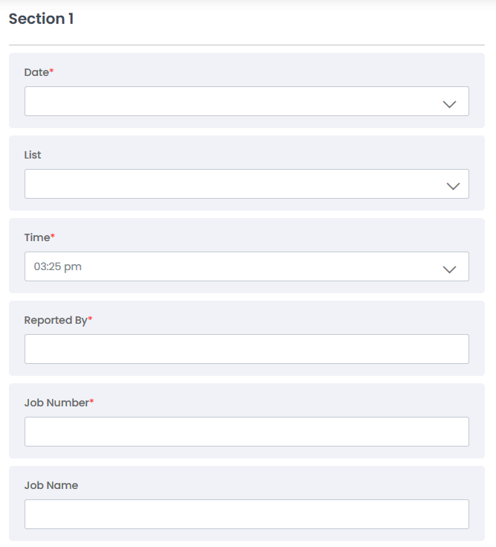

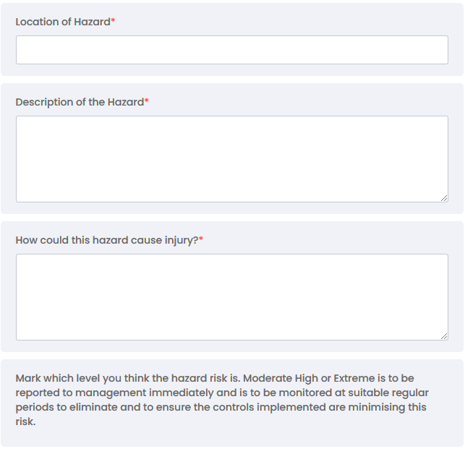

This completed form is to be held on site in the main Hazard ID file. A copy is to be forwarded to Sansom office (reception@sansom.co.nz)

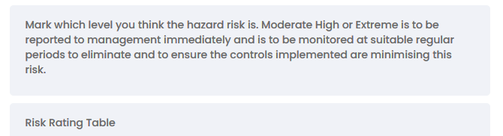

HAZARDOUS SUBSTANCE REGISTER
Substance | UN # | SDS Held? Y/N | What is the harm? | Safer alternative? | PPE required? | Initial risk | Recommended Action | Residual Risk
 |  | Yes | Refer SDS  Section 2: Hazard Identification | NA | Refer SDS  Section 8: Exposure Controls/Personal Protection | HIGH  10 | Refer SDS  Section 7: Handling and Storage | MODERATE  4
 |  | Yes | Refer SDS  Section 2: Hazard Identification | NA | Refer SDS  Section 8: Exposure Controls/Personal Protection | HIGH  10 | Refer SDS  Section 7: Handling and Storage | MODERATE  4
 |  | Yes | Refer SDS  Section 2: Hazard Identification | NA | Refer SDS  Section 8: Exposure Controls/Personal Protection | HIGH  10 | Refer SDS  Section 7: Handling and Storage | MODERATE  4
 |  | Yes | Refer SDS  Section 2: Hazard Identification | NA | Refer SDS  Section 8: Exposure Controls/Personal Protection | HIGH  10 | Refer SDS  Section 7: Handling and Storage | MODERATE  4
 |  | Yes | Refer SDS  Section 2: Hazard Identification | NA | Refer SDS  Section 8: Exposure Controls/Personal Protection | HIGH  10 | Refer SDS  Section 7: Handling and Storage | MODERATE  4
 |  | Yes | Refer SDS  Section 2: Hazard Identification | NA | Refer SDS  Section 8: Exposure Controls/Personal Protection | HIGH  10 | Refer SDS  Section 7: Handling and Storage | MODERATE  4
 |  | Yes | Refer SDS  Section 2: Hazard Identification | NA | Refer SDS  Section 8: Exposure Controls/Personal Protection | HIGH  10 | Refer SDS  Section 7: Handling and Storage | MODERATE  4
 |  | Yes | Refer SDS  Section 2: Hazard Identification | NA | Refer SDS  Section 8: Exposure Controls/Personal Protection | HIGH  10 | Refer SDS  Section 7: Handling and Storage | MODERATE  4
 |  | Yes | Refer SDS  Section 2: Hazard Identification | NA | Refer SDS  Section 8: Exposure Controls/Personal Protection | HIGH  10 | Refer SDS  Section 7: Handling and Storage | MODERATE  4
 |  | Yes | Refer SDS  Section 2: Hazard Identification | NA | Refer SDS  Section 8: Exposure Controls/Personal Protection | HIGH  10 | Refer SDS  Section 7: Handling and Storage | MODERATE  4

SAFETY DATA INFORMATION
Chemical Hazardous Record ID - Donesafe
Record ID | Status | Product name | UN number | SDS Date | SDS Expire | Hazardous or a Dangerous good? | Hazard posed by chemical | SDS available

ACCIDENT/INCIDENT REGISTER
SITE |  | EMPLOYER
Date and Time | Details (See example at the bottom page)  Name of person (injured or observer)  - Description of accident/incident/near miss  - Cause of harm  - Type of injury/disease | Immediate action taken  First Aid  - Corrective action  - Review hazard register | Notifiable event  Y/N | WorkSafe NZ  Notified  Y/N | Investigation  actioned and documented  Y/N  (Separate form) | Investigation outcomes  discussed at the Safety Meeting on:

INCIDENT REPORT FORM
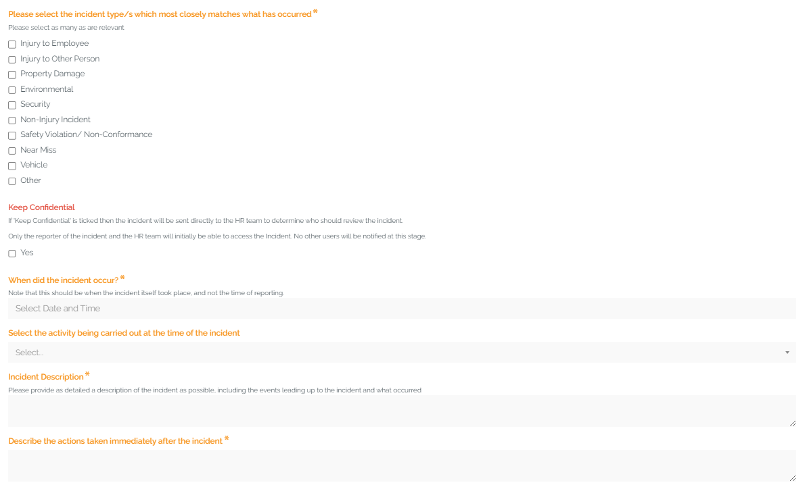

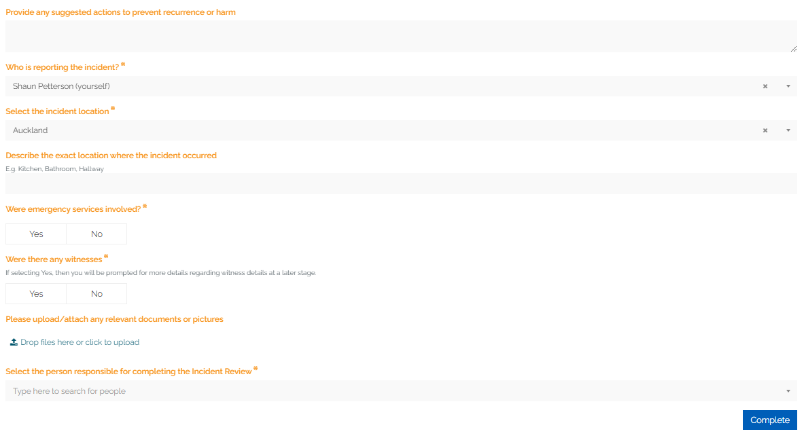

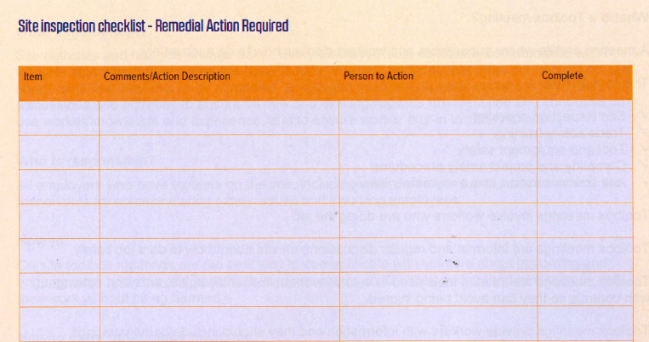
HSEQ - WEEKLY SITE SAFETY INSPECTION FORM
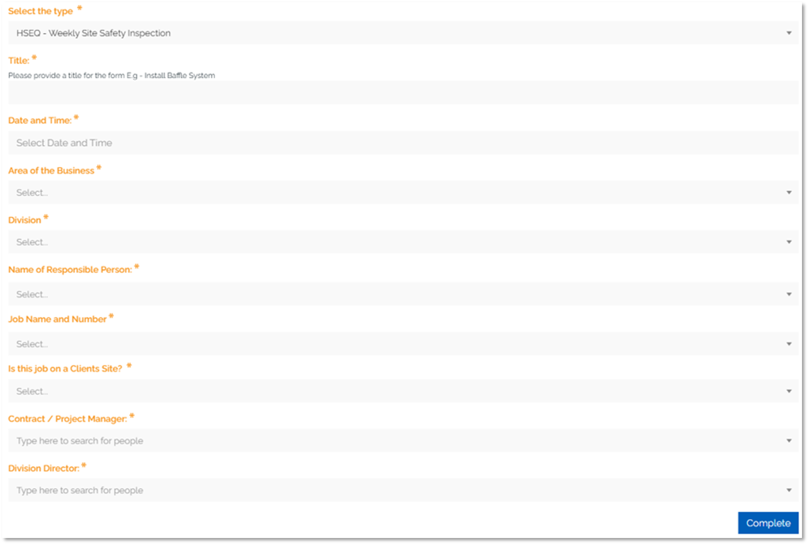

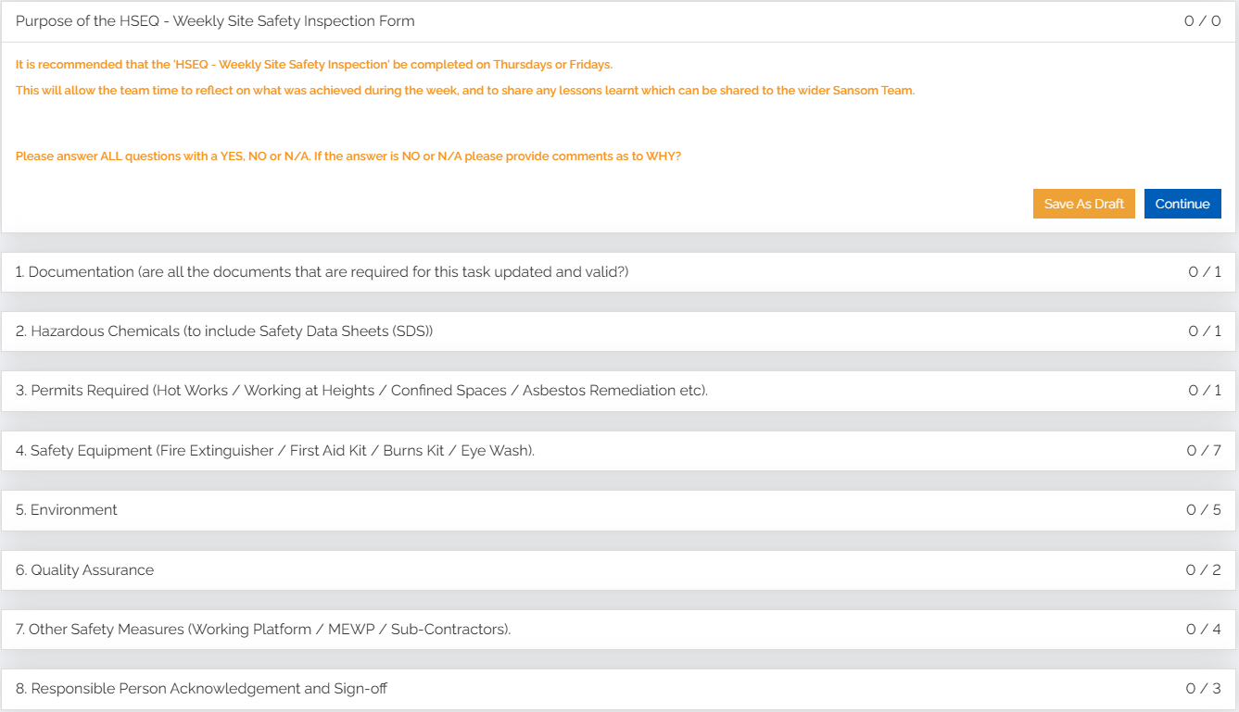

HSEQ - WEEKLY TOOLBOX MEETING FORM

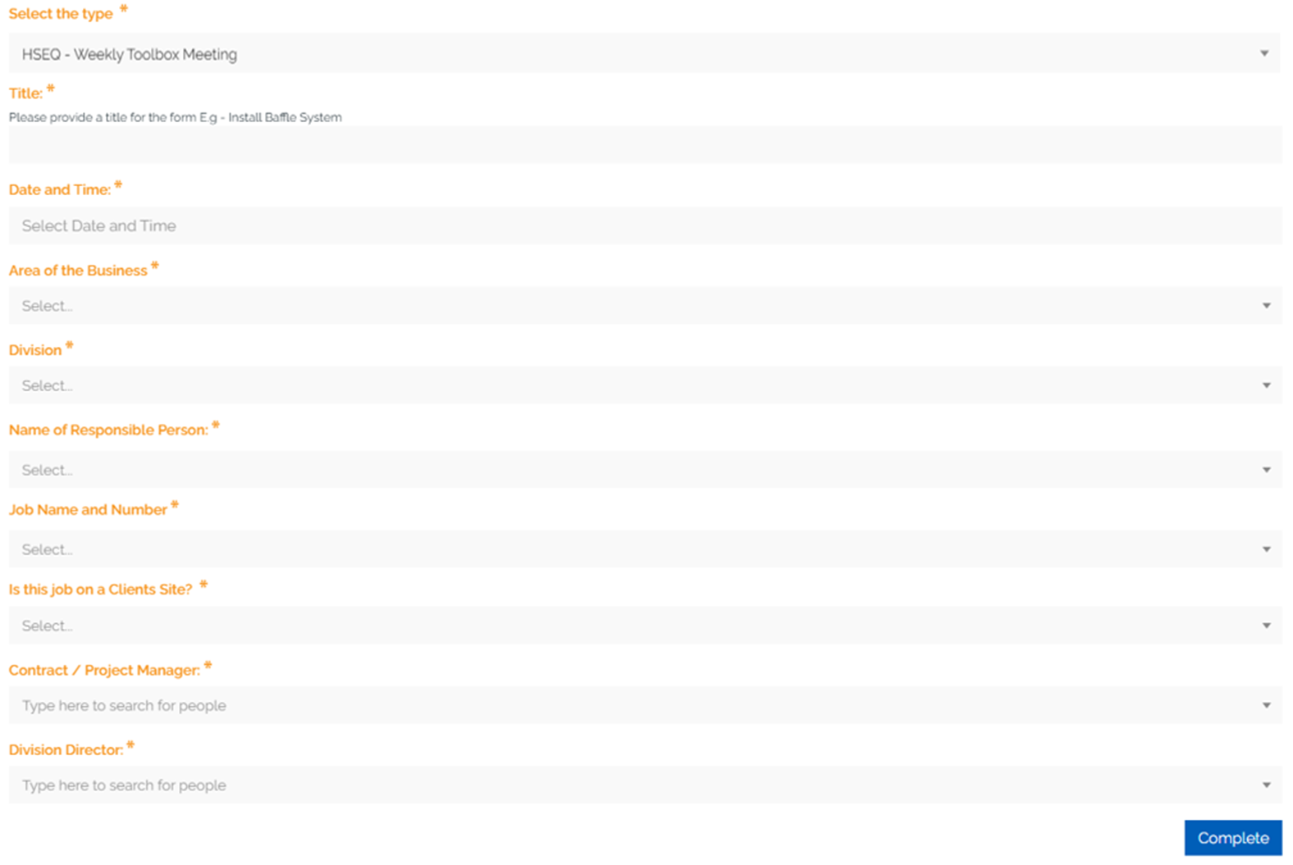

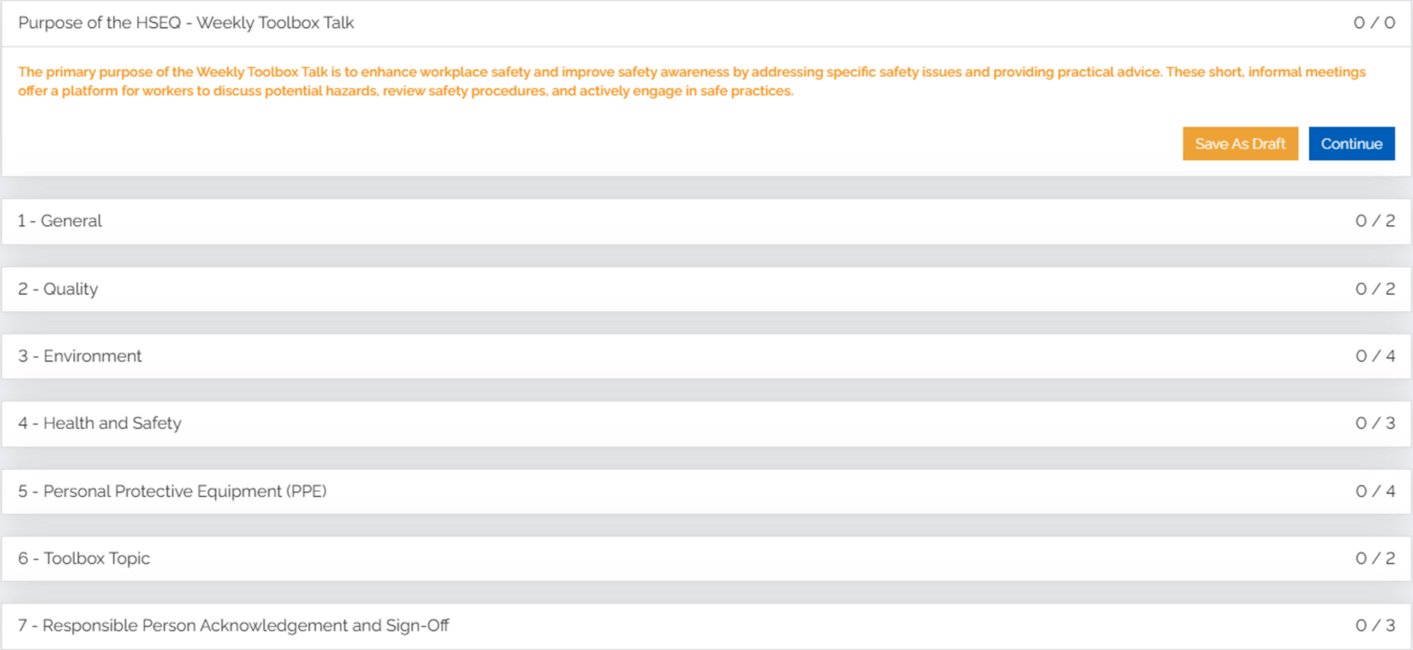

HSEQ - DAILY PRE-START ASSESSMENT FORM
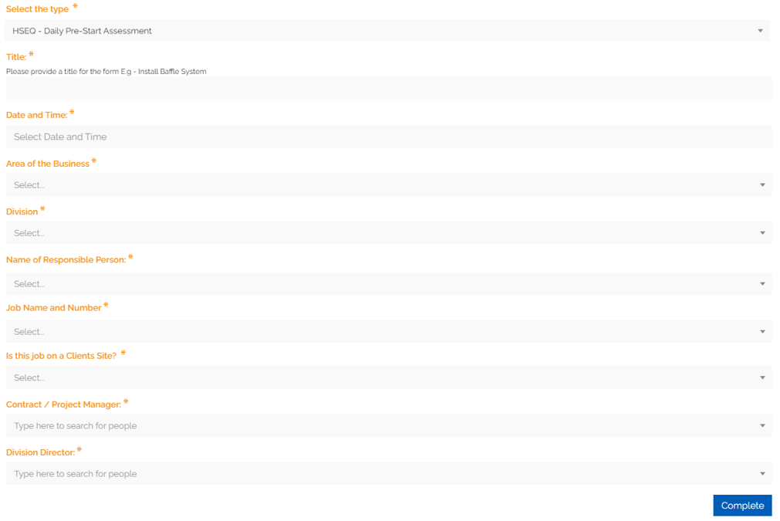

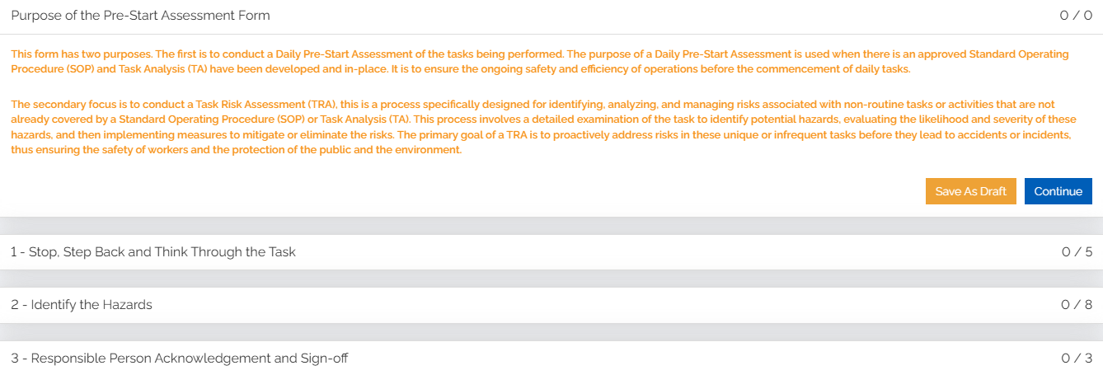

REVIEWED TASK ANALYSIS
Signed Chairman:
Toolbox Safety Meeting Attendees Sign Off:

NAME: (print clearly) SIGNATURE:
1
2
3
4
5
6
7
8
9
10
11
12
13
14
15
16
17
18
19
20
21
22
23
24
25
SUPERVISORS NAME:

SANSOM TRAINING & COMPETENCY REGISTER

SIGN OFF PAGE
Project Information
Project Name | [CostCon: Job Name]
Job Number | [CostCon: Job Number]
Start Date | Click to enter start date
End Date | Click to enter end date
PCBU 1 (Principal/Main Contractor/Owner)
Business Name | Click to enter business name
Approver Name | Click to enter name
Approver Signature
Date approved | Click to enter end date
PCBU 2 (Subcontractor)
Business Name | Click to enter business name
Approver Name | Click to enter name
Approver Signature
Date approved | Click to enter end date
Please return a copy of the SSSP and this sign off page to: reception@sansom.co.nz

ACKNOWLEDGEMENT AND AGREEMENT
We have read the Site-Specific Safety Plan provided by Sansom Concrete Repairs Ltd and agree that it is the appropriate approach to health and safety on this site for the duration of the contract.
Name | Company | Date

