Installing and Experimenting with Development Tools
Adna Ahmed

Exercise 1 — Draw.io
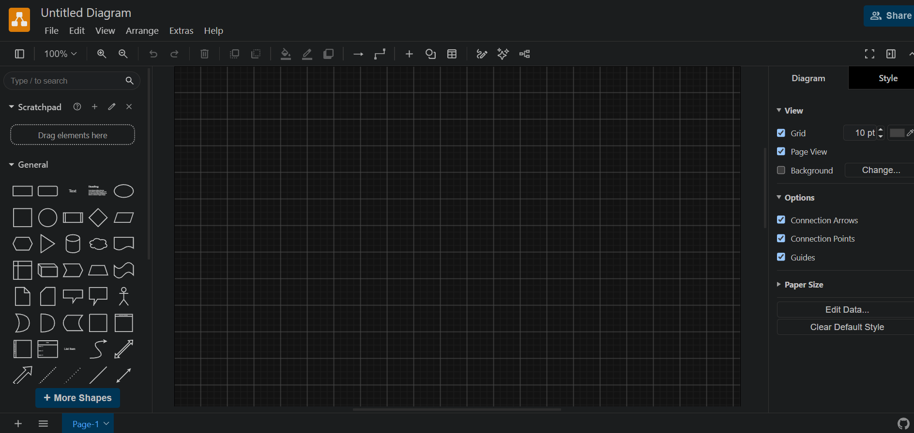

Exercise 2 — Python 3.14.3
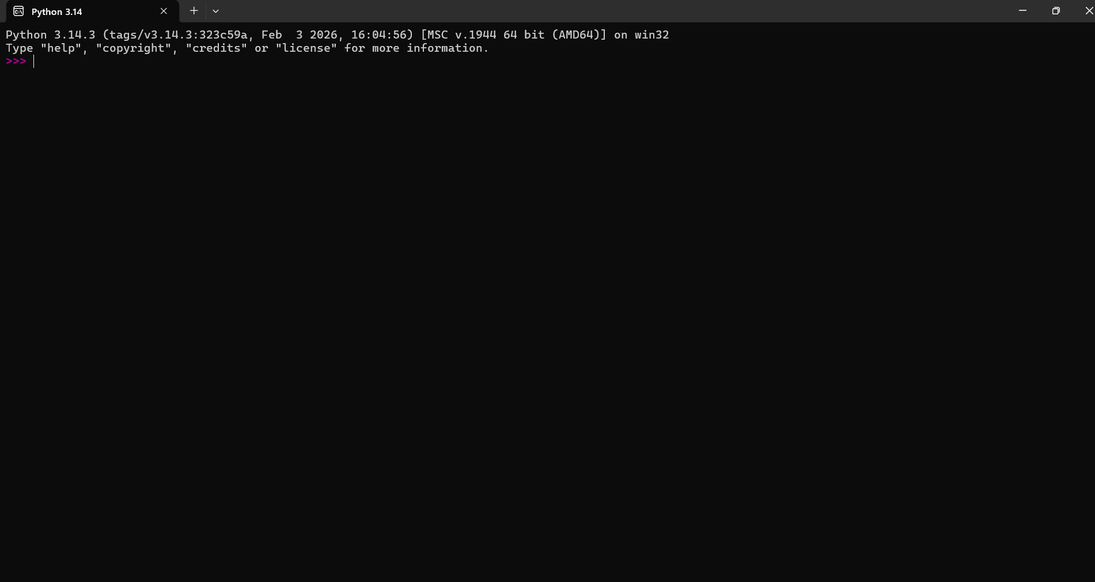

Exercise 3 — GitHub Desktop
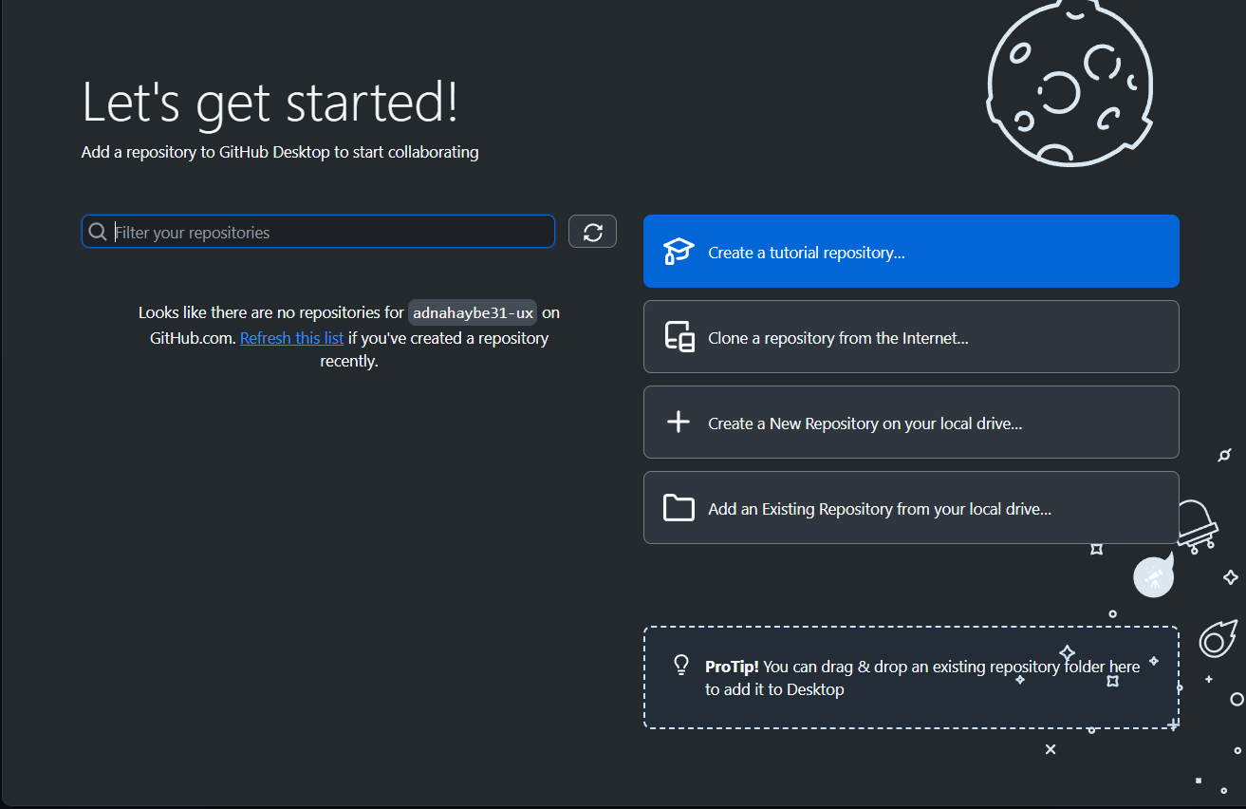

Exercise 4 — Five Rules of Pseudocode
- Use simple English: Write instructions in words that are easy to understand.
- Write one step at a time: Each step should describe one action.
- Use clear keywords: Use START, STOP, INPUT, OUTPUT, IF, and ELSE when appropriate.
- Keep steps in order: List actions in the order they should happen.
- Use indentation: Indent steps inside decisions and loops so the logic is clear.
Note: Screenshots show the applications open. GitHub repository publishing and screenshot uploads should be completed separately as required by the assignment.

