

**NMAM INSTITUTE OF TECHNOLOGY**

(A unit of Nitte Education Trust)

Nitte - 574 110, Karkala taluk, Udupi Dist., Karnataka

**Department of Computer Science and Engineering.**

**RDBMS PROJECT REPORT ON**

**Personalized Movie Database System**

**And Booking**

***PROJECT ASSOCIATES***

**Skanda Bhat Vineeth Bekal**

**4NM17CS181 4NM16CS210**

**V Sem, Sec 'D' V Sem, Sec 'D'**

**Dept of C.S.E Dept of C.S.E**

**PROJECT GUIDE**

**Mrs. Anusha A**

**Dept of C.S.E.**

**NMAMIT**

**ABSTRACT**

* Objective: The main aim of this Movie World is online booking tickets for various movies in registered theatres by the users.
* Problem Definition:Here details about Now playing movies and no of tickets available in aparticular theatre for particular movie, Movie Details, ticket cost for registered users
* This project contains three modules

1. Admin

2. Booking tickets

3. Users

1. Admin: In this module administrator has to register the theatres assign moviesto theatres, register users,
2. Booking tickets: In this project details about booked tickets and tickets booking
3. Admin can update and delete purchase, sales and other details.
4. Users: In this users can see the showing movies and upcoming movies details, ticket booking and registering as members.

**TABLE OF CONTENTS**

**Chapter Page no.**

**1. CERTIFICATE 4**

**2. ACKNOWLEDGEMENT 5**

**3. INTRODUCTION 6-9**

**4. PROBLEM STATEMENT 10**

**5. DATABASE DESIGN 11-12**

**6. FRONT END TECHNOLOGY 13**

**7.BACK END TECHNOLOGY 14**

**8.SCREENSHOTS 15-19**

**9.CONCLUSION 20**

**10.REFERENCES 21**

**CERTIFICATE**

Certified that the project work carried out by **Skanda Bhat** (**4NM17CS181**) and **Vineeth Bekal** (**4NM16CS210**) bonafide students of NMAM Institute of Technology, Nitte in fulfillment for the Relational database Management System lab in Computer Science and Engineering during the academic year 2019-2020.

Signature of the Examiners:

Signature of the Guide:

1.

2.

**ACKNOWLEDGEMENT**

The satisfactions that accompany the successful completion of any task would be incomplete without the mention of the people who made it possible. So we acknowledge all those whose guidance and encouragement served as a beacon of light and crowned our efforts with success.

We are thankful to our project guide, Mrs. Anusha A, Dept. of CSE for her valuable guidance and advice. Her willingness to motivate us contributed tremendously to our project.

We would like to place on record our deep sense of gratitude to Dr. K. R. Udaya Kumar Reddy, HOD-Dept. of Computer Science and Engineering, NMAMIT, Nitte for his generous guidance, help and useful suggestions. We also acknowledge and express our sincere thanks to our beloved Dr. Niranjan. N. Chiplunkar, Principal, NMAMIT, Nitte who is a source of inspiration to us.

We thank all the Teaching and Non-Teaching staff members of the department of CSE for providing resources for the completion of the project. A special thanks goes to our parents, friends and relatives for supporting and encouraging us in all ways thus making our project

successful. Finally, we thank all those who have contributed directly or indirectly in making this project a grand success.

**Skanda Bhat Vineeth Bekal**

**4NM17CS181 4NM16CS210**

**CHAPTER 1**

**INTRODUCTION**

INTRODUCTION

1.1 Problem Definition:

The general use of this movie database will be for leisure. It will be tailored to college students who have an interest in movies and will be intended for use in a casual setting. The general user is assumed to have an interest in a wide variety of movies including comedy, drama, independent, horror, along with many others. This site will be an excellent resource for movie aficionados, but it was also serve as a good resource for people who want to find a good movie to watch or who are just looking to kill some time. The movie rankings will be from the creator’s point of view, but the user will be allowed to leave reviews/comments on the movies, actors, and directors, allowing them to share their opinions and collaborate with other users.

In the current scenario, a moviegoer (user) has to visit more than one website to get the following basic movie information

* List of movies playing in theatres, upcoming movies, DVD/Blu-ray movies
* Trailers
* IMDB Rating; Rotten Tomatoes Rating
* Simple Plot, Cast & Crew, Genre, Year Released, Runtime
* Show Times
* Links to stream/rent the movie online, buy DVD/Blu-ray
* Similar Movie Suggestions

PROBLEM STATEMENT AND SYSTEM STUDY

Design a database that keep track of various data on movies, actors, roles in movies and famous quotes in movies and provide basic booking facilities.

There are websites like www.imdb.com and www.rottentomatoes.com with rich amount of the aforementioned data but the user has to open at least 3-4 websites to view all the data. Therefore this web application is a Personalized Movie Database System (PMDS) with booking where the user can login and see the movies.

The purpose of the Movie Database:

● Help users to find interesting movies easier

··Allow the user to search movies by typing in the key word of the movie

··Allow the user to search movies by typing in the name of director

··Allow the user to search movies by typing in the name of an actor.

··Allow the user to search movies by typing in the movie's name

● Help inform the user about popular movies

··Show the rating for each movie.

··Offer a brief description of each movie.

* Simplify existing sites like IMDB and Rotten Tomatoes
* Movies in the database will be movies that we feel would be worth watching (college demographic.)
* Book the required Number of tickets

OBJECTIVES OF THE STUDY

Movie Database Files college students' need:

Although, there are some movie database online, most of them are not specific to university students. College students are not interested in many movies on those databases and their ratings do not offer much help to college students when choosing movies. Our movie database full-fills this need of college students. Since all of our project's developers are college students, we know what college students would like to watch. Most of the rating is done by college students, so we can give helpful suggestions to college students when they choose a movie.

Useful opportunities:

● Date with friends at home or dorm.

● Spend leisure time with family

● Be used for teaching purposes in class

● Learn foreign language by watching movies

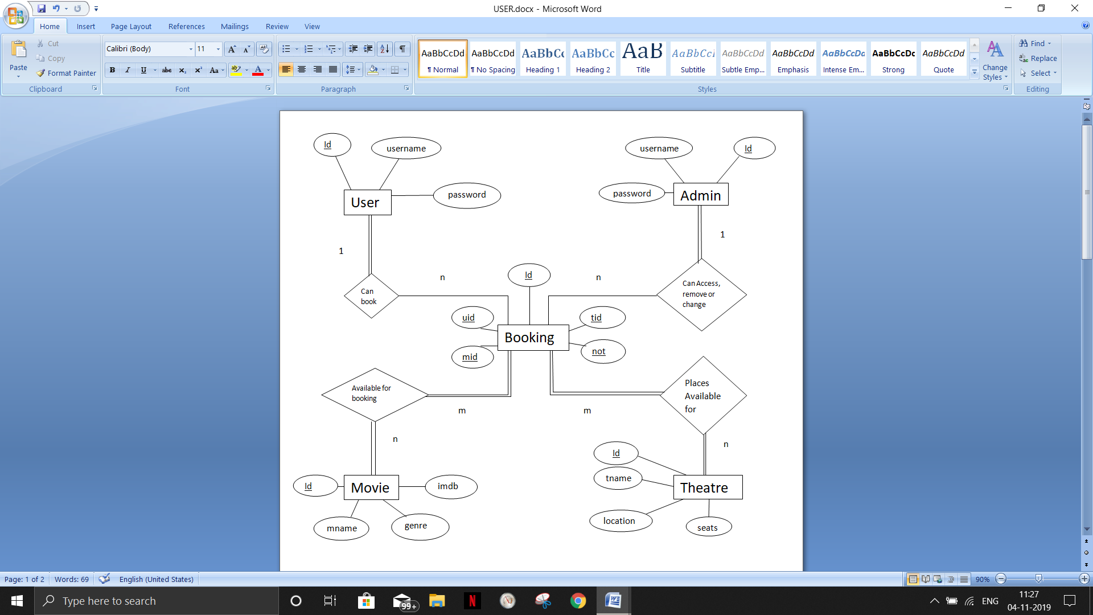**ER-Diagram**

**SCHEMA**

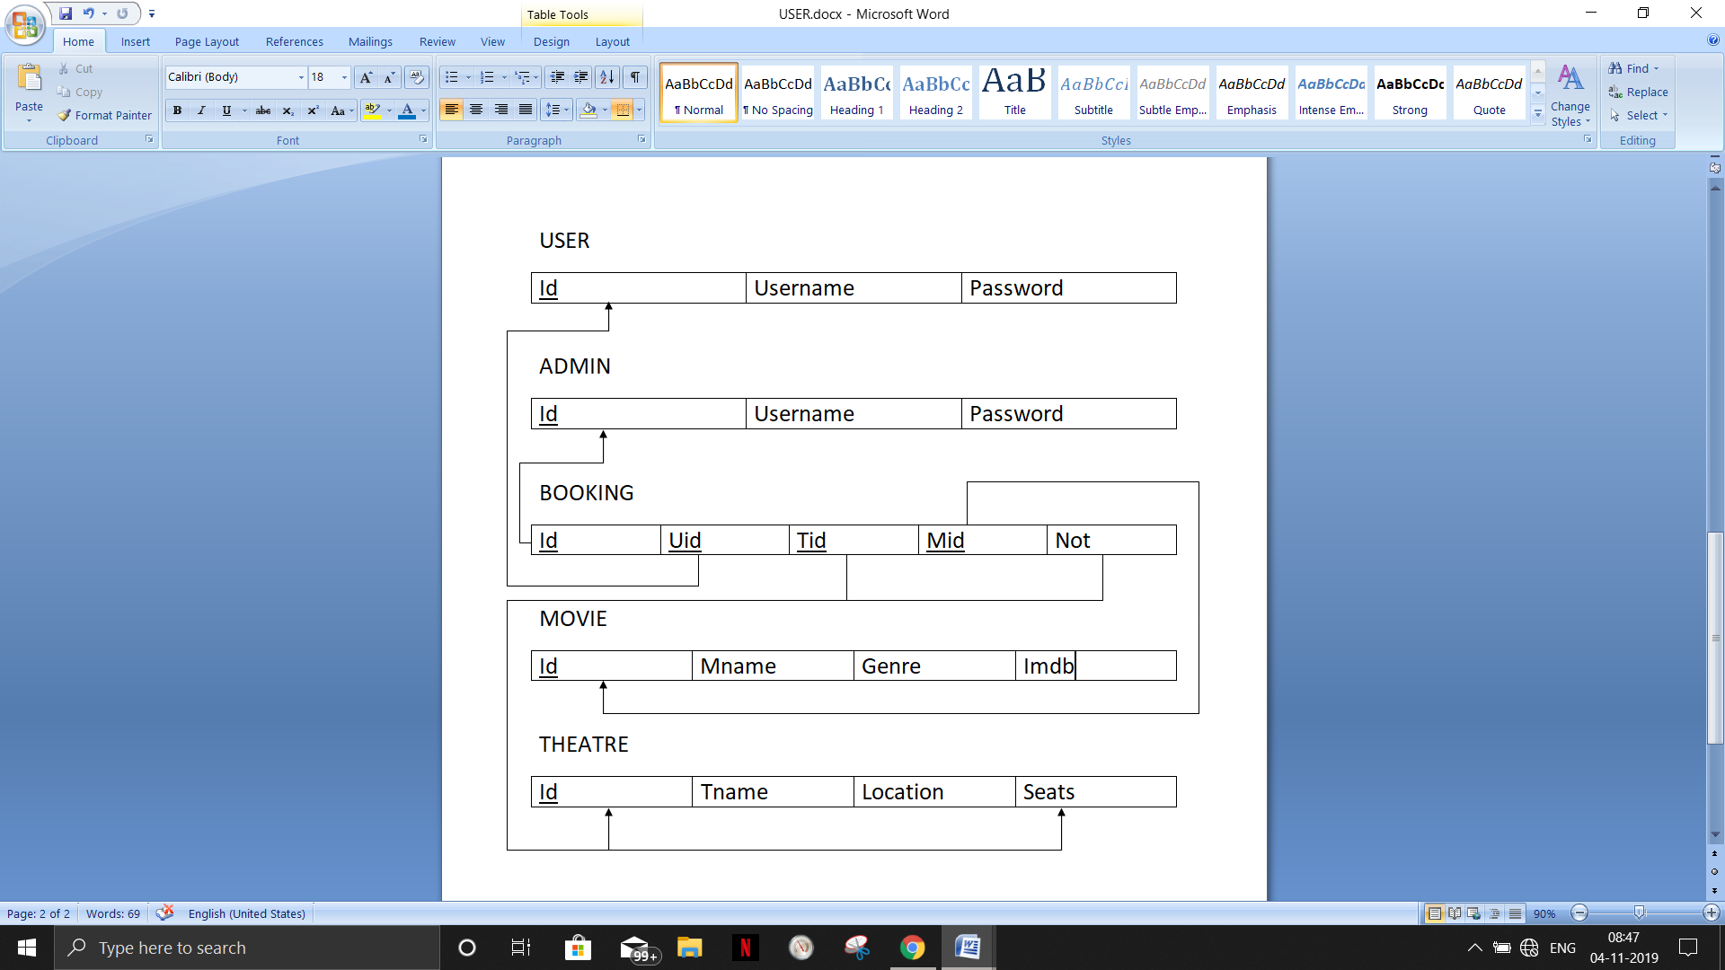

**CHAPTER 2**

**FRONTEND TECHNOLOGY**

**List of technologies for frontend**

**1. Hyper Text MarkupLanguage(HTML)**

Hypertext Markup Language is the standard markup language for creating web pages and web applications.

**2. Cascading Style Sheets(CSS)**

Cascading Style Sheets is a style sheet language used for describing the presentation of a document written in a markup language like HTML

**3. JavaScript**

JavaScript, often abbreviated as JS, is a high-level, interpreted programming language. It is a language which is also characterized as dynamic, weakly typed, prototype-based and multi-paradigm.

**CHAPTER 5**

**BACKEND TECHNOLOGY**

**List of technologies for Backend**

**1.PHP**

Hypertext Pre-processor is a server-side scripting language designed for Web development, and also used as a general-purpose programming language. It was originally created by Rasmus Lerdorf in 1994, the PHP reference implementation is now produced by The PHP Group.

**2. LARAVEL**

**Laravel** is a free, open-source PHP web framework, created by Taylor Otwell and intended for the development of web applications following the model–view–controller (MVC) architectural pattern and based on Symfony. Some of the features of Laravel are a modular packaging system with a dedicated dependency manager, different ways for accessing relational databases, utilities that aid in application deployment and maintenance, and its orientation toward syntactic sugar.

**Database:**

**MySQL:**

MySQL is an open-source relational database management system. Its name is a combination of "My", the name of co-founder Michael Widenius's daughter, and "SQL", the abbreviation for Structured Query Language.

**Chapter 6**

**SCREENSHOTS**

**Home page:**

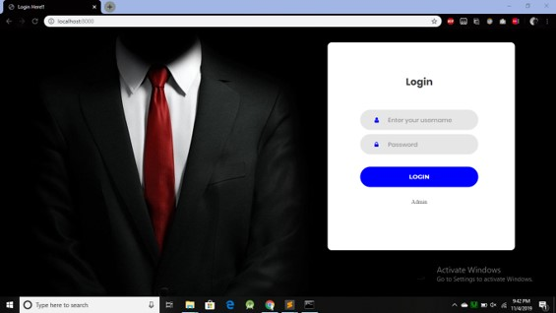

The Homepage to Movie Website

**ADMIN LOGIN:**

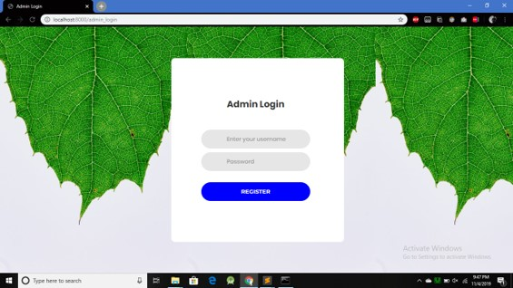

Homepage elongates 2 provisions.

Admin Login and User Login

**HOME:**

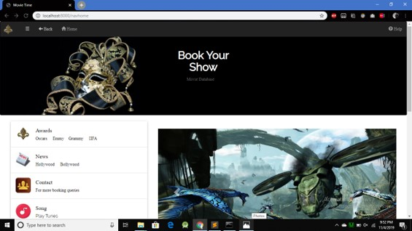

Shows the most popular items on Tienda.

**VIEW PRODUCTS:**

User Login enables the main page of the website.

It consists of a navigation bar, carousel for choosing genre, movie ticket booking, help, contact details, awards, song selection, etc.

**VIEW BOOKINGS:**

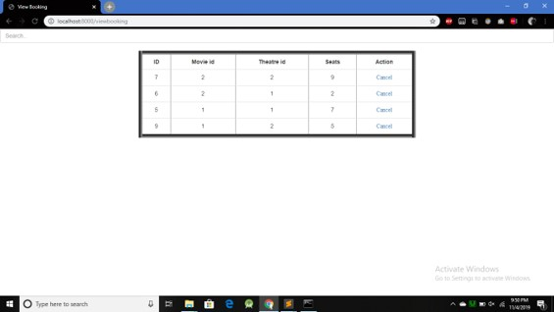

Ticket booking views for adminstator usage .

**AWARDS:**

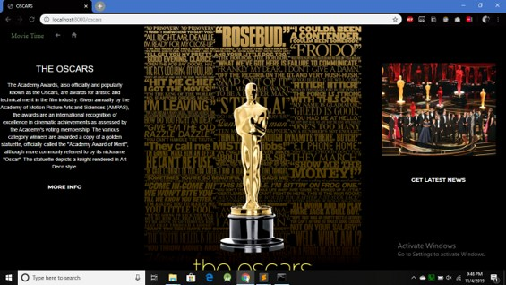

Sample page in awards selection.

Choose category of awards provided.

Links are given to Wikipedia and official Oscars website.

**CHANGE DATABASE AND BOOKINGS:**

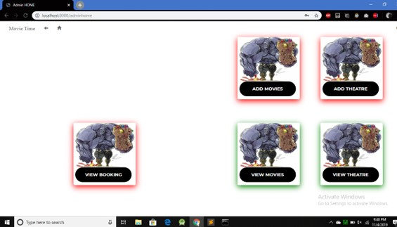

Admin home page.

Has provisions for add movie ,theatre.

And view movie, theatre, bookings.

**ADD MOVIE:**

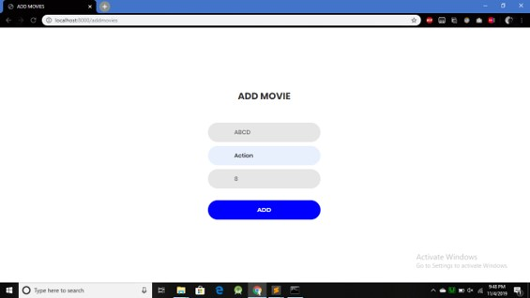

Add movie for administrator usage.

**VIEW THEATRE:**

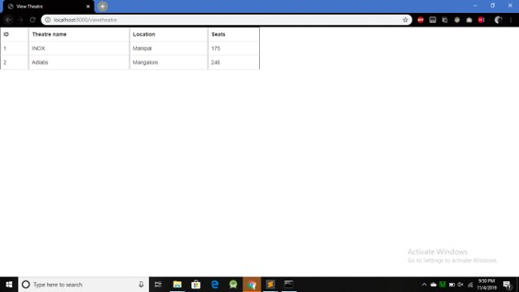

View theatre for administrator usage.

**ADD THEATRE:**

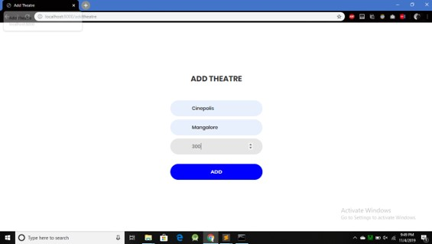

Add theatre for administrator usage.

**CUSTOMER FEEDBACK:**

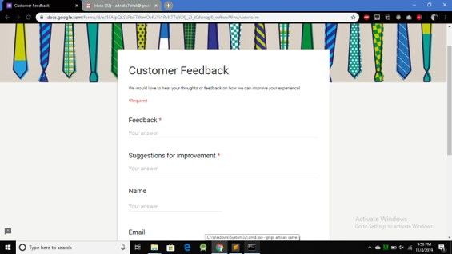

Customer feedback form for users to help developer improvise the website.

**CONTACT US:**

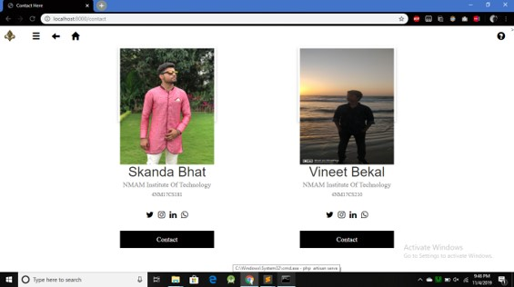

Contact blade for users to get in touch with users.

**NEWS AND TRENDING:**

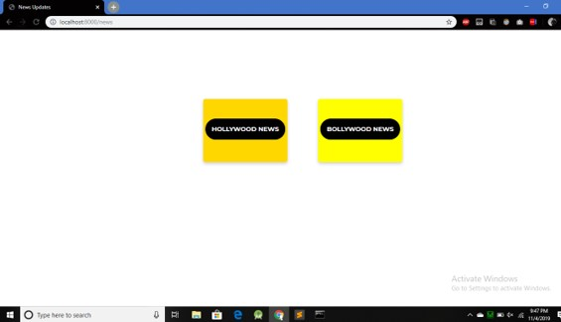

**BOOK TICKETS:**

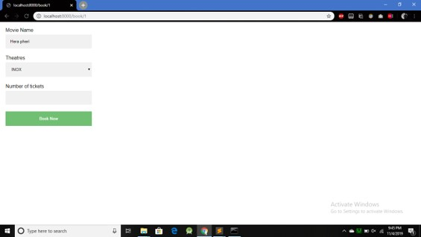

**ADMIN CONTROL:**



**CHAPTER 7**

**CONCLUSION**

The “**MOVIE BOOKING AND DATABASE**” is successfully designed and developed to fulfilling the necessary requirements as the system is very much user friendly, form level validation and field level validation are performing very efficiently. The present project has been developed to meet the aspirations indicated in the modern age.

**MOVIE BOOKING AND DATABASE** is a web application developed as a handy one-stop destination for a user who is interested to see the ratings, trailers, show times and streaming information of movies. It is successful in meeting the application requirements and there is a lot of scope for future development. The system is strong enough to withstand operations under conditions where the database is maintained. The implementation of the system in the organization will considerably reduce data entry and time.

Future Work:

o In this project, the movies that are fetched belong to these categories only: In theatres, Upcoming, DVD/Blu-ray. In future, PMDS would be developed to fetch the movies from more categories.

o Steps will be taken to improve the speed and performance of the application.

o A smart search engine based on tags, genre, and actors would be developed.

o In future, PMDS must be able to suggest the user based on their search history, ratings.

o A more professional GUI must be developed.

**CHAPTER 8**

**REFERENCES**

**1.** [**www.stackoverflow.com**](http://www.stackoverflow.com)

**2. [www.youtube.com](http://www.youtube.com)**

**3.** [**www.w3schools.com**](http://www.w3schools.com)

**4. www.laravel.com**