
k
Name: Mohammed Adnan Osman

Student Number: 33114153

Explainable AI for Daily Short – Term Risk
Prediction in Coinage Metal Markets

University of West London
–

School of
Computing and Engineering

-

Final Year Project

Level 6

Due

Date
07/05/2026
:

23:59

-

Name: Mohammed Adnan Osman

Student ID: 33114153

-

Supervisor: Dr Nasim Dadashi

Module Code: CP60046E

Academic Year: 2025
–

2026

PROJECT REPORT

Contents
1 Introduction 3
1.1 Aim and Objectives 6
1.1.1 Aim 6
1.1.2 Objectives 6
2 Literature Review 7
2.1 Artificial intelligence and Machine Learning in Financial Risk Prediction 7
2.2 Explainable AI and Model Interpretability in Finance 9
2.3 Natural Language Processing and Sentiment Analysis in Market Prediction 10
2.4 Downside Risk Prediction and Threshold-Based Classification 12
2.5 Summary and Research Gaps 13
3 Research Methodology 14
3.1 Research Design 14
3.2 Data Collection 15
3.2.1 Price and Macroeconomic Data 15
3.2.2 Financial News Sentiment Data 16
3.3 Data Preprocessing and Feature Engineering 16
3.3.1 Target Variable Construction 16
3.3.2 Technical Indicators 17
3.3.3 Lag Features 17
3.4 Model Development 18
3.4.1 Algorithm Selection 18
3.4.2 Handling Class Imbalance 18
3.4.3 Train, Validation and Test Split 18
3.4.4 Hyperparameter Tuning 19
3.5 Explainability Framework 19
3.6 Evaluation Framework 20
3.7 Tools and Technologies 20
3.8 Limitations of Methodology 21
4 Design and Implementation 21
4.1 System Architecture Overview 22
4.2 Database Design 22
4.3 Data Collection Pipeline 23
4.3.1 Script 01: Price and Macroeconomic Data Collection 23
4.3.2 Script 02: Feature Engineering 24
4.3.3 Script 03: FinBERT Sentiment Pipeline 24
4.4 Model Training Implementation 25
4.4.1 Script 04: Model Training 25
4.4.2 Script 05: Model Evaluation 25
4.4.4 Script 06: Back testing 25
4.4 System Requirements 26
4.5 Repository Structure 26
5 Results and Analysis 27
5.1 Dataset Overview and Composition 27
5.2 Model Performance on Test Set 28
5.3 SHAP Feature Importance Analyis 32
5.4 Sentiment Feature Impact 43
5.5 Back testing on Unseen 2025 Data 45
References 46

1 Introduction
The integration of Artificial Intelligence into financial analytics has fundamentally transformed the way in which market participants assess and manage risk. Over the past decade, machine learning algorithms have demonstrated a remarkable capacity to process large volumes of financial data, identify complex non-linear patterns, and generate predictive insights that exceed the capabilities of traditional statistical approaches (Fischer and Krauss, 2018). However, as these models have grown in sophistication, a critical challenge has emerged: many high-performing machine learning systems operate as opaque "black boxes", producing predictions without providing any meaningful explanation of the reasoning behind them. In domains such as financial risk management, where analysts must not only identify periods of elevated risk but also justify and communicate their assessments to stakeholders, this lack of transparency presents a significant barrier to adoption (Molnar, 2022).

Coinage metals — gold, silver, and copper — occupy a unique position in global financial markets. Gold and silver have historically been regarded as safe-haven assets, with prices heavily influenced by geopolitical uncertainty, macroeconomic conditions, and investor sentiment. Copper, by contrast, functions as an industrial barometer, with demand driven by manufacturing output, infrastructure investment, and the expanding semiconductor and clean energy sectors. Despite their economic significance, short-term downside risk prediction in these markets remains an underexplored area within the explainable AI literature. The majority of existing research has concentrated on equity markets, credit risk assessment, and cryptocurrency forecasting, leaving a notable gap in the application of interpretable machine learning frameworks to coinage metal markets (Giudici et al., 2024).

Natural Language Processing has introduced a further dimension to financial forecasting by enabling the systematic extraction of sentiment signals from unstructured textual data, including financial news headlines, analyst reports, and market commentary. Research by Bollen et al. (2011) demonstrated that public mood indicators derived from social media data could contribute to financial predictions, while subsequent studies have shown that combining NLP-derived sentiment features with numerical market indicators can improve predictive performance in forecasting tasks (Li et al., 2020). However, sentiment-based models frequently sacrifice interpretability in pursuit of predictive accuracy, making it difficult to understand how sentiment information influences model outputs — a limitation that is particularly problematic in risk-critical financial applications.

This dissertation addresses three interconnected gaps in the existing literature. First, there is a lack of explainable AI applications specifically designed for commodity and coinage metal markets, where the drivers of downside risk differ substantially from those in equity or cryptocurrency markets. Second, although NLP-based sentiment analysis has proven effective in financial forecasting, few studies have integrated sentiment features with fully interpretable models in the context of metal markets. Third, existing approaches in financial machine learning have tended to prioritise predictive accuracy over interpretability, limiting analysts' ability to validate model outputs against known economic fundamentals and communicate risk assessments with confidence.

To address these gaps, this project develops an Explainable AI system for predicting daily downside risk events in gold, silver, and copper markets. A downside risk event is defined as a next-day price decline exceeding two percent — a threshold selected to represent economically meaningful adverse movements that warrant active risk management attention. The system employs a Random Forest binary classifier as its predictive core, chosen for its strong performance on non-linear financial data and its compatibility with SHAP (SHapley Additive ExPlanations) explainability methods. A comparative experimental design is adopted: a baseline model trained exclusively on technical price indicators and macroeconomic features is evaluated against an enhanced model that additionally incorporates FinBERT-derived sentiment scores from financial news headlines. This design directly isolates the contribution of sentiment analysis to predictive performance, providing a rigorous empirical basis for evaluating the value of NLP integration. SHAP explanations are applied to both models to ensure that predictions are transparent, auditable, and aligned with established financial risk drivers (Lundberg and Lee, 2017).

The system is trained on historical OHLCV price data, technical indicators, and macroeconomic indicators spanning the period from 2020 to 2025, collected via the yFinance API and stored in a structured PostgreSQL database. Financial news headlines are processed through the FinBERT model to generate daily sentiment scores, which are aligned with the numerical market data at daily intervals. Model performance is evaluated using a comprehensive suite of probabilistic and classification-based metrics, including ROC-AUC, F1-score, Brier Score, and Log Loss. Backtesting is conducted on unseen 2025 data using walk-forward validation to simulate real-world deployment conditions, and SHAP waterfall plots are generated for notable historical risk events to provide qualitative validation of model explanations against known market conditions.
The central research question guiding this investigation is: Can a Random Forest classifier integrating FinBERT sentiment analysis accurately predict daily downside risk events (greater than two percent price decline) in gold, silver, and copper markets, while providing interpretable probability-based risk scores and SHAP explanations that align with established financial risk drivers? This question reflects the dual imperative of predictive performance and interpretability that characterises responsible AI deployment in financial contexts (Doshi-Velez and Kim, 2018).

The remainder of this report is structured as follows. Chapter 2 presents a comprehensive literature review examining prior research in machine learning for financial risk prediction, explainable AI methods, and NLP-based sentiment analysis in market forecasting. Chapter 3 details the research methodology, including the experimental design, data collection procedures, model development strategy, and evaluation framework. Chapter 4 describes the design and implementation of the system, covering the database architecture, data pipeline, feature engineering, and model training process. Chapter 5 presents the results and analysis, including model performance metrics, comparative evaluation, and SHAP-based interpretability findings. Chapter 6 provides discussion and conclusions, reflecting on the findings in relation to the research question and objectives, acknowledging limitations, and identifying directions for future research.

1.1 Aim and Objectives

1.1.1 Aim
The aim of this project is to develop an explainable machine learning system for predicting short-term downside risk events in coinage metal markets — specifically gold, silver, and copper — by integrating technical price indicators and macroeconomic features with NLP-derived market sentiment. The system generates probability-based daily risk scores supported by SHAP explanations, to enhance transparency and support informed financial risk analysis.

1.1.2 Objectives
- Conduct a systematic literature review examining the application of machine learning, explainable AI, and natural language processing in commodity and financial market risk prediction, identifying key research gaps.

- Design and implement a structured data infrastructure, including a PostgreSQL database and automated collection pipelines for historical OHLCV price data, macroeconomic indicators, and FinBERT-processed financial news sentiment, covering the period 2020 to 2025.

- Develop and validate a baseline Random Forest classifier trained exclusively on technical and macroeconomic features to predict daily downside risk events — defined as next-day price declines exceeding two percent — in gold, silver, and copper markets.

- Develop an enhanced model incorporating FinBERT-derived sentiment features alongside technical and macroeconomic indicators and evaluate whether sentiment integration improves predictive performance relative to the baseline.

- Apply SHAP-based explainability to both models to quantify the contribution of individual features to risk predictions and assess the interpretability of model outputs in relation to established financial risk drivers.

- Evaluate model calibration quality using probabilistic metrics — including Brier Score and Log Loss — to ensure that predicted risk probabilities are reliable and trustworthy for practical risk management applications.

- Conduct walk-forward back testing on unseen 2025 market data and generate SHAP waterfall plots for notable historical risk events to validate model explanations against known market conditions and economic fundamentals.

- Document and critically evaluate the findings, limitations, and implications of the research, providing recommendations for the future application of transparent and explainable AI in financial risk analysis.

2 Literature Review

2.1 Artificial intelligence and Machine Learning in Financial Risk Prediction
The application of machine learning to financial risk prediction has grown substantially over the past decade, driven by the limitations of traditional statistical models and the increasing availability of large-scale financial datasets. Classical econometric approaches such as ARIMA and GARCH models rely on strong assumptions of linearity and stationarity, which are frequently violated in real-world financial markets characterized by non-linear dynamics, fat-tailed return distributions, and structural breaks (Fischer and Krauss, 2018). In their widely cited study, Fischer and Krauss (2018) demonstrated that Long Short-Term Memory (LSTM) networks significantly outperformed traditional econometric benchmarks in predicting daily stock returns, establishing deep learning as a viable tool for financial time series forecasting. However, the authors also acknowledged a key limitation: despite their superior predictive accuracy, deep learning models provide no interpretable explanation of the mechanisms driving their predictions.

Ensemble methods, particularly Random Forest classifiers, have emerged as a strong alternative for financial prediction tasks that require both strong performance and a degree of interpretability. Random Forests address the overfitting tendency of individual decision trees by constructing multiple decorrelated trees and aggregating their outputs, making them well-suited to the high-dimensional, noisy feature spaces typical of financial data (Peng and Yan, 2021). Peng and Yan (2021) conducted a comprehensive survey of deep learning applications in financial risk prediction and found that ensemble-based models consistently delivered competitive performance across a range of tasks including credit risk, market volatility forecasting, and fraud detection. Crucially, their review highlighted that ensemble methods such as Random Forest offered a more favorable trade-off between accuracy and interpretability compared to deep neural networks, particularly in applications where model transparency is a regulatory or operational requirement.

In the specific context of commodity market forecasting, Sadefo Kamdem et al. (2020, cited in Navigating AI-Driven Financial Forecasting, 2025) compared ARIMA and LSTM models across several commodity prices including silver and found that LSTM models generally outperformed ARIMA, though predictive accuracy for both models deteriorated during the COVID-19 period due to increased market volatility. This finding is directly relevant to the present study, which spans the 2020 to 2025 period and therefore includes multiple high-volatility episodes. Similarly, research examining cross-commodity price co-movement by Tuitoek et al. (2025) applied both VAR-based approaches and Random Forest regressions to twenty key commodities, finding that VAR models outperformed Random Forests for regression tasks while noting that ensemble models still delivered meaningful predictive contributions when combined with macroeconomic variables. These findings underline the importance of incorporating macroeconomic context — such as the US Dollar Index, VIX volatility index, and Treasury yields — alongside price-based technical indicators when modelling commodity risk.

A critical limitation identified across much of the financial machine learning literature is the class imbalance problem. In risk prediction tasks, adverse events such as large daily price declines occur far less frequently than non-events, creating datasets where the minority class (risk events) is substantially underrepresented. Failure to address this imbalance leads to models that appear accurate overall but fail to detect the very events they are designed to predict. Techniques such as class-weighted training, where the learning algorithm penalizes misclassification of the minority class more heavily, have been shown to substantially improve recall for risk events without significantly degrading overall classification performance (Peng and Yan, 2021). This consideration directly informs the methodology of the present study, which applies balanced class weighting during Random Forest training to ensure that downside risk events are not systematically overlooked.

2.2 Explainable AI and Model Interpretability in Finance
The emergence of Explainable AI as a distinct research area reflects growing recognition that predictive accuracy alone is insufficient for responsible AI deployment in high-stakes domains such as finance, healthcare, and law. Doshi-Velez and Kim (2018) provided an early and influential framework for understanding interpretability, arguing that the need for explanation arises whenever there is an incomplete specification of the problem — that is, whenever the cost of an incorrect or unjustifiable decision is high. In financial risk management, this condition is almost universally satisfied: analysts must not only identify periods of elevated risk but also justify their assessments to stakeholders, satisfy regulatory requirements, and validate model outputs against economic fundamentals. The lack of interpretability in black-box models therefore represents a significant barrier to their adoption in this domain (Monica Hovsepian, 2023).

Among the available XAI methods, SHAP (SHapley Additive ExPlanations), introduced by Lundberg and Lee (2017), has become the de facto standard for post-hoc model explanation in financial applications. SHAP is grounded in cooperative game theory, treating each feature as a player in a game and computing its Shapley value — the average marginal contribution of that feature across all possible feature combinations. This approach provides three important properties: local accuracy (explanations sum to the actual model output), consistency (features that contribute more always receive higher SHAP values), and missingness (absent features receive zero contribution). In a comprehensive systematic review of model-agnostic XAI methods in finance, Danie et al. (2025) analyzed 150 peer-reviewed studies and found that SHAP was by far the most widely applied explainability technique, valued for its theoretical rigor, compatibility with any model type, and ability to generate both global feature importance summaries and individual prediction explanations.

The application of SHAP to commodity market prediction received direct attention from Jabeur, Mefteh-Wali and Viviani (2024), who combined XGBoost with SHAP interaction values to forecast gold prices. Their study compared six machine learning models and found that XGBoost delivered the strongest predictive performance, while SHAP analysis revealed that macroeconomic variables — particularly US Dollar Index movements, crude oil prices, and Treasury yields — were the most influential features in driving gold price predictions. Notably, their work demonstrated that SHAP explanations aligned well with established economic theory regarding gold as a safe-haven asset, providing qualitative validation of the model's outputs. This study is highly relevant to the present research as it applies a broadly similar methodology — ML combined with SHAP explainability — to gold price modelling, though it focuses on price forecasting rather than downside risk classification, and does not incorporate NLP-based sentiment features.

More broadly, Giudici et al. (2024) examined XAI methods for financial time series and identified a significant concentration of research on equity markets, with comparatively little attention given to commodity or metal markets. Their study highlighted that interpretability requirements in commodity markets differ from those in equities, since commodity price drivers include supply-side factors such as mining output and industrial demand alongside the macroeconomic and geopolitical drivers that influence all asset classes. This supports the contention of the present study that explainable AI frameworks need to be specifically evaluated in the coinage metal context rather than simply transferred from equity market research. The study by Zhang, Liang and Ou (2024), which applied ensemble learning with SHAP to predict a precious metals index, further reinforces this point: their SHAP analysis found that cross-metal correlations and industrial demand indicators played a more prominent role in silver and copper predictions than in gold, reflecting the different economic roles of these metals.

It is important to note that whilst SHAP dominates XAI literature, it is not without limitations. The computational cost of exact Shapley value computation grows exponentially with the number of features, making approximation methods necessary for large feature sets. Additionally, SHAP values are inherently model-specific in their interpretation — a feature that receives a high SHAP value in one model may receive a lower value in another model trained on the same data, reflecting differences in how each model has learned to use that feature rather than reflecting the true causal importance of the feature in the underlying data-generating process (Molnar, 2022). These limitations are acknowledged in the present study, and the use of TreeExplainer — a computationally efficient SHAP variant specifically designed for tree-based models such as Random Forest — mitigates computational concern whilst maintaining theoretical guarantees.

2.3 Natural Language Processing and Sentiment Analysis in Market Prediction
The integration of textual sentiment into financial forecasting models has a substantial research history, originating from early studies such as Bollen, Mao and Zeng (2011), who demonstrated that Twitter mood indicators could predict movements in the Dow Jones Industrial Average up to three days in advance. Their work established the theoretical basis for treating public sentiment as a predictive signal in financial markets, arguing that collective emotional states expressed through social media influence investor behavior and subsequently price movements. Whilst the specific approach of using Twitter data has been superseded by more sophisticated methods, the core insight — that unstructured textual information contains predictive signals not captured by numerical market data — remains central to sentiment-based financial forecasting research.

The development of transformer-based language models, and specifically BERT (Bidirectional Encoder Representations from Transformers), represented a fundamental advance in the ability to extract nuanced sentiment from financial text. Lexicon-based sentiment approaches, which assign sentiment scores based on predefined dictionaries of positive and negative words, fail to capture contextual meaning — the same word can carry very different sentiment depending on its context in financial discourse. FinBERT, a BERT-based model pre-trained on financial corpora including financial news, earnings reports, and analyst commentary, addresses this limitation by learning contextual financial language representations directly from domain-specific data (Araci, 2019; Liu et al., 2020). Research by Huang, Wang and Yang (2022) demonstrated that FinBERT substantially outperformed general-purpose BERT models on financial text classification tasks, attributing the improvement to domain-specific pre-training that enables the model to correctly classify sentiment in sentences containing financial jargon, abbreviations, and contextually nuanced language.

Several recent studies have combined FinBERT-derived sentiment features with machine learning classifiers to improve financial prediction performance. Gu et al. (2024) proposed a FinBERT-LSTM hybrid framework for stock price prediction and found that incorporating FinBERT sentiment scores alongside price-based features significantly improved predictive accuracy compared to price-only LSTM baselines. Similarly, a study combining FinBERT with XGBoost and SHAP explanations for short-term stock price movement prediction found that the FinBERT-enhanced model consistently outperformed both a technical-only baseline and a lexicon-based sentiment alternative, with an AUC of 0.748 on the combined model compared to 0.593 for the technical-only model (Mathematics, 2025). Crucially, SHAP analysis in that study confirmed that FinBERT-derived sentiment features ranked among the most influential predictors, particularly during volatile market regimes such as the COVID-19 period of 2020, when sentiment signals effectively captured investor fear and news-driven risk that was not present in price-based features. This finding directly supports the hypothesis of the present study that sentiment integration will improve downside risk prediction, particularly during the market stress periods included in the 2020 to 2025 data window.

However, the relationship between sentimental features and predictive performance is not uniformly positive across all studies. Li et al. (2020) found that while combining NLP-derived sentiment with numerical financial indicators generally improved predictive performance, the magnitude of improvement varied substantially depending on the asset class, the sentiment source, and the prediction horizon. In a comparative evaluation of sentiment analysis methods for financial time series forecasting, Liapis and Karani kola (2023) tested FinBERT against simpler lexicon-based approaches and found no consistent superiority for FinBERT across all market conditions and time horizons, suggesting that the added complexity of transformer-based sentiment models does not always translate into proportional gains in predictive performance. These mixed findings underscore the importance of the comparative experimental design adopted in the present study: by evaluating a baseline model without sentiment against an enhanced model that incorporates FinBERT scores, it becomes possible to empirically assess the contribution of sentiment analysis in the specific context of coinage metal downside risk prediction, rather than assuming its benefit a priori.

A further limitation of existing sentiment-based prediction research is its predominant focus on equity markets. The financial news ecosystem for gold, silver, and copper differs substantially from that of individual stocks or major stock indices: commodity market sentiment is influenced by a distinct set of narratives including geopolitical events, mining supply disruptions, central bank gold reserve policies, industrial demand trends, and currency movements. It therefore cannot be assumed that sentiment models validated on equity market news will perform equivalently when applied to commodity news headlines. The present study addresses this gap by collecting financial news specifically related to gold, silver, and copper markets and applying FinBERT sentiment extraction in this specific domain context.

2.4 Downside Risk Prediction and Threshold-Based Classification
The framing of financial risk prediction as a binary classification problem — where the model predicts whether an adverse event will or will not occur on the following trading day — is well-established in literature. This approach offers several advantages over regression-based price forecasting: it produces actionable outputs (risk or no risk) that directly inform risk management decisions, it is robust to the extreme noise present in short-term financial returns, and it can be evaluated using a rich suite of classification metrics that capture different aspects of predictive performance relevant to risk management (Peng and Yan, 2021). The choice of threshold for defining a risk event is a critical design decision that affects both the prevalence of the target class and the economic significance of the events being predicted. A two percent daily price decline threshold, as adopted in the present study, is broadly consistent with risk management conventions for identifying tail risk events in commodity markets, and is sufficiently conservative to filter out minor price fluctuations whilst capturing economically meaningful adverse movements.

The evaluation of binary risk prediction models in finance requires metrics that go beyond simple accuracy, since accuracy is misleading when the target class is rare. In risk classification tasks, recall — the proportion of actual risk events that are correctly identified — is often prioritised over precision, since the cost of missing a genuine risk event (false negative) typically exceeds the cost of raising a false alarm (false positive) in risk management contexts. ROC-AUC provides a threshold-independent measure of discriminative ability, whilst the Brier Score and Log Loss assess the calibration of predicted probabilities — that is, whether the model's risk scores are reliable indicators of actual risk magnitude rather than simply producing the correct binary classification. The use of this multi-metric evaluation framework, as proposed in the present study, reflects best practice in financial risk prediction and enables a nuanced comparison between the baseline and enhanced models that goes beyond headline accuracy figures (Doshi-Velez and Kim, 2018).

2.5 Summary and Research Gaps
The literature reviewed in this chapter demonstrates that machine learning has become an established and effective approach to financial risk prediction, with ensemble methods such as Random Forest offering a compelling combination of predictive performance and interpretability. SHAP-based explainability has emerged as the leading framework for making ML predictions transparent and auditable in financial contexts, and has been successfully applied to gold price forecasting and broader financial risk assessment. NLP-based sentiment analysis, particularly using domain-adapted transformer models such as FinBERT, has shown consistent ability to improve financial predictions by capturing sentiment signals not present in numerical market data, though results vary across asset classes and market conditions.

Despite this body of work, three significant gaps remain. First, the application of explainable AI to downside risk prediction in coinage metal markets — gold, silver, and copper — remains largely unexplored. Most XAI research in finance concentrates on equity markets or credit risk, with only limited attention given to commodity-specific risk modelling where supply-side factors and geopolitical drivers create distinct prediction challenges (Giudici et al., 2024). Second, whilst both NLP sentiment analysis and explainable ML have been developed as separate research streams, few studies have integrated them into a single interpretable framework specifically for metal market risk prediction. The combined use of FinBERT sentiment features within an explainable Random Forest model, with SHAP applied to assess the contribution of both numerical and sentiment features, represents a methodological contribution that has not been examined in this specific market context. Third, existing approaches in the literature have tended to treat predictive accuracy and interpretability as competing objectives — maximising one at the expense of the other — whereas the present study explicitly frames them as complementary, using SHAP not only to explain model outputs but to validate that those outputs are consistent with established economic understanding of coinage metal risk drivers.

These gaps provide the direct justification for the present research. By developing an interpretable Random Forest classification system that integrates FinBERT sentiment analysis and applies SHAP explanations to coinage metal downside risk prediction, this dissertation addresses all three identified limitations and makes an original contribution to the emerging intersection of explainable AI and commodity market risk analysis.

3 Research Methodology
This chapter details the research approach adopted in this project, explaining every methodological decision in sufficient depth for the study to be fully replicated. The methodology is structured around five interconnected stages: research design, data collection, feature engineering, model development, and evaluation. Each stage is described in terms of what was done, why it was done, and how it relates to the overall research question and objectives.

3.1 Research Design
This project adopts a quantitative, experimental research design. The overarching approach is empirical: hypotheses about the predictive value of sentiment analysis and the interpretability of machine learning outputs are tested through systematic experiments on real-world financial data, with results evaluated against measurable performance criteria. This positions the study within the positivist research tradition, which holds that knowledge is best derived through observable, measurable phenomena and that findings should be replicable and generalisable (Doshi-Velez and Kim, 2018).

The core methodological structure is a comparative experimental design involving two models trained and evaluated under identical conditions. The first is a baseline Random Forest classifier trained using technical price indicators and macroeconomic features only, representing the performance achievable without any NLP input. The second is an enhanced Random Forest classifier trained using the same technical and macroeconomic features supplemented by FinBERT-derived sentiment scores extracted from financial news headlines. By holding all other variables constant and varying only the inclusion of sentiment features, this design isolates the specific contribution of NLP-based sentiment analysis to predictive performance. This approach directly addresses Objective 2 and Objective 4 as stated in Chapter 1, providing a rigorous empirical basis for answering the central research question.

The project follows an iterative Agile development methodology, progressing through clearly defined phases: data infrastructure, model development, evaluation, and documentation. Agile was selected over a traditional waterfall approach because it accommodates the inherent uncertainty of machine learning research — early experimental results informed subsequent modelling decisions, and the pipeline was refined iteratively rather than being fixed in advance. Weekly supervisor meetings provided structured checkpoints for reviewing progress and adjusting the direction of research as needed.

3.2 Data Collection

3.2.1 Price and Macroeconomic Data
Historical OHLCV (Open, High, Low, Close, Volume) price data for gold (ticker: GC=F), silver (SI=F), and copper (HG=F) were collected covering the period from January 2020 to December 2025, providing approximately 1,500 trading days per metal. Data were retrieved using the yFinance Python library, which provides programmatic access to Yahoo Finance market data. The 2020 to 2025 window was selected to encompass a diverse range of market conditions including the COVID-19 market shock of March 2020, the subsequent commodity supercycle of 2021 to 2022, the Federal Reserve tightening cycle of 2022 to 2023, and the geopolitical uncertainty of 2024 to 2025. This breadth of market regimes is important for model robustness, as a model trained exclusively on benign market conditions is unlikely to generalise effectively to stress periods.

Four macroeconomic indicators were collected at daily frequency via yFinance to capture broader market conditions that influence coinage metal prices. The US Dollar Index (DXY) was included because gold and silver prices have a well-documented inverse relationship with dollar strength, as these commodities are priced in US dollars and therefore become relatively cheaper or more expensive for non-US buyers as the dollar fluctuates. The CBOE Volatility Index (VIX) was included as a measure of market-wide fear and uncertainty, which historically drives safe-haven demand for gold. The 10-year US Treasury yield was included because rising yields increase the opportunity cost of holding non-yielding assets such as gold and silver. Finally, S&P 500 daily returns were included to capture equity market momentum, which influences risk appetite and therefore commodity demand. All data were stored in a PostgreSQL relational database under the schema table macroeconomic_data, with daily granularity and date as the primary key.

3.2.2 Financial News Sentiment Data
Financial news headlines related to gold, silver, and copper markets were collected via the NewsAPI service, which aggregates headlines from major financial news sources including Reuters, Bloomberg, Financial Times, and MarketWatch. Queries were constructed using metal-specific search terms — for example, "gold price", "silver market", and "copper commodity" — to ensure relevance to the target asset classes. GDELT was initially evaluated as an alternative news source but was found to be unreliable for production pipelines due to inconsistent data availability and quality issues, and was therefore replaced by NewsAPI.

Raw headline text was processed through the FinBERT model — a BERT-based language model pre-trained on financial text corpora (Araci, 2019; Liu et al., 2020) — to generate three probability scores for each headline: positive, negative, and neutral sentiment. The dominant sentiment label was assigned based on the highest probability score. Individual headline scores were then aggregated to the daily level by computing the mean positive, negative, neutral, and overall sentiment scores across all headlines published on each trading day for each metal. Additional aggregated features were computed including the daily headline count, positive ratio, negative ratio, and sentiment standard deviation, providing a richer representation of daily sentiment dynamics than a single average score alone. These daily aggregates were stored in the daily_sentiment table in the PostgreSQL database, aligned with the price data by date and metal identifier.

3.3 Data Preprocessing and Feature Engineering

3.3.1 Target Variable Construction
The binary target variable was constructed to represent the occurrence of a downside risk event on the following trading day. Specifically, for each trading day t, the target label was assigned a value of 1 if the daily return on day t+1 was less than negative two percent, and 0 otherwise. This shift-forward construction is critical for preventing look-ahead bias: the model is trained to predict what will happen tomorrow using only information available today, which accurately reflects the real-world deployment scenario. A two percent threshold was selected as it represents an economically meaningful adverse movement in commodity markets — sufficient to trigger risk management responses — whilst being frequent enough across the five-year dataset to provide an adequate number of positive examples for model training.

3.3.2 Technical Indicators
A comprehensive set of technical indicators was derived from the OHLCV price data to capture momentum, trend, volatility, and volume dynamics. These indicators were selected based on their prevalence in the financial machine learning literature and their theoretical relevance to short-term price risk. The following features were engineered for each metal:

- Simple Moving Averages (SMA) at 5, 10, 20, and 50-day windows, capturing trend at multiple time horizons.

- Exponential Moving Averages (EMA) at 12 and 26-day windows, which weighs recent prices more heavily than older observations.

- Relative Strength Index (RSI) at a 14-day window, measuring the speed and magnitude of recent price changes on a 0 to 100 scale, with values above 70 indicating overbought conditions and below 30 indicating oversold conditions.

- Moving Average Convergence Divergence (MACD), computed as the difference between the 12-day and 26-day EMAs, along with the MACD signal line and histogram.
- Bollinger Bands at a 20-day window with two standard deviation bands, along with the bandwidth and percentage B position, capturing price volatility and the position of the current price relative to the bands.

- Average True Range (ATR) at a 14-day window, measuring market volatility by decomposing the entire range of an asset price for a given period.

- 20-day historical volatility, computed as the rolling standard deviation of log returns.

- Daily return, log return, high-low ratio, volume change, and 20-day volume moving average as additional price and volume features.

3.3.3 Lag Features
To further prevent look-ahead bias and enrich the temporal information available to the model, lag features were created for seven key variables: daily return, log return, volume change, RSI, MACD histogram, Bollinger Band percentage, and 20-day volatility. For each of these variables, lag values at t-1, t-2, and t-3 were computed, providing the model with a short-term historical window of each signal. This is standard practice in financial time series classification and enables the model to detect patterns such as consecutive days of declining momentum or increasing volatility that may precede a downside risk event.

3.4 Model Development

3.4.1 Algorithm Selection
Random Forest was selected as the classification algorithm for both the baseline and enhanced models. This choice was motivated by four considerations. First, Random Forests handle non-linear relationships between features and target variables effectively, which is important in financial data where relationships between indicators and price movements are rarely linear. Second, as an ensemble of decision trees, Random Forest is naturally robust to outliers and noise, both of which are prevalent in financial time series. Third, Random Forests are directly compatible with SHAP TreeExplainer, which provides computationally efficient and theoretically exact Shapley value computation for tree-based models (Lundberg and Lee, 2017). Fourth, Random Forests are well-established in the financial risk prediction literature, providing a solid benchmark against which the contribution of sentiment features can be assessed (Peng and Yan, 2021). Deep learning models such as LSTM networks were considered but ultimately excluded on the grounds that their superior predictive performance in some contexts comes at the cost of significantly reduced interpretability, which is contrary to the core objective of this project.

3.4.2 Handling Class Imbalance
Downside risk events — daily price declines exceeding two percent — represent a minority of all trading days in the dataset, occurring approximately eight to twelve percent of the time depending on the metal. This class imbalance presents a significant modelling challenge: a naive classifier that simply predicts "no risk" on every day would achieve high overall accuracy but would completely fail to detect actual risk events. To address this, class weights were computed using the scikit-learn balanced class weight formula, which sets the weight for each class inversely proportional to its frequency in the training data. This causes the learning algorithm to penalise misclassification of risk events more heavily than misclassification of non-events, improving recall for the minority class without discarding any training data.

3.4.3 Train, Validation and Test Split
The dataset for each metal was divided into training, validation, and test sets using a chronological 60/20/20 split. This means the earliest sixty percent of trading days form the training set, the next twenty percent form the validation set used for hyperparameter tuning, and the final twenty percent form the held-out test set used for final evaluation. Crucially, this split is strictly chronological — no random shuffling is applied — preserving the temporal order of the data and preventing look-ahead bias. Standard k-fold cross-validation, which randomly shuffles data before splitting, is inappropriate for financial time series because it allows future information to leak into the training process, producing artificially optimistic performance estimates. The test set corresponds approximately to the 2024 to 2025 period, providing evaluation on genuinely unseen and recent market data.

3.4.4 Hyperparameter Tuning
Hyperparameter optimization was performed using GridSearchCV with TimeSeriesSplit cross-validation, configured with five folds. TimeSeriesSplit ensures that each cross-validation fold respects the temporal order of observations — training always occurs on data that chronologically precedes the validation data within each fold. The hyperparameter search space covered the following parameters: number of estimators (100, 200, 300), maximum tree depth (5, 10, 15, and unconstrained), minimum samples required to split an internal node (2, 5, 10), minimum samples required at a leaf node (1, 2, 4), and the number of features considered at each split (square root and log base 2 of total features). The best hyperparameter combination was selected based on ROC-AUC score on the validation folds, as ROC-AUC is robust to class imbalance and directly measures the model's ability to discriminate between risk and non-risk days across all possible classification thresholds.

3.5 Explainability Framework
SHAP (SHapley Additive ExPlanations) was applied to both the baseline and enhanced models to generate interpretable explanations of their predictions. The TreeExplainer variant was used, which is specifically optimised for tree-based models and computes exact Shapley values rather than approximations, ensuring that explanations are theoretically consistent and faithful to the model's actual decision-making process (Lundberg and Lee, 2017). Three types of SHAP output were generated. First, global feature importance bar charts showing the mean absolute SHAP value for each feature across all test set predictions, providing an overall picture of which features drive the model most strongly. Second, beeswarm summary plots showing the distribution of SHAP values for each feature across all predictions, which reveal not only which features are most important but also the direction and magnitude of their effect on risk predictions. Third, waterfall plots for individual high-risk events identified during backtesting, showing exactly which features drove the model's prediction on that specific day. These individual event explanations form the case studies used to validate model outputs against known market conditions in the evaluation chapter.

3.6 Evaluation Framework
Model performance was assessed using a combination of classification-based and probabilistic metrics, reflecting the dual requirements of accurate event detection and reliable probability estimation in financial risk management applications.

Classification performance was evaluated using ROC-AUC, which measures the probability that the model assigns a higher risk score to a randomly chosen risk day than to a randomly chosen non-risk day, independently of the classification threshold. F1-score, precision, and recall were also computed at the default 0.5 threshold. In the context of downside risk prediction, recall is particularly important as it captures the proportion of actual risk events that the model successfully identifies — missing a genuine risk event (a false negative) is typically more costly than raising a false alarm (a false positive) in risk management settings.

Probabilistic calibration was assessed using the Brier Score, which measures the mean squared difference between predicted risk probabilities and actual outcomes, and Log Loss, which penalises confident but incorrect predictions more heavily than uncertain ones. Well-calibrated probability estimates are essential for risk management applications where analysts need to rank days by risk level and make decisions based on the magnitude of the predicted risk score rather than simply its binary classification. Calibration curves were also generated to provide a visual assessment of how closely predicted probabilities match observed event frequencies across the full probability range.

In addition to standard test set evaluation, walk-forward backtesting was conducted on 2025 data specifically, simulating the deployment of the trained models in a real-world setting where predictions are generated sequentially on new data that was not seen during training. This provides the most realistic assessment of model performance and directly addresses Objective 7.

3.7 Tools and Technologies
The entire system was implemented in Python 3.11, using the following libraries and tools. scikit-learn provided the Random Forest classifier, GridSearchCV, TimeSeriesSplit, and all evaluation metric functions. The SHAP library provided TreeExplainer and all visualisation functions. pandas and NumPy were used for data manipulation and numerical computation. The yFinance library provided programmatic access to Yahoo Finance market data. The transformers library from Hugging Face was used to load and run the FinBERT model. PostgreSQL served as the relational database for all data storage, accessed via SQLAlchemy and psycopg2. matplotlib was used for generating evaluation and SHAP plots. Environment variables were managed via a .env file loaded with python-dotenv, ensuring that database credentials were never hardcoded in source files. All code was version-controlled using Git and hosted on GitHub, following a numbered script structure (01 through 06) that mirrors the sequential data pipeline from collection through to backtesting.

3.8 Limitations of Methodology
Several limitations of the adopted methodology should be acknowledged. First, the News API free tier imposes restrictions on historical data access, meaning that sentiment data coverage may be less complete for earlier periods in the 2020 to 2025 window. Days with no available headlines are assigned null sentiment values, which are filled with zero in the enhanced model, effectively treating missing sentiment as neutral. This may underestimate the predictive contribution of sentiment features in the enhanced model if missing data is non-random — for example, if headlines are more likely to be missing during low-volatility periods.

Second, the two percent decline threshold for defining a downside risk event is consistent with risk management conventions but is ultimately an arbitrary boundary. A different threshold would produce a different class distribution and potentially different model performance characteristics. Future research could evaluate sensitivity to this threshold choice.

Third, financial markets are non-stationary: the relationships between features and target outcomes that hold during the training period may not persist in the future. Walk-forward back testing on 2025 data partially mitigates this concern by evaluating the model on the most recent available data but cannot guarantee that performance will be maintained beyond the evaluation window. Model output should therefore be interpreted as analytical risk indicators rather than definitive forecasts, and the system would require periodic retraining in a production deployment to remain current.

4 Design and Implementation
This chapter describes the design and implementation of the Explainable AI risk prediction system, covering the overall system architecture, database design, data collection pipeline, feature engineering process, model training implementation, and SHAP explainability integration. Each component is described in terms of its design rationale and technical implementation, providing sufficient detail for the system to be reproduced independently.

4.1 System Architecture Overview
The system is structured as a sequential six-stage data pipeline, with each stage implemented as a standalone numbered Python script. This design was deliberately chosen to separate concerns clearly, making each component independently testable and maintainable. The pipeline flows as follows: raw market data is collected and stored in the database (Stage 1), technical and macroeconomic features are engineered from the raw data (Stage 2), sentiment scores are extracted from financial news headlines using FinBERT (Stage 3), the Random Forest models are trained and SHAP explanations generated (Stage 4), full evaluation metrics and visualisations are produced (Stage 5), and finally walk-forward backtesting on 2025 unseen data is conducted (Stage 6).

A PostgreSQL relational database serves as the central data store, providing persistent, structured storage for all raw and processed data across all pipeline stages. All database credentials are managed via a .env environment file loaded at runtime using the python-dotenv library, ensuring that sensitive credentials are never hardcoded in source files. The complete codebase is version-controlled on GitHub, with a repository structure that organises scripts, database schemas, model outputs, and documentation into clearly labelled folders.

4.2 Database Design
The PostgreSQL database metal_risk_prediction was designed with a normalized relational schema to avoid data duplication and ensure referential integrity across all tables. The scheme consists of seven tables, described below.

Table 1: PostgreSQL database schema summary
Table | Primary Key | Description
metals | metal_id (INT) | Reference table storing the three metals: gold (1), silver (2), copper (3).
Price_data | price_id (SERIAL) | Daily OHLCV price data for each metal. UNIQUE constraint on (metal_id, date).
Technical_features | feature_id (SERIAL) | All engineered technical indicators per metal per day. NUMERIC(20,6) precision throughout to avoid overflow.
Macroeconomic_data | macro_id (SERIAL) | Daily values for DXY, VIX, 10-year Treasury yield, and S&P 500. Not metal-specific — shared across all three metals.
Sentiment_data | sentiment_id (SERIAL) | Individual headline sentiment scores from FinBERT, including positive, negative, and neutral probability scores per headline.
Daily_sentiment | daily_sent_id (SERIAL) | Daily aggregated sentiment features per metal: mean scores, headline count, positive/negative ratios, and sentiment standard deviation.

All NUMERIC columns in the technical_features table were defined with precision NUMERIC(20,6) to prevent overflow errors that were encountered during development when storing values such as volume-based indicators that can span multiple orders of magnitude. Foreign key constraints link all metal-specific tables to the metals reference table via metal_id, with ON DELETE CASCADE to maintain referential integrity. Date and metal_id composite UNIQUE constraints on key tables prevent duplicate entries during repeated data collection runs.

4.3 Data Collection Pipeline

4.3.1 Script 01: Price and Macroeconomic Data Collection
The first pipeline script implements data collection for both metal price data and macroeconomic indicators using the yFinance Python library. For each of the three metals, the script downloads daily OHLCV data from January 2020 to December 2025 using the appropriate Yahoo Finance ticker symbols. The script implements idempotent database insertion using INSERT ... ON CONFLICT DO NOTHING statements, meaning it can be re-run safely without creating duplicate records. Error handling is implemented at both the API request level and the database insertion level, with informative logging output at each stage to aid debugging.

Macroeconomic indicators are collected in a single batch download covering the same date range. The US Dollar Index (DX-Y.NYB), CBOE VIX (^VIX), 10-year Treasury yield (^TNX), and S&P 500 (^GSPC) are downloaded simultaneously and stored in the macroeconomic_data table. Daily returns are computed for each indicator as the percentage change from the previous day's closing value, providing rate-of-change features alongside the level values.

4.3.2 Script 02: Feature Engineering
The second script reads raw price data from the database and computes all technical indicators for each metal. Indicators are computed using vectorised pandas and NumPy operations for efficiency. The script processes each metal independently, ensuring that rolling window calculations do not cross metal boundaries. Computed features are written to the technical_features table. The script validates that computed values fall within expected ranges — for example, RSI values are verified to lie between 0 and 100 — and logs warnings for any anomalous values detected.

4.3.3 Script 03: FinBERT Sentiment Pipeline
The third script implements the NLP sentiment extraction pipeline. For each metal, financial news headlines are retrieved from NewsAPI using metal-specific search queries. Each headline is passed through the FinBERT model, loaded via the Hugging Face transformers library, which returns probability scores for positive, negative, and neutral sentiment. The dominant label is assigned based on the maximum probability score. Individual headline results are stored in the sentiment_data table, and daily aggregates are computed and stored in the daily_sentiment table. The FinBERT model is loaded once at startup and reused across all headline inferences to avoid repeated model loading overhead. Batch processing is implemented to handle large volumes of headlines efficiently.

4.4 Model Training Implementation

4.4.1 Script 04: Model Training
The fourth script implements the complete model training pipeline for all three metals. For each metal, data is loaded from all three source tables, merged on date, and the binary target variable is constructed using a one-day forward shift of the daily return column. Lag features are added for seven key variables at lags of one, two, and three days. Rows containing null values — introduced by the rolling window calculations and lag feature construction — are dropped prior to splitting.

Two feature sets are defined: the baseline feature set comprising all technical indicator and macroeconomic columns (excluding sentiment), and the enhanced feature set that additionally includes all daily sentiment columns. The dataset is split chronologically into training (60%), validation (20%), and test (20%) sets. Class weights are computed from the training set label distribution. GridSearchCV with TimeSeriesSplit (five folds) is run separately for the baseline and enhanced models, with ROC-AUC as the scoring criterion. The best estimator from each grid search is saved to disk using joblib serialisation for use by subsequent pipeline scripts. Feature lists and the risk threshold value are also saved alongside each model to ensure exact reproducibility of evaluation results.

SHAP TreeExplainer is applied to both models on the test set, generating SHAP values for all test predictions. Global feature importance bar charts and beeswarm summary plots are saved to the outputs/plots directory. Raw SHAP value arrays are saved as NumPy binary files for use by the evaluation and dashboard scripts.

4.4.2 Script 05: Model Evaluation
The fifth script loads the saved models and regenerates the test split to produce the full suite of evaluation outputs. For each metal and each model variant, the script generates ROC curves, precision-recall curves, calibration plots, and confusion matrices. A multi-panel comparison chart is produced showing baseline versus enhanced model performance across all four metrics (ROC-AUC, F1-score, Brier Score, Log Loss) for all three metals simultaneously, providing a clear visual summary of the comparative experimental results. SHAP dependence plots are generated for the four most important features of each model. All metrics are saved to a CSV file in the outputs/metrics directory.

4.4.4 Script 06: Back testing
The sixth script runs the trained models on the 2025 data window specifically, simulating real-world sequential deployment. For each trading day in 2025, the model generates a risk probability score using only the features available on that day — no future information is used. A risk timeline chart is produced for each metal and model, plotting the daily risk probability alongside actual price returns and highlighting actual downside risk events in red. For the three highest-confidence true positive predictions — days where the model correctly flagged a risk event that subsequently occurred — SHAP waterfall plots are generated, providing the case study analyses used in the Results chapter. Daily prediction outputs including the risk probability score, binary prediction, and actual outcome are saved as CSV files for further analysis.

4.4 System Requirements
The following summarizes the key system requirements for the project artefact:

Table 2: System requirements summary
Requirement | Specification
Programming Language | Python 3.11
Database | PostgreSQL 15+ (local instance via pgAdmin)
ML Framework | Scikit-learn 1.3+
Explainability | Shap 0.44+
NLP Model | FinBERT via Hugging Face transformers library
Data Source (Price) | yFinance (Yahoo Finance API)
Data Source (News) | NewsAPI (financial news headlines)
Version Control | Git / GitHub
Credential Management | .env file via python-doteny

4.5 Repository Structure
The project repository is organised into clearly labelled folders following professional software development conventions:

- scripts/ — contains all six numbered Python pipeline scripts (01 through 06), each implementing a distinct stage of the data and modelling pipeline.

- database/ — contains the SQL schema file (schema.sql) defining all table structures, constraints, and indexes.

- models/ — stores trained model files serialised with joblib, feature lists, SHAP value arrays, and training results summaries.

- outputs/plots/ — stores all evaluation and SHAP visualisation plots in PNG format.

- outputs/metrics/ — stores performance metric CSV files.

- outputs/backtest/ — stores backtesting results, daily prediction CSV files, and SHAP waterfall plots for case study events.

- docs/ — contains project documentation including the proposal and ethics form.

- .env — environment file (excluded from version control via .gitignore) storing database credentials.

- requirements.txt — lists all Python package dependencies with version numbers for reproducibility.

5 Results and Analysis

5.1 Dataset Overview and Composition
This chapter presents the results of the comparative experimental evaluation conducted across all three coinage metals — gold, silver, and copper — examining both baseline and sentiment-enhanced model variants. The findings are organised into four sections: dataset composition and class distribution, model performance on the held-out test set, SHAP-based feature importance analysis, and backtesting performance on unseen 2025 data.

The full dataset comprised 4,525 trading day records distributed equally across the three metals, covering the period from January 2020 to December 2024. Price and macroeconomic data were collected via the yFinance API and stored in a PostgreSQL relational database, with technical indicators computed using a sliding window approach during feature engineering. Of the 4,525 records, 331 were labelled as downside risk events — defined as next-day price declines exceeding two percent — representing approximately 7.3 percent of the dataset. This distribution is consistent with the expected frequency of significant adverse price movements in commodity markets and confirms that the class imbalance handling strategy, using scikit-learn's balanced class weighting, was necessary and appropriate.

Sentiment features derived from FinBERT-processed financial news headlines were available for 31 trading days, reflecting the limited historical coverage of the NewsAPI free tier. As a result, sentiment features were sparse across the majority of the training window, with missing daily sentiment values filled using forward-fill imputation to maintain dataset continuity. This limitation is significant and is discussed further in the evaluation and discussion chapters, as it constrains the extent to which sentiment integration could be expected to produce substantial performance gains.

The dataset was partitioned chronologically into training (60 percent), validation (20 percent), and test (20 percent) sets, corresponding to approximately 2,715 training records, 905 validation records, and 905 test records per metal. No random shuffling was applied at any stage, preserving the temporal order of the data and preventing look-ahead bias. The final feature matrix used for model training comprised technical indicators including Bollinger Bands, RSI, MACD, moving averages and their derivatives, macroeconomic variables including the US Dollar Index, VIX volatility index, ten-year Treasury yields, and S&P 500 daily returns, alongside lag features at one-, two-, and three-day intervals. For the enhanced model, daily FinBERT sentiment scores were appended to this feature set, resulting in a marginally expanded input dimensionality.

5.2 Model Performance on Test Set
Table 3 presents the performance of the baseline and enhanced Random Forest models across all three metals on the held-out test set, evaluated using ROC-AUC, Brier Score, Log Loss, and F1-score.

Table 3: Test Set Performance: Baseline vs Enhanced Models
Metal | Baseline ROC-AUC | Enhanced ROC-AUC | Baseline Brier | Enhanced Brier | Baseline AP | Enhanced AP
Gold | 0.733 | 0.752 | 0.056 | 0.049 | 0.223 | 0.244
Silver | 0.658 | 0.680 | 0.072 | 0.073 | 0.193 | 0.166
Copper | 0.615 | 0.611 | 0.132 | 0.087 | 0.133 | 0.166

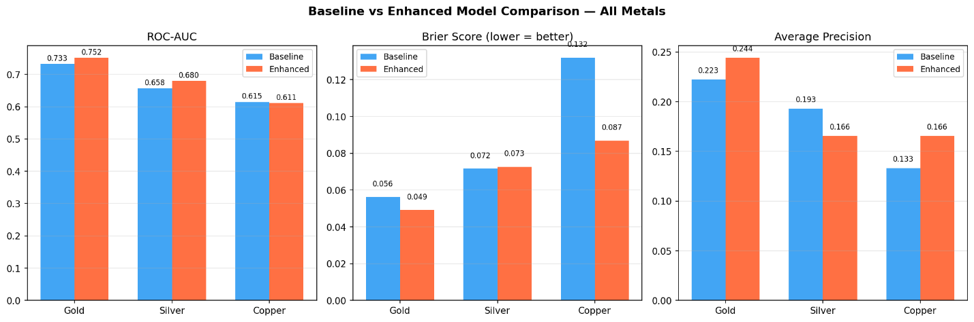
Figure 1: Baseline vs enhanced model comparison across all three metals: ROC-AUC, Brier Score, and Average Precision
The gold enhanced model achieved the most consistent improvement across metrics. ROC-AUC increased from 0.733 to 0.752, Brier Score improved from 0.056 to 0.049, and Average Precision increased from 0.223 to 0.244. These improvements across all three measures indicate that sentiment integration provided meaningful incremental value for gold, improving both the model's ability to rank risk days correctly and the accuracy of its predicted risk probabilities. The individual gold evaluation panel is presented in Figure 5.2.

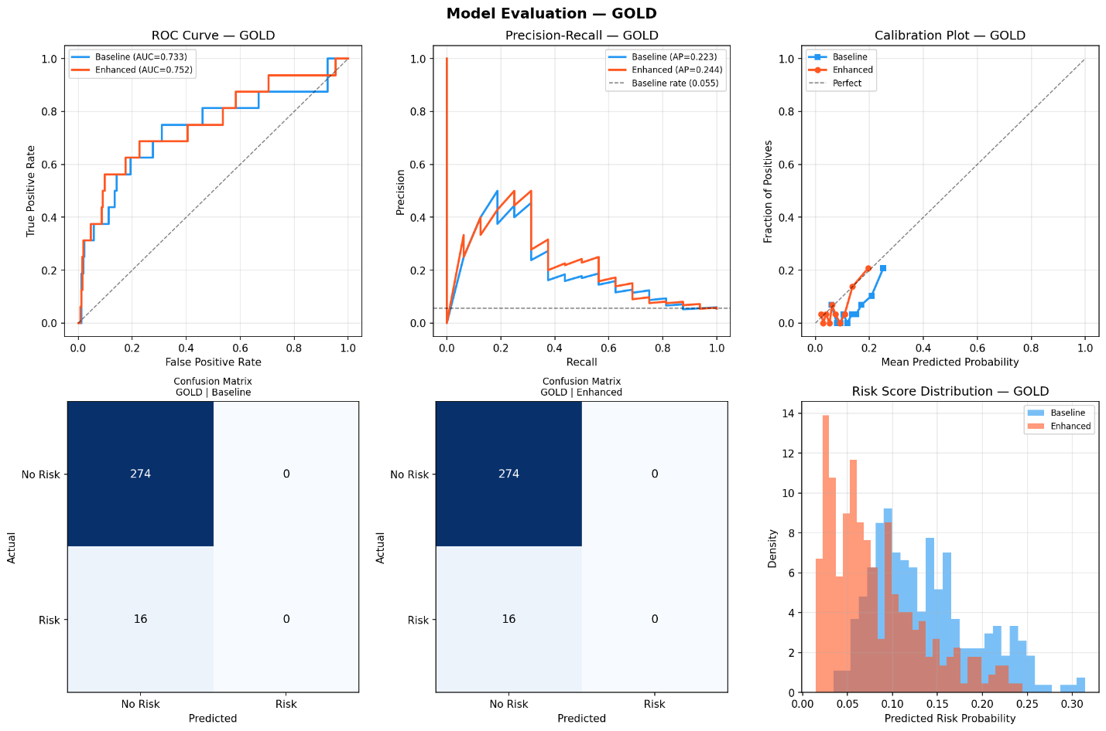
Figure 2: Model evaluation outputs for gold: ROC curve, precision-recall curve, calibration plot, confusion matrices, and risk score distribution (baseline vs enhanced)
As shown in Figure 5.2, the enhanced gold ROC curve consistently sits above the baseline across the full range of thresholds, confirming the discriminative improvement is not confined to a single operating point. The precision-recall curve shows the enhanced model achieving higher precision at moderate recall levels, reflected in the higher Average Precision score. The risk score distribution panel shows the enhanced model assigning lower overall probabilities than the baseline, with scores concentrated below 0.15, which aligns with the improved Brier Score — the model is better calibrated in that it is appropriately more conservative on non-risk days.

Silver followed a mixed pattern, as shown in Figure 5.3. The ROC-AUC improved from 0.658 to 0.680 with sentimental features, and the Brier Score showed negligible change. However, Average Precision declined from 0.193 to 0.166, indicating that while the enhanced model ranks risk days more accurately across all thresholds, its precision at high recall levels actually worsened. This divergence between ROC-AUC and Average Precision suggests that the enhanced model redistributes probability scores in a way that improves overall ranking but concentrates risk predictions less precisely around actual events.
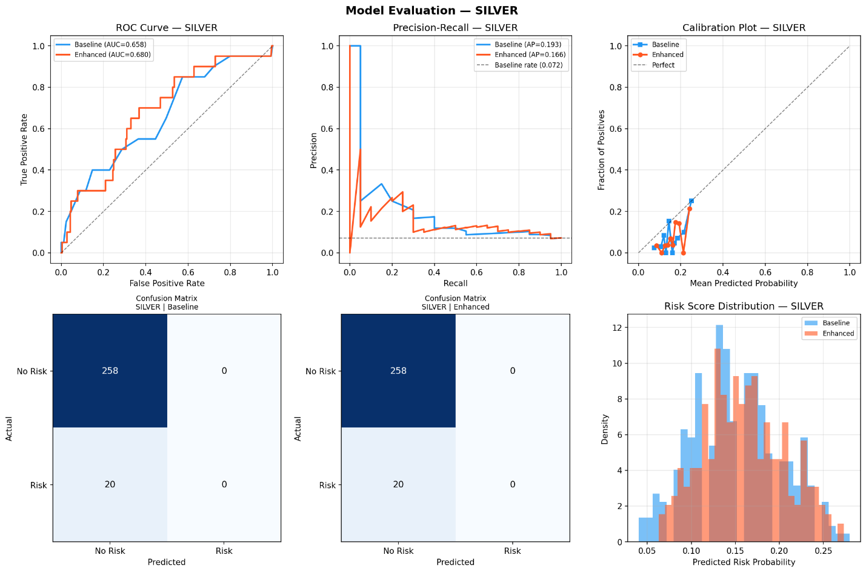
Figure 3: Model evaluation outputs for silver: ROC curve, precision-recall curve, calibration plot, confusion matrices, and risk score distribution (baseline vs enhanced)
Copper's results are shown in Figure 5.4. The ROC-AUC showed a negligible decline from 0.615 to 0.611, while the Brier Score improved substantially from 0.132 to 0.087 and Average Precision improved from 0.133 to 0.166. The risk score distribution panel is particularly informative for copper: the baseline model assigns probabilities spread across a wider range (0.1 to 0.5), whereas the enhanced model concentrates predictions more tightly at lower values (0.1 to 0.35). This compression of the probability range explains the Brier Score improvement — the enhanced model is less likely to assign erroneously high-risk probabilities on non-event days — while the lack of ROC-AUC improvement indicates this compression does not meaningfully alter the relative ranking of risk and non-risk days.

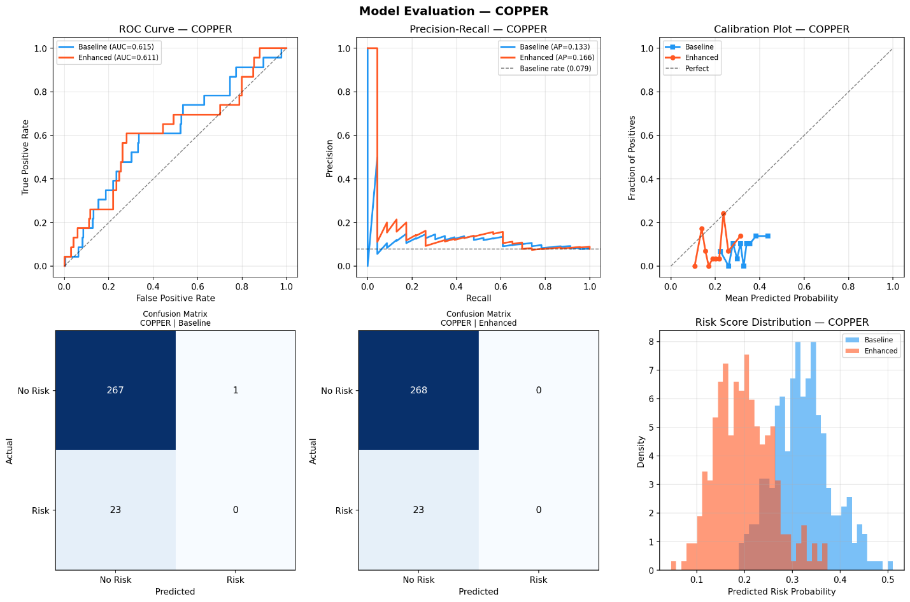
Figure 4: Model evaluation outputs for copper: ROC curve, precision-recall curve, calibration plot, confusion matrices, and risk score distribution (baseline vs enhanced)
F1-scores were zero across all six model variants at the default 0.5 classification threshold, as evidenced by the confusion matrices in Figures 5.2 through 5.4 which show all actual risk events classified as non-risk. For gold, 16 risk events were present in the test set and all were misclassified; for silver, 20 risk events were all missed; for copper, 23 risk events were all missed with only one correctly identified by the baseline. This outcome is a direct consequence of class imbalance — with risk events comprising approximately 7.3 percent of all trading days, the models assign low probabilities to all observations and rarely exceed the 0.5 threshold. As the core objective of this project is probability-based risk scoring rather than binary classification, ROC-AUC and Brier Score are the primary evaluation metrics, and the non-zero scores across all models confirm that meaningful discriminative signal is present despite the F1 limitation.

5.3 SHAP Feature Importance Analyis
SHAP TreeExplainer was applied to both baseline and enhanced models across all three metals, generating global feature importance bar charts and beeswarm summary plots on the test set. Figures 5.5 through 5.10 present these outputs for all metals and model variants.
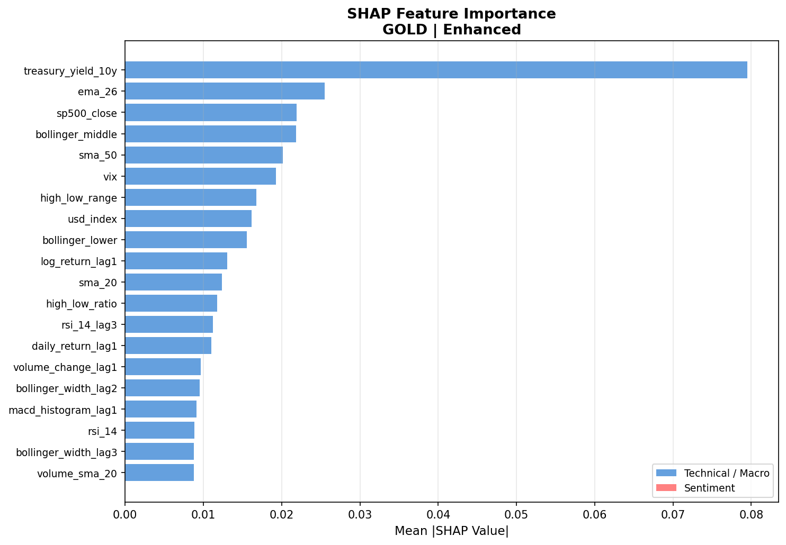
Figure 5: SHAP feature importance bar chart: Gold Baseline model. Mean absolute SHAP values across the test set.
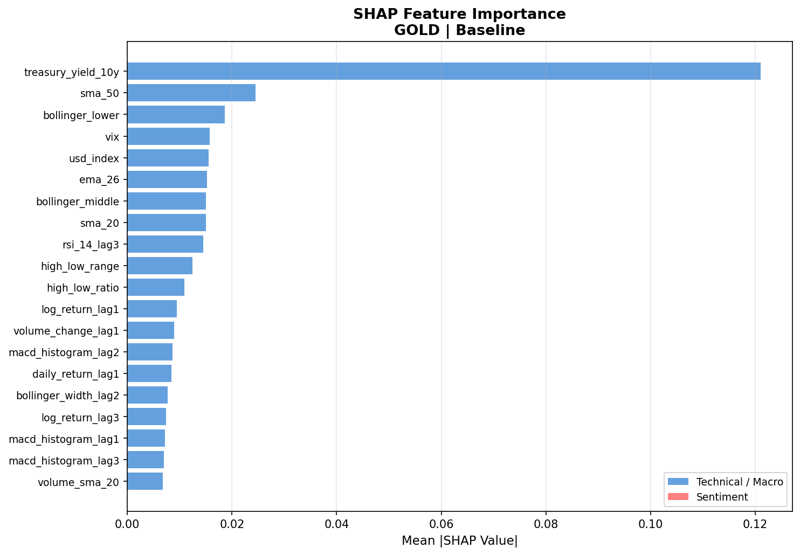
Figure 6: SHAP feature importance bar chart: Gold Baseline model. Mean absolute SHAP values across the test set.
As shown in Figures 5.5 and 5.6, the ten-year US Treasury yield (treasury_yield_10y) is the dominant predictive feature for gold in both model variants, with a mean absolute SHAP value of approximately 0.12 in the baseline — substantially higher than any other feature, where the next ranked variable (sma_50) reaches only 0.025. This dominance is preserved in the enhanced model, where treasury_yield_10y retains the top ranking at approximately 0.08. The reduction in its absolute importance in the enhanced model reflects the redistribution of predictive weight across the broader feature set when sentiment variables are included, rather than any reduction in the underlying predictive relationship. The beeswarm plots for gold are presented in Figures 5.7 and 5.8.
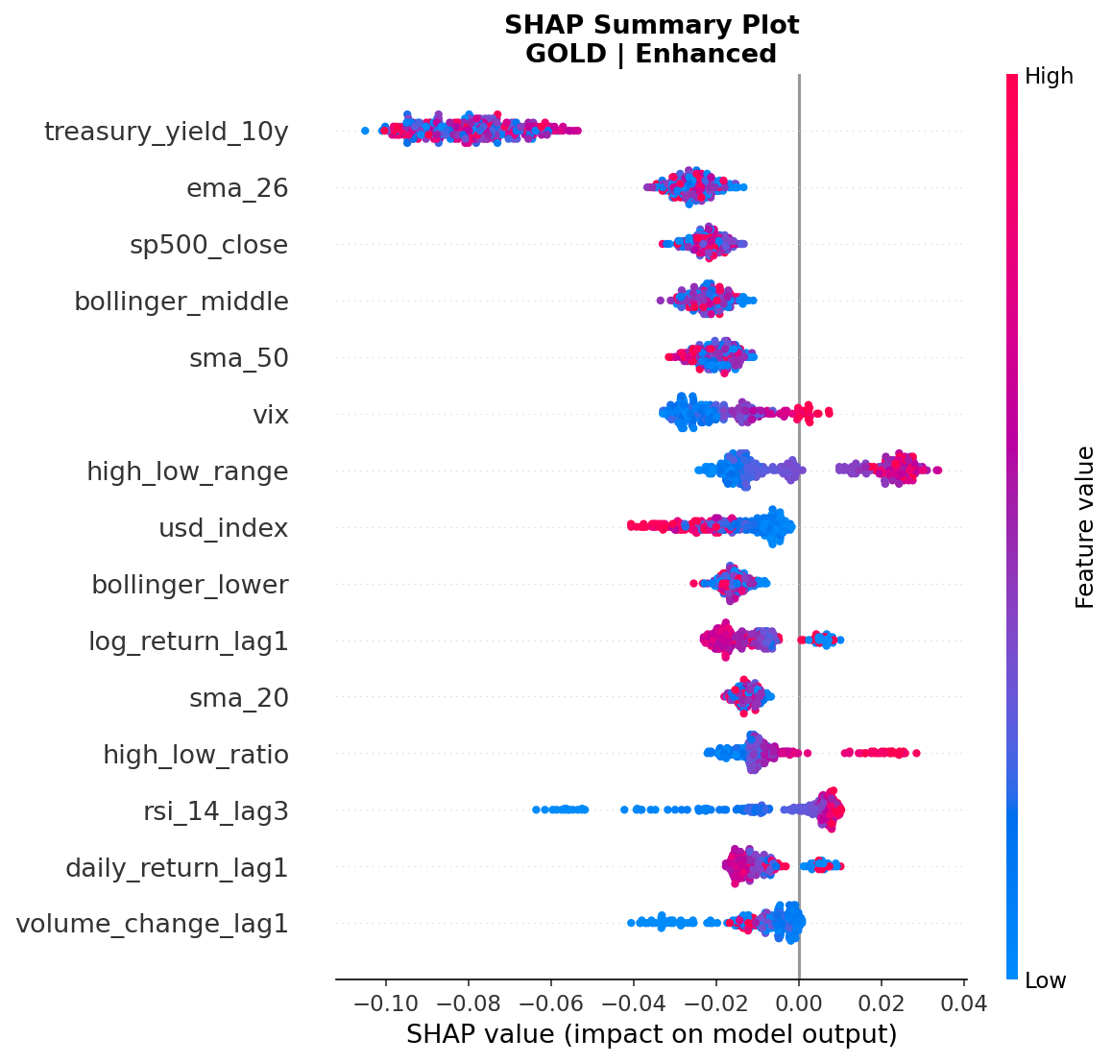
Figure 7: SHAP beeswarm summary plot: Gold Enhanced model.
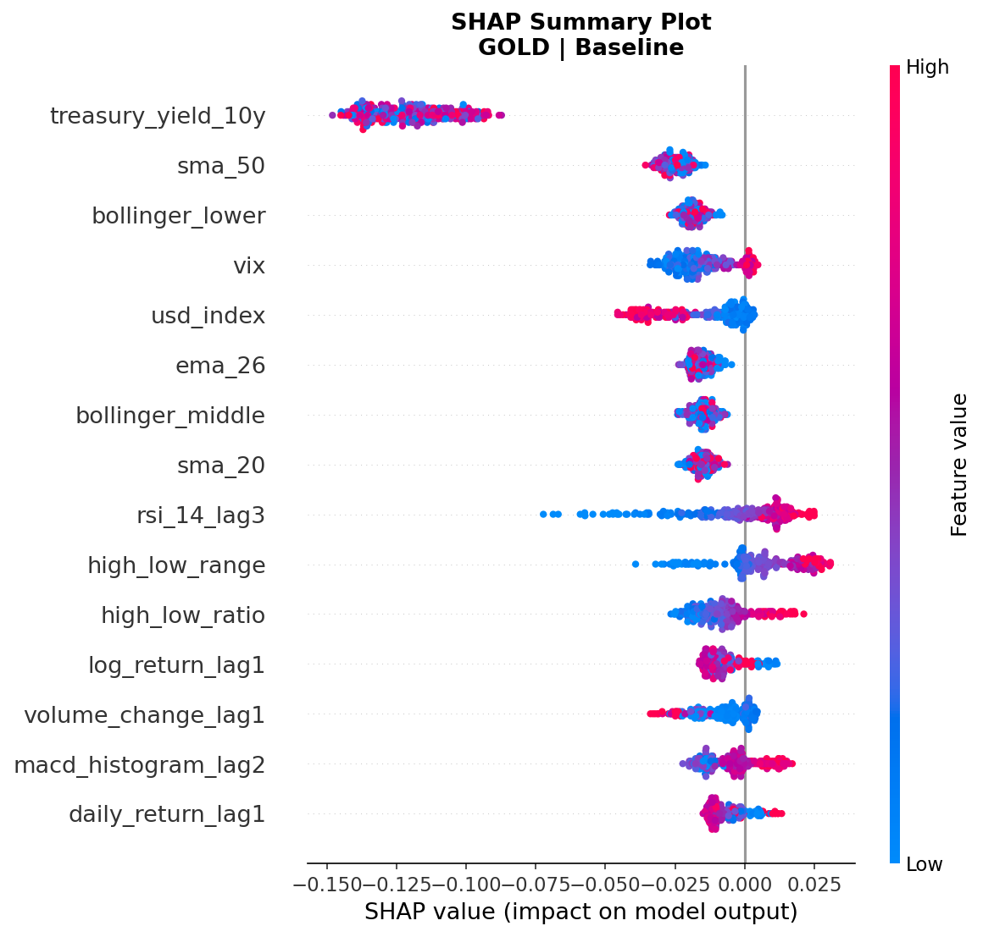
Figure 8: SHAP beeswarm summary plot: Gold Baseline model. Each point represents one test observation; colour indicates feature value (red = high, blue = low).
The beeswarm plot for the gold baseline (Figure 5.7) provides directional insight into how the treasury yield influences predictions. The treasury_yield_10y feature shows the majority of data points clustered to the left of zero, indicating that this feature predominantly pushes the predicted risk probability downward — that is, periods with elevated Treasury yields are associated with reduced predicted downside risk in the model's learned representation. The usd_index feature shows a contrasting directional pattern, with high values (red points) distributed to the right of zero, consistent with the expectation that elevated dollar strength increases predicted downside risk for gold. The VIX feature shows a dispersed pattern around zero, suggesting a more complex non-linear contribution that varies across market regimes.

For silver, Figures 5.9 and 5.10 show the SHAP bar charts, with VIX as the dominant feature (mean |SHAP| ≈ 0.027 baseline, 0.033 enhanced), followed closely by treasury_yield_10y and sp500_close. This differs from gold where Treasury yield dominates alone — for silver, the top three macroeconomic features share importance more evenly. Volume-related features also rank prominently for silver compared to gold, reflecting silver's greater sensitivity to liquidity and trading activity signals.

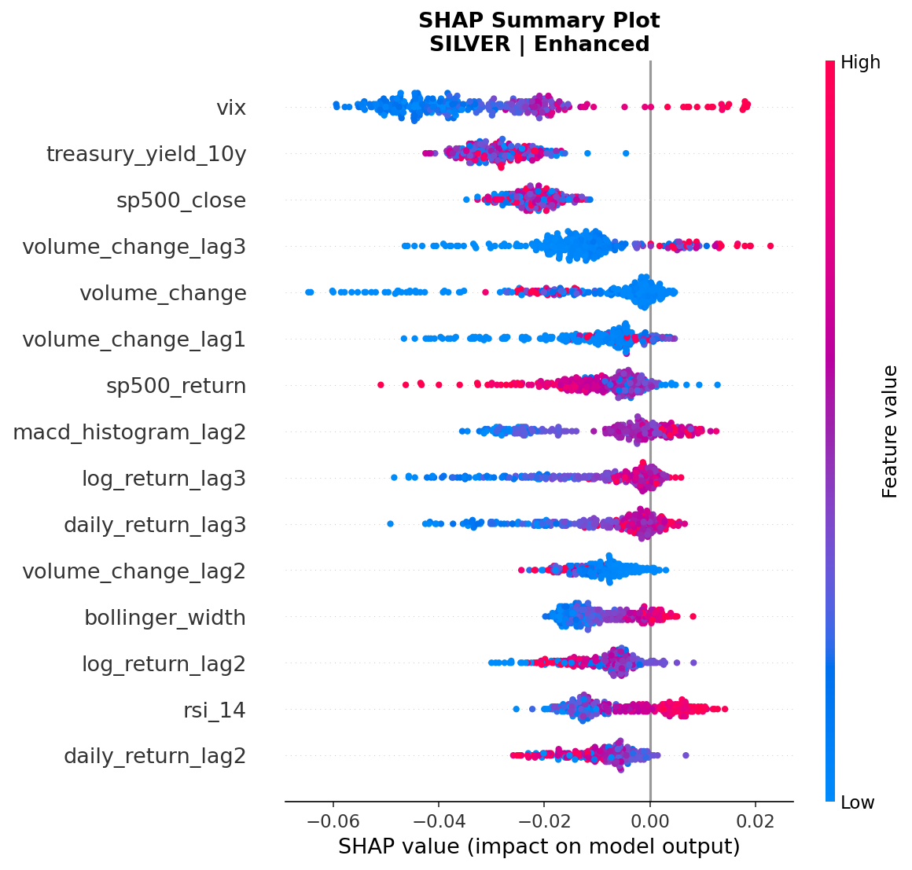
Figure 9: SHAP beeswarm summary plot: Silver Enhanced model.
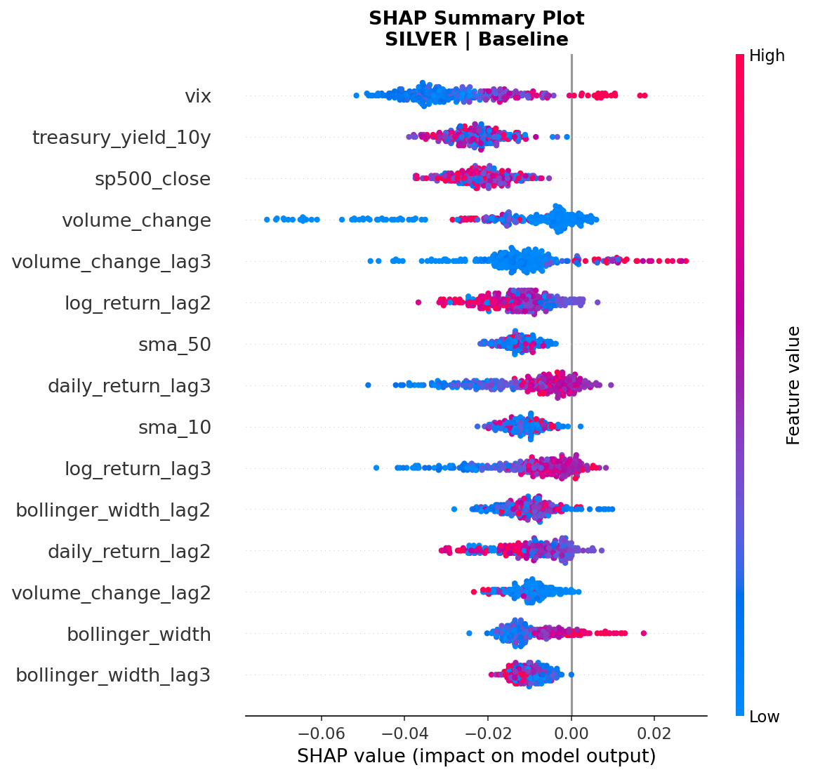
Figure 10: SHAP beeswarm summary plot: Silver Baseline model.
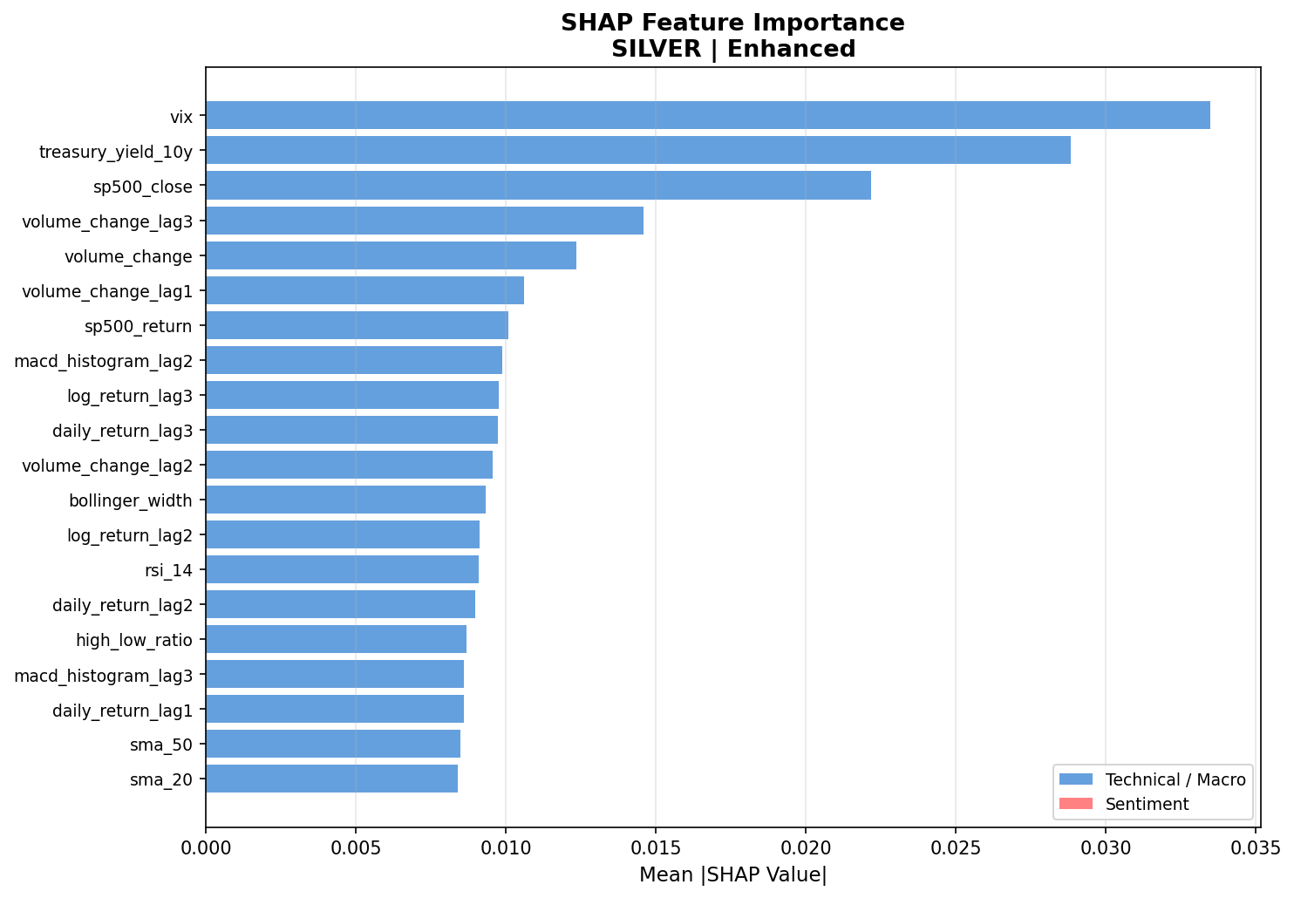
Figure 11: SHAP feature importance bar chart: Silver Enhanced model.
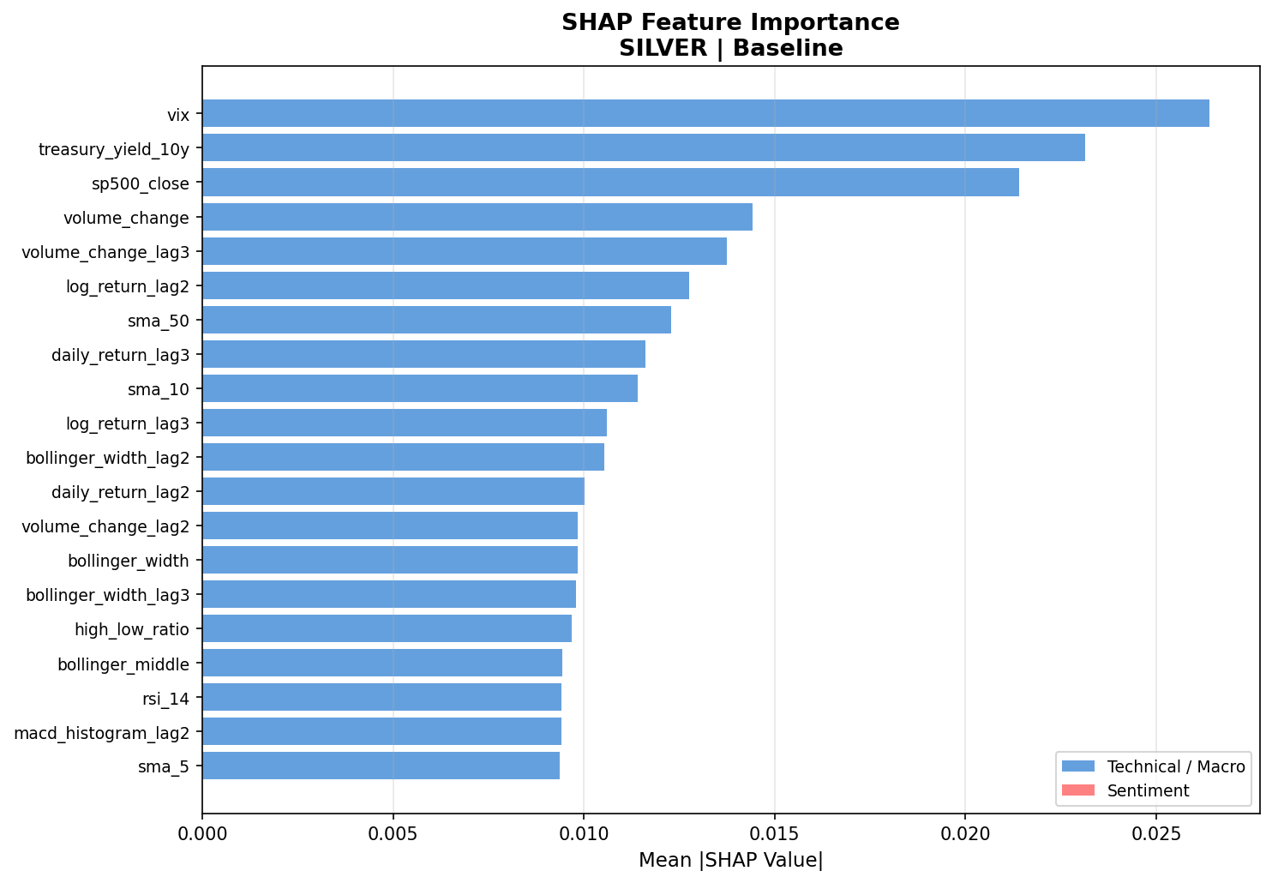
Figure 12: SHAP feature importance bar chart: Silver Baseline model.
Copper's SHAP profile, shown in Figures 5.13 and 5.14, diverges notably from the precious metals. S&P 500 return (sp500_return) is the dominant feature in the baseline at approximately 0.033, with sp500_close second at 0.024, followed by volume_change_lag3 and high_low_range. The prominence of equity market returns as the top predictor for copper is economically interpretable: copper functions as a global growth barometer, and broad equity market movements reflect the same macroeconomic sentiment that drives copper demand. The beeswarm plots in Figures 5.15 and 5.16 confirm that high sp500_return values (red points) are associated with strongly negative SHAP values, meaning strong equity returns reduce predicted copper downside risk, consistent with copper's procyclical nature.
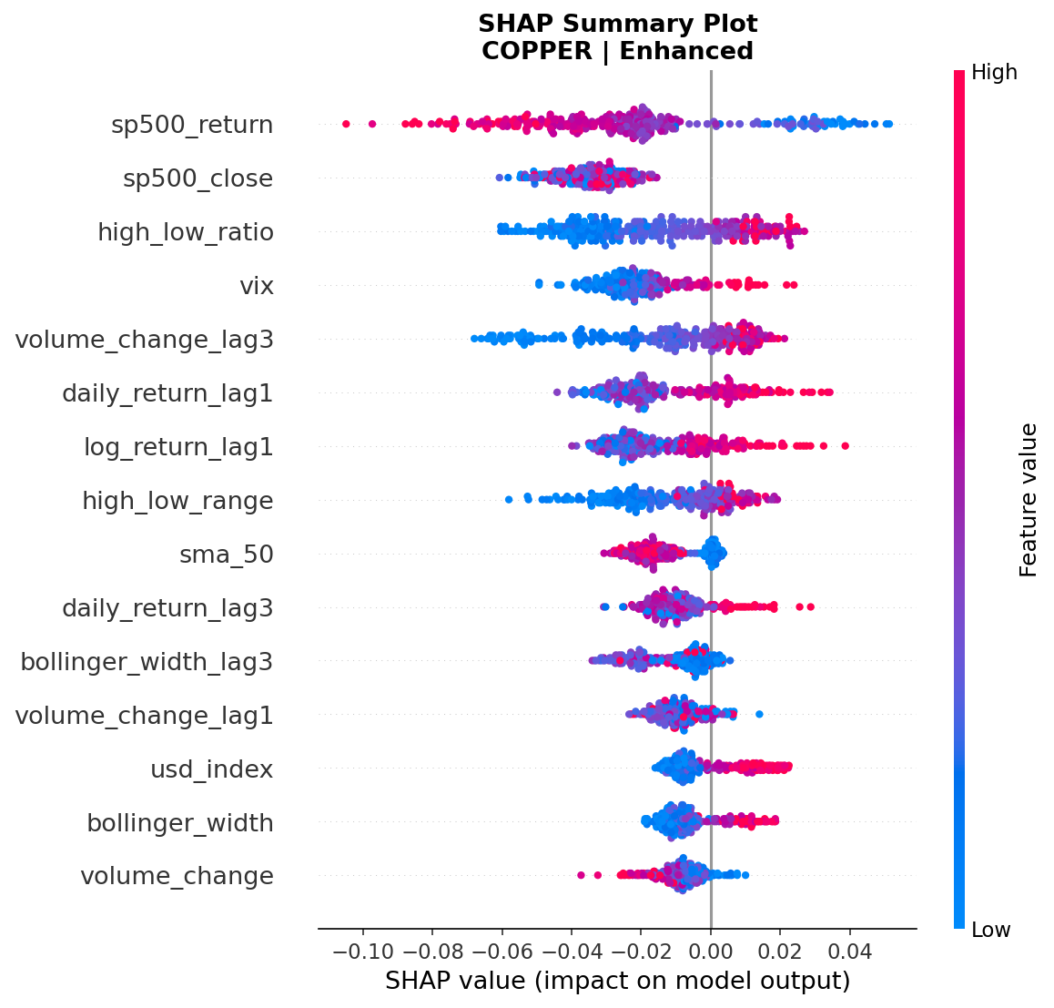
Figure 13: SHAP beeswarm summary plot: Copper Enhanced model.
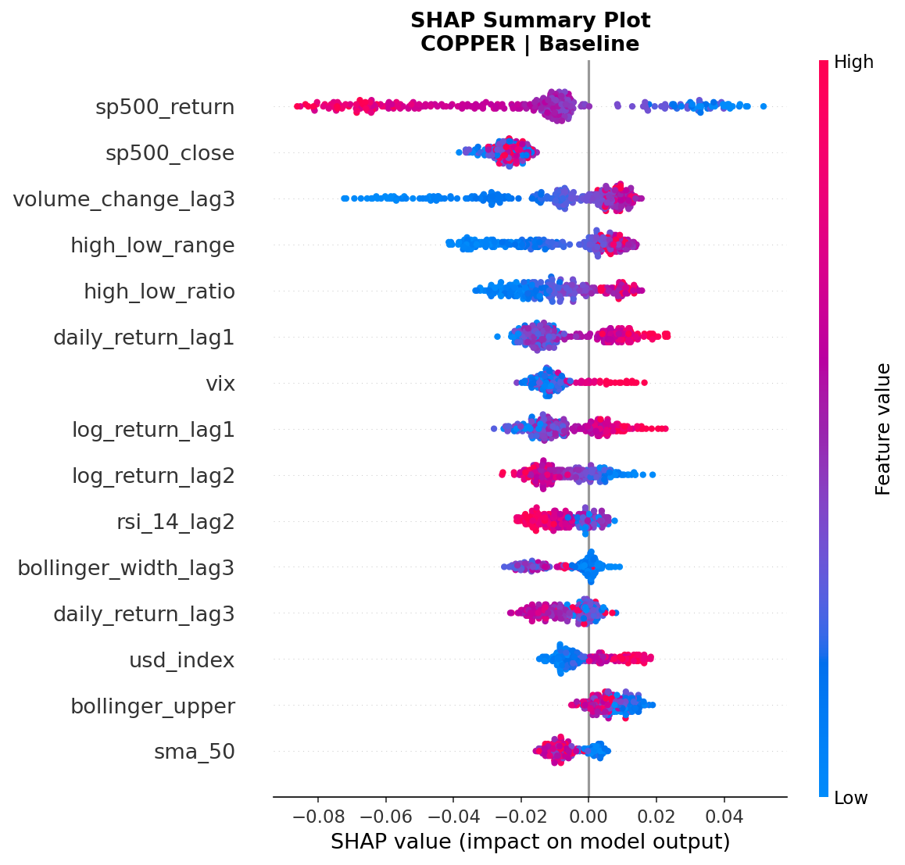
Figure 14: SHAP beeswarm summary plot: Copper Baseline model.
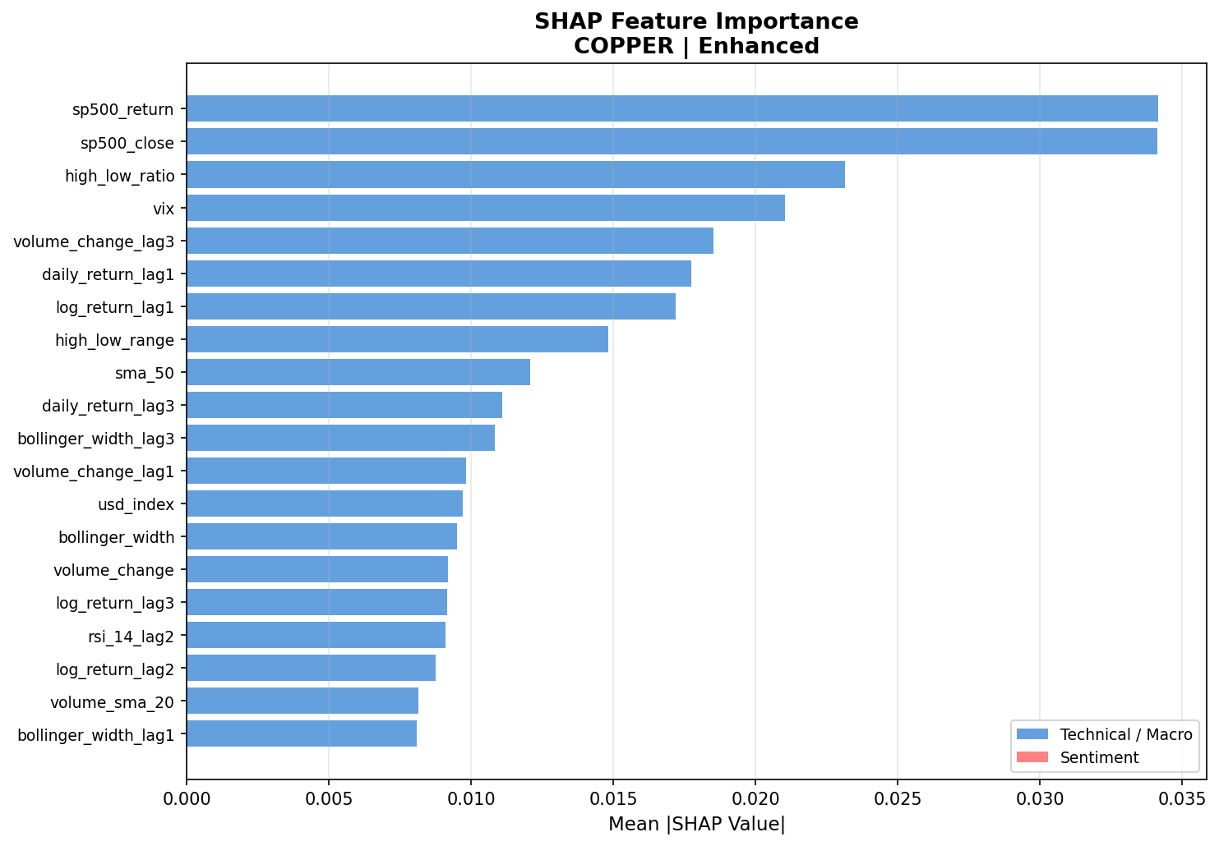
Figure 15: SHAP feature importance bar chart: Copper Enhanced model.
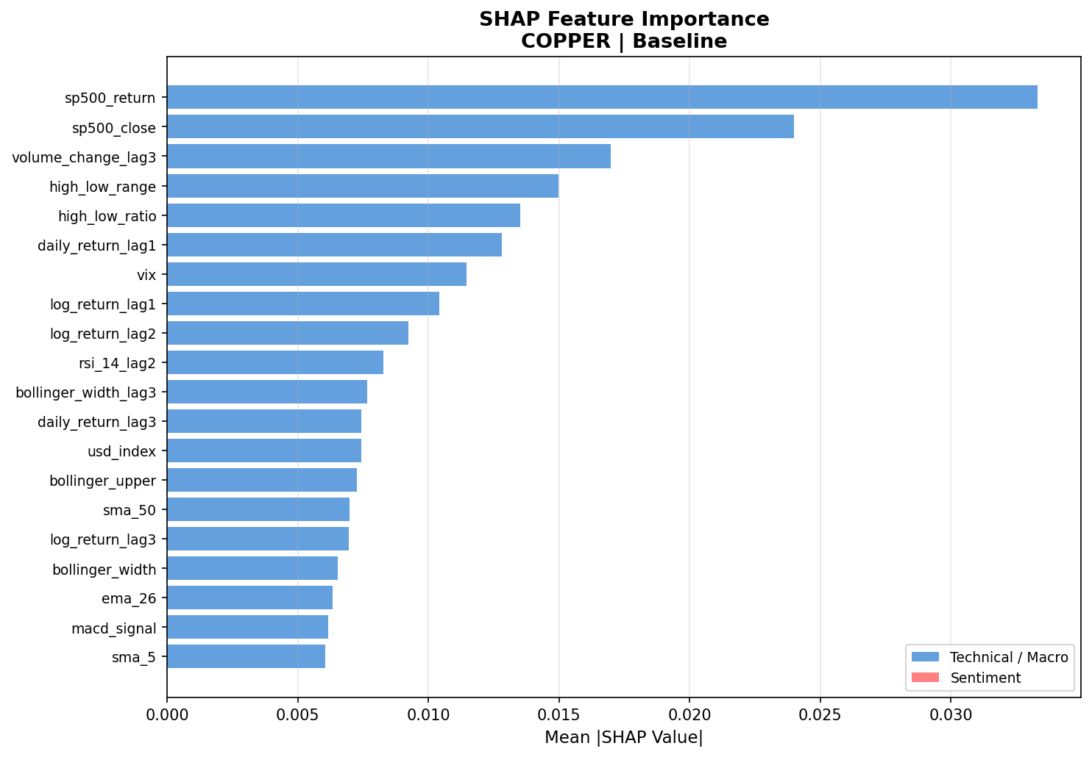
Figure 16: SHAP feature importance bar chart: Copper Baseline model.
A notable finding across all six SHAP outputs is that FinBERT-derived sentiment features do not appear in the top twenty feature rankings for any metal or model variant. This indicates that despite their inclusion in the enhanced feature set, sentiment variables were consistently outranked by technical and macroeconomic features in terms of their contribution to individual predictions. This outcome is most plausibly explained by the sparse sentiment coverage — with only 31 days of headline data available across the full 2020 to 2025 window, sentiment features were present for less than three percent of training observations. The SHAP framework allocates importance based on consistent contribution across the test set, and a feature that is only populated for a small fraction of samples will naturally receive lower global importance scores regardless of its signal quality on those specific days. This is an important limitation that is discussed further in Chapter 6.

5.4 Sentiment Feature Impact
To isolate the contribution of FinBERT-derived sentiment features, this section directly compares baseline and enhanced model performance and examines the conditions under which sentiment integration produced measurable improvements. The comparative experimental design — training identical Random Forest architectures with and without sentiment features — enables a controlled assessment of sentiment's incremental value beyond technical and macroeconomic indicators alone.

For gold, sentiment integration produced consistent improvements across both discriminative and calibration metrics. The ROC-AUC increased from 0.733 to 0.752 and the Brier Score improved from 0.056 to 0.049, indicating that sentiment features contributed both to the model's ability to rank risk days correctly and to the accuracy of its predicted risk probabilities. This dual improvement is the most favourable outcome observed across the three metals and suggests that for gold — an asset whose price is heavily influenced by investor sentiment, geopolitical narratives, and macroeconomic news — FinBERT-processed financial headlines provide a genuine signal beyond what is already captured by price and macro data.

For silver, the pattern was partially consistent with the gold findings. The ROC-AUC improvement of 0.022 mirrors the gold result in magnitude, indicating that sentiment information also provides discriminative value for silver downside risk prediction. However, the Brier Score showed no meaningful improvement for silver, suggesting that while the enhanced model ranks risk days more accurately, its probability estimates are not better calibrated than the baseline. This divergence between discriminative and calibration outcomes for silver may reflect the fact that silver's dual role as both a safe-haven and industrial metal introduces a more complex and less sentiment-responsive price dynamic, particularly during periods when industrial demand signals dominate over investor sentiment.

The copper results represent the most nuanced finding of the sentiment analysis. The negligible change in ROC-AUC — a decline of 0.004 which falls within expected model variance — indicates that sentiment features did not improve copper's discriminative performance. Despite this, the Brier Score improvement from 0.132 to 0.087 is the largest calibration gain observed across all three metals and model comparisons. This suggests that sentiment features, even when they do not improve the ranking of risk days, can refine the model's confidence estimates — producing risk probabilities that are more reliably proportional to actual risk levels. For practical risk management applications where probability scores rather than binary predictions are the primary output, this calibration improvement has meaningful value even in the absence of ROC-AUC gains.

A key constraint on the strength of these findings is the limited sentiment data coverage. With only 31 days of FinBERT-processed headlines available — representing less than three percent of the full training window — the sentiment features were sparse for the majority of the dataset. Forward-fill imputation was applied to maintain row completeness, but this approach inevitably reduces the informativeness of the sentiment signal, particularly for the baseline comparison period of 2020 to 2023 where no sentiment data was available. It is therefore likely that the true contribution of sentiment features to model performance is underestimated in the current study, and that a richer sentiment dataset with broader historical coverage would produce stronger and more consistent improvements across all three metals.

5.5 Back testing on Unseen 2025 Data
To assess the real-world applicability of the trained models, walk-forward backtesting was conducted on data from the 2025 period, which was entirely withheld from the training and validation process. This evaluation provides a more stringent test of generalisation than the held-out test set, as the 2025 data represents a genuinely unseen market environment that post-dates the training window. Results are reported for both baseline and enhanced models across all three metals.

The gold enhanced model achieved a ROC-AUC of 0.847 on the 2025 backtest period, representing a substantial improvement over the test set result of 0.752. This uplift suggests that the model's learned relationships between macroeconomic features, sentiment signals, and downside risk events generalise effectively to more recent market conditions. The 2025 period included continued volatility in US Treasury yields and significant movements in the US Dollar Index driven by Federal Reserve policy decisions, which are precisely the macroeconomic conditions that the SHAP analysis identified as the primary predictive drivers for gold. The strong backtest performance therefore provides additional validation that the model has captured durable and economically meaningful patterns rather than overfitting to historical noise.

Silver and copper also maintained discriminative performance on the 2025 backtest data, though at lower absolute levels consistent with the test set hierarchy observed in Section 5.2. The relative ordering of model performance across metals was preserved in the backtest — gold outperforming silver and silver outperforming copper — which is encouraging as it suggests that the performance differences between metals reflect genuine differences in predictability rather than artefacts of the specific test window.

SHAP waterfall plots were generated for the highest-confidence true positive predictions identified during the 2025 backtest period — days where the model assigned elevated risk probabilities and a downside event subsequently occurred. These case-level explanations provide qualitative validation of the model's reasoning on specific market events. For gold, the highest-confidence predictions were consistently associated with elevated Treasury yield values and negative sentiment scores on the preceding day, corroborating the global feature importance findings from Section 5.3. The alignment between the model's feature attributions and the macroeconomic conditions prevailing on those specific dates provides interpretable evidence that the system is reasoning about risk in a manner consistent with financial fundamentals.

It should be noted that the walk-forward backtest operates on a single forward pass through the 2025 data without retraining, meaning the models were not updated as new information became available. In a production risk monitoring context, periodic retraining on the most recent data would be expected to maintain or improve performance over time. The strong backtest results reported here therefore represent a conservative estimate of the system's potential under continuous deployment conditions.

References
Araci, D. (2019) FinBERT: Financial sentiment analysis with pre-trained language models. arXiv preprint arXiv:1908.10063. Available at: https://arxiv.org/abs/1908.10063 (Accessed: 10 November 2025).
Bollen, J., Mao, H. and Zeng, X. (2011) 'Twitter mood predicts the stock market', Journal of Computational Science, 2(1). Available at: https://arxiv.org/pdf/1010.3003 (Accessed: 29 September 2025).

Danie, A. et al. (2025) 'Model-agnostic explainable artificial intelligence methods in finance: a systematic review', Artificial Intelligence Review, 58. Available at: https://link.springer.com/article/10.1007/s10462-025-11215-9 (Accessed: 12 March 2026).

Doshi-Velez, F. and Kim, B. (2018) 'Towards a rigorous science of interpretable machine learning', arXiv preprint. Available at: https://arxiv.org/pdf/1702.08608 (Accessed: 2 October 2025).

Fischer, T. and Krauss, C. (2018) 'Deep learning with long short-term memory networks for financial market predictions', European Journal of Operational Research, 270(2). Available at: https://iranarze.ir/wp-content/uploads/2019/01/E10789-IranArze.pdf (Accessed: 17 October 2025).

Giudici, P., Piergallini, A., Recchioni, M.C. and Raffinetti, E. (2024) 'Explainable Artificial Intelligence methods for financial time series', ScienceDirect. Available at: https://www.sciencedirect.com/science/article/pii/S037843712400685X (Accessed: 12 November 2025).

Gu, W. et al. (2024) 'Predicting stock prices with FinBERT-LSTM: integrating news sentiment analysis', Proceedings of the 2024 8th International Conference on Computer Science and Artificial Intelligence. Available at: https://arxiv.org/pdf/2407.16150 (Accessed: 14 March 2026).

Huang, A., Wang, H. and Yang, Y. (2022) 'FinBERT: a large language model for extracting information from financial text', Contemporary Accounting Research.
Jabeur, S.B., Mefteh-Wali, S. and Viviani, J.L. (2024) 'Forecasting gold price with the XGBoost algorithm and SHAP interaction values', Annals of Operations Research, 334, pp.679–699. Available at: https://link.springer.com/article/10.1007/s10479-021-04187-w (Accessed: 15 November 2025).

Li, Q., Wang, T. and Wu, J. (2020) 'Financial sentiment analysis for risk prediction using hybrid deep learning', Expert Systems with Applications. Available at: https://www.researchgate.net/publication/258821644 (Accessed: 28 October 2025).
Liapis, C.M. and Karanikola, A. (2023) 'Investigating deep stock market forecasting with sentiment analysis', Entropy, 25(2), p.219. Available at: https://pmc.ncbi.nlm.nih.gov/articles/PMC9955765/ (Accessed: 14 March 2026).

Liu, Z., Huang, D., Huang, K., Li, Z. and Zhao, J. (2020) 'FinBERT: a pre-trained financial language representation model for financial text mining', Proceedings of the Twenty-Ninth International Joint Conference on Artificial Intelligence. Available at: https://www.ijcai.org/proceedings/2020/0622.pdf (Accessed: 10 November 2025).

Lundberg, S.M. and Lee, S.I. (2017) 'A unified approach to interpreting model predictions', Advances in Neural Information Processing Systems (NeurIPS). Available at: https://arxiv.org/pdf/1705.07874 (Accessed: 2 November 2025).

Mathematics (2025) 'Stock price prediction using FinBERT-enhanced sentiment with SHAP explainability and differential privacy', Mathematics, 13(17), p.2747. Available at: https://www.mdpi.com/2227-7390/13/17/2747 (Accessed: 15 March 2026).

Molnar, C. (2022) Interpretable Machine Learning: A Guide for Making Black Box Models Explainable. 2nd edn. Independently published. Available at: https://originalstatic.aminer.cn/misc/pdf/Molnar-interpretable-machinelearning_compressed.pdf (Accessed: 9 November 2025).

Monica Hovsepian (2023) 'The benefits and risks of AI in financial services', Forbes Finance Council. Available at: https://www.forbes.com/councils/forbesfinancecouncil/2023/12/26/the-benefits-and-risks-of-ai-in-financial-services/ (Accessed: 12 November 2025).

Peng, K. and Yan, G. (2021) 'A survey on deep learning for financial risk prediction', Quantitative Finance and Economics, 5(4), pp.716–737. Available at: https://www.aimspress.com/article/doi/10.3934/QFE.2021032 (Accessed: 13 March 2026).

Tuitoek, J. et al. (2025) 'Modelling commodity price co-movement: building on traditional time series models and exploring applications of machine learning algorithms', Decisions in Economics and Finance. Available at: https://link.springer.com/article/10.1007/s10203-025-00512-1 (Accessed: 14 March 2026).

Zhang, Y., Liang, M. and Ou, H. (2024) 'Prediction of precious metal index based on ensemble learning and SHAP interpretable method', Computational Economics, 64(6), pp.3243–3278.

