Name:-Adnan Hasan

GitHub Link:-

<https://github.com/adnan-984/Cognizant_6364530_Adnan>

CognizantDotNet

**-----------------------------------------------------------------------------------------**

**Web API (Handson 02)  
  
1. Created a Project named “SwaggerDemoAPI”  
  
Program.cs**using Microsoft.OpenApi.Models;

var builder = WebApplication.CreateBuilder(args);

builder.Services.AddControllers();

builder.Services.AddSwaggerGen(c =>

{

c.SwaggerDoc("v1", new OpenApiInfo

{

Title = "Swagger Demo",

Version = "v1",

Description = "TBD",

TermsOfService = new Uri("https://example.com/terms"),

Contact = new OpenApiContact

{

Name = "John Doe",

Email = "john@xyzmail.com",

Url = new Uri("https://www.example.com")

},

License = new OpenApiLicense

{

Name = "License Terms",

Url = new Uri("https://www.example.com")

}

});

});

var app = builder.Build();

app.UseSwagger();

app.UseSwaggerUI(c =>

{

c.SwaggerEndpoint("/swagger/v1/swagger.json", "Swagger Demo");

});

app.UseAuthorization();

app.MapControllers();

app.Run();  
 **ValuesController.cs**  
  
using Microsoft.AspNetCore.Mvc;

using System.Collections.Generic;

namespace SwaggerDemoAPI.Controllers

{

[Route("api/[controller]")]

[ApiController]

public class ValuesController : ControllerBase

{

static List<string> values = new List<string> { "value1", "value2", "value3" };

[HttpGet]

[ProducesResponseType(StatusCodes.Status200OK)]

public ActionResult<IEnumerable<string>> Get()

{

return Ok(values);

}

[HttpGet("{id}")]

[ProducesResponseType(StatusCodes.Status200OK)]

[ProducesResponseType(StatusCodes.Status404NotFound)]

public ActionResult<string> Get(int id)

{

if (id >= values.Count || id < 0) return NotFound();

return Ok(values[id]);

}

[HttpPost]

[ProducesResponseType(StatusCodes.Status201Created)]

public ActionResult Post([FromBody] string value)

{

values.Add(value);

return Created("", value);

}

[HttpPut("{id}")]

[ProducesResponseType(StatusCodes.Status204NoContent)]

[ProducesResponseType(StatusCodes.Status404NotFound)]

public ActionResult Put(int id, [FromBody] string value)

{

if (id >= values.Count || id < 0) return NotFound();

values[id] = value;

return NoContent();

}

[HttpDelete("{id}")]

[ProducesResponseType(StatusCodes.Status204NoContent)]

[ProducesResponseType(StatusCodes.Status404NotFound)]

public ActionResult Delete(int id)

{

if (id >= values.Count || id < 0) return NotFound();

values.RemoveAt(id);

return NoContent();

}

}

}

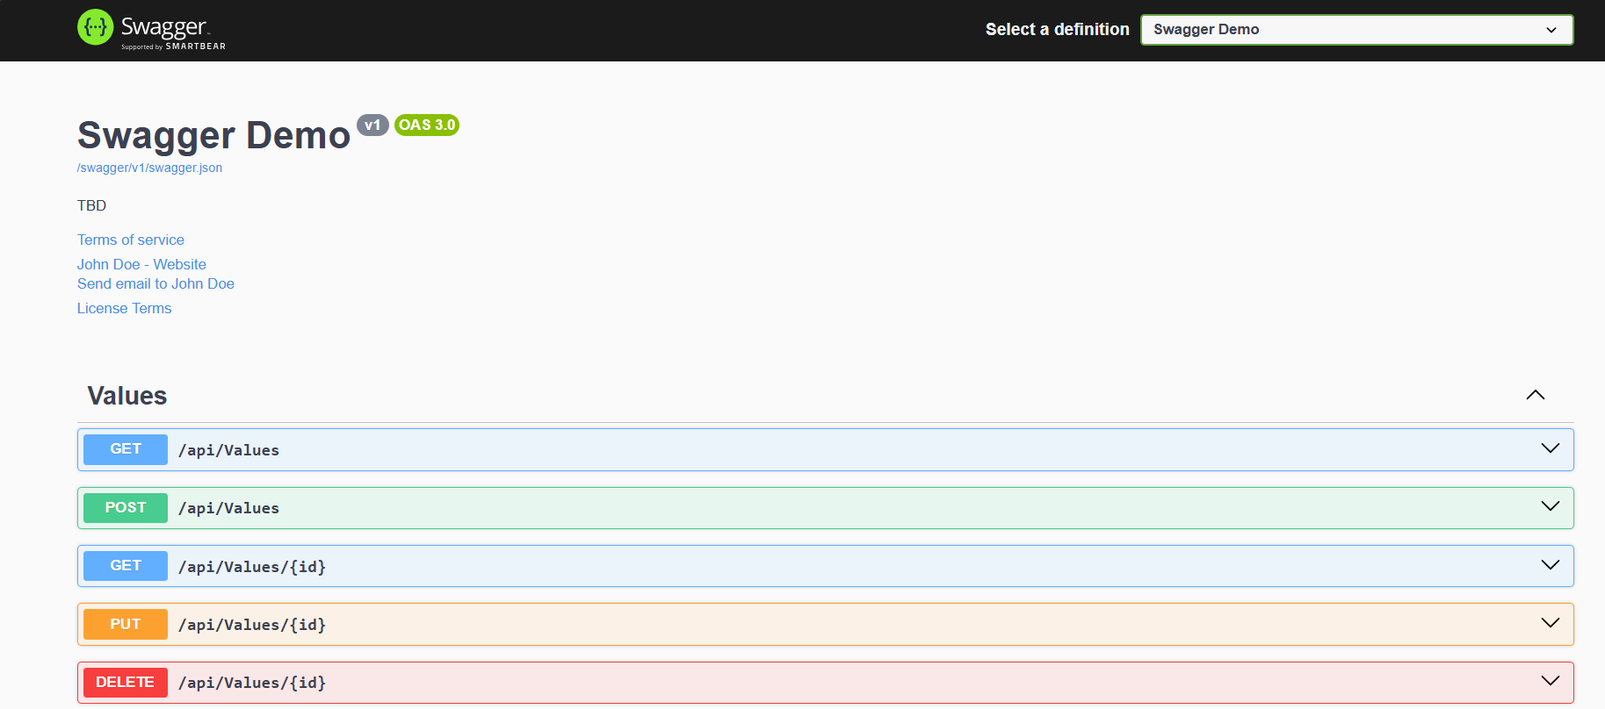

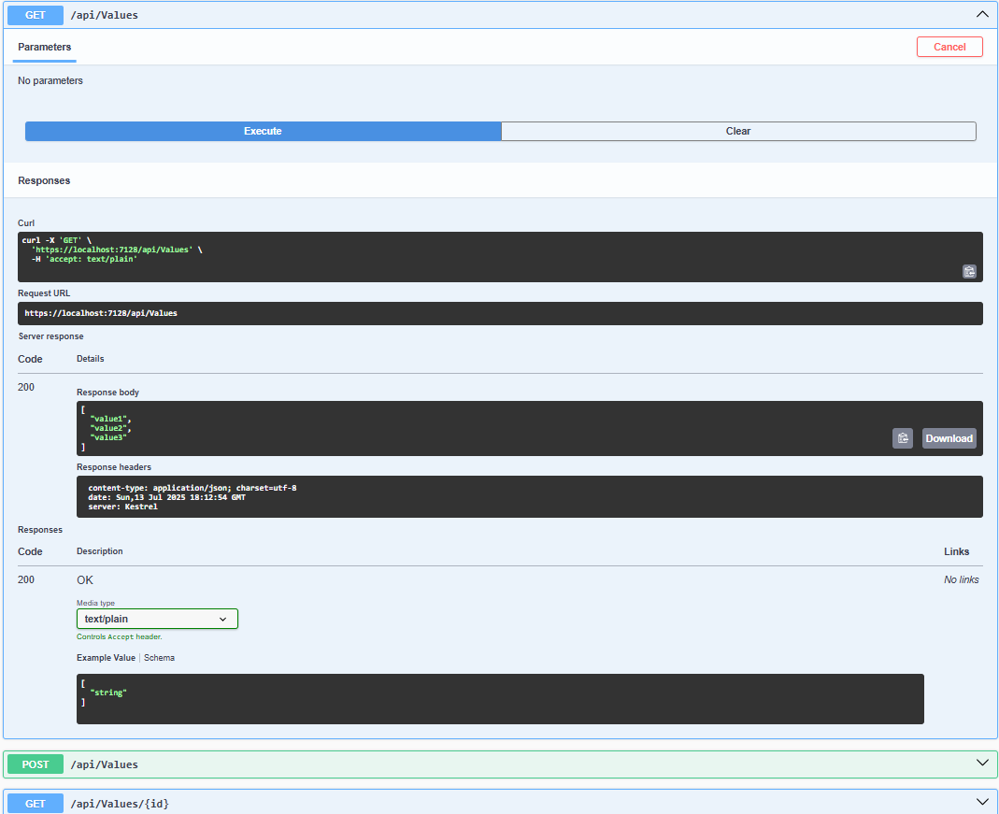  
  
  
  
  
  
  
  
  
**2. Use POSTMAN tool, to point to the local Web API that was created with Employee controller. Test the GET action method using POSTMAN**  
  
using Microsoft.AspNetCore.Mvc;

using System.Collections.Generic;

namespace SwaggerDemoAPI.Controllers

{

[Route("api/[controller]")]

[ApiController]

public class EmployeeController : ControllerBase

{

private static List<string> employees = new List<string>

{

"John", "Ritesh", "Sneha", "Aditya"

};

[HttpGet]

[ProducesResponseType(StatusCodes.Status200OK)]

public IActionResult GetEmployees()

{

return Ok(employees);

}

}

}

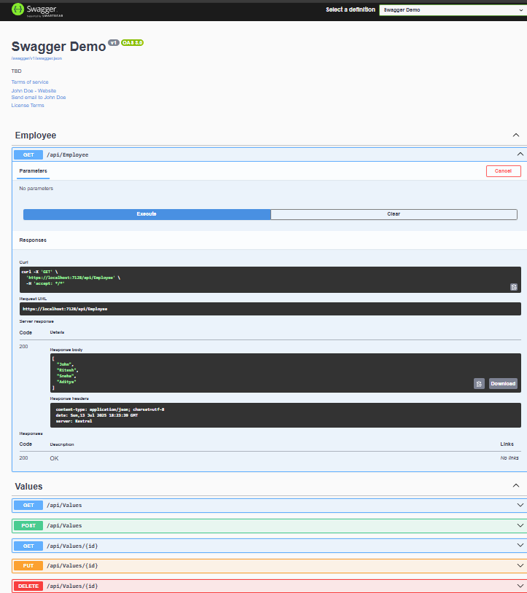  
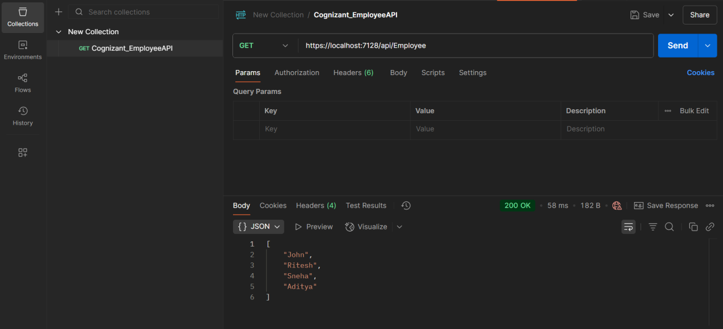  
  
  
  
  
  
  
**3. Modify the Controller name in the Route attribute of the Employee controller to ‘Emp’ and check its access thru POSTMAN**

**EmployeeController.cs**  
  
using Microsoft.AspNetCore.Mvc;

using System.Collections.Generic;

namespace SwaggerDemoAPI.Controllers

{

[Route("api/Emp")]

[ApiController]

public class EmployeeController : ControllerBase

{

private static List<string> employees = new List<string>

{

"John", "Ritesh", "Sneha", "Aditya"

};

[HttpGet]

[ProducesResponseType(StatusCodes.Status200OK)]

public IActionResult GetEmployees()

{

return Ok(employees);

}

}

}  
