


TOKENWISE
Sustainable Context Optimization for Coding Agents
SE-801: Software Project
Final Report

Submitted by
Adnan Bin Wahid
Roll: BSSE-1442

Supervised by
Mridha Md. Nafis Fuad
Lecturer
Institute of Information Technology
University of Dhaka

Submission Date: 10-10-2026

Acknowledgment
I would like to express my sincere gratitude to the Institute of Information Technology, University of Dhaka, for providing the opportunity to undertake TokenWise: Sustainable Context Optimization for Coding Agents as my Software Project Lab III project.
I am particularly grateful to my supervisor, Mridha Md. Nafis Fuad, for his guidance and support throughout the project. His feedback encouraged me to examine not only the implementation of the extension but also its validation, comparative evaluation, and practical usefulness.
I also appreciate my teachers, classmates, and friends for their suggestions and feedback. Their questions and experiences helped identify usability issues, refine the demonstration process, and improve the project’s presentation.
I acknowledge the researchers behind SWE-Pruner and the SEAL energy-estimation research, whose work informed important aspects of TokenWise. I also acknowledge the developers of the open-source libraries, pretrained models, and development tools used in the implementation.
This project provided valuable experience in software architecture, editor-extension development, repository analysis, machine-learning integration, and evidence-based evaluation.

Abstract
AI coding agents require relevant repository information to answer programming questions effectively. However, manually selecting source files places an additional burden on developers, while supplying an entire repository introduces unrelated information and can exceed practical context limits. Follow-up questions create a further challenge because their meaning may depend on earlier conversation intent. These problems motivate an automatic, task-aware approach to preparing repository context.
This project presents TokenWise, an editor extension with a local Python backend for sustainable context optimization, primarily integrated with Antigravity. TokenWise analyzes Python repositories using abstract syntax trees, extracts structural information, and retrieves source files and related tests according to the developer’s request. It combines lexical and dependency-based retrieval with SWE-Pruner-based neural pruning and structured context packing. The resulting reference packet is bounded by a configurable token budget. Background indexing and incremental updates support repeated requests without rebuilding all repository metadata.
The extension supports repository discovery, selected-file and selected-code workflows, and bounded same-conversation memory. Task-aware prompt-engineering guidance accompanies the retrieved evidence to encourage source-grounded responses. Inspectable result views expose included files, pruning decisions, token statistics, and comparison results. A SEAL-derived estimator provides approximate inference energy and carbon estimates under explicit model and workload assumptions.
Validation includes automated extension, backend, and demonstration tests, browser-based interface checks, and a local comparative study involving twenty Python repositories. The retrieval-only condition produced an aggregate packet-token reduction of 93.58% against a hypothetical all-Python repository baseline. A separate matched-excerpt neural comparison achieved 3.25% aggregate packet-token reduction. These results also revealed evidence-preservation trade-offs, demonstrating that smaller context does not automatically imply better answers.
TokenWise demonstrates an implemented approach to automatic, bounded and inspectable repository-context preparation. The reported token measurements concern locally constructed packets, not verified Antigravity provider usage. Carbon values are estimates rather than measured emissions. Controlled downstream answer-quality evaluation remains necessary to establish broader effectiveness.
Table of Contents
Acknowledgment 2
Abstract 3
1. Project Overview 10
1.1 Project Title and Definition 10
1.2 Problem Statement 11
1.3 Objectives 11
1.4 Scope and Evolution 12
1.5 Deliverables and Contribution 13
1.6 Evidence Basis and Terminology 13
2. Requirements Analysis 14
2.1 Requirement Identification 14
2.2 Functional Requirements 14
2.3 Non-Functional Requirements 16
2.4 Users and Use Cases 16
3. Component Level Design 17
3.1 Overall Architecture 17
3.2 Component Responsibilities 18
3.3 End-to-End Task Lifecycle 19
3.4 Structured Goal Compilation 20
3.5 Python AST Indexing 21
3.6 Incremental Updates and Search Caches 21
3.7 Lexical Retrieval 21
3.8 Structural Retrieval and Explicit Topic Scope 22
3.9 Neural Pruner and Research Foundation 22
3.10 Line Decisions and Semantic Boundaries 23
3.11 Tiered Packing and Complete-Packet Budget 23
3.12 Token Statistics and Honest Reduction 23
3.13 Outgoing Prompt Engineering 24
3.14 Bounded Conversation Memory 24
3.15 Persistent Data and Ownership 24
3.16 Backend Contracts and Concurrency 26
3.17 Carbon Data Preparation and Training 27
3.18 Runtime Energy and Carbon Calculation 28
3.19 Integration, Trust, and Cleanup 29
4. Interface Design 30
4.1 Users, Navigation, and Interaction Model 30
4.2 Interface Objects and Actions 30
4.3 States, Freshness, and Failure Feedback 31
5. Testing 32
5.1 Testing Strategy 32
5.2 Pass/Fail Criteria 32
5.3 Recorded Results 32
5.4 Representative Test Cases and Traceability 33
5.5 Skipped Platform Case 34
5.6 Teaching Application Verification 34
5.7 Browser Fixture Verification 35
5.8 Reproduction 35
5.9 Defects, Risks, and Test Limits 36
6. User Manual 36
6.1 Prerequisites and Installation Files 36
6.2 Download, Install and Upgrade 37
6.3 Managed Backend Setup and Recovery 38
6.4 Verify Installation and Enable the Workspace 40
6.5 Ask an Ordinary Antigravity Question 41
6.6 Discover the Extension Commands 42
6.7 Repository Discovery without a Selected File 44
6.8 Read the Repository Context View 45
6.9 Interpret the Carbon and Energy Values 49
6.10 Prune a Selected File or Highlighted Excerpt 50
6.11 Demonstrate Same-Conversation Context 52
6.12 Inspect Prompt Guidance, Comparison and Export 54
6.13 Troubleshooting, Readiness and Cleanup 55
7. Validation and Comparative Study 56
7.1 Validation Questions 56
7.2 Functional Integration Validation 56
7.3 Completed Study Protocol 57
7.4 Experimental Conditions 57
7.5 Evidence Rubric and Measurement 58
7.6 Dataset and Per-Repository Results 58
7.7 Aggregate Context and Evidence 59
7.8 Matched Neural Comparison 60
7.9 Conversation-Memory Ablation 60
7.10 Latency and Failed Full-File Pilot 61
7.11 Carbon Estimates 61
7.12 Native Antigravity WITH/WITHOUT Evaluation 62
7.12.1 WITHOUT Condition 63
7.12.2 WITH Condition 64
7.13 Source-Grounded Answer Scoring 64
7.14 Measurement and Results Worksheets 65
7.15 Current Execution Status and Validity Limits 69
7.16 Reproduction and Final Comparative Interpretation 70
8. Conclusion 71
8.1 Achieved Outcomes 71
8.2 Limitations 71
8.3 Prioritized Future Work 72
8.4 Final Assessment 72
References 72

List of Figures
The list identifies the report's embedded figures and explicit future screenshot locations. Entries labeled pending require genuine captures after the corresponding validation. Page numbers are generated by the table of contents after document pagination.
Figure | Caption / status
1 | TokenWise runtime architecture and processing boundaries
2 | Task-to-context activity flow and the separate overview path
3 | Repository metadata, cache and owned-file relationships
4 | Automatic prompt retrieval and asynchronous result enrichment
5 | Recorded extension/backend software verification (pending screenshot)
6 | Demonstration application verification (pending screenshot)
7 | Prerequisite and environment information
8 | Download page and VSIX installation guide
9 | Seven-stage managed backend illustration
10 | Step 3/7 private-environment setup notification
11 | Installed TokenWise extension and controls
12 | Recorded project-overview conversation with retrieval acknowledgement
13 | Command palette
14 | Pruning input-mode selection
15 | Requested threshold input
16 | Repository input trace, memory state and goal
17 | Repository token, carbon and file-provenance values
18 | Selected-file Session-class pruning result
19 | Same-chat account-lockout follow-up invocation
20 | Completed follow-up memory inspector (pending screenshot)
21 | Outgoing task-aware guidance (pending screenshot)
22 | Local automatic packet comparison (pending screenshot)
23 | Verified backend readiness (pending screenshot)
24 | Recorded twenty-repository component study (pending screenshot)
25 | Native WITHOUT answer and tools (pending successful run)
26 | Matched WITH answer and TokenWise delivery (pending successful run)
27 | Measured paired-run results (pending evaluation)

List of Tables
Table | Title
1 | Project objectives, implementation, and assessment
2 | Proposal-to-implementation scope
3 | Terminology and evidence categories
4 | Functional requirements and traceability
5 | Non-functional requirements and boundaries
6 | Major components and responsibilities
7 | Storage and ownership categories
8 | Backend API contracts
9 | Important defaults and limits
10 | Recorded carbon-model cross-validation metrics
11 | Interface objects and user actions
12 | Operational states and recovery
13 | Recorded software verification results
14 | Representative validation cases
15 | Browser fixture states
16 | Installation stages and retry actions
17 | Common commands and when to use them
18 | Repository input-trace and goal fields
19 | Repository result token values in Figure 17
20 | Included-file values transcribed from Figure 17
21 | Configured repository carbon and energy values in Figure 17
22 | Estimator assumptions and provenance shown in the result
23 | Neural-pruning values shown in Figure 18
24 | Selected-file energy and carbon values in Figure 18
25 | User recovery actions
26 | Functional integration validation checklist
27 | Comparative-study conditions
28 | Dataset and per-repository packet tokens
29 | Aggregate context and evidence results
30 | Memory-ablation outcomes
31 | Observed component latency
32 | Matched-packet carbon estimates
33 | Live comparison settings to record before execution
34 | Six-fact rubric for the separate account-lockout pilot
35 | How each native comparison measurement is collected
36 | Single-pair WITH/WITHOUT results template
37 | Overall live results template for 20 repositories and 120 planned runs
38 | Per-repository live result worksheet, three planned pairs each
39 | Threats and interpretation boundaries
40 | Achieved outcomes and remaining limitations

1. Project Overview

1.1 Project Title and Definition
TokenWise: Sustainable Context Optimization for Coding Agents is a developer extension with a local Python backend for preparing task-relevant repository evidence. Its primary workflow is integration with Antigravity: a developer opens a trusted local Python repository, enables automatic context, and submits an ordinary programming question. TokenWise discovers relevant source and tests, reduces or structurally represents their content, and returns an organized reference packet bounded by a configured token budget.
The system also estimates the inference energy and operational carbon difference between defined before/after context inputs. These estimates use locally trained, SEAL-derived regression artifacts and explicit model, hardware, workload, and electricity-intensity assumptions. They are not direct observations of Antigravity's provider infrastructure.
TokenWise is not a replacement coding assistant and does not generate the final answer itself. It operates before or within the agent's information-gathering workflow. Antigravity remains responsible for interpreting the supplied evidence, reading originals when necessary, answering the user, and performing authorized edits. TokenWise's preparation does not itself authorize edits.
The source repository is identified in the extension manifest as https://github.com/adnan-bin-wahid/Tokenwise-updated.
The user-facing distribution is a VSIX extension and a versioned presentation bundle, rather than a GitHub Pages application.

1.2 Problem Statement
A repository question is rarely answered by a single isolated file. For example, account-lockout behavior depends on a service, account fields, configuration, and tests that establish timing boundaries. A user who selects only the service can omit the threshold value or the exact expiry semantics. A user who includes the complete repository supplies unrelated functionality and substantial formatting and source content that may not help answer the question.
Manual context selection transfers the retrieval burden to the developer. This is inconvenient when the developer is unfamiliar with the codebase, and it is especially awkward for follow-up questions whose subject depends on earlier user intent. Conversely, indiscriminate all-code context is not a reliable solution: large repositories exceed practical budgets, and the presence of more code does not establish that the agent will identify the decisive evidence.
The engineering problem is to discover relevant evidence automatically, preserve enough information to support the task, and bound the complete supplied packet. The research problem is to establish the trade-off between smaller context and retained evidence, rather than equating compression with correctness. A separate sustainability problem is to make the energy implications inspectable while acknowledging uncertainty in model and hardware assumptions.
The supplied SWE-Pruner paper motivates task-conditioned code skimming. The supplied SEAL paper motivates benchmark-informed, phase-specific energy estimation. Their published results establish a research basis, not TokenWise's own answer-quality or energy-metering results. [R1, R2]

1.3 Objectives
Table 1. Project objectives, implementation, and assessment.
ID | Objective | Implemented mechanism | Assessment
O1 | Reduce manual repository selection | Prompt-driven lexical and structural retrieval | Automatic input traces, workspace tests, demonstration procedure
O2 | Focus code on the current task | Goal compiler, pretrained neural line scoring, explicit source scope | Selected-source outputs and matched excerpt study
O3 | Keep supplied context bounded | Tokenizer-aware final packet packing | Budget assertions and recorded study packets
O4 | Preserve useful cross-file context | Dependency/caller expansion, test discovery, short-source/interface handling | Candidate coverage and packed evidence measurements
O5 | Support relevant follow-up intent | Bounded same-chat user-reference selection | Memory contract tests and controlled memory ablation
O6 | Support grounded agent responses | Task-aware response guidance, provenance and uncertainty instructions | Template/budget tests; downstream improvement remains unmeasured
O7 | Expose sustainability assumptions | Separate prefill/decode regressors and carbon conversion | Artifact metrics and configured before/after estimates
O8 | Make the extension usable by others | Managed setup, arbitrary-workspace links, retries, diagnostics, VSIX | Setup/lifecycle tests and recorded distribution checks
O9 | Keep results inspectable and comparable | Result panels, line masks, memory traces, packet and usage export | UI tests, browser fixtures, study artifacts

These objectives describe delivered mechanisms and evaluation questions. They do not imply that every task improves, that every necessary line survives, or that actual cloud billing and total carbon are reduced in every workflow.

1.4 Scope and Evolution
The proposal defines a task-aware skimming, context-pruning, and carbon-tracking cycle. The implementation extends that cycle with repository discovery, editor integration, installation and lifecycle handling, explicit measurement baselines, and bounded conversation memory. These additions make the research ideas usable as a local developer tool. [R3]
Table 2. Proposal-to-implementation scope.
Proposed direction | Current realization | Boundary
Goal-driven hint generation | Deterministic structured compiler; optional local model | Default mode makes no extra goal-generation LLM call
Line-level neural skimming | SWE-Pruner-derived pretrained runtime | Upstream checkpoint was not trained from scratch by this project
Adaptive pruning | User threshold, tier-dependent treatment, source/interface policies | Not a universal syntactic or semantic preservation guarantee
Benchmark feature fusion | Performance/quality data preparation and local training | Local corpus, target reconstruction, and evaluation differ from SEAL
Prefill/decode carbon estimation | Four phase/range artifacts with model registry | Approximate workload scenarios, not direct provider telemetry
Sustainability dashboard | Manual and asynchronously enriched automatic results | Failure of estimation does not invalidate prepared context
Lower cost and better answers | Packet comparison and actual-usage import support | Full live answer-quality/billing improvement remains unestablished

Repository intelligence currently targets Python. A neural endpoint accepting arbitrary text is not equivalent to repository-aware support for every language. The supported setup scope is local trusted folders. Windows is the tested native platform. Portable launchers exist for macOS/Linux, but native validation on those systems has not been completed. Remote, virtual, browser, and first-run WSL/dev-container workspaces are not claimed as supported.

1.5 Deliverables and Contribution
The delivered project contains a TypeScript editor extension, a local FastAPI service, Python AST indexing and structural retrieval, neural pruning integration, bounded packing, goal and response-guidance templates, same-chat reference selection, a trained estimation workflow, recoverable backend installation, owned-resource cleanup, and a single runnable teaching application.
The contribution is the design and engineering of this connected workflow: discovering repository evidence from a prompt, managing computational and packet limits, exposing provenance, integrating with the editor, and validating the resulting system. The student developed and adapted these project components. Pretrained Qwen/SWE-Pruner assets and the followed research remain credited to their original creators. Building this application from its requirements does not mean inventing its third-party model architecture or pretrained weights.

1.6 Evidence Basis and Terminology
Source descriptions in this report were checked against the current manifest, retrieval/indexing modules, neural wrapper, carbon pipeline, workspace setup, demonstration, and saved evaluation artifacts. Test counts refer to recorded verification on 9 October 2026, not to a newly rerun complete suite during the writing of this document. The current checkout includes later documentation commits; experiment records retain their original implementation revision.
Table 3. Terminology and evidence categories.
Term | Meaning
Goal | Structured description of the developer's current information need
Candidate | File discovered before final packet allocation
Anchor | Selected editor source or a file chosen from the task
Neural pruning | Learned relevance scoring followed by line selection
Interface representation | Structural declarations with implementation bodies omitted
Packet | Complete supplied context including source, headings, fences, guidance, and references
Token budget | Limit measured with the backend tokenizer, not a provider billing limit
Memory | Selected earlier user references, not the whole conversation
Evidence anchor | Study proxy requiring a source declaration and a selected body line
Ablation | Experimental condition isolating or omitting a component
Carbon estimate | Modeled operational inference emissions under stated assumptions
Fixture | Controlled test data; not an observed live model outcome

Implemented capability, observed software behavior, local research measurement, published paper result, and proposed future evaluation are kept separate throughout the report.

2. Requirements Analysis

2.1 Requirement Identification
The TW-FR-* and TW-NFR-* identifiers below are reporting identifiers created for this final document. They are not presented as identifiers from the proposal. Their purpose is to connect obligations to implemented modules and evidence. Acceptance is scoped to exercised contracts rather than universal correctness.

2.2 Functional Requirements
Table 4. Functional requirements and traceability.
ID | Requirement | Implementation and evidence | Limitation
TW-FR-01 | Install and register a usable local backend | Managed backend and installer checkpoint tests | Initial Python/dependency/model access required
TW-FR-02 | Retry individual failed installation stages | Verified state, substep reuse, retry controls | Unresolved permissions/network failures still block setup
TW-FR-03 | Enable any trusted local Python workspace | Central registration link, owned rule/launchers, setup tests | No requirement that the workspace be inside this checkout
TW-FR-04 | Preserve unrelated workspace customization | Validated merges and ownership hashes | Malformed/customized owned files require explicit recovery
TW-FR-05 | Index saved Python source and refresh changes | AST cache, watchers, update/reconcile endpoints | Unsaved editor buffers are not the repository snapshot
TW-FR-06 | Interpret tasks and identify ambiguity | Structured deterministic goal compiler and optional local model | Clarification flag is guidance, not a forced dialog
TW-FR-07 | Discover relevant files without selection | Weighted lexical postings, symbols, graph expansion | Static heuristics may miss dynamic relationships
TW-FR-08 | Include relevant dependencies and tests when found | Forward/reverse graph and task matching | Candidate discovery does not guarantee final body retention
TW-FR-09 | Prune selected files or text with explicit scope | Direct pruning commands and input trace | Result may omit decorators, imports, or necessary conditions
TW-FR-10 | Provide broad repository overviews | Documentation, repository map, representative source mode | Bounded overview is not exhaustive coverage
TW-FR-11 | Bound the complete outgoing packet | Tokenizer-aware packing and budget checks | Correct size does not prove correct evidence
TW-FR-12 | Add task-aware response guidance | Versioned profiles and bounded instruction insertion | Cannot replace or enforce Antigravity's system prompt
TW-FR-13 | Use relevant prior same-chat user intent | Bounded lexical memory, provenance, latest-request precedence | No perfect semantic memory or full transcript injection
TW-FR-14 | Deliver context in Antigravity | Native supported hook or workspace rule/command | Fallback depends on agent compliance and command permission
TW-FR-15 | Show provenance and source decisions | Result panel, file relations, masks, memory/source traces | UI values must be interpreted with their declared baseline
TW-FR-16 | Estimate defined before/after impact | Carbon request with shared model/hardware assumptions | Estimates exclude physical local/cloud metering
TW-FR-17 | Compare/export context strategies | Explicit all-code/selected/automatic packets and JSON | All-code baseline is hypothetical, not native agent telemetry
TW-FR-18 | Import genuinely reported agent usage | Independent successful CLI log validation | Does not launch paid runs or observe private IDE counters
TW-FR-19 | Remove owned resources conservatively | Registry, validated paths/hashes, process identity checks | Modified/shared/unverifiable resources may be retained

The normal user workflow primarily exercises TW-FR-01 through TW-FR-08 and TW-FR-11 through TW-FR-16. Manual selected-source commands are complementary inspection tools, not mandatory steps before every automatic prompt.

2.3 Non-Functional Requirements
Table 5. Non-functional requirements and boundaries.
ID | Category | Requirement and assessment boundary
TW-NFR-01 | Usability | A normal user installs the VSIX and follows managed setup, without compilation/F5
TW-NFR-02 | Recoverability | Failed stages identify their cause and support retry without erasing verified downloads
TW-NFR-03 | Freshness | Saved source fingerprints and watcher sequences invalidate affected cached results
TW-NFR-04 | Performance | Reuse indexes and search data; bound candidate/neural work; measure cold/warm paths separately
TW-NFR-05 | Explainability | Show task, scope, selected files, pruning method, memory provenance, and estimator assumptions
TW-NFR-06 | Safety | Require trusted local setup, reject escaped paths, and preserve unrelated resources
TW-NFR-07 | Privacy | Process retrieval locally while disclosing downstream model transmission and setup downloads
TW-NFR-08 | Compatibility | Operate in the tested Windows editor workflow; disclose untested portable platforms
TW-NFR-09 | Maintainability | Separate editor services, backend contracts, retrieval, neural runtime, training, and evaluation
TW-NFR-10 | Scientific integrity | Preserve signed changes, failures, missing usage, and limitations without invented superiority

No universal response-time target or formal accessibility certification is invented. Responsiveness depends on model input length and hardware; the full-file CPU pilot demonstrates why indexing performance alone cannot establish the latency of the entire extension.

2.4 Users and Use Cases
The primary user is a developer asking questions about a Python repository. The evaluator is a teacher inspecting functionality and research evidence. The maintainer installs dependencies, runs tests, packages releases, and diagnoses backend issues. These roles describe tasks, not authenticated accounts; the local extension does not implement a multi-user service.
The main use case is: open a repository, configure it once, submit an ordinary question, receive fresh automatic context, and inspect the resulting explanation. Alternative cases include selected-file pruning, selected-excerpt pruning, repository overview, follow-up memory inspection, comparison export, and retry after a failed setup stage. Exceptional cases include no Python source, ambiguous task, unavailable model, stale comparison snapshot, and unsafe cleanup targets.

3. Component Level Design

3.1 Overall Architecture
The editor extension manages user interaction and integration. It communicates with a local HTTP service that owns expensive model loading and repository processing. A central managed backend can serve several configured workspaces, while small workspace links and launchers point to that installation. This separation prevents each repository from needing its own model download and private environment.
At runtime, the Python backend indexes saved source, compiles a goal, retrieves and ranks candidate files, applies task-appropriate reduction, and constructs a bounded reference packet. The agent receives that packet through a supported hook or local command output. A separate extension-side request enriches fresh automatic results with carbon estimates; context retrieval need not wait for that enrichment.
The normal backend binds to loopback. Antigravity's downstream model may still be hosted externally. Initial setup contacts dependency/model hosts, and an optional goal-generation model can introduce another configured endpoint. Local retrieval therefore does not mean the complete workflow is offline or that all supplied source remains on the machine.
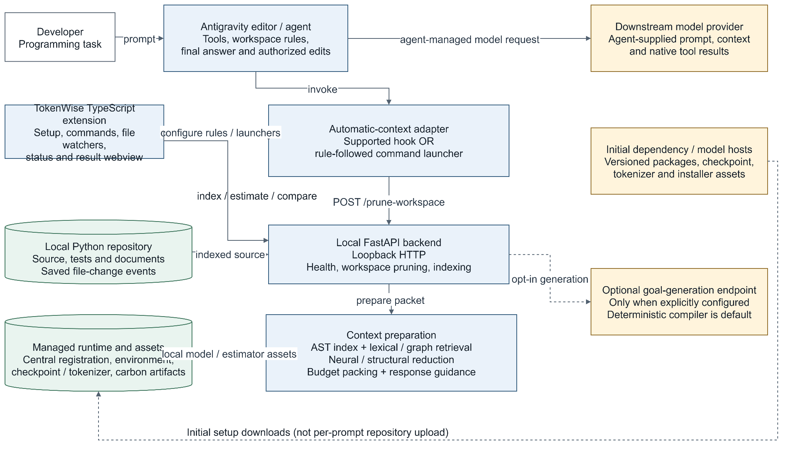
Figure 1. TokenWise runtime architecture and processing boundaries

3.2 Component Responsibilities
Table 6. Major components and responsibilities.
Component | Responsibility | Principal collaborators
Extension activation | Register commands, monitors, index synchronization, and lifecycle services | VS Code APIs and editor services
Backend manager | Find installation, start verified service, check health | Managed registration and setup controller
Automatic workspace setup | Merge configuration, generate owned rule/launchers, register workspace | Cleanup registry, filesystem validation
RepositoryIndexSync | Debounce saved changes and renew watcher leases | /index-workspace, local workspace link
GoalCompiler | Convert query/evidence into structured information need | Task templates, optional generator, scope extraction
RepositoryIndex | AST/source metadata, content hashes, incremental updates | PythonASTIndexer, lexical features
LexicalRetriever | Weighted term and exact-symbol discovery | Cached postings and file features
DependencyGraph/GraphRetriever | Resolve approximate relationships and traverse neighbors | Indexed imports/calls and reverse links
WorkspaceContextBuilder | Combine modes, scope, ranking, caching, guidance, and packing | Goal, graph, model, ContextBuilder
Neural pruner | Score goal-conditioned tokens and select source lines | Pretrained backbone, compression/document heads
ContextBuilder | Allocate source/interface excerpts under final packet budget | Tokenizer, pruning results, metadata
Conversation selection | Select same-chat user intent and constraints | Scoped transcript or labeled fallback input
Response guidance | Insert bounded task-profile instructions | Goal task type and packet tokenizer
Carbon estimator | Resolve scenario features, predict phase energy, convert to carbon | Registry and trained artifacts
ResultPanel | Present outputs, provenance, comparisons, copy/export | Validated extension-side result data
Usage importer | Validate paired reported CLI records | Session/model/status/tool parsing
Cleanup/uninstall | Remove verified owned resources without broad deletion | Paths, hashes, process identities, registry

These responsibilities are implemented across classes and functions. The table does not imply that each conceptual stage is an independent process or a class.

3.3 End-to-End Task Lifecycle
Enabling a workspace creates a small local integration configuration and a link to the registered backend. When a configured trusted folder opens, the extension can warm the repository index in the background. Saving source causes targeted updates rather than an unconditional rescan of all files on each normal watched request.
For a focused question, the backend compiles a goal, retrieves lexical matches, adds exact identifier seeds and structural neighbors, prioritizes the likely anchor and relevant configuration, and applies explicit topic scope. Automatic retrieval uses neural pruning on a bounded subset of candidates and reuses the same result's document score for ranking. Remaining candidates may use compact interfaces, or retain short task-matched source where the policy allows it.
The packer includes task guidance and selected earlier references only when they fit alongside an evidence reserve. It records file relations, tiers, pruning methods, thresholds where meaningful, and source/token metrics. The adapter records activity and returns context. The extension then displays the fresh result and, independently, estimation or comparison enrichment when requested. Each stage can report its own failure rather than fabricating an otherwise successful observation.
Overview questions take a separate path: representative architecture and project documents are more useful than a narrow neural search for words such as "project." That path avoids neural line pruning, selects source/document representations, allocates space across components, and discloses omitted coverage or scaffold-only source.
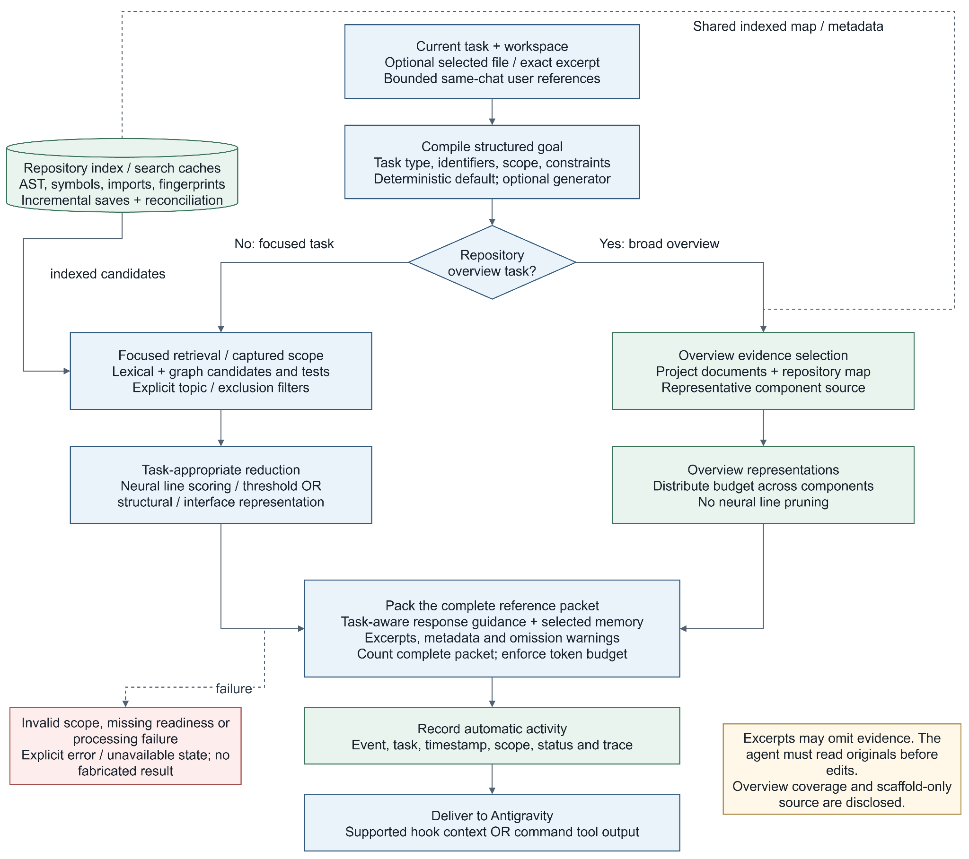
Figure 2. Task-to-context activity flow and the separate overview path

3.4 Structured Goal Compilation
The deterministic compiler recognizes information needs such as fixing, debugging, refactoring, adding features, generating tests, and understanding behavior. It produces a task type, objective, identifiers, observed diagnostics, retrieval questions, required context, exclusions, and ambiguity status as applicable. This gives retrieval and pruning a more explicit focus than passing an isolated filename.
The optional local generator receives a constrained JSON task. Returned identifiers are filtered against words present in the query or available editor evidence. Generation is opt-in; failure falls back to the deterministic path. The default workflow does not require Ollama or another goal-generation model.
Vague requests and unresolved follow-ups can set clarification_required. The packet then advises clarification. This is not a dedicated enforced conversation state machine: the downstream agent must still decide how to respond. Rule-based task classification is also not perfect intent understanding; its behavior depends on wording and supplied evidence.

3.5 Python AST Indexing
The indexer uses Python's standard ast parser rather than executing repository modules. It records functions/classes, line ranges, imports, calls, selected class relationships, and test indicators. Interface construction retains structural declarations, imports and assignments while replacing function bodies with ellipses where appropriate. This avoids repeatedly generating free-form summaries and preserves real signatures/defaults better than an invented explanation.
Source content remains available even when parsing fails; structural metadata can be empty and interface generation limited. The existence of source in the index does not prove successful semantic analysis. Dynamic imports, aliasing, reflection, inherited APIs, and complex cross-file resolution remain limitations of a lightweight static index.
The repository walker excludes known environment, generated, editor, and runtime directories including .git, .venv, node_modules, __pycache__, build, dist, .agents, and .tokenwise. Its eligible repository scope is not a claim to ingest every Git-tracked asset or to implement comprehensive secret detection. Python-only indexing is distinct from bounded root-document loading used by overview mode.

3.6 Incremental Updates and Search Caches
File metadata stores version information and a SHA-256 content digest. An unchanged digest allows AST metadata and derived caches to be reused. Updates commit a new repository fingerprint and serve copy-on-write snapshots so a request can operate against a coherent indexed view. Escaped, excluded, missing, renamed, and directory-subtree paths receive explicit treatment.
The editor batches change bursts with a 150 ms debounce and sends sequenced updates. A 30-second heartbeat renews a backend watcher lease. The backend's 90-second lease prevents a closed editor from indefinitely convincing the backend that filesystem observation remains reliable. Periodic reconciliation approximately every 120 seconds verifies bytes, including changes whose file timestamps were preserved. When no valid watcher exists, retrieval conservatively checks the repository before serving a request.
Freshness is eventual across these boundaries: a just-saved edit becomes available after its update completes, while a missed event can remain unseen until reconciliation. This is not a promise of instantaneous unsaved-buffer visibility. Multiple revisions and sequence checks guard against late updates overwriting newer state.
Prepared lexical postings and dependency graphs are cached by workspace and repository fingerprint. Source metadata carries term counts, interfaces, and token-count caches. These reusable search structures benefit different queries. Complete prepared answers require an exact cache key including query, structured goal, snapshot, active file, thresholds, budget, candidate limit, reference hint, and guidance version/state. Similar-looking prompts are not treated as identical.

3.7 Lexical Retrieval
Search normalizes snake-case and camel-case identifiers, lowercases terms, and applies a small plural normalization. It removes common task words and considers positive query scope. Each file's cached feature combines content frequency, path terms, and symbol terms. A term contributes a capped content count, plus a path weight of five and a symbol weight of three. An inverse-frequency factor reduces the value of common words.
The implemented scoring can be summarized as:
term_weight = ln(1 + number_of_files / (1 + content_document_frequency))
file_term_evidence = 5 * path_match + 3 * symbol_match + min(content_count, 4)
file_score = sum(term_weight * file_term_evidence for matching query terms)
This is a lightweight weighted lexical method, not a claim of full BM25, embedding retrieval, or universal semantic matching. Exact class/function identifiers add seeds separately. The lack of a useful lexical match is reported or handled through fallback anchoring rather than an invented high-confidence match.

3.8 Structural Retrieval and Explicit Topic Scope
The dependency graph stores forward import/call approximations, reverse dependents, and symbol definitions. Two-hop neighbor retrieval can expose an implementation's configuration and callers, including tests that import or exercise it. Reverse links matter because a service typically does not import its own tests.
Automatic retrieval can reserve short configuration dependencies so candidate expansion does not crowd out constants. Positive lexical evidence and neural document scores are combined for ordering. Static graph matches remain heuristics, not a sound whole-program call graph.
Scope processing recognizes explicit exclusions such as "session expiry, not invoice pricing." It can filter unrelated symbols even when they share one file. Shared imports, configuration, or supporting declarations may remain when necessary to interpret the included behavior. An exclusion therefore does not mean deleting every occurrence of an associated word regardless of dependency.

3.9 Neural Pruner and Research Foundation
The supplied SWE-Pruner research describes goal-conditioned code skimming that scores source relevance and returns selected lines. TokenWise integrates that approach through a pretrained runtime associated with a Qwen3-Reranker-0.6B backbone. The approximately 1.35 GB checkpoint is a downloaded third-party asset, not a new language model trained in this application. [R1, R4]
The model uses token-level compression and document-level relevance outputs. Its multi-layer path combines earlier, middle, and later backbone representations before compression processing. The runtime converts token logits to sigmoid probabilities and aggregates relevant code token positions into line scores. At the requested threshold, scored lines are retained, with limited preservation/readability and gap-bridging behavior.
Although the implementation includes CRF-related components, the deployed pruning wrapper's selection is based on probabilities and line thresholds. It should not be described as using Viterbi decoding for every live prune. Likewise, a reported relevance score is not a calibrated probability that an answer is correct.
The working model window is 8,192 tokens including query/instruction overhead. Long source is split into overlapping chunks, processed, and mapped back to original positions. Input is not padded to a full 8k sequence for every small request, avoiding unnecessary CPU work. Nonetheless, long inputs and fusion attention can impose substantial time and memory cost. The failed CPU pilot in Chapter 7 is evidence of this remaining constraint.

3.10 Line Decisions and Semantic Boundaries
A line at or above threshold can be selected; optional first-fragment preservation and one-line gap bridging can change the decision mask. Output formatting can restore tiny gaps when a filtered marker would cost more than the original text. Consequently the decision mask, emitted source, and measured token difference are related but not identical representations.
Filtered-line markers tell the agent that surrounding source was omitted. They are not Python syntax and do not make an excerpt executable. The pruner does not universally preserve imports, decorators, enclosing conditions, exception paths, or invariants. For example, retaining the Session class fields but removing @dataclass loses useful initialization/equality context. An agent must inspect originals before editing or making claims that the excerpt cannot support.
Lower thresholds generally retain more scored material; higher thresholds can remove more evidence. They do not guarantee a target compression ratio or monotonic downstream answer quality. The defaults must be evaluated against real tasks, not justified by a large reduction percentage alone.

3.11 Tiered Packing and Complete-Packet Budget
Tier 1 represents the active or prompt-selected anchor with relatively light pruning. Tier 2 handles direct/high-relevance evidence more aggressively. Tier 3 can use interfaces for distant or unpruned dependencies. The current automatic path bounds neural work to a small subset, reuses prepruned results, and can retain short task-matched source. Manual anchored workflows can use a different ranking/pruning sequence. These are policies, not equal treatment of every file.
The final budget includes all formatting, path headers, fenced blocks, relation labels, safety text, guidance, repository map, and selected references. The packer calculates available space, truncates content when necessary, and recounts the concatenated packet before accepting a block. It stops when the next block cannot fit. Overview mode also reserves a fair share for later components instead of letting a long README consume the entire packet.
The hard bound controls the context supplied by TokenWise. It does not constrain Antigravity's system instructions, extra tool reads, subsequent rounds, or provider-tokenizer accounting. Nor does it guarantee complete evidence: a relevant candidate can be present as an interface while its decisive body is missing. Chapter 7 measures precisely this distinction.

3.12 Token Statistics and Honest Reduction
Source-only counts compare included original content with retained content. Packed counts describe the complete supplied reference. Formatting overhead is reported separately, with care that tokenization across boundaries is not strictly additive. A raw-context baseline can retain matching packet formatting to make a like-for-like comparison.
For a positive baseline B and prepared packet P, the signed difference is:
token_difference = B - P
reduction_percent = 100 * (B - P) / B, for B > 0
A zero baseline makes the percentage undefined and should be N/A. Negative values are genuine increases under the defined comparison, not percentages to clamp into a misleading saving. A separate source-only reduction must not compare 17 source tokens against a 117-token wrapper. If all 17 source tokens remain, source reduction is zero; the additional 100 tokens are overhead. This explains and corrects the earlier misleading -588.24% presentation without asserting that small packets never expand.

3.13 Outgoing Prompt Engineering
TokenWise adds versioned response guidance separate from repository reference data. Common guidance asks the agent to honor the latest request and constraints, cite real files/symbols, inspect originals when evidence is omitted, distinguish facts from assumptions, and avoid claiming unexecuted tests passed. Task profiles specialize this for bug fixes, refactors, features, tests, overviews, and generic explanations.
The guidance follows full, compact, or omitted forms. Its insertion limit is at most 160 tokens or one quarter of the configured packet budget, and it retains an evidence reserve of 96 tokens. It adds no extra LLM inference call. State and template version participate in cache identity.
These are real prompt-engineering mechanisms: task framing, constraint preservation, grounded-answer instructions, explicit uncertainty, and separation of instructions from source data. They are designed to support better answers, but this project has not yet established their downstream improvement through a controlled live guidance-on/off answer-quality study.

3.14 Bounded Conversation Memory
Version 0.6.8 selects relevant earlier user intent instead of using only the latest message. It considers bounded user-turn candidates and recognizes topic continuity, follow-ups, recognized requirements, resets, and supersession through deterministic lexical heuristics. It excludes assistant answers, tool output, and previously injected packets to avoid treating generated claims as new user requirements.
Candidate storage is bounded to 32 turns, each at most 2,000 characters. Up to eight selected earlier turns share at most 4,000 characters. A native transcript reader scans a bounded 16 MiB tail and up to 64 qualifying earlier user turns before normalization. Identity checks require a matching conversation identity or verified chat-scoped path; state from another chat is not automatically carried forward.
Fallback transport accepts separately supplied user references and labels their origin. It is not an invisible unrestricted reader of the native IDE chat. The outgoing quoted reference block is at most 384 tokens or a quarter of the packet, can be compact or omitted, and preserves an evidence reserve. The inspector distinguishes selection from the actual outgoing reference status. The latest activity file remains a latest-result record, not a complete archive of every message. Lexical selection is useful but cannot guarantee perfect meaning recognition or preservation of all historical constraints.

3.15 Persistent Data and Ownership
Table 7. Storage and ownership categories.
Data category | Purpose | Ownership/freshness boundary
Managed private environment | Backend dependencies and interpreter | Installed in user/profile-managed storage, not each repository
Registration and workspace link | Resolve central runtime | Verified paths and schema; repository does not choose arbitrary executable settings
Downloaded checkpoint/tokenizer | Local neural inference | Pinned integrity checks; third-party license applies
Carbon artifacts and registry | Scenario predictions and feature lookup | Versioned local files; not live provider instrumentation
In-memory repository/search caches | AST, features, postings, graph, exact context reuse | Fingerprint and watcher/reconciliation invalidation
.agents owned files | Rule, configuration, hook/launcher integration | Merge rather than erase unrelated customization
.tokenwise/latest.json and related state | Latest activity/provenance and bounded reference state | Snapshot/task/event interpretation required
Evaluation records | Reproducible study cases, pins, results, summaries | Separate from runtime state and from physical energy logs

The normal TokenWise architecture does not require PostgreSQL or another relational service. Its data design concerns repository snapshots, derived caches, registration links and file ownership rather than a relational database schema.
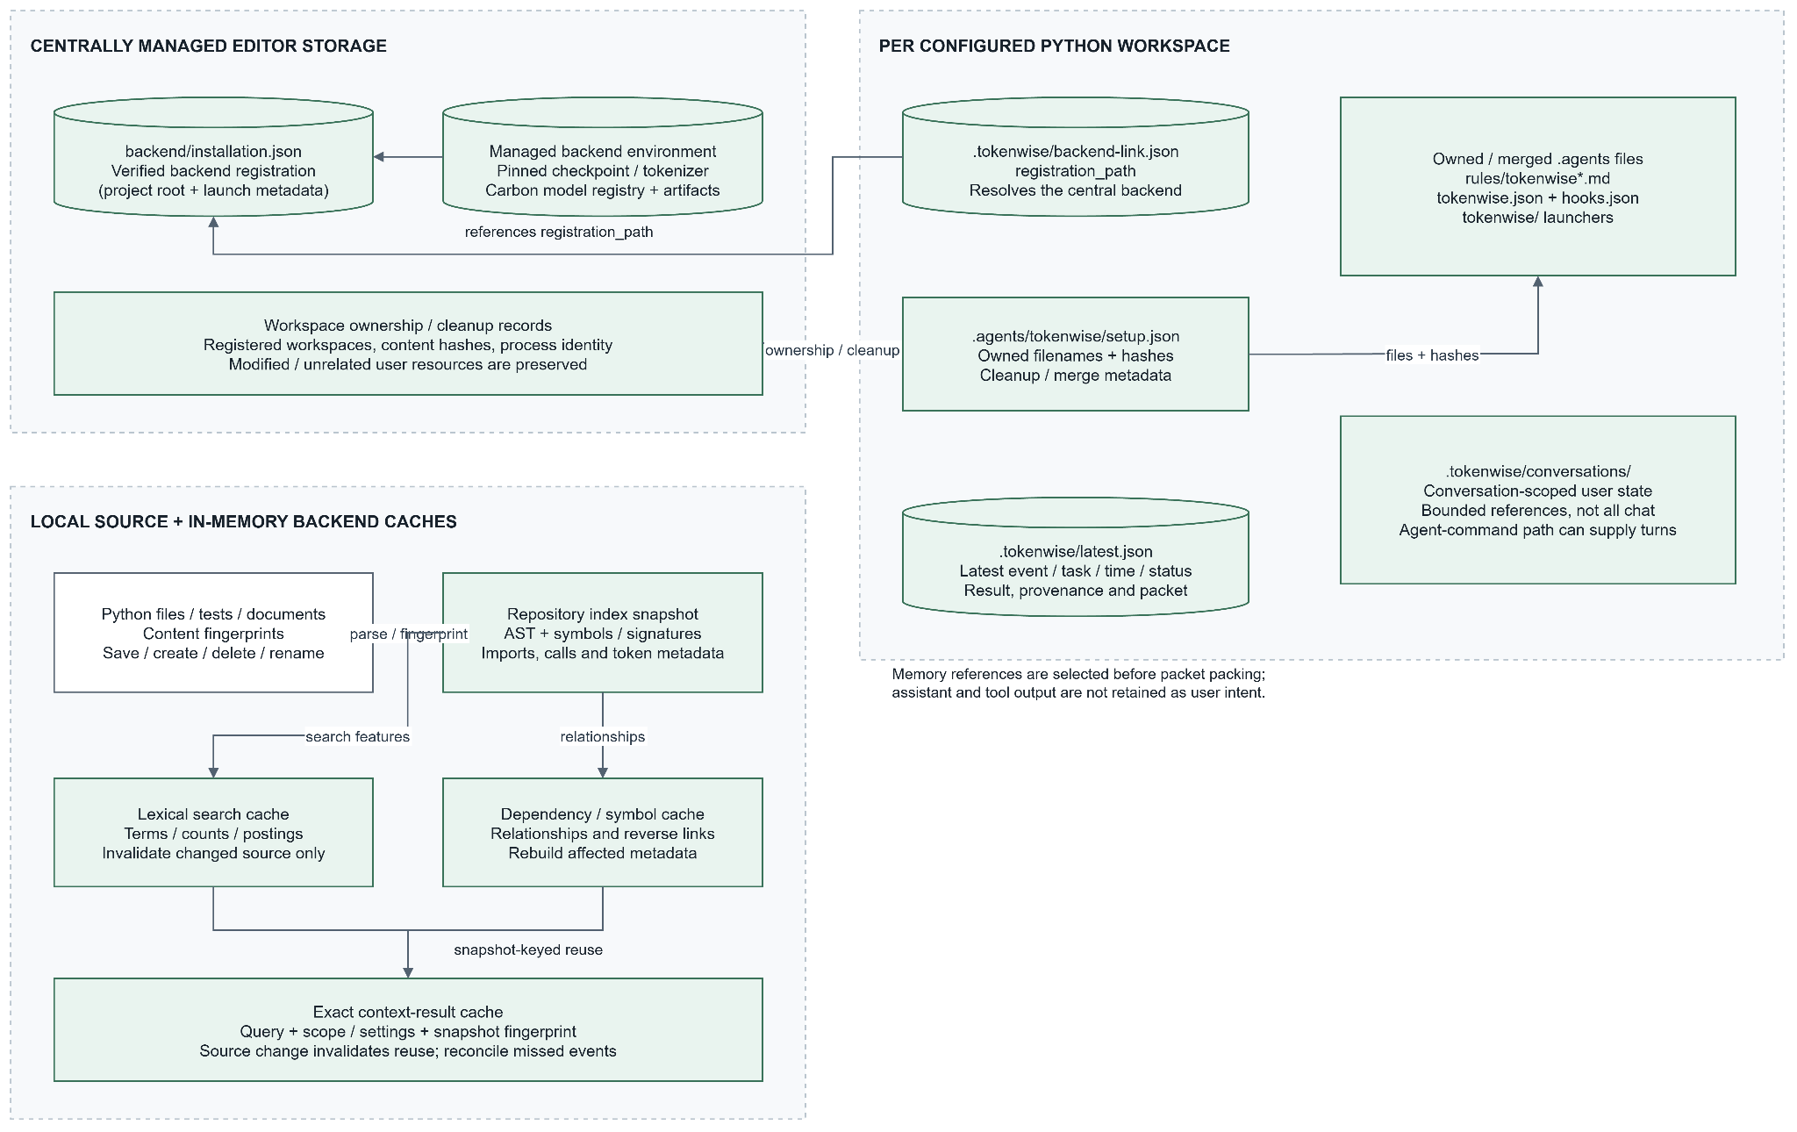
Figure 3. Repository metadata, cache, and owned-file relationships

3.16 Backend Contracts and Concurrency
Table 8. Backend API contracts.
Operation | Purpose | Important boundary
GET /health | Report service/model/estimator readiness | Availability is not pruning accuracy
POST /index-workspace | Start/update/reconcile/stop sequenced watcher state | Valid local paths, bounded update lists
POST /prune | Direct task-conditioned text pruning | Threshold and input scope explicitly supplied
POST /prune-workspace | Goal/retrieval/packing for a repository | Valid workspace and total packet budget
POST /compare-workspace | Build explicit comparison strategies | Selected-source validation and export guardrails
POST /compare-prepared-workspace | Compare an already prepared packet without another prune | Reconciled snapshot must match; stale comparison rejected
POST /estimate-carbon | Estimate prefill/decode energy and emissions | Requires valid token counts and scenario features

Pydantic models validate request types and ranges. Missing neural readiness can produce a 503; invalid workspace/input can produce a client error. Oversized comparisons use 413 and stale/inconsistent prepared comparisons can use 409. These are explicit failure states rather than valid zero-valued results.
Neural requests share an inference lock to avoid uncontrolled CPU oversubscription. Default CPU parallelism is four threads, bounded by configured limits. Serialization protects resource use but can queue requests; concurrent users or workspaces do not gain unlimited independent model throughput.
Table 9. Important defaults and limits.
Setting | Current scope/value
Extension version | 0.6.8
Manual repository-context budget | 8,192 tokens by default
Newly generated automatic workspace budget | 4,096 tokens
Automatic workspace candidate default | Six
Backend request candidate range | One through 32; default eight
Repository budget range | 256 through 32,768
Default extension threshold | 0.45
Prepared retrieval cache | Up to eight workspace entries
Complete workspace-context cache | Up to sixteen exact entries
All-code comparison export guard | At most 200 Python files and 2 MiB source
Default estimator model | meta-llama-3-8b-instruct
Default expected output | 256 tokens
Default carbon intensity | 475 gCO2/kWh

Defaults differ by workflow and existing user settings are preserved. A study using eight candidates is not the same configuration as a fresh automatic workspace using six.

3.17 Carbon Data Preparation and Training
The estimation workflow follows the SEAL idea of combining benchmark-derived performance attributes with model-quality attributes and training separate phase models. The local pipeline acquires/normalizes performance and quality tables, matches model/precision identity, handles GPU categories, constructs features, splits by configured size range, cross-validates, fits, and saves artifacts. [R2]
Recorded local preparation contains 1,612 normalized quality rows and 12,822 normalized performance rows. Merge statistics record 3,407 matched rows and 101 final deduplicated rows. These numbers differ from the paper's corpus and must not be described as an exact replication. Performance inputs include multiple configurations, so careful identity/deduplication matters.
Eight numerical/encoded feature columns are input tokens, output tokens, model size, per-input-token latency, per-output-token latency, GPU category, MMLU-Pro, and BBH. Quality scores are explanatory features associated with models, not the quality score of the current user prompt. GPU encoding is a local categorical representation, not a physical law of energy consumption.
Measured energy fields are converted to joules where present. The fetch pipeline can synthesize missing phase energy from GPU TDP and latency assumptions. Those targets are proxies, not independently measured ground truth. Their presence limits the strength of later accuracy claims and can create dependence between latency predictors and constructed targets.
Four artifacts are trained: prefill/decode XGBoost interpolation models and prefill/decode Ridge extrapolation models. The local configured interpolation range is 7 through 111 billion parameters. Training uses five shuffled KFold splits with seed 42, not the paper's ten-fold evaluation. XGBoost uses 100 estimators, depth three, and learning rate 0.3; Ridge uses alpha 1.0.
Table 10. Recorded carbon-model cross-validation metrics.
Artifact | MAPE | MAE, J | RMSE, J | R-squared
XGBoost prefill interpolation | 13.83% | 16.846 | 32.349 | 0.879
XGBoost decode interpolation | 22.41% | 409.597 | 1,008.756 | 0.246
Ridge prefill extrapolation | 22.08% | 2.776 | 4.251 | 0.993
Ridge decode extrapolation | 46.59% | 109.631 | 149.419 | 0.901

These are recorded local artifact metrics, not measurements rerun for this report. Weak decode interpolation fit and high decode extrapolation percentage error constrain confidence. High R-squared alone does not establish small relative error or reliable behavior outside the observed data. Random-row validation is also weaker than a fully independent model/hardware holdout.
A separate saved two-sample external-reference check reports approximately 365.72 J against 349.96 J for one sample, and 419.12 J against 602.27 J for the other, averaging 17.46% relative error. This is a small published-reference comparison, not a local power-meter experiment or broad external validation. The artifact files are linked in References.

3.18 Runtime Energy and Carbon Calculation
Runtime feature lookup uses a model registry and explicit request overrides. The estimator identifies the feature source and interpolation/extrapolation route. Missing or incompatible artifacts lead to unavailable/error reporting, not silently successful carbon measurement.
The local artifact convention predicts a reference workload of 256 input and 128 output tokens. Phase predictions are then scaled once to the request's actual token counts, avoiding using the actual count both as a feature and as a second multiplier:
prefill_J = max(0, reference_prefill_J) * actual_input_tokens / 256
decode_J = max(0, reference_decode_J) * expected_output_tokens / 128
total_J = prefill_J + decode_J
CO2_g = total_J / 3,600,000 * intensity_g_per_kWh
estimated_difference_g = before_CO2_g - after_CO2_g
This linear phase-scaling convention is an explicit approximation. It does not model all batching, caching, queueing, quantization, network, or datacenter effects. When expected output length remains fixed, decode estimates remain fixed while input reduction changes prefill. Input-token reduction therefore need not equal total energy or carbon reduction.
The estimates omit TokenWise's own inference/index/setup energy, downloaded model training, idle backend use, embodied hardware, and unknown future agent rounds. An avoided-input scenario is not proven net environmental benefit. The configured target model is not automatically Antigravity's actual model.

3.19 Integration, Trust, and Cleanup
Native-hook support can inject context where the editor exposes a compatible invocation event. Stable fallback behavior uses an always-on workspace rule that asks the agent to run a local launcher and read its output. The fallback depends on the agent following the rule and having permission; it is not universal interception before the first model call. Neither mode claims to replace every subsequent native file read.
Repository excerpts are labeled reference data rather than instructions. The backend installation is centrally registered rather than blindly chosen by arbitrary repository settings. Workspace setup rejects unsafe escaped/link targets and preserves unrelated customizations. These are practical safety controls, not a formal guarantee against prompt injection or malicious local processes. The loopback service is not an authenticated public internet API.
Cleanup uses recorded ownership, content hashes, path constraints, and verified process identity. PID reuse and junctions make broad deletion or stopping every process with a saved PID unsafe. Customized owned files, unverifiable processes, and user-owned checkout backends can be preserved with warnings. The project must not promise that uninstall deletes every file containing the word TokenWise, including user data and shared caches.
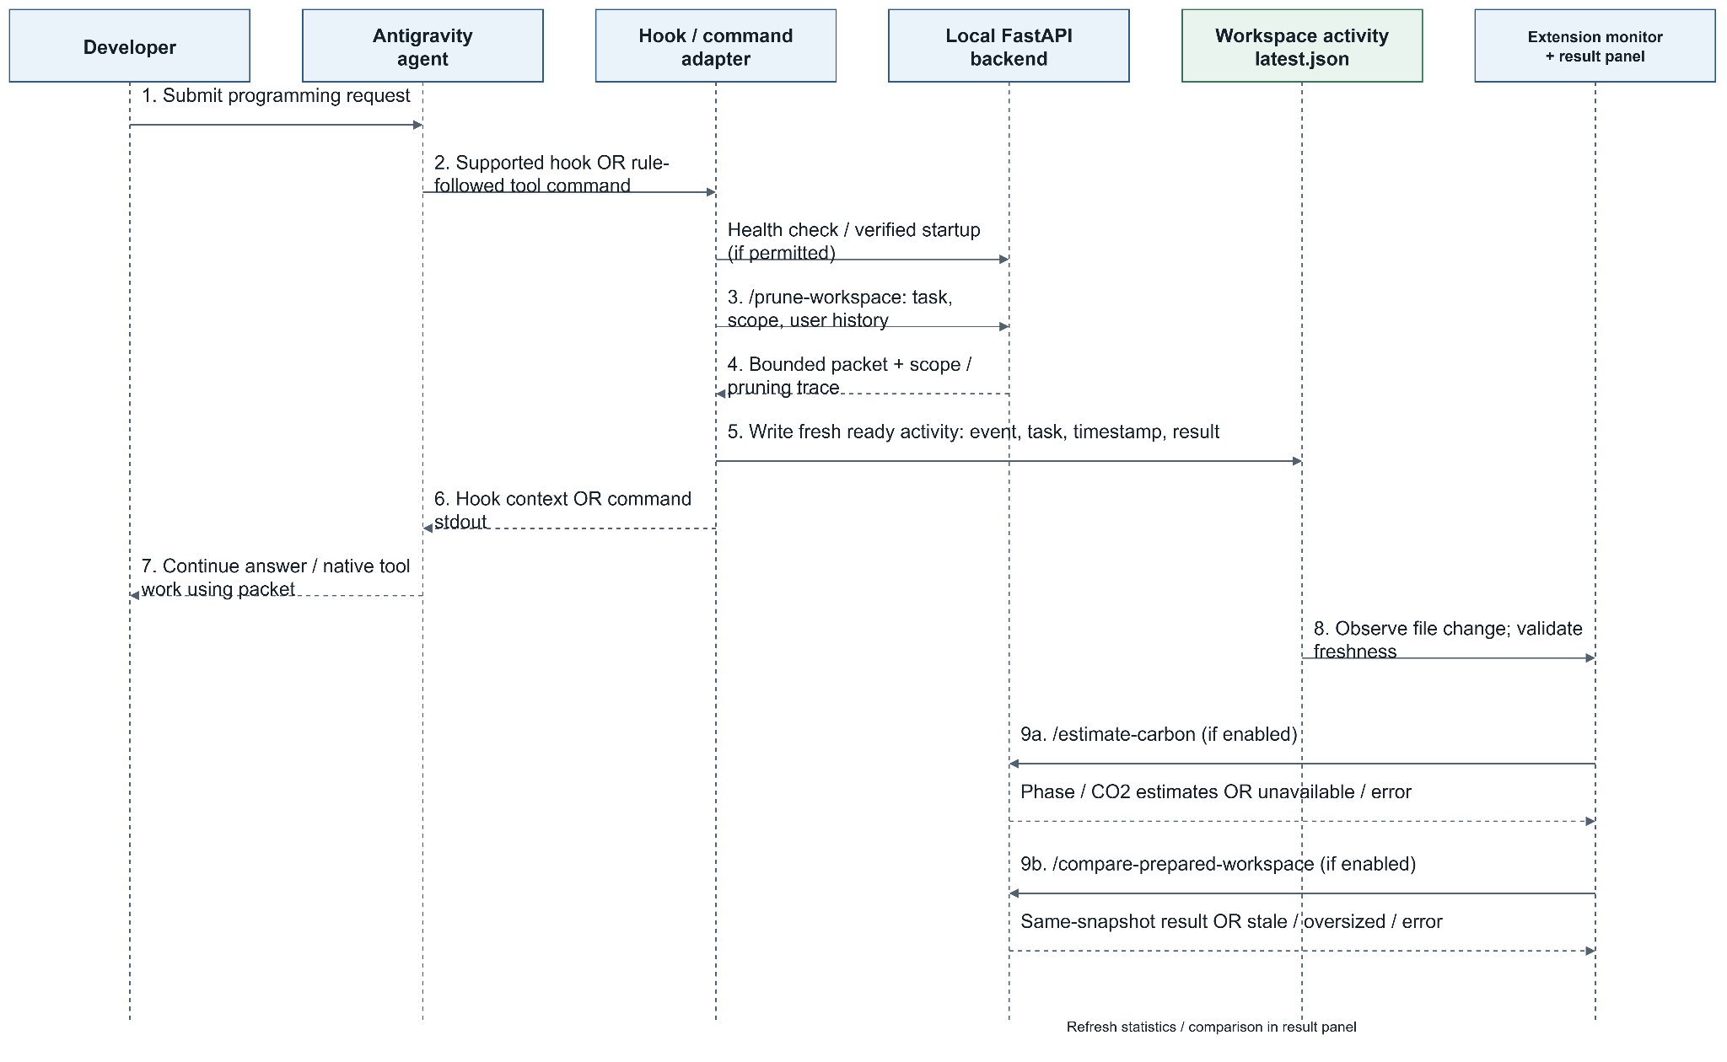
Figure 4. Automatic prompt retrieval and asynchronous result enrichment

4. Interface Design

4.1 Users, Navigation, and Interaction Model
TokenWise uses the editor's command palette, status bar, output channels, and result webview. It does not require a separate website or a sequence of forms before each task. Automatic results can open beside the editor without taking keyboard focus, keeping the prompt workflow central while making the context visible.
The status bar offers a compact indication of current automatic activity. Detailed panels expose selected files and excerpts. Diagnostics and setup channels serve recovery. Commands that build context manually coexist with automatic integration so a teacher can inspect the exact input scope and selection process.

4.2 Interface Objects and Actions
Table 11. Interface objects and user actions.
Object/control | Action | Observable result
Install from VSIX | Install downloaded package | TokenWise listed with version/icon
Set Up Backend | Start or update managed installation | Numbered stages, progress, logs, retry
Enable Automatic Context | Configure selected workspace | Owned rule/launchers and central link
Automatic status | Inspect prepared activity | Current versus last/test result labeling
Repository Context | Read included files and unified context | Relations, tiers, token metrics, warnings
Prune Current File / Selected Code | Supply task for explicit source | Original/pruned content and source trace
Line decisions | Inspect selected mask and mean relevance | Source-line relevance and preservation detail
Conversation memory | Expand selected references | Turn selection, origin, omissions, outgoing status
Carbon result | Inspect scenario | Phase joules, before/after CO2, assumptions
Configure Automatic Comparison | Enable/disable/retry local comparison | All-Python and exact prepared packet comparison
Compare Context Strategies | Compare selected/all/automatic inputs | Labeled packet strategy results and export
Import Antigravity Usage Comparison | Select real independent CLI logs | Reported counters/answers/tools or validation error
Copy/Export | Transfer displayed context or evidence | Clipboard or downloadable JSON/message feedback
Diagnose Setup / guides | Inspect readiness/instructions | Relevant error, environment, next action

4.3 States, Freshness, and Failure Feedback
Table 12. Operational states and recovery.
State | Meaning | User response
Awaiting prompt | Configured but no current automatic result | Submit an ordinary question in a new chat
Setup in progress | Backend dependencies/assets being prepared | Wait or inspect the current numbered step
Setup failure | Identified stage did not complete | Correct cause and retry that step
Ready context | Current task produced a packet | Inspect actual chat delivery and source evidence
Last result | Saved historical activity | Do not treat it as a fresh response
Verification/test result | Controlled validation activity | Do not relabel it as a live agent run
Carbon pending/disabled/unavailable | Separate estimation state | Context can remain useful; inspect estimation settings/errors
Comparison pending | Background measurement not finished | Keep the fresh prepared result and await enrichment
Comparison stale/unavailable | Snapshot changed or size/service guard failed | Submit a new prompt or retry after correction

The interface keeps successful retrieval separate from optional measurement availability. Missing data are not displayed as measured zero. A view is interpreted using its task, timestamp, event, and snapshot, not merely because it is the most recently open tab.

5. Testing

5.1 Testing Strategy
Testing addresses extension contracts, backend processing, demonstration correctness, and result-panel rendering. The purpose is to verify observable behavior at each boundary: installation recovery, safe workspace setup, source scope, memory isolation, cache invalidation, packet limits, estimation states, comparison identity, export behavior, and conservative cleanup.
The recorded tests use controlled doubles where deterministic behavior is necessary. A mocked model permits precise assertions about packing and errors; a real tokenizer permits precise local token-budget assertions. Neither alone establishes learned relevance accuracy. The comparative study separately invokes the real neural checkpoint on bounded excerpts.
The result summaries below are the saved verification basis from 9 October 2026. They are not described as a fresh complete test execution performed while writing this report. Their detailed record is tests.md. [R5]

5.2 Pass/Fail Criteria
An executed assertion is a pass only when its runner reports success. A designed case, inspected code, or intended screenshot is not a passed test. A skipped case remains skipped. Expected negative-test error logs are not failures when the assertion explicitly verifies rejection or unavailable-state behavior.
Packet correctness requires validating the complete token count and the stated baseline; source selection requires validating actual input scope and source identity. Memory correctness requires preventing cross-chat contamination and respecting limits and current instructions. Setup and cleanup correctness requires preserving unrelated files and rejecting unsafe targets. Estimation correctness requires accurate unit conversion and assumption provenance, not agreement with a physical meter that was never attached.

5.3 Recorded Results
Table 13. Recorded software verification results.
Group | Discovered/exercised | Passed | Failed | Skipped
Extension automated suite | 193 | 193 | 0 | 0
Backend automated suite | 142 | 141 | 0 | 1
Teaching application tests | 20 | 20 | 0 | 0
Three-suite total | 355 | 354 | 0 | 1
Separate browser fixture views | 10 | 10 | 0 | 0
Separate study-harness checks | 10 | 10 | 0 | 0

The ten browser views are presentation scenarios, not ten additional backend unit tests. The ten study-harness checks verify research instrumentation and remain outside the 193/141/20 implementation counts. The deterministic demo entry point also completed successfully, but is not another unittest case.
The recorded environment used Node.js 22.12.0 and Python 3.12.4 on Windows 11. No line/branch coverage percentage, mutation score, universal correctness rate, or 354-session live agent evaluation is supported by these totals.
ADD SCREENSHOT - Figure 5: Capture genuine dated extension/backend runner summaries showing the commands, passed/discovered/skipped totals and any failures. Keep the historical table aligned with its recorded date; update it only if new runs are performed. Caption: Recorded extension and backend software verification.

5.4 Representative Test Cases and Traceability
Table 14. Representative validation cases.
Case | Requirement | Input/procedure | Expected behavior | Recorded evidence and scope
TC01 | TW-FR-01/02 | Simulate valid/failed setup stages and rerun installer | Checkpoints verified, retry/resume bounded, corrupt assets rejected | Extension setup suites and backend test_installer.py; controlled paths
TC02 | TW-FR-03/04 | Enable a local workspace with existing rules/hooks | Owned integration added; unrelated customization preserved | automaticSetup.test.cjs, enableAutomaticContext.test.cjs; mocked editor
TC03 | TW-FR-05 | Save/create/delete/rename source and reconcile | Changed metadata replaces prior snapshot; late sequences do not regress state | repositoryIndexSync.test.cjs, test_repository_cache.py
TC04 | TW-FR-06 | Supply vague, explicit, overview and excluded-topic tasks | Correct recorded goal/scope, ambiguity remains visible | Overview/query-focus/backend contracts
TC05 | TW-FR-09 | Capture a file and then an exact highlighted excerpt | Captured scope and first source line differ correctly | pruningInputs.test.cjs, test_demonstration.py
TC06 | TW-FR-10/11 | Prepare scaffold and multi-component overview under budget | Coverage/scaffold warnings and bounded complete packet | test_overview.py; controlled repository fixtures
TC07 | TW-FR-12 | Toggle guidance and vary available budget | Full/compact/disabled/omitted trace and correct token accounting | responseGuidance.test.cjs, test_response_guidance.py
TC08 | TW-FR-13 | Follow-up, superseded requirement, new chat, bounded transcript | Relevant user references only, correct provenance and limits | test_conversation_memory.py, automatic-result tests
TC09 | TW-FR-16 | Before/after estimate including zero/invalid overrides | Valid assumptions preserved; failure displayed unavailable | carbonComparison.test.cjs and client verification
TC10 | TW-FR-17 | Compare saved and changed snapshots | Valid same-snapshot comparison or explicit stale rejection | compareContextStrategies.test.cjs, preparedComparisonApi.test.cjs
TC11 | TW-FR-18 | Pair valid/failed/resumed/identical-session usage logs | Only admissible independent reported runs accepted | antigravityUsage.test.cjs, importAntigravityComparison.test.cjs
TC12 | TW-FR-19 | Test owned/custom files, junctions and reused/foreign PIDs | Unsafe/unknown resources retained; unrelated resources preserved | Uninstall/ownership suites; simulated lifecycle operations

These case descriptions summarize exercised suites rather than inventing new per-case executions. Precise assertion names and fixture inputs remain in the linked test directories. Passing controlled conditions does not imply every native editor or installation environment has been tested.

5.5 Skipped Platform Case
The skipped backend case is test_repository_cache.RepositoryCacheTests.test_retargeted_symlink_removes_previous_cached_content. Its recorded reason is: This Windows account cannot create file symlinks. The intended case creates a symlink, changes its target, and verifies invalidation of previous cached content. It did not pass under this account and must not be counted as successful retargeted-symlink validation. An environment with file symlink permission is needed to complete this check.

5.6 Teaching Application Verification
The single teaching repository contains eleven Python files, including the package initializer, and twenty unittest cases: five authentication, ten workflow, two model, and three reporting tests. It has no required third-party application dependency. The parent runner also invokes the deterministic application entry point.
Authentication tests establish three failures, the 60-second deadline, rejection before expiry, acceptance/reset at expiry, successful reset before lockout, and a fresh count after expiry. Workflow tests establish session expiry/revocation and invoice/shipping boundaries. These facts form source-grounded demonstration criteria; they do not prove Antigravity answers correctly with TokenWise.
The digest helper is explicitly teaching-only unsalted SHA-256. In-memory dataclasses and integer clocks make controlled evaluation easy, but the fixture is not production authentication or billing software.
ADD SCREENSHOT - Figure 6: In the demo folder, capture real unittest discovery output and app.py execution with folder/commands visible. Caption: Demonstration application verification. Do not infer live Antigravity quality from these deterministic tests.

5.7 Browser Fixture Verification
The compiled result renderer was checked in Playwright/Chromium at 1280x1000 and 390x844 using synthetic data and a mocked webview host.
Table 15. Browser fixture states.
State | Desktop | Narrow | Interpretation
Conversation memory | Passed | Passed | Rendering selected-reference details
Automatic packet comparison | Passed | Passed | Two-packet metrics and actions
Comparison pending | Passed | Passed | Loading presentation
Comparison unavailable | Passed | Passed | Visible measurement failure
Imported CLI usage | Passed | Passed | Rendering controlled imported counters

Recorded checks show no page errors, no document-level horizontal overflow, no overflowing statistic elements, and no overlapping statistics in those ten views. Copy/export message assertions passed. The retained record is browser-checks.json. These are not screenshots of ten native live Antigravity chats.

5.8 Reproduction
From vscode-extension, with development dependencies installed:
npm test
Its pretest compiles TypeScript and then runs Node's test runner. From the checkout root, using the configured development Python environment:
.\.venv\Scripts\python.exe -m unittest discover -s swe-pruner/swe-pruner/tests -v
.\.venv\Scripts\python.exe demonstration/run_checks.py
.\.venv\Scripts\python.exe evaluation/comparative-study/test_protocol.py -v
Each line is a separate invocation. The .venv path is a developer-checkout prerequisite, not a path available to every installed-extension user. Browser verification additionally requires an installed Playwright module and Chromium. Its script is verify-comparison-panels.cjs; use the documented local module/browser paths from tests.md or substitute an actual installation. Ignored temporary paths are not bundled prerequisites guaranteed on a friend's machine.

5.9 Defects, Risks, and Test Limits
Known contracts and failure handling are extensively exercised, but model relevance, live integration, installed-platform compatibility, and physical energy accuracy are separate concerns. Mocks cannot establish cloud quota, native hook availability, every process lifecycle, or all adversarial source behavior. The symlink skip and untested native macOS/Linux workflow remain gaps.
Research failures are not suppressed because software tests pass. Three neural implementation anchors were lost, packed retrieval-only evidence was sparse, and the full-file CPU pilot failed to finish. These observations inform future engineering priorities in Chapter 8.

6. User Manual

6.1 Prerequisites and Installation Files
The normal user installs TokenWise as a VSIX extension in Antigravity. The procedure does not require cloning the source repository, compiling TypeScript, pressing F5, or starting a development server. This manual describes version 0.6.8 and the single demonstration/tokenwise_demo application. An arbitrary trusted local Python repository can be used instead.
Figure 7 summarizes the prerequisites: Antigravity with workspace rules and a command tool; 64-bit Python 3.12; a local Python folder; initial dependency/model download access; approximately 10 GB free disk; and adequate memory. Eight GB RAM is a starting recommendation, not a guarantee for long inputs. CPU operation is supported; a GPU, Ollama and an MCP server are not required. Antigravity access and billing are separate from TokenWise, which needs no API key of its own. Windows is the verified native platform; portable launchers do not establish completed macOS/Linux testing.
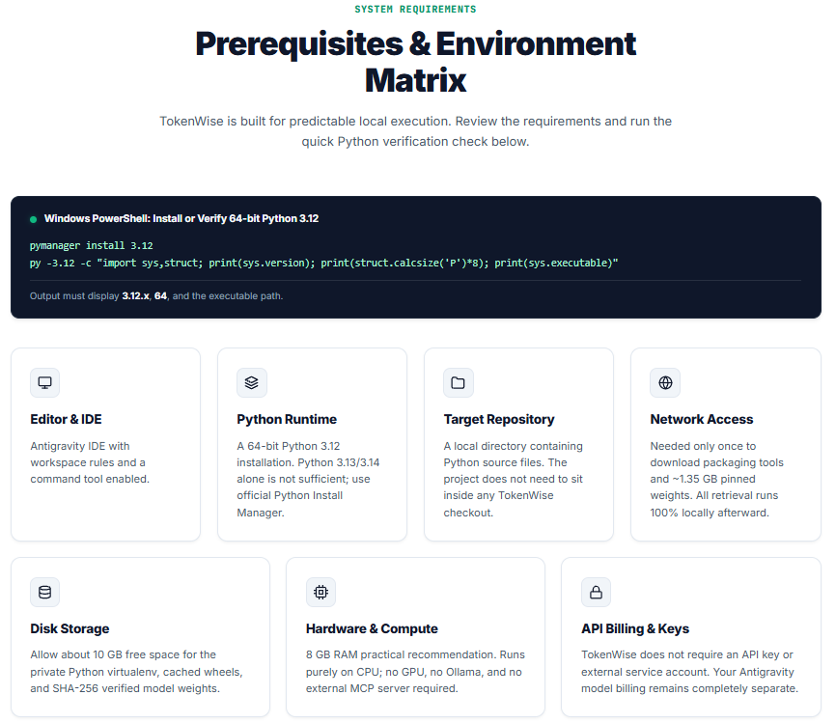
Figure 7. TokenWise prerequisite and environment information on the distribution website.
The website's statement that retrieval runs locally refers to TokenWise indexing and pruning. Once context is supplied to Antigravity, the configured downstream model may process it externally. The prerequisite illustration is guidance, not evidence that installation or inference completed.

6.2 Download, Install and Upgrade
1. Open https://tokenwise-extension.vercel.app/ and select Download for Antigravity (.vsix). Alternatively, use the versioned v0.6.8 GitHub release linked in the project README. The demonstration ZIP contains presentation materials; GitHub's source-code ZIP is not the extension installer.
2. In Antigravity, open Extensions, select the three-dot menu and choose Install from VSIX. Select tokenwise-vscode-0.6.8.vsix and reload the window when requested.
3. Open the command palette with Ctrl+Shift+P and run TokenWise: Set Up Backend. When updating, update the backend as well as the VSIX so that the service supports the same features.
4. Open the intended Python folder, run TokenWise: Enable Automatic Context and start a new chat after configuration. Re-enable after an upgrade to refresh owned rules and launchers.
Figure 8 shows the distribution page with separate VSIX, demonstration-bundle and repository buttons. Its four installation panels correspond to downloading the package, opening Extensions, installing from VSIX and reloading the editor. The web page distributes the extension; it is not the runtime repository-pruning service.
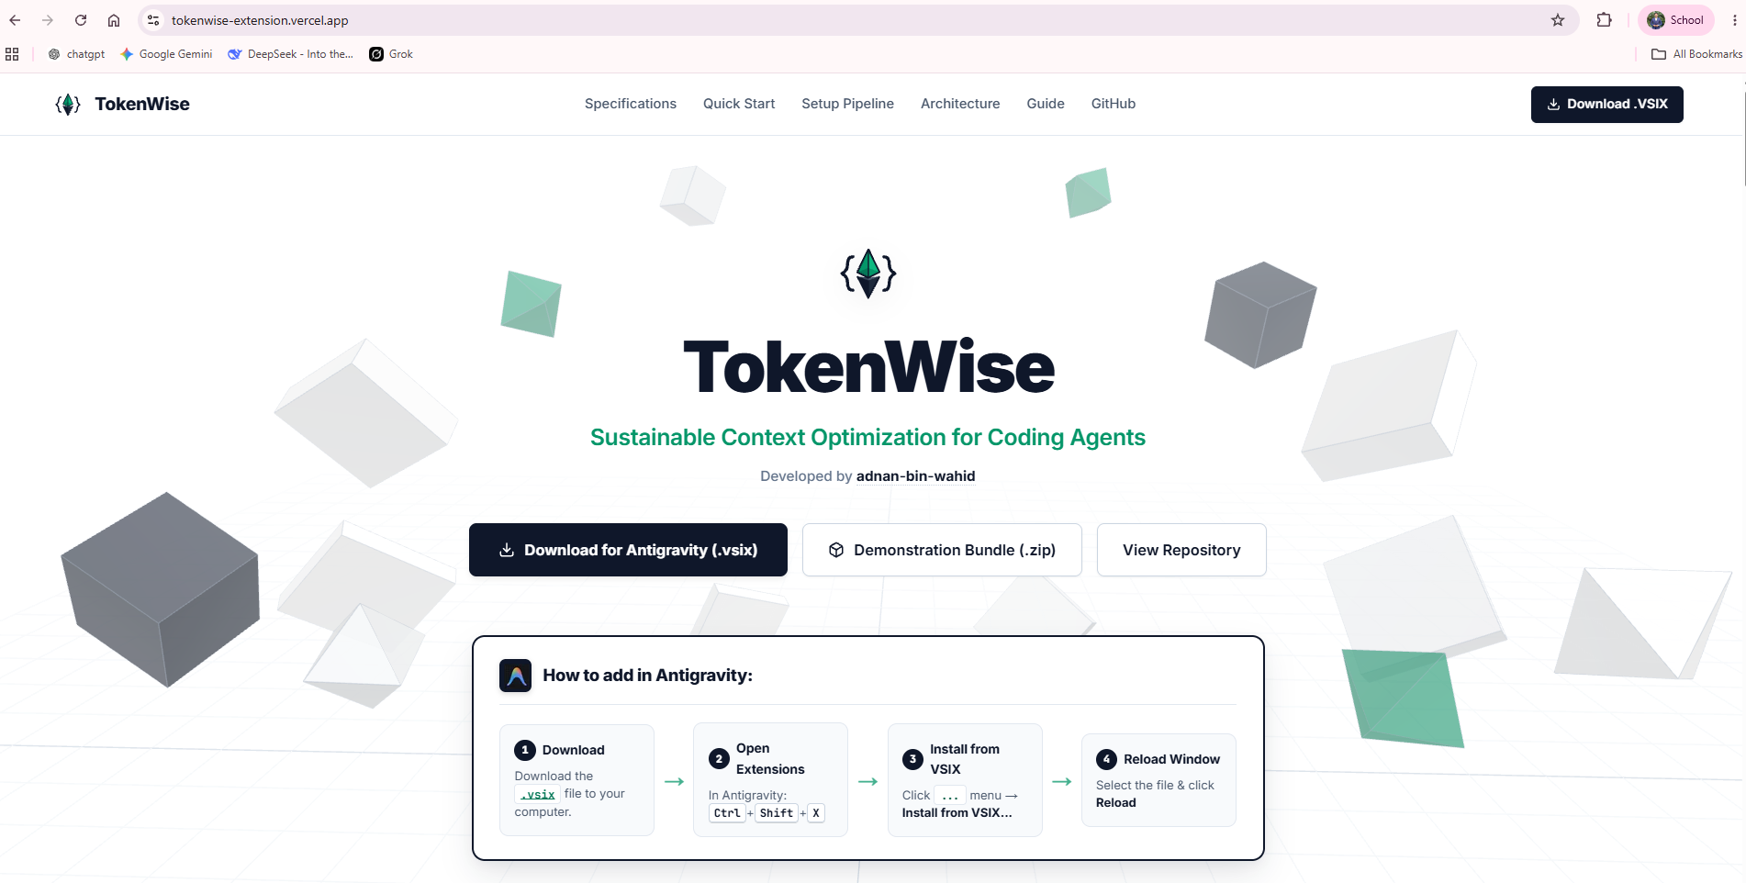
Figure 8. TokenWise download page and the four-step VSIX installation guide.

6.3 Managed Backend Setup and Recovery
On a new computer, choose Install Managed Backend, review the confirmation and allow setup to finish. The installer prepares a private environment and integrity-checked runtime shared by configured workspaces. If a complete development backend already exists, Use Existing Backend is an alternative: select its root, not the target application or the inner swe-pruner folder.
Figure 9 explains the seven stages. It is a website illustration of the process, not a successful installation log. Stage 7 registers the validated backend; workspace rules and launchers are then configured by Enable Automatic Context. These are related operations rather than evidence that every workspace is automatically configured by backend registration.
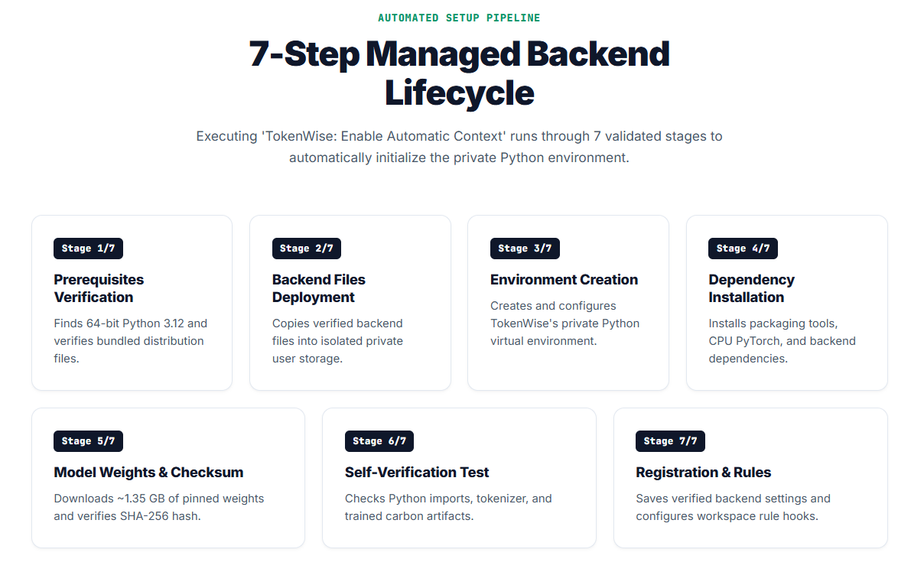
Figure 9. Illustration of the seven managed backend installation stages.
Table 16. Installation stages and retry actions.
Stage | Operation | If the stage fails
1. Prerequisites | Find 64-bit Python 3.12 and verify bundled files | Install or repair Python 3.12; restart Antigravity; set TokenWise Python Path if detection fails.
2. Backend files | Copy verified runtime into private storage | Check free space and write permissions; retry the failed step.
3. Environment | Create or verify the private Python environment | Correct the interpreter/environment error; retain validated model caches.
4. Dependencies | Install packaging tools, CPU PyTorch and backend dependencies | Correct network/proxy/package-host access; retry and reuse validated substeps.
5. Model | Download approximately 1.35 GB of pinned weights and verify SHA-256 | Check model-host access and storage; allow supported resumption and checksum verification.
6. Verification | Check imports, tokenizer and carbon-estimation artifacts | Read the exact import/artifact error in TokenWise Setup and fix its cause.
7. Registration | Save the verified installation and its user setting | Correct storage/settings permissions and retry without deleting verified weights.
Choose View > Output > TokenWise Setup for the detailed error. Use Retry Failed Step if offered. If the notification was dismissed or setup was cancelled, run Set Up Backend again in the same editor profile. Do not uninstall or erase caches as the first recovery action. Setup completion time depends on the network and hardware and is not an end-to-end response benchmark.
Figure 10 is an actual editor notification at Step 3/7: Creating a private Python environment. The Source label identifies TokenWise and Cancel stops the current setup. It shows progress at that stage, not completion of all seven stages.
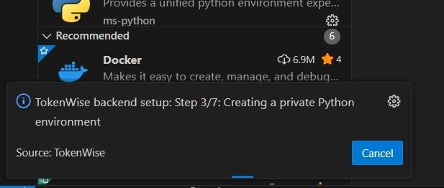
Figure 10. Backend setup notification during private environment creation, Step 3/7.

6.4 Verify Installation and Enable the Workspace
1. Use File > Open Folder to open demonstration/tokenwise_demo, or the root of another local Python application. Trust only a repository whose contents you trust.
2. Run TokenWise: Enable Automatic Context and confirm the selected workspace. In a multi-folder window, enable each required repository separately.
3. Open Agent Settings > Customizations > Rules and verify the TokenWise rule. Existing unrelated rules and hooks should remain unchanged.
4. Run TokenWise: Diagnose Setup and resolve any reported error. Check Backend Health or Start Backend can be used for explicit inspection; normal retrieval starts the registered backend when needed.
Setup adds owned integration files under .agents and a backend link/activity directory under .tokenwise. It does not require the application to be inside a TokenWise checkout. Unrelated customization is preserved; malformed JSON and customized owned launchers are not silently replaced.
Figure 11 shows TokenWise in the Extensions view with its icon, publisher adnan-bin-wahid, description and Disable/Uninstall controls. Those controls indicate that the extension is installed. The details describe conversation-memory behavior for 0.6.8. The image does not itself prove backend readiness or a public marketplace listing; installing a VSIX also creates an installed entry.
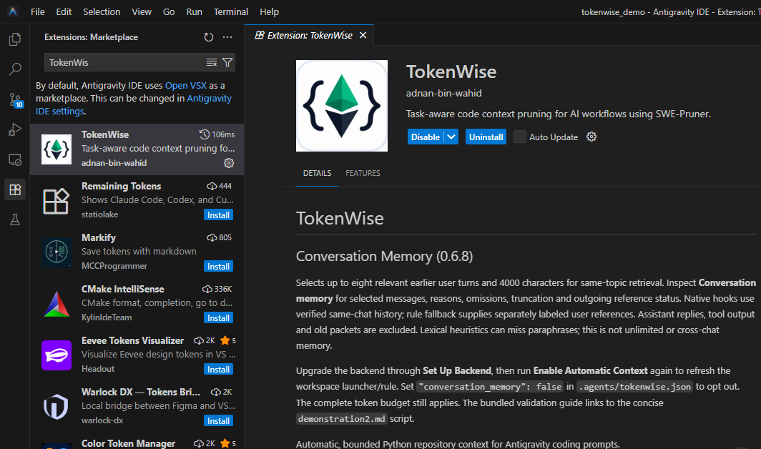
Figure 11. Installed TokenWise extension and its available lifecycle controls.

6.5 Ask an Ordinary Antigravity Question
1. Start a fresh Antigravity chat. Close unnecessary source editors, clear highlighted code and attach no files when demonstrating automatic discovery.
2. Send the following read-only question. The same exact wording is used for the comparison in Chapter 7.
Explain account lockout after failed login attempts and its related tests. Do not modify any files. Cite relevant files and test names.
3. Allow the local TokenWise launcher if the editor asks for permission. Wait for its completed context output; do not interpret a waiting timer as successful retrieval.
4. Inspect the final answer and run TokenWise: Show Automatic Context. Match the current prompt, event/timestamp and included excerpts. A status-bar entry or old latest.json alone is not proof of delivery for this request.
Figure 12 records a different illustrative prompt, Explain me the project. The agent waits for TokenWise and then reports context from app.py, reports.py, security/auth_service.py, security/models.py, security/settings.py and workflows.py before displaying a project summary. This shows the agent's visible invocation/acknowledgement in that conversation. Its waiting messages and Worked durations must not be treated as the total time of a controlled comparison. They also do not reveal billed tokens or all internal file reads.
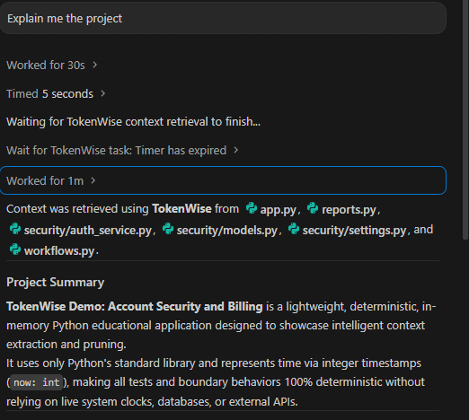
Figure 12. Recorded Antigravity project-overview conversation with TokenWise retrieval acknowledgement.
Automatic context is the normal prompt workflow. The teaching commands below prepare inspectable outputs independently; running them does not by itself inject their output into an Antigravity conversation.

6.6 Discover the Extension Commands
Press Ctrl+Shift+P and type TokenWise. Figure 13 shows the command palette with setup, automatic context, pruning, comparison and guide commands. The highlighted Demonstrate Pruning Inputs command is for inspecting the three input modes; it is not required before every chat prompt.
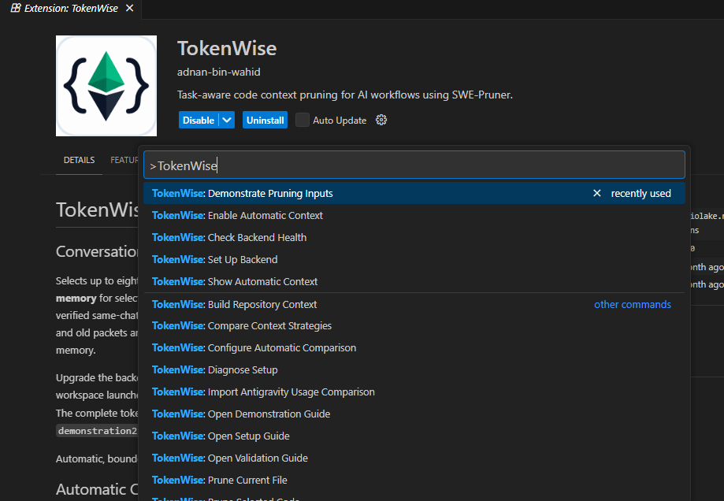
Figure 13. TokenWise commands available through the Antigravity command palette.
Table 17. Common commands and when to use them.
Command, prefixed TokenWise: | Purpose
Set Up Backend / Diagnose Setup | Install/update the runtime and inspect failures or readiness.
Enable Automatic Context / Show Automatic Context | Configure the current workspace and inspect the latest prepared result.
Demonstrate Pruning Inputs | Choose repository discovery, selected source or controlled conversation replay.
Prune Current File / Prune Selected Code | Prune the whole active file or exactly the highlighted source.
Build Repository Context | Prepare a manual task-aware workspace packet.
Compare Context Strategies | Compare explicit context-packet strategies using the local tokenizer.
Configure Automatic Comparison | Enable, disable or retry background prepared-packet comparison.
Import Antigravity Usage Comparison | Import two genuine independent successful CLI logs; no model call is launched.
Open Setup Guide / Open Demonstration Guide / Open Validation Guide | Open bundled instructions for recovery or presentation.

6.7 Repository Discovery without a Selected File
1. Run Demonstrate Pruning Inputs and choose Repository: no selected file.
2. In the subsequent task input, enter: Explain session expiry and revocation, not invoice pricing.
3. Enter 0.45 in the threshold input and confirm. Wait for the Repository Context result.
Figure 14 is the mode-selection menu, not the task input. Its blank search box filters the three choices: Repository: no selected file, Selected file or highlighted excerpt, and Conversation: replay earlier user context. The task question is entered after choosing a mode. Repository mode intentionally supplies no active-file hint even if an editor happens to be open.
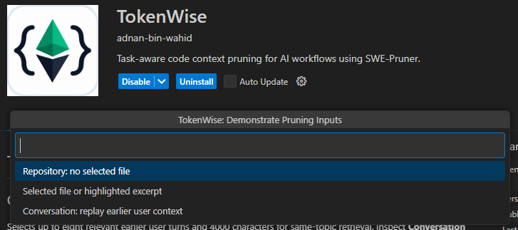
Figure 14. Three input scopes offered by Demonstrate Pruning Inputs.
Figure 15 shows the separate threshold input. A value must be between 0 and 1; Enter confirms and Escape cancels. The requested 0.45 is the user setting, not a promised 45% saving. The repository policy can apply tier-adjusted thresholds or use a non-neural representation, as the included-file table later discloses.
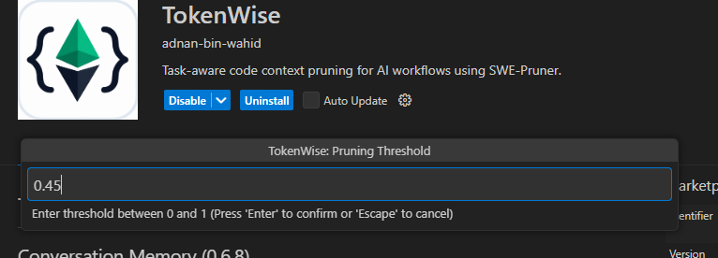
Figure 15. Requested pruning-threshold input set to 0.45.

6.8 Read the Repository Context View
Figures 16 and 17 are two portions of one recorded repository-discovery result. They illustrate the session-expiry/revocation task rather than the account-lockout comparison. Values are transcribed from the supplied images, not newly measured during this report revision. The task's invoice exclusion guides source selection but does not guarantee that every retained supporting declaration is unrelated to billing.
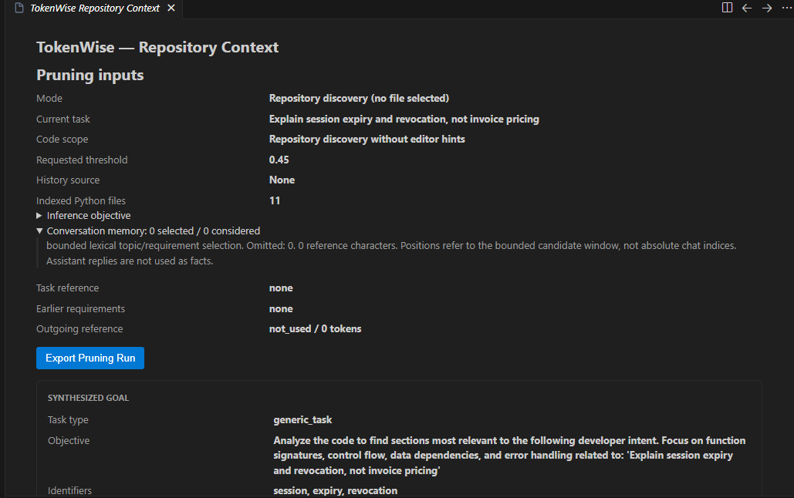
Figure 16. Repository discovery input trace, memory state and synthesized goal.
Table 18. Repository input-trace and goal fields.
Visible field | Recorded value or state | Interpretation
Mode | Repository discovery (no file selected) | Search starts from the prompt rather than highlighted source.
Current task | Explain session expiry and revocation, not invoice pricing | The latest request, including its exclusion.
Code scope | Repository discovery without editor hints | No active-file anchor is supplied by this teaching mode.
Requested threshold | 0.45 | Requested starting threshold; effective file thresholds may differ.
History source | None | No earlier user reference was supplied for this run.
Indexed Python files | 11 | Eligible Python files in the indexed workspace; not all are sent.
Inference objective | Expandable | The effective task-conditioned objective used for retrieval/pruning.
Conversation memory | 0 selected / 0 considered; omitted 0; 0 characters | No eligible earlier user turns were considered or injected.
Task reference / Earlier requirements | none / none | No historical topic or retained requirement is reported.
Outgoing reference | not_used / 0 tokens | There is no outgoing memory block in this packet.
Export Pruning Run | Action button | Save input scope and result evidence for inspection.
Task type | generic_task | Deterministic classification of this explanation request; not an accuracy label.
Objective / Identifiers | Task-focused objective; session, expiry, revocation | Converted task focus and search identifiers. Excluded topics and diagnostics, when shown, describe constraints/errors, not successful test execution.
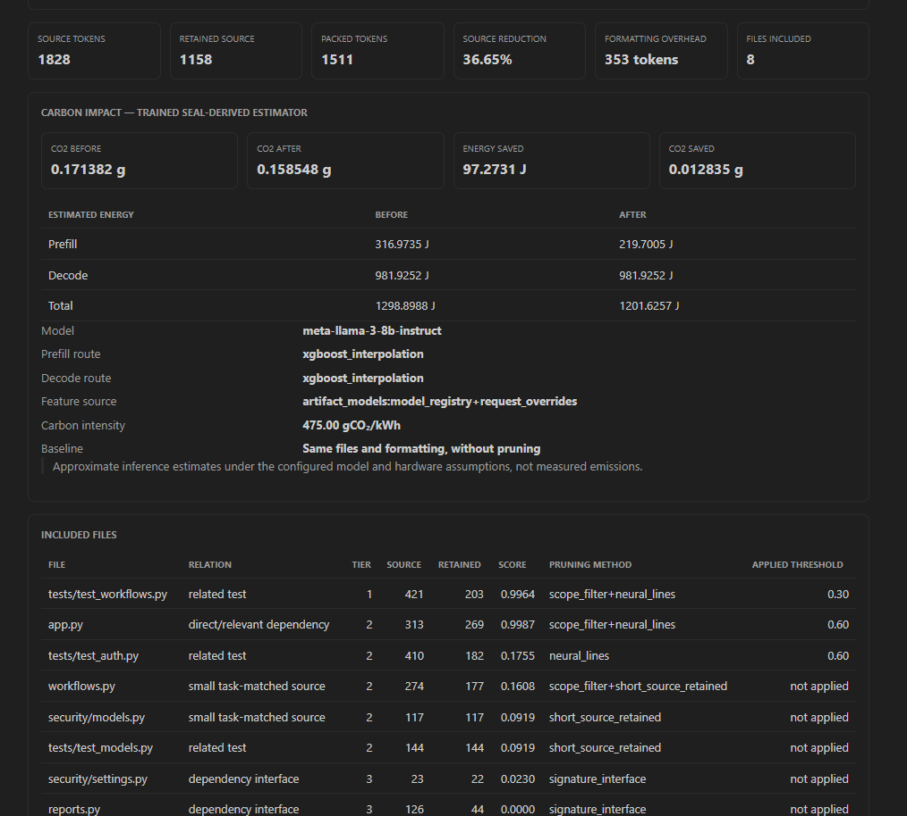
Figure 17. Repository source/packet metrics, configured carbon estimates and included-file provenance.
Table 19. Repository result token values in Figure 17.
Field | Value | Meaning
Source tokens | 1,828 | Original source token counts for the included files, not the entire repository or provider request.
Retained source | 1,158 | Source remaining after the selected pruning/representation policy.
Packed tokens | 1,511 | Complete outgoing reference packet, including its formatting and other bounded blocks.
Source reduction | 36.65% | 100 x (1,828 - 1,158) / 1,828; a source-only comparison.
Formatting overhead | 353 tokens | Reported packet overhead: 1,511 - 1,158. It is not extra source.
Files included | 8 | Files represented in this packet, out of 11 indexed Python files.
The source reduction must not be calculated by comparing 1,828 source tokens directly with a differently formatted full packet. Packed tokens are the relevant size for TokenWise's complete-packet budget, but remain local-tokenizer counts. Guidance and memory consume packet space when present. If an automatic result also shows Prepared in, that is TokenWise preparation time, not total Antigravity answer time.
Table 20. Included-file values transcribed from Figure 17.
File | Relation / tier | Source / retained | Score | Method / applied threshold
tests/test_workflows.py | related test / 1 | 421 / 203 | 0.9964 | scope_filter+neural_lines / 0.30
app.py | direct/relevant dependency / 2 | 313 / 269 | 0.9987 | scope_filter+neural_lines / 0.60
tests/test_auth.py | related test / 2 | 410 / 182 | 0.1755 | neural_lines / 0.60
workflows.py | small task-matched source / 2 | 274 / 177 | 0.1608 | scope_filter+short_source_retained / not applied
security/models.py | small task-matched source / 2 | 117 / 117 | 0.0919 | short_source_retained / not applied
tests/test_models.py | related test / 2 | 144 / 144 | 0.0919 | short_source_retained / not applied
security/settings.py | dependency interface / 3 | 23 / 22 | 0.0230 | signature_interface / not applied
reports.py | dependency interface / 3 | 126 / 44 | 0.0000 | signature_interface / not applied
File is the repository-relative source path; Relation explains its discovery or representation; Tier controls treatment priority. Source and Retained are per-file local counts, whose totals are 1,828 and 1,158. Score is a retrieval/ranking signal, not a probability that the final answer is correct. A file can remain as supporting context despite a low score. Tier 1 uses lighter pruning here (0.30), while neural Tier 2 uses 0.60. The requested 0.45 is therefore not applied identically to every file. Not applied means that this row used scope filtering, short-source retention or an interface rather than a neural threshold. The final Unified context is the actual excerpt to inspect; filenames alone do not establish preserved behavior. Copy Unified Context copies that packet, not an answer or the entire repository.

6.9 Interpret the Carbon and Energy Values
The Carbon impact region in Figure 17 compares the same included files and formatting without pruning against the prepared packet under a fixed inference scenario. It does not compare a live disabled Antigravity conversation with an enabled one, and does not compare the entire repository against eight files.
Table 21. Configured repository carbon and energy values in Figure 17.
Quantity | Before | After / difference
CO2 | 0.171382 g | 0.158548 g
Prefill energy | 316.9735 J | 219.7005 J
Decode energy | 981.9252 J | 981.9252 J
Total energy | 1,298.8988 J | 1,201.6257 J
Energy saved | Before minus after | 97.2731 J
CO2 saved | Before minus after | 0.012835 g
Prefill estimates processing the supplied input; Decode estimates generating the configured expected output. Decode is unchanged because the output-length assumption is held constant. Total is the sum of the two phases. Energy saved and CO2 saved are signed differences calculated from full-precision predictions; subtracting the rounded displayed endpoints can differ in the final decimal. Smaller input therefore does not imply the same percentage reduction in total energy.
Table 22. Estimator assumptions and provenance shown in the result.
Field | Recorded value | Explanation
Model | meta-llama-3-8b-instruct | Estimator target; not automatically the model selected in Antigravity.
Prefill route / Decode route | xgboost_interpolation / xgboost_interpolation | Trained artifact family used for each phase within the configured size range.
Feature source | artifact_models:model_registry+request_overrides | Registry-backed model/hardware attributes combined with explicit request assumptions.
Carbon intensity | 475.00 gCO2/kWh | Assumed electricity emissions factor; not a measurement of the user's or provider's power grid.
Baseline | Same files and formatting, without pruning | Matched formatted-context comparison, distinct from all-code or native-agent baselines.
Disclaimer | Approximate inference estimates, not measured emissions | Predictions exclude local TokenWise work and do not establish net environmental savings.
The conversion is CO2_g = energy_J / 3,600,000 x intensity_g_per_kWh. For example, 97.2731 J at 475 gCO2/kWh is approximately 0.012835 g. A pending or unavailable estimate must remain pending/unavailable, not zero. Positive expansion can appear as Energy increase or CO2 increase. The estimator's expected output-token setting should be recorded in the export even when it is not visible in the screenshot.

6.10 Prune a Selected File or Highlighted Excerpt
1. Open security/models.py. Clear the selection, run Demonstrate Pruning Inputs and choose Selected file or highlighted excerpt.
2. Enter Explain session class and threshold 0.45 to reproduce the input represented in Figure 18. Prune Current File is also a direct whole-file command.
3. For excerpt mode, highlight the Session decorator and class body and repeat the teaching command. The captured scope changes to Selected excerpt; unselected Account code was never input in that run.
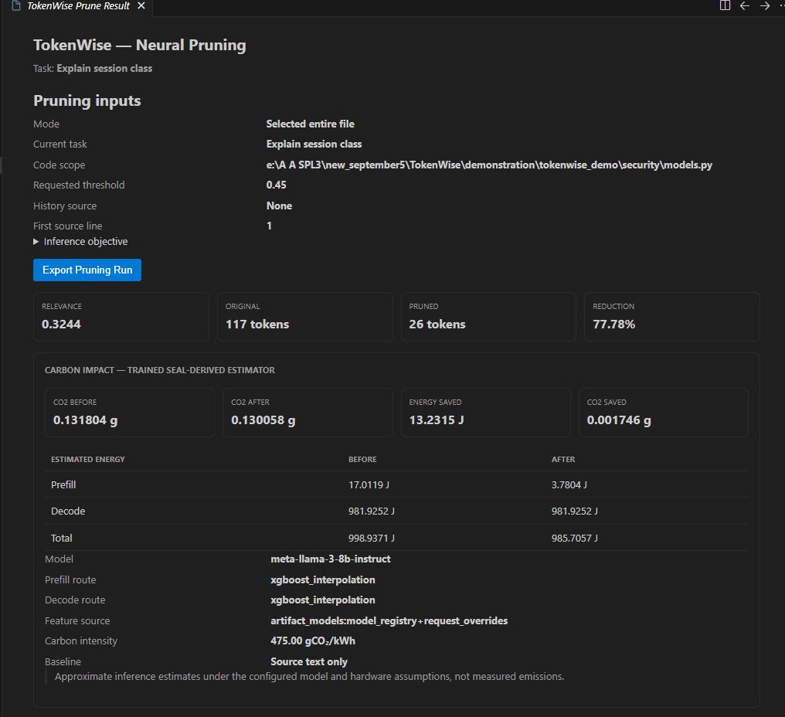
Figure 18. Selected-file neural pruning of security/models.py for the Session class.
Figure 18 reports Selected entire file, the task Explain session class, the full security/models.py path, requested threshold 0.45, History source None and First source line 1. Inference objective expands the actual goal; Export Pruning Run saves the trace. These fields identify the input before judging the output.
Table 23. Neural-pruning values shown in Figure 18.
Field | Value | Interpretation
Relevance | 0.3244 | Document-level task-relevance signal; not answer correctness or a percentage of lines retained.
Original | 117 tokens | Whole selected file counted by TokenWise's tokenizer.
Pruned | 26 tokens | Emitted pruned text, including its elision formatting.
Reduction | 77.78% | 100 x (117 - 26) / 117; not a provider-usage measurement.
Table 24. Selected-file energy and carbon values in Figure 18.
Quantity | Before | After / difference
CO2 | 0.131804 g | 0.130058 g
Prefill energy | 17.0119 J | 3.7804 J
Decode energy | 981.9252 J | 981.9252 J
Total energy | 998.9371 J | 985.7057 J
Energy saved | Before minus after | 13.2315 J
CO2 saved | Before minus after | 0.001746 g
The model, routes, feature source and 475.00 gCO2/kWh factor match Figure 17, but Baseline is Source text only: it compares this selected source before and after pruning rather than full formatted repository context. The 77.78% text reduction is accompanied by only about 1.32% predicted total-energy reduction because the decode workload stays fixed.
Below the visible region, inspect Pruning details, Line decisions, Original and Pruned context. Model input tokens include task/instruction overhead and differ from source tokens. Kept line fragments identify the decision mask; each Source line is an original line number, Mean relevance is its aggregated score, and Decision mask distinguishes Keep: threshold, Keep: preservation/gap and Not selected by mask. Unscored lines are not relevance zero. Formatting can restore tiny gaps, so the emitted text is the final reference. A retained Session body may omit @dataclass or imports: inspect originals before explaining constructor behavior or editing. Copy Pruned Context copies the excerpt. Filtered-line markers are not executable Python.

6.11 Demonstrate Same-Conversation Context
1. In one new chat with automatic context enabled, send the account-lockout prompt from Section 6.5 and wait for the final answer.
2. In that same chat, send: What about its expiry boundary? Do not modify any files.
3. Show Automatic Context and inspect the new task, effective objective, History source and Conversation memory. Confirm that the subject is account lockout rather than unrelated session or invoice behavior.
Figure 19 shows the preceding lockout question, a reference to test_wrong_password_after_expiry_starts_a_new_count, and the follow-up about its expiry boundary. The visible launcher command reformulates the subject as account lockout expiry boundary and related tests and encodes it with QueryBase64. Encoding transports the query; it is not token reduction or encryption. Working indicates that the command is still running. This screenshot demonstrates visible topic continuity and invocation, but does not display the completed follow-up answer, the bounded memory inspector or provider usage.
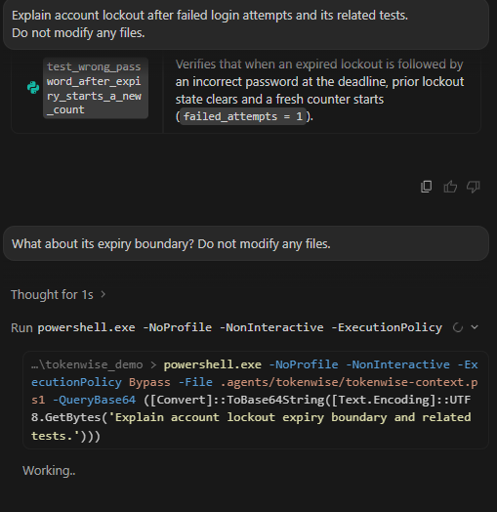
Figure 19. Same-chat account-lockout follow-up and visible subject-focused TokenWise launcher invocation.
The memory inspector separately reports selected/considered turn counts, omissions, reference characters, reasons, task reference, recognized earlier requirements and outgoing status/token count. Selected history is not necessarily all injected: the packet can include a full or compact reference block or omit it to preserve evidence space. Native scoped user turns and agent-supplied fallback references have different labels; a controlled replay is not native transcript capture. Assistant answers and tool output are excluded as user requirements. Selection is bounded to eight relevant earlier turns and 4,000 characters and uses lexical heuristics, not unlimited or perfect semantic memory.
ADD SCREENSHOT - Figure 20: After the follow-up completes, capture Show Automatic Context with the current task, expanded Conversation memory, selected messages/reasons, history source and exact outgoing status/token count. Caption: Inspectable bounded user references for a completed follow-up. Use the actual capture date.
For a separate teaching replay, choose Conversation: replay earlier user context, supply the earlier lockout task and ask Which tests cover that behavior? Label it replay. For a new-chat control, ask only that vague question in a fresh chat; the extension must not invent the prior conversation. Memory can be disabled with conversation_memory: false in .agents/tokenwise.json and restored afterward. Keep these demonstrations outside independently timed WITH/WITHOUT trials.

6.12 Inspect Prompt Guidance, Comparison and Export
In a repository result, inspect Response guidance and the Unified context. The outgoing task-aware guidance asks for grounded claims, real file/symbol citations, respect for user constraints and explicit uncertainty. Its version, task profile, full/compact/omitted status and local token cost are inspectable. It is separate from source data and adds no extra goal-generation model call by default. Guidance is intended to support better answers; its presence is not proof that answer accuracy improved.
ADD SCREENSHOT - Figure 21: Capture the actual Response guidance metadata and its outgoing block, alongside the source-reference boundary. Caption: Bounded task-aware prompt guidance in the prepared context.
1. Run Configure Automatic Comparison and choose Enable automatic packet comparison. Send a fresh ordinary prompt with TokenWise enabled.
2. Wait for Context strategy comparison in Show Automatic Context. Inspect All-Python baseline, TokenWise packet, packet change, task-plus-packet counts, file lists and estimator assumptions. Export Comparison saves the evidence; a stale-snapshot error requires fresh retrieval.
3. Disable this background comparison before timed native trials. The extra local comparison is an inspection feature, not necessary for ordinary context delivery.
The comparison assumes all indexed Python code is supplied in its baseline. Source tokens count source; Packet tokens include packet formatting; Task + packet tokens also include the task. The displayed change can be a genuine increase for small inputs. Energy/CO2 columns remain estimates. This is not automatic monitoring of Antigravity's file reads, billing or actual model requests.
ADD SCREENSHOT - Figure 22: Capture a completed automatic packet comparison with exact task, both file lists, locally counted complete packets and the signed change. Caption: Hypothetical all-Python versus TokenWise prepared-packet comparison. Do not label it actual Antigravity usage.
For real reported agent usage, run Import Antigravity Usage Comparison and select two independent successful single-turn CLI JSON/stream-JSON logs from matched WITHOUT and WITH runs. The importer validates sessions, available model identity, usage, answer and completed tools. It does not start paid calls or grade answer quality. A manual IDE answer may have no reported input counter; record N/A rather than substituting the local packet count. Export Pruning Run, Export Comparison and saved chat/tool evidence answer different reproducibility questions.

6.13 Troubleshooting, Readiness and Cleanup
Table 25. User recovery actions.
Symptom | Action and verification
No automatic context | Check trusted local workspace, enabled setting, active TokenWise rule, selected registered backend and command permission. Send a fresh prompt after correction.
Backend unreachable / older feature missing | Run Diagnose Setup, Set Up Backend and Start Backend as applicable; refresh workspace rules after upgrading.
Permission denied | Review and approve only the required local TokenWise operation. Do not enable blanket command bypass or report a denied run as successful.
Old result shown | Match query/event/timestamp and send a new prompt. Close the old panel; a previous latest.json does not prove current activity.
CO2 pending, disabled or unavailable | Check enableCarbonEstimation and diagnostic/artifact errors. Retrieval can succeed independently; missing estimation is not zero emissions.
Large input is slow | Allow cold startup, inspect timeouts and source scope, and test a focused excerpt. A small output budget does not itself cap neural input computation.
Comparison stale or unavailable | Retrieve again on the current saved snapshot and retry through Configure Automatic Comparison.
No reported provider tokens | Keep actual input tokens N/A. Store local packet tokens in a separately labeled field.
ADD SCREENSHOT - Figure 23: Capture actual Diagnose Setup output showing the selected backend, readiness and any resolved error. Caption: Verified backend readiness before live validation. Do not replace this with a website setup illustration.
For temporary disabling, set enabled: false in .agents/tokenwise.json and change the TokenWise rule to Manual without invoking it. A clean comparison baseline also requires no active duplicate rule or injected packet. Preserve backups and restore the original rule/settings afterward. For removal, TokenWise: Remove All Local Data and extension uninstall use ownership-aware cleanup. Modified, shared or unverifiable resources can be retained with warnings; never promise deletion of arbitrary user files or shared caches.

7. Validation and Comparative Study

7.1 Validation Questions
Validation asks whether the software works as specified: source scope is correct, a fresh prompt triggers retrieval, the context is delivered, the packet is bounded, references remain scoped, changes invalidate caches, and failures are visible. Comparative evaluation asks what changes when a defined component or the whole system is enabled rather than disabled under controlled conditions.
This report contains a completed twenty-repository local component study and recorded software verification. The native WITH/WITHOUT evaluation is specified below with fill-ready templates; it remains uncompleted as of this revision. One failed CLI preflight is recorded separately, not counted as answer-quality evidence.
The local research questions are:
• How much smaller are defined prepared packets than all indexed Python source?
• What additional change does actual neural pruning make to the same selected excerpt?
• How much predefined source-body evidence survives final packing?
• How does selected earlier user intent affect a vague follow-up's candidate coverage?
• What local latency and configured carbon differences are observed?
• Which constraints prevent these findings from establishing downstream superiority?

7.2 Functional Integration Validation
Table 26. Functional integration validation checklist.
Check | Required observation | What it does and does not establish
Fresh prompt reaches retrieval | Matching current task, event/timestamp, actual invocation | Preparation for this task, not an old report
Context delivered | Actual tool output or supported hook injection | Workflow delivery, not private model reasoning
Cross-file evidence | Relevant settings/service/models/test excerpts | Available evidence; filenames alone are insufficient
Complete budget | Count of entire supplied packet | TokenWise budget compliance, not provider billed usage
Grounded answer | Correct behavior and genuine file/test citations | Observable source-supported response, not universal correctness
Read-only task | Source hashes/diff unchanged | No source edits during this validation
Saved-edit freshness | Controlled change then fresh snapshot/output | Exercised cache update path
Same-chat memory | Related user references and correct provenance | Bounded continuity without cross-chat carryover

The checklist specifies evidence to capture during live validation; its entries are not newly executed native checks. Use the manual's input traces and completed transport output for operational evidence. Perform any reversible source-change/cache test separately, restore the original source and rerun the demonstration tests before matched comparison trials.

7.3 Completed Study Protocol
The final protocol is tokenwise-context-study-v2-bounded-neural, recorded on 9 October 2026. The run used real local neural weights and twenty pinned public Python repositories. Each repository supplied one fixed explanation task, a target function/method, and seven packet conditions. There were 140 measured packets and twenty actual bounded neural calls, with no Antigravity cloud answer generation. [R6]
The study indexed 538 Python files comprising 4,381,075 source bytes. A prepared 1024-token excerpt ceiling limited neural inputs; none of the selected excerpts required clipping. The bounded packing budget was 4,096 tokens, threshold 0.45, and candidate limit eight. Guidance was enabled. The local service used four CPU threads on Windows 11/Python 3.12.4; the recorded machine had sixteen logical processors, with the accompanying study reporting an Intel Core i5-13400 and approximately 15.77 GiB visible memory.
Snapshots include exact commit identifiers and archive/content fingerprints. Downloaded repository code was parsed as source, not imported, installed, or executed. Preparation selected the reference evidence before inspecting neural outputs. Cases use releases chosen for controlled evaluation, not a claim that they are current versions or recommendations.

7.4 Experimental Conditions
Table 27. Comparative-study conditions.
Condition | Definition | Valid interpretation
all_python | Formatted full content of every indexed Python file | Hypothetical all-code prepared context
selected_file | Complete informed implementation file | Manual selection baseline
selected_excerpt | Known target function/method with matched formatting | Already focused, informed excerpt baseline
neural_excerpt | Real /prune on that same excerpt and task | Matched neural contribution
retrieval_only | Lexical/identifier/graph discovery and bounded interface/short-source packing | Retrieval ablation, not complete production pipeline
history_off | Same vague follow-up without earlier intent | No-hint retrieval-only control
history_on | Same follow-up plus selected task and formatting user reference | Controlled memory/retrieval ablation

The retrieval-only conditions deliberately avoid neural ranking/line pruning. Their explicit lexical/graph/interface policy does not reproduce every production candidate reservation, exclusion, or allocation decision. They must not be relabeled as the complete automatic extension.
The history task is Which tests cover that behavior? Do not modify any files. The on condition supplies the preceding explicit repository task and a bullet- point requirement. This is controlled user-reference input, not a captured live native Antigravity conversation.

7.5 Evidence Rubric and Measurement
Each repository has one implementation anchor and up to two qualifying related test anchors, frozen before neural inference. Click contributes two anchors; the other nineteen cases contribute three each, giving 59 total. An anchor requires both a declaration and a selected non-comment body/assertion line in the correct file's code fence after whitespace normalization. A filename, query, reference block, or declaration alone does not satisfy it.
Selection uses qualified AST symbols, implementation-overload handling, and deterministic test association/order. This is a syntactic evidence proxy, not independently adjudicated comprehensive ground truth. A missing line can indicate an omission under the rubric without proving that every possible answer fails; a retained line cannot establish complete behavior either.
Required-file coverage measures discovery before packing, with 43 required implementation/test file locations counted across cases. Final evidence retention measures content actually present after packing. Confusing these metrics would conceal the important interface-packing losses.
Complete-packet tokens use the same local tokenizer. Aggregate reduction is a ratio of summed tokens; mean per-repository reduction gives every repository equal weight. There are no significance tests or population confidence claims for this small purposive corpus. The output scorer was corrected to handle variable-length fences/embedded headings and re-applied to preserved originals; it did not regenerate prompts, outputs, timings, or source oracles.

7.6 Dataset and Per-Repository Results
Table 28. Dataset and per-repository packet tokens.
Repository, fixed tag | Python files | All Python | Selected file | Excerpt before | Neural after | Retrieval-only
pallets/click, 8.1.8 | 70 | 135,043 | 8,292 | 264 | 265 | 4,095
pallets/itsdangerous, 2.2.0 | 15 | 14,370 | 1,810 | 721 | 719 | 4,096
pallets/markupsafe, 3.0.2 | 11 | 7,695 | 3,427 | 278 | 278 | 2,348
pallets-eco/blinker, 1.9.0 | 7 | 8,612 | 4,188 | 436 | 436 | 2,243
psf/requests, v2.32.3 | 36 | 88,709 | 7,590 | 378 | 378 | 4,096
pallets/flask, 3.1.0 | 83 | 133,434 | 3,382 | 329 | 329 | 4,095
hukkin/tomli, 2.2.1 | 14 | 13,128 | 6,533 | 600 | 600 | 2,954
hukkin/tomli-w, 1.2.0 | 10 | 5,827 | 1,840 | 104 | 104 | 2,069
tqdm/tqdm, v4.67.1 | 62 | 75,649 | 13,079 | 622 | 440 | 4,095
theskumar/python-dotenv, v1.0.1 | 18 | 15,937 | 2,787 | 342 | 342 | 4,096
dbader/schedule, 1.2.2 | 4 | 29,086 | 7,190 | 166 | 166 | 2,765
mahmoud/boltons, 24.1.0 | 65 | 196,713 | 7,239 | 162 | 162 | 4,096
pypa/packaging, 24.2 | 35 | 119,637 | 4,330 | 357 | 357 | 4,095
tox-dev/platformdirs, 4.3.6 | 15 | 24,480 | 2,633 | 149 | 149 | 4,096
tox-dev/filelock, 3.16.1 | 13 | 18,619 | 3,282 | 779 | 716 | 4,096
tkem/cachetools, v5.5.1 | 18 | 22,669 | 5,613 | 125 | 125 | 3,141
un33k/python-slugify, v8.0.4 | 7 | 10,110 | 1,480 | 993 | 993 | 2,356
more-itertools/more-itertools, v10.6.0 | 8 | 123,127 | 41,677 | 539 | 539 | 4,096
python-semver/python-semver, 3.0.3 | 26 | 28,000 | 5,943 | 157 | 157 | 4,096
jd/tenacity, 9.0.0 | 21 | 36,387 | 1,026 | 74 | 74 | 4,095

Exact full commit pins and measured memory rows are in the generated tables and snapshots.json. Each case's query, target symbol, and settings are in cases.json. The complete dataset is retained in results.json and metrics.csv.
ADD SCREENSHOT - Figure 24: Capture the saved twenty-repository component-study table with the measured date, seven condition labels and totals. Caption: Recorded twenty-repository context-efficiency study. This is not a live Antigravity answer-quality table.

7.7 Aggregate Context and Evidence
Table 29. Aggregate context and evidence results.
Condition | Total packet tokens | Mean per repository | Retained anchors / 59 | Cases above 4,096
All Python | 1,107,232 | 55,361.60 | 59 | 20
Selected file | 133,341 | 6,667.05 | 20 | 11
Selected excerpt | 7,575 | 378.75 | 20 | 0
Neural excerpt | 7,329 | 366.45 | 17 | 0
Retrieval-only | 71,119 | 3,555.95 | 6 | 0
History off | 71,558 | 3,577.90 | 4 | 0
History on | 71,248 | 3,562.40 | 6 | 0

Retrieval-only packets are 93.58% smaller in aggregate than the hypothetical all-Python packets. Mean per-repository reduction is 84.75%, a different statistic because large repositories dominate the summed baseline. Every bounded retrieval/history packet fits 4,096 tokens. All full-repository packets exceed that benchmark budget.
The large reduction demonstrates capacity control under the defined ablation, not preservation of all behavior. Retrieval-only discovers 40/43 required files but retains only 6/59 predefined body anchors. Interfaces often omit the very implementation or assertion needed to explain behavior. This is a material negative result and a priority for improved allocation.
Selected source has fewer tests because it contains only the informed implementation file/excerpt. Missing related-test anchors already absent from that baseline cannot be attributed to neural deletion.

7.8 Matched Neural Comparison
The fair neural-only comparison is the same selected excerpt before and after actual pruning, with matched task and packet format. Summed complete packets fall from 7,575 to 7,329 tokens: a 3.25% aggregate reduction. Raw source tokens fall from 6,664 to 6,418. The per-case median reduction is zero and the mean is 1.86%. Three packets shrink, sixteen remain equal, and one grows.
Click changes from 264 to 265 packet tokens, a 0.38% increase. Itsdangerous changes from 721 to 719, while losing its implementation anchor. tqdm changes from 622 to 440, a 29.26% reduction, but also loses the required implementation anchor. Filelock changes from 779 to 716, an 8.09% reduction with its implementation anchor retained. Across all twenty cases, seventeen implementation anchors survive; Click, Itsdangerous, and tqdm lose theirs under the frozen rubric.
The result is not that the pretrained model never helps. It is that already focused short inputs provide limited additional compression in this sample, and reduction can remove meaningful evidence. Reporting only the strongest 29.26% example without its evidence loss would misrepresent effectiveness.

7.9 Conversation-Memory Ablation
Table 30. Memory-ablation outcomes.
Metric | History off | History on
Required-file candidate coverage | 33/43, 76.74% | 40/43, 93.02%
Macro per-case required-file coverage | 77.50% | 93.33%
Retained packed anchors | 4/59 | 6/59
Goal clarification flags | 20/20 | 0/20
Total packet tokens | 71,558 | 71,248

Six cases improve candidate-file coverage, thirteen tie, and one worsens. Improvements occur for Click, Requests, Flask, Boltons, Cachetools, and Semver. Platformdirs regresses from 3/3 required files to 2/3. Tomli-W improves final anchors from zero to two even though its file coverage ties.
Selected history helps resolve the deliberately vague follow-up in this controlled setting. The large file-coverage gain and small packed-anchor gain must both be reported. They do not prove that complete chat retention is useful, that memory always saves tokens, or that every relevant requirement survives. Native transcript capture and downstream answer quality were not evaluated through these ablation records.

7.10 Latency and Failed Full-File Pilot
Table 31. Observed component latency.
Operation | Minimum | Median | Mean | Maximum
Index and search-structure preparation | 16.75 ms | 73.48 ms | 126.80 ms | 318.93 ms
Warm search, median of three calls per repository | 0.245 ms | 0.290 ms | 0.306 ms | 0.466 ms
Actual bounded neural HTTP request | 0.472 s | 1.476 s | 2.281 s | 13.865 s

Warm search excludes neural inference, packet formatting/tokenization, HTTP, the editor, and downstream generation. The extension does not complete an entire task in 0.290 ms. First-forward effects and fixed order can affect the bounded inference results; no stable p95 guarantee or repeated independent latency distribution is established.
Before the bounded protocol, an actual full-file /prune-workspace CPU pilot on the Click snapshot reached a 600-second local HTTP timeout. One process observation recorded approximately 4.74 GiB working set and 8.89 GiB private memory; these are not instrumented peaks. The owned study backend was stopped to recover resources. Later reset/refusal records follow that termination and are not nineteen further independent repository failures.
No successful complete automatic packet was obtained from that pilot. The bounded neural/retrieval-ablation study is a deliberately narrower replacement protocol, not proof the full-file workflow succeeded. A final output budget does not itself bound neural input work or memory. The raw failed record remains in full-file-pilot.json.

7.11 Carbon Estimates
All study estimates use the same configured scenario: target meta-llama-3-8b-instruct, 256 expected output tokens, and 475 gCO2/kWh. Registry-backed features select XGBoost interpolation for both phases. Actual /estimate-carbon calls produced the saved values; no physical energy meter or downstream Antigravity inference was used.
Table 32. Matched-packet carbon estimates.
Quantity | Recorded estimate
Selected excerpts before, summed across twenty tasks | 2.485763 g CO2
Neural excerpts after, summed across twenty tasks | 2.481059 g CO2
Difference | 0.004704 g CO2
Aggregate estimated CO2 reduction | 0.1893%
Aggregate matched packet-token reduction | 3.2475%

The percentage differs because expected decode workload remains fixed. For the defined all-Python and retrieval-only scenarios, summed predictions are approximately 23.514830 g and 3.700934 g respectively. Many all-source packets would not fit a practical target request, so those predictions are hypothetical scaling comparisons, not accepted cloud requests or observed consumption.
The estimator cannot establish actual Antigravity emissions, billed savings, or net environmental benefit after added TokenWise computation. Its weak local fit in some routes, reconstructed training targets, and workload assumptions must remain visible alongside these numerical estimates.

7.12 Native Antigravity WITH/WITHOUT Evaluation
This evaluation compares Antigravity's normal repository-assisted answer with the same workflow using TokenWise. It is distinct from the completed local packet study in Sections 7.3-7.11. WITHOUT retains native file-reading tools; it is not an all-code packet forced into a prompt. WITH must demonstrate delivery of a fresh TokenWise packet, not just an installed extension or an old result.
RESULTS STATUS - The live comparison tables below are fill-ready templates, not measured outcomes. Replace bracketed fields only after saving the real runs. The 120-run evaluation has not been completed during report revision; do not submit Pending fields as experimental results.
The planned scope is 20 pinned Python repositories with one predefined task each, three paired repetitions per repository and two independent conditions per pair: 60 pairs and 120 runs. The numbered source folders are under demonstration/comparative_study. Exact tasks are in TASKS.md, provenance in manifest.json and the 120-row capture worksheet in results-template.csv. The folders are source snapshots, not individual Git clones. Keep searches inside the opened numbered folder; do not let Git commands search the parent TokenWise repository.
Before the full study, rehearse one lockout pair in demonstration/tokenwise_demo using the following question. This is a separate functional pilot, not one of the 20 upstream repository tasks. Each formal repository uses its own source-grounded six-fact rubric defined before either answer is inspected; the lockout rubric cannot grade Click or another unrelated task.
Explain account lockout after failed login attempts and its related tests. Do not modify any files. Cite relevant files and test names.
Table 33. Live comparison settings to record before execution.
Control | Recorded setting
Actual evaluation date(s) | [INSERT actual dates]
Editor/CLI version and transport | [INSERT IDE or CLI; do not combine their telemetry]
TokenWise/backend revision | [INSERT installed version and backend revision]
Pinned model / reasoning effort | [INSERT identical model and effort for both conditions]
Task, source snapshot and rubric | [INSERT task IDs, full commits and frozen six-fact rubric evidence]
Token budget / threshold / candidate limit | [INSERT actual automatic settings; fresh-workspace defaults are 4096 / 0.45 / 6]
Native tools and permissions | [INSERT matched usable policy; no deliberately restricted baseline]
Background packet comparison | Disabled during timed runs
Backend state and initialization | [INSERT warm/cold state and any pre-run warm-up]
Attached files, selection and previous history | None; each run begins in a fresh independent chat

7.12.1 WITHOUT Condition
1. Back up .agents/tokenwise.json and the TokenWise rule outside the active project's context. Set the existing enabled flag to false. Set only the TokenWise rule activation to Manual and do not invoke it; verify no duplicate active rule or hook injects context.
2. Disable automatic packet comparison, close prior result/source panels, clear highlighted code and attach no files. Leave Antigravity's native reading tools available.
3. Start a new chat, start a stopwatch when submitting the fixed task and stop it when the final answer finishes. Save the entire answer and visible tool activity or a genuine CLI trace.
4. Verify no new TokenWise invocation or supplied packet occurred. Record model, effort, source snapshot, conversation identity, timing, observed calls, actual reported counters or N/A, and failure status.
ADD SCREENSHOT - Figure 25: After a genuine successful WITHOUT run, capture the fixed task, final answer, selected model and expanded native reading tools, with the disabled integration recorded separately. Caption: Native Antigravity answer without TokenWise. Do not use the permission-blocked preflight as a successful baseline.

7.12.2 WITH Condition
1. Restore enabled: true and the TokenWise rule's original activation, normally Always On. Keep source, model, reasoning effort, permissions and editor state matched.
2. Start another fresh chat and submit the identical task. Time submission through final completion, including TokenWise retrieval and agent tools.
3. Save the answer, visible context delivery/tool trace, fresh task/event/timestamp and actual supplied packet. Inspect its excerpts and evidence, not only its included-file names.
4. Record total answer time and TokenWise preparation time separately. Keep provider input/output/cache/thinking counters separate from locally counted context tokens. Verify source bytes are unchanged.
ADD SCREENSHOT - Figure 26: Capture the independent matched WITH answer and completed TokenWise invocation/output, together with the current task and model. Caption: Native Antigravity answer with fresh TokenWise context. A status-bar count alone is insufficient.
Alternate order across the three repetitions: WITHOUT then WITH; WITH then WITHOUT; WITHOUT then WITH. Record whether the backend was cold or warm rather than attributing startup differences to answer quality. Any permission denial, timeout, quota failure, empty answer, source modification or baseline contamination remains a failed/invalid trial. Preserve it before a replacement run; do not silently substitute zero-valued metrics.

7.13 Source-Grounded Answer Scoring
For the lockout pilot, the original settings, service and tests provide the six facts below. AuthService.authenticate checks now < locked_until before accepting a password. At an existing deadline it clears the old lockout state before the next password check. The fixture uses integer time, dataclasses and teaching-only password hashing; it has no background unlock thread, JWT subsystem or persistent user database.
Table 34. Six-fact rubric for the separate account-lockout pilot.
ID | Supported fact | Verification source
F1 | The third failed password attempt triggers lockout | security/settings.py; test_lockout_threshold
F2 | The deadline is the triggering failure time plus 60 seconds | security/settings.py; AuthService.authenticate; test_lockout_threshold
F3 | Even a correct password is rejected before the deadline | test_correct_password_rejected_during_lockout
F4 | At the exact deadline a correct password succeeds and both failure/deadline fields reset | test_expiry_boundary
F5 | A successful login before lockout resets accumulated failures | test_success_resets_failures_before_lockout
F6 | A wrong password at expiry clears the old lock and starts a new failure count of one | test_wrong_password_after_expiry_starts_a_new_count
All named tests are in demonstration/tokenwise_demo/tests/test_auth.py. Three wrong attempts at time 100 produce a deadline of 160: a correct password fails at 159 and succeeds at 160. A wrong password at expiry yields False, failed_attempts = 1 and locked_until = 0. Define equivalent task-specific rubrics from original source/tests for all 20 upstream tasks before scoring them.
Award one point for each accurately stated, source-supported rubric fact, maximum six. A missing or incorrect fact earns zero for that criterion, but is not automatically an unsupported claim. Count distinct false factual assertions as incorrect and distinct assertions lacking repository evidence as unsupported; do not count the same assertion twice or count repeated wording multiple times. Keep the two categories separately in the worksheet and use their sum only in the combined summary row. Check exact cited functions/test names. Token-saving claims and generic recommendations do not replace behavior facts. Student scoring should retain supporting notes and can be reviewed by the supervisor; it is not automatically blinded independent assessment.

7.14 Measurement and Results Worksheets
One run record is required for each of the 120 planned runs. Its fields include repository/commit, task, repeat, condition, chat ID, model/effort, backend state, answer, rubric marks, incorrect and unsupported claim notes, total wall time, preparation time, tool evidence, reported usage source and success/failure status. One paired record links two independent chats with identical controls. Store raw material outside the active repository so earlier answers and rubrics do not become model context.
Table 35. How each native comparison measurement is collected.
Measurement | Collection rule
Correct supported facts, /6 | Read the saved answer against its predefined repository-specific six-fact rubric; sum supported criteria.
Incorrect or unsupported claims | Mark distinct factual claims against original code/tests; record claim text and reason separately.
Total answer time, seconds | Stopwatch or harness wall time from submission until final response finishes, including preparation and tool work. UI Worked timers are not automatically this measurement.
Observed tool calls | Count visible tool invocations once; for CLI streams deduplicate step indices. Retain successful and failed counts separately.
Observed file-reading calls | Count successful visible operations returning repository source, including content-reading commands; one call returning several files remains one call. Record searches and unique files separately when possible.
Actual reported input tokens | Use genuine provider/CLI terminal usage once when reported. Do not sum cumulative step and terminal counters or add cache counters twice. Missing telemetry stays N/A.
Local source-context tokens | Optional separate tokenizer count of captured source/packets; not actual provider input and not proof of all internal reads.
Outcome validity | Record failures, permissions, task/snapshot matching, fresh delivery and unchanged source; require a matched valid pair for comparative outcomes.
Table 36. Single-pair WITH/WITHOUT results template.
Measurement | WITHOUT TokenWise | WITH TokenWise
Repository / task / repetition | [INSERT] | [INSERT matched task]
Correct supported facts | [INSERT score] /6 | [INSERT score] /6
Incorrect or unsupported claims | [INSERT count] | [INSERT count]
Total answer time | [INSERT seconds] | [INSERT seconds]
Observed tool / file-reading calls | [INSERT tool count / read count] | [INSERT tool count / read count]
Actual reported input tokens | N/A until genuinely reported | N/A until genuinely reported
Run status and saved evidence | [INSERT status / path] | [INSERT status / path]
Table 37. Overall live results template for 20 repositories and 120 planned runs.
Measurement | WITHOUT, 60 planned runs | WITH, 60 planned runs
Attempted / successful runs | [INSERT counts] /60 planned | [INSERT counts] /60 planned
Valid matched pairs used for summary | [INSERT n] /60 planned pairs | Same matched set
Mean correct supported facts | [INSERT mean] /6 | [INSERT mean] /6
Mean incorrect or unsupported claims | [INSERT mean] per answer | [INSERT mean] per answer
Median total answer time | [INSERT seconds] | [INSERT seconds]
Median observed tool calls | [INSERT count] | [INSERT count]
Median observed file-reading calls | [INSERT count] | [INSERT count]
Median actual reported input tokens | N/A until reported | N/A until reported
Matched pairs with comparable reported input usage | [INSERT n] /60 planned pairs | Same telemetry-matched set
Quality outcomes: WITH better / tied / worse | [INSERT paired counts and metric] | [INSERT paired counts and metric]
Table 38. Per-repository live result worksheet, three planned pairs each.
Repository | Valid pairs /3 | Mean facts /6 WO | W | Mean claims WO | W | Median time s WO | W | Median reads WO | W | Median reported input WO | W
01_click | Pending | Pending | Pending | Pending | Pending | N/A | N/A
02_itsdangerous | Pending | Pending | Pending | Pending | Pending | N/A | N/A
03_markupsafe | Pending | Pending | Pending | Pending | Pending | N/A | N/A
04_blinker | Pending | Pending | Pending | Pending | Pending | N/A | N/A
05_requests | Pending | Pending | Pending | Pending | Pending | N/A | N/A
06_flask | Pending | Pending | Pending | Pending | Pending | N/A | N/A
07_tomli | Pending | Pending | Pending | Pending | Pending | N/A | N/A
08_tomli-w | Pending | Pending | Pending | Pending | Pending | N/A | N/A
09_tqdm | Pending | Pending | Pending | Pending | Pending | N/A | N/A
10_python-dotenv | Pending | Pending | Pending | Pending | Pending | N/A | N/A
11_schedule | Pending | Pending | Pending | Pending | Pending | N/A | N/A
12_boltons | Pending | Pending | Pending | Pending | Pending | N/A | N/A
13_packaging | Pending | Pending | Pending | Pending | Pending | N/A | N/A
14_platformdirs | Pending | Pending | Pending | Pending | Pending | N/A | N/A
15_filelock | Pending | Pending | Pending | Pending | Pending | N/A | N/A
16_cachetools | Pending | Pending | Pending | Pending | Pending | N/A | N/A
17_python-slugify | Pending | Pending | Pending | Pending | Pending | N/A | N/A
18_more-itertools | Pending | Pending | Pending | Pending | Pending | N/A | N/A
19_python-semver | Pending | Pending | Pending | Pending | Pending | N/A | N/A
20_tenacity | Pending | Pending | Pending | Pending | Pending | N/A | N/A
WO denotes WITHOUT and W denotes WITH. The per-repository table summarizes three matched repetitions only after they exist. Failed runs are not zero scores; missing counters are not zero tokens. Compute quality means and timing/read medians on valid matched pairs, report sample count for each metric and keep failures separately. If only some pairs expose comparable usage, report that smaller denominator and do not impute the rest. An unreported read trace is N/A, while a complete observed trace with no successful reads can legitimately be zero.
Mean supported facts = sum of rubric scores / number of scored valid runs
Median paired time difference = median(time_WITH - time_WITHOUT)
Per-pair input change (%) = 100 x (input_WITHOUT - input_WITH) / input_WITHOUT, only if input_WITHOUT > 0
Aggregate comparable input reduction (%) = 100 x (sum(input_WITHOUT) - sum(input_WITH)) / sum(input_WITHOUT)
Use the identical telemetry-matched pair set for both input sums. A negative time difference favors WITH on time; a positive token-change percentage indicates less reported input. Report genuine increases and ties. Input reduction is not necessarily proportional billed-cost reduction, especially when caching or pricing differ. Three repetitions are descriptive evidence, not a strong population-level significance claim.
ADD SCREENSHOT - Figure 27: After completing the real runs, capture the filled summary or validated imported comparison with the actual sample counts, supported-fact scores, time/read measurements, reported usage or N/A, and failure accounting. Caption: Observed paired WITH/WITHOUT comparison results. Leave this unfilled until measured.

7.15 Current Execution Status and Validity Limits
As of 9 October 2026, zero valid native comparison pairs are saved. One fresh CLI WITHOUT preflight on Click, using gemini-3.8-flash-high, authenticated but its repository-search command was denied. It ended with an empty answer despite terminal status SUCCESS. The captured wall time was 25.373 seconds and the terminal reported 11,696 input tokens. Those are observations of a failed preflight, not baseline effectiveness results. They are excluded from the live summary tables. The raw trace and explanation are in demonstration/comparative_study/PREFLIGHT.md and its local results directory. No fabricated example values are used in this report.
REPLACE AFTER EXECUTION - Update the preceding status paragraph with actual completed/failed/replacement counts, dates, model and evidence paths. Retain the failed preflight in the audit record rather than counting it as a successful answer or silently deleting it.
Table 39. Threats and interpretation boundaries.
Threat | Required handling
Small purposive sample; one task per repository | Describe exact source pins/tasks and three repetitions; do not generalize to every language or task.
Matched settings or source differ | Reject the comparison or rerun a fresh matched pair; source snapshots must stay inside the selected workspace.
Cold start, order and cloud variability | Alternate order, record backend state and use repeated total workflow measurements.
Incomplete/subjective answer scoring | Freeze six-fact rubrics, retain claim reasons/citations, and request supervisor review.
Failed/denied or contaminated baseline | Report it separately; keep native tools available and do not force WITHOUT to fail.
Local packets confused with reported usage | Separate source counts, prepared packets and provider counters; preserve N/A.
High retrieval coverage but missing packed bodies | Inspect actual implementation/assertion excerpts; filenames and candidate coverage are not answer quality.
Carbon predictions omit added local work | Report estimator assumptions and excluded overhead, not measured or net emissions.
Controlled memory replay / fixture UI | Label replay and synthetic rendering separately from native chat capture and live workflow evidence.

7.16 Reproduction and Final Comparative Interpretation
The completed component study retains cases, full source pins, metrics, summaries and the failed CPU pilot under evaluation/comparative-study. Research packet/archive files live in ignored scratch directories and may be absent in another checkout. Re-running measurements can replace artifacts; save the dated originals first. The report revision did not rerun the full software suites or the component experiment.
.\.venv\Scripts\python.exe evaluation/comparative-study/test_protocol.py -v
.\.venv\Scripts\python.exe scripts/run_comparative_study.py --prepare-only
.\.venv\Scripts\python.exe scripts/run_comparative_study.py
.\.venv\Scripts\python.exe scripts/run_comparative_study.py --rescore
.\.venv\Scripts\python.exe scripts/summarize_comparative_study.py
Each line is a separate development-checkout command, not a prerequisite for installed-extension users. Preparation may download pinned public source; component measurement uses local weights and CPU, not paid Antigravity calls. Live comparison records use demonstration/comparative_study/results-template.csv and the protocol in LIVE_STUDY.md. The current capture helper supports baseline trials only and is not a completed 120-run paired harness.
The completed component results support bounded context management: retrieval-only packets are 93.58% smaller in aggregate than the defined all-Python baseline. Actual neural pruning adds 3.25% aggregate reduction on matched focused excerpts but loses three implementation anchors. Selected history improves candidate-file coverage in the controlled ablation but does not guarantee retained bodies. These findings remain valid within their scopes; they do not supply missing live accuracy, tool-read, timing or provider-usage values.
FINAL RESULT PARAGRAPH - After execution replace this instruction with: 'Across [n] valid matched pairs from [r] repositories, mean supported facts were [WITHOUT]/6 and [WITH]/6; median total answer times were [WITHOUT] s and [WITH] s; median observed file-reading calls were [WITHOUT] and [WITH]. Comparable reported input usage was available for [k] pairs and changed by [signed aggregate percentage or N/A]. [State failures, ties, regressions and limitations.]' Use measured values only; do not assert improvement in an unmeasured metric.

8. Conclusion

8.1 Achieved Outcomes
TokenWise delivers an integrated local context-preparation extension rather than a standalone pruning script. It connects natural-language tasks, Python repository metadata, lexical/structural discovery, pretrained neural pruning, bounded packing, same-chat user references, outgoing prompting, approximate carbon estimates, and inspectable editor results. Managed setup and central workspace registration allow another developer to use the extension without the author's development checkout.
The recorded three implementation suites contain 355 discovered tests with 354 passes and one platform skip. Ten synthetic browser views and ten separate study-protocol tests supplement that verification. The twenty-repository study adds actual component measurements, including limitations not visible in passing unit tests.
Table 40. Achieved outcomes and remaining limitations.
Outcome | Evidence | Remaining boundary
Automatic repository discovery | Source pipeline, input traces, tested contracts | Agent-followed fallback and static retrieval limits
Explicit source pruning | Real neural excerpt measurements and line masks | Incomplete structural/behavioral retention
Complete packet limits | Tokenizer checks and bounded study packets | Essential evidence can still be omitted
Reusable search metadata | Incremental cache and warm-search measurements | Neural/agent work still dominates many tasks
Bounded prior user intent | Memory tests and coverage ablation | Lexical selection and one observed regression
Outgoing prompt engineering | Real templates, trace and budget tests | Downstream answer-quality improvement unmeasured
Sustainability visibility | Trained artifacts and phase-specific predictions | Not actual or net carbon measurement
Recoverable user installation | Managed stages, retry/integrity/lifecycle tests | Native portability and resource constraints remain
Scientific comparison support | Labeled baselines, raw records, usage importer | Native paired outcomes remain to be collected

8.2 Limitations
The most important limitation is evidence preservation under tight context and compute budgets. Candidate-file discovery can be good while final packed source lacks required bodies. Neural pruning can remove decisive conditions/decorators, and large-file CPU inference can consume impractical resources despite a small output budget. These are engineering and research challenges, not cosmetic dashboard issues.
Other limits include Python-focused static relationships, saved-file rather than unsaved-buffer indexing, eventual watcher/reconciliation freshness, editor-dependent hook/fallback delivery, and heuristic bounded memory. Native macOS/Linux, broader IDE versions, accessibility, and adversarial source handling require further validation.
Carbon results remain scenario estimates with imperfect learned fits, partially reconstructed benchmark targets, simplified token scaling, and excluded local overhead. Software-test success cannot establish model accuracy or net sustainability. Completed native paired answer-quality and usage measurements are still needed before claiming superiority over Antigravity's normal retrieval.

8.3 Prioritized Future Work
First, improve final evidence allocation: reserve task-relevant function bodies, configuration, and assertions instead of favoring interfaces solely because they fit. Evaluate packing against fact-level ground truth rather than filenames and compression alone.
Second, bound neural input computation independently from output size. Evaluate function-level preselection, chunk/token work caps, compatible lower-memory execution, cancellation, and fallbacks on the large-file cases that caused the CPU pilot limitation. Measure total overhead and retained evidence together.
Third, conduct repeated native with/without trials using fixed source/model/ permissions, alternating order, independently scored facts, actual reported usage, and failure accounting. Run separate ablations for outgoing guidance and memory rather than attributing every effect to neural pruning.
Fourth, validate estimation on independent model/hardware groups and measured workloads. Retain provenance for measured versus reconstructed targets, quantify uncertainty, and include local TokenWise energy in any net-benefit claim.
Fifth, broaden native installation, editor compatibility, security, and accessibility evaluation while retaining ownership-aware setup and cleanup. Additional repository languages require appropriate parsers/resolvers and new evaluation, not simply accepting non-Python text at the neural endpoint.

8.4 Final Assessment
The project's strongest demonstrated contribution is a usable, inspectable context-management system with explicit constraints and reproducible component evidence. It automates a meaningful developer task and makes its inputs, selection decisions, assumptions, and failures visible. The findings also identify where smaller context ceases to be sufficient context. A sound defense can therefore explain both why the system is useful and what remains necessary to prove broader downstream and sustainability benefits.

References
R1. Wang, Y., Shi, Y., Yang, M., Zhang, R., He, S., Lian, H., Chen, Y., Ye, S., Cai, K., and Gu, X. SWE-Pruner: Self-Adaptive Context Pruning for Coding Agents. arXiv:2601.16746v3, 26 April 2026. Supplied research PDF. The report uses this as a research foundation; the paper's agent benchmark results are not attributed to TokenWise.
R2. Pathania, P., Mehra, R., Sharma, V. S., Kaulgud, V., Nevels, T., Podder, S., and Burden, A. P. SEALing the Gap: A Reference Framework for LLM Inference Carbon Estimation via Multi-Benchmark Driven Embodiment. ICSE 2026 NIER; arXiv:2603.02949v1. DOI: 10.1145/3786582.3786846. Supplied research PDF. Local datasets and validation differ from the paper's implementation.
R3. Wahid, A. B. TokenWise: Sustainable Context Optimization for Coding Agents. Project proposal, Institute of Information Technology, University of Dhaka. Supplied spl3-1442.docx.pdf. The proposal states objectives, not measured outcomes.
R4. TokenWise implementation and third-party attribution, inspected 9 October 2026: vscode-extension/package.json; services/automaticSetup.ts and repositoryIndexSync.ts; swe_pruner/prune_wrapper.py, repository modules, retrieval/context_builder.py and workspace_context.py; carbon-engine training; swe_pruner/carbon_artifacts/cv_metrics.json and validation_report.json; THIRD_PARTY_NOTICES.md. Public source: https://github.com/adnan-bin-wahid/Tokenwise-updated.
R5. TokenWise Test and Verification Report, tests.md; evaluation/test-validation/browser-checks.json; extension/backend test directories; demonstration/run_checks.py. Historical verification recorded 9 October 2026, distinct from live model effectiveness.
R6. TokenWise Comparative Study, comparative_study.md; evaluation/comparative-study/cases.json, snapshots.json, metrics.csv, results.json, summary.json and full-file-pilot.json; scripts/run_comparative_study.py and summarize_comparative_study.py. Completed local component measurements, 9 October 2026.
R7. TokenWise user and evaluation instructions: README.md, demonstation.md, demonstration2.md, validation.md, demonstration/tokenwise_demo and demonstration/comparative_study/{TASKS.md, manifest.json, LIVE_STUDY.md, PREFLIGHT.md, results-template.csv}. Live answer-quality worksheets are planned/uncollected unless backed by saved successful runs.
R8. DeHalu: Agentic Hallucination Detection and Mitigation in Local CodeLLMs. Supplied Frineds_report/DeHalu_Final_Report.docx. Used only for report organization and presentation patterns, not TokenWise implementation, personal details or results.

