**Assignment on 4-bit computer**

BANGLADESH UNIVERSITY OF ENGINEERING AND TECHNOLOGY



**Course Number:** EEE 415

**Course Title:** Microprocessor and Embedded Systems

**Prepared For:**

Dr. Sajid Muhaimin Chowdhury

Assistant Professor,Department of EEE, BUET

**Prepared By:**

Md Adnan Faisal Hossain

**Student ID  :** 1606063

**Level            :** 4**Term:** 1

**Department :** EEE

**Section:** A2

**Date of Submission:** 01/04/2021

**Problem Statement:**

Implement a 4-bit computer in Verilog HDL with the given instruction set.

ID = 1606063

Therefore, assigned instruction set with explanation is given below:

|  |  |  |
| --- | --- | --- |
| **Roll XX3** | | |
| 1 | ADD A, B | The values in registers A and B are added and stored in A. If the value of summation is greater than 15 (maximum possible 4-bit number) overflow flag OF is set to 1. If the result of summation is zero, zero flag ZF is set to 1. |
| 2 | SUB A, B | The value in register B is subtracted from the value of register A and stored in A. If the result of subtraction is a negative number (B>A) then sign flag SF is set to 1. If the result of subtraction is zero, ZF is set to 1. |
| 3 | XCHG A, B | The value in register A is transferred to register B, and the value in register B is transferred to register A. |
| 4 | IN A | The value at the input port is transferred to register A. |
| 5 | OUT A | The value at register A is transferred to the output port. |
| 6 | INC A | The value of register A is increased by 1 and the result is stored in A. If the new value is greater than 15, then OF is set to 1. |
| 7 | MOV A, [ADDRESS] | The value at the given ADDRESS location is transferred to register A. |
| 8 | MOV A, BYTE | Register A is assigned the value which BYTE is set to. |
| 9 | JZ ADDRESS | If ZF is set to 1 then set the program counter (instruction pointer) to the value ADDRESS. |
| 10 | PUSH B | Transfer the value of register B to the Stack at the location where the current stack pointer is pointed. Simultaneously increment the stack pointer by 1. |
| 11 | POP B | Transfer the value at the location which the stack pointer is currently pointing to, to register B. Simultaneously decrement the stack pointer by 1. If B is equal to zero, set ZF to 1. |
| 12 | RCL B | Rotate with carry left by 1 unit the value stored in register B, and then store the result in register B. |
| 13 | CALL ADDRESS | Store the current value of the program counter in the stack, and set the program counter to the value ADDRESS. |
| 14 | RET | Set the program counter to the current value in the stack at which stack pointer is pointed. |
| 15 | AND A, [ADDRESS] | Perform bitwise AND operation between the value in A register and the value at the location address, and then store the result in register A. If the result is equal to zero, then set ZF to 1. |
| 16 | HLT | Terminate the program and set halt flag to 1. Set the instruction pointer and stack pointer to zero. Clear all the memory in registers A and B, and in RAM and stack memory. |

**Block Diagram of the computer:**

**4-Bit Bus**

**Output port**

**Input port**

**Register B**

**Register A**

**Program Counter**

**4 × 4**

**Stack memory**

**16 × 4**

**RAM**

**(Holds both instructions as well as data)**

**Controller**

**Control Word**

**Verilog Code:**

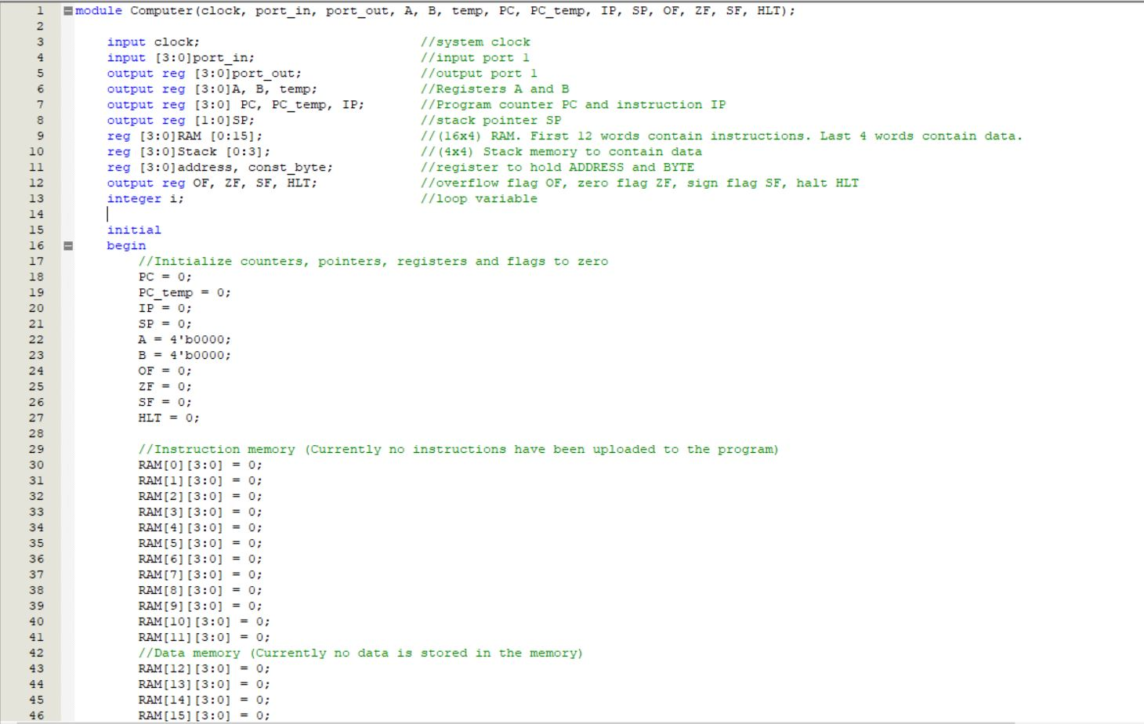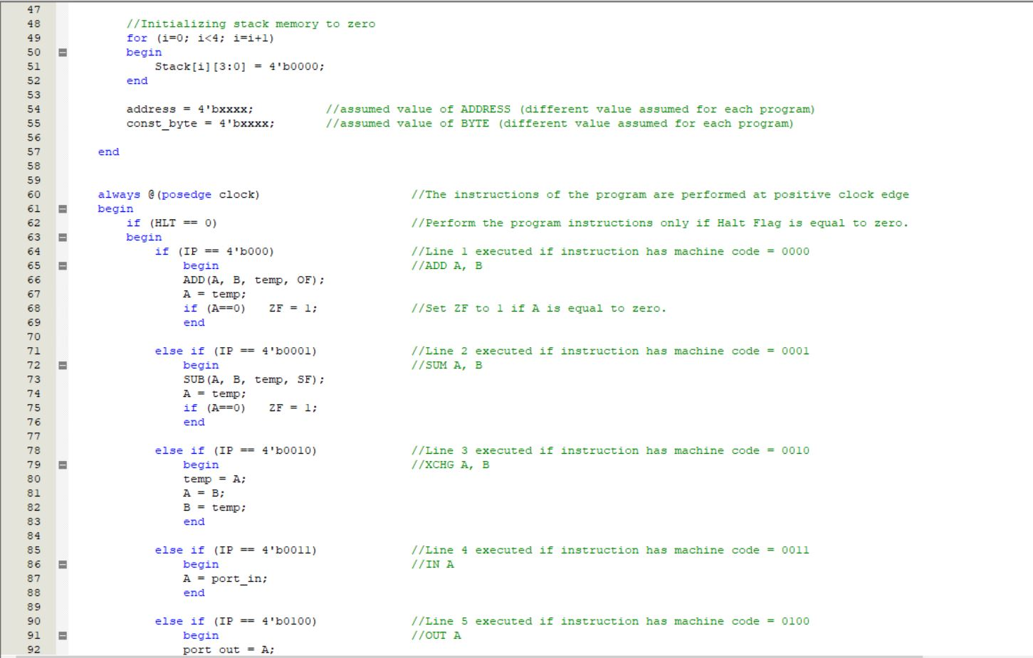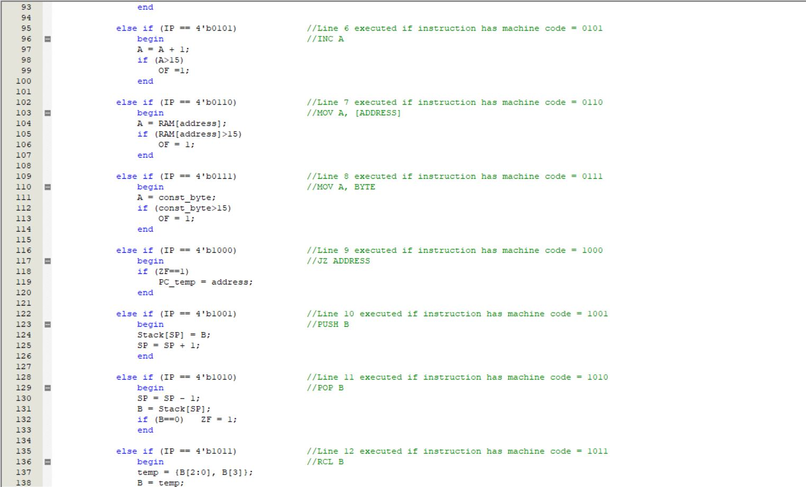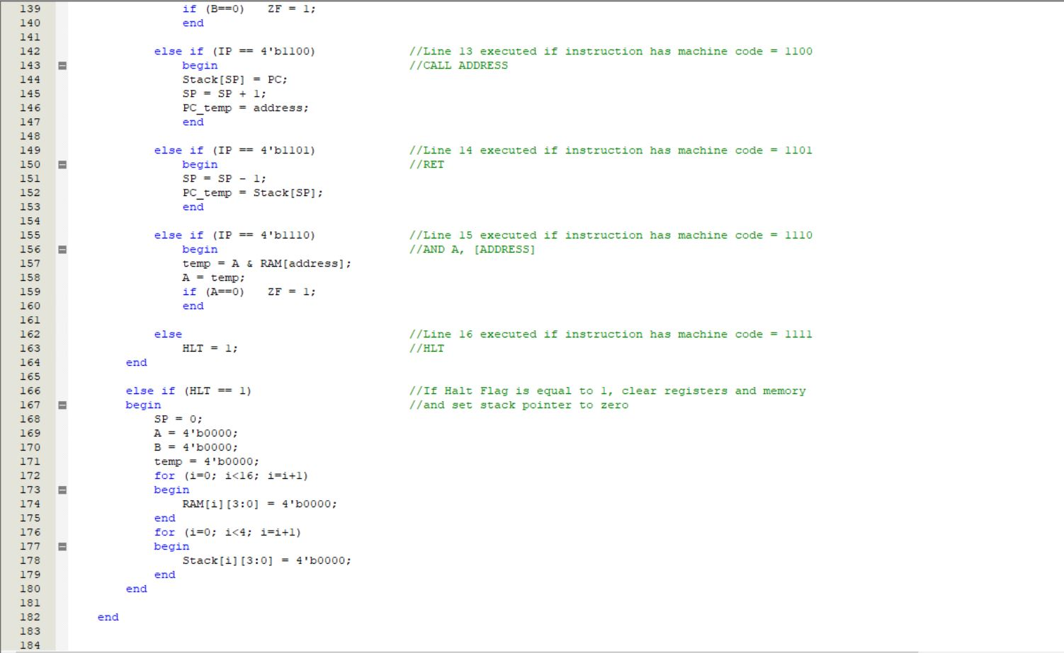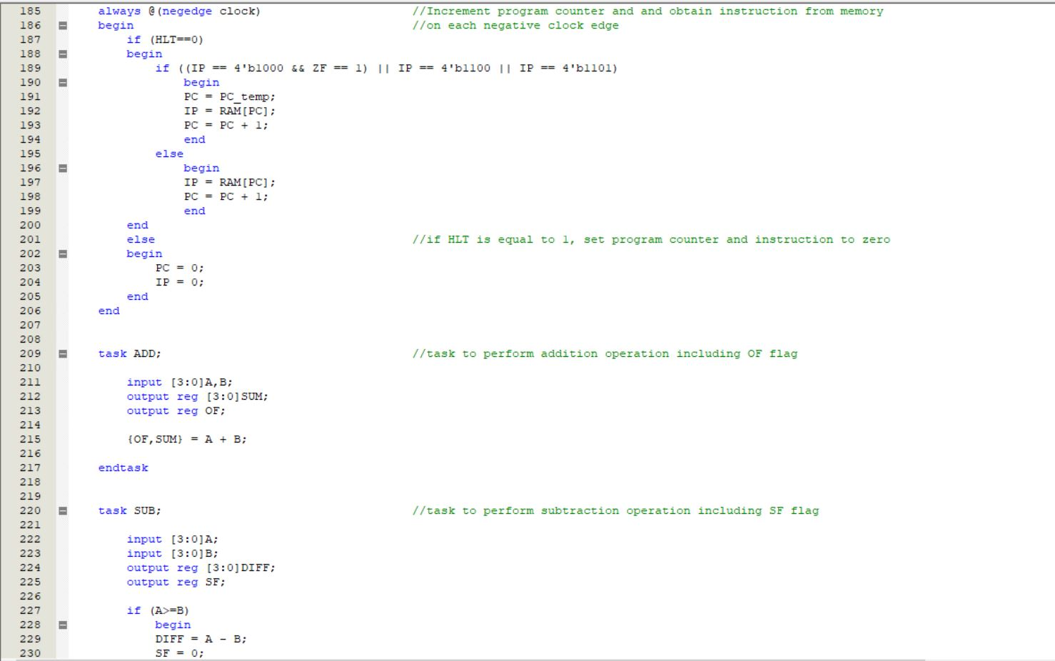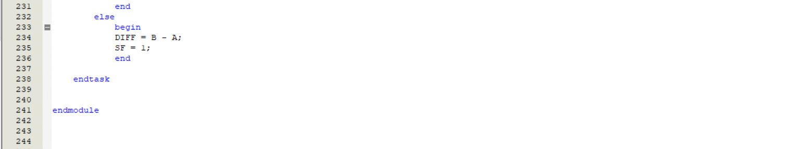

We created a module with two registers A and B, a 16x4 RAM and a 4x4 Stack memory. The first 12 words of the RAM are meant to hold instructions while the last 4 words are meant to hold data. Since we were asked to build a 4-bit computer, we restrained ourselves to only 4-bit data. Therefore, the RAM only contains (16 = 24) memory locations, and each memory location can contain only 4-bit data. We needed to perform the 16 operations given in our instruction set. So all the possible 16 (24) binary numbers were assigned as Op-codes for the instructions. We restricted ourselves to 4 bits, and therefore we could not assign any Op-codes to extract data from memory locations, as that would require the use of 8 bit instructions. The code for the module is explained above with necessary comments.

**Test Programs to test the operations of the computer:**

**Test Code – 1**

Assume address = 14 and byte = 10.

MOV A, [address]

XCHG B, A

MOV A, byte

SUB A, B

ADD A, B

PUSH B

RCL B

POP B

HLT

**Instruction and Data section of memory in the Verilog code:**

//Instruction memory

RAM[0][3:0] = 6;

RAM[1][3:0] = 2;

RAM[2][3:0] = 7;

RAM[3][3:0] = 1;

RAM[4][3:0] = 0;

RAM[5][3:0] = 9;

RAM[6][3:0] = 11;

RAM[7][3:0] = 10;

RAM[8][3:0] = 15;

RAM[9][3:0] = 4’bxxxx;

RAM[10][3:0] = 4’bxxxx;

RAM[11][3:0] = 4’bxxxx;

//Data memory

RAM[12][3:0] = 0;

RAM[13][3:0] = 0;

RAM[14][3:0] = 6;

RAM[15][3:0] = 0;

//Initializing stack memory to zero

for (i=0; i<4; i=i+1)

begin

Stack[i][3:0] = 4’b0000;

end

address = 14;

const_byte = 10;

**Vector waveform file:**

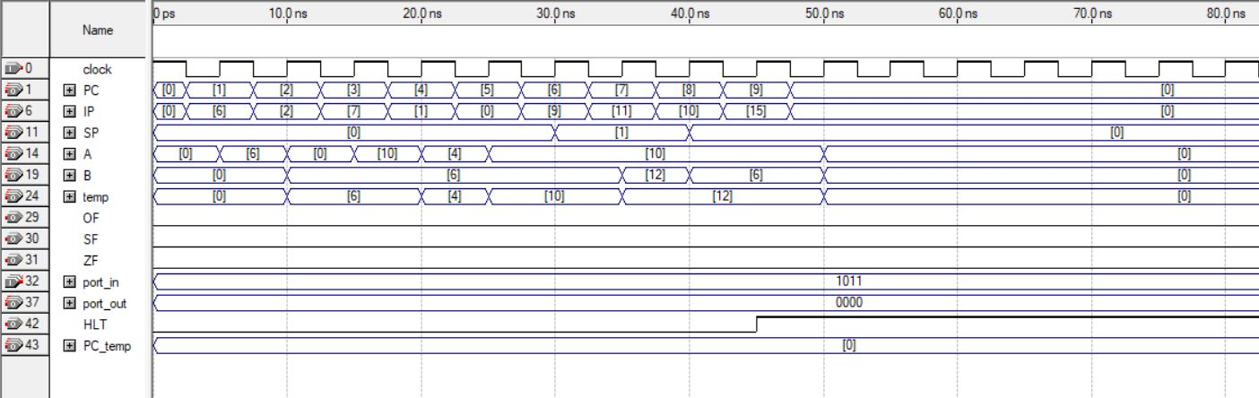

**Figure: Output for Test Code 1**

In this test code we tested the operations MOV, XCHG, ADD, SUB, PUSH, POP, RCL and HLT. We assumed the value of ADDRESS to be 14, the value stored at address location 14 be 6 and BYTE to be 10. We can see in the waveforms above that on each negative edge of clock program counter PC increments by 1 and the corresponding instruction that the instruction pointer is pointing at also changes. We can see the order of the instructions is 6, 2, 7, 1, 0, 9, 11, 10, 15 which corresponds to our Assembly Language.

MOV A, [ADDRESS] (instruction 6H) - When IP = 6, at the first positive edge of clock register A is set to the value of 6 which is the value stored in address location EH (14).

XCHG B, A (instruction 2H) – When IP = 2, at the first positive edge of clock register A is set to 0 (previous value of register B) and register B is set to 6 (previous value of register A).

MOV A, BYTE (instruction 7H) – When IP = 7, at the first positive edge of clock, register A is set to the value of BYTE (10).

SUB A, B (instruction 1H) – When IP = 1, at the first positive edge of clock, A is subtracted from B (10 – 6) and the result (4) is stored in A. B is unchanged.

ADD A, B (instruction 0H) – When IP = 0, at the first positive edge of clock, A is added to B (4 + 6) and the result (10) is stored in A. B is unchanged.

PUSH B (instruction 9H) – When IP = 9, at the first positive edge of clock, the value of register A is pushed to the stack. We can see SP changes to 1. So, stack pointer now points to memory location 1H of stack memory from 0H.

RCL B (instruction BH) – When IP = 11, at the first positive clock edge, the value of B rotates to the left by 1 unit and changes from 6 (0110B) to 12 (1100B).

POP B (instruction AH) – When IP = 10, at the first positive clock edge, the value at them stack memory at which the stack pointer is pointing (6) is passed to B. The stack pointer is decremented by 1 from 1 to 0.

HLT (instruction FH) – When IP = 15, at the first positive edge of clock, HLT is set to 1 indicating the end of program. At the next negative clock edge PC, IP and SP are set to 0, and at the following positive clock edge the RAM, stack and registers A and B are cleared.

**Test Code – 2**

Assume address = 6, input = 8 and byte = 10.

IN A

XCHG B, A

MOV A, 8H

SUB A, B

JZ 6H

RCL B

INC A

OUT A

HLT

**Instruction and Data section of memory in the Verilog code:**

//Instruction memory

RAM[0][3:0] = 3;

RAM[1][3:0] = 2;

RAM[2][3:0] = 7;

RAM[3][3:0] = 1;

RAM[4][3:0] = 8;

RAM[5][3:0] = 11;

RAM[6][3:0] = 5;

RAM[7][3:0] = 4;

RAM[8][3:0] = 15;

RAM[9][3:0] = 4’bxxxx;

RAM[10][3:0] = 4’bxxxx;

RAM[11][3:0] = 4’bxxxx;

//Data memory

RAM[12][3:0] = 0;

RAM[13][3:0] = 0;

RAM[14][3:0] = 0;

RAM[15][3:0] = 0;

//Initializing stack memory to zero

for (i=0; i<4; i=i+1)

begin

Stack[i][3:0] = 4’b0000;

end

address = 6;

const_byte = 8;

**Vector waveform file:**

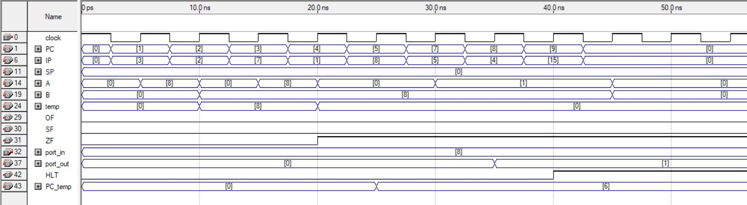

**Figure: Output for Test Code 2**

In this test code we tested the operations IN, OUT and INC. We also checked how the ZF flag changes. We assumed the value of ADDRESS to be 6, input to be 8 and BYTE to be 8. We can see in the waveforms above that on each negative edge of clock program counter PC increments by 1 and the corresponding instruction that the instruction pointer is pointing at also changes. We can see the order of the instructions is 3, 2, 7, 1, 8, 11, 5, 4, 15 which corresponds to our Assembly Language.

IN A (instruction 3H) – When IP = 3, at the first positive clock edge, the value at the input port (8) is passed to the register A.

ZF – When IP = 1, initially both A and B have the same value of 8. At the first positive clock edge SUB A, B is performed. Hence the value of A changes to 0. Simultaneously, ZF is updated to 1.

INC A (instruction 5H) – When IP = 5, at the first positive clock edge, the value of register A increments by 1 and changes from 0 to 1.

OUT A (instruction 4H) – When IP = 4, at the first positive clock edge, the value of register A (1) is passed to the output port.

**Test Code – 3**

Assume address = 8, input = 7 and byte = 11.

MOV A, BYTE

XCHG B, A

IN A

CALL ADDRESS

OUT A

HLT

ADD A, B

RET

**Instruction and Data section of memory in the Verilog code:**

//Instruction memory

RAM[0][3:0] = 7;

RAM[1][3:0] = 2;

RAM[2][3:0] = 3;

RAM[3][3:0] = 12;

RAM[4][3:0] = 4;

RAM[5][3:0] = 15;

RAM[6][3:0] = 4’bxxxx;

RAM[7][3:0] = 4’bxxxx;

RAM[8][3:0] = 0;

RAM[9][3:0] = 13;

RAM[10][3:0] = 4’bxxxx;

RAM[11][3:0] = 4’bxxxx;

//Data memory

RAM[12][3:0] = 0;

RAM[13][3:0] = 0;

RAM[14][3:0] = 0;

RAM[15][3:0] = 0;

//Initializing stack memory to zero

for (i=0; i<4; i=i+1)

begin

Stack[i][3:0] = 4’b0000;

end

address = 8;

const_byte = 11;

**Vector waveform file:**

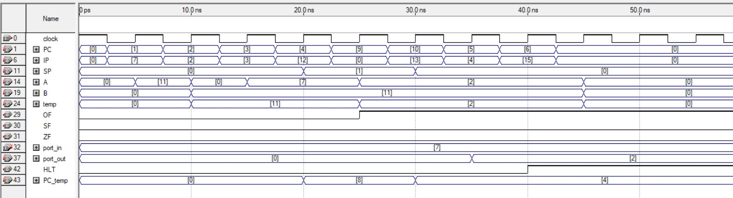

**Figure: Output for Test Code 3**

In this test code we tested the operations CALL and RET. We also checked how the OF flag changes. We assumed the value of ADDRESS to be 8, input to be 7 and BYTE to be 11. We can see in the waveforms above, that on each negative edge of clock, program counter PC increments by 1 and the corresponding instruction that the instruction pointer is pointing at also changes. We can see the order of the instructions is 7, 2, 3, 12, 0, 13, 4, 15 which corresponds to our Assembly Language.

CALL ADDRESS (instruction CH) – When IP = 12, at the first positive clock edge the current value of the PC (4) gets stored in the stack and the SP gets updated to 1. The PC value gets updated to the value ADDRESS. The instruction corresponding to that value (0) gets performed.

OF – When IP = 0, at the first positive clock edge ADD A, B (7+11) is performed. As the result is greater than 15, we cannot store it in a 4-bit number and hence the OF flag is updated to 1.

RET (instruction DH) – When IP =13, at the first positive edge of clock, the PC is set to the value at the stack memory at which the SP is currently pointed (4), and the SP is decremented to 0 form 1.

**Test Code – 4**

Assume address = 15, input = 11 and byte = 14.

MOV A, BYTE

XCHG B, A

MOV A, [ADDRESS]

SUB A, B

IN A

AND A, [ADDRESS]

HLT

**Instruction and Data section of memory in the Verilog code:**

//Instruction memory

RAM[0][3:0] = 7;

RAM[1][3:0] = 2;

RAM[2][3:0] = 6;

RAM[3][3:0] = 1;

RAM[4][3:0] = 3;

RAM[5][3:0] = 14;

RAM[6][3:0] = 15;

RAM[7][3:0] = 4’bxxxx;

RAM[8][3:0] = 4’bxxxx;

RAM[9][3:0] = 4’bxxxx;

RAM[10][3:0] = 4’bxxxx;

RAM[11][3:0] = 4’bxxxx;

//Data memory

RAM[12][3:0] = 0;

RAM[13][3:0] = 0;

RAM[14][3:0] = 0;

RAM[15][3:0] = 12;

//Initializing stack memory to zero

for (i=0; i<4; i=i+1)

begin

Stack[i][3:0] = 4’b0000;

end

address =15;

const_byte = 14;

**Vector waveform file:**

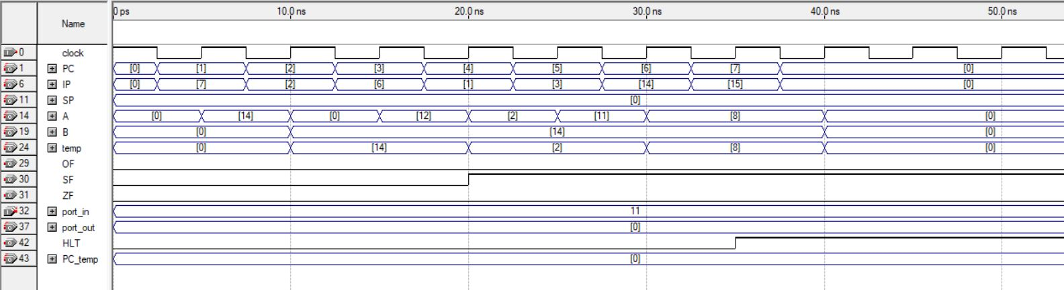

**Figure: Output for Test Code 4**

In this test code we tested the operation AND. We also checked how the SF flag changes. We assumed the value of ADDRESS to be 15, input to be 11 and BYTE to be 14. We can see in the waveforms above, that on each negative edge of clock, program counter PC increments by 1 and the corresponding instruction that the instruction pointer is pointing at also changes. We can see the order of the instructions is 7, 2, 6, 1, 3, 4, 15 which corresponds to our Assembly Language.

AND A, [ADDRESS] (instruction EH) – When IP = 14, at the first positive edge of clock, bitwise AND is performed between A (11 = 1011B) and the value at location ADDRESS (12 = 1100B). The result (1011B & 1100B = 1000B = 8) is stored in A.

SF – When IP = 11, at the first positive clock edge B is subtracted from A (12 – 14). As the result is negative, the SF flag is updated to 1.

**Assembler:**

An assembler was implemented to convert Assembly Language to Machine Language using Python.

**Python Code:**

assembly_file = open ('Assembly Test Code 2.txt', 'r')

machine_file = open ('Machine Test Code 2.txt', 'w')

assembly_str = assembly_file.read()

assembly_list = assembly_str.split('\n')

print(assembly_list)

for item in assembly_list:

if 'ADD' in item:

machine_file.write('0000\n')

elif 'SUB' in item:

machine_file.write('0001\n')

elif 'XCHG' in item:

machine_file.write('0010\n')

elif 'INC' in item:

machine_file.write('0101\n')

elif 'IN' in item:

machine_file.write('0011\n')

elif 'OUT' in item:

machine_file.write('0100\n')

elif 'MOV' in item:

if '[' in item:

machine_file.write('0110\n')

else:

machine_file.write('0111\n')

elif 'JZ' in item:

machine_file.write('1000\n')

elif 'PUSH' in item:

machine_file.write('1001\n')

elif 'POP' in item:

machine_file.write('1010\n')

elif 'RCL' in item:

machine_file.write('1011\n')

elif 'CALL' in item:

machine_file.write('1100\n')

elif 'RET' in item:

machine_file.write('1101\n')

elif 'AND' in item:

machine_file.write('1110\n')

elif 'HLT' in item:

machine_file.write('1111\n')

assembly_file.close()

machine_file.close()

**Examples of how the assembler works:**

**Test code 1 (Assembly Language)**

MOV A, [14]

XCHG B, A

MOV A, 10

SUB A, B

ADD A, B

PUSH B

RCL B

POP B

HLT

**Test code 1 (Machine Language generated using Assembler)**

1010

0010

0111

0001

0000

1001

1011

1010

1111

**Test code 2 (Assembly Language)**

IN A

XCHG B, A

MOV A, 8H

SUB A, B

JZ 6H

RCL B

INC A

OUT A

HLT

**Test code 2 (Machine Language generated using Assembler)**

0011

0010

0111

0001

1000

1011

0101

0100

1111

**Conclusion:**

The 4-bit computer was successfully implemented using Verilog HDL. The code was written in Quartus II software. Vector waveform files to test the performance of the computer were also generated using Quartus II. Different test programs were used to test the performance of the code and it was seen that the computer is successfully able to perform all the tasks given in the instruction set. An assembler was also created using Python to convert Assembly code to Machine code.