AI Knowledge Retention Predictor
Predictive learning analytics and personalized revision
planning powered by Generative AI

Project Overview:
The AI Knowledge Retention Predictor is an intelligent, end-to-end learning support system designed to help learners understand not just what they have studied, but how well they are likely to retain it over time. Unlike traditional learning platforms that focus only on content delivery and assessment scores, this system uses generative AI to analyse study behaviour and predict future forgetting patterns. By considering factors such as last revision date, quiz performance, and perceived topic difficulty, the application estimates retention risk, identifies likely forgetting windows, and recommends optimal revision timings along with personalized study strategies.
Powered by Google’s Gemini generative AI and implemented through a FastAPI backend with a Streamlit-based interactive dashboard, the system transforms raw study inputs into actionable learning insights. Learners can visualize retention risks, receive structured revision roadmaps, and reinforce their understanding through automatically generated topic-wise quizzes. The project demonstrates a practical application of prompt engineering, schema-driven AI design, and responsible AI usage, enabling a shift from reactive revision to predictive, data-informed learning support.

Scenario 1: Student Learning and Exam Preparation
Students preparing for academic exams often revise multiple subjects but struggle to identify which topics require immediate attention. The AI Knowledge Retention Predictor helps students overcome this challenge by analysing their study history, including revision dates, quiz scores, and perceived difficulty levels. Based on this information, the system predicts the likelihood of forgetting each concept and highlights high-risk topics that need timely revision. This enables students to prioritize their study efforts more effectively instead of revising all topics uniformly.
By providing clear forgetting windows, recommended revision timings, and step-by-step revision roadmaps, the system supports smarter and more efficient exam preparation. The inclusion of AI-generated quizzes allows students to actively test their understanding after revision, reinforcing learning through practice. As a result, learners can improve retention, reduce last-minute cramming, and approach exams with greater confidence and clarity.

Scenario 2: Self-Directed Learning and Skill Development
Self-learners and professionals acquiring new skills often study independently without structured feedback on their retention levels. The AI Knowledge Retention Predictor acts as a personalized learning assistant by continuously evaluating how well newly learned concepts are retained over time. Through regular input of learning progress, users receive predictive insights into which skills may fade without reinforcement, helping them maintain long-term mastery rather than short-term familiarity.
The system also supports continuous skill development by offering adaptive revision strategies and knowledge checks tailored to each concept. By combining retention analysis with automated quizzes and visual progress indicators, learners gain a clearer understanding of their strengths and gaps. This makes the platform especially useful for professionals preparing for certifications, interviews, or technical upskilling, where sustained retention and consistent revision are critical for success.

Architecture Overview:
The AI Knowledge Retention Predictor is built on a modular, service-oriented architecture that cleanly separates user interaction, AI reasoning, and application logic. At the frontend, a Streamlit-based interface allows learners to input study data, visualize retention insights, and interact with AI-generated quizzes in real time. This interface communicates with a FastAPI backend through a single prediction endpoint, ensuring a lightweight and scalable client–server interaction. User inputs are validated using structured schemas before being processed, which guarantees data consistency and reliability throughout the system.
At the core of the backend lies the AI intelligence layer powered by Google’s Gemini generative model. Carefully designed prompt templates guide the model to analyse learning behaviour, estimate retention risk, and generate structured revision advice and assessments. The backend coordinates retention analysis and quiz generation while handling AI output validation and error safety. Environment variables and secure configuration management ensure safe API usage, making the overall architecture robust, extensible, and suitable for real-world educational or EdTech deployments.

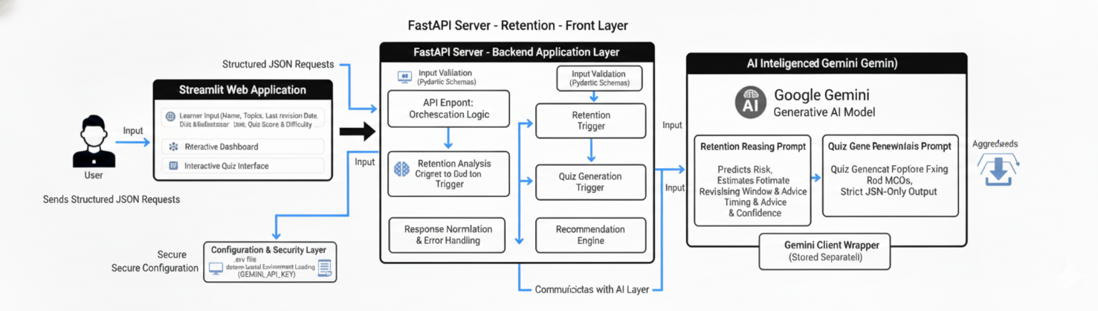

Core Technologies:
- Streamlit: Used as the frontend framework to build an interactive and visually rich web interface. It manages learner input, session state, dashboards, retention reports, and quiz interaction in real time, enabling a smooth and intuitive user experience without complex frontend development.

- FastAPI: Serves as the backend API framework responsible for handling HTTP requests, validating learner input, orchestrating AI workflows, and returning structured responses. Its high performance and asynchronous support make it suitable for scalable AI-driven applications.

- Google Gemini (Generative AI Model): Acts as the core intelligence engine of the system. Gemini is used to analyse learner study behaviour, estimate retention risk, predict forgetting windows, generate personalized study advice, and create topic-wise assessment quizzes using advanced prompt engineering techniques.

- Prompt Engineering Module: A dedicated logic layer that constructs structured prompts for retention reasoning and quiz generation. It enforces strict JSON output formats, applies instruction prompting, and ensures consistent, reliable AI responses aligned with educational objectives.

- Pydantic (Data Validation & Schemas): Used to define strict input schemas for learner data and study concepts. It ensures type safety, validates incoming requests, and maintains data integrity across the backend and AI processing pipeline.

- Python Backend Logic: Coordinates data flow between the frontend, API layer, AI model, and response formatter. It handles preprocessing, postprocessing, error handling, and normalization of AI outputs, forming the backbone of the system’s reliability.

- dotenv (Environment Management): Provides secure management of sensitive credentials such as the Gemini API key. Environment variables are loaded safely at runtime, preventing hardcoding and supporting secure deployment practices.

- Plotly: Used within the Streamlit interface to create interactive visualizations such as retention risk gauges, progress indicators, and summary charts. These visuals help learners quickly interpret AI-generated insights.

- Requests Library: Enables communication between the Streamlit frontend and the FastAPI backend through RESTful API calls, ensuring smooth data exchange and real-time updates.

- Session State Management: Streamlit’s session state is leveraged to maintain learner progress, concept lists, quiz answers, and navigation flow across multiple interactions without data loss.

Component-Wise Architecture:
Component | Description
User Interface (Streamlit) | Provides an interactive web-based dashboard for learners to input study concepts, view retention analysis, explore revision strategies, and participate in AI-generated quizzes. It manages session state, navigation, and real-time visualization of learning insights.
Backend API Layer (FastAPI) | Acts as the central coordination layer that receives validated learner input, triggers retention analysis and quiz generation, and returns structured responses to the frontend. It ensures a clean separation between UI and AI logic.
Retention Analysis Engine | Uses Google Gemini with structured prompts to analyse learner study behaviour and estimate retention risk, forgetting windows, revision timing, and personalized study advice for each concept.
Quiz Generation Engine | Dynamically generates topic-wise multiple-choice quizzes based on analysed concepts. It reinforces learning by transforming AI reasoning outputs into assessment questions aligned with the learner’s weak areas.
Prompt Engineering Module | Builds and manages strict prompt templates for both retention reasoning and quiz generation. It enforces output structure, minimizes hallucinations, and ensures consistent AI behaviour across requests.
Data Schema & Validation Layer | Implements Pydantic-based schemas to validate learner input and concept data before AI processing. This layer ensures type safety, prevents malformed requests, and maintains consistency across the system.
Response Normalization & Recommendation Engine | Formats and normalizes AI-generated outputs into a predictable structure, handling edge cases where the AI response may deviate from the expected schema.
Visualization & Analytics Layer | Uses Plotly within Streamlit to present retention risks, progress summaries, and performance indicators through intuitive charts and gauges, enabling quick interpretation of results.
Session & State Manager | Maintains learner state, concept lists, quiz responses, and navigation flow across analysis and quiz stages, ensuring continuity in the user experience.
Environment & Configuration Manager | Securely loads and manages environment variables such as API keys using dotenv, initializes AI models, and handles application-level configuration settings.
Error Handling & Safety Layer | Captures API failures, invalid AI outputs, and connection issues, returning user-friendly error messages while preventing system crashes.

Pre-requisites:
1. Python Environment Setup: The system is built using Python 3.9 or above for flexibility and strong AI library support. Create and activate a dedicated virtual environment to manage dependencies.
Official Documentation: https://www.python.org/downloads/
2. Streamlit Installation and Configuration: Streamlit powers the interactive interface for AI-driven content generation. Install and configure Streamlit to build and run the web application.
Learn More:
- Docs: https://docs.streamlit.io/library/get-started/installation
- Tutorial: https://www.youtube.com/watch?v=JwSS70SZdyM
3. Google Gemini API Integration: The project integrates Google Gemini 2.0 Flash for intelligent tone analysis and content creation. Set up by creating an API key in Google AI Studio and securely storing it in a .env file.
Resources:
- AI Studio: https://aistudio.google.com/
- SDK (PyPI): https://pypi.org/project/google-generativeai/
4. Environment & Security Configuration: Uses python-dotenv to manage sensitive credentials securely. Store your Gemini API key in a .env file to avoid exposure.
Reference: https://pypi.org/project/python-dotenv/
5. Dependency Installation
All dependencies are listed in requirements.txt.
Key libraries include:
- streamlit – Interactive UI
- google-generativeai – Gemini API integration
- python-dotenv – Environment management
- pyperclip – Clipboard functionality
6. Development Tools
Recommended IDEs:
- Visual Studio Code: https://code.visualstudio.com/
- PyCharm (Community Edition): https://www.jetbrains.com/pycharm/download/
7. Optional Learning Resources
Enhance understanding with:
- Prompt Engineering Guide: https://learnprompting.org/
- Streamlit Components Gallery: https://streamlit.io/components
- Gemini Tutorials: https://www.youtube.com/@GoogleDevelopers

Project Flow:
1. Gemini API Infrastructure Initialization
- Activity 1.1: Obtain Google Gemini API Key from Google AI Studio and store it securely in a .env file.

- Activity 1.2: Create and activate a virtual environment, install required dependencies (streamlit, fastapi, google-generativeai, python-dotenv, pydantic, plotly, requests), and configure the API key within the configuration module.

- Activity 1.3: Validate Gemini LLM connectivity by executing a test generation call to confirm API access, permissions, and response validity.

2. Core Retention Analysis & Quiz Intelligence Development
- Activity 2.1: Define and validate learner data schemas (learner name, topic, revision date, quiz score, difficulty) using Pydantic.

- Activity 2.2: Design a structured retention reasoning prompt to predict retention risk, forgetting window, revision timing, and study advice with strict JSON output.

- Activity 2.3: Implement the retention analysis engine to send learner data to Gemini, clean responses, and normalize results.

- Activity 2.4: Create a quiz generation prompt to produce exactly ten topic-wise MCQs aligned with retention risk.

- Activity 2.5: Develop the quiz generation engine to dynamically generate, parse, and validate quizzes safely.

3. Backend API Orchestration and System Integration
- Activity 3.1: Initialize the FastAPI backend and load AI prompt templates at startup.

- Activity 3.2: Implement a POST API endpoint to accept learner data and orchestrate retention analysis and quiz generation.

- Activity 3.3: Add robust error handling for AI failures and invalid outputs.

4. Streamlit Frontend Integration and User Experience
- Activity 4.1: Configure the Streamlit layout and manage session state for learner data, results, and quiz flow.

- Activity 4.2: Build intuitive input forms for adding and managing study concepts.

- Activity 4.3: Connect the frontend to the backend API with progress indicators and user feedback.

- Activity 4.4: Visualize retention insights using charts, gauges, and metric cards.

- Activity 4.5: Implement an interactive quiz interface with scoring and feedback.

- Activity 4.6: Enhance UI/UX using custom CSS, animations, and responsive design.
5. Testing, Optimization, and Deployment Readiness
- Activity 5.1: Validate retention analysis accuracy and quiz generation correctness.

- Activity 5.2: Test UI interactions, session persistence, and visual components.

- Activity 5.3: Optimize performance by refining prompts, reducing latency, and improving responsiveness.
MILESTONE 1: Gemini API Infrastructure Initialization
This foundational milestone establishes the technical environment required to build and run the AI Knowledge Retention Predictor. The objective of this stage is to ensure that all system dependencies, frameworks, and external AI integrations are correctly configured so that the backend intelligence layer and frontend interface can operate seamlessly. A properly configured environment is critical for secure API access, reliable AI responses, and smooth interaction between the Streamlit frontend and FastAPI backend.

Activity 1.1: Obtain Google Gemini API Key
- Sign in or create an account on the official Google AI Studio platform https://aistudio.google.com/


- Clicking on “Get Started” that’s leads to this Google AI Dashboard:
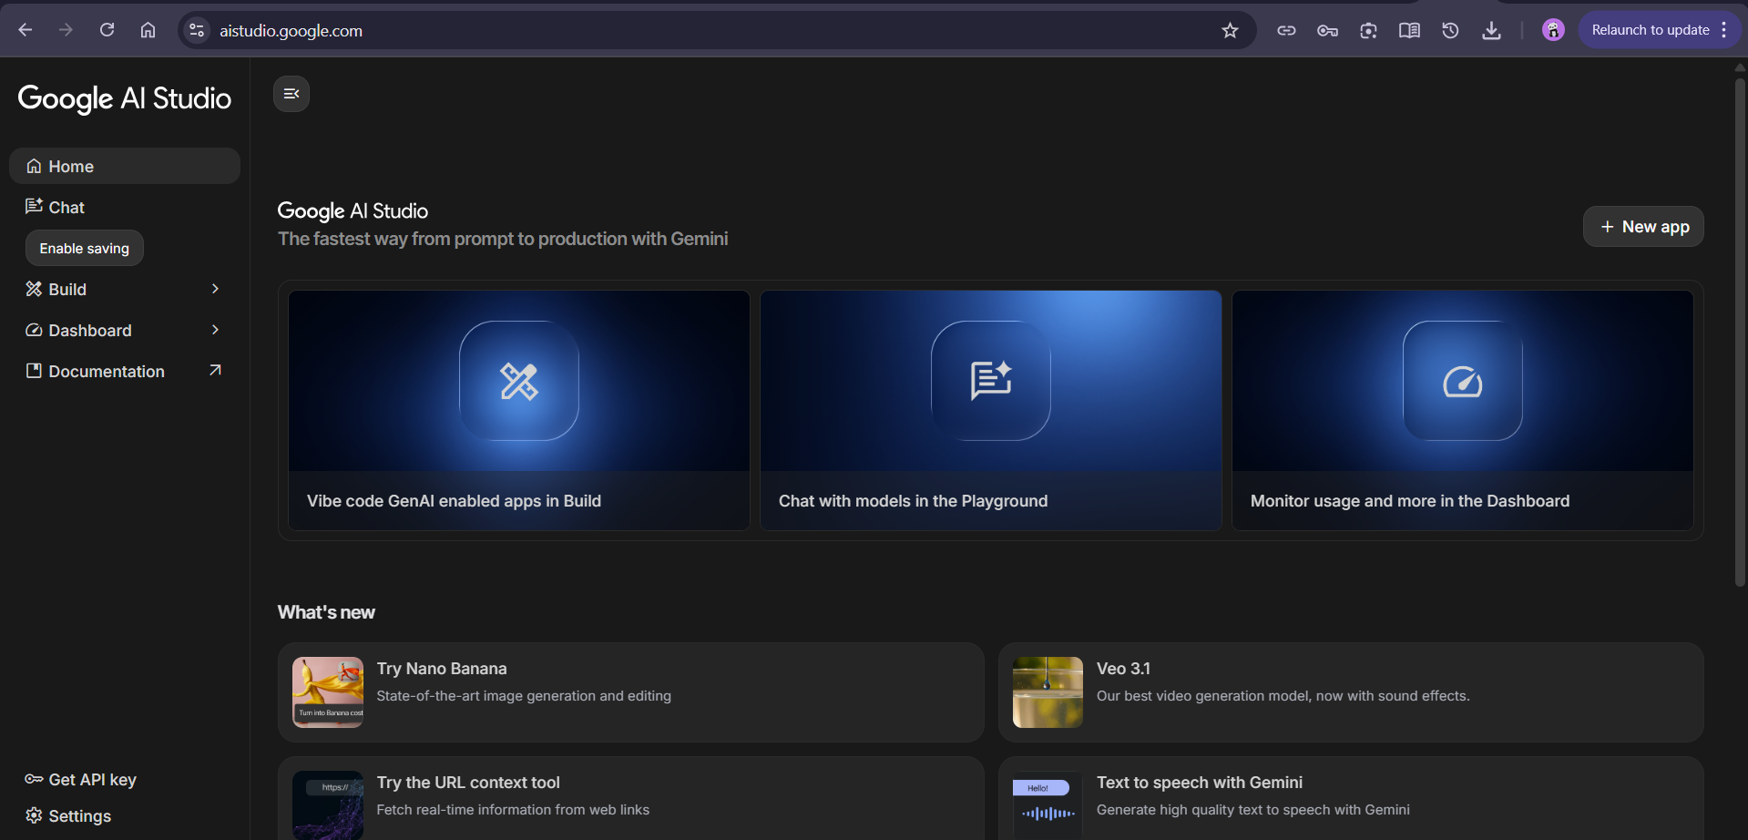

- Navigate to the Get API Keys section under your account dashboard.
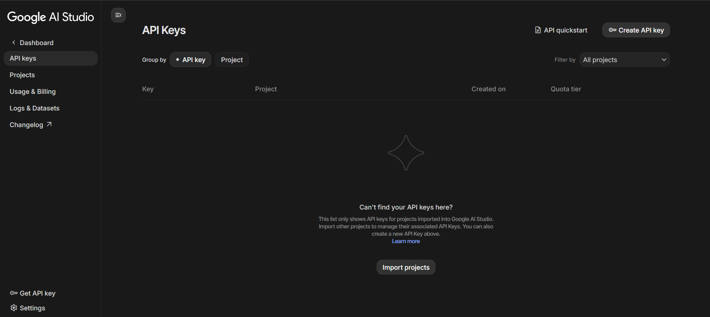

- Click on “Create API Key” to generate a new key for your project.
- Name the key appropriately (e.g., AI_Knowledge_Retention_Analyse) for easy identification.
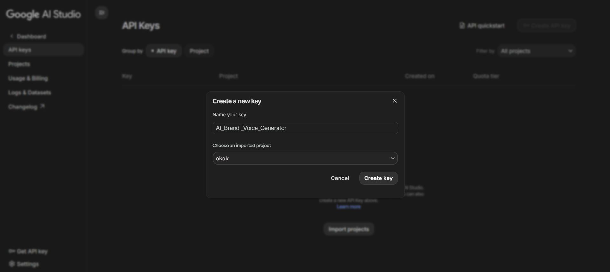

- Copy and securely store the generated API key for later configuration in your .env file.
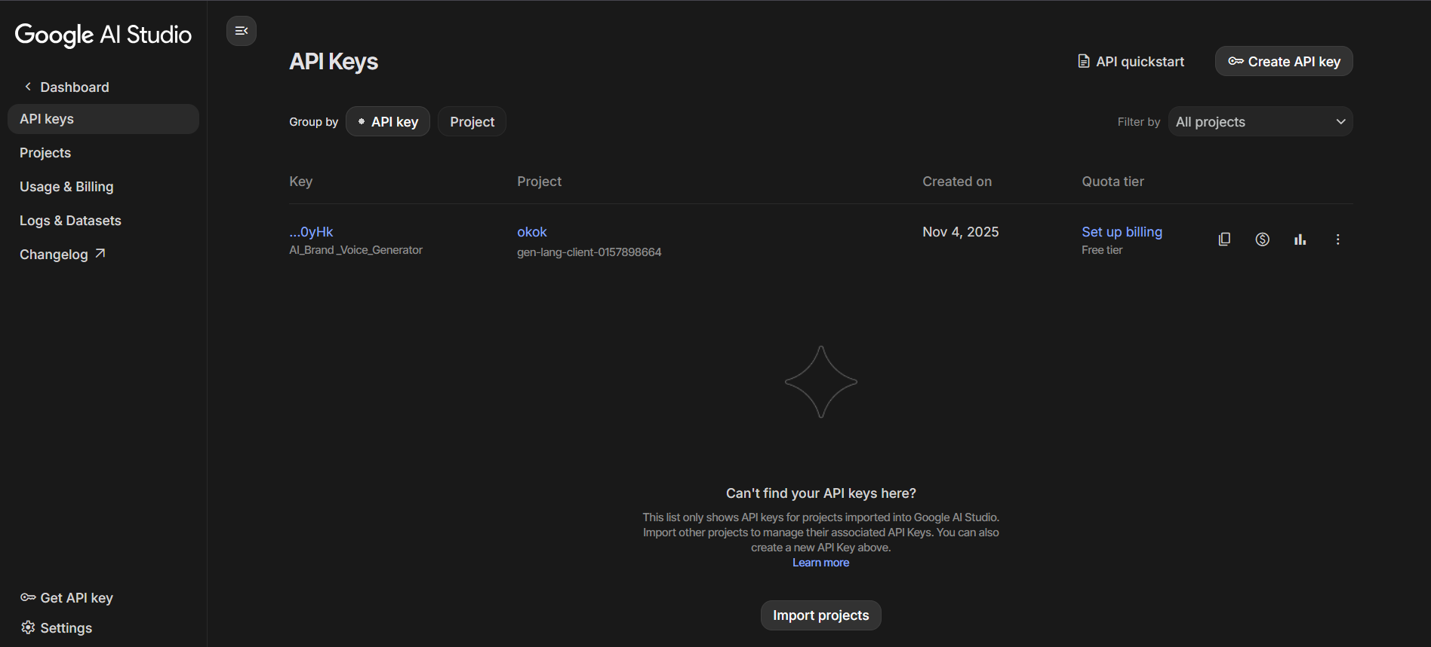

Activity 1.2: Environment Setup & Dependency Installation
- Create a virtual environment for the project:

- Install project dependencies:
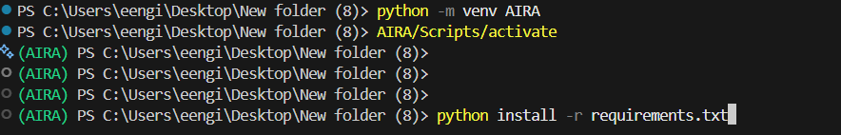

- Making a .env for securing the Gemini API Key as paste the api key here:
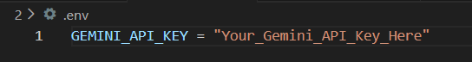

- Set up the project structure for modular development:
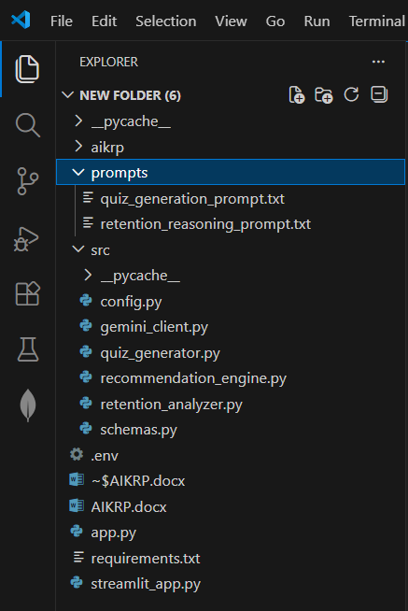

Activity 1.3: Validate Gemini LLM Connectivity and Configuration
- After setup, verify successful connectivity and configuration by performing a test generation call using the Gemini API.
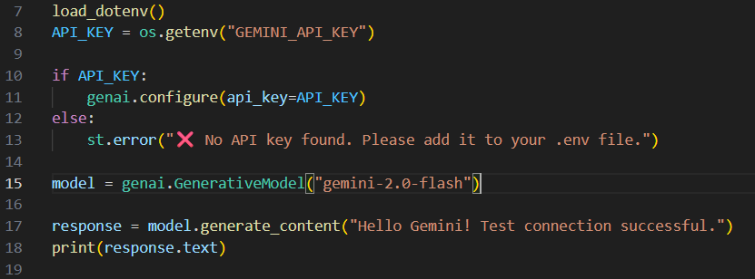

- Confirm that the model responds with valid text output, indicating proper API linkage.
- Validate API key permissions and rate limits within the Google Cloud Console if connectivity fails.
- Once verified, ensure that all AI-driven content generation functions including brand tone analysis, tagline generation, and marketing content creation can be initialized without latency or configuration errors.
MILESTONE 2: Core Retention Analysis & Quiz Intelligence Development
This milestone focuses on building the core intelligence layer of the AI Knowledge Retention Predictor. The objective is to design and implement the AI-driven logic that analyses learner study behaviour, predicts retention risk, and generates personalized revision guidance and assessment quizzes. By the end of this stage, the system is capable of converting structured learner input into meaningful, actionable learning insights using Google’s Gemini generative AI.

Activity 2.1: Learner Data Modelling and Validation
- Design structured schemas to capture learner information such as learner name, topic, last revision date, quiz score, and perceived difficulty.

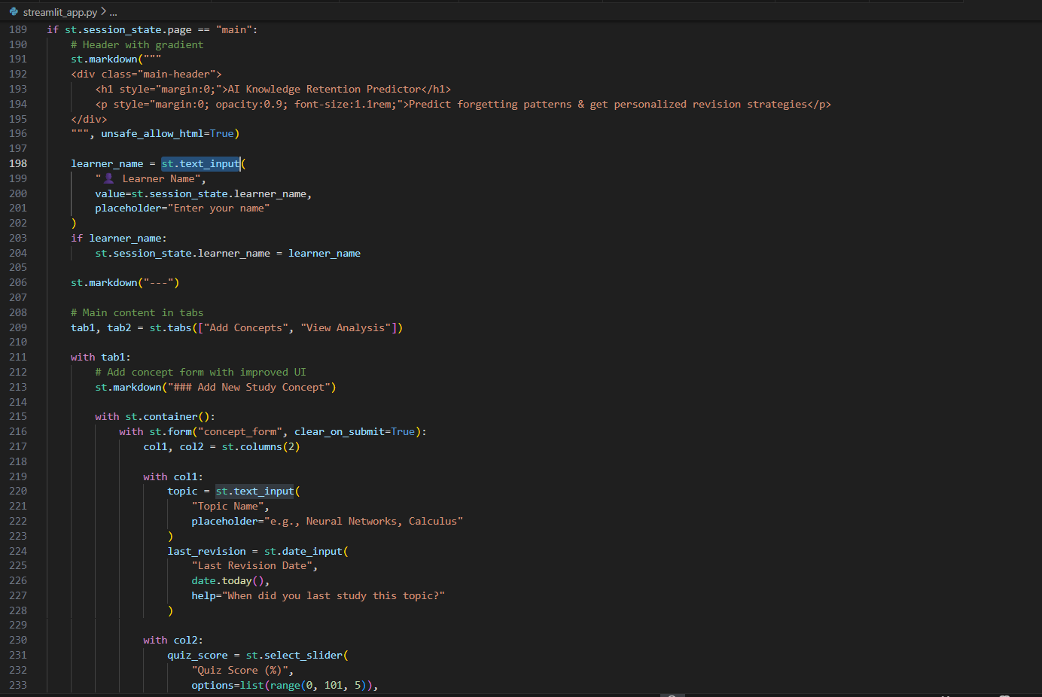

- Implement schema validation using Pydantic to ensure type safety and prevent malformed input.

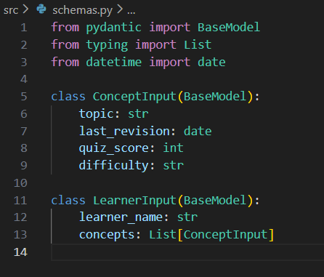

- Convert date objects into standardized string formats to maintain consistency during AI prompt construction.

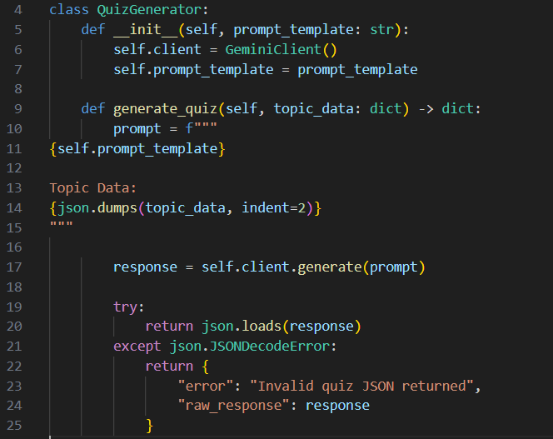

Activity 2.2: Retention Reasoning Prompt Design
- Construct a structured prompt that instructs the model to estimate retention risk, forgetting windows, revision timing, and study advice.

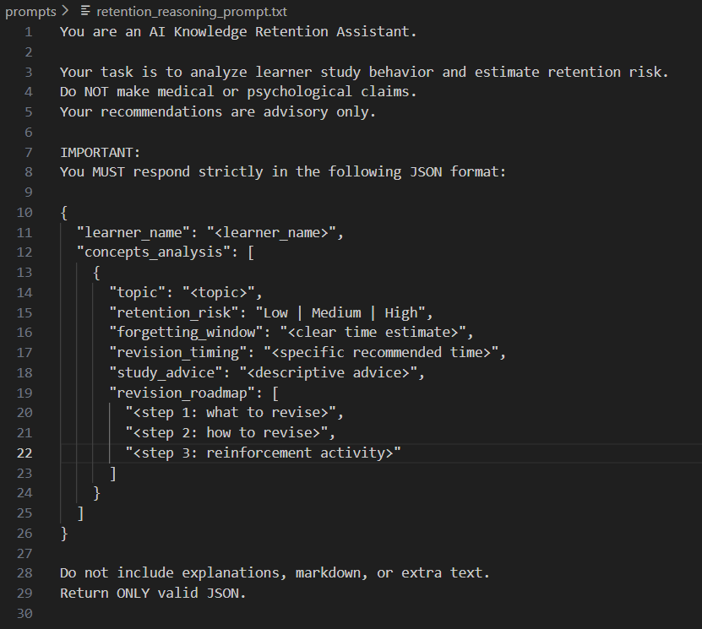
- Enforce strict JSON output formatting to ensure machine-readable and predictable AI responses.

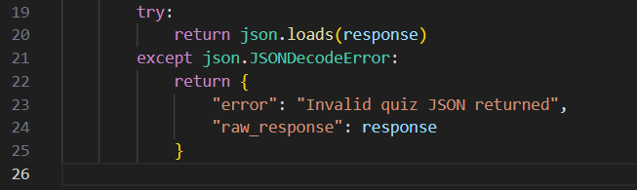

Activity 2.3: Retention Analysis Engine Implementation
- Inject structured learner data into the retention prompt template.

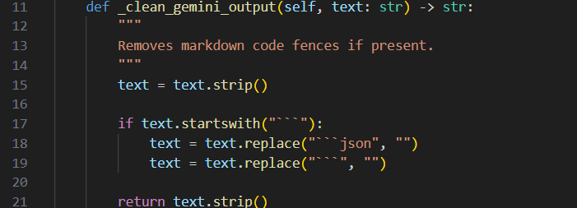

- Send prompts to the Gemini model through a centralized AI client.

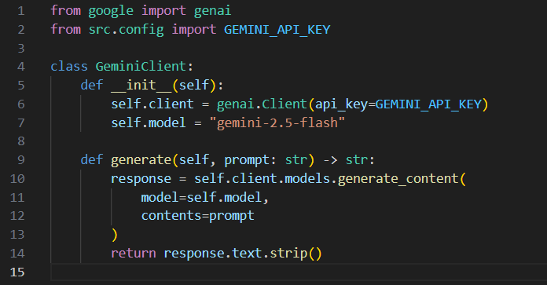

- Clean AI responses by removing markdown artifacts and validating JSON structure.

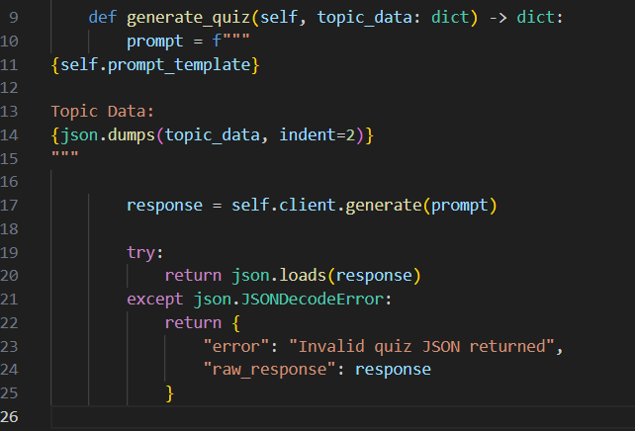
- Normalize outputs to guarantee the presence of required fields such as concept analysis results.

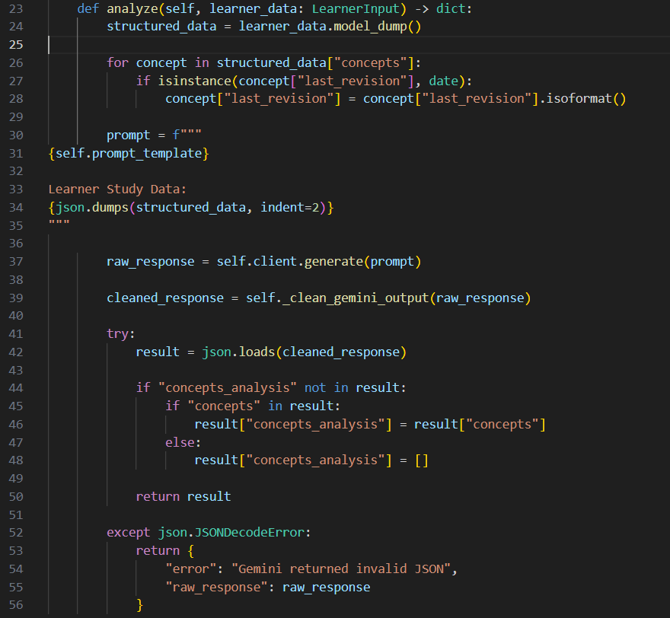

Activity 2.4: Quiz Generation Prompt Engineering
- Build a quiz generation prompt that produces exactly ten multiple-choice questions per topic.

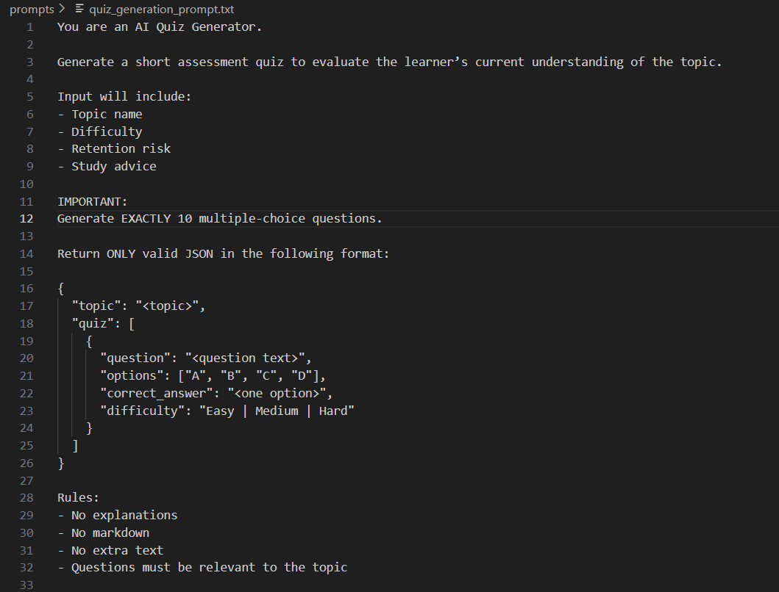

- Enforce strict rules such as no explanations, no extra text, and fixed JSON structure.
- Align question difficulty and relevance with the analysed topic and retention risk.
Activity 2.5: Quiz Generation Engine Development
- Pass concept-level analysis data into the quiz generation prompt.

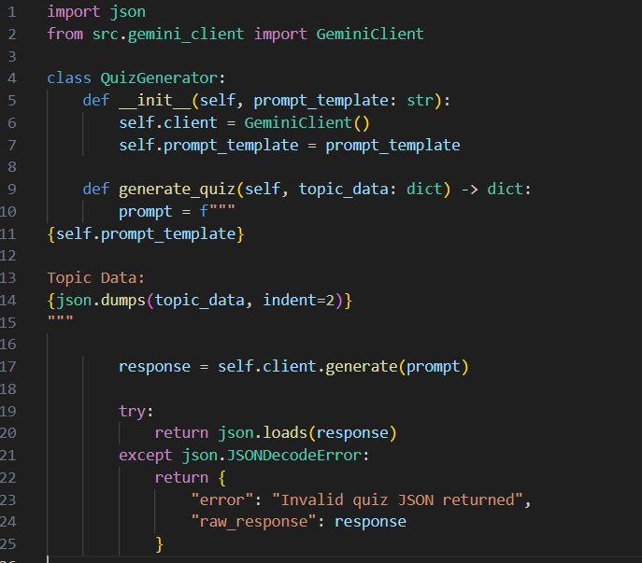

- Invoke Gemini to generate topic-wise quizzes dynamically.

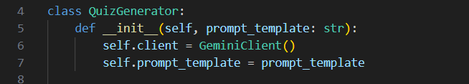

- Parse and validate AI responses, handling invalid JSON safely without crashing the system.

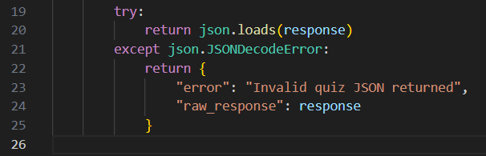

MILESTONE 3: Backend API Orchestration and System Integration
This milestone focuses on integrating all core intelligence components into a unified backend service that can be consumed by the frontend application. The objective is to expose a clean, reliable API that orchestrates retention analysis and quiz generation in a single workflow. By the end of this stage, the system functions as a cohesive service capable of receiving learner data, invoking AI reasoning, and returning structured insights and assessments.

Activity 3.1: FastAPI Service Initialization
- Initialize the FastAPI application with a clear service title.

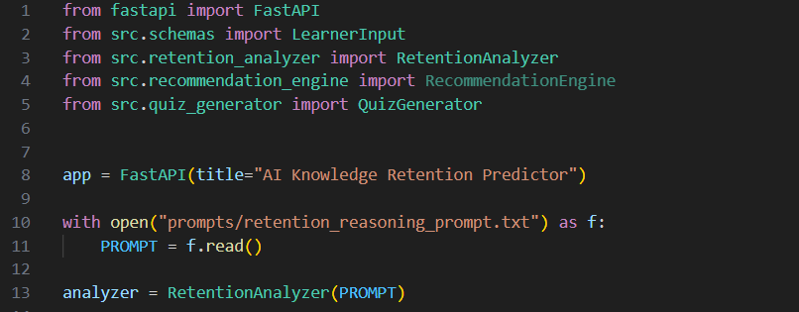

- Configure the application to load AI prompt templates at startup.

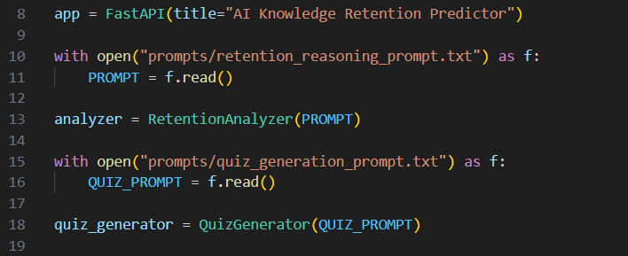

Activity 3.2: API Endpoint Design and Input Handling
- Define a POST endpoint to accept learner data in a structured format.

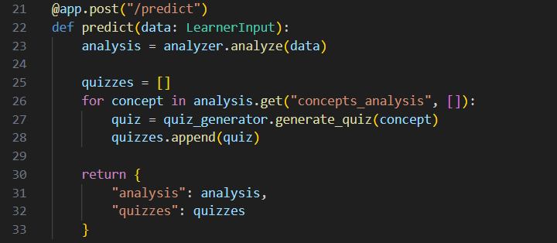

- Validate incoming requests using predefined schemas to ensure correctness.
- Handle improper or incomplete input gracefully without system failure.

Activity 3.3: Error Handling and Reliability Measures
- Capture and handle AI API failures gracefully.

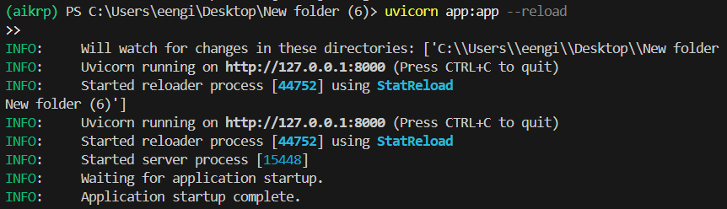

- Return meaningful error messages while preserving system integrity.

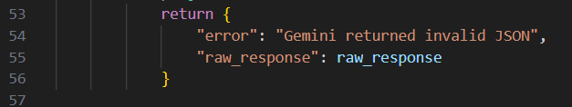
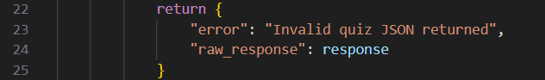

MILESTONE 4: Streamlit Frontend Integration and User Experience Development
This milestone focuses on building a fully interactive, visually polished, and user-friendly frontend that connects seamlessly with the backend API. The objective is to present complex AI-driven retention insights and assessments in an intuitive format that learners can easily understand and act upon. By the end of this stage, the AI Knowledge Retention Predictor functions as a complete, end-to-end application with smooth navigation, rich visual feedback, and an engaging learning experience.

Activity 4.1: Streamlit Application Setup and Session Management
- Configure the Streamlit page.

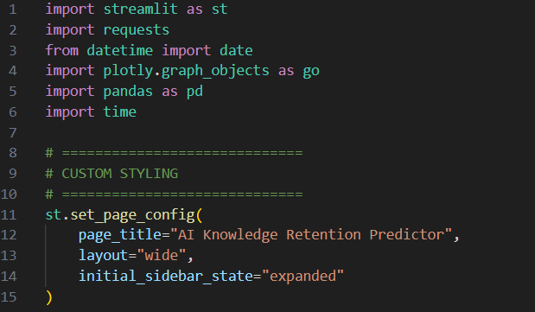

- Initialize session state variables to store learner name, concepts, analysis results, and quiz progress.

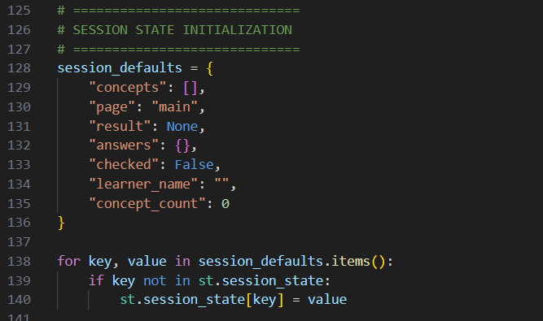

- Implement navigation logic to switch between concept input, analysis dashboard, and quiz views without data loss.

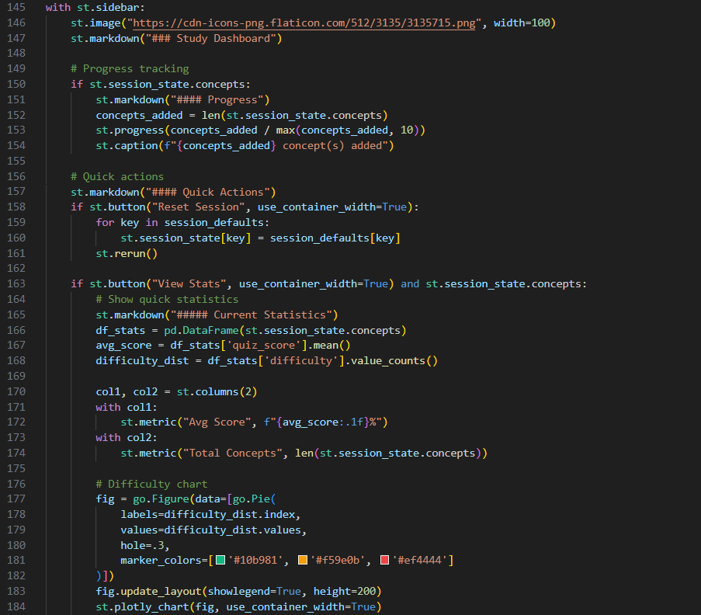

Activity 4.2: Learner Input Interface and Concept Management
- Design input forms for adding study concepts, including topic name, last revision date, quiz score, and difficulty level.

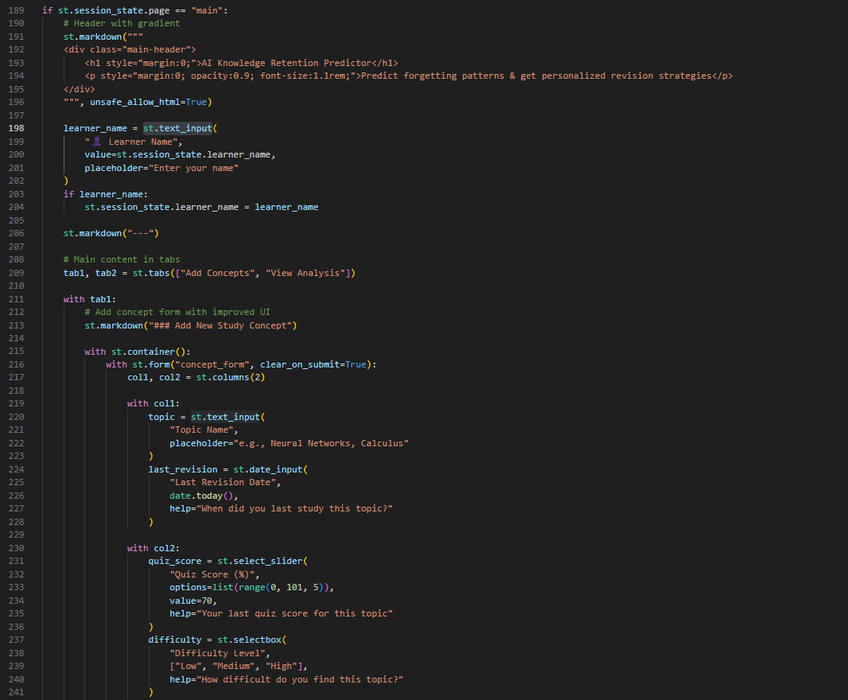

- Display added concepts dynamically with visual indicators for difficulty and mastery level.

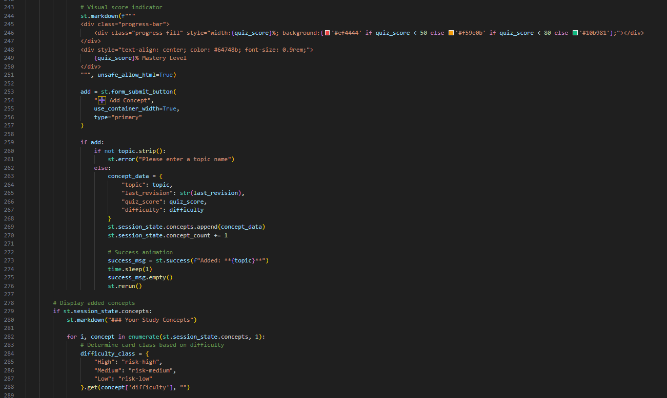

Activity 4.3: Backend API Integration and Analysis Trigger
- Construct structured payloads from session data and send them to the backend API.

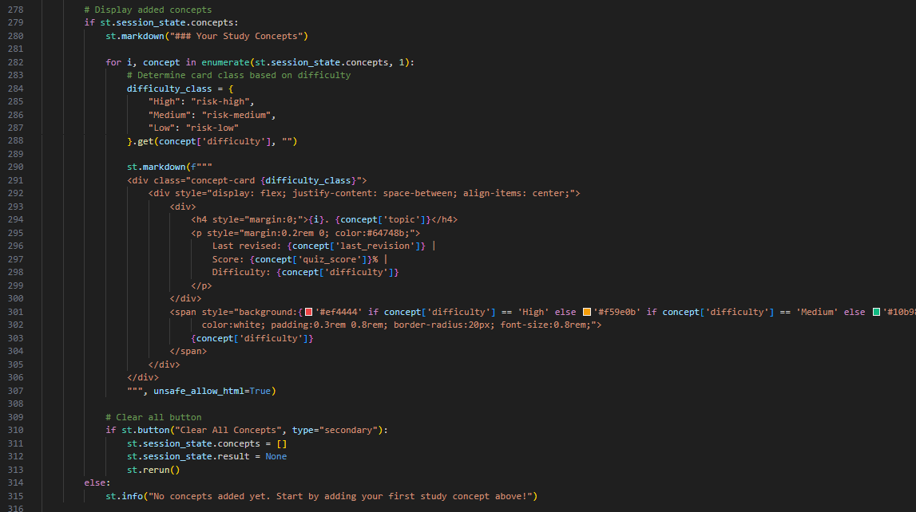

- Display progress indicators and loading animations during analysis.

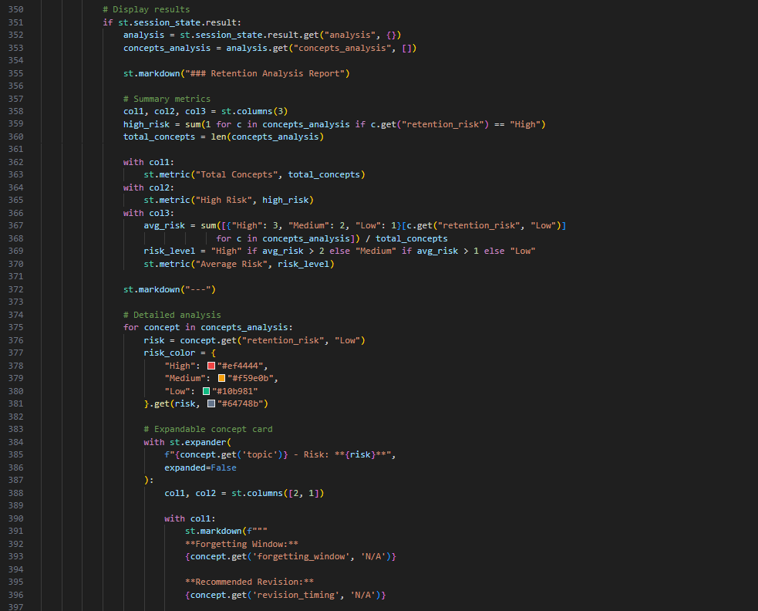

- Handle successful responses and connection errors with appropriate user feedback.
Activity 4.4: Retention Analysis Visualization
- Display retention risk levels, forgetting windows, revision timing, and study advice for each concept.

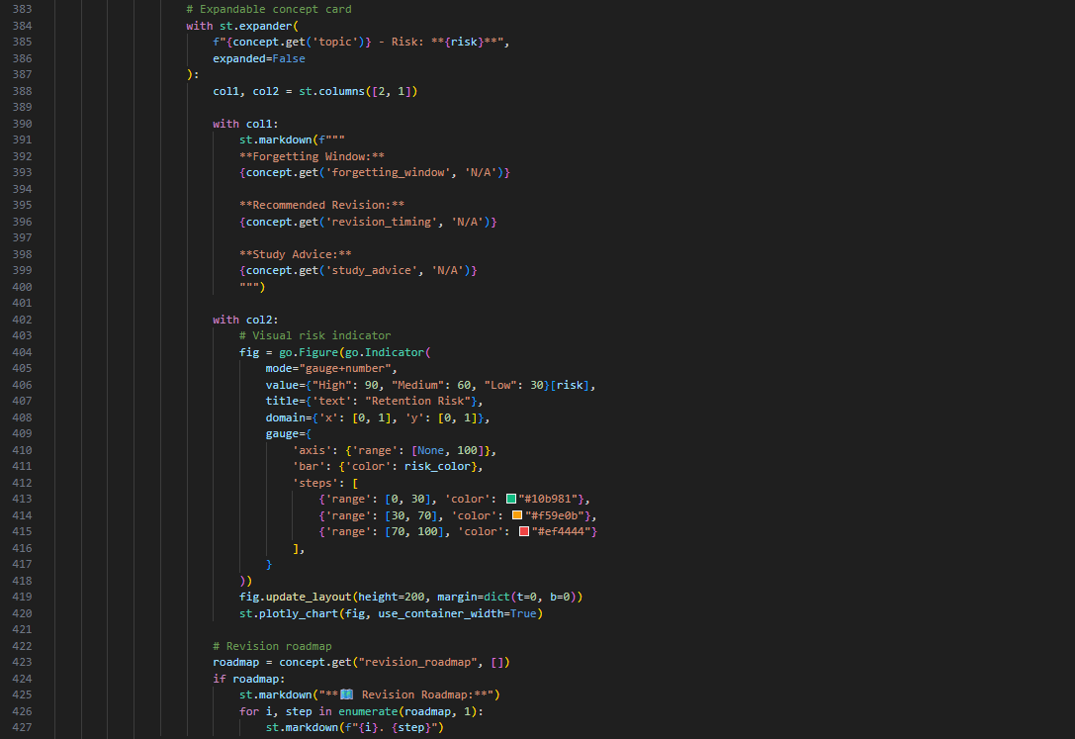

- Use interactive charts, gauges, and metric cards to summarize overall learning status.

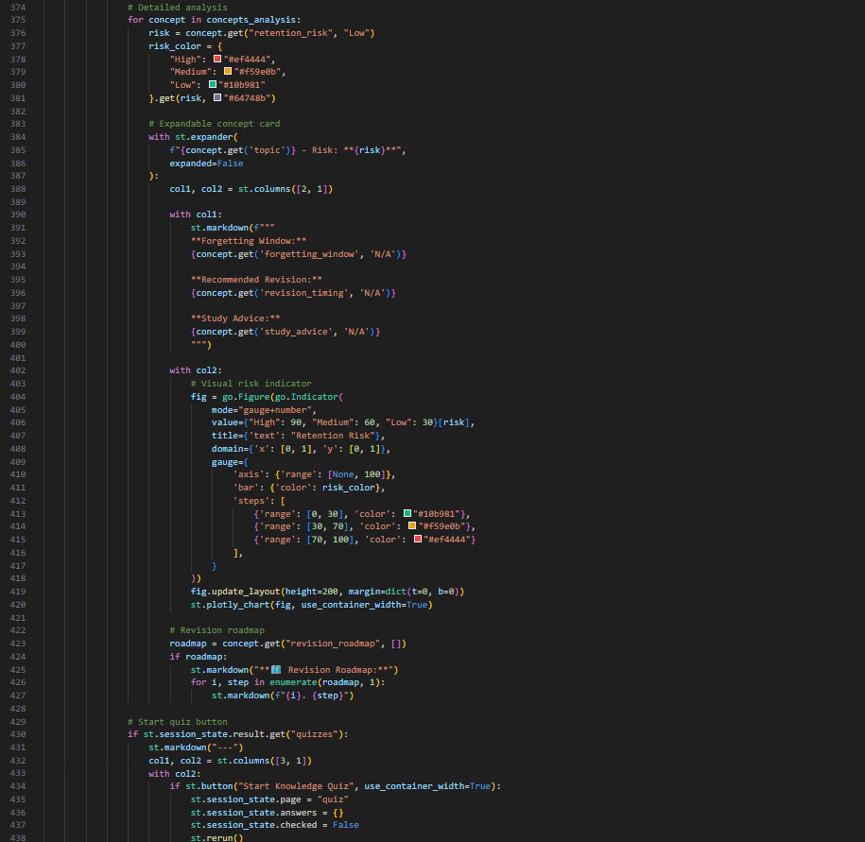

Activity 4.5: Quiz Interface and Knowledge Reinforcement
- Present AI-generated multiple-choice questions topic-wise.

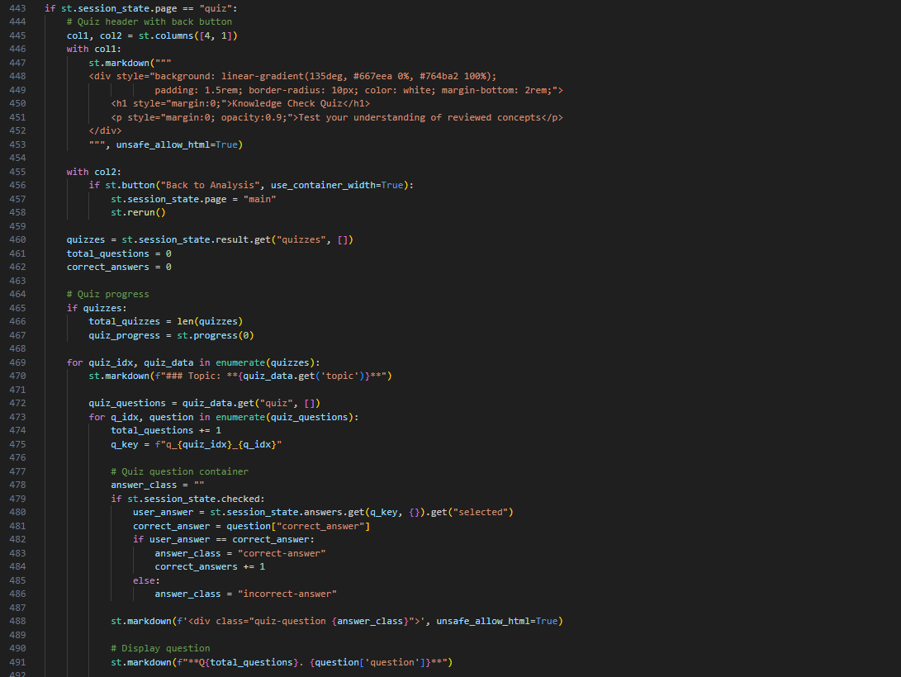

- Allow learners to select answers and submit responses.

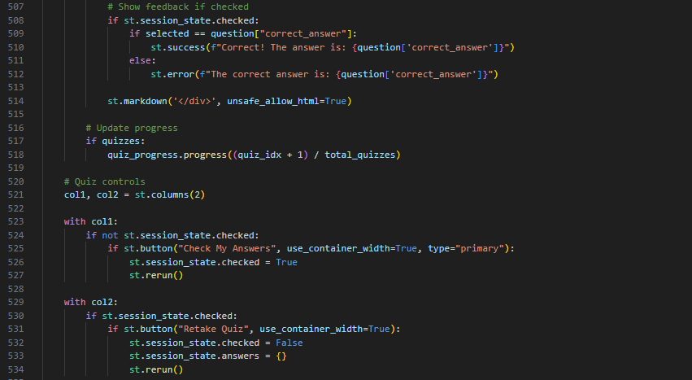

- Highlight correct and incorrect answers with visual feedback.

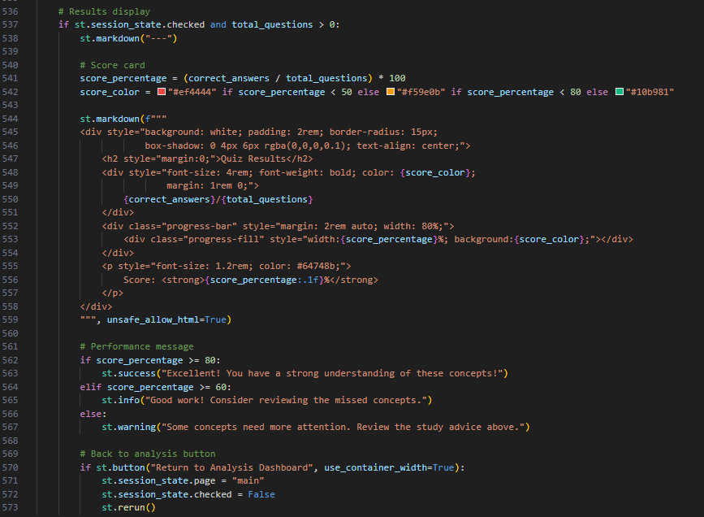

- Display final scores, progress bars, and performance messages.

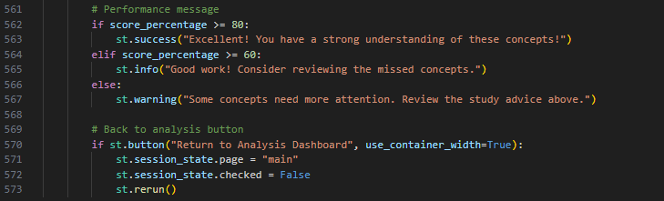

Activity 4.6: UI/UX Enhancement and Visual Styling
- Apply custom CSS for consistent colour schemes, spacing, and typography.

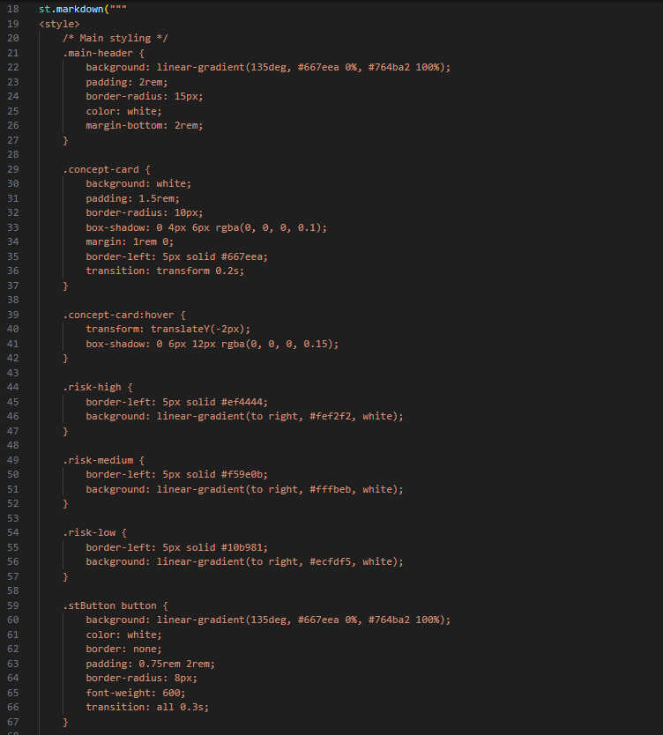

- Add animations, transitions, and hover effects for better interactivity.

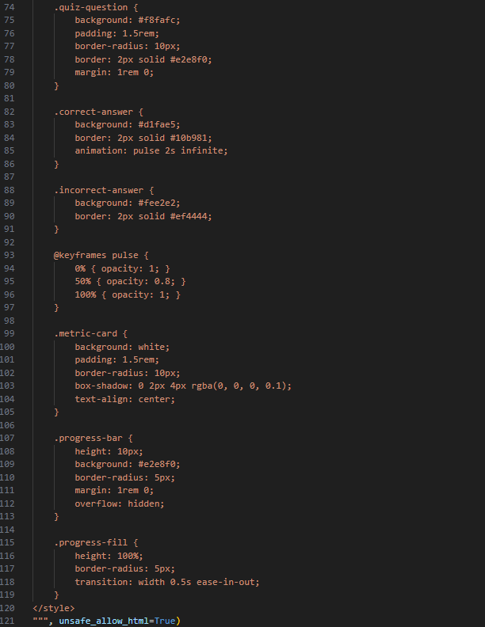

MILESTONE 5: Testing, Optimization, and Deployment Readiness
This milestone ensures that the AI Knowledge Retention Predictor is reliable, efficient, and ready for real-world use. The focus is on validating system behaviour, optimizing performance, and confirming that both backend and frontend components work together smoothly under different user scenarios. By the end of this stage, the application delivers consistent AI insights, stable user interaction, and a polished overall experience.

Activity 5.1: Functional Testing and Validation
- Test Streamlit properly rendering along with heading, tagline, and all necessary inputs fields.

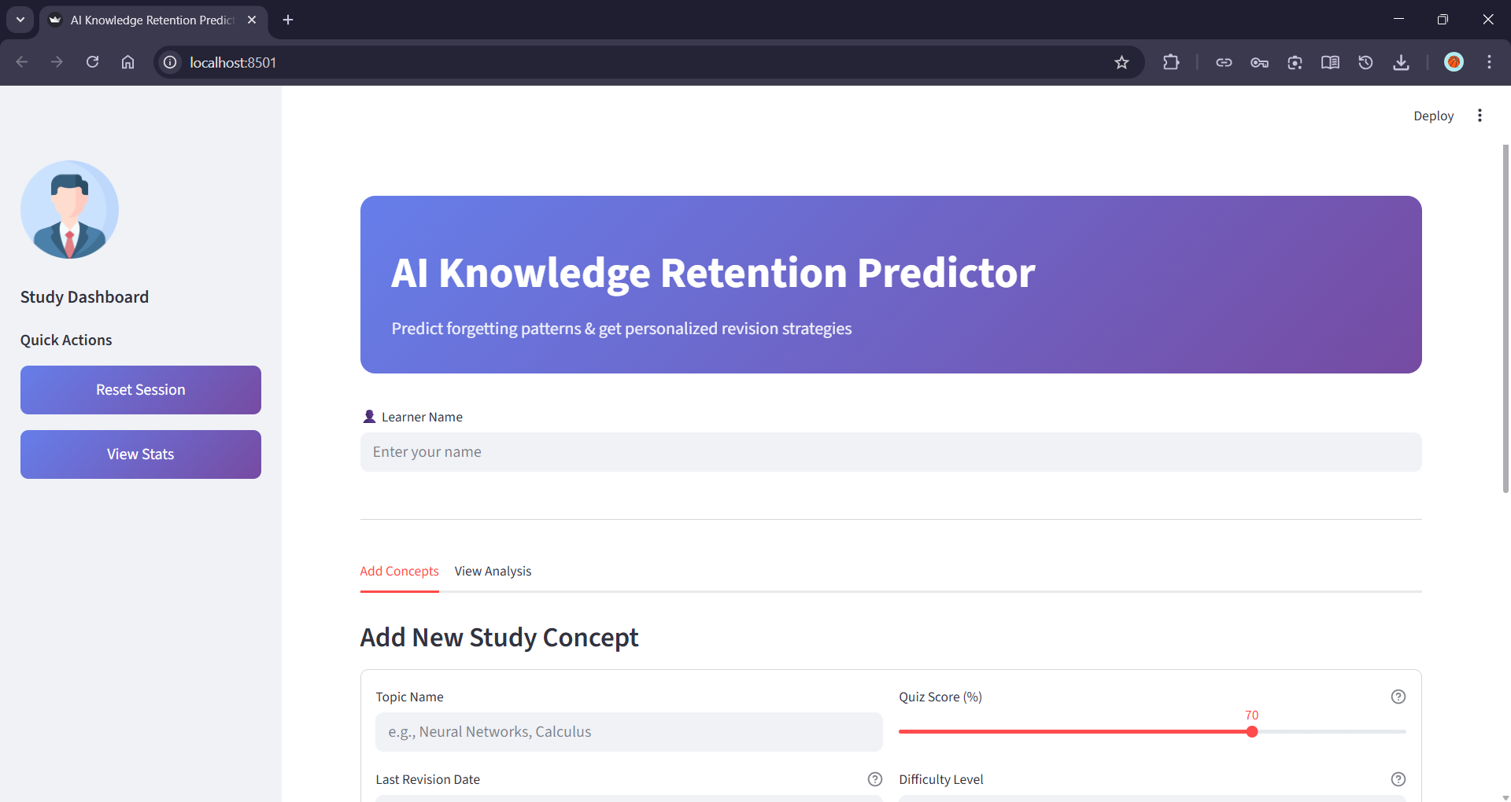

- Validate retention analysis inputs, ensuring correct risk levels and forgetting windows are returned.

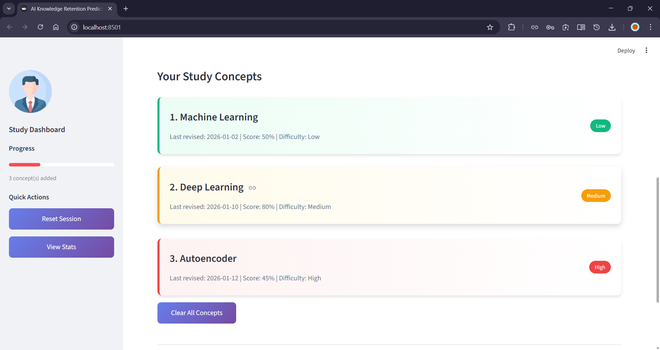
- Verify advise generation accuracy, structure, and alignment with respective topics.

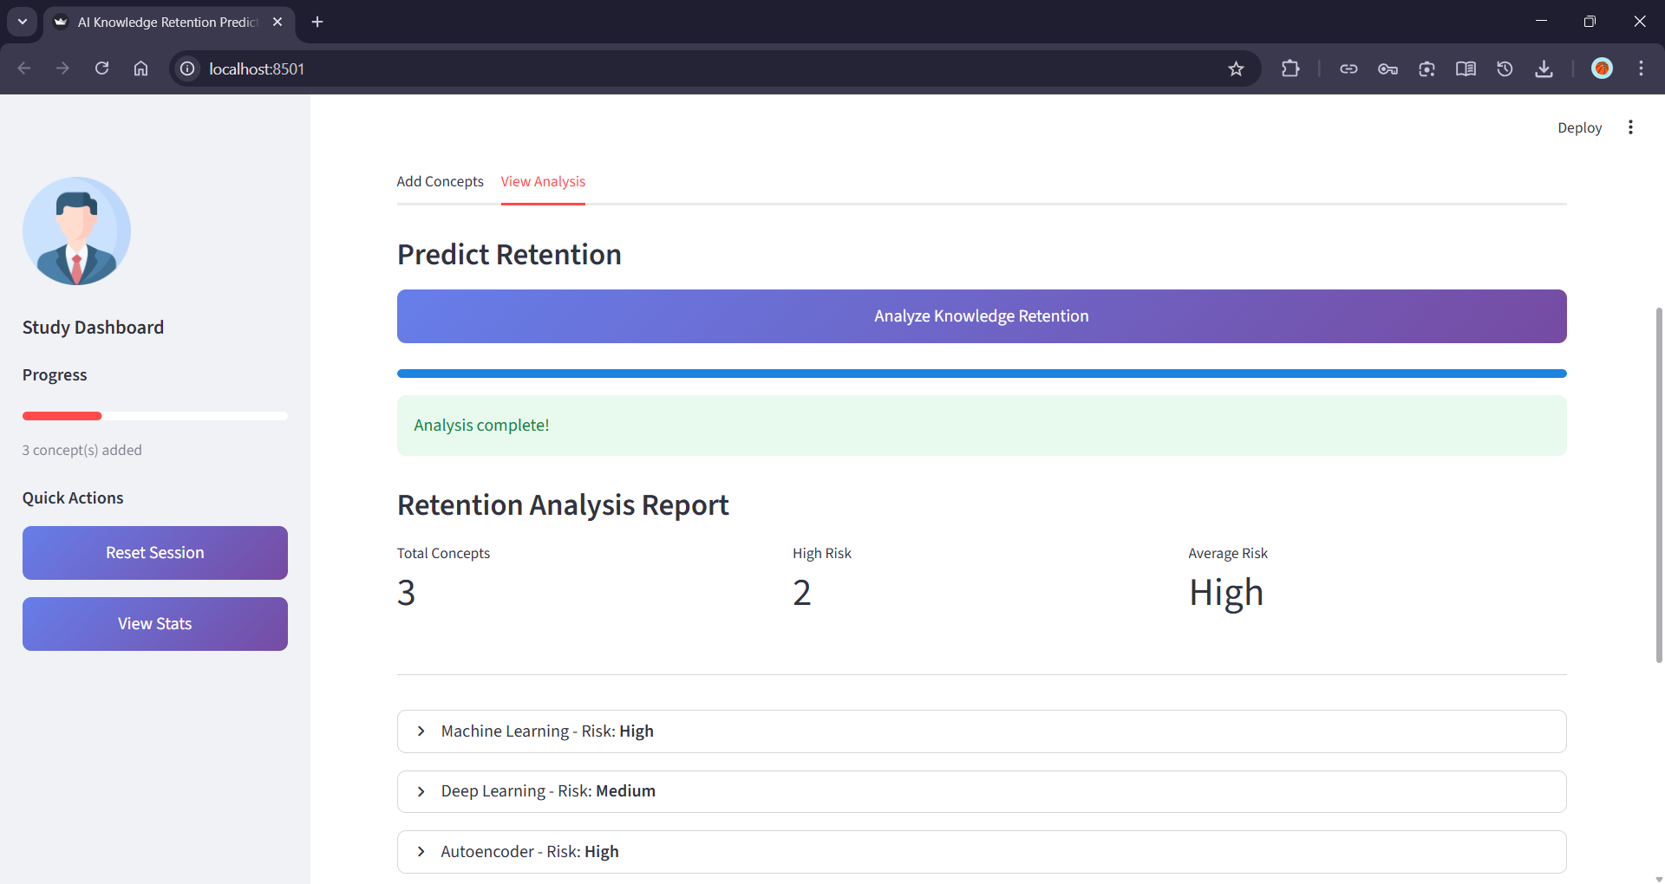

- Confirm advise is shown for each topic with a proper plot.

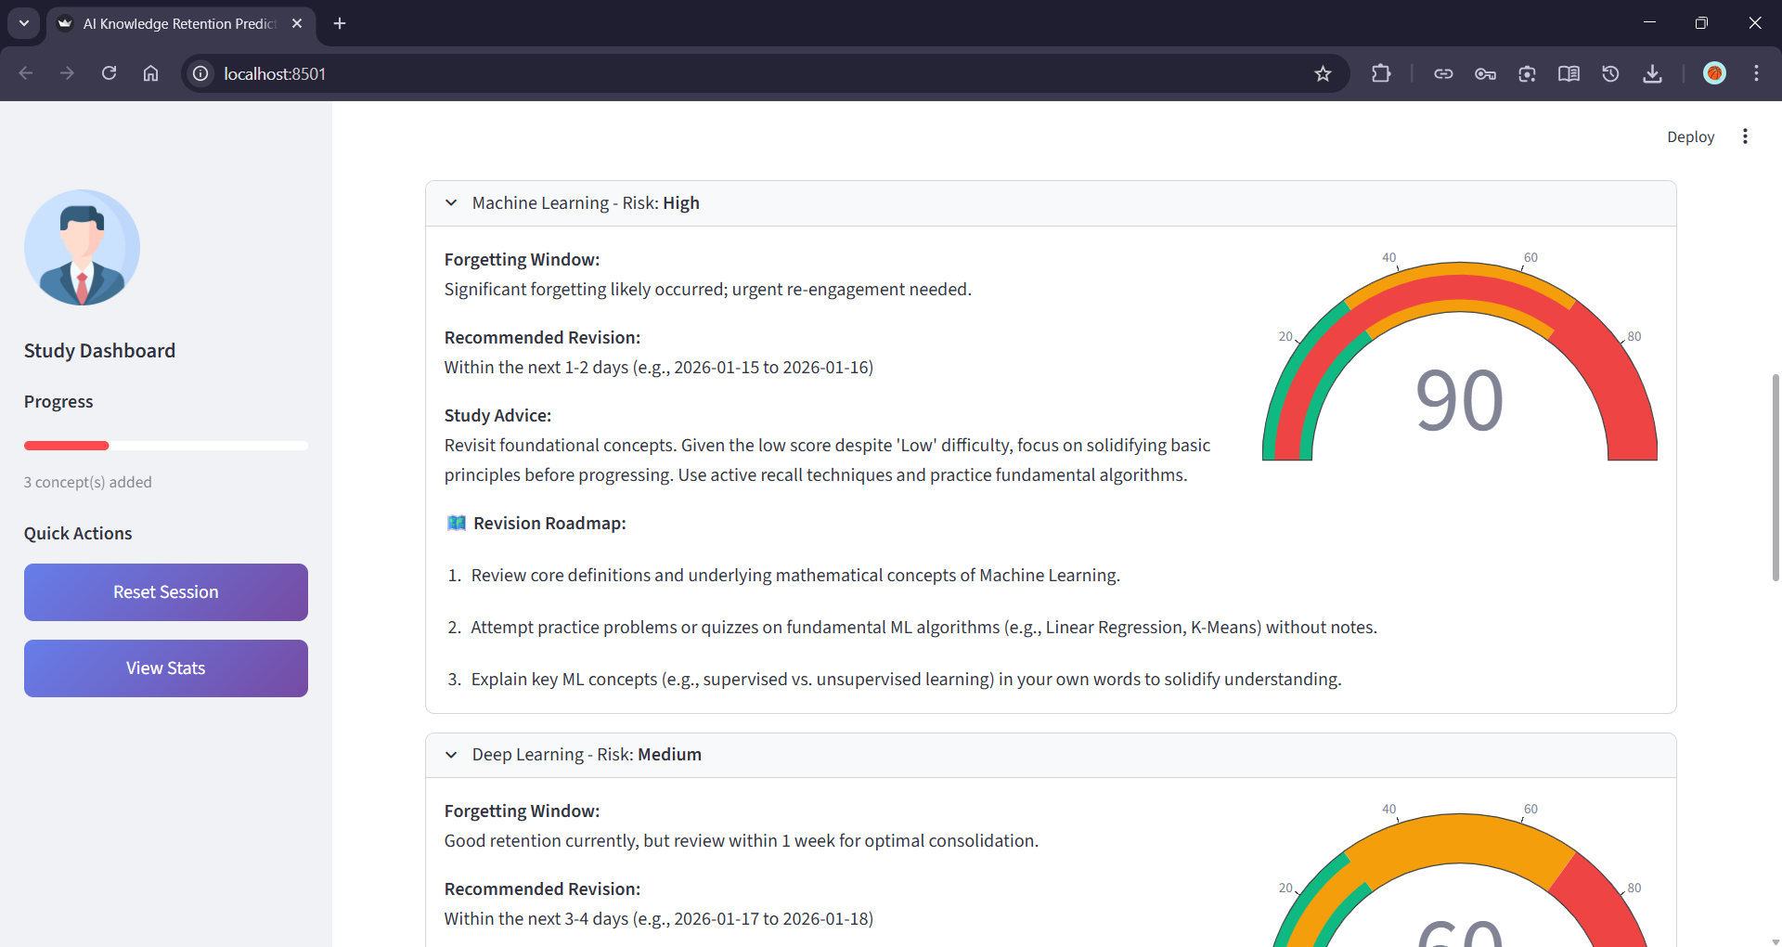

Activity 5.2: UI and Interaction Testing
- Validate concept addition, removal, and session persistence across reruns.

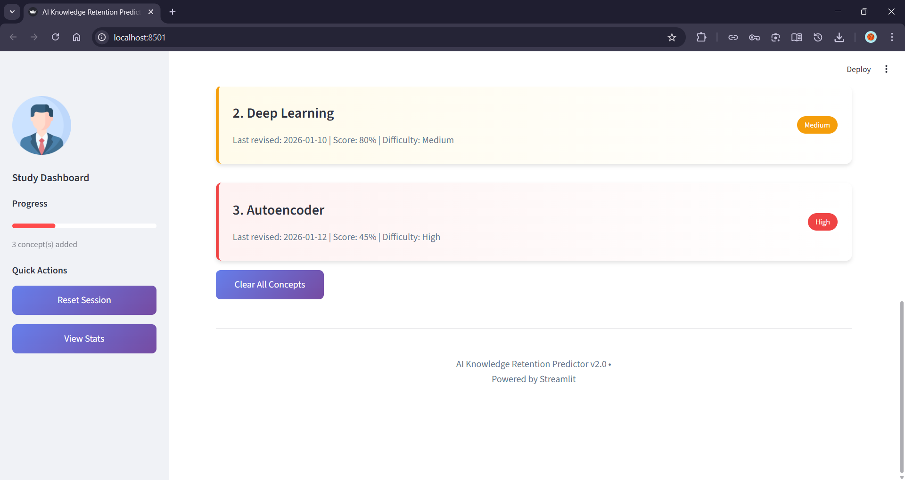

- Test navigation between analysis and quiz sections without data loss.

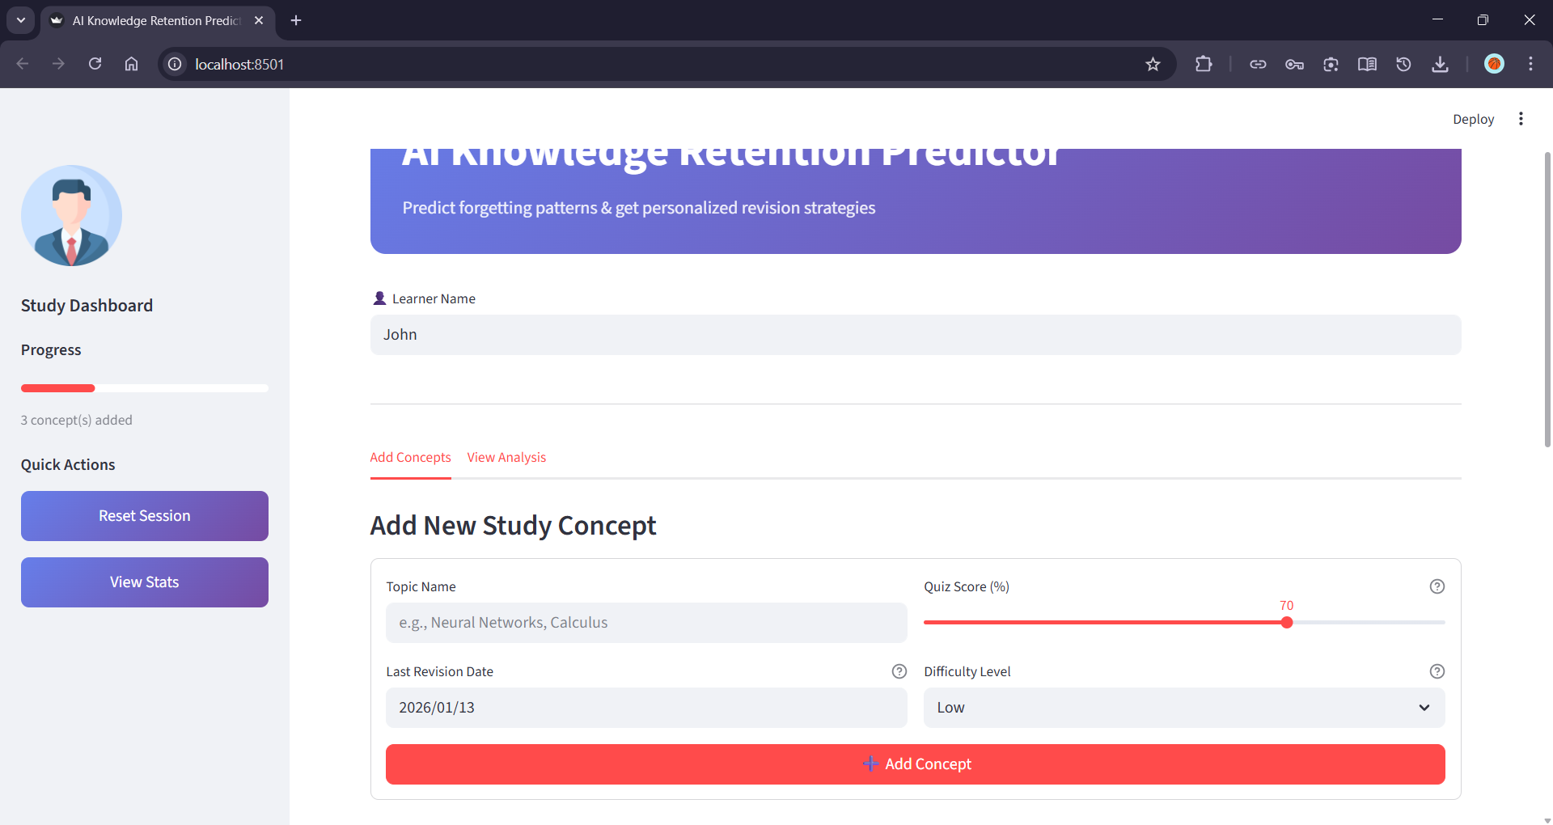

- Verify visual components such as charts, gauges, progress bars, and metric cards render correctly.

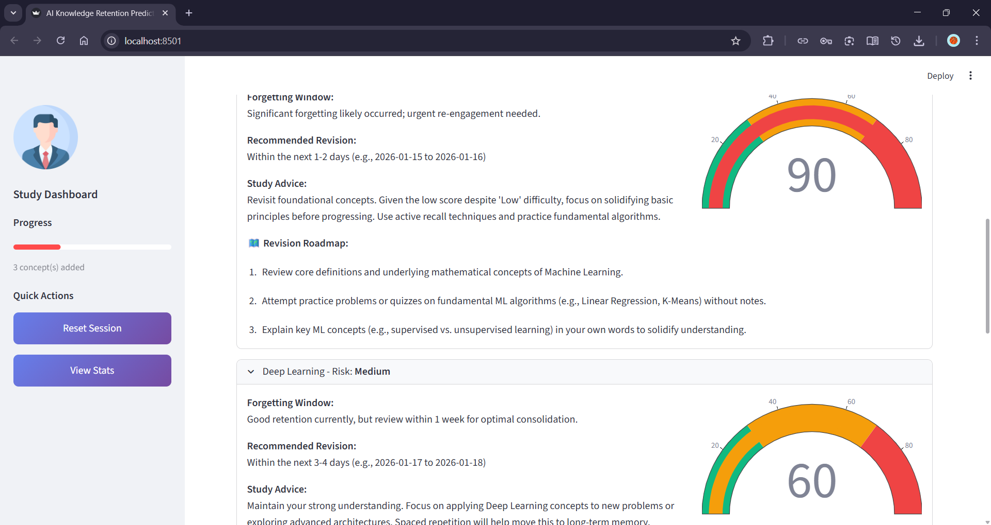

- Ensure quiz answer selection, result evaluation, and score display function as expected.

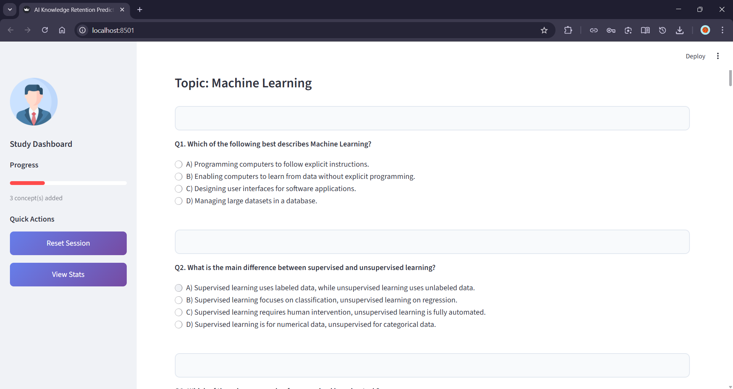

Activity 5.3: Deployment Preparation
- Verify environment variables load correctly in the deployment environment.
- Confirm backend and frontend configurations are production-ready.
- Perform end-to-end testing in a deployed or staging setup.
- Ensure documentation and usage instructions are clear for end users.

Conclusion
The AI Knowledge Retention Predictor demonstrates how generative AI can be applied effectively to enhance learning outcomes by moving beyond traditional assessment-based systems. By combining structured learner data with advanced AI reasoning, the system provides predictive insights into retention risk, identifies likely forgetting windows, and delivers personalized revision strategies. This approach enables learners to study more intelligently, focus on high-risk concepts, and reinforce understanding through timely, targeted practice rather than relying on repetitive or last-minute revision.
Built with a modular FastAPI backend and an interactive Streamlit frontend, the project showcases a practical, end-to-end implementation of prompt engineering, schema-driven design, and responsible AI usage. The integration of automated quiz generation further strengthens the learning loop by converting insights into actionable reinforcement. Overall, the AI Knowledge Retention Predictor highlights the potential of AI-driven educational tools to support personalized, data-informed learning experiences and serves as a strong foundation for future enhancements such as adaptive learning paths, long-term progress tracking, and integration with existing learning platforms.

