**What is Jenkins?**

Jenkins is an open-source automation server that enables developers to build, test, and deploy different application. Jenkins benefits automate the different parts of software development related to building, testing, and deploying, facilitating continuous integration and continuous delivery (CI/CD). Jenkins is highly extensible, supporting a variety of plugins that integrate with other tools and processes in the development pipeline.

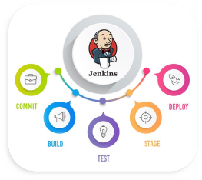

**Key Features:**

* **Open-source**: Freely available and supported by a large community.
* **Extensible**: Thousands of plugins available to extend its capabilities.
* **Distributed Builds**: Supports distributed builds across multiple machines.
* **Easy Configuration**: User-friendly web interface and configuration via code.
* **Continuous Integration/Continuous Deployment (CI/CD)**: Automates the software delivery process.

**Jenkins Architecture**

1. **Master-Slave Architecture**:
   * **Master**: The Jenkins Master is the central control unit of a Jenkins instance. It schedules build jobs, dispatches builds to the slaves for actual job execution, monitors the slaves, and records and presents the build results.
   * **Slave**: The Jenkins Slave is a Java executable that runs on a remote machine. The Slave listens for requests from the Master, executes build jobs assigned to it, and reports the results back to the Master.

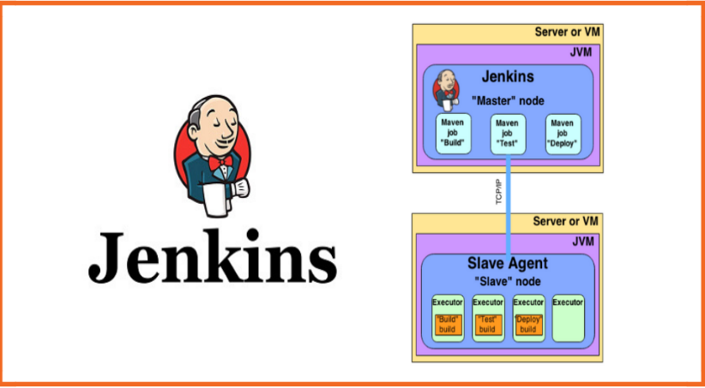

1. **Components**:
   * **Controller**: Manages the Jenkins environment, schedules jobs, and executes them on the agents.
   * **Agents**: Also known as Nodes, they are the machines where the build and deployment tasks run.
   * **Jobs/Projects**: These are the tasks that Jenkins executes, such as building code, running tests, and deploying applications.
   * **Plugins**: Extend Jenkins' functionality, integrating with various tools and systems.
2. **Communication**:
   * Communication between the Master and Slaves can be secured with SSH, JNLP, or other protocols.

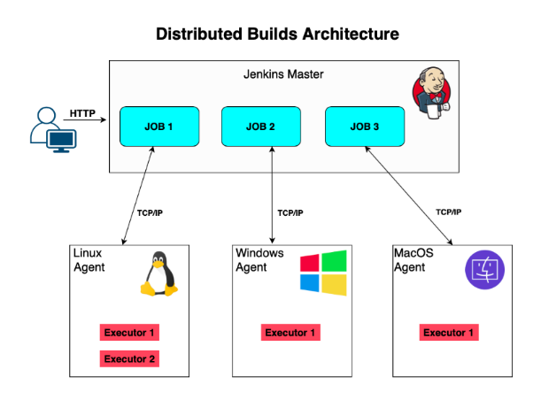

If you are not sure about OS version in linux

How to check Ubuntu Release version:

$ cat /etc/os-release,

$ lsb_release -a,

$ hostnamectl,

$ uname -r

**Installation**

**Prerequisites**:

* Java Development Kit (JDK) installed on your machine.
* Stable Internet connection to download necessary packages.

**On Ubuntu/Debian:**

# Update your system

sudo apt update

sudo apt upgrade

# Install Java

sudo apt install openjdk-11-jdk

sudo apt install openjdk-17-jdk

# Add Jenkins repository and key

curl -fsSL https://pkg.jenkins.io/debian/jenkins.io.key | sudo tee /usr/share/keyrings/jenkins-keyring.asc > /dev/null

echo deb [signed-by=/usr/share/keyrings/jenkins-keyring.asc] https://pkg.jenkins.io/debian binary/ | sudo tee /etc/apt/sources.list.d/jenkins.list > /dev/null

# Update and install Jenkins

sudo apt update

sudo apt install jenkins

# Start Jenkins service

sudo systemctl start jenkins

# Enable Jenkins to start on boot

sudo systemctl enable jenkins

**On Windows:**

1. Download Jenkins from Jenkins' official website.
2. Run the installer and follow the setup wizard.
3. Open Jenkins from your browser using http://localhost:8080.
4. Complete the initial setup by unlocking Jenkins with the provided administrator password.

### Basic Commands

**Starting Jenkins:**

# On Linux

sudo systemctl start jenkins

sudo systemctl status jenkins

(75019880c87d4e329673fb5befdcb1e2)

http://localhost:8080/

# On Windows

net start jenkins

**Stopping Jenkins:**

# On Linux

sudo systemctl stop jenkins

# On Windows

net stop jenkins

**Restarting Jenkins:**

# On Linux

sudo systemctl restart jenkins

# On Windows

net stop jenkins

net start jenkins

**Check Jenkins Status:**

# On Linux

sudo systemctl status jenkins

**Access Jenkins CLI:**

1. Download the Jenkins CLI jar from your Jenkins server (typically at http://your_jenkins_url/jnlpJars/jenkins-cli.jar).
2. Run commands using the CLI:

java -jar jenkins-cli.jar -s http://your_jenkins_url/ <command>

**Example CLI Commands:**

# Get list of jobs

java -jar jenkins-cli.jar -s http://your_jenkins_url/ list-jobs

# Create a new job

java -jar jenkins-cli.jar -s http://your_jenkins_url/ create-job my-new-job < config.xml

# Trigger a job

java -jar jenkins-cli.jar -s http://your_jenkins_url/ build my-job