**A MINI PROJECTREPORT**

**ON**

**“Web Application”**

Submitted in the partial fulfillment of the requirements for

The degree of

**BACHELOR of Engineering IN Computer Engineering**

**By**

1)Shaikh Adnan Shaukat Ali

2) BinitDev pandey

3) Kanchan Mengune

4)Zeeshan shafiq ansari

**UNDER THE GUIDANCE OF**

**Prof. Sonali Shukla**



Department of Computer Engineering  
Saraswati College of Engineering, Kharghar, Navi Mumbai  
University of Mumbai  
2020-21

**Saraswati College of Engineering, Kharghar**

**Vision:**

To be universally accepted as autonomous center of learning in Engineering Education and Research.

**Mission:**

* To educate students to become responsible and quality technocrats to fulfil society and industry needs.
* To nurture student’s creativity and skills for taking up challenges in all facets of life.

**_______________________________________________**

**Department of Computer Engineering**

**Vision:**

To be among renowned institution in Computer Engineering Education and Research by developing globally competent graduates.

**Mission:**

* To produce quality Engineering graduates by imparting quality training, hands on experience and value education.
* To pursue research and new technologies in Computer Engineering and across interdisciplinary areas that extends the scope of Computer Engineering and benefit humanity.
* To provide stimulating learning ambience to enhance innovative ideas, problem solving ability, leadership qualities, team-spirit and ethical responsibilities.



**DEPARTMENT OF COMPUTER ENGINEERING**

**PROGRAM EDUCATIONAL OBJECTIVE’S**

* To embed a strong foundation of Computer Engineering fundamentals to identify, solve, analyze and design real time engineering problems as a professional or entrepreneur for the benefit of society.
* To motivate and prepare students for lifelong learning & research to manifest global competitiveness.
* To equip students with communication, teamwork and leadership skills to accept challenges in all the facets of life ethically.



**DEPARTMENT OF COMPUTER ENGINEERING**

**PROGRAM OUTCOMES**

* Apply the knowledge of Mathematics, Science and Engineering Fundamentals to solve complex Computer Engineering Problems.
* Identify, formulate and analyze Computer Engineering Problems and derive conclusion using First Principle of Mathematics, Engineering Science and Computer Science.
* Investigate Complex Computer Engineering problems to find appropriate solution leading to valid conclusion.
* Design a software System, components, Process to meet specified needs with appropriate attention to health and Safety Standards, Environmental and Societal Considerations.
* Create, select and apply appropriate techniques, resources and advance Engineering software to analyze tools and design for Computer Engineering Problems.
* Understand the Impact of Computer Engineering solution on society and environment for Sustainable development.
* Understand Societal, health, Safety, cultural, Legal issues and Responsibilities relevant to Engineering Profession.
* Apply Professional ethics, accountability and equity in Engineering Profession.
* Work Effectively as a member and leader in multidisciplinary team for a common goal.
* Communicate effectively within a Profession and Society at large.
* Appropriately incorporate principles of Management and Finance in one’s own Work.
* Identify educational needs and engage in lifelong learning in a Changing World of Technology.



**DEPARTMENT OF COMPUTER ENGINEERING**

**PROGRAMME SPECIFIC OUTCOME**

* Formulate and analyze complex engineering problems in computer engineering (Networking/Big data/ Intelligent Systems/Cloud Computing/Real time systems).
* Plan and develop efficient, reliable, secure and customized application software using cost effective emerging software tools ethically.



**(Approved by AICTE, recg. By Maharashtra Govt. DTE ,Affiliated to Mumbai University)**

**PLOT NO. 46/46A, SECTOR NO 5, BEHIND MSEB SUBSTATION, KHARGHAR, NAVI MUMBAI-410210**

**Tel. : 022-27743706 to 11 * Fax : 022-27743712 * Website:** [**www.sce.edu.in**](http://www.sce.edu.in/)

**CERTIFICATE**

*This is to certify that the requirements for the mini project report entitled ”****Project Title****” have been successfully completed by the following students:*

Roll numbers Name

55 Shaikh Adnan Shaukat Ali

40 BinitDev Pandey

33 Kanchan Mengune

03 Zeeshan Shafiq Ansari

In partial fulfillment of Sem –III, **Bachelor of Engineering of Mumbai University in Computer Engineering** of Saraswati college of Engineering , Kharghar during the academic year 2020-21.

**Internal Guide**  **External Examiner**

Prof. Sonali Shukla

**Mini Project Co-ordinator**  **Headof Department**

Prof. Monali DeshmukhProf. Sujata Bhairnallykar

**DECLARATION**

I declare that this written submission represents my ideas in my own words and where others ideas or words have been included. I have adequately cited and referenced the original sources. I also declare that I have adhered to all principles of academic honesty and integrity and have not misrepresented or fabricated or falsified any idea/data/fact/source in my submission. I understand that any violation of the above will be cause for disciplinary action by the Institute and can also evoke penal action from the sources which have thus not been properly cited or from whom proper permission has not been taken when needed.

* Adnan
* Binit
* Kanchan
* Zeeshan

Date:

**ACKNOWLEDGEMENT**

After the completion of this work, words are not enough to express feelings about all those who helped us to reach goal.

It’s a great pleasure and moment of immense satisfaction for us to express my profound gratitude to **MiniProject Guide**, **Prof.Sonali Shukla** , whose constant encouragement enabled us to work enthusiastically. His perpetual motivation, patience and excellent expertise in discussion during progress of the project work have benefited us to an extent, which is beyond expression.

We would also like to give our sincere thanks to **Prof.Sujata Bhairnallykar, Head of Department**, and **Prof.Monali Deshmukh ,Mini Project co-coordinator** from Department of Computer Engineering, Saraswati college of Engineering, Kharghar, Navi Mumbai, for their guidance, encouragement and support during a project.

I am thankful to **Dr. ManjushaDeshmukh, Principal,**Saraswati College of Engineering, Kharghar, Navi Mumbai for providing an outstanding academic environment, also for providing the adequate facilities.

Last but not the least we would also like to thank all the staffs of Saraswati college of Engineering (Computer Engineering Department) for their valuable guidance with their interest and valuable suggestions brightened us.

**Abstract**

The project is about a web application named "QUACK QUACK" made using Django-3.0.11, which is a Python framework and it uses Vue JS, Bulma CSS and HTML for its frontend. It's for the socialization purpose where user can communicate and express their thoughts. It make works more easy for the people and can be used for multi-purpose options.

**Table of Contents**

|  |  |
| --- | --- |
|  |  |
| **List of Figures ………………………………………………………………………...** | **1** |
| **1. Introduction ………………………………………………………………………..** | **2** |
| **1.1 General ……………………………………………………………………..….** | **2** |
| **1.2 Objective and problem statement ……………………………........................** | **3** |
| **2. Methodology ……………………………………………………………….............** | **6** |
| **2.1 Algorithmic details .…………………………………………………………...** | **6** |
| **2.2 Hardware and Software requirements……………………………..............** | **12** |
| **2.3 Design Details…………………………………………………………………** | **13** |
| **3. Implementation and Results …………………………………………………….** | **15** |
| **3.1. Implementation ....………………………………………………….................** | **15** |
| **3.2. Results ...………………………………………………………………............** | **16** |
| **4.Conclusion and Future Scope……………………………………………………..** | **18** |
| **5. References………………………………………………………………...........** | **19** |

**List of Figures**

|  |  |  |
| --- | --- | --- |
| **Figure No.** | **Name** | **Page No.** |
| 1 | Introduction | 11 |
| 2 | Algorithm and flowchart | 12-15 |
| 3 | Requirements | 16 |
| 4 | Design and Details | 17 |
| 5 | Implementation and results | 18-20 |
| 6 | Conclusion and future scope | 21 |
| 7 | References | 22 |
|  |  |  |
|  |  |  |
|  |  |  |
|  |  |  |
|  |  |  |

**CHAPTER 1**

**INTRODUCTON**

* 1. **GENERAL:**

**Aim**: The project based upon on a web application, its main motive is to keep people connected.

**Summary**: The project is written on Django-3.0.11 which is a python framework and it uses Vue JS-2.6, Bulma CSS-0.9.0 and HTML for its frontend.

This project allow user to follow and message other users and vice-versa. User can also post on the feed which can be seen and like by other users which follows them. User will also receive notification if someone message, follow or mention them in a post.

As we see every big organization required web app or app where people (their users) can ask questions regarding their problems/issues which they are facing in their apps, games or devices and which can be answer by their workers.

So, it is very helpful for them to have an app like this.

**1.2 OBJECTIVE AND PROBLEM STATEMENT**

To create a web application which helps people to stay connected using Python as its backend and use HTML, CSS AND Java Script as its frontend.

**CHAPTER 2**

**METHODOLOGY**

**2.1 ALGORITHMIC DETAILS**

**Literature Review:**

The 'QUACK QUACK" web application had a significant impact on all aspects of our society. As These generation relies more on web, the dependability of web application has become increasingly important. Our web helps the community to come together and be in touch with everyone. We provide platform where people can text each other and also they can express their thoughts by posting it which will be seen by their followers. Followers can like the post and can visit profile through that post.Every users will have their own unique account which they can access after login.

**Algorithm:**

1. Run server

2. Go to the Host page where you will be get the options of LOGIN/SIGNUP at the top right corner.

3. If you dont have an account then SIGNUP with a unique username and password.

NOTE: password should be created under certain rules which are mentioned on the sign up page.

4. After the successfull SIGNUP/LOGIN you will be redirected to our feed page where you can access all the applications of our 'QUACK QUACK'.

5. At the top right corner we get options which are link to all the apps of our project.

6. You will get to surf your feed, notifications, message box, profile, edit profile, logout.

7. At top left Search option is available where You can get all the users and posts related to the search word .

Note: If u are not LOGIN and try to search then you will be redirected to LOGIN page.

8. Feed page comes with a text box at top where you can write your content and post for your followers. just below that you will get posts of all your followers sorted according time.

9. You can like the post and even you can open the profile of that user.

10.In notification option u will be notified if someone likes your post, mentioned in post, follows you, messages you.

11.if someone mentions then clicking u will be redirected to that particular post or messages you then u will be redirected to the users chatbox.

12.Message box will get u details of users messages.

13. Users Profile option is also available to see yourdisplay pictures,follows,followers and all your posts . Also you can see the number of likes on your all post.

14.You can also edit your profile ,where You will get an option to choose file and save changes.

15. Logout the account from the top right corner if you are done using our 'QUACK QUACK' web application.

16.ADMIN SIDE: Admin application is already provided by django framework where Superusers can log in and handle all the project acitvities like blocking account or deleting post which are inappropriate.

**Flowchart**

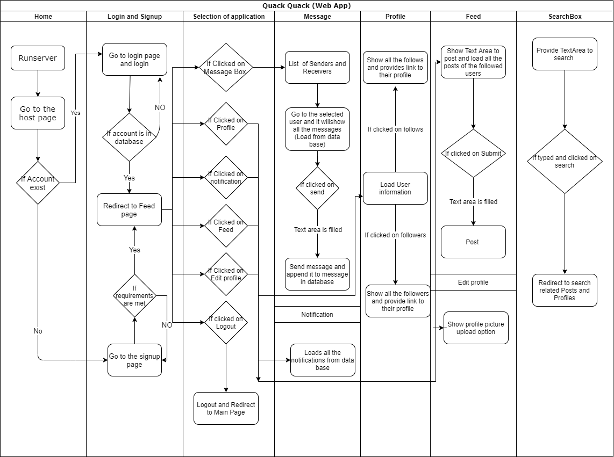

**2.2 HARDWARE AND SOFTWARE REQUIREMENTS**

**2.2.1 HARDWARE REQUIREMENTS**

* RAM : 512 MB RAM
* Hard Drive : 40 GB Hard Drive
* Processor : Intel Core 2 Processor
* camera module (Webcam)
* Projector
* Colour Markers

**2.2.2 SOFTWARE REQUIREMENTS**

* Python -3.8
* Django -3.0.11
* Bulma CSS -0.9.0
* Vue JS -2.6

**2.3 DESIGN DETAILS :**

1.The web application is designed as user friendly , so that everyone can access to its all features easily.

2.The home page consist of SIGNUP and LOGIN option at the top right corner where u can access to your account or create a new one.

3.After the Successful Signup or login, you will be redirected to feed page where you can access all the features.

4.The feed page provides u with the search option at the top, where you will get to access search related queries.

5.At the top right you will be provided with options such as, notifications, feed, message box, profile, Edit profile, logout.

6.Notification page will be in a list format, where you will be notified about all your activity.

7.Feed page will provide a text box along with the submit option, where you can upload your content and below that posts are available of the users which you have followed.

8.Message box will also be in list format where messages sorted according to time.

9.The profile is design effortlessly where you can see display picture at top and below that your followers and following and all your posts.

10.Also an edit profile option is available just before logout option.

11.Overall it is design in such a way that user can operate it without any problem.

**CHAPTER 3**

**IMPLEMENTATION AND RESULTS**

**3.1 IMPLEMENATAION:**

1. Quack Quack serves as a platform for Company users to ask and answer questions to each other or to do discussion on any topic. For employers, Quack Quack provides tools to make their profile, earn followers and stay connected with each other.
2. Quack Quack also provides platform for college students to discuss their project related queries, issues and many other topics.
3. This project is helpful for needy people to get solution of their queries.
4. It's basically a helpful for programmers, where you post your questions or issues, and get the solution.

**3.2 RESULTS:**

1. With Django free and open source, it makes the web development process very easy and the developer can fully focus on the designing process and boost performance.
2. Django very well reduced the complexities from a web application, giving it a more simplified approach.
3. When you are doing it in Django, it is ensured that developers don’t commit any mistakes related to security.
4. While PHP is specifically designed for web designs, Django bases on more robust language. So, to write a good code, it is easier to do it in python compared to PHP.
5. One of the nicest advantages of Django is that it can handle traffic and mobile app API usage of more than 400 million+ users helping maximize scalability and minimize web hosting costs
6. PHP is good in the short term. However, when you are done with the initial phase, you will need the help of a language which is deep and long lasting.
7. Django is a good place to start as it has the nicest documentation and tutorials in software development.
8. Django is a perfect solution for both startups and large companies that aim to deliver their products as quickly as possible and at efficient cost.

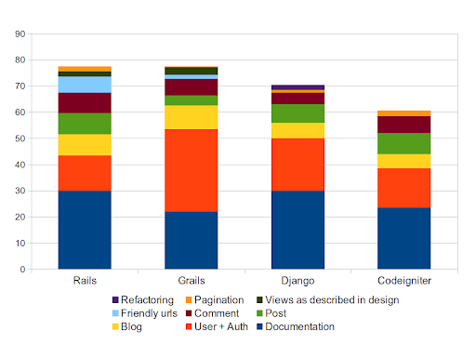

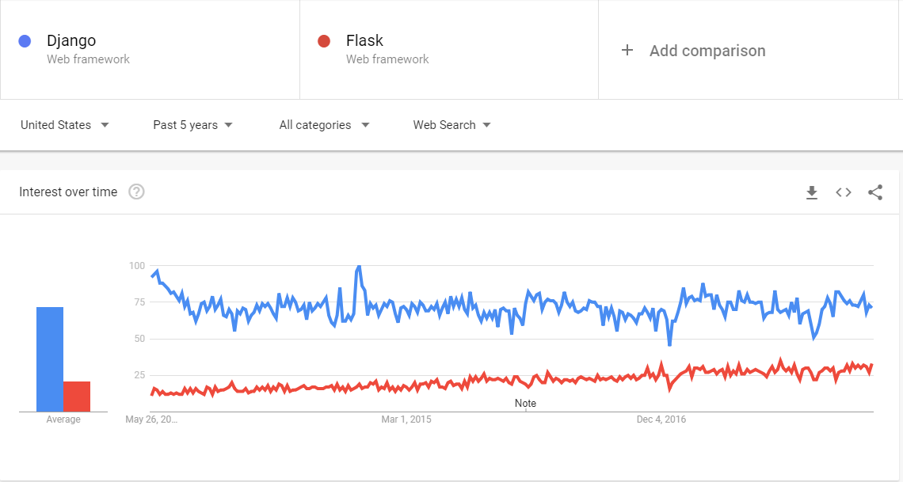

**CHAPTER 4**

**CONCLUSION AND FUTURE SCOPE**

**4.1 CONCLUSION:**

Thus here we conclude that we have made this mini project of SE Computer dept. on QUACK QUACK (Using Django framework ) Successfully.

**4.2 FUTURE SCOPE:-**

Technically speaking, Quack Quack is defined as “an assembly, meeting place, etc., for the discussion of questions of public interest.”

It seems almost counterintuitive to revisit technology developed decades ago, but today people are all about streamlining content. Most of the time, doing a quick internet search of a few key words and having the answer at your fingertips is all that people desire. That’s exactly what the forums of the past gave us, and that’s exactly why we’re turning back to them today.

**CHAPTER 5**

**REFERENCES**

[**https://docs.djangoproject.com/en/3.1/**](https://docs.djangoproject.com/en/3.1/)

[**https://bulma.io/documentation/**](https://bulma.io/documentation/)

[**https://v3.vuejs.org/guide/introduction.html**](https://v3.vuejs.org/guide/introduction.html)

[**https://docs.python.org/3/**](https://docs.python.org/3/)

[**https://www.w3schools.com/**](https://www.w3schools.com/)

[**https://stackoverflow.com/**](https://stackoverflow.com/)