# SɅRɅSWɅTI

## Department of Computer Engineering

**College of Engineering**

SɅRɅSWɅTI

### Experiment 1

**Aim: Identify the case study and detail statement of problem.**

**Design an Entity-Relationship (ER) / Extended Entity-Relationship (EER) Model**

**Hardware and Software Requirement:** P-IV and above

###### Theory:

The entity-relationship E-R model is very useful in mapping the meanings and interactions of real-world enterprises onto a conceptual schema. Because of this usefulness, many database- design tools draw on concepts from the E-R model. The E-R data model employs three basic concepts: entity sets, relationship sets, and attributes. The E-R model also has an associated diagrammatic representation, the ER diagram, which can express the overall logical structure of a database graphically.

An entity is an object that exists and is distinguishable from other objects. Example: specific person, company, event, plant

An entity set is a set of entities of the same type that share the same properties. Example: set of all persons, companies, trees, holidays

An entity is represented by a set of attributes; i.e., descriptive properties possessed by all members of an entity set.

Example:

*instructor =* (*ID, name, street, city, salary* )

*course=* (*course_id, title, credits*)

A subset of the attributes form a primary key of the entity set; i.e., uniquely identifying each member of the set.

Attribute types:

* Simple and composite attributes.
* Single-valued and multivalued attributes
  + Example: multivalued attribute: *phone_numbers*
* Derived attributes
  + an be computed from other attributes
  + Example: age, given date_of_birth

# SɅRɅSWɅTI

## Department of Computer Engineering

**College of Engineering**

SɅRɅSWɅTI

Domain – the set of permitted values for each attribute

Express the number of entities to which another entity can be associated via a relationship set. Most useful in describing binary relationship sets.

For a binary relationship set the mapping cardinality must be one of the following types: One to one

One to many Many to one Many to many

###### Symbols Used in E-R Notation

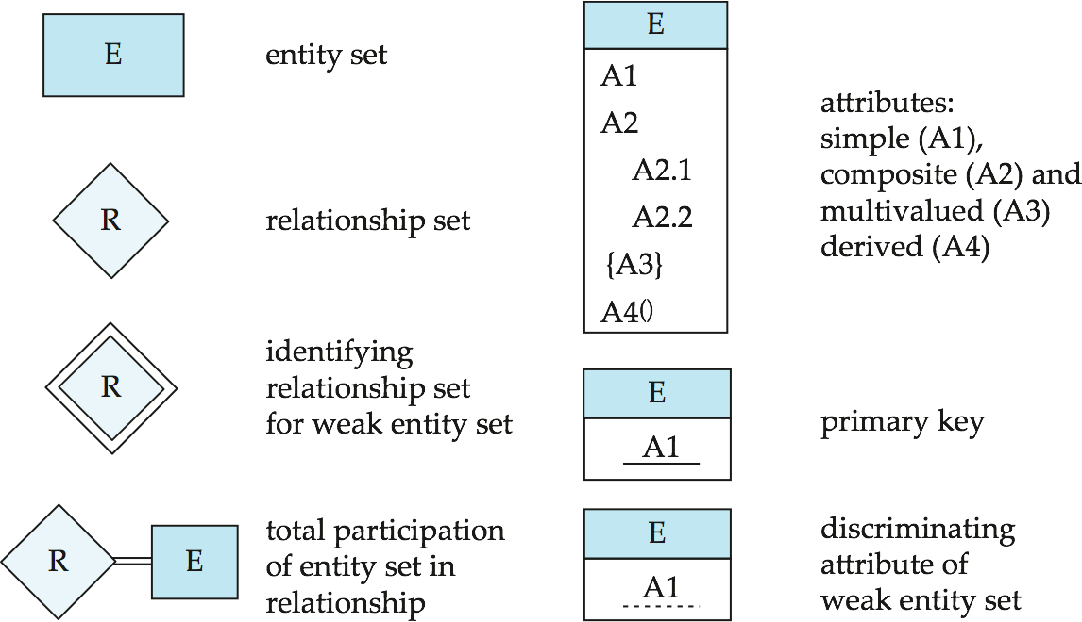

**SɅRɅSWɅTI**

**Department of Computer Engineering**

**College of Engineering**

SɅRɅSWɅTI

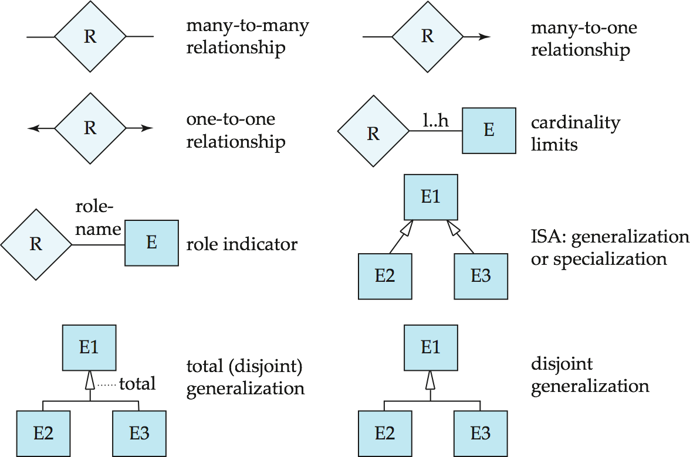

**Conclusion: We have Successfully design ER model for Ecommerce website.**

**User-Customer Model:**

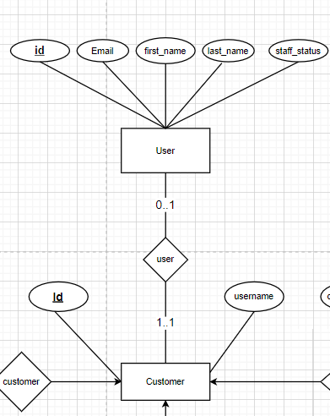

**Customer-Order Model:**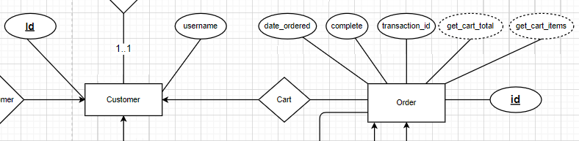

**Customer-Shipping Model:**

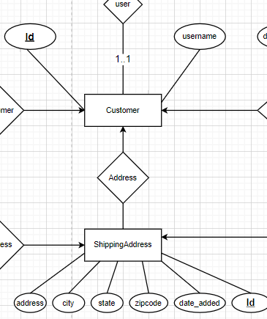

**Product-OrderItem Model:**

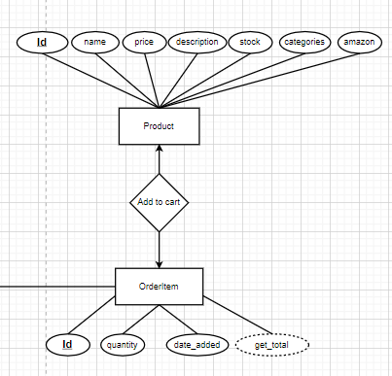

**Order-OrderItem Model:**

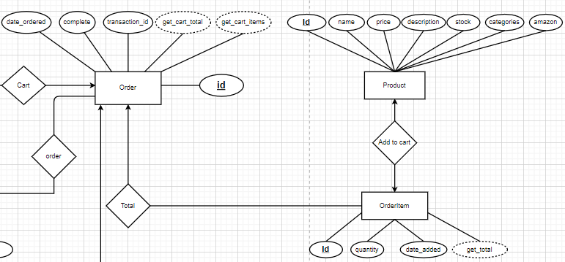

**Ordered-Customer-Address-Order Model:**

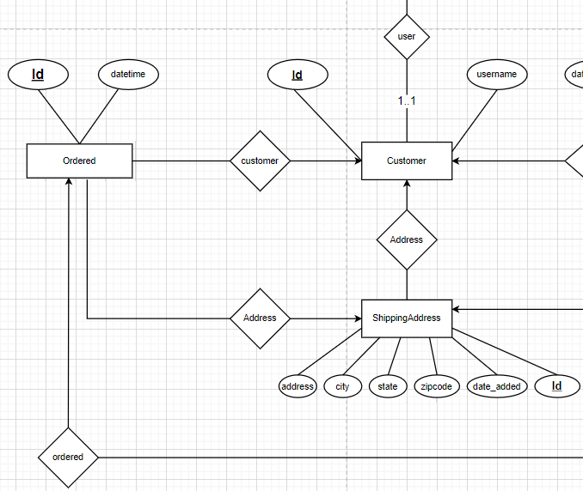

**Final Model:**

