# SɅRɅSWɅTI

## Department of Computer Engineering

**College of Engineering**

SɅRɅSWɅTI

### Experiment 6

###### Aim: To Perform Join operations

**Resources required:** P-IV and above, notepad, browser, stylus studio

###### Theory:

Different types of the JOINs in SQL:

* + **(INNER) JOIN**: Returns records that have matching values in both tables
  + **LEFT (OUTER) JOIN**: Return all records from the left table, and the matched records from the right table
  + **RIGHT (OUTER) JOIN**: Return all records from the right table, and the matched records from the left table
  + **FULL (OUTER) JOIN**: Return all records when there is a match in either left or right table

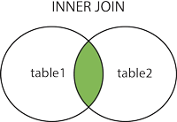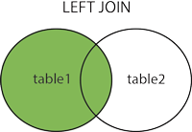

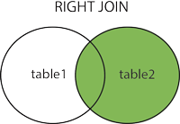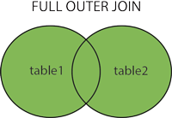

###### select master.rno, demo.rno, demo.name from master right outer join demo on master.rno=demo.rno;

**Conclusion: We have successfully performed various join operations using MySQL command line.**

**Code and Output:**

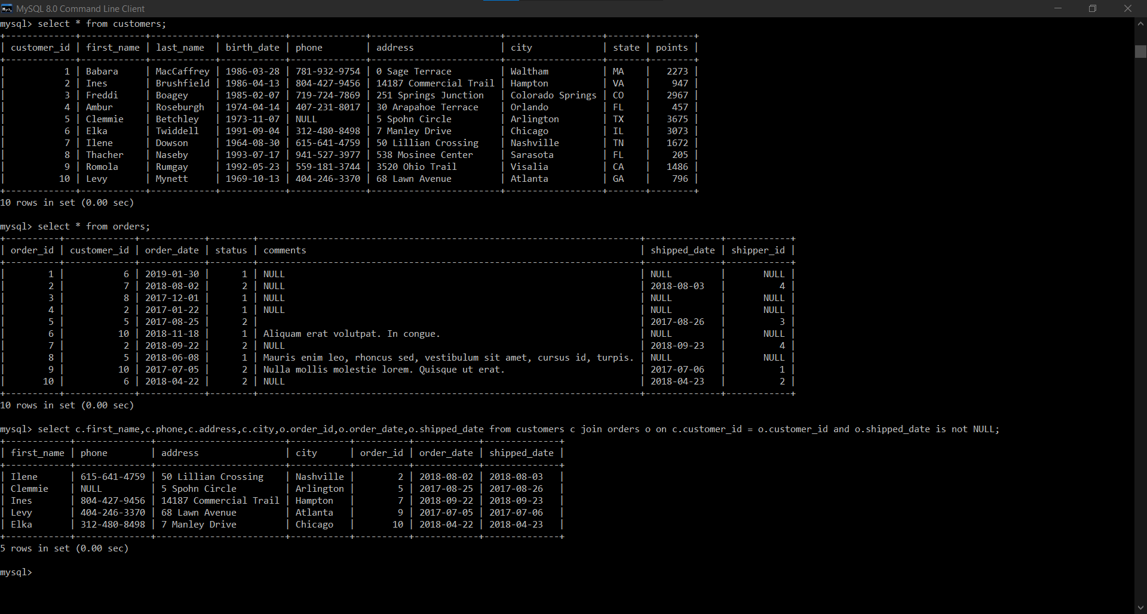

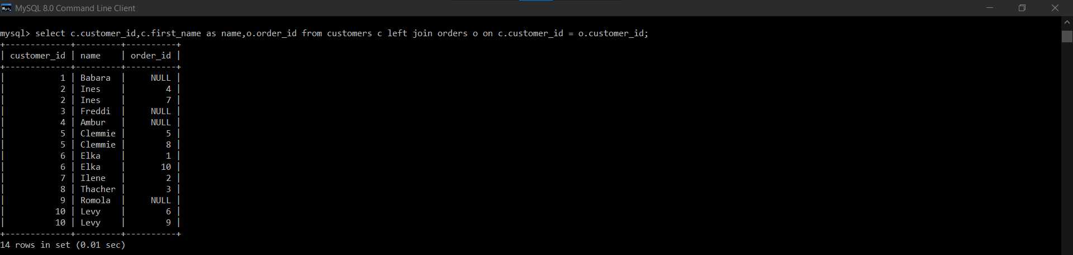

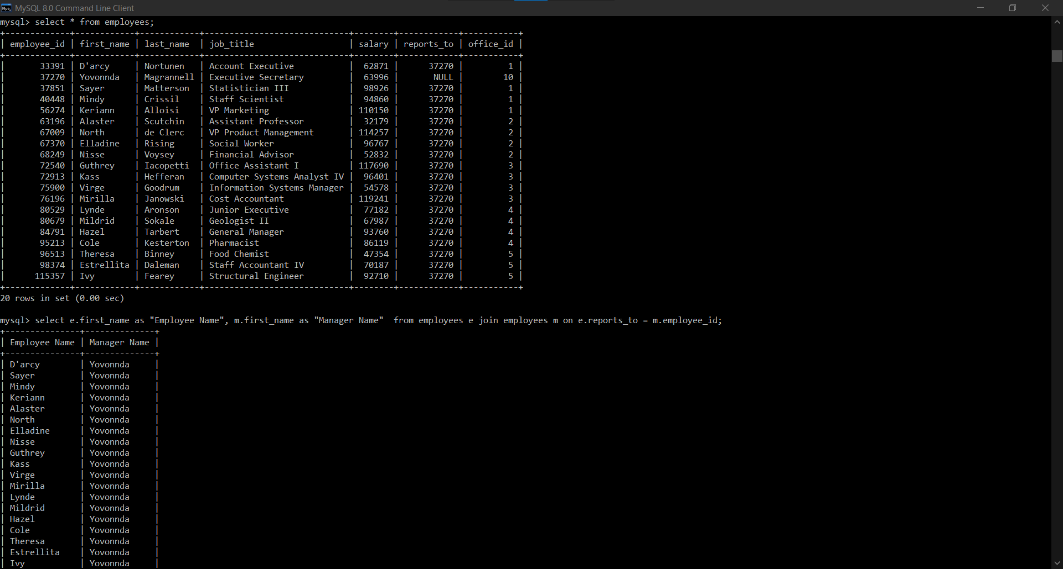

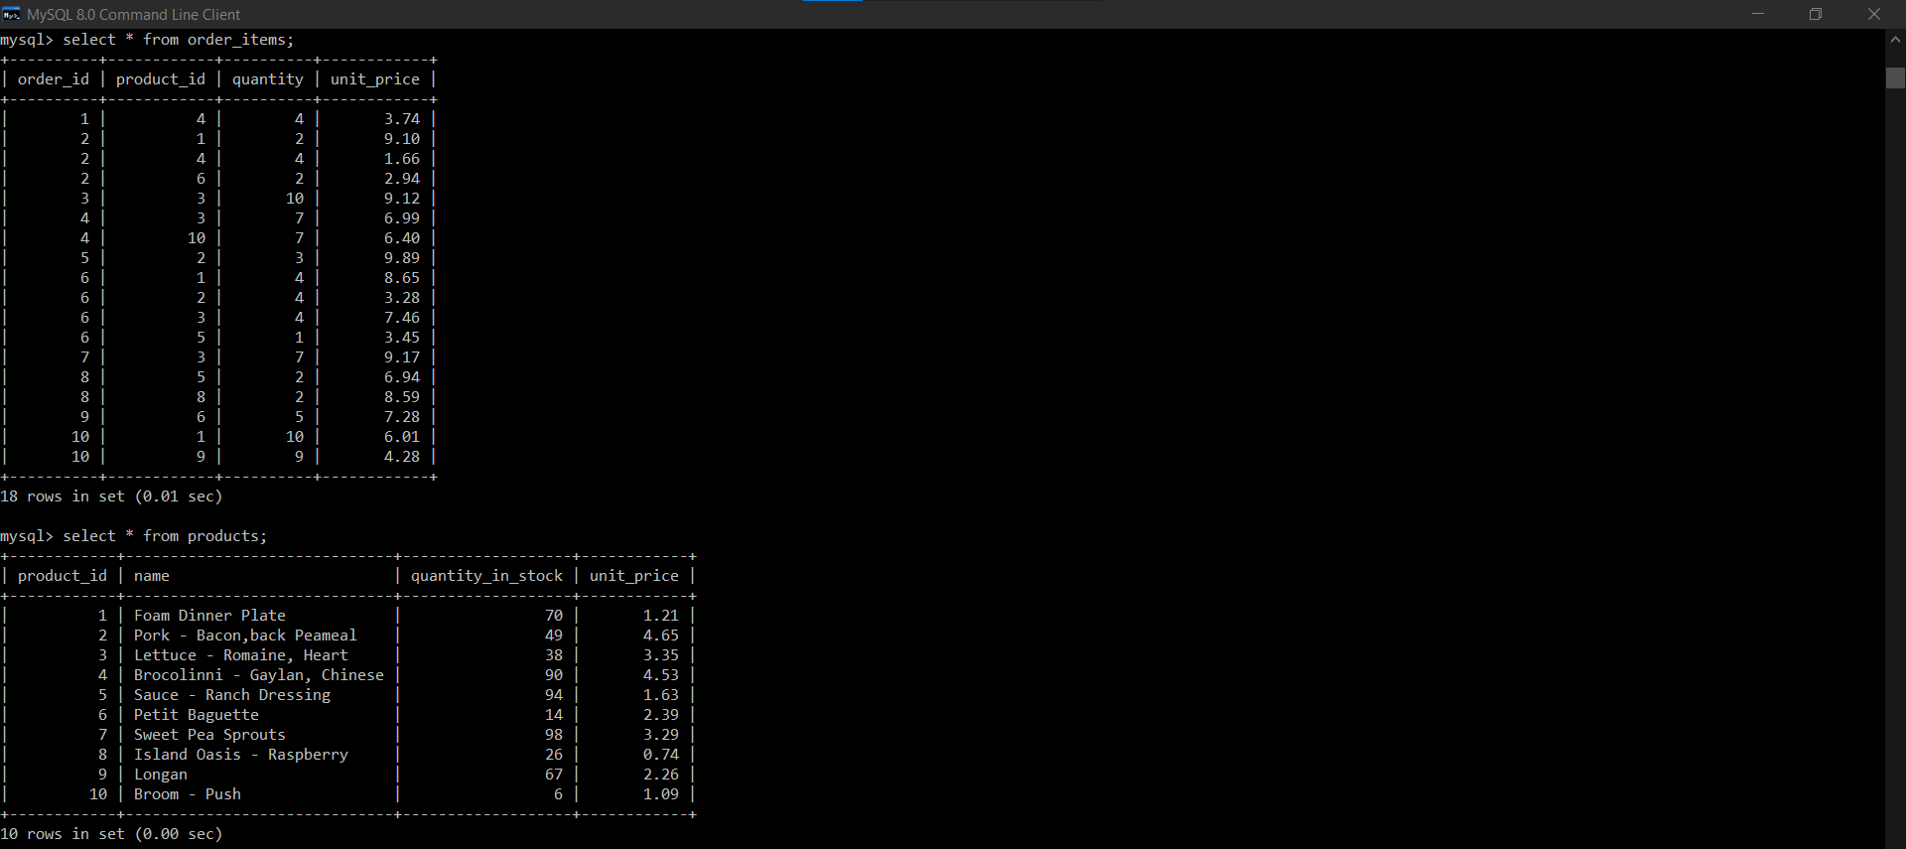

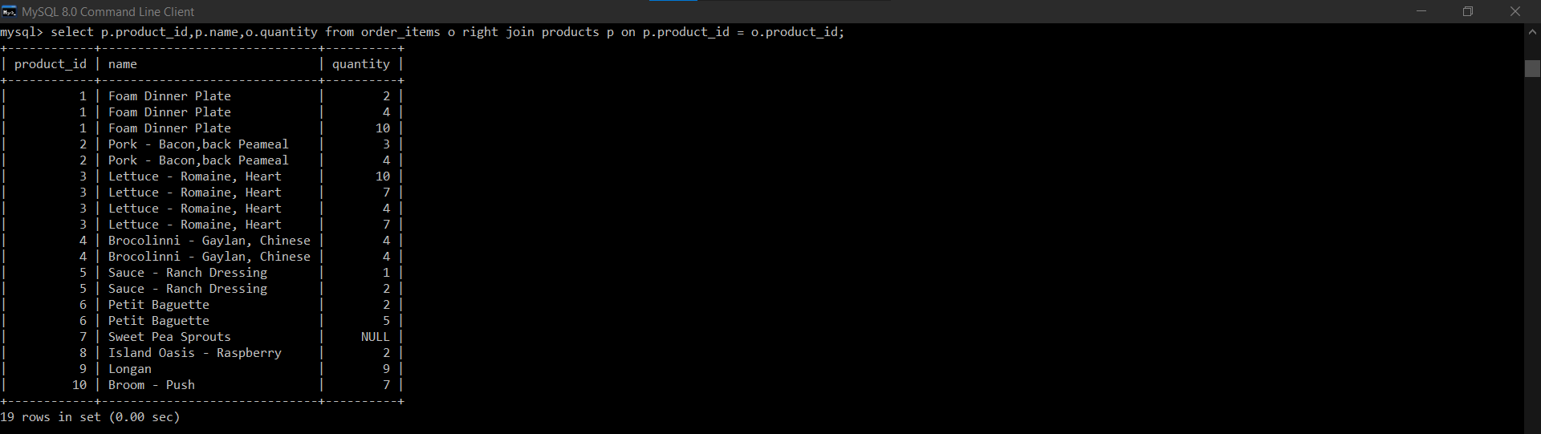

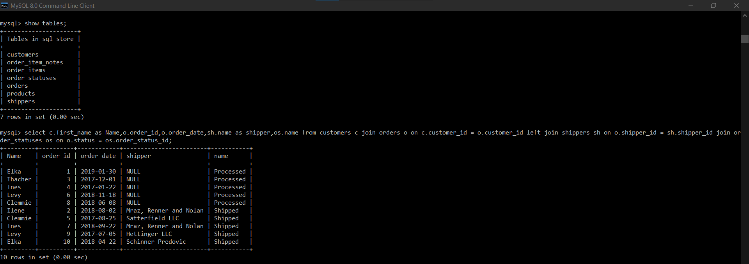

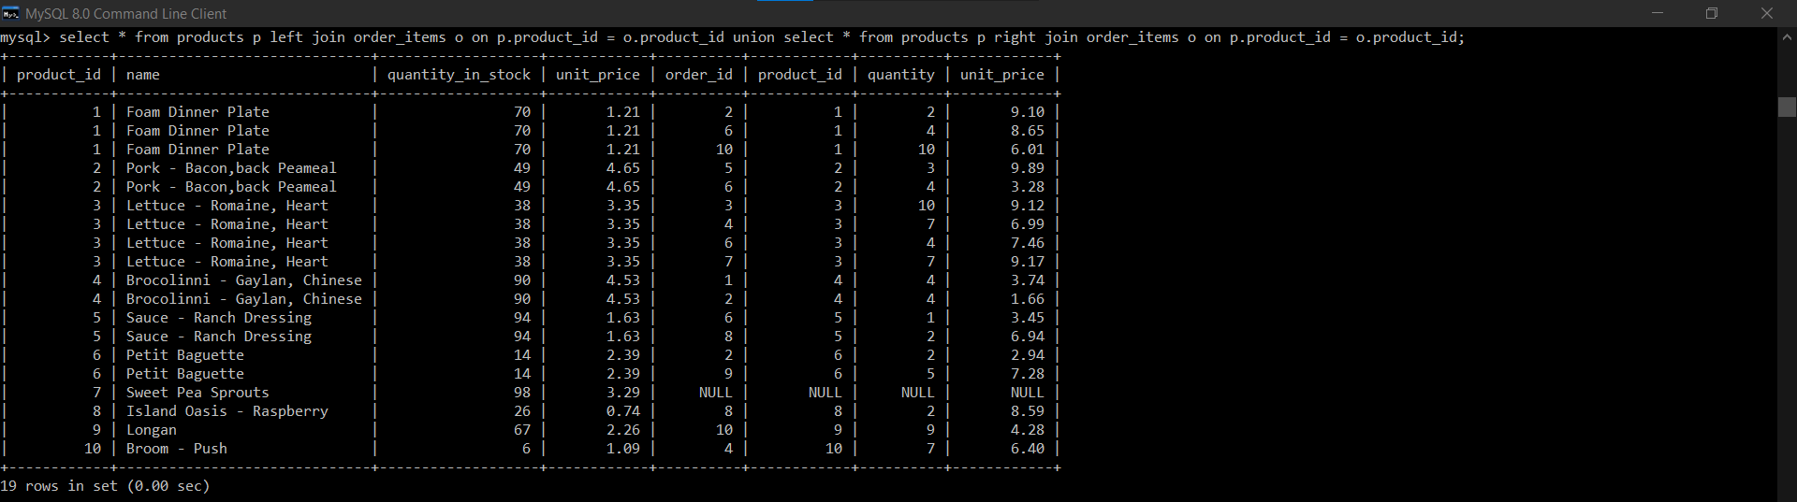

SɅRɅSWɅTI