

**Department of Computer Engineering**

**Name: Shaikh Adnan Shaukat Ali**

**Roll No: 68**

**Subject: Computer Network Lab(CNL)**

**Class/Sem: T.E. / SEM-V**

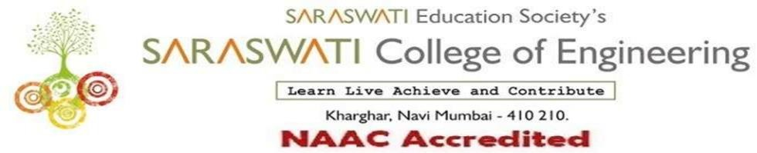

###### COMPUTER ENGINEERING DEPARTMENT

Subject: Computer Network Lab (CNL) Class/Sem: TE/V

**Name of the Laboratory: System Lab Year: 2021-2022**

**LIST OF EXPERIMENTS**

|  |  |  |  |
| --- | --- | --- | --- |
| **Expt. No.** | **Date** | **Name of the Experiment** | **Page No.** |
| 1 | 29/7/2021 | Study of RJ45 and CAT6 Cabling and connection using crimping tool. |  |
| 2 | 5/8/2021 | Use basic networking commands in Linux (ping, tracert, nslookup, netstat, ARP, RARP, ipconfig, dig, route ) |  |
| 3 | 29/7/2021 | Build a simple network topology and configure it for static routing protocol using packet tracer. |  |
| 4 | 12/8/2021 | Setup a network and configure IP addressing, subnetting, masking using Packet Tracer. |  |
| 5 | 5/8/2021 | Set up multiple IP addresses on a single LAN.  Using nestat and route commands of Linux, do the following:  ● View current routing table |  |
| 6 | 26/8/2021 | Perform Remote login using Telnet using packet tracer. |  |
| 7 | 9/9/2021 | Use Wireshark to understand the operation of TCP/IP layers:  ● Ethernet Layer: Frame header, Frame size.  ● Data Link Layer : MAC address, ARP  ● Network Layer : IP Packet (header, fragmentation), ICMP (Query and Echo)  ● Transport Layer: TCP Ports, TCP handshake segments etc.  ●Application Layer: DHCP, FTP, HTTP header formats. |  |
| 8 | 16/9/2021 | Socket programming using TCP or UDP. (Chat application) |  |
| 9 | 6/10/2021 | Study and Installation of Network Simulator (NS3). |  |
| 10 | 13/10/2021 | Perform File Transfer and Access using FTP using Packet tracer |  |
| 11 |  | Write a program to simulate leaky bucket algorithm. |  |
| 1 | 23/8/2021 | Assignment-1 |  |
| 2 | 14/10/2021 | Assignment-2 |  |

|  |  |
| --- | --- |
| **H/W Requirement** | P I and above, RAM 128MB, Printer, Cartridges |
| **S/W Requirement** | C, C++, Java, Cisco Packet Tracer, Wireshark. |

Prof. Arti K. Gore Prof. Sujata Bhairnallykar

**Subject In-charge HOD**