

**Department of Computer Engineering**

**Name: Shaikh Adnan Shaukat Ali**

**Roll No: 68**

**Subject: SOFTWARE ENGINEERING (SE)**

**Class/Sem: T.E. / SEM-V**

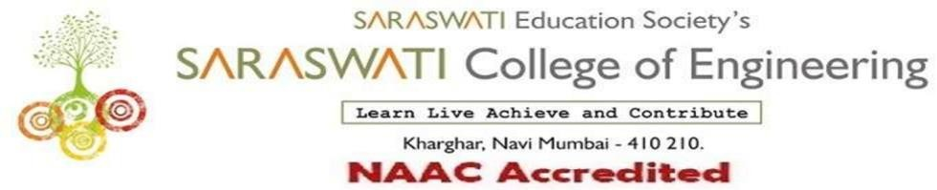

###### Department of Computer Engineering

Subject :Software Engineering Class/Sem:TE/V

**Name of the Laboratory: Software Engineering Lab Year: 2021-2022**

**LIST OF EXPERIMENTS**

|  |  |  |  |
| --- | --- | --- | --- |
| **Expt. No.** | **Date** | **Name of the Experiment** | **Page No.** |
| 1. | 30-07 | Application of at least two traditional process models. |  |
| 2. | 30-07 | Application of the Agile process models. |  |
| 3. | 06-08 | Preparation of software requirement specification (SRS) document in IEEE format |  |
| 4. | 13-08 | Structured data flow analysis. |  |
| 5. | 03-09 | Use of metrics to estimate the cost |  |
| 6. | 16-09 | Scheduling & tracking of the project. |  |
| 7. | 01-10 | Write test cases for black box testing. |  |
| 8. | 01-10 | Write test cases for white box testing. |  |
| 9 | 06-10 | Preparation of Risk Mitigation, Monitoring and Management Plan (RMMM). |  |
| 10 | 13-10 | Version controlling of the project |  |
| 1 | 09-09 | Assignment-1 |  |
| 2 | 04-10 | Assignment-2 |  |

Prof. Diksha Bhalerao Prof. Sujata Bhairnallykar

**Subject In-charge HOD**