**Experiment No. 11**

**Aim:** To calculate factorial of a number using Prolog.

**Requirements:** Compatible version of SWI-Prolog.

**Theory:**

**Formula:**

$$F\left(x\right)=\left\{\begin{aligned}1 x=1 \\ x*F\left(x-1\right) x>1\end{aligned}\right.$$

**Code:**

factorial(1,X):- X is 1.

factorial(N,X) :- N1 is N-1, factorial(N1,X1),X is N*X1.

**Output:**

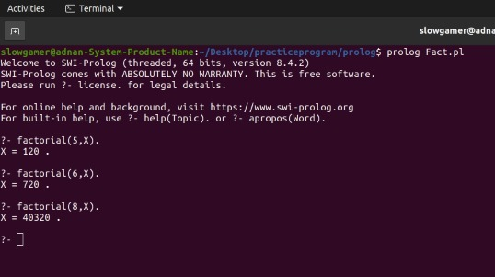

**Conclusion:** We have successfully calculated factorial of two number using Prolog.