

**Department of Computer Engineering**

**Name: Shaikh Adnan Shaukat Ali**

**Roll No: 76**

**Subject Name: Cloud computing Lab (CCL)**

**Class/Sem: T.E. / SEM-VI**

**Year: 2021-2022**

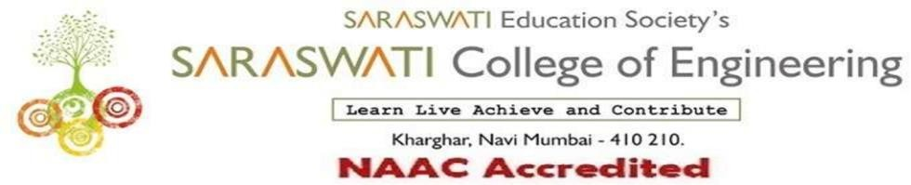

###### COMPUTER ENGINEERING DEPARTMENT

Subject: Cloud Computing Lab Class/Sem: TE/VI

**Name of the Laboratory: SDC LAB Year: 2021-2022**

**LIST OF EXPERIMENTS**

|  |  |  |  |
| --- | --- | --- | --- |
| **Expt. No.** | **Date** | **Name of the Experiment** | **Page No.** |
| 1 | 24/01/2022 | Study of Cloud Computing and it’s Architecture. | 3-17 |
| 2 | 02/02/2022 | To study and implement Hosted Virtualization using VirtualBox and KVM. | 18-25 |
| 3 | 08/02/2022 | To study and Implement Bare-metal Virtualization using Xen, HyperV or VMware Esxi. | 26-36 |
| 4 | 15/02/2022 | To study and implement Infrastructure as a Service using AWS / Microsoft Azure. | 37-42 |
| 5 | 22/02/2022 | To study and implement Platform as a Service using AWS Elastic Beanstalk / Microsoft Azure App Service. | 43-49 |
| 6 | 02/03/2022 | To implement Storage as a Service using S3 and S3 Glacier. | 50-58 |
| 7 | 16/03/2022 | To study and Implement Database as a Service on SQL/NOSQL databases like AWS RDS, AZURE SQL/ MongoDB Lab/ Firebase. | 59-68 |
| 8 | 24/03/2022 | To study and Implement Security as a Service on AWS/Azure. | 67-82 |
| 9 | 07/04/2022 | To study and implement Identity and Access Management (IAM) practices on AWS/Azure cloud | 83-86 |
| 10 | 12/04/2022 | To study and implement Containerization using Docker. | 87-96 |
| 1 | 25/01/2022 | Assignment No. 1 | 97-100 |
| 2 | 15/03/2022 | Assignment No. 2 | 101-105 |

|  |  |
| --- | --- |
| **H/W Requirement** | P I and above, RAM 128MB, Printer, Cartridges. |
| **S/W Requirement** | VirtualBox Machine, Ubuntu, AWS/Azure account, Docker. |

Dr. Prof. Sujata Bhairnallykar

**Subject In-charge HOD**