**Experiment No. 1**

**Aim:** To understand concept of Cloud Computing.

**Theory:**

**What is cloud computing?**

Cloud computing is the delivery of computing services—including servers, storage, databases, networking, software, analytics, and intelligence—over the Internet (“the cloud”) to offer faster innovation, flexible resources, and economies of scale. You typically pay only for cloud services you use, helping lower your operating costs, run your infrastructure more efficiently and scale as your business needs change.

**Cloud Computing Architecture**

The Architecture of Cloud computing contains many different components. It includes Client infrastructure, applications, services, runtime clouds, storage spaces, management, and security. These are all the parts of a Cloud computing architecture.

* **Front End:** The client uses the front end, which contains a client-side interface and application. Both of these components are important to access the Cloud computing platform. The front end includes web servers (Chrome, Firefox, Opera, etc.), clients, and mobile devices.
* **Back End:** The backend part helps you manage all the resources needed to provide Cloud computing services. This Cloud architecture part includes a security mechanism, a large amount of data storage, servers, virtual machines, traffic control mechanisms, etc.

**Virtualization and Cloud Computing**

The main enabling technology for Cloud Computing is Virtualization. Virtualization is the partitioning of a single physical server into multiple logical servers. Once the physical server is divided, each logical server behaves like a physical server and can run an operating system and applications independently. Many popular companies like VMware and Microsoft provide virtualization services. Instead of using your PC for storage and computation, you can use their virtual servers. They are fast, cost-effective, and less time-consuming.

For software developers and testers, virtualization comes in very handy. It allows developers to write code that runs in many different environments for testing.

Virtualization is mainly used for three main purposes: 1) Network Virtualization, 2) Server Virtualization, and 3) Storage Virtualization

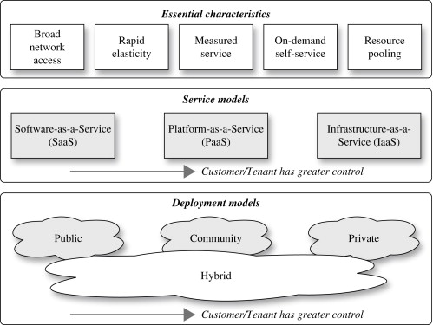

**Cloud Deployment Models**

NIST defines four cloud deployment models: public clouds, private clouds, community clouds, and hybrid clouds. A cloud deployment model is defined according to where the infrastructure for the deployment resides and who has control over that infrastructure. Deciding which deployment model you will go with is one of the most important cloud deployment decisions you will make.

Each cloud deployment model satisfies different organizational needs, so it’s important that you choose a model that will satisfy the needs of your organization. Perhaps even more important is the fact that each cloud deployment model has a different value proposition and different costs associated with it. Therefore, in many cases, your choice of a cloud deployment model may simply come down to money. In any case, to be able to make an informed decision, you need to be aware of the characteristics of each environment.

The four Cloud Deployment models:

* **Private cloud:** The cloud infrastructure is operated solely for an organization. It may be managed by the organization or a third party and may exist on premise or off premise.
* **Community cloud:** The cloud infrastructure is shared by several organizations and supports a specific community that has shared concerns (e.g., mission, security requirements, policy, and compliance considerations). It may be managed by the organizations or a third party and may exist on premise or off premise.
* **Public cloud:** The cloud infrastructure is made available to the general public or a large industry group and is owned by an organization selling cloud services.
* **Hybrid cloud:** The cloud infrastructure is a composition of two or more clouds (private, community, or public) that remain unique entities but are bound together by standardized or proprietary technology that enables data and application portability (e.g., cloud bursting for load-balancing between clouds).

These four deployment models can see significant variation depending on other factors that we will discuss in the next section, but they serve to address the broad questions as to how one can deploy pooled cloud resources. It is important to make two points about the NIST Cloud Model:

A customer or tenant can have greater security control over more resources as one moves from SaaS to PaaS and again from PaaS to the IaaS service model.

A customer or tenant can achieve greater security control over more resources when moving from a Public cloud to a community cloud and again from a community cloud to a Private cloud.

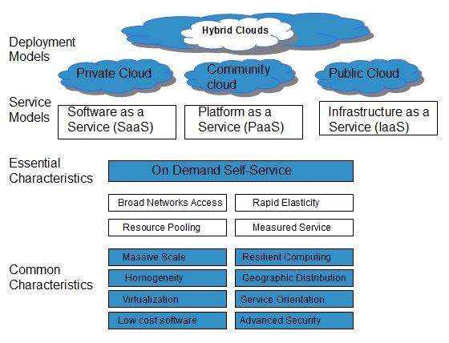

**Cloud Service models**

**Software as a Service:** Software as a Service, also known as SaaS, is essentially a web platform that provides users access to cloud computing on a subscription basis. Instead of purchasing the solution one time, as if it would be a product, the software is delivered continuously — like a service. SaaS services provide companies with data storage and management features. Often, these are services for process automation, marketing, collaboration, and data organization. Development environments can also be done as SaaS — software developers receive access to the platform where they can build, test, and deploy a product, configure its functionality and interface with built-in tools and templates.

[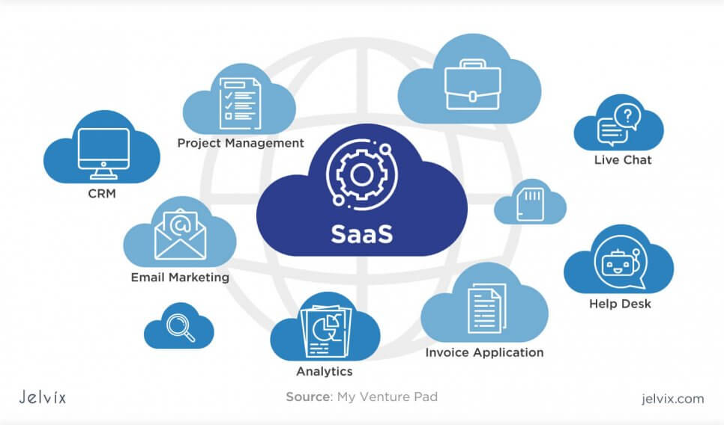](https://jelvix.com/wp-content/uploads/2020/02/what-is-saas.jpg)

Examples of SaaS:

* + **Google’s G Suite:** top cloud service provides businesses with access to management, communication, and organization tools and uses cloud for data computing. Gmail, Google Drive, Google Docs, Google Planner, Hangouts —  these are all SaaS tools that can be accessed anytime and anywhere.
  + **Microsoft Office 365:** the series of web services that provide business owners and individuals with access to Microsoft Office main tools directly from their browsers. Users can access Microsoft editing tools, business email, communication instruments, and documentation software.
  + **Salesforce:** the most popular CRM on the market that unites marketing, communication, e-commerce. Salesforce uses cloud computing benefits to provide access to its services and internal data. Business owners can keep track of their sales, client relations, communications, and relevant tasks from any device. Salesforce can be integrated into the website — the information about incoming leads will be sent to the platform automatically.
* **Platform as a Service:** Platform as a Service is software that provides access to development tools, APIs, and deployment instruments. Users receive access to virtual development environments and Cloud storage, where they can build, test, and run applications. In PaaS, users are billed only for the platforms that they use for the time when the services were used. There is no need to pay for excessive functionality, like in desktop solutions.

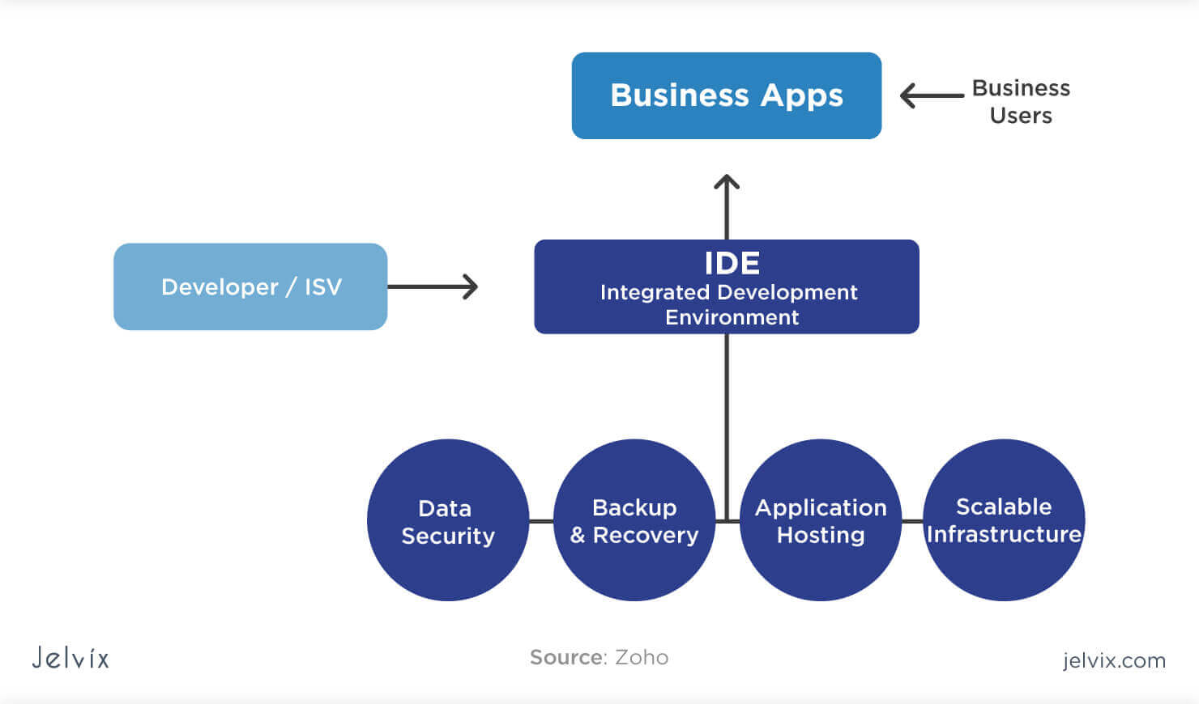

Examples of PaaS:

* + **AWS Elastic Beanstalk:** a web platform for software deployment and management, powered by the AWS Cloud. Users upload their applications to the service, and it automatically monitors the performance, load capacity, and checks for deployment errors.
  + **Apache Stratos:** the Cloud computing platform for arranging PHP and MySQL. The PaaS provides users with ready-to-use tools for database development and testing, performance monitoring, integration, and billing.
  + **Magento Commerce Cloud:** Magento Cloud offers tools for e-commerce development, testing, deployment, and maintenance. The Cloud environment allows accessing the store settings anytime and anywhere as well as automates the key processes.
* **Infrastructure as a service:** IaaS provides businesses with ready-to-use IT infrastructure: development environment, private networks, secure data storage, instruments for software development and testing, functionality monitoring, etc. The enterprises don’t need to build and secure their own IT infrastructure — they fully power the development process with third-party servers and cloud backup storage.

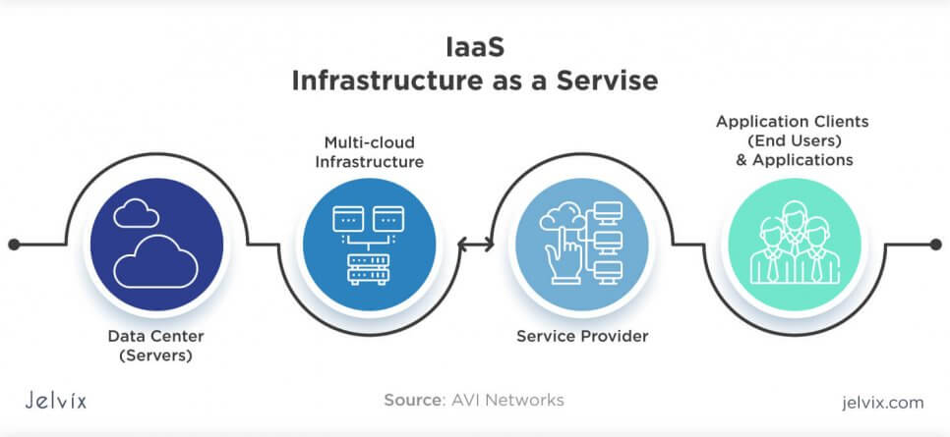

Examples of IaaS:

* **Amazon Web Services:** a public cloud that offers subscribers access to virtual servers for product deployment, Cloud storage, tools for development, testing, and analytics. The application provides a ready-to-use environment to develop and test the product and offers the full cloud infrastructure for its deployment and maintenance.
* **Microsoft Azure:** the combination of IaaS and platform as a service, the software offers 100+ services for software development, administration, and deployment, provides tools for working with innovative technologies (big data, machine learning, Internet of Things), etc.
* **IBM Infrastructure:** IBM uses its in-house services to store the data of infrastructure users, enabling remote data access via Cloud computing. IBM servers support AI, block chain, and the Internet of Things. The infrastructure also provides Cloud storage and virtual development environments, enabled on the subscription basis.
* **Google Cloud Infrastructure:** the large network of international servers that provides users access to remote Cloud data centres. Companies can store their information in Asia, Europe, and Latin America, which minimizes the risk of a security breach.

**Advantages of Cloud**

* **Cost:** Cloud computing eliminates the capital expense of buying hardware and software and setting up and running on-site datacentres—the racks of servers, the round-the-clock electricity for power and cooling, the IT experts for managing the infrastructure. It adds up fast.
* **Global scale:** The benefits of cloud computing services include the ability to scale elastically. In cloud speak, that means delivering the right amount of IT resources—for example, more or less computing power, storage, bandwidth—right when it is needed and from the right geographic location.
* **Performance:** The biggest cloud computing services run on a worldwide network of secure datacentres, which are regularly upgraded to the latest generation of fast and efficient computing hardware. This offers several benefits over a single corporate datacentre, including reduced network latency for applications and greater economies of scale.
* **Security:** Many cloud providers offer a broad set of policies, technologies and controls that strengthen your security posture overall, helping protect your data, apps and infrastructure from potential threats.
* **Speed:** Most cloud computing services are provided self service and on demand, so even vast amounts of computing resources can be provisioned in minutes, typically with just a few mouse clicks, giving businesses a lot of flexibility and taking the pressure off capacity planning.
* **Productivity:** On-site datacentres typically require a lot of “racking and stacking”—hardware setup, software patching, and other time-consuming IT management chores. Cloud computing removes the need for many of these tasks, so IT teams can spend time on achieving more important business goals.
* **Reliability:** Cloud computing makes data backup, disaster recovery and business continuity easier and less expensive because data can be mirrored at multiple redundant sites on the cloud provider’s network.

**Disadvantages of cloud computing**

* **Downtime:** Downtime is often cited as one of the biggest disadvantages of cloud computing. Since cloud computing systems are internet-based, service outages are always an unfortunate possibility and can occur for any reason.
* **Security and privacy:** Although cloud service providers implement the best security standards and industry certifications, storing data and important files on external service providers always opens up risks. Any discussion involving data must address security and privacy, especially when it comes to managing sensitive data. We must not forget what happened at Code Space and the hacking of their AWS EC2 console, which led to data deletion and the eventual shutdown of the company. Their dependence on remote cloud-based infrastructure meant taking on the risks of outsourcing everything.
* **Vulnerability to attack:** In cloud computing, every component is online, which exposes potential vulnerabilities. Even the best teams suffer severe attacks and security breaches from time to time. Since cloud computing is built as a public service, it’s easy to run before you learn to walk. After all, no one at a cloud vendor checks your administration skills before granting you an account: all it takes to get started is generally a valid credit card.
* **Limited control and flexibility:** Since the cloud infrastructure is entirely owned, managed, and monitored by the service provider, it transfers minimal control over to the customer. To varying degrees (depending on the particular service), cloud users may find they have less control over the function and execution of services within a cloud-hosted infrastructure. A cloud provider’s end-user license agreement (EULA) and management policies might impose limits on what customers can do with their deployments. Customers retain control of their applications, data, and services, but may not have the same level of control over their backend infrastructure.
* **Vendor lock-in:** Vendor lock-in is another perceived disadvantage of cloud computing. Easy switching between cloud services is a service that hasn’t yet completely evolved, and organizations may find it difficult to migrate their services from one vendor to another. Differences between vendor platforms may create difficulties in migrating from one cloud platform to another, which could equate to additional costs and configuration complexities. Gaps or compromises made during migration could also expose your data to additional security and privacy vulnerabilities.

**Applications of Cloud Computing**

* **Online Data Storage:** Organizations have a lot of data to store and with time the size of this data increases. This data can be in any format like text, image, audio, or video. Now, in order to store and maintain this huge amount of data, organizations are no longer needed to set physical storage systems. They can use Clouds to store their data. The whole data of an organization can be categorized into two types – current data and historical data. Data that is used very frequently in order to perform some day-to-day operations is known as current data. On the other hand, data that is not operational but is of value and needs to be stored is known as historical data. So, in order to store these two types of data separately, we have two storage options available:
* Hot Storage: The data which needs to be accessed right away or very frequently, is stored in this storage.
* Cold Storage: The data which does not require fast access or frequent access is stored in cold storage.
* Cloud storage of data also makes it easily accessible because now you can access it from anywhere in the world with just an internet connection.
* **Backup and Recovery:** Cloud service providers offer a lot of options for data recovery. They offer various recovery plans at different costs. The cloud provider gives the option for data redundancy, i.e., a copy of data is stored at different places. It can be a different server or data centre or even a different geographic location. The reason for this redundant storage option is to provide safety against data and to provide flexibility in accessing the data. Suppose, at the primary location data becomes inaccessible somehow, then it can be easily accessed from other storage locations. Some data redundancy options available are:
* Locally redundant storage (LRS)
* Zone-redundant storage (ZRS)
* Geo-redundant storage (GRS)
* Geo-zone-redundant storage (GZRS)
* **Testing and Development:** After the development of a product, testing plays a major role in finalizing it for deployment. Before the final delivery, a product needs to be tested properly. It must be tested on different machines with different infrastructures because the end-user of that product can be anywhere. It also must be tested for load balancing. Load balancing- How the performance of a product affects when a large number of users use it simultaneously. To accomplish such tasks testing requires different IT resources and different computer infrastructures. Now, A cloud can provide these testing features at one place. Organizations can easily test the performance of their product on the cloud against a large number of users.
* **Cloud Computing in Medical Fields:** In the medical field also, cloud computing is doing wonders. It is used to store data of patients and helps to access it over the internet without any need of the physical computer set up to trace the previous records, or even doesn’t need the paperwork. In case of emergencies, the patient’s data can be accessed remotely from anywhere rather than waiting till they get access to information from the hospital computer.
* **Big Data analysis:** Big Data analysis involves dealing with huge amounts of data having sizes from terabytes to zettabytes (known as big data). Now for any traditional database management system, it is very difficult to maintain this amount of data. Cloud Computing allows us to store large data sets that include structured, and unstructured data, from different sources, and in different sizes from terabytes to zettabytes. Not only the storage, it also provides us various tools in order to do the analysis on this big data. Because the main purpose of storing big data is to derive something out of it.The flexibility of the cloud makes it a good choice for big data analytics. Organizations will have a major financial advantage by using the cloud because it is much cheaper than the traditional large-scale big data resources. Now they do not need to maintain large data centres. Moreover, the cloud also makes data integration from different resources much easier for organizations.
* **Entertainment Applications:** Today we get a lot of entertainment content on the internet, let it be Netflix web series episodes, online games, or YouTube videos. This data is widely used by users from almost all parts of the world. It is also very necessary to provide a great customer experience. So that this content is available on-demand. For this, the entertainment companies reach their customers through a multi-cloud strategy. With the help of the cloud, the entertainment industry is reaching new heights.
* **Social Network Platforms:** Social network platforms play an important role in day-to-day life. They have changed the way of communication and interaction. These platforms have a large number of users across the globe and this makes them ideal candidates for cloud computing adaptation. Social media sites contain heavy multimedia content like images and videos and they are capable of making the whole network slow, here cloud storage comes into play. Cloud storage helps social media applications to run smoothly. Apart from data storage, cloud services also offer cost-effective analytics for these sites. Another advantage of cloud computing is data backup and recovery in case of any disaster. Social media sites store the personal data of their users and therefore they cannot afford to lose even a small part of it. If the data is only stored in one central location it can be insecure. If something happens there, it is almost impossible to recover the data. But through cloud security services they remain accessible through shared resources across the globe.
* **Anti-virus Applications:** Nowadays we have cloud-based antivirus solutions which perform better than traditional antivirus software. The main reason behind this is – Cloud-based antivirus stores malware information on the cloud rather than on the user system. Traditional antivirus software is used to store malware information on the user system itself which can adversely affect the performance of the user’s system.
* **Accounting Application:** Cloud-based accounting applications help an organization to manage their business accounting and finances in less time, effort, expense, and labour. It allows businesses to manage their finances from anywhere in the world without compromising on the security of data. Cloud-based accounting applications or software are scalable because now companies can expand their workforce without investing in the infrastructure. Cloud makes this software easy to upgrade because now we do not have to worry about our system specifications and resources.
* **Management Applications:** Management Application like ‘Evernote’ is cloud-based application. It helps to save, format, and share notes over the cloud. Evernote uses cloud computing’s storage service to store the data of the users. Because of being in the cloud storage, the data can be accessed at any time, from anywhere, and on any device. The security service of the cloud helps to keep the data secure. Also, there are no chances of data loss because of the redundant storage service that Evernote uses in Cloud Computing.

**Conclusion:** We have successfully understand the concept of cloud computing, NIST Architecture and Infrastructure of cloud computing, various Deployment models of cloud computing and when to use specific or combination of Deployment model, different Services models and their level of access, Advantages and Disadvantages of cloud computing and whereas areas where it can be implemented and how it can be implemented.