**Experiment No. 3**

**Aim:** To study and Implement Bare-metal Virtualization using Xen, HyperV or VMware Esxi.

**Requirements:** Xenserver.

**Theory:**

**The Xen Hypervisor**

The Xen hypervisor forms the core of all Xen-based virtualization platforms and, like VMware ESXi and Microsoft Hyper-V, is a “bare metal” hypervisor. This means that the first code that starts on the machine is the hypervisor and that a general-purpose operating system isn’t required to manage the system.

Originally designed at the University of Cambridge in Cambridge, England, Xen forms the core hypervisor in not only XenServer but also Oracle VM and can be used as an optional hypervisor within major Linux distributions such as CentOS, Debian, and SUSE Linux Enterprise Server. Additionally, Xen has been heavily used with what is arguably the most famous deployment at Amazon: providing the basis of its Amazon Web Services product offering.

Xen is actively developed under stewardship within the Xen Project: a Linux Foundation Collaborative Project, where it benefits from the active participation and contributions of well over a dozen organizations. This breadth of development ensures that the Xen hypervisor technology keeps pace with changing trends in data center operations while remaining focused on delivering hypervisor services.

Along with the depth of development put into the Xen hypervisor, it’s important to note that each Xen-based product chooses which version of the Xen hypervisor to support and which features of that version to integrate. As such, it’s common for some hypervisor features present in Xen to not be utilized in other packaged solutions.

**Software architecture**

Xen Project runs in a more privileged CPU state than any other software on the machine, except for Firmware.

Responsibilities of the hypervisor include memory management and CPU scheduling of all virtual machines ("domains"), and for launching the most privileged domain ("dom0") - the only virtual machine which by default has direct access to hardware. From the dom0 the hypervisor can be managed and unprivileged domains ("domU") can be launched.

The dom0 domain is typically a version of Linux or BSD. User domains may either be traditional operating systems, such as Microsoft Windows under which privileged instructions are provided by hardware virtualization instructions (if the host processor supports x86 virtualization, e.g., Intel VT-x and AMD-V), or paravirtualized operating systems whereby the operating system is aware that it is running inside a virtual machine, and so makes hypercalls directly, rather than issuing privileged instructions.

Xen Project boots from a bootloader such as GNU GRUB, and then usually loads a paravirtualized host operating system into the host domain (dom0).

**Output**:

Step 1: Install Xen Server

Step i: Insert Bootable Xen Server CD into CDROM and Make first boot device as a CDROM from BIOS

Step ii: press F2 to see the advanced options, otherwise press Enter to start installation Step iii -: Select Keyboard Layout

Step iv: Press Enter to load Device Drivers

Step v: Press Enter to Accept End user license Agreement

Step vi: Select Appropriate disk on which you want to install Xenserver

Step vii: Select appropriate installation Media (LOCAL Media) Step viii: Select Additional Packages for installation

Step ix: Specify Root password

Step x: Specify IP Address to Xenserver

Step xi: Select Time Zone

Step xii: Specify NTP Servers address or use manual time entry then start installation. Once installation is done you will see the final screen shown below.

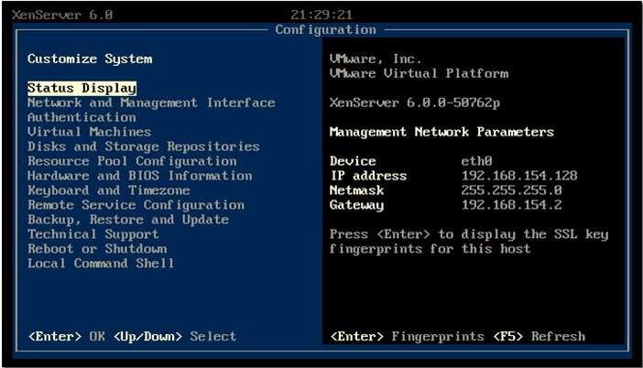

Step 2: Connect Xen Server to Xen Center

Firstly, download the xen center a management utily from xen server by opening the xen severs IP address as a URL on browser. Once Xen center is downloaded, install it.Open Xen center from start menu of Windows.

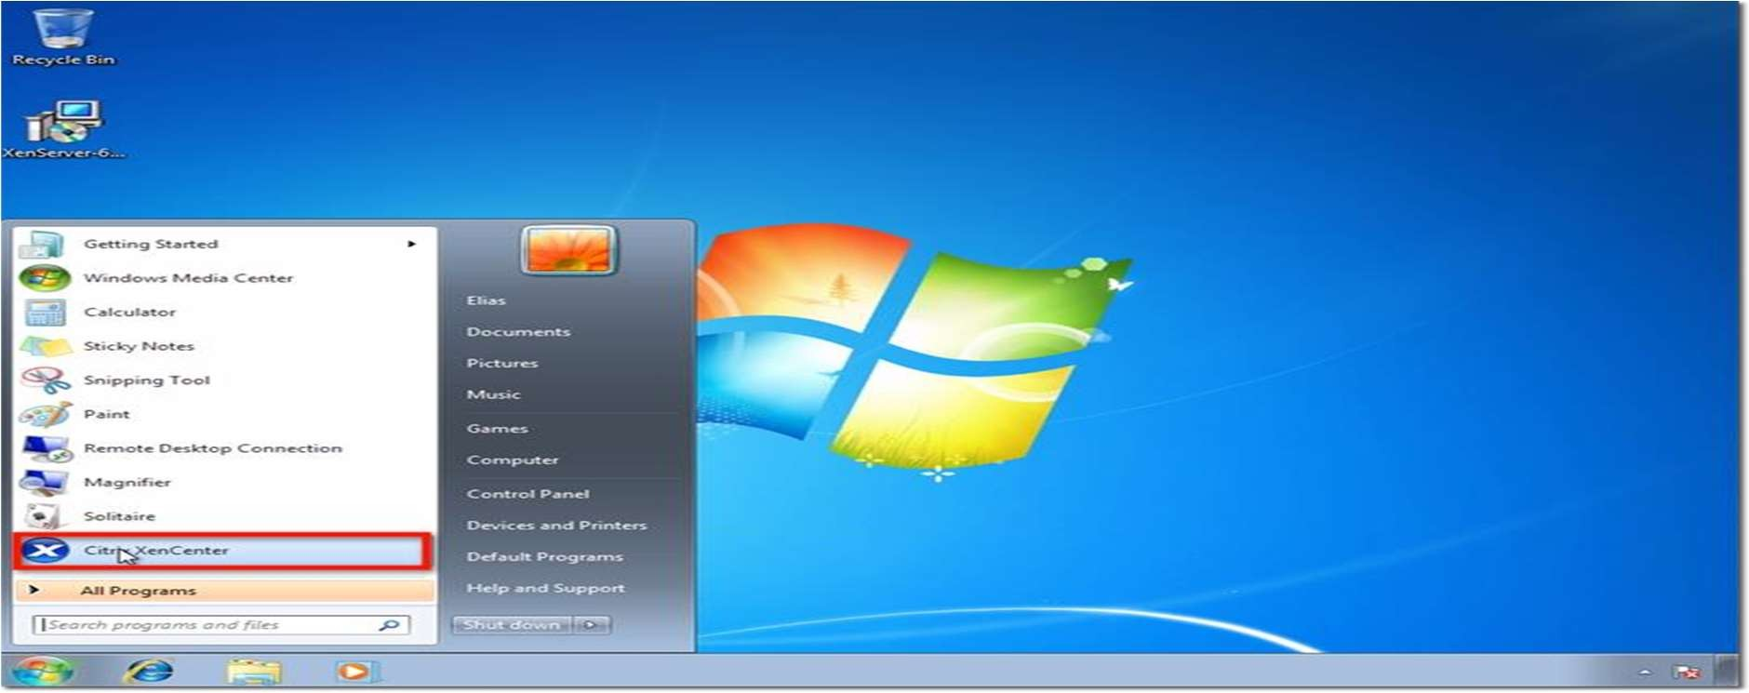

To connect to the XenServer host you configured earlier, click Add a server.

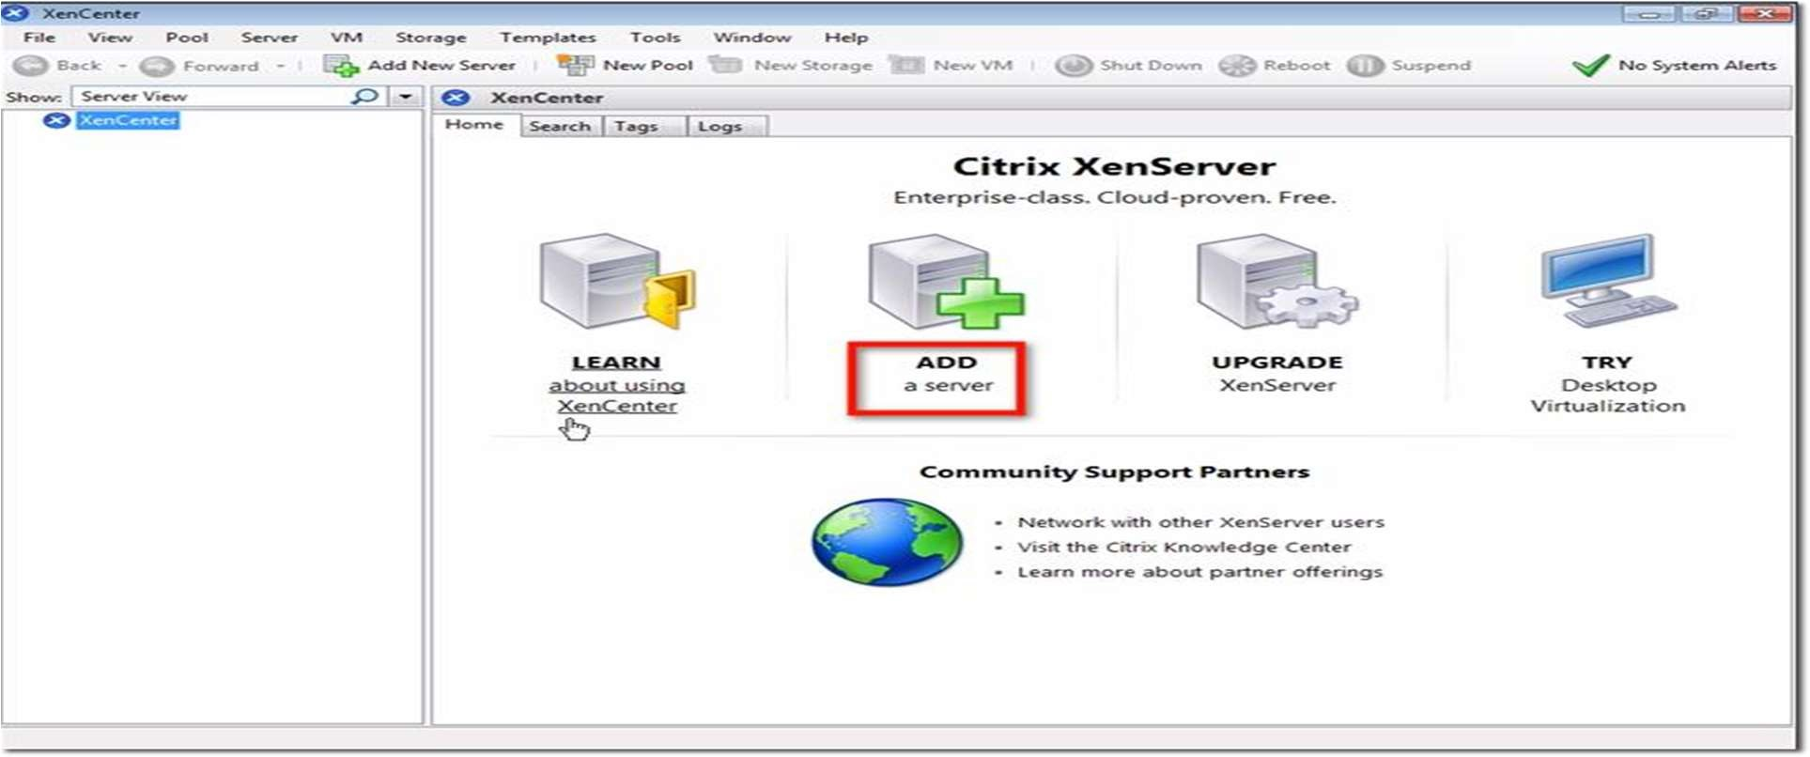

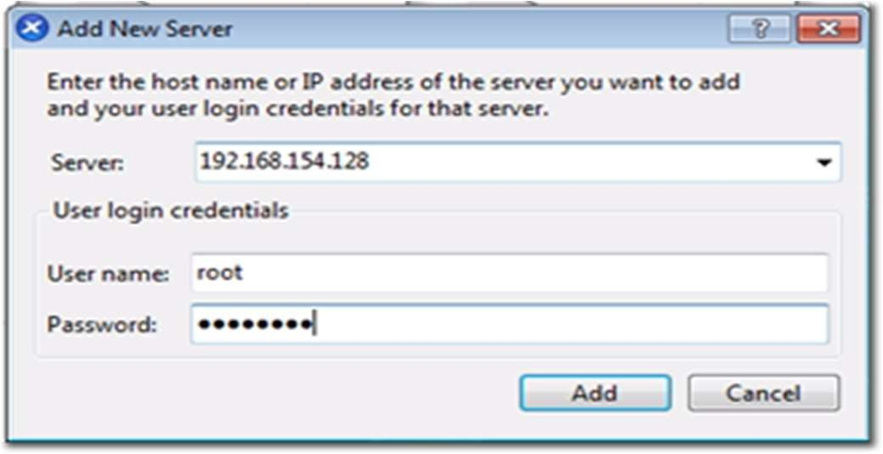Enter the IP address I asked you to take note of earlier. Also enter the password you assigned for your root account. Click Add.

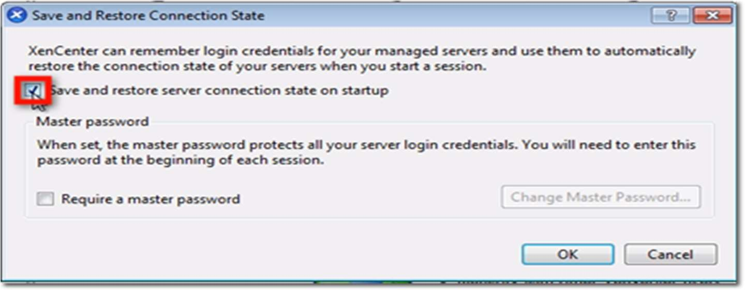One of the first things you want to make sure as you’re adding a new XenServer to XenCenter is to save and restore the server connection state on startup. Check the box that will do just that.

Once you do that, you will be allowed to configure a master password for all the XenServers you’ll be associating with this XenCenter. Click the Require a master password checkbox if that’s what you want to do, and then enter your desired master password in the fields provided.

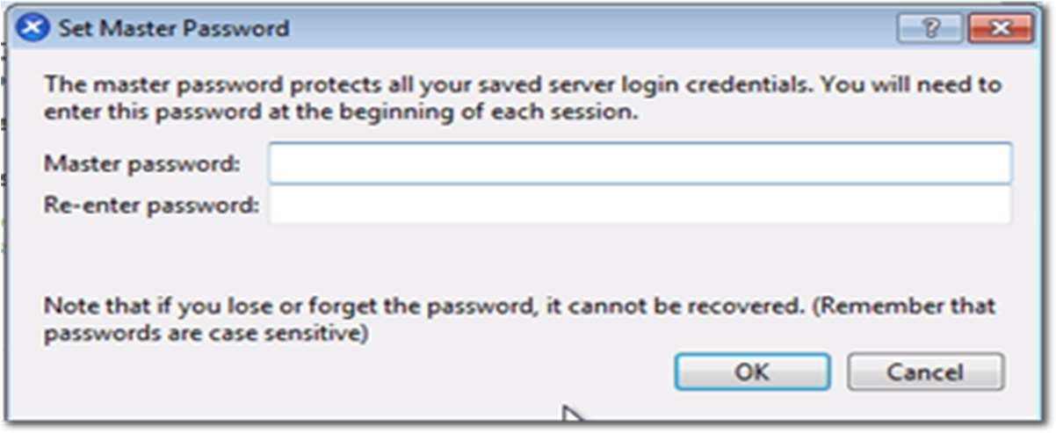

After you click OK, you’ll be brought back to the main screen, where you’ll see your XenServer already added to XenCenter.

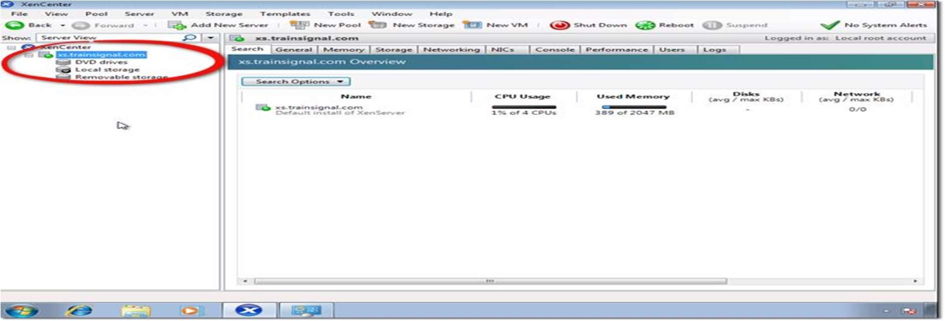

Step 3: Create Storage Repository and Installing VM

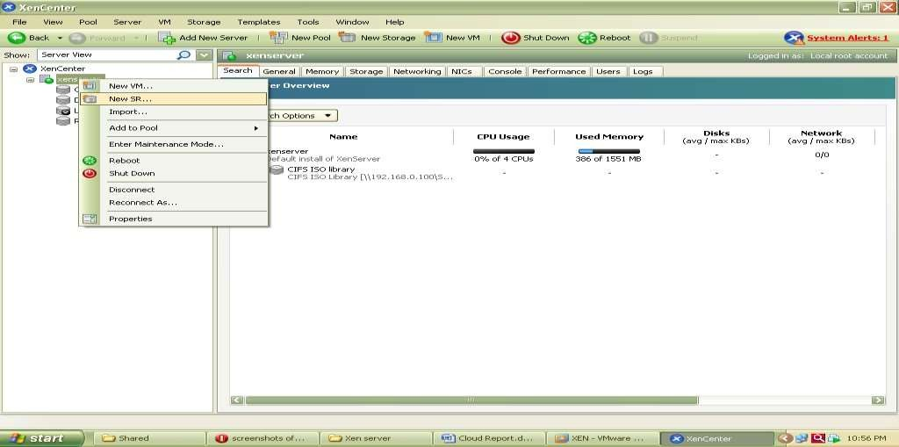Now Before Creating VM we have to Create Storage Repository first which is nothing but shared directory on Xen Center which holds all iso files and which is required to install Operating system on Xen Server its steps are as follows.Right click on Xenserver icon on xen center and click on New SR

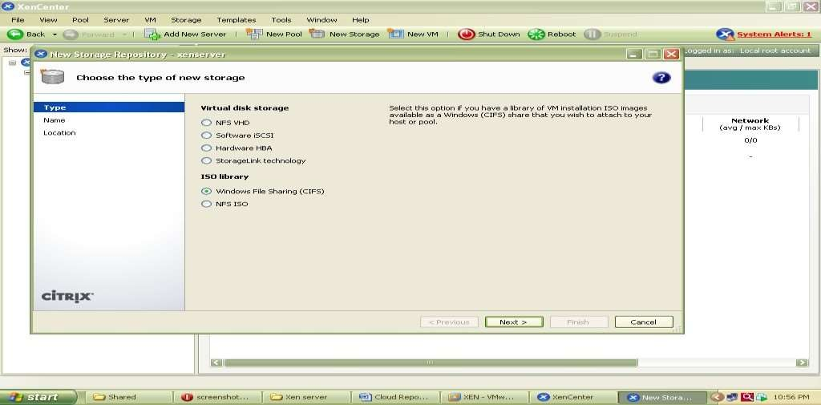Now Select Windows CIFS library

Specify Storage Repository Name

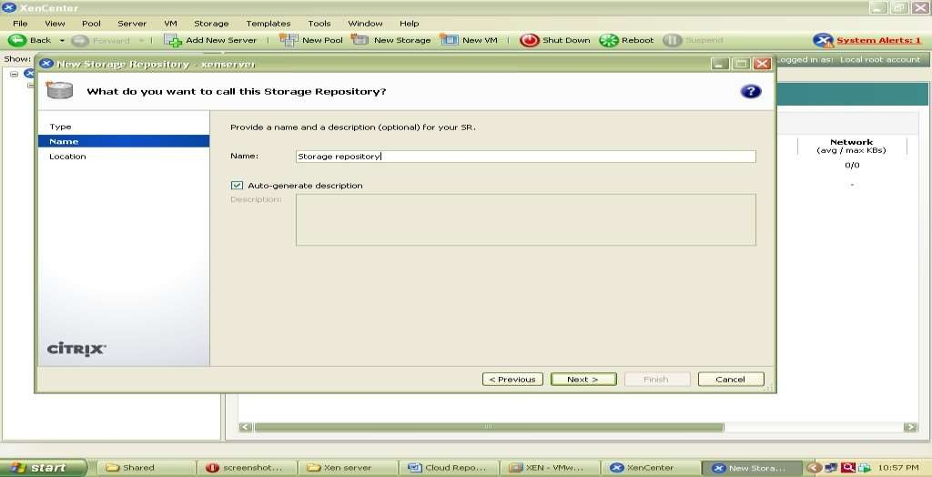

Now specify path of shared folder at client side which holds all iso files of os or VM which we are going to install on Xen Server.

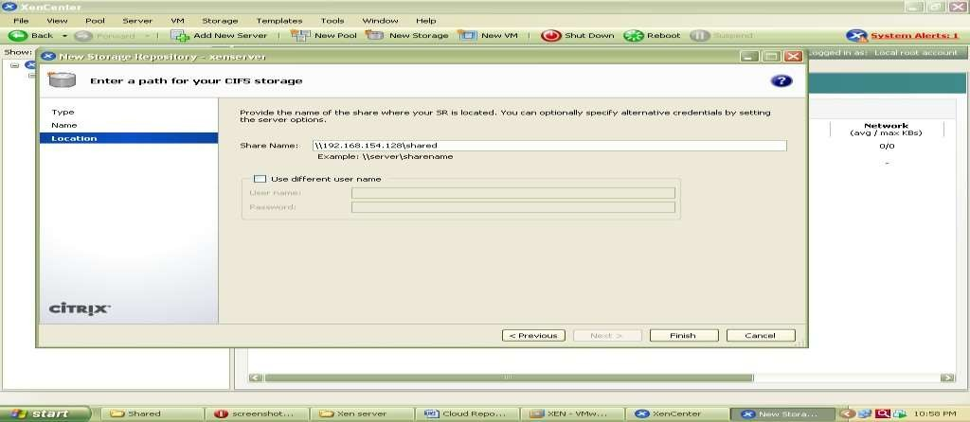

At the end Click on finish to create SR. To check all iso files click on CIFS library and select storage this will show you all iso files.

**Installation of UBUNTU Server on Xen Server**

Step 1 -: Right click on Xenserver icon on xen center and select New VM

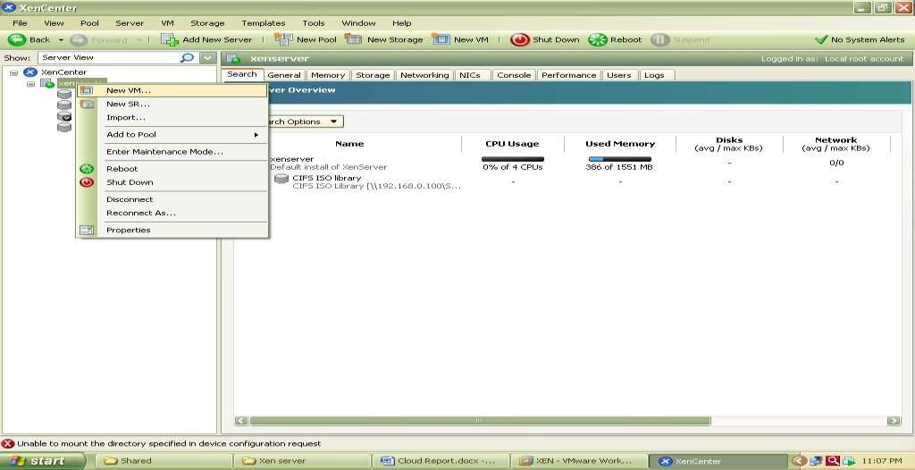

Now select an Operating System to be install here select Ubuntu Lucid Lynx and click on next

Now specify Instance Name as ubuntu server Select iso file of Ubuntu server 10.10 to be install

Now select hardware for vm i.e. no. of cpu’s and memory Select local storage

Select network And click on finish

Now go to Console tab to install ubuntu and follow installation Steps.

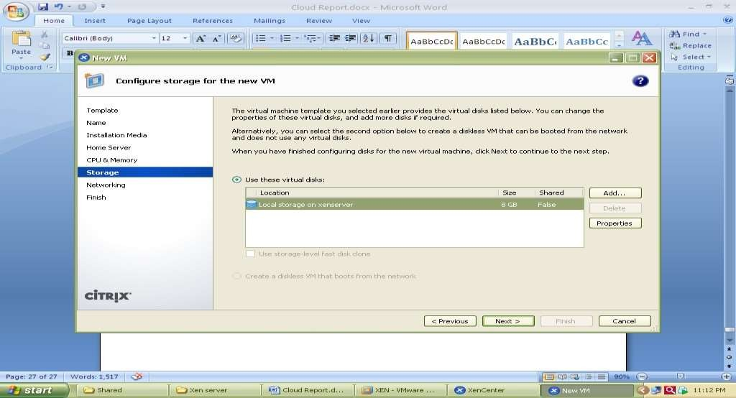

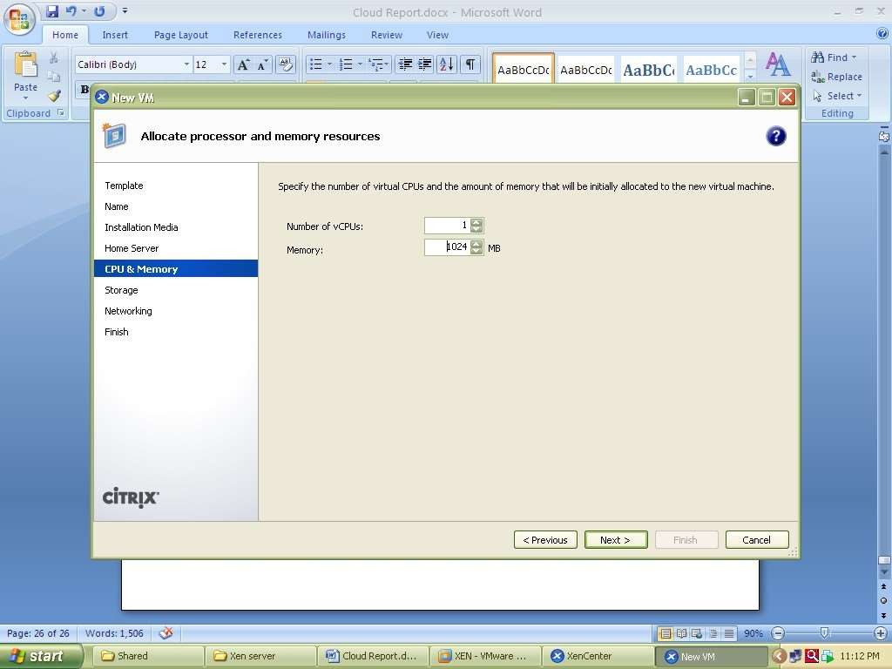

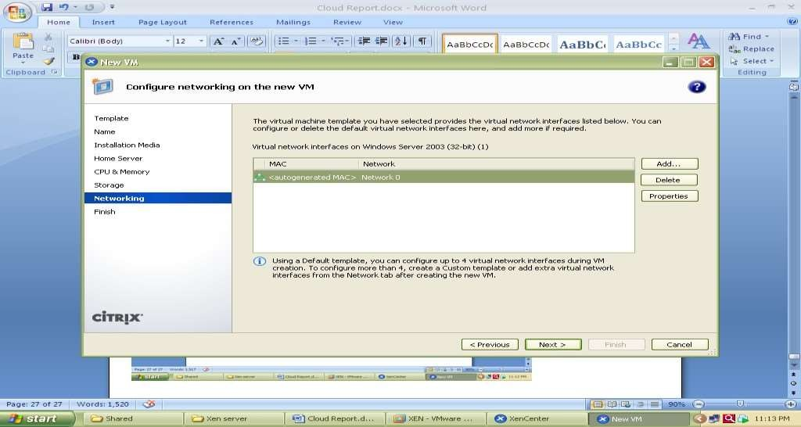

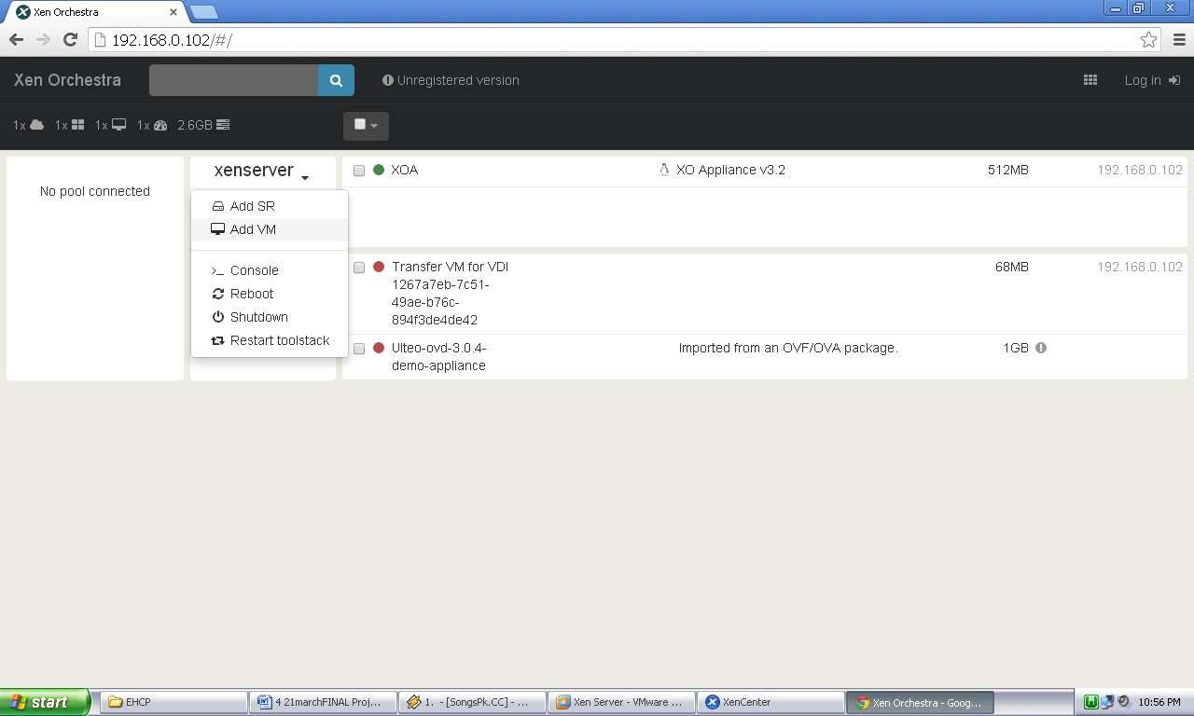The Xen orchestra provides web based functionality of Xen Center.it provides access to all the VMs with their lifecycle management which are installed over Xen Server shown in figure Xen Orchestra (XOA) Portal.

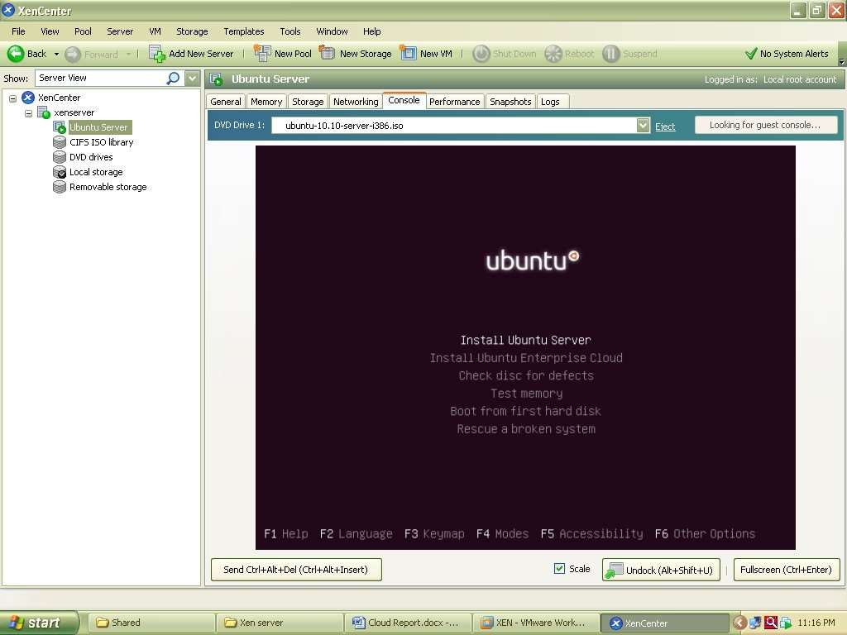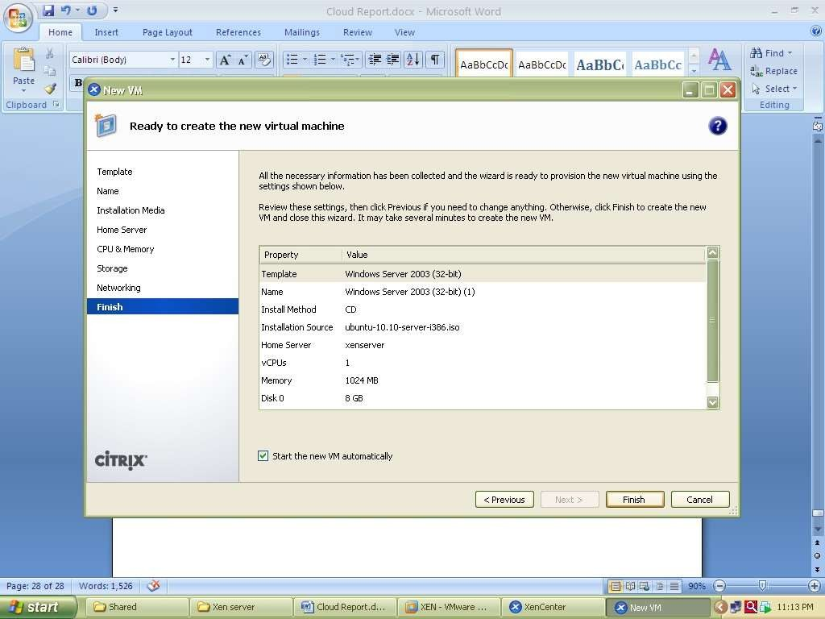

The Windows XP image running on Xen Orchestra over Google chrome web browser is shown in following screenshot

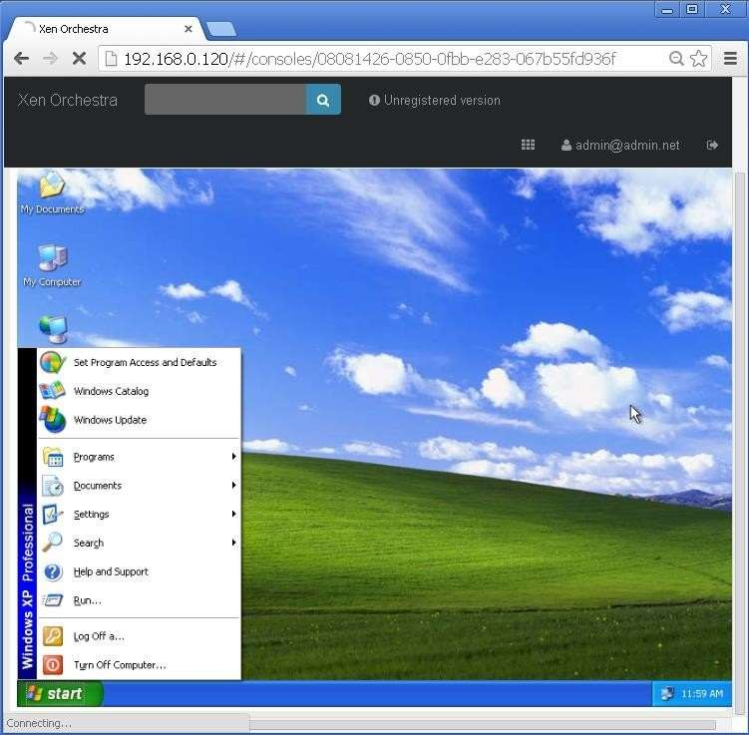

**Conclusion**: We have successfully implemented Bar-metal Metal virtualization using Xen.