**Experiment No. 4**

**Aim:** To study and Implement Infrastructure as a Service using AWS/Microsoft Azure.

**Requirements:** Windows/Mac/Linux O.S, AWS/Azure account and Remmina for Linux.

**Theory:**

**Infrastructure as a service:** IaaS provides businesses with ready-to-use IT infrastructure: development environment, private networks, secure data storage, instruments for software development and testing, functionality monitoring, etc. The enterprises don’t need to build and secure their own IT infrastructure — they fully power the development process with third-party servers and cloud backup storage.

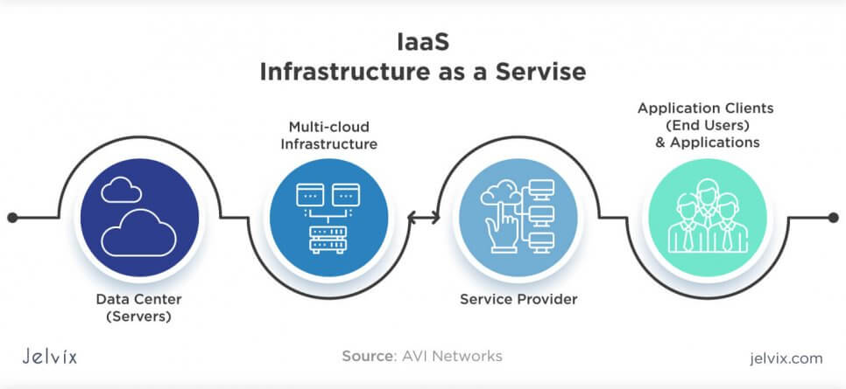

Examples of IaaS:

**Amazon Web Services:** a public cloud that offers subscribers access to virtual servers for product deployment, Cloud storage, tools for development, testing, and analytics. The application provides a ready-to-use environment to develop and test the product and offers the full cloud infrastructure for its deployment and maintenance.

**Microsoft Azure:** the combination of IaaS and platform as a service, the software offers 100+ services for software development, administration, and deployment, provides tools for working with innovative technologies (big data, machine learning, Internet of Things), etc.

**IBM Infrastructure:** IBM uses its in-house services to store the data of infrastructure users, enabling remote data access via Cloud computing. IBM servers support AI, block chain, and the Internet of Things. The infrastructure also provides Cloud storage and virtual development environments, enabled on the subscription basis.

**Google Cloud Infrastructure:** the large network of international servers that provides users access to remote Cloud data centres. Companies can store their information in Asia, Europe, and Latin America, which minimizes the risk of a security breach.

**Implementation:**

1. Creating Virtual Machine in Azure:

i) Basics

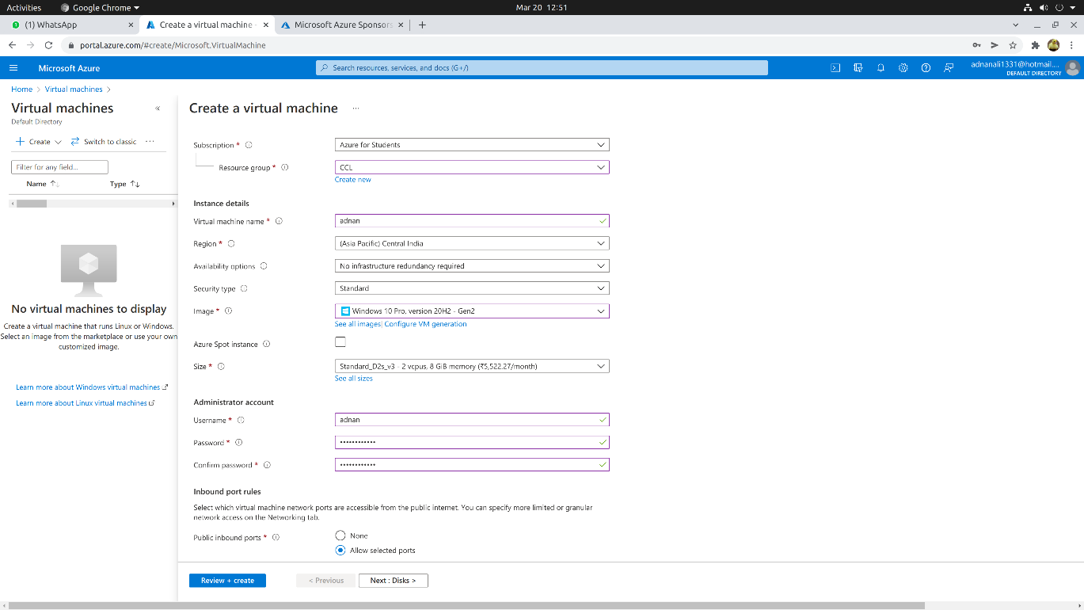

ii) Disks

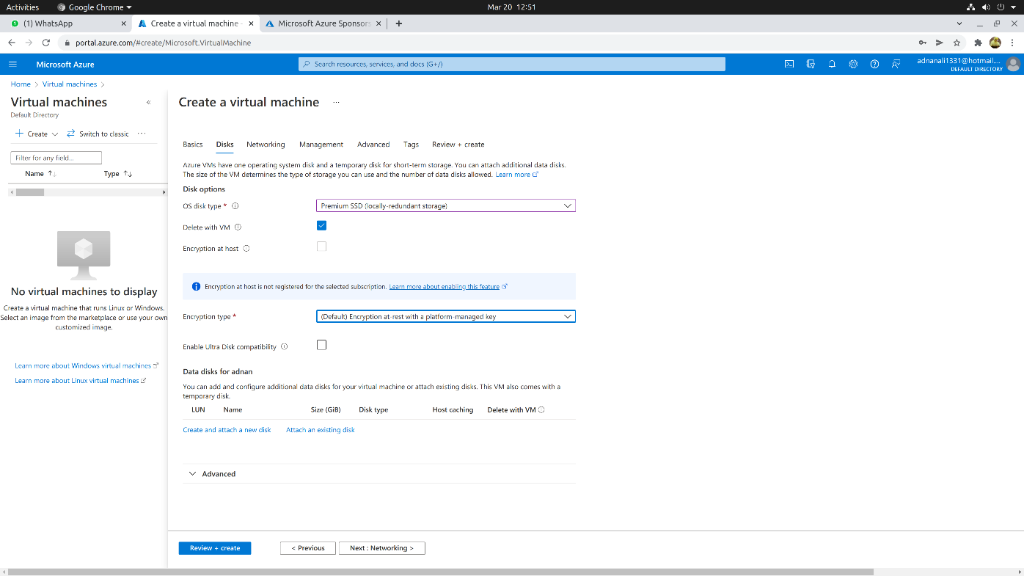

iii) Network

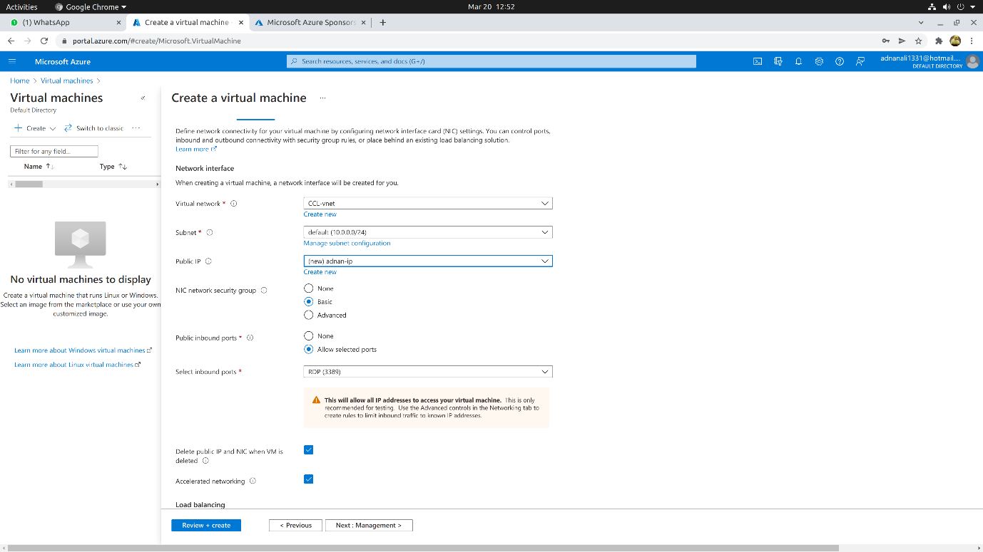

iv) Management

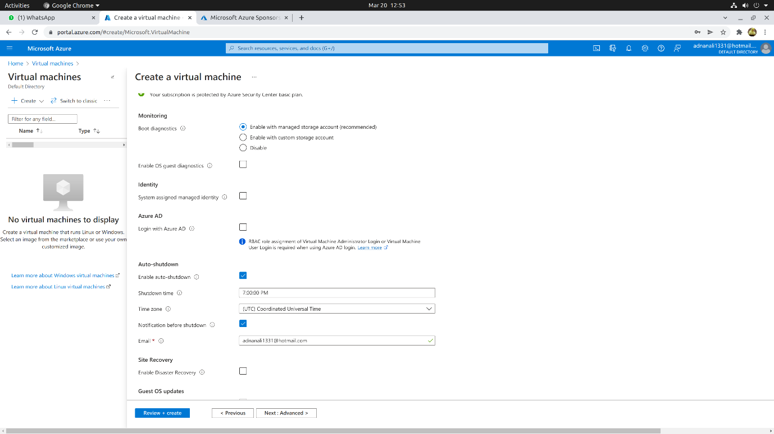

v) Tags

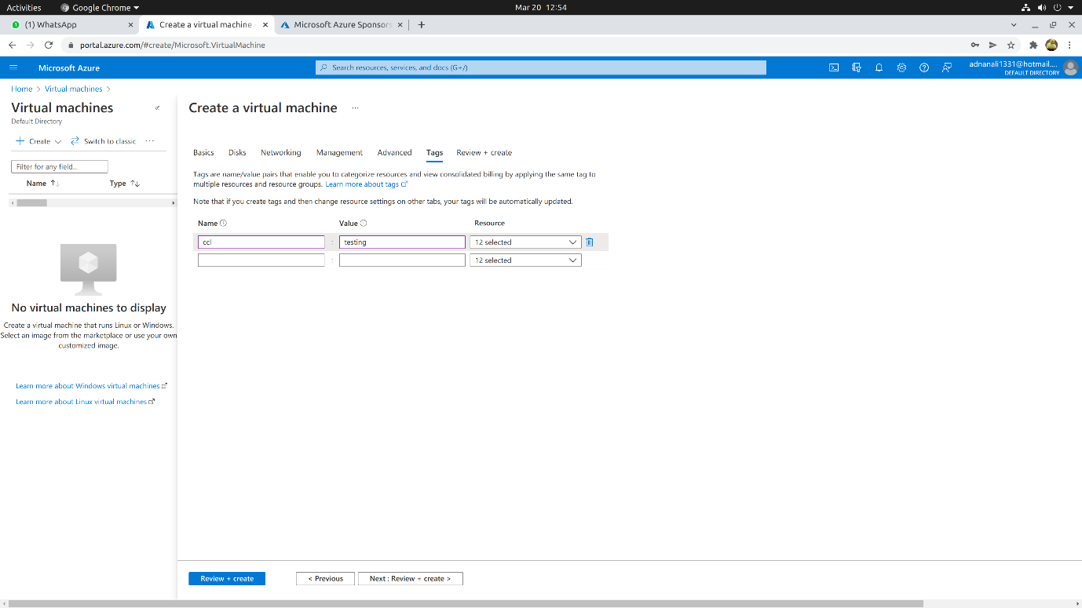

vi) Creating

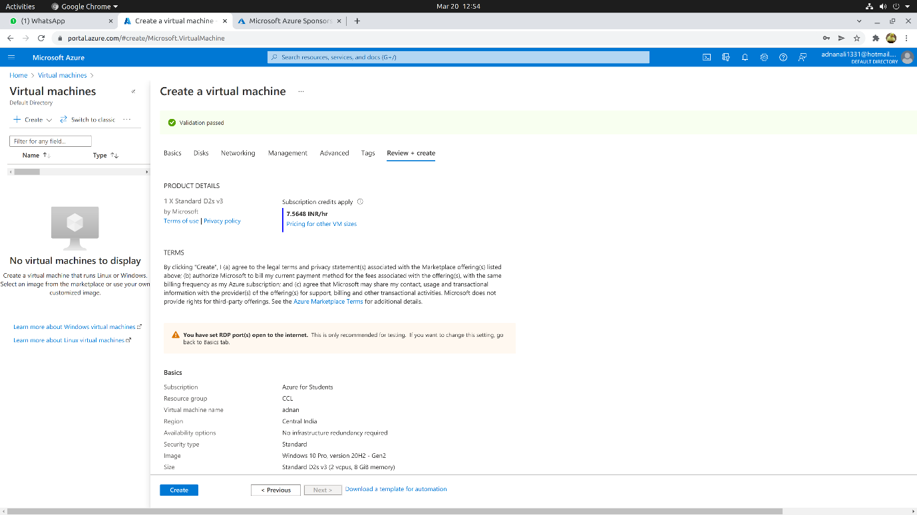

vii) Deployment complete

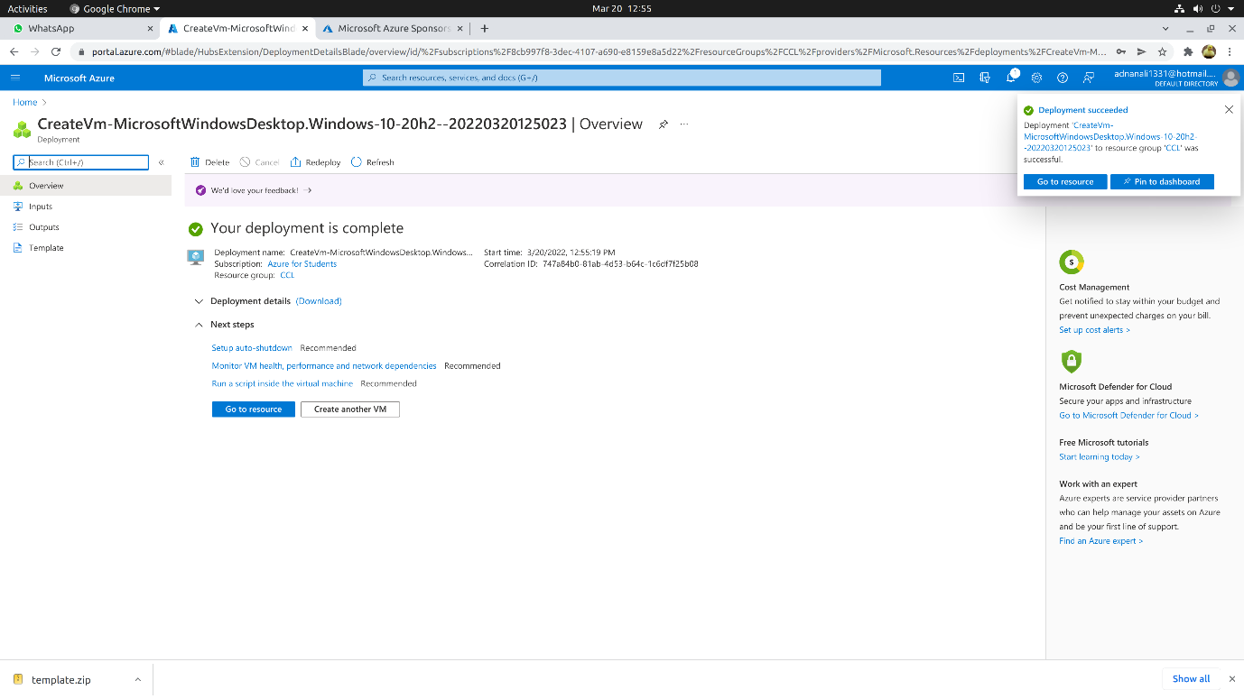

2) RDP connection:

i) Configuring and downloading RDP file

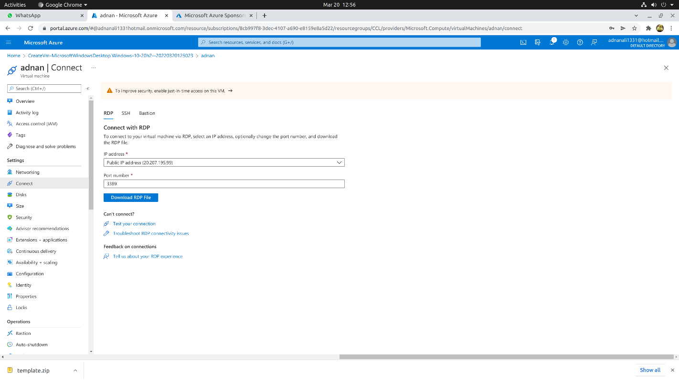

ii) Connecting through Remmina

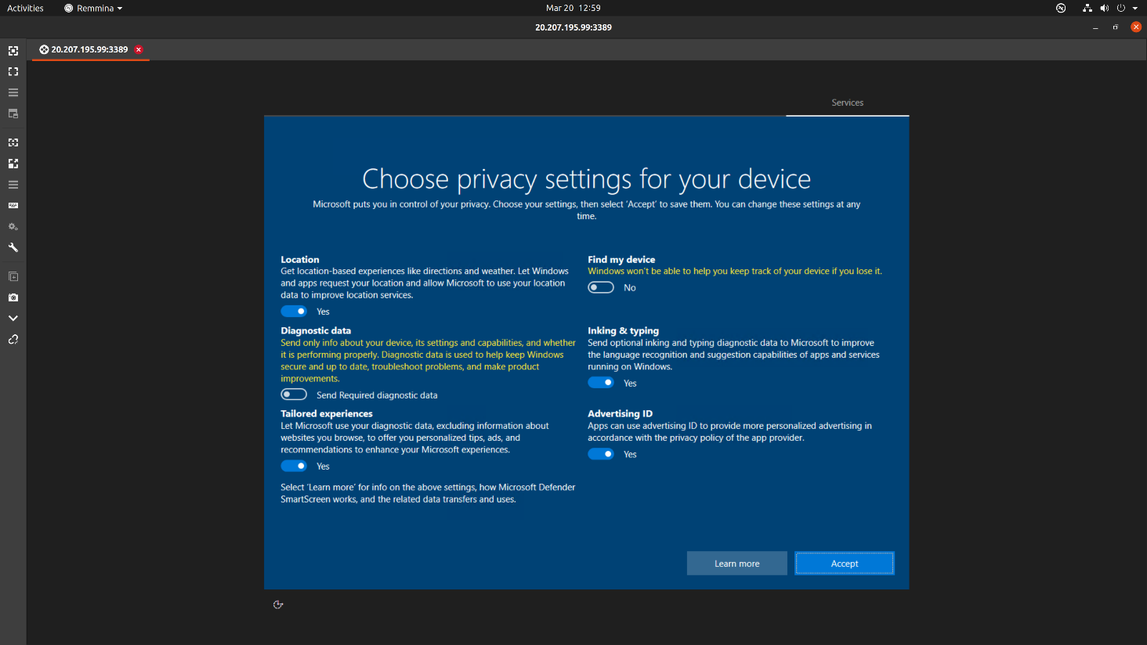

3) Result:

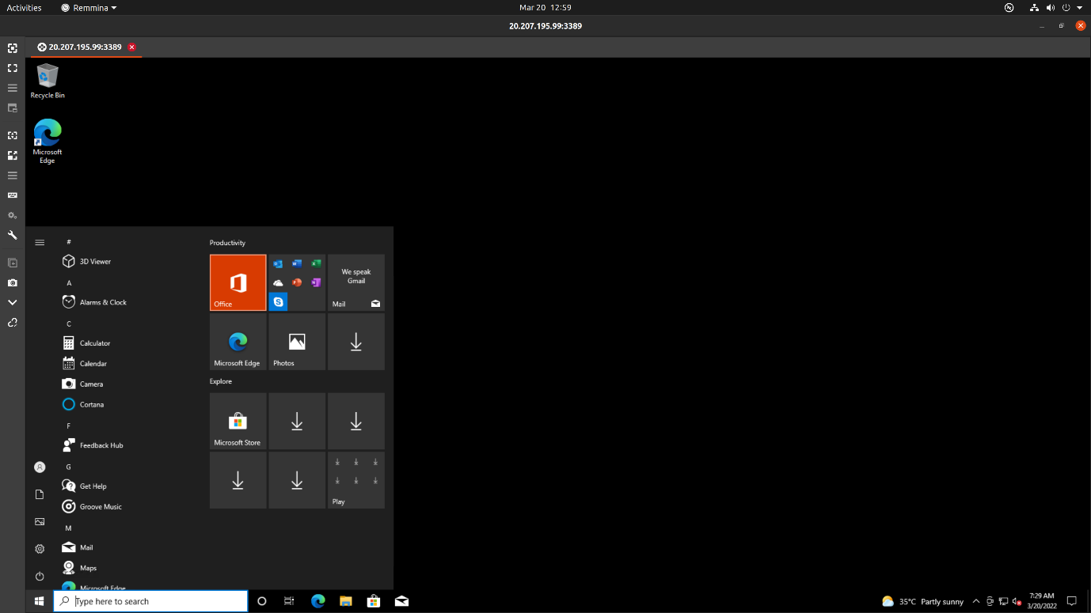

**Conclusion:** We have successfully implemented infrastructure as a service using Azure.