**Experiment No. 5**

**Aim:** To study and Implement Platform as a Service using AWS Elastic Beanstalk/ Microsoft Azure App Service.

**Requirements:** Windows/Mac/Linux O.S, AWS/Azure account and compatible version of python.

**Theory:**

**Platform as a Service:** Platform as a Service is software that provides access to development tools, APIs, and deployment instruments. Users receive access to virtual development environments and Cloud storage, where they can build, test, and run applications. In PaaS, users are billed only for the platforms that they use for the time when the services were used. There is no need to pay for excessive functionality, like in desktop solutions.

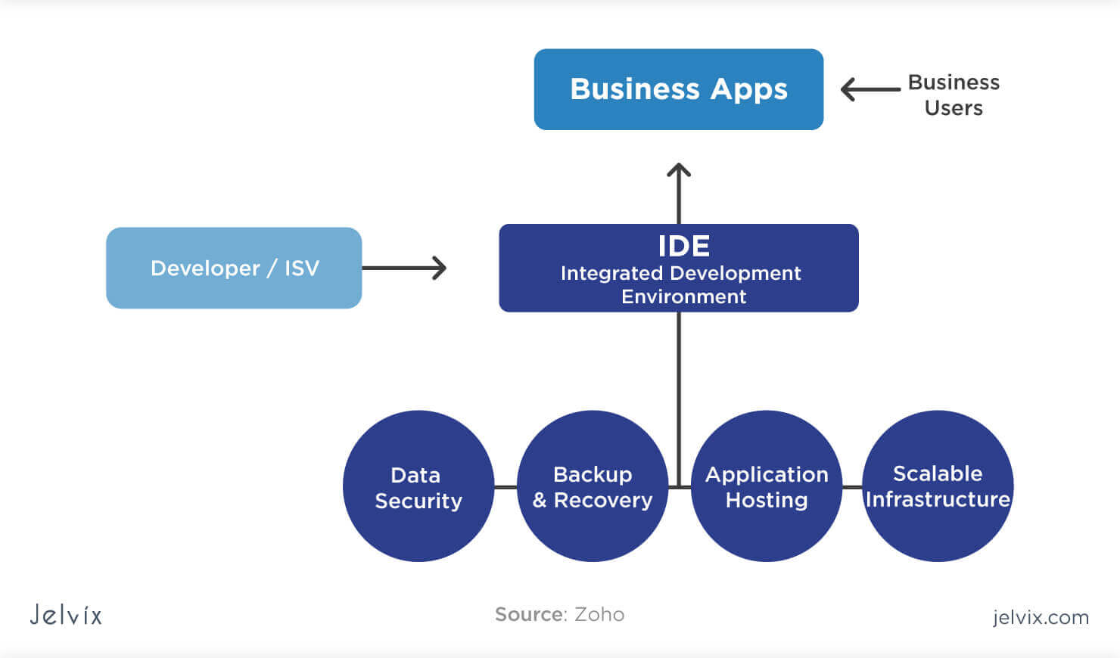

Examples of PaaS:

**AWS Elastic Beanstalk:** a web platform for software deployment and management, powered by the AWS Cloud. Users upload their applications to the service, and it automatically monitors the performance, load capacity, and checks for deployment errors.

**Apache Stratos:** the Cloud computing platform for arranging PHP and MySQL. The PaaS provides users with ready-to-use tools for database development and testing, performance monitoring, integration, and billing.

**Magento Commerce Cloud:** Magento Cloud offers tools for e-commerce development, testing, deployment, and maintenance. The Cloud environment allows accessing the store settings anytime and anywhere as well as automates the key processes.

**Implementation:**

1) Cloning sample project of Azure to deploy it using Azure App service

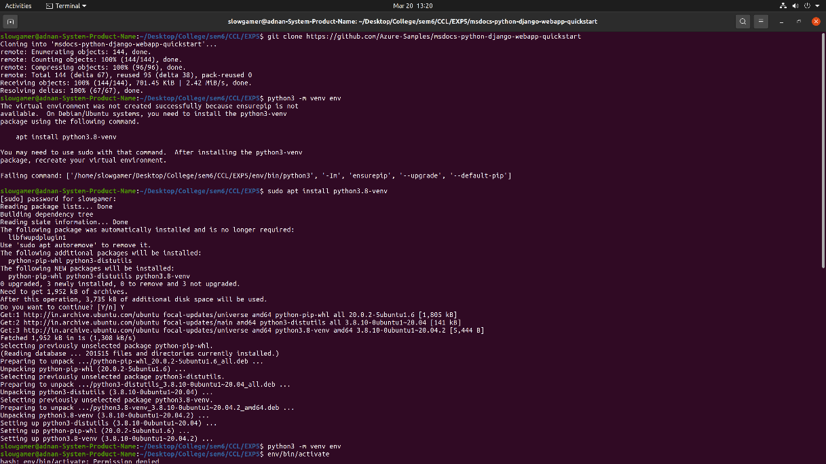

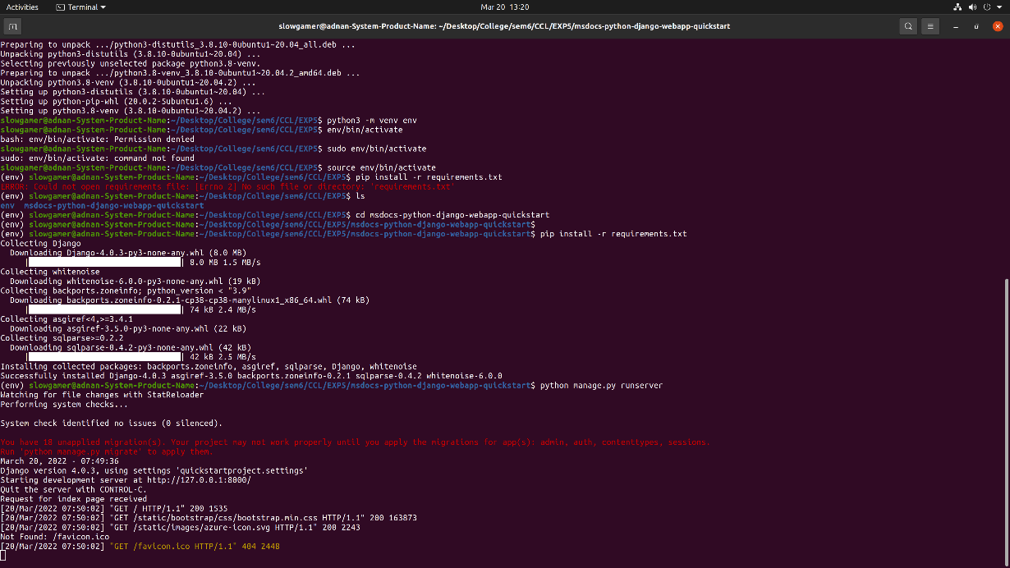

2) Creating App service

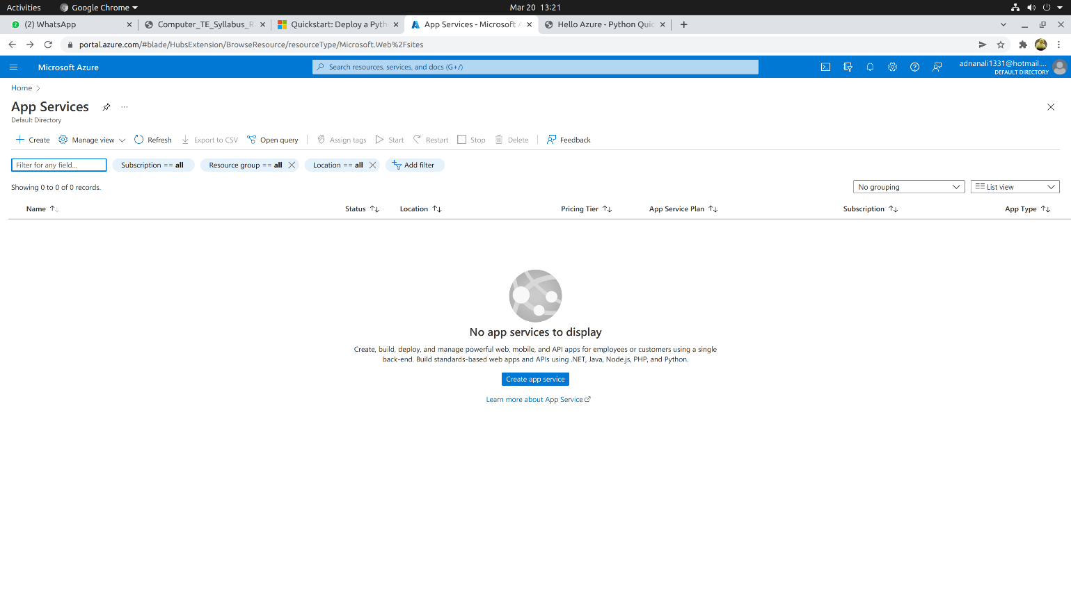

Selecting plan

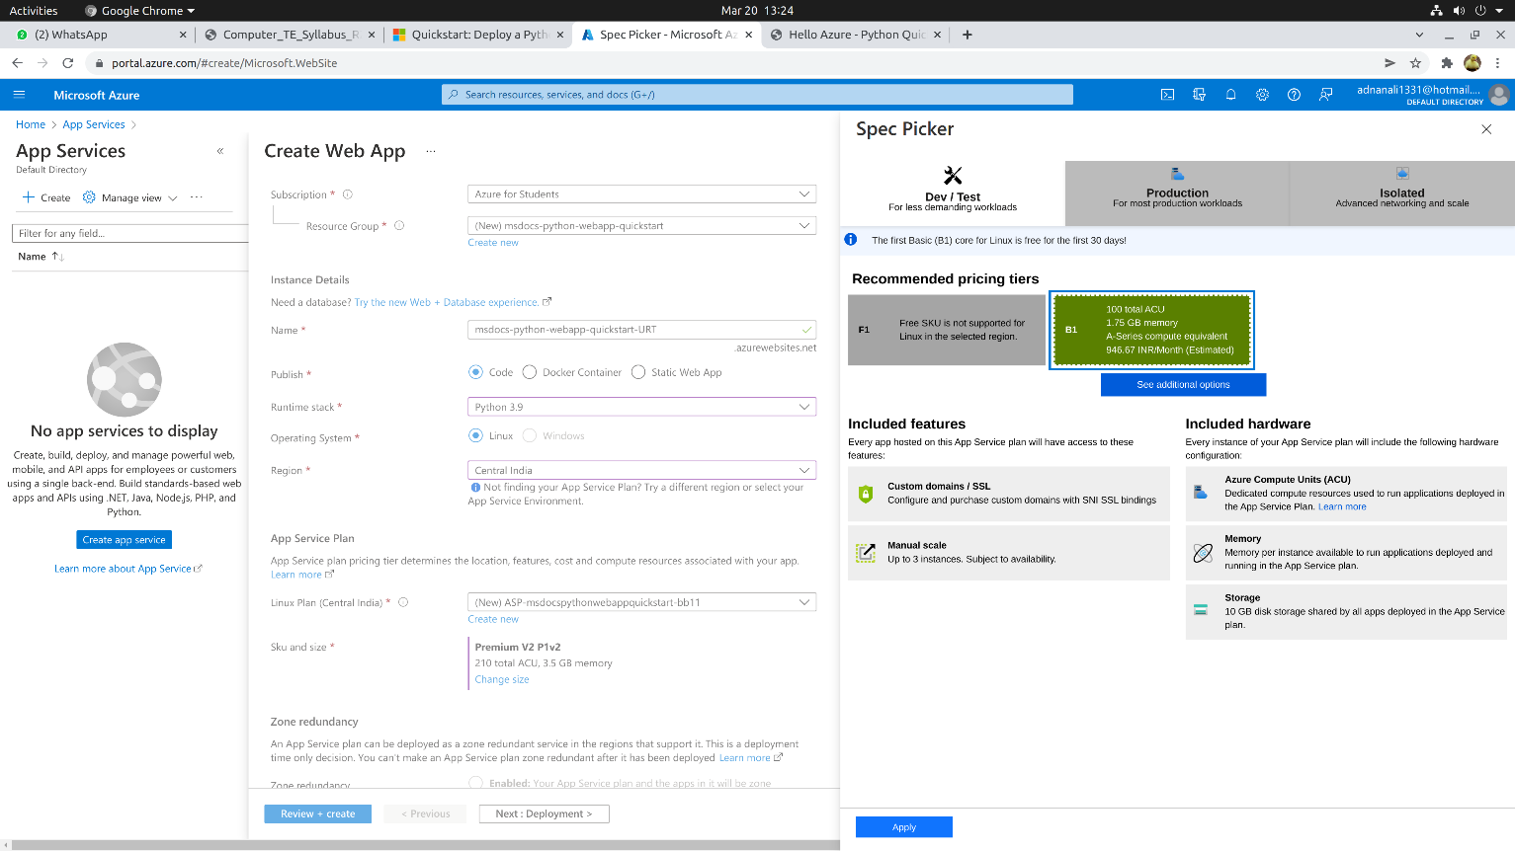

Configuration and specs

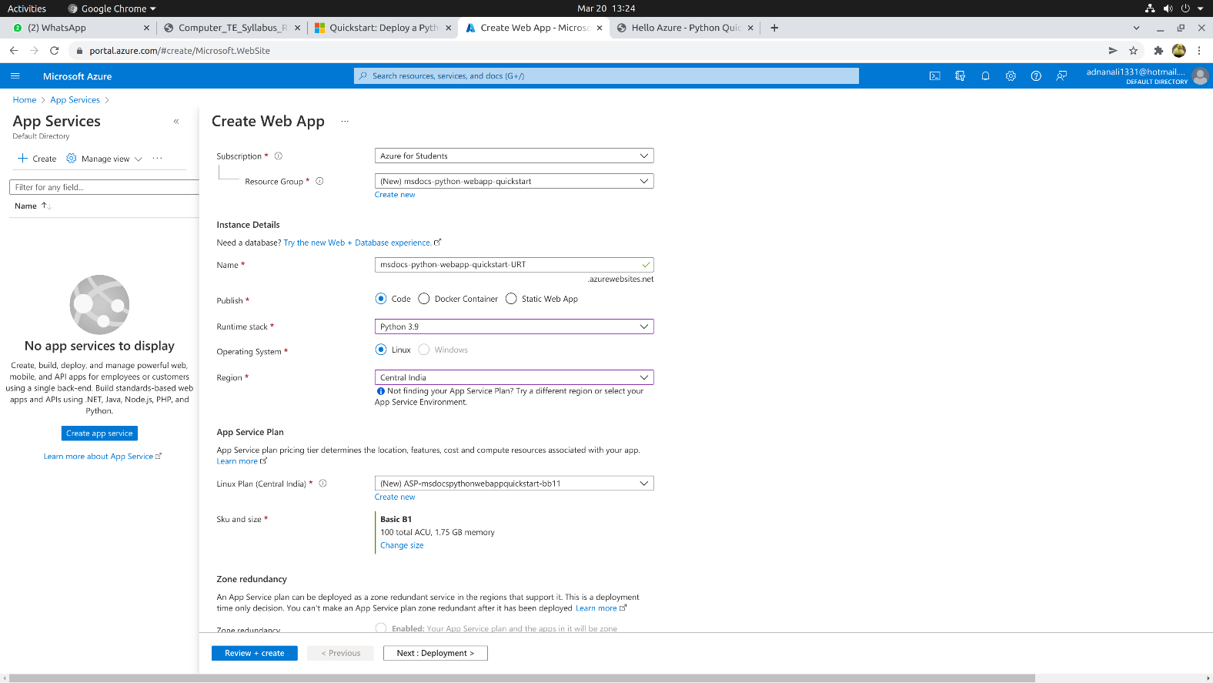

Review and create

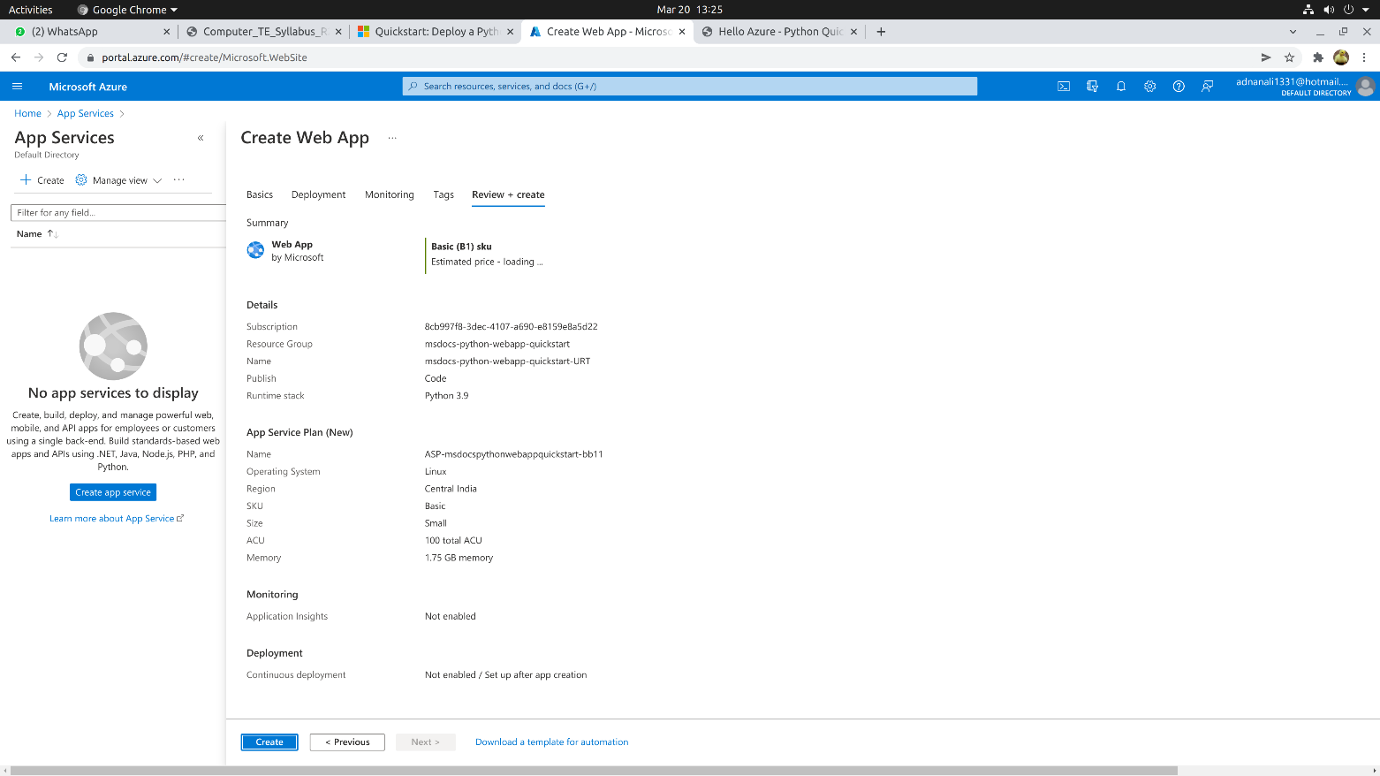

Deployment complete

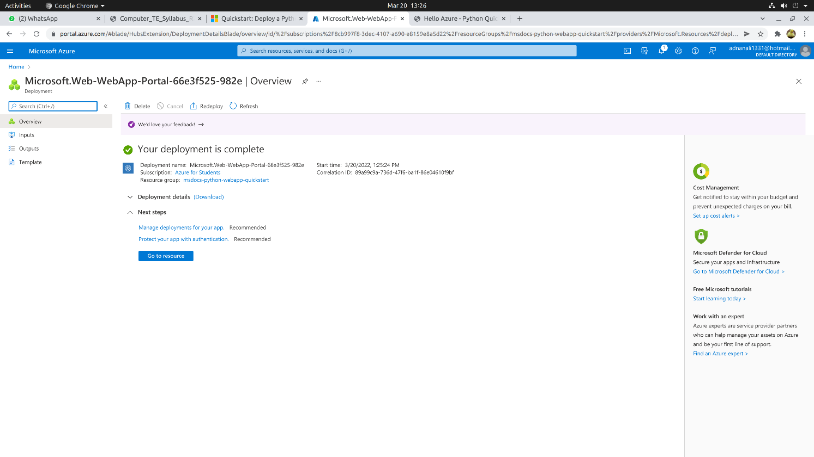

3) Sample App deployment in above app service using Azure tool in VSCode

Linking Azure account and selecting Deploy to Web app

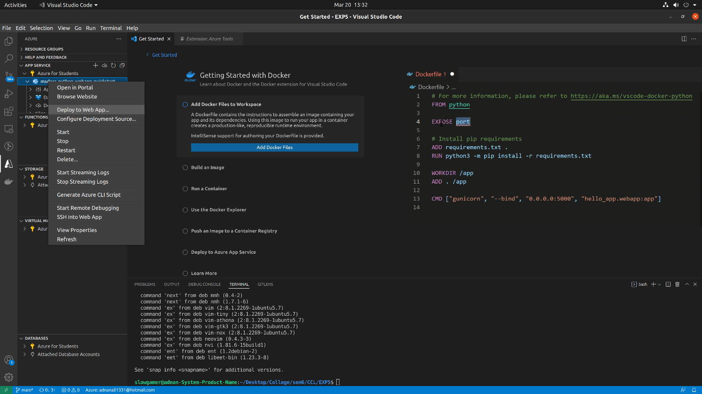

Selecting App to be Deploy

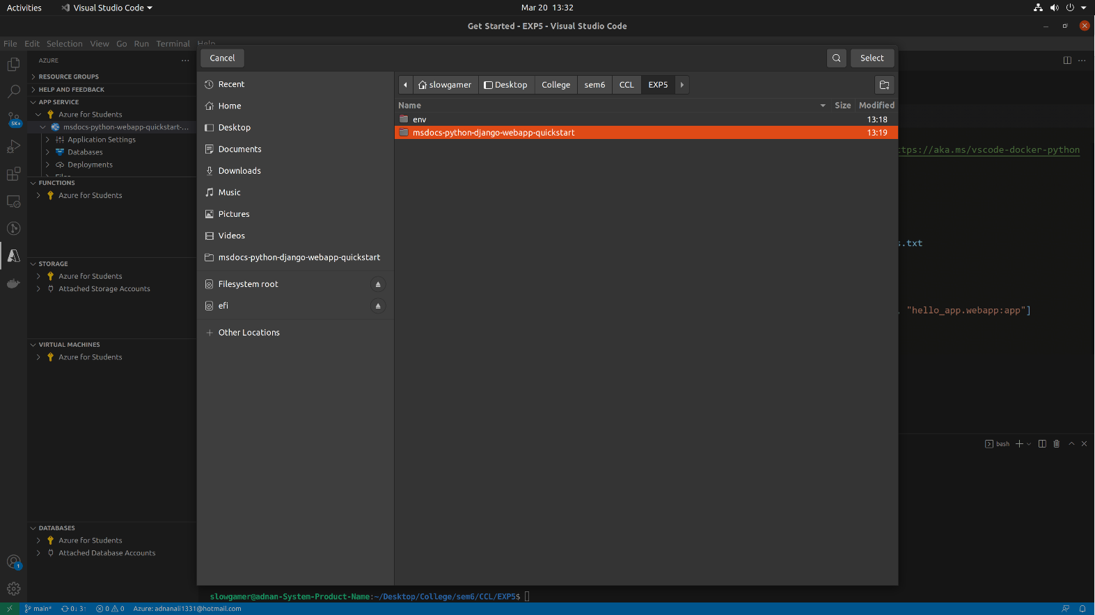

Finalizing Deployment

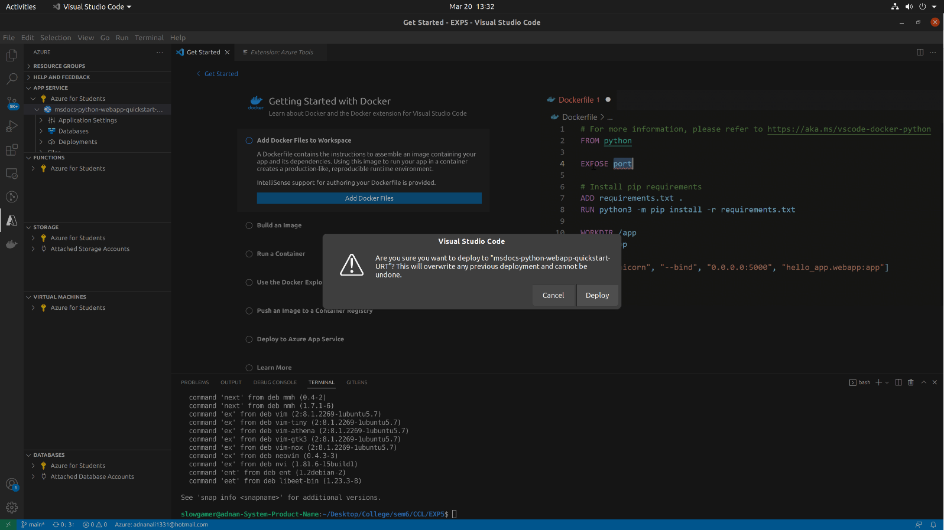

4) Result:

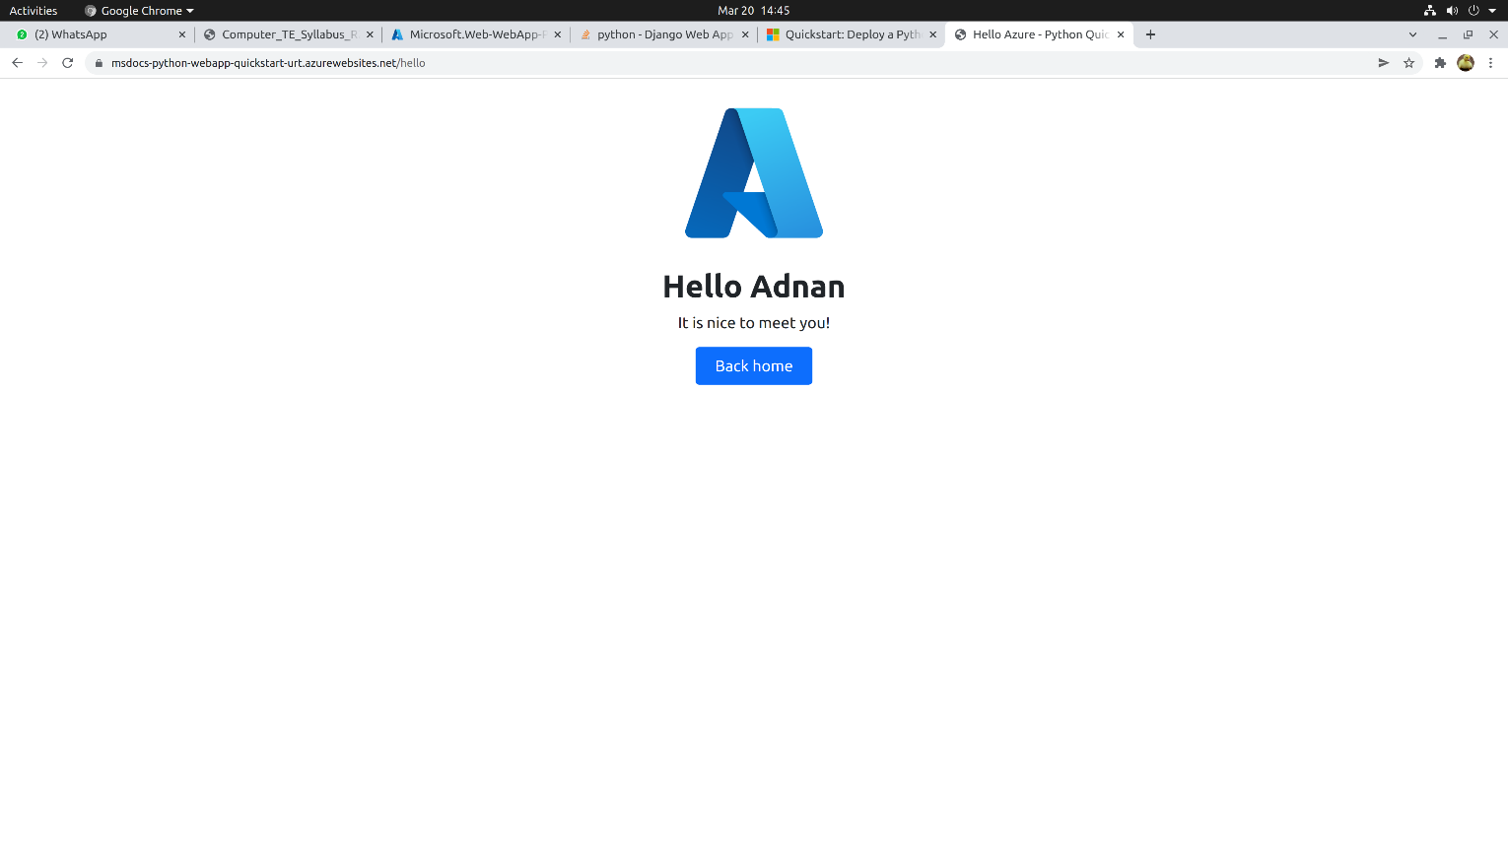

**Conclusion:** We have successfully implemented Platform as a Service in Azure.