**Experiment No. 6**

**Aim:** To study and Implement Storage as a Service using Own Cloud/ AWS S3, Glaciers/ Azure Storage.

**Requirements:** Windows/Mac/Linux O.S and AWS/Azure account.

**Theory:**

**What Is Storage as a Service?**

Storage as a service (STaaS) is a data storage business model where a provider rents storage resources to a customer through a subscription. STaaS saves you money through operating expenditure (OpEx) agility—you only pay for the storage you need, when you need it.

**Why Use Storage as a Service?**

Buying new storage capacity can be an expensive capital expenditure (CapEx), especially if you aren’t sure how much capacity you’ll need in the future. You can try to predict the growth of your business and purchase with the future in mind, but it can tie up financial resources that might have more impact elsewhere in your business.

Fortunately, there’s no shortage of major tech companies with large data centers that are willing to sell their excess capacity. For these businesses, storage is just another service that’s part of their expansive product offerings, and they’re more than happy to absorb the expenses of managing, upgrading, and maintaining large-scale storage area networks (SANs). Amazon Web Services (AWS), Microsoft Azure, Google Cloud, and Oracle Cloud are all examples of major cloud storage providers with STaaS subscription options.

STaaS lets you treat storage as OpEx. You sign a service level agreement (SLA) with your STaaS provider and pay for storage and data transfer rates (e.g., cost per gigabyte). Best of all, this whole process is automated, allowing you to scale your storage needs up and down as demand requires while maintaining performance and availability 24/7.

**Benefits of Storage as a Service**

* OpEx subscription model that lets you optimize your storage costs
* Ability to quickly scale and provision storage resources to your apps as you grow
* Always-on reliability of major cloud service providers
* Simplified storage management environment

**Implementation:**

1) Creating Storage Account

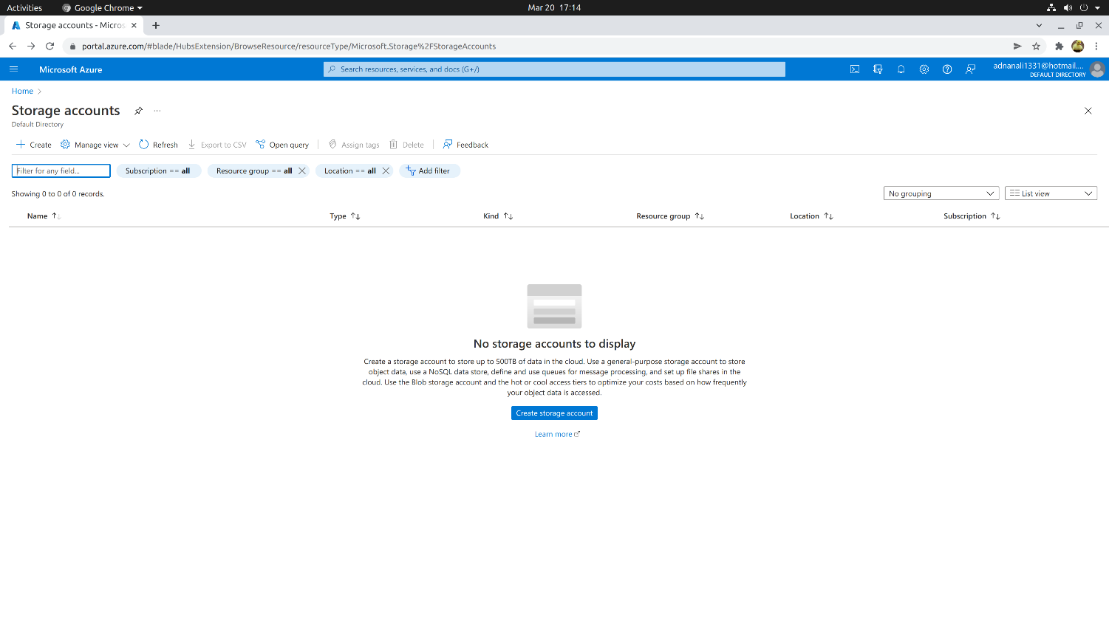

a) Basics

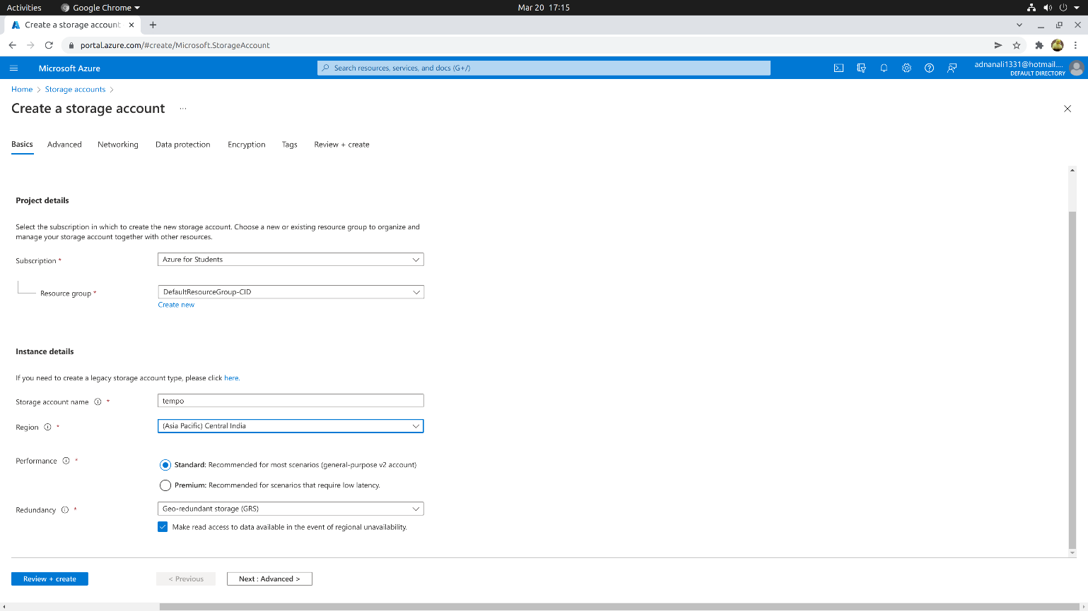

b) Advance

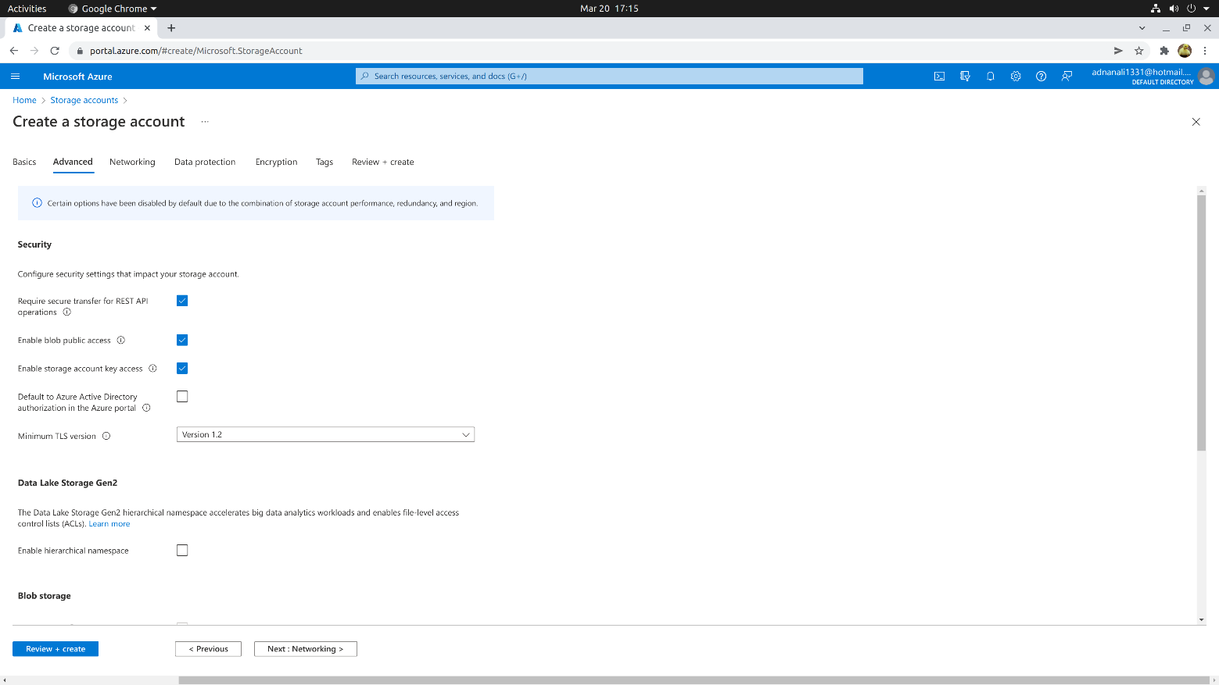

c) Network

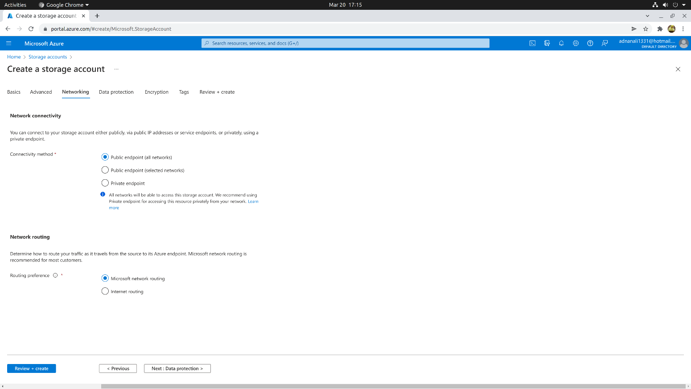

d) Protection

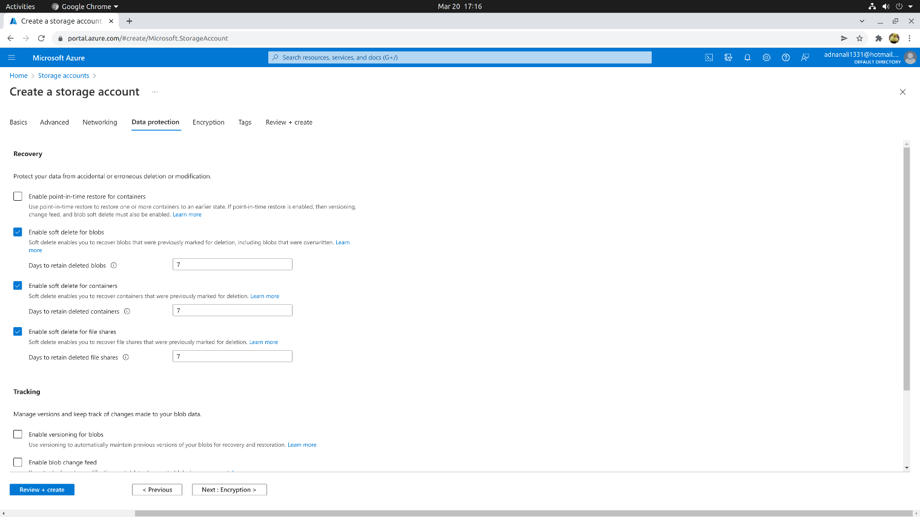

e) Encryption

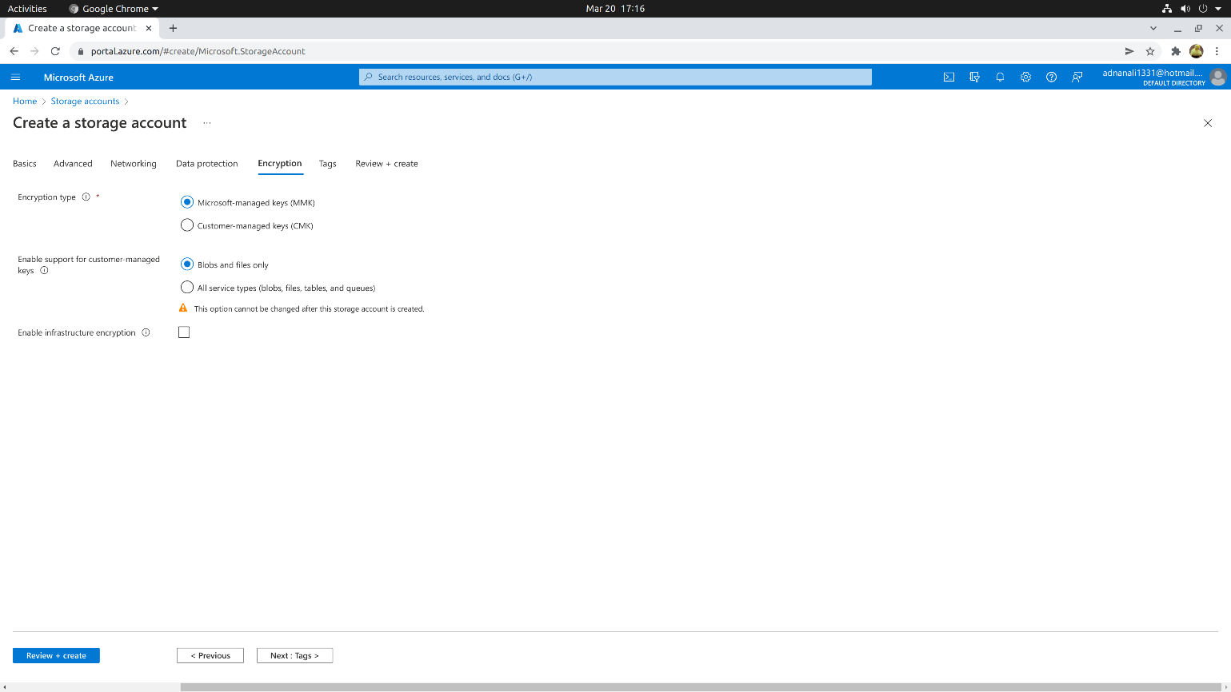

d) Tags

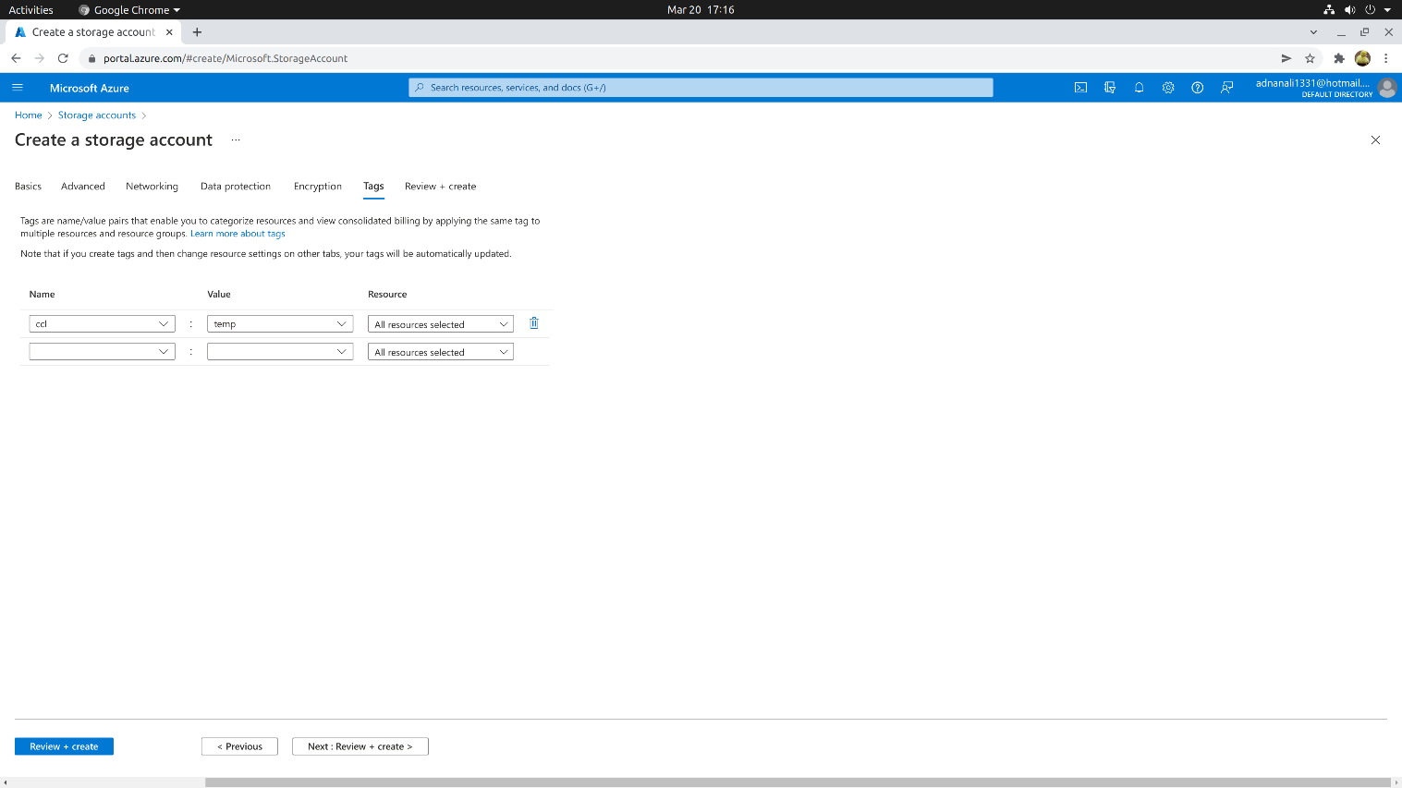

e) Reviewing and creating

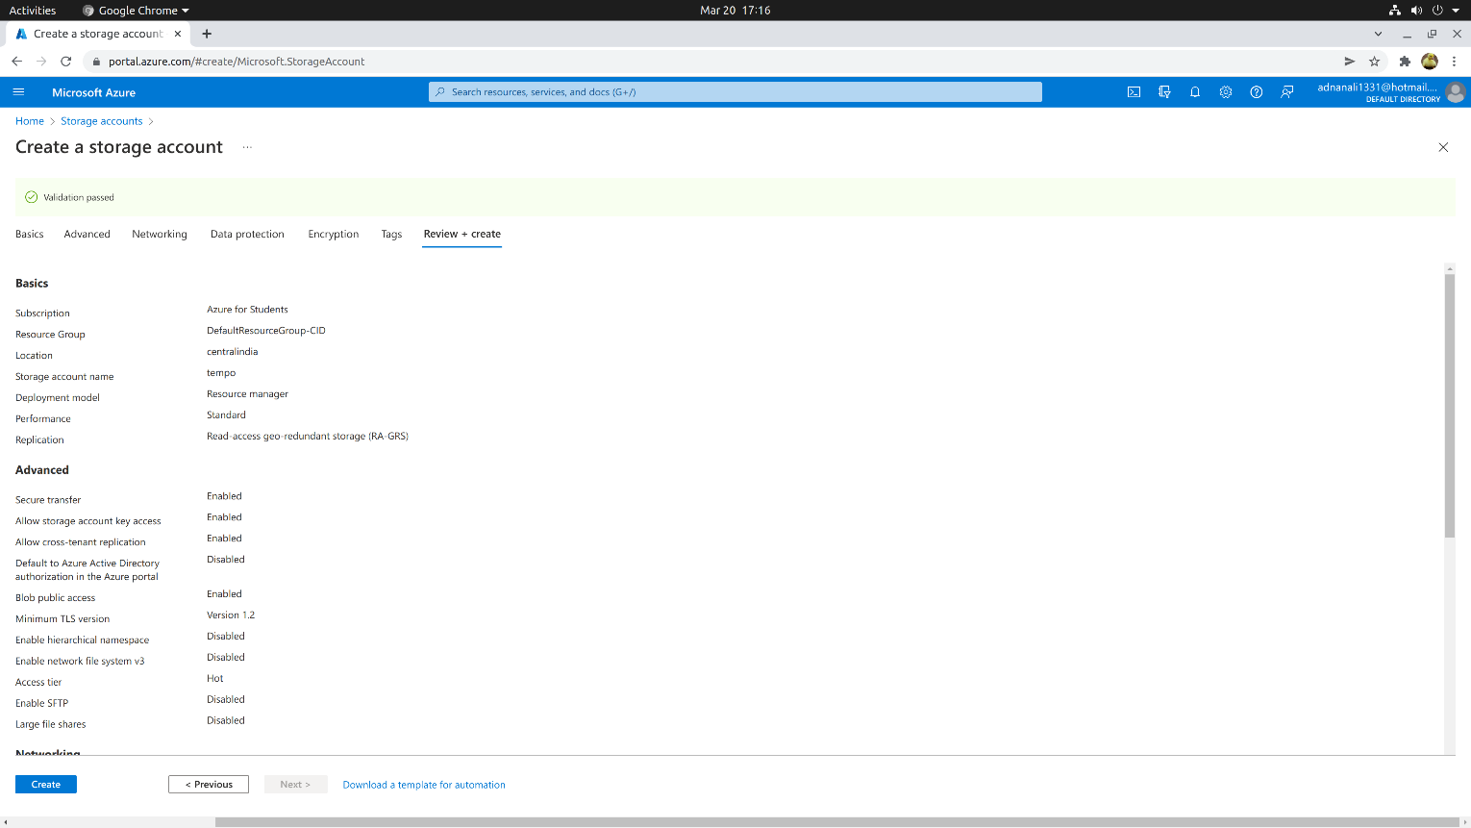

d) Successful deployment

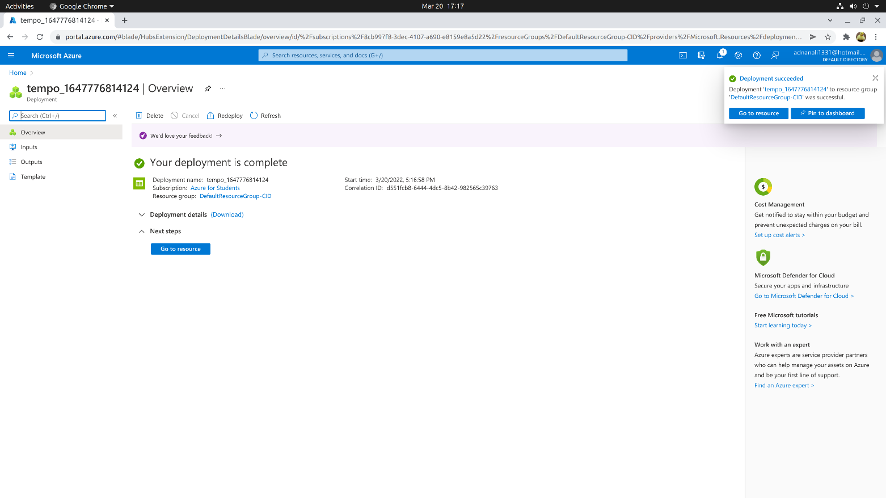

2) Creating Share File storage

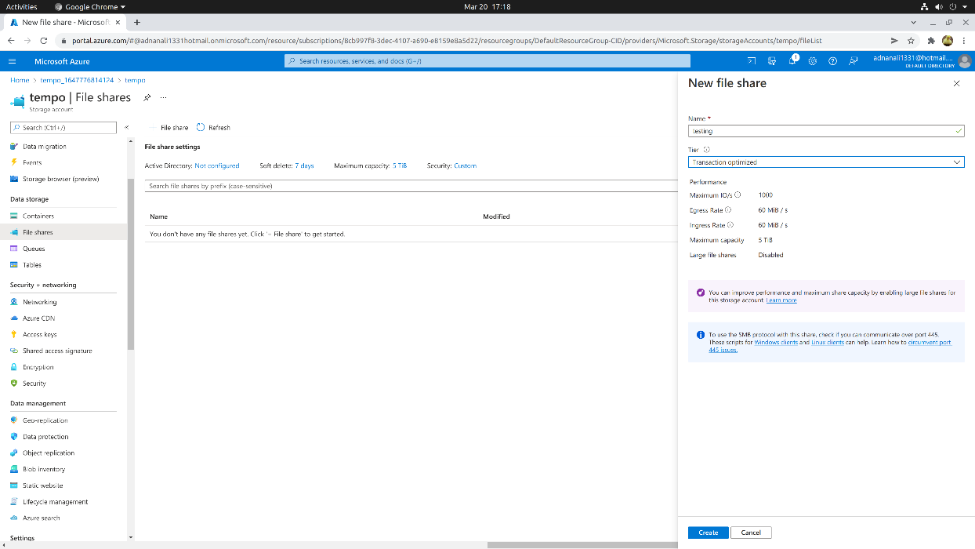

3) Uploading file

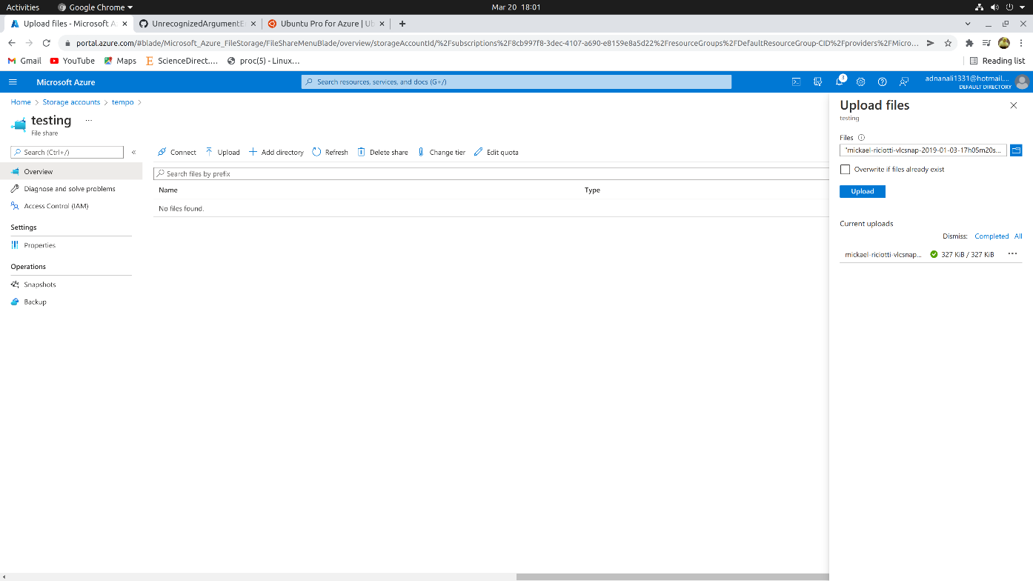

4) Creating Linux VM to access this File shares

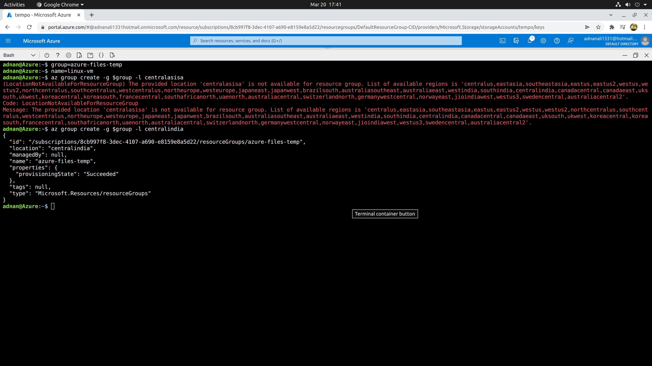

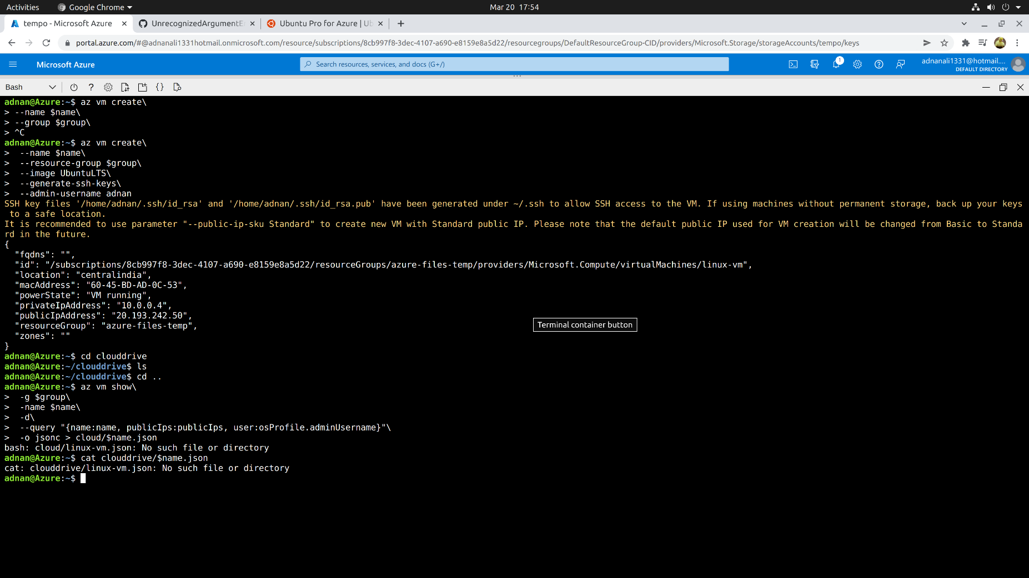

5) Accessing storage account through SSH

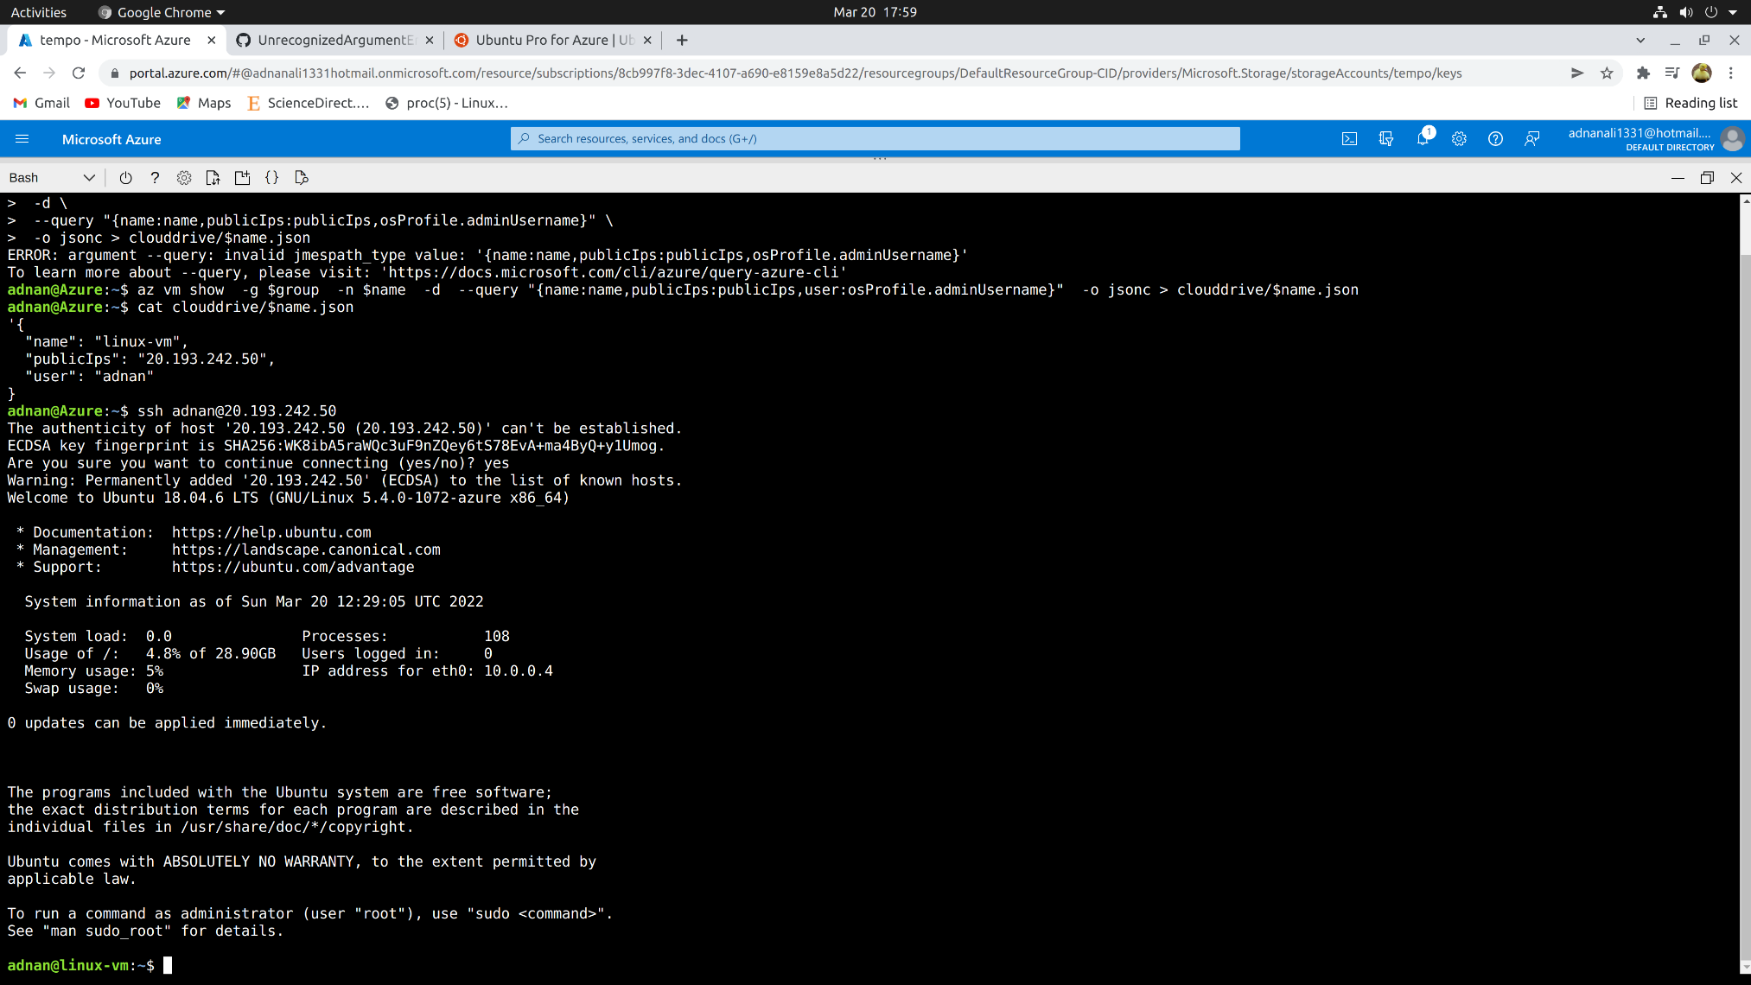

6) Connecting VM to File Share storage:

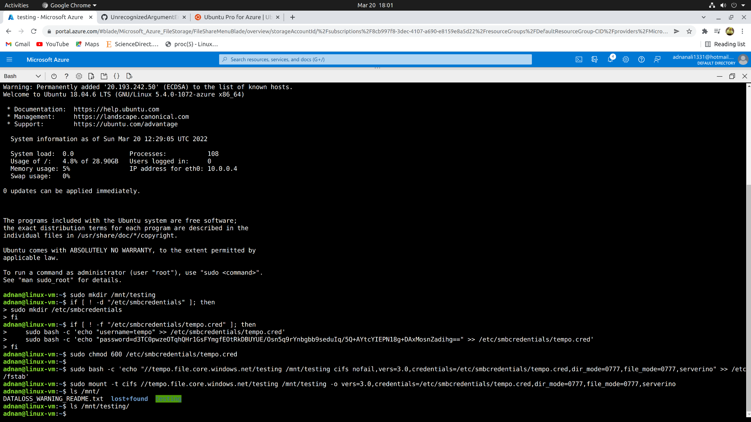

7) Reading and writing files to File Share storage

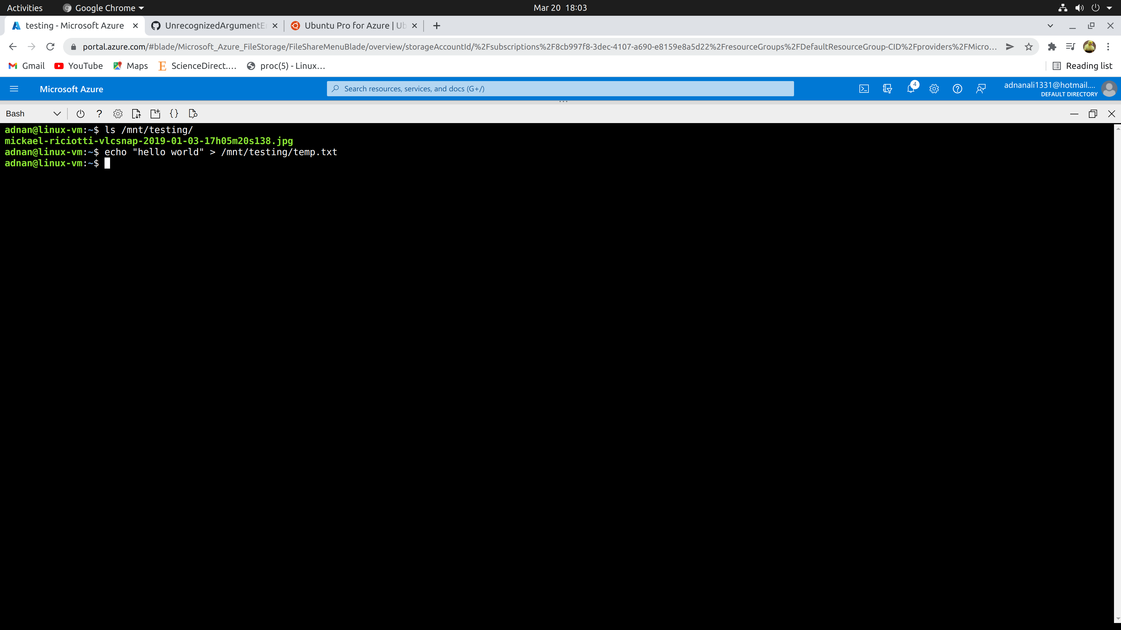

8) Result

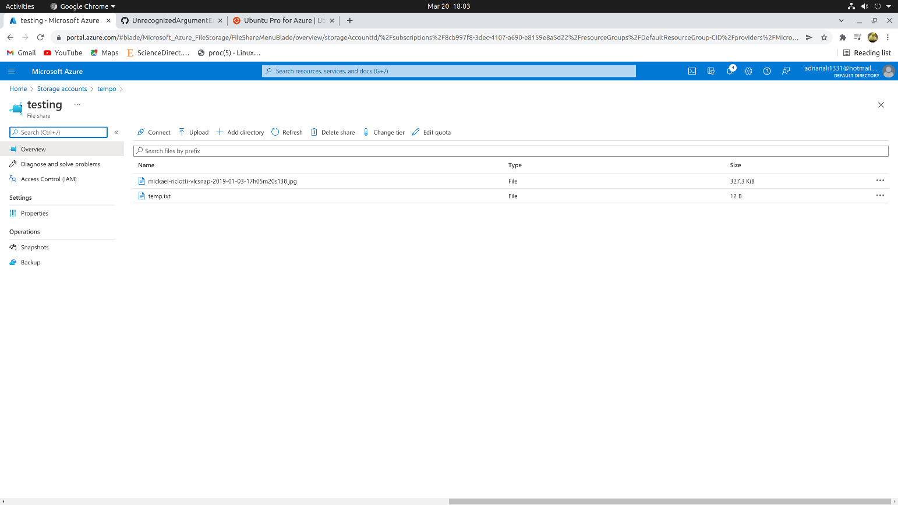

**Conclusion:** We have successfully implemented Storage as a Service using Azure.