**Experiment no. 7**

**Aim:** To study and Implement Database as a Service on SQL/NOSQL databases like AWS RDS, AZURE SQL/ MongoDB Lab/ Firebase.

**Requirements**: Azure account and MySQL.

**Theory**:

**What is Azure Database for MySQL?**

Azure Database for MySQL is a relational database service in the Microsoft cloud based on the MySQL Community Edition (available under the GPLv2 license) database engine, versions 5.6 (retired), 5.7, and 8.0. Azure Database for MySQL delivers:

* Zone redundant and same zone high availability.
* Maximum control with ability to select your scheduled maintenance window.
* Data protection using automatic backups and point-in-time-restore for up to 35 days.
* Automated patching and maintenance for underlying hardware, operating system and database engine to keep the service secure and up to date.
* Predictable performance, using inclusive pay-as-you-go pricing.
* Elastic scaling within seconds.
* Cost optimization controls with low cost burstable SKU and ability to stop/start server.
* Enterprise grade security, industry-leading compliance, and privacy to protect sensitive data at-rest and in-motion.
* Monitoring and automation to simplify management and monitoring for large-scale deployments.
* Industry-leading support experience.

These capabilities require almost no administration and all are provided at no additional cost. They allow you to focus on rapid app development and accelerating your time to market rather than allocating precious time and resources to managing virtual machines and infrastructure. In addition, you can continue to develop your application with the open-source tools and platform of your choice to deliver with the speed and efficiency your business demands, all without having to learn new skills.

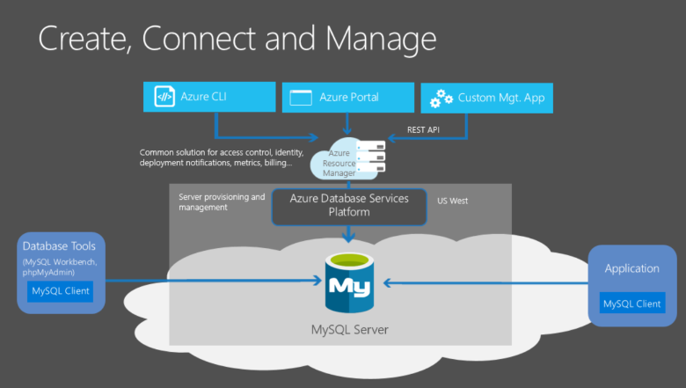

**Deployment models**

Azure Database for MySQL powered by the MySQL community edition is available in two deployment modes:

* Flexible Server
* Single Server

**Azure Database for MySQL - Flexible Server**

Azure Database for MySQL Flexible Server is a fully managed production-ready database service designed for more granular control and flexibility over database management functions and configuration settings. The flexible server architecture allows users to opt for high availability within single availability zone and across multiple availability zones. Flexible servers provides better cost optimization controls with the ability to stop/start server and burstable compute tier, ideal for workloads that do not need full compute capacity continuously. Flexible Server also supports reserved instances allowing you to save up to 63% cost, ideal for production workloads with predictable compute capacity requirements. The service supports community version of MySQL 5.7 and 8.0. The service is generally available today in wide variety of Azure regions.

The Flexible Server deployment option offers three compute tiers: Burstable, General Purpose, and Memory Optimized. Each tier offers different compute and memory capacity to support your database workloads. You can build your first app on a burstable tier for a few dollars a month, and then adjust the scale to meet the needs of your solution. Dynamic scalability enables your database to transparently respond to rapidly changing resource requirements. You only pay for the resources you need, and only when you need them.

Flexible servers are best suited for

* Ease of deployments, simplified scaling and low database management overhead for functions like backups, high availability, security and monitoring
* Application developments requiring community version of MySQL with better control and customizations
* Production workloads with same-zone, zone redundant high availability and managed maintenance windows
* Simplified development experience
* Enterprise grade security

**Azure Database for MySQL - Single Server**

Azure Database for MySQL Single Server is a fully managed database service designed for minimal customization. The single server platform is designed to handle most of the database management functions such as patching, backups, high availability, security with minimal user configuration and control. The architecture is optimized for built-in high availability with 99.99% availability on single availability zone. It supports community version of MySQL 5.6 (retired), 5.7 and 8.0. The service is generally available today in wide variety of Azure regions.

Single servers are best suited **only for existing applications already leveraging single server**. For all new developments or migrations, Flexible Server would be the recommended deployment option.

**Output**:

1. Creating MySQL Database

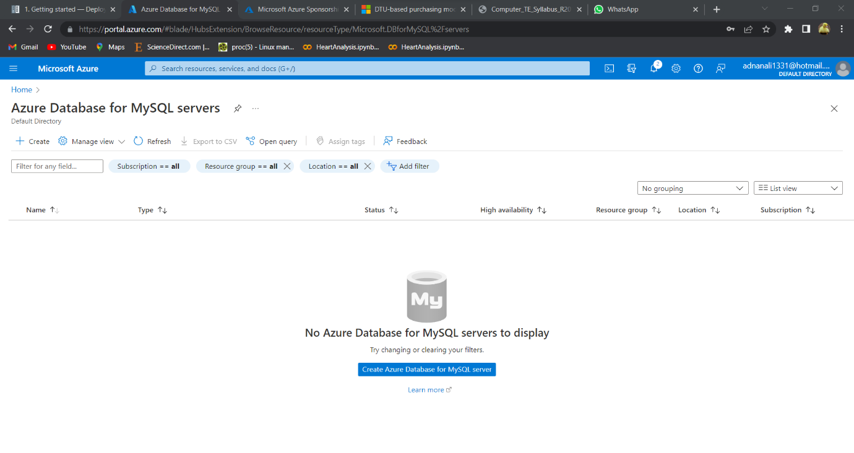

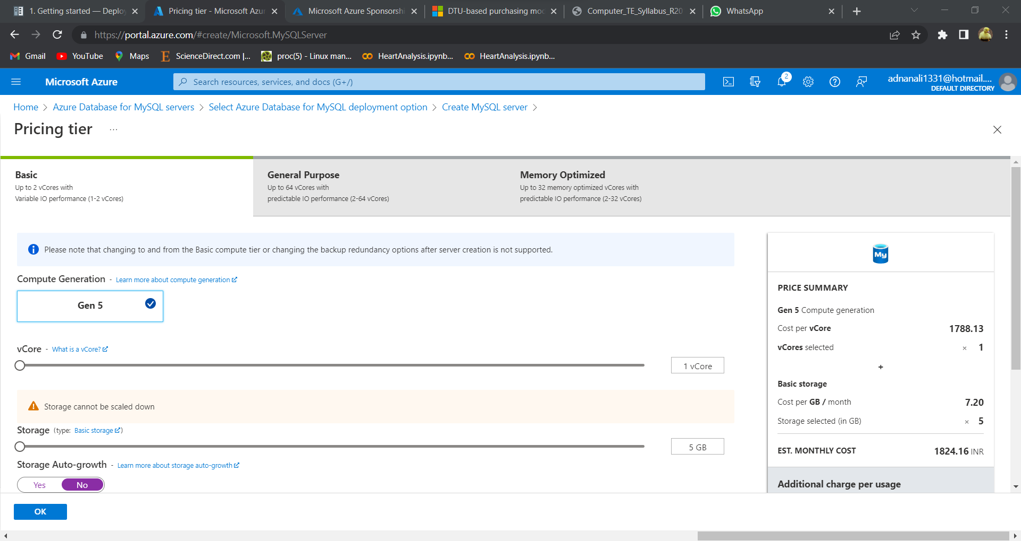

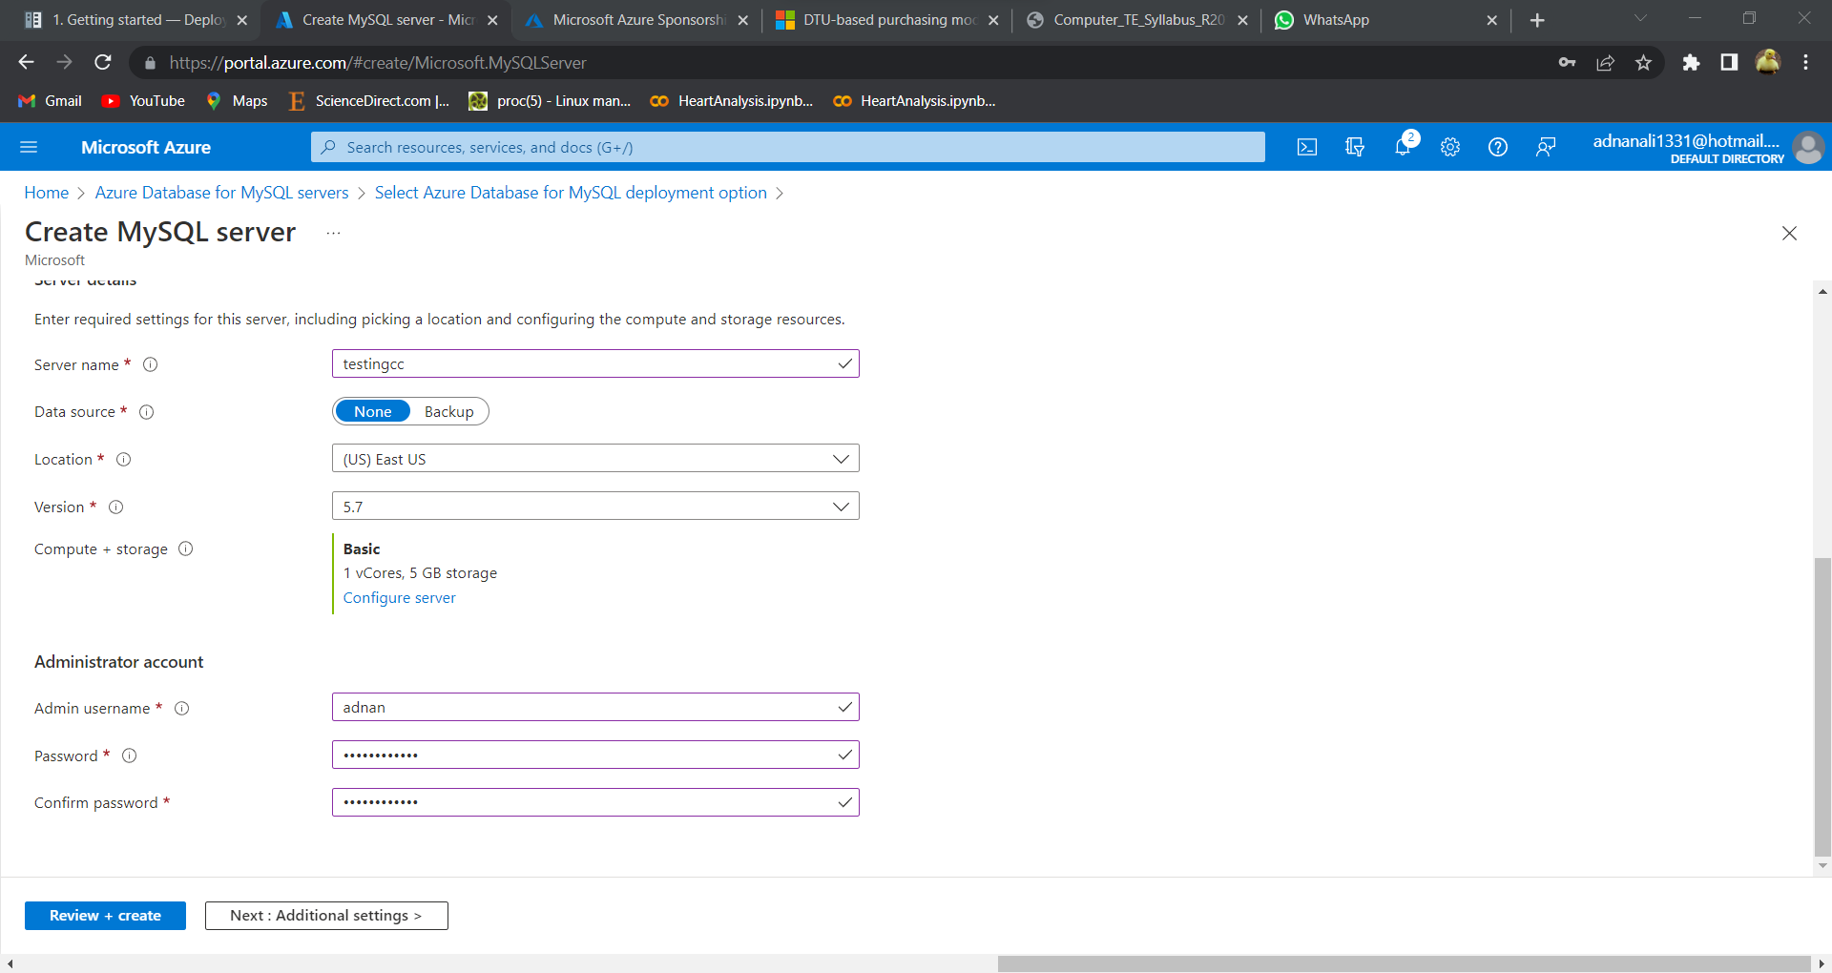

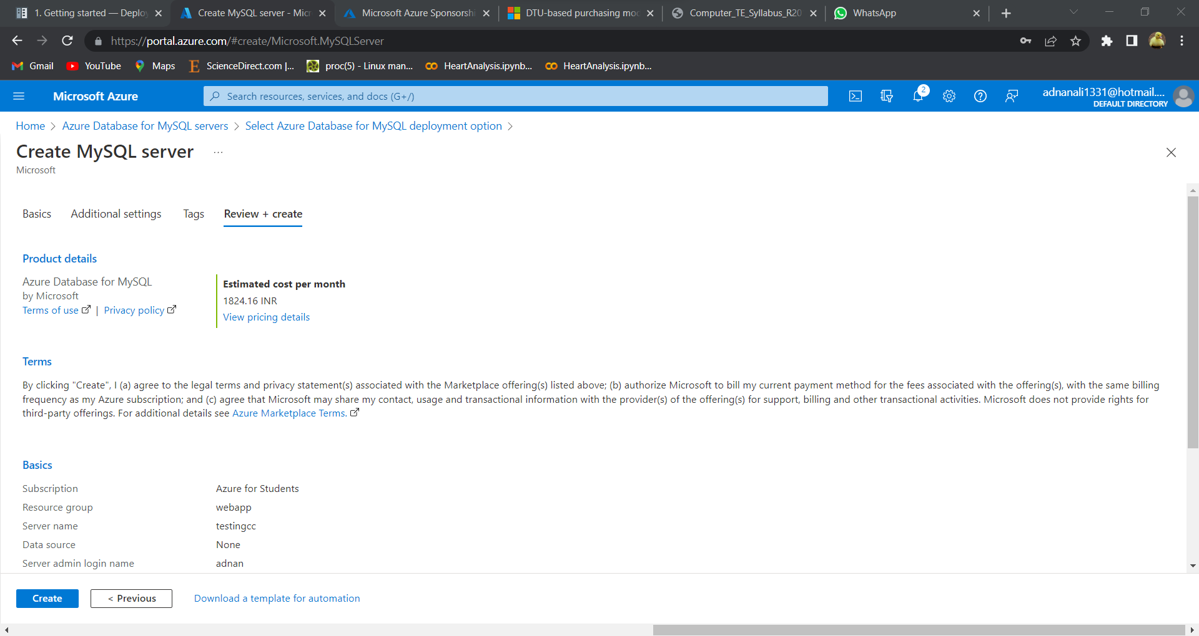

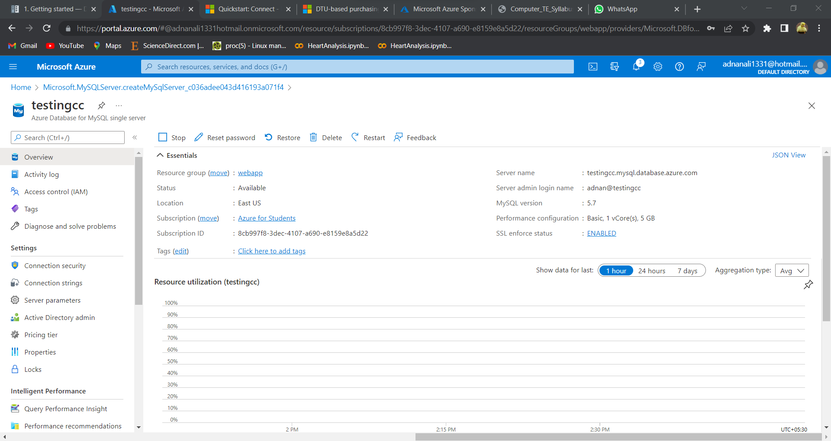

**Configure a server-level firewall rule**

By default, the new server is protected with a firewall. To connect, you must provide access to your IP by completing these steps:

Go to **Connection security** from the left pane for your server resource and add your ip.

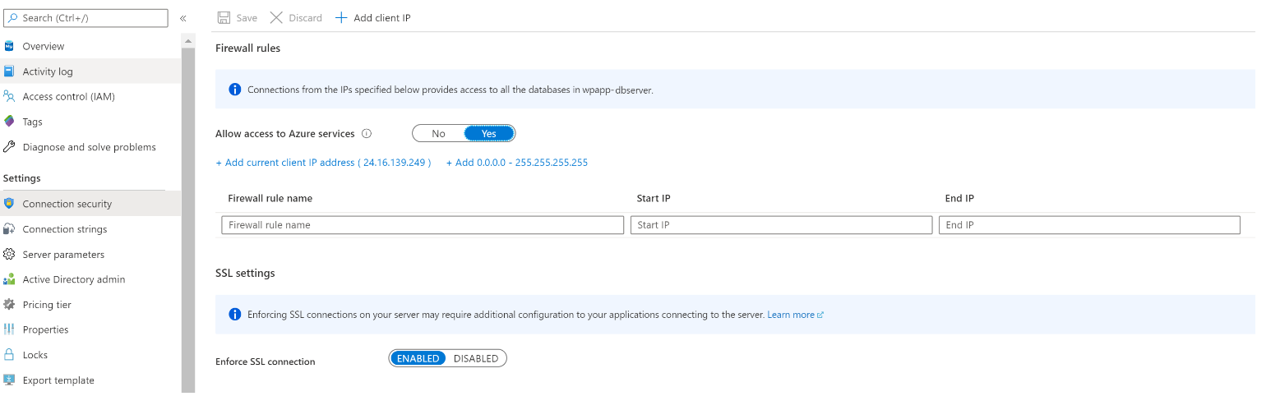

**Connect to the server by using MySQL Workbench**

To connect to Azure MySQL Server by using the GUI tool MySQL Workbench:

1. Launch the MySQL Workbench application on your computer.
2. In **Setup New Connection** dialog box, enter the following information on the **Parameters** tab:

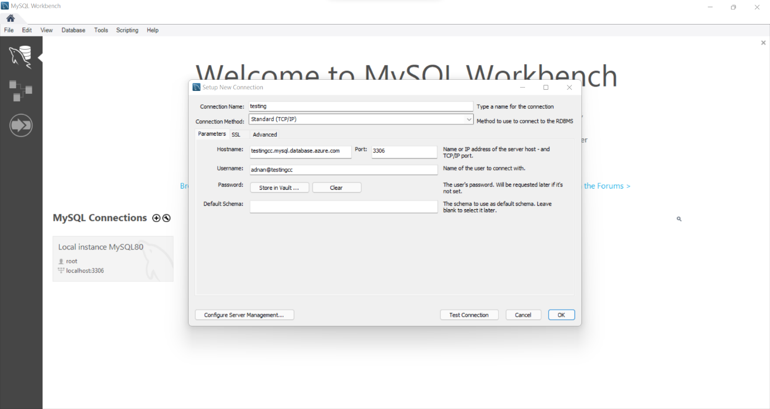

1. Click **Test Connection** to test if all parameters are correctly configured.
2. Click **OK** to save the connection.
3. In the listing of **MySQL Connections**, click the tile corresponding to your server, and then wait for the connection to be established.

‘

**Create a table, insert data, read data, update data, delete data (CRUD)**

1. Open Azure connected Database in MySQL

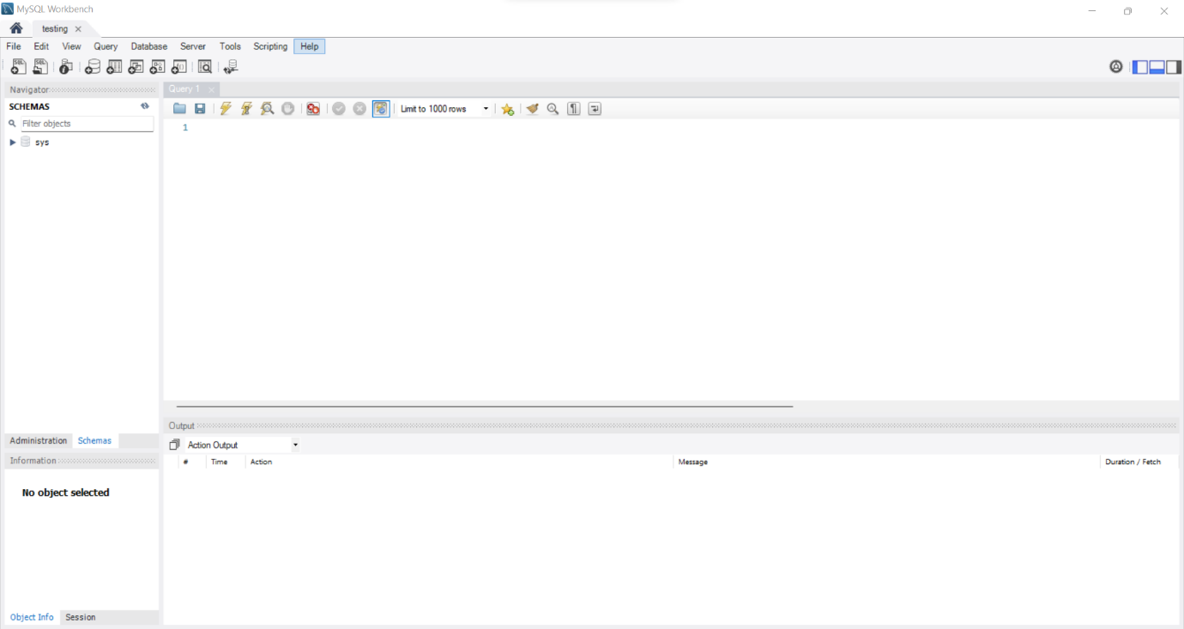

2. Perform CRUD

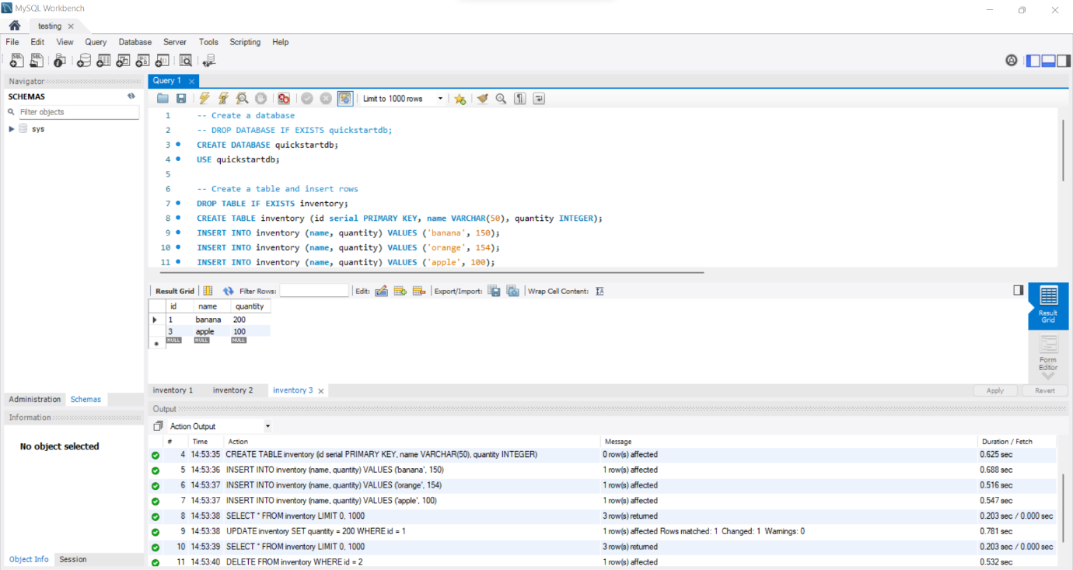

**Conclusion**: We have successfully implemented database as a service in Azure MySQL and performed CRUD operation.