**A MINI PROJECT REPORT**

**ON**

**“Online Shopping Web App”**

Submitted in the partial fulfilment of the requirements for

The degree of

**BACHELOR OF ENGINEERING IN COMPUTER ENGINEERING**

**By**

**1. Navnath Auti.**

**2. Omkar Harade.**

**3. Sahil Nazare.**

**4. Adnan Shaikh.**

**UNDER THE GUIDANCE OF**

**Prof. Hemlata Gosavi.**



Department of Computer Engineering  
Saraswati College of Engineering, Kharghar, Navi Mumbai  
University of Mumbai  
2021-22

**Saraswati College of Engineering, Kharghar**

**Vision:**

To be universally accepted as autonomous center of learning in Engineering Education and Research.

**Mission:**

* To educate students to become responsible and quality technocrats to fulfil society and industry needs.
* To nurture student’s creativity and skills for taking up challenges in all facets of life.

**_______________________________________________**

**Department of Computer Engineering**

**Vision:**

To be among renowned institution in Computer Engineering Education and Research by developing globally competent graduates.

**Mission:**

* To produce quality Engineering graduates by imparting quality training, hands on experience and value education.
* To pursue research and new technologies in Computer Engineering and across interdisciplinary areas that extends the scope of Computer Engineering and benefit humanity.
* To provide stimulating learning ambience to enhance innovative ideas, problem solving ability, leadership qualities, team-spirit and ethical responsibilities.



**DEPARTMENT OF COMPUTER ENGINEERING**

**PROGRAM EDUCATIONAL OBJECTIVE’S**

1. To embed a strong foundation of Computer Engineering fundamentals to identify, solve, analyze and design real time engineering problems as a professional or entrepreneur for the benefit of society.
2. To motivate and prepare students for lifelong learning & research to manifest global competitiveness.
3. To equip students with communication, teamwork and leadership skills to accept challenges in all the facets of life ethically.



**DEPARTMENT OF COMPUTER ENGINEERING**

**PROGRAM OUTCOMES**

1. Apply the knowledge of Mathematics, Science and Engineering Fundamentals to solve complex Computer Engineering Problems.
2. Identify, formulate and analyze Computer Engineering Problems and derive conclusion using First Principle of Mathematics, Engineering Science and Computer Science.
3. Investigate Complex Computer Engineering problems to find appropriate solution leading to valid conclusion.
4. Design a software System, components, Process to meet specified needs with appropriate attention to health and Safety Standards, Environmental and Societal Considerations.
5. Create, select and apply appropriate techniques, resources and advance Engineering software to analyze tools and design for Computer Engineering Problems.
6. Understand the Impact of Computer Engineering solution on society and environment for Sustainable development.
7. Understand Societal, health, Safety, cultural, Legal issues and Responsibilities relevant to Engineering Profession.
8. Apply Professional ethics, accountability and equity in Engineering Profession.
9. Work Effectively as a member and leader in multidisciplinary team for a common goal.
10. Communicate effectively within a Profession and Society at large.
11. Appropriately incorporate principles of Management and Finance in one’s own Work.
12. Identify educational needs and engage in lifelong learning in a Changing World of Technology.



**DEPARTMENT OF COMPUTER ENGINEERING**

**PROGRAM SPECIFIC OUTCOME**

1. Formulate and analyze complex engineering problems in computer engineering (Networking/Big data/ Intelligent Systems/Cloud Computing/Real time systems).
2. Plan and develop efficient, reliable, secure and customized application software using cost effective emerging software tools ethically.



**(Approved by AICTE, recg. By Maharashtra Govt. DTE, Affiliated to Mumbai University)**

**PLOT NO. 46/46A, SECTOR NO 5, BEHIND MSEB SUBSTATION, KHARGHAR, NAVI MUMBAI-410210**

**Tel.: 022-27743706 to 11 *Fax: 022-27743712 * Website: www.sce.edu.in**

**CERTIFICATE**

*This is to certify that the requirements for the mini project report entitled “****online shopping webapp****” have been successfully completed by the following students:*

Roll numbers Name

28 Navnath Auti

43 Omkar Harade

60 Sahil Nazare

76 Adnan Shaikh

In partial fulfillment of Sem –VI, **Bachelor of Engineering of Mumbai University in Computer Engineering** of Saraswati college of Engineering, Kharghar during the academic year 2021-22.

**Internal Guide**  **External Examiner**

Prof. Hemlata Gosavi.

**Mini Project Co-Ordinator**  **Head of Department**

Prof. Bhagyashri Sonawale Prof. Sujata Bhairnallykar

**DECLARATION**

I declare that this written submission represents my ideas in my own words and where others’ ideas or words have been included. I have adequately cited and referenced the original sources. I also declare that I have adhered to all principles of academic honesty and integrity and have not misrepresented or fabricated or falsified any idea/data/fact/source in my submission. I understand that any violation of the above will be cause for disciplinary action by the Institute and can also evoke penal action from the sources which have thus not been properly cited or from whom proper permission has not been taken when needed.

1. Navnath Auti.
2. Omkar Harade.
3. Sahil Nazare.
4. Adnan Shaikh.

**ACKNOWLEDGEMENT**

After the completion of this work, words are not enough to express feelings about all those who helped us to reach goal.

It’s a great pleasure and moment of immense satisfaction for us to express my profound gratitude to **Mini Project Guide**, **Prof. Hemlata Gosavi** whose constant encouragement enabled us to work enthusiastically. Her perpetual motivation, patience and excellent expertise in discussion during progress of the project work have benefited us to an extent, which is beyond expression.

We would also like to give our sincere thanks to **Prof. Sujata Bhairnallykar, Head of Department**, and **Prof. Bhagyashri Sonawale, Mini Project coordinator** from Department of Computer Engineering, Saraswati college of Engineering, Kharghar, Navi Mumbai, for their guidance, encouragement and support during a project.

I am thankful to **Dr. Manjusha Deshmukh, Principal,** Saraswati College of Engineering, Kharghar, Navi Mumbai for providing an outstanding academic environment, also for providing the adequate facilities.

Last but not the least we would also like to thank all the staffs of Saraswati college of Engineering (Computer Engineering Department) for their valuable guidance with their interest and valuable suggestions brightened us.

1. Navnath Auti.

2. Omkar Harade.

3. Sahil Nazare.

4. Adnan Shaikh.

**Abstract**

Nowadays, as computers are powerful enough for implementing complex algorithms, there are numerous applications that people utilize computers to run. Cloud hosting makes applications and websites accessible using cloud resources. Unlike traditional hosting, solutions are not deployed on a single server. Instead, a network of connected virtual and physical cloud servers hosts the application or website, ensuring greater flexibility and scalability. There are many traditional web hosting types for building your website, including shared, dedicated, WordPress hosting, and virtual private servers (VPS). However, cloud hosting option enables you to distribute your site across multiple servers and provides a flexible way to power your website, which can be leveraged accordingly. Cloud hosting basically works on “pay as you go” model, which permits user to pay the amount only for which the website is accessed or according to the traffic it received. At the higher level, cloud hosting can be great for organizations who need to have near perfect uptime and want to grow their servers as they see fit, without experiencing any delay.

**Table of Contents**

|  |  |
| --- | --- |
|  |  |
| **List of Figures ………………………………………………………………………...** |  |
| **1. Introduction ……………………………………………………………………….** | **2-4** |
| **1.1 General …………………………………………………………………….….** | **2-3** |
| **1.2 Objective and problem statement ……………………………........................** | **3-4** |
| **2. Methodology ……………………………………………………………….............** | **5-7** |
| **2.1 System Design.…………………………………………………………...** | **5** |
| **2.2 Hardware and Software requirements……………………………..............** | **6** |
| **2.3 Design Details…………………………………………………………………** | **7** |
| **3. Implementation and Results …………………………………………………….** | **8-16** |
| **3.1. Implementation ....………………………………………………….................** | **8-12** |
| **3.2. Results ...………………………………………………………………............** | **12-16** |
| **4. Conclusion and Future Scope…………………………………………………….** | **17-18** |
| **4.1. Conclusion ……………………………………………………………………** | **17-18** |
| **4.2. Future Scope ………………………………………………………………...** | **18** |
| **References………………………………………………………………...........** | **19** |

# List of Figures

|  |  |  |
| --- | --- | --- |
| **Figure No.** | **Name** | **Page No.** |
| 2.1.1 | Flow chart | 5 |
| 2.3.1 | ER Diagram | 7 |

# CHAPTER 1

**INTRODUCTION**

## GENERAL:

PURPOSE:

* + The core purpose of cloud hosting is to make the procedure of accessing the website hassle free and efficiently.
  + Website to be up and running all the time.
  + Easily accessible via link click.

SCOPE:

* + We have successfully managed to host website via cloud hosting using Azure Web Services.
  + Objects are public so that the website runs smoothly.

FEATURES:

* Easy to use.
* Interactive and lively.
* Efficient and time saving.

OVERVIEW:

Our project is hosted on Azure Web Services cloud with App Service:

* Weebowear website.

## OBJECTIVE AND PROBLEM STATEMENT:

One of the most common ways of accessing websites are:

* Hosting the website locally i.e., on personal system.

Local sites are typically used for testing and development or staging and are only seen by the site's owner and/or developer. The problem with hosting the websites locally is that the website is accessible to only ones who are on that particular system for a particular time being. This brings concern about next to zero traffic for the website, as website is exposed to only few known people. This process is also very time consuming as for every user the system needs to be started if it is stopped or down in runtime. Also, as a locally hosted website, the database also needs a reboot after every downtime. Another concern in hosting a website locally is the security. When user needs to connect to the website, it needs access to the system and if the system is given full access, there is no surety that the user can be trusted. This may lead to user accessing important and sensitive data present in the system. There is also a possibility of malicious activity by the user which may lead to fatal circumstances in the system.

To overcome such problems, we come up with cloud hosting facility which provides integrity and security of the system as there is no contact with the system of developer. This helps in regular monitoring as well as security check of the system and the website as user can access the website on their personal system. The issue of website downtime is also solved as there is negligible downtime to the website by the cloud provider.

# CHAPTER 2

**METHODOLOGY**

## 2.1. SYSTEM DESIGN:

Flow chart

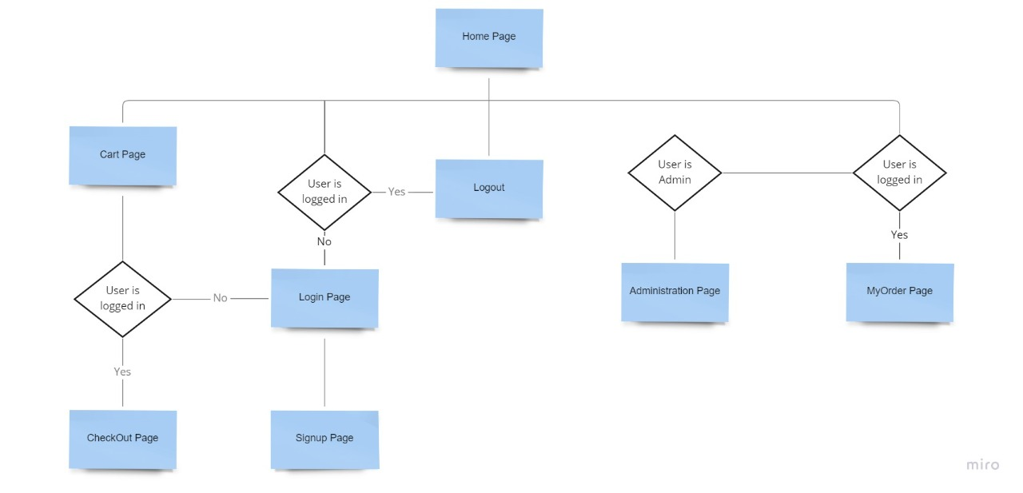

Fig 2.1.1: Flow Chart

## 2.2. HARDWARE AND SOFTWARE REQUIREMENTS:

2.2.1. Hardware Requirements:

* RAM: 4GB+ RAM.
* Hard Drive: 40GB + Hard Drive.
* Processor: Intel Pentium IV Processor.

2.2.2. Software Requirements:

* Python 3.
* Django.
* HTML, CSS, JS

## 2.3. DESIGN DETAILS:

ER Diagram:

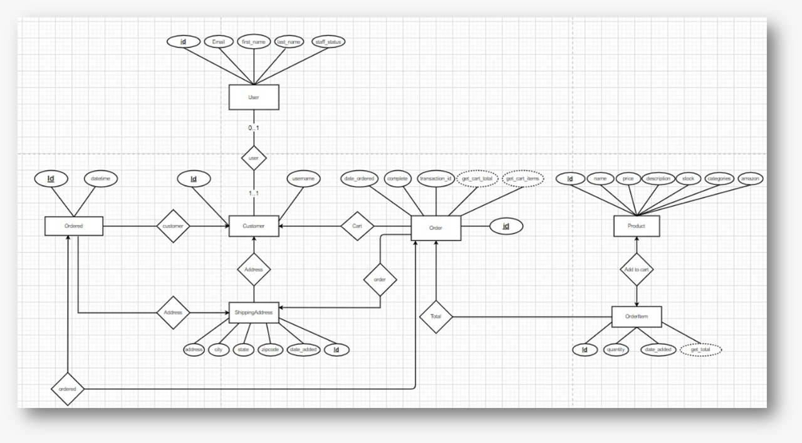

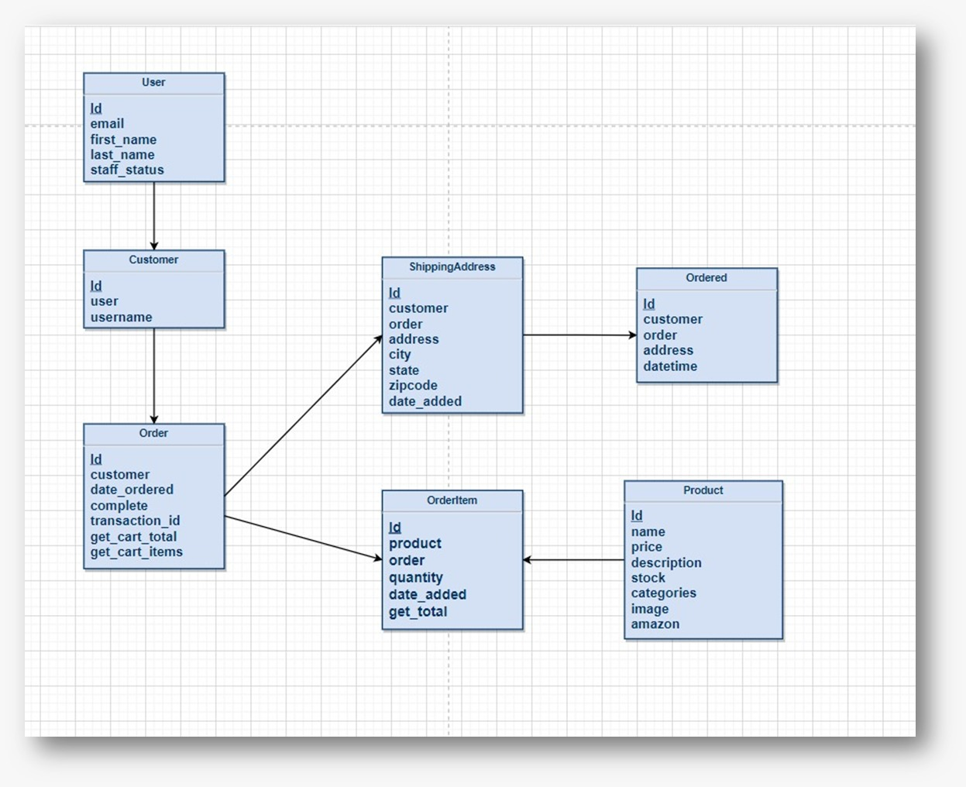

Figure 2.3.1: ER Diagram

# CHAPTER 3

**IMPLEMENTATION AND RESULTS**

## 3.1 IMPLEMENTATION:

Installing Azure Tools in vscode:

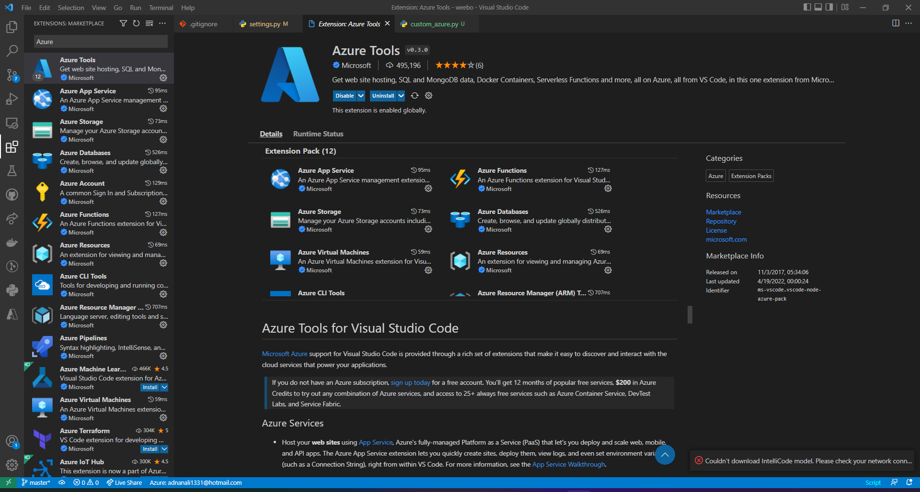

Creating virtual environment, activating it and installing dependencies:

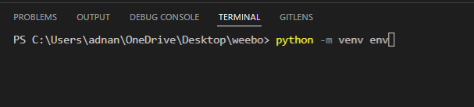

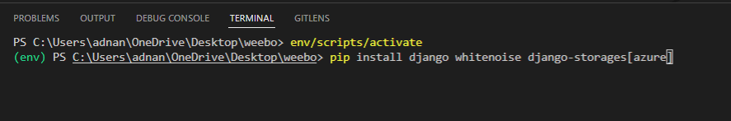

Creating azure storage account to store media files:

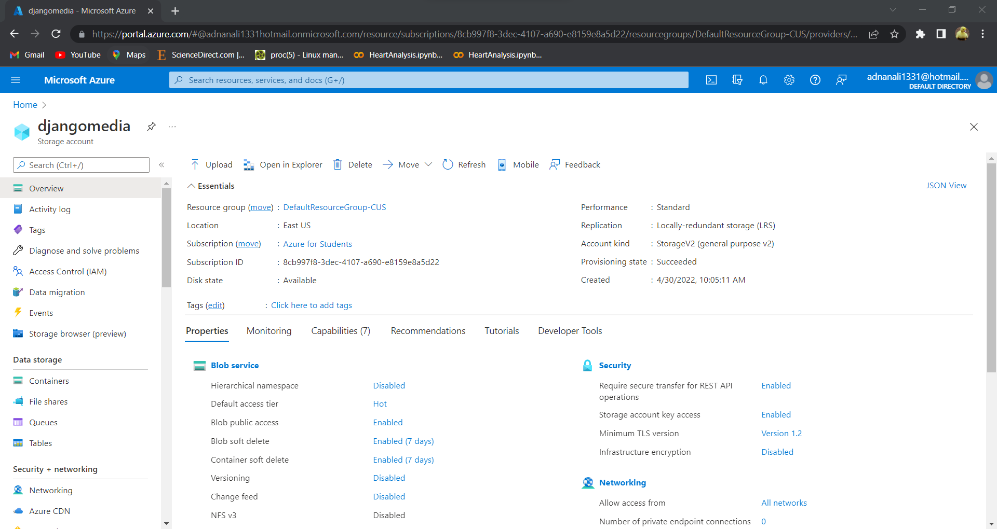

Configuring media and static Storage and URL:

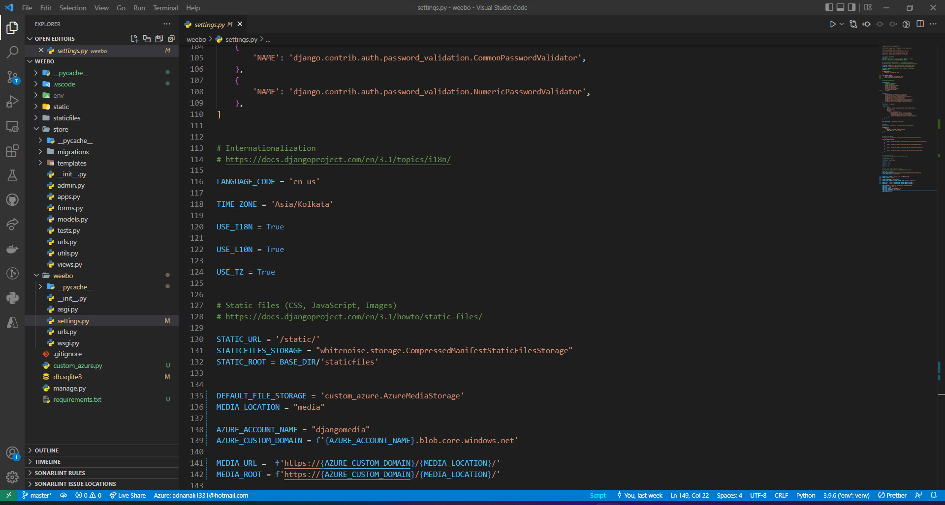

Configuring media URL:

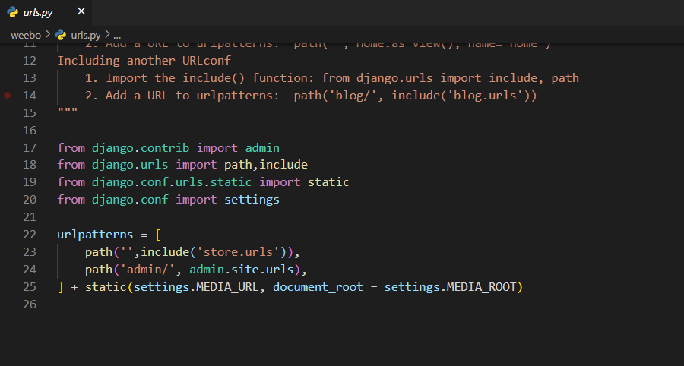

Adding storage to Installed Apps and White noise to Middleware:

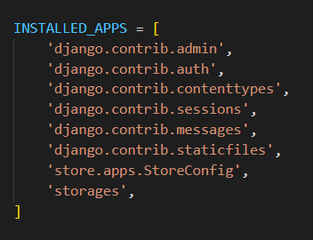 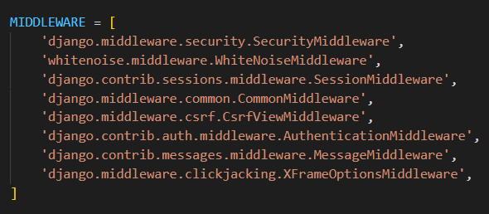

Adding custom azure file with storage key to access the storage blob:

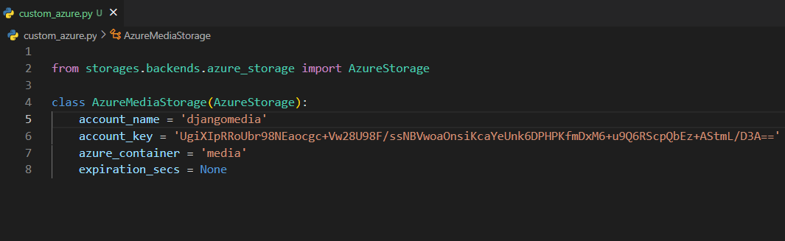

Creating new webapp resources using Azure tools:

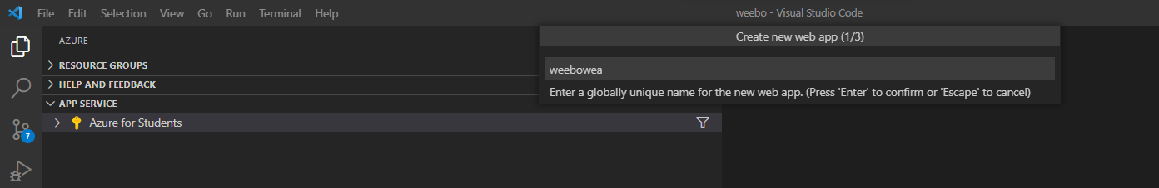

Allowing hosting from our webapp:

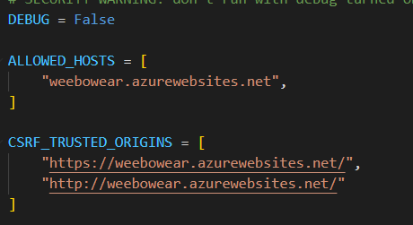

Collecting all dependencies:

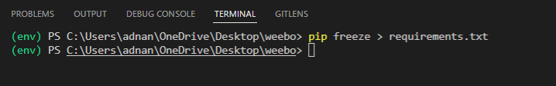

Deploying site to webapp using Azure tools:

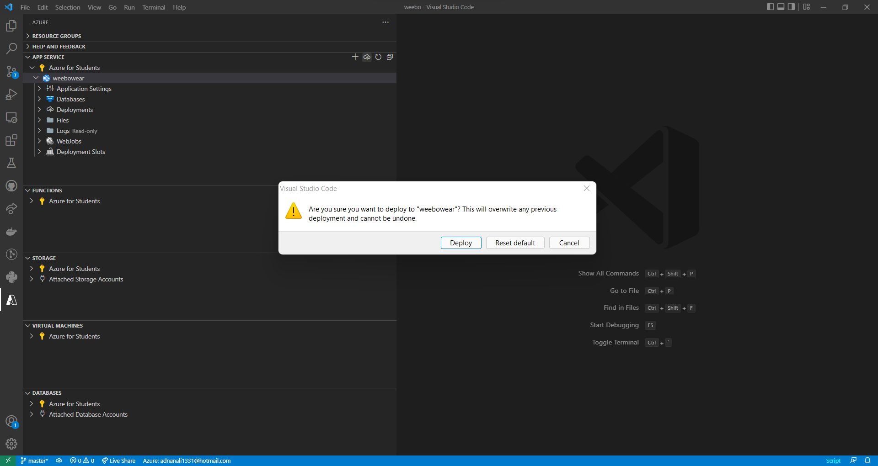

Checking if the website is correctly deployed from Azure portal:

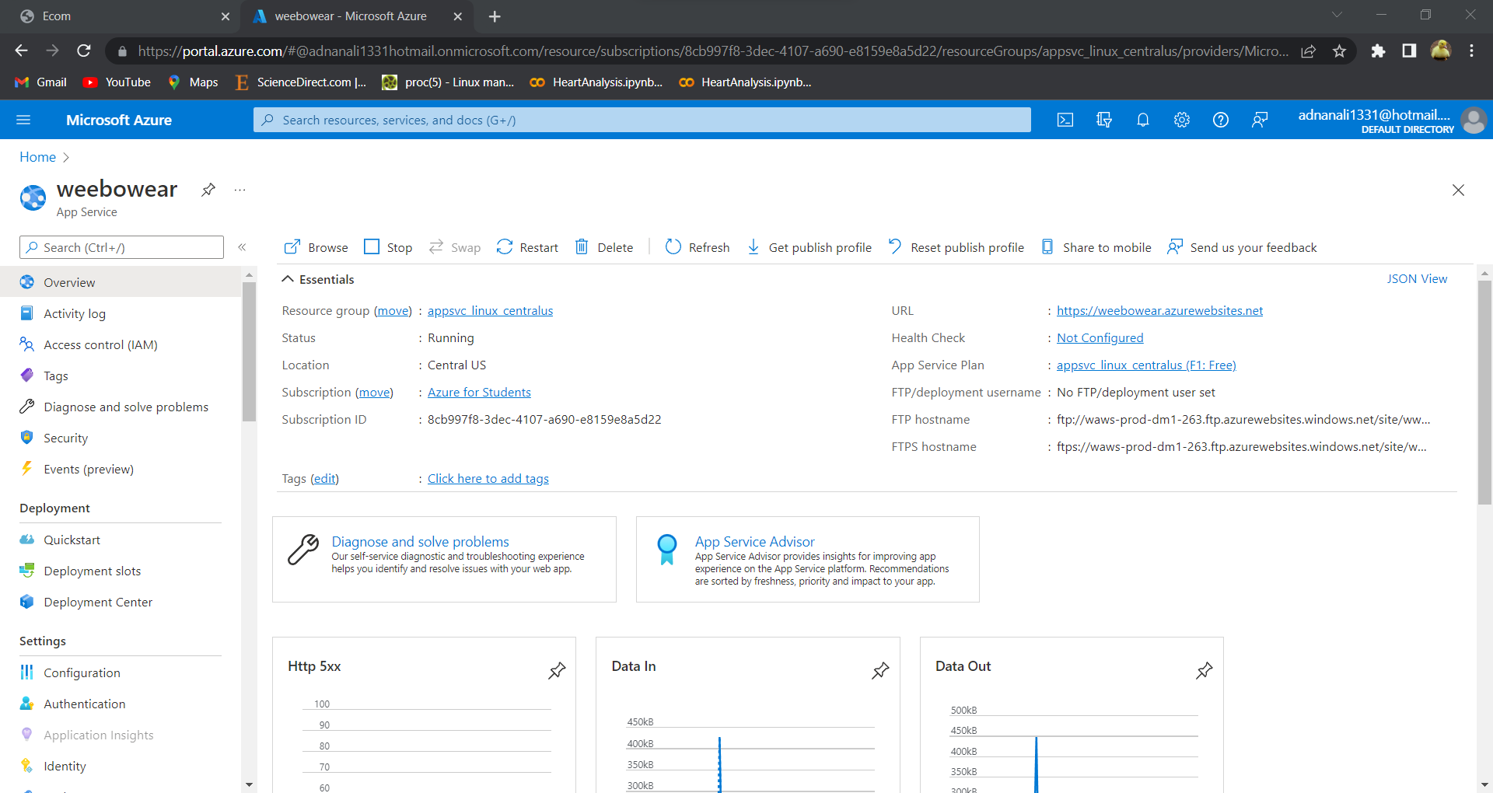

## 3.2 RESULT:

Successfully deployed website: https://weebowear.azurewebsites.net/

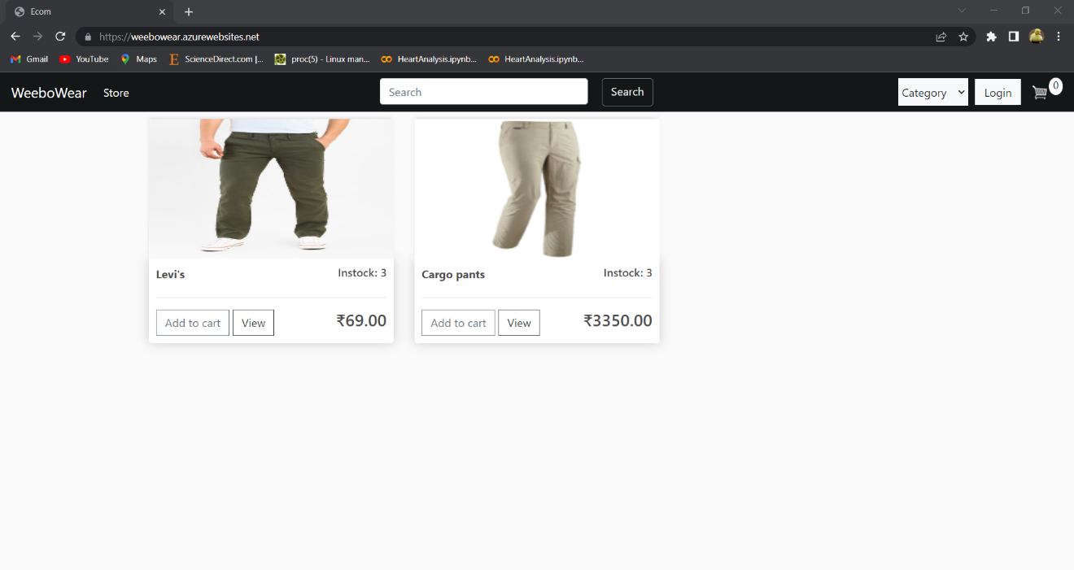

Login page:

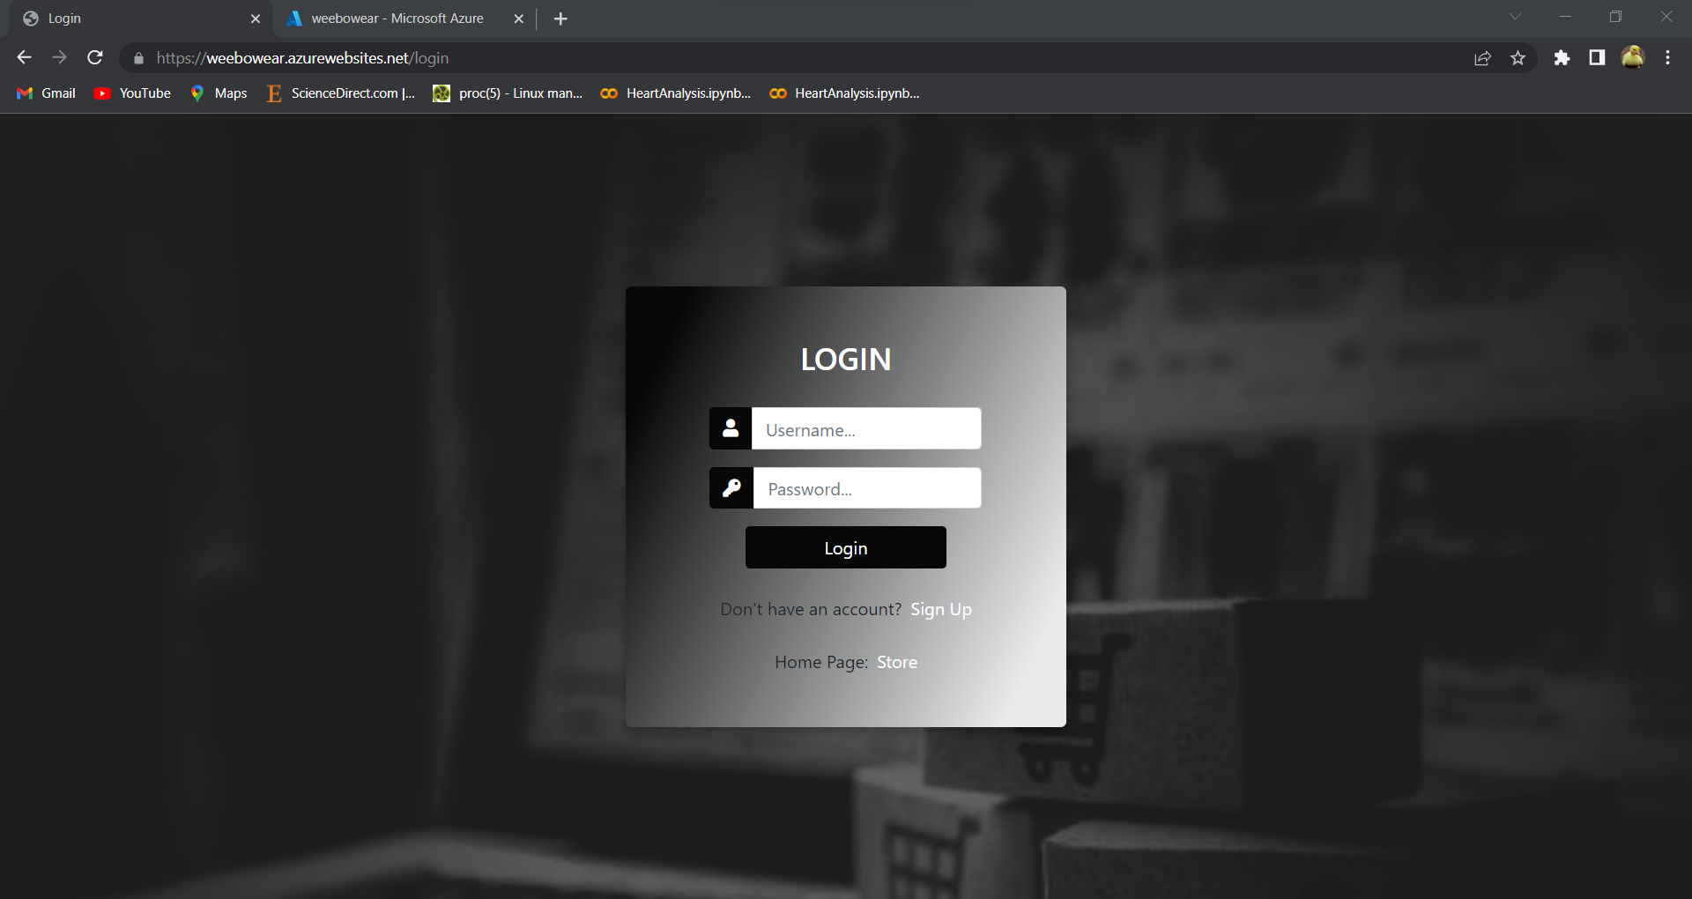

Signup page:

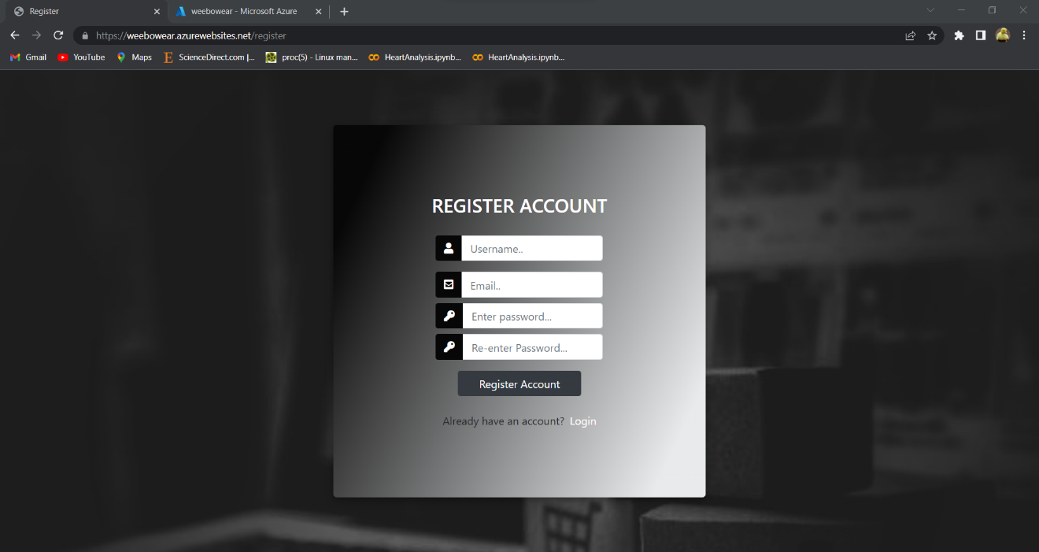

Cart page:

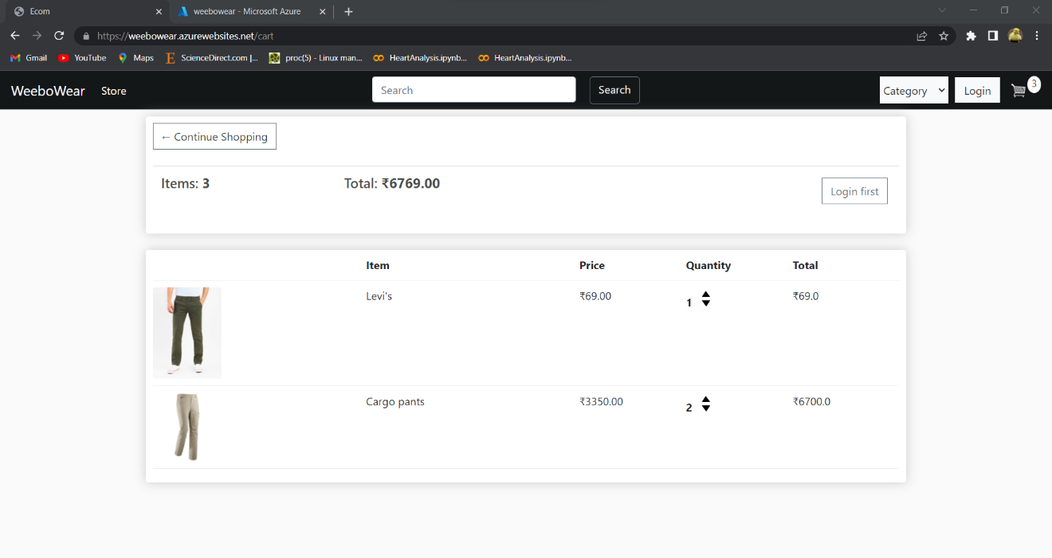

Checkout page:

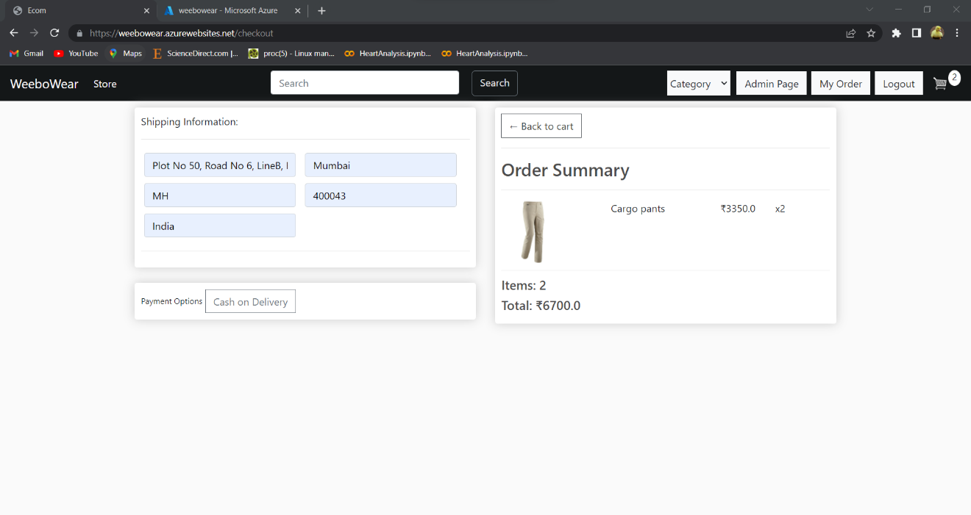

My order page:

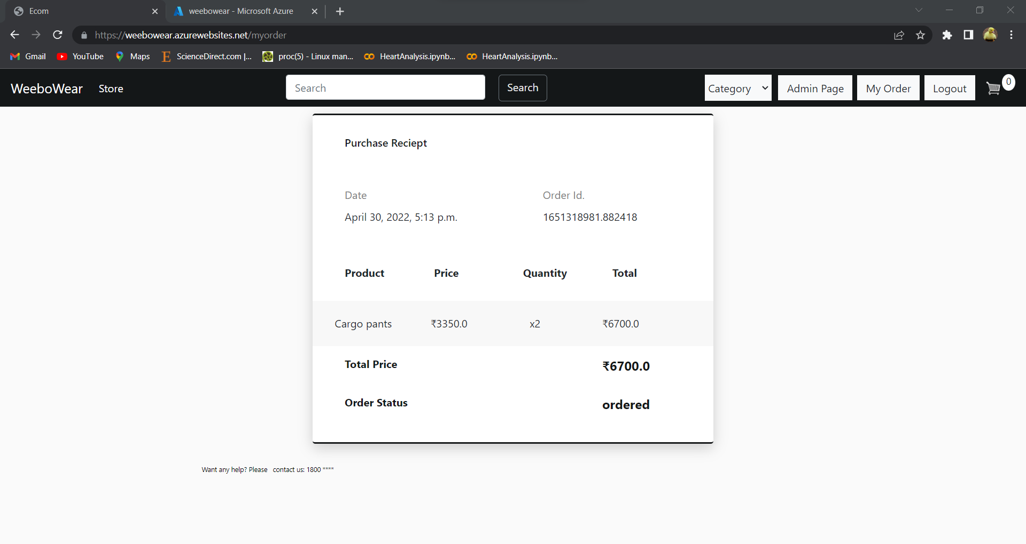

Admin Page:

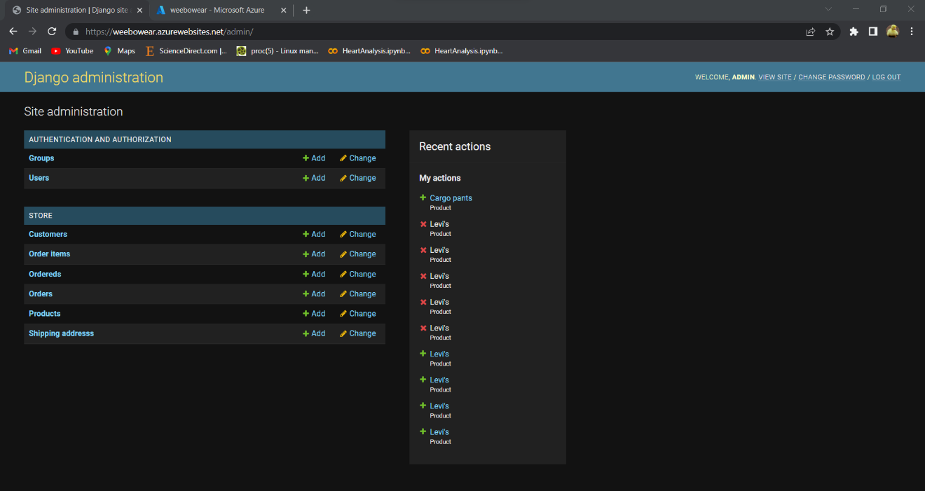

Adding Product and uploading image to media folder of storage account:

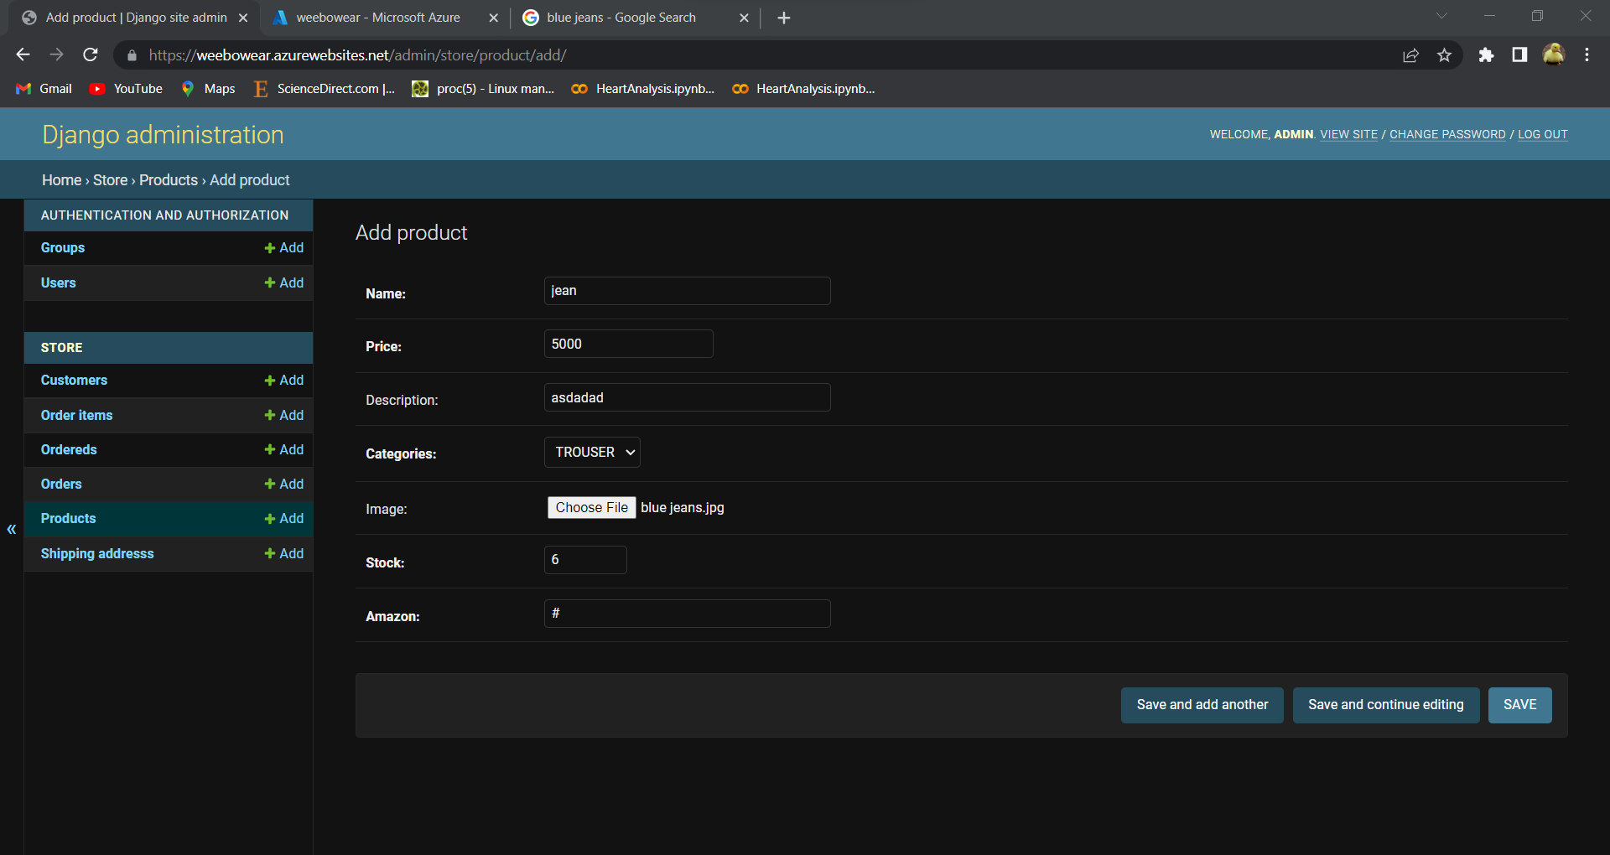

Media folder of storage account:

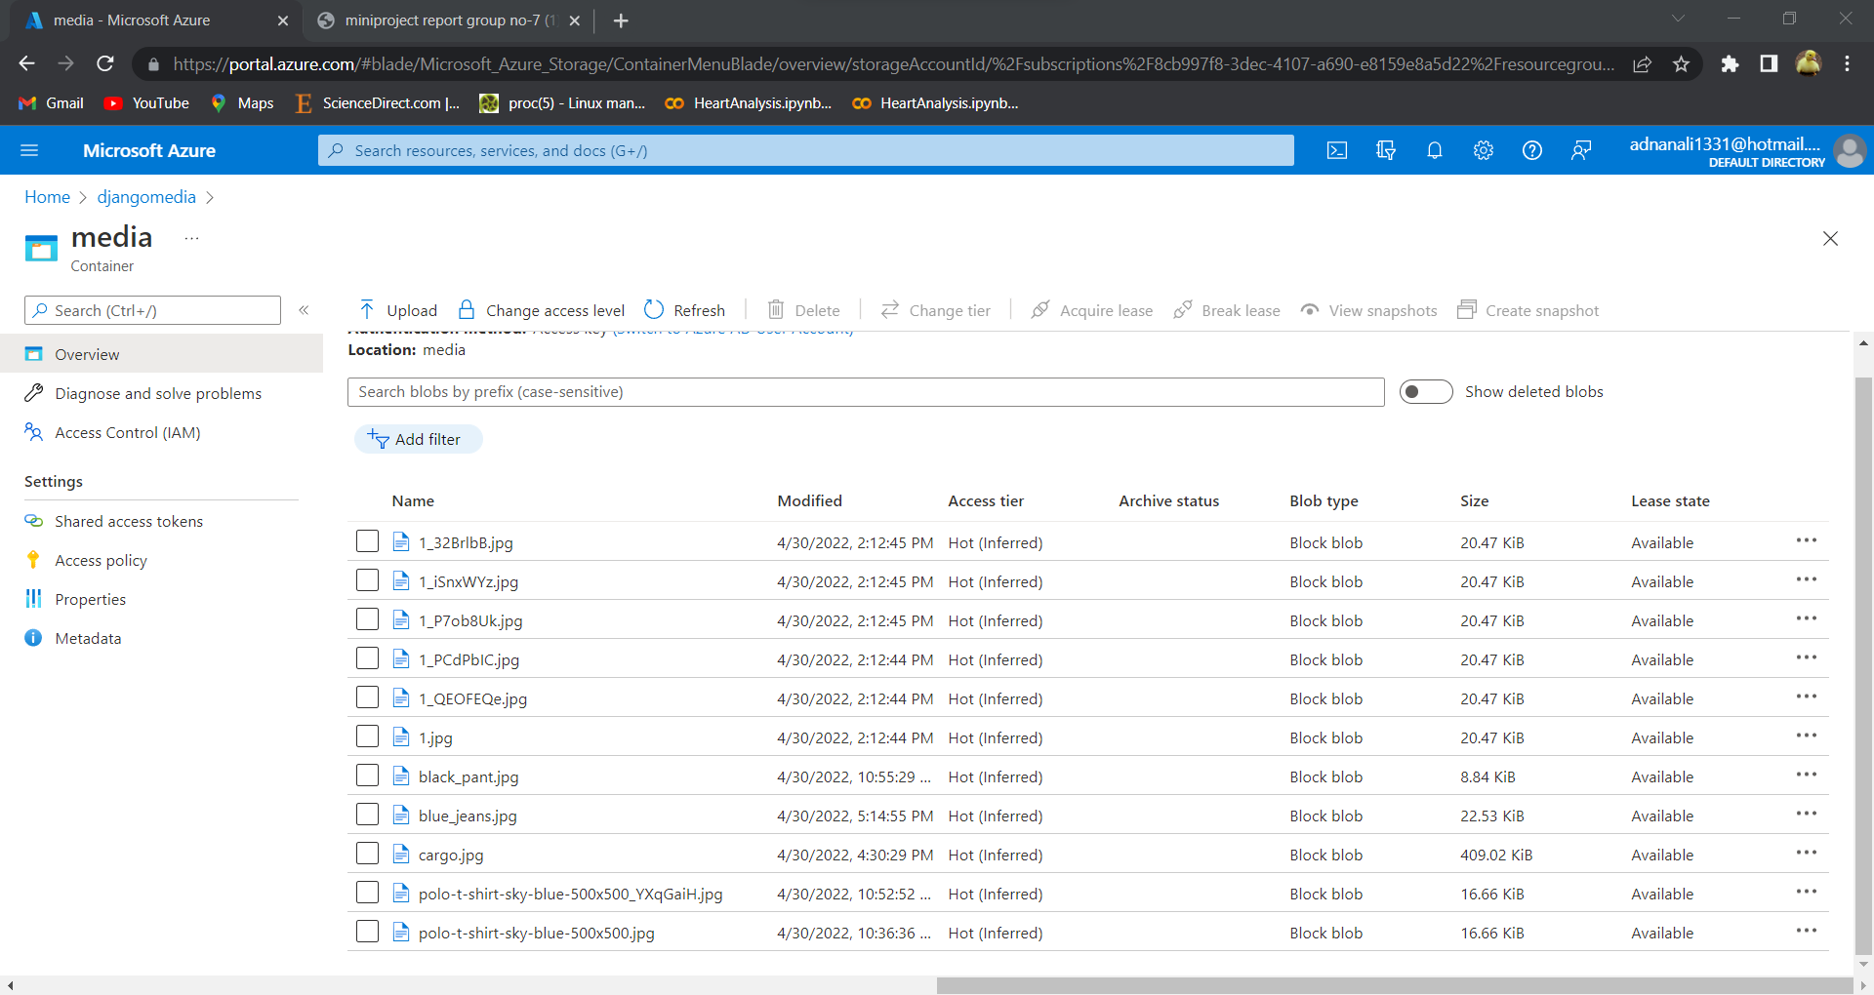

# CHAPTER 4

**CONCLUSION AND FUTURE SCOPE**

## 4.1 CONCLUSION:

* Web hosting is the backbone of your website, and provides complete resources on which your website runs. It is very important to choose the right web hosting provider to ensure that your website never goes down and always performs error-free whenever someone visits it
* Microsoft Azure is considered to be the top most cloud provider in the cloud industry, with Microsoft Azure you can host/run your website with ease and comfort.
* Also, there are several different cloud service providers like GCP, AWS, which provides similar kind of services.
* Maintenance of the website is quite easy and feasible as the cloud providers provide detailed information about the website traffic and engagements.
* As Microsoft Azure and other cloud service providers provide transparency in billing, there is no room for concern about money to be paid to the provider. The provider works on “pay as you go” model, which means you only pay for only what you consume.
* Hence, a website with expected results has been deployed.

## 4.2 FUTURE SCOPE:

* Database can be migrated from dbsqlite3 to PostgreSQL or MySQL for handling heavy traffic.
* Better web services plan are available on Azure and can be upgraded anytime according to need.
* Storage account can be upgraded to new plan for quick retrieval of media files.
* Azure chat bot can be added for customer queries.
* DDOS plan can be activated if needed for network security group (NSG).
* Azure app loading balancing feature can be added to control heavy traffic.
* More resources can be added and manage in NSG.

# CHAPTER 5

**REFERENCE**

[1] [Azure django app deployment tutorial](https://docs.microsoft.com/en-us/azure/app-service/tutorial-python-postgresql-app?tabs=django%2Cwindows%2Cazure-portal%2Cterminal-bash%2Cazure-portal-access%2Cvscode-aztools-deploy%2Cdeploy-instructions-azportal%2Cdeploy-instructions--zip-azcli%2Cdeploy-instructions-curl-bash)

[2] [Azure for everyone](https://azure4everyone.com/)

[3] [Azure storage account](https://docs.microsoft.com/en-us/azure/storage/common/storage-account-create?toc=%2Fazure%2Fstorage%2Fblobs%2Ftoc.json&tabs=azure-portal)