**Experiment No. 9**

**Aim**: To implement income tax and EMI calculator

**Requirements**: Compatible version of Android Studio, Gradle and Java.

**Theory**:

**What is income tax?**

According to the Income Tax Act, 1961, every salaried person needs to pay an amount from their salary as tax to the country. This amount of tax is called the income tax. The law consists of a lot of amendments and variations with subsections describing the details about tax payment, deductions, and computations. A lot of deductions from subsection 80C to 80U are available. The final amount after subtracting all the available tax-saving provisions and deductions is given to the government as the income tax on salary.

|  |  |
| --- | --- |
| Income Source | Description |
| Income from Salary | All income you receive from your job like salary, leave encashment, allowances and so on. |
| Income from Property | Income from house or land (rented or self-occupied) |
| Income from Business/Profession | Earnings form part-time job or profession |
| Income from Gains | Earnings from the sale of a capital asset |
| Income from other sources | Residual income like earnings from the fixed deposit, gifts, pension, etc. |

The EMI of a loan depends on three factors:  
Loan amount – This stands for the total amount that has been borrowed the individual. Interest rate – This stands for the rate at which the interest is charged on the amount borrowed. Tenure of loan – This stands for the agreed loan repayment time-frame between the borrower and the lender.

**How is EMI calculated?**  
  
The mathematical formula to calculate EMI is:

$$EMI = \frac{P × r × (1 + r)n}{(1 + r)n - 1}$$

Where, $P= Loan amount, r= interest rate, n=tenure in number of months.$

**Code**:

package com.cmt.taxcalculator;  
  
import android.content.Intent;  
import androidx.appcompat.app.AppCompatActivity;  
import android.os.Bundle;  
import android.view.View;  
import android.widget.Button;  
import android.widget.TextView;  
  
public class MainActivity extends AppCompatActivity {  
 TextView t;  
 Button b1;  
 Button b2;  
  
 @Override  
 protected void onCreate(Bundle savedInstanceState) {  
 super.onCreate(savedInstanceState);// To Display The Layout from activy_main resource layout file.   
 setContentView(R.layout.*activity_main*);  
 b1 = findViewById(R.id.*button1*);  
 b2 = findViewById(R.id.*button2*);  
  
 b1.setOnClickListener(new View.OnClickListener() {  
 @Override  
 public void onClick(View view) {  
 Intent intent= new Intent(MainActivity.this, com.cmt.taxcalculator.IncomeActivity.class);  
 startActivity(intent); // On clicking on the button, Income Tax Calculator activity is called  
 }  
 });  
  
 b2.setOnClickListener(new View.OnClickListener() {  
 @Override  
 public void onClick(View view) {  
 Intent intent=new Intent(MainActivity.this, com.cmt.taxcalculator.EMIActivity.class);  
 startActivity(intent);// On clicking on the button, EMI activity is called  
 }  
 });  
 }  
  
 public void exitApp() {  
 finish();  
 }  
  
}

**Output**:

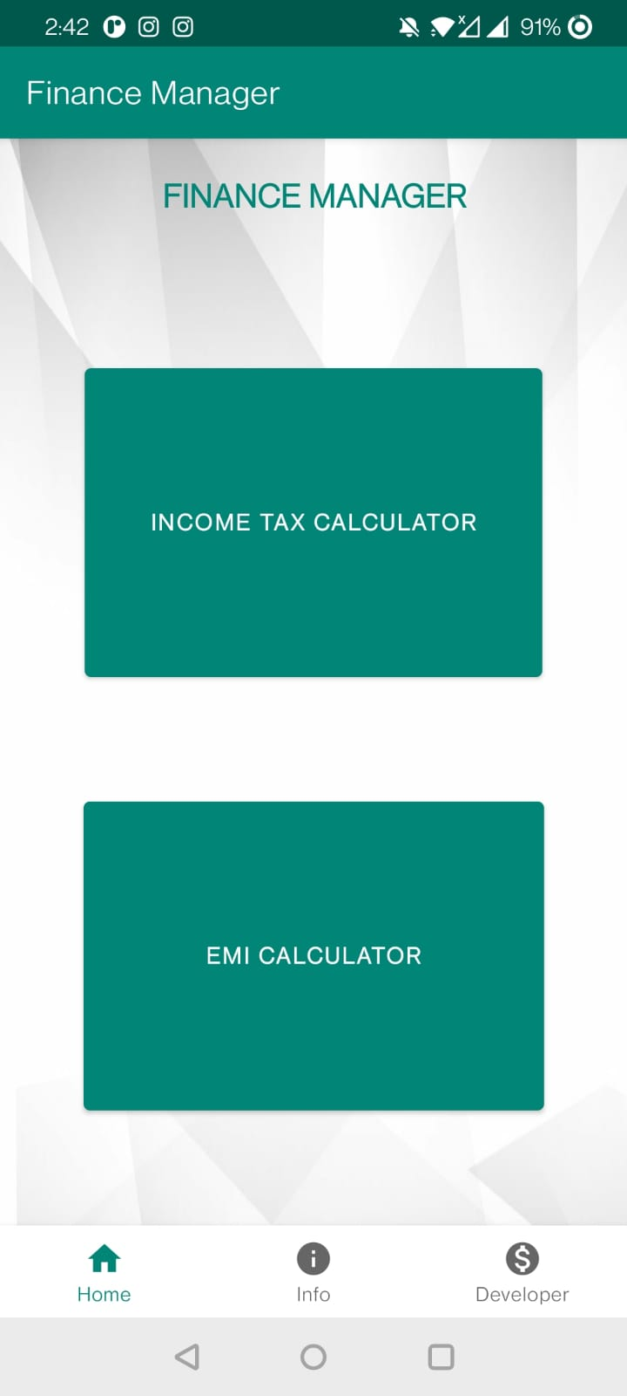 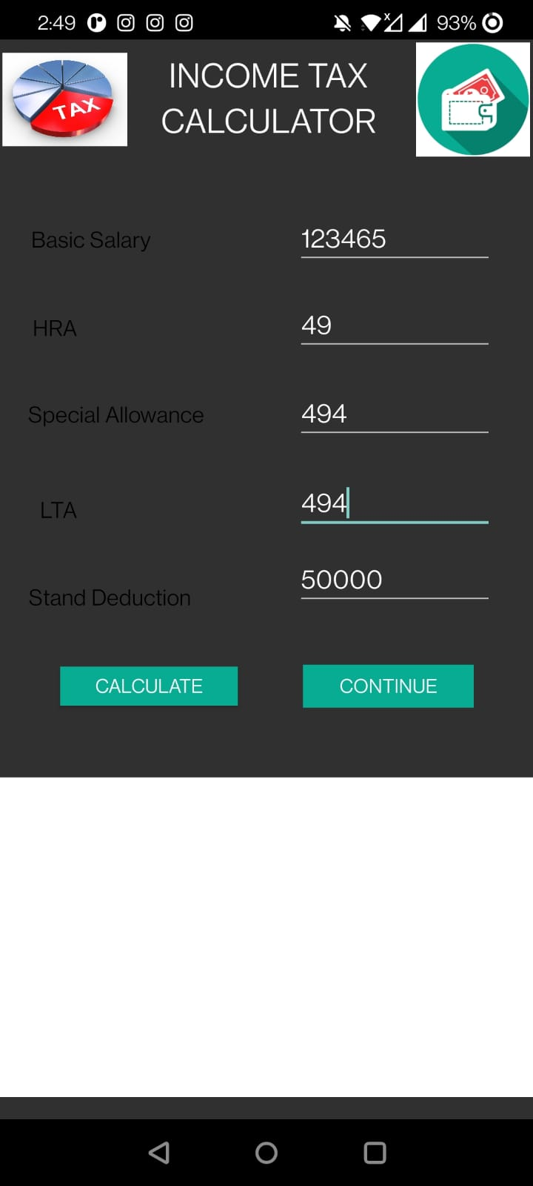

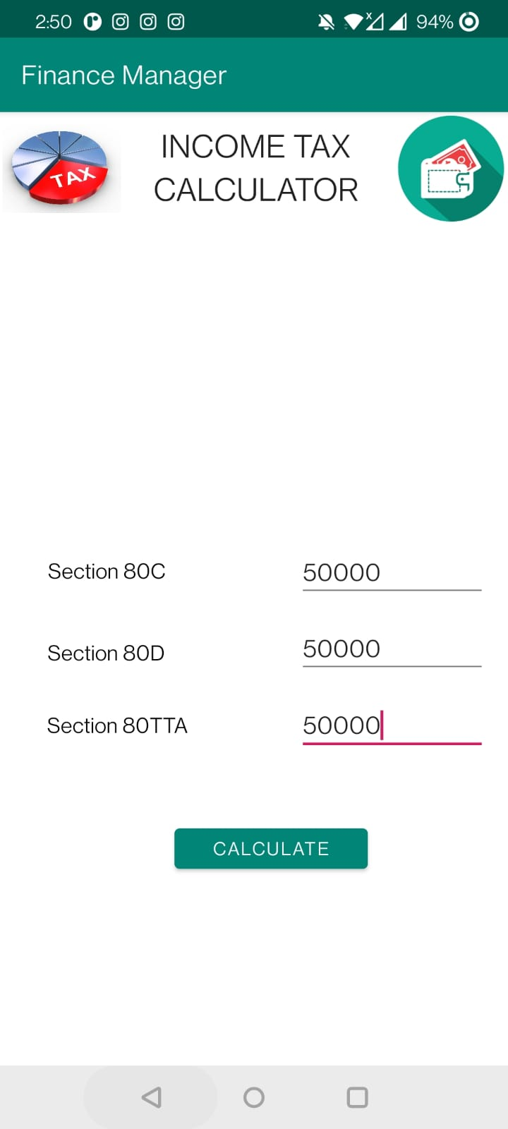 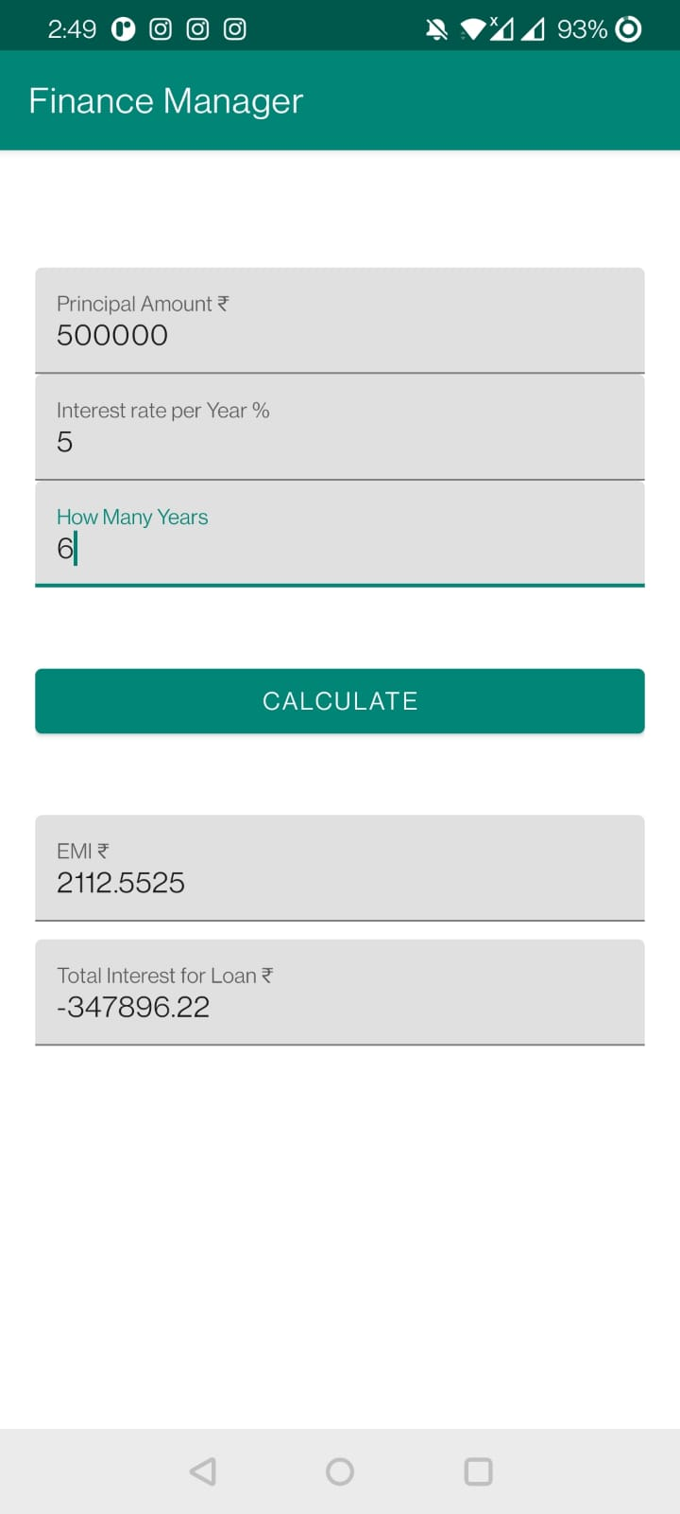

**Conclusion**: We have successfully implemented EMI and Tax calculator in Android.