**Experiment No. 3**

**Aim:** To implement security algorithm of GSM in python.

**Requirements:** Compatible version of python.

**Theory:**

GSM is the most secured cellular telecommunications system available today. GSM has its security methods standardized. GSM maintains end-to-end security by retaining the confidentiality of calls and anonymity of the GSM subscriber.

Temporary identification numbers are assigned to the subscriber’s number to maintain the privacy of the user. The privacy of the communication is maintained by applying encryption algorithms and frequency hopping that can be enabled using digital systems and signalling.

**Mobile Station Authentication:**

The GSM network authenticates the identity of the subscriber through the use of a challenge-response mechanism. A 128-bit Random Number (RAND) is sent to the MS. The MS computes the 32-bit Signed Response (SRES) based on the encryption of the RAND with the authentication algorithm (A3) using the individual subscriber authentication key (Ki). Upon receiving the SRES from the subscriber, the GSM network repeats the calculation to verify the identity of the subscriber.

The individual subscriber authentication key (Ki) is never transmitted over the radio channel, as it is present in the subscriber's SIM, as well as the AUC, HLR, and VLR databases. If the received SRES agrees with the calculated value, the MS has been successfully authenticated and may continue. If the values do not match, the connection is terminated and an authentication failure is indicated to the MS.

The calculation of the signed response is processed within the SIM. It provides enhanced security, as confidential subscriber information such as the IMSI or the individual subscriber authentication key (Ki) is never released from the SIM during the authentication process.

**Signalling and Data Confidentiality:**

The SIM contains the ciphering key generating algorithm (A8) that is used to produce the 64-bit ciphering key (Kc). This key is computed by applying the same random number (RAND) used in the authentication process to ciphering key generating algorithm (A8) with the individual subscriber authentication key (Ki).

GSM provides an additional level of security by having a way to change the ciphering key, making the system more resistant to eavesdropping. The ciphering key may be changed at regular intervals as required. As in case of the authentication process, the computation of the ciphering key (Kc) takes place internally within the SIM. Therefore, sensitive information such as the individual subscriber authentication key (Ki) is never revealed by the SIM.

Encrypted voice and data communications between the MS and the network is accomplished by using the ciphering algorithm A5. Encrypted communication is initiated by a ciphering mode request command from the GSM network. Upon receipt of this command, the mobile station begins encryption and decryption of data using the ciphering algorithm (A5) and the ciphering key (Kc).

**Subscriber Identity Confidentiality:**

To ensure subscriber identity confidentiality, the Temporary Mobile Subscriber Identity (TMSI) is used. Once the authentication and encryption procedures are done, the TMSI is sent to the mobile station. After the receipt, the mobile station responds. The TMSI is valid in the location area in which it was issued. For communications outside the location area, the Location Area Identification (LAI) is necessary in addition to the TMSI.

**Code:**

import random

import math

def encryption(data_size):

assert 8<= data_size <= 128, "Data size should be in range [8,128]"

assert data_size & (data_size-1) == 0, "Data size must be in power of two"

key, data = [bin(random.getrandbits(data_size))[2:].zfill(data_size) for _ in range(2)]

key_left, key_right = key[:data_size//2], key[data_size//2:]

data_left, data_right = data[:data_size//2], data[data_size//2:]

a1, a2 = int(key_left,2)^int(data_right,2),int(key_right,2)^int(data_left,2)

a3 = a1^a2

a4 = bin(a3)[2:].zfill(data_size//2)

a5, a6 = a4[:data_size//4], a4[data_size//4:]

a7 = int(a5,2)^int(a6,2)

return key, data, bin(a7)[2:].zfill(data_size//4)

data_size = int(input("Enter number in range [8,128] and in power of 2: "))

print()

try:

key, random_bits, res_sres_ratio = encryption(data_size)

print(f"{data_size} bit key= {key}\n\n{data_size} random bits generated= {random_bits}\n")

print(f"RES/SRES= {res_sres_ratio}")

except AssertionError as error:

print(error)

**Output:**

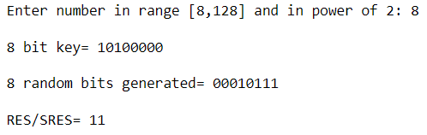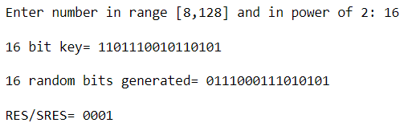

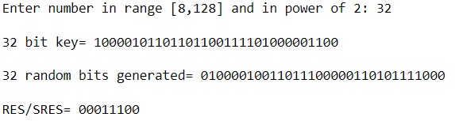

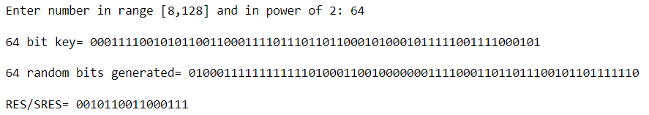

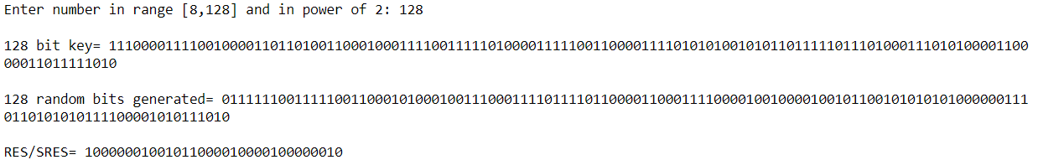

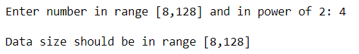 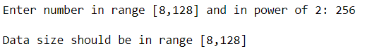

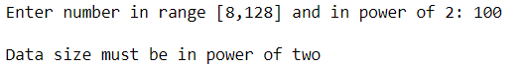

**Conclusion:** We have successfully implemented GSM security algorithm in python.