

**Department of Computer Engineering**

**Name: Shaikh Adnan Shaukat Ali**

**Roll No: 76**

**Subject code: CSL601**

**Subject Name: System Programming and Compiler Construction Lab**

**Class/Sem: T.E. / SEM-VI**

**Year: 2021-2022**

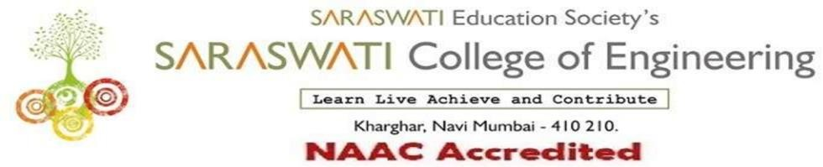

###### COMPUTER ENGINEERING DEPARTMENT

Subject: System Programming and Compiler Construction Lab. Class/Sem: TE/VI

**Name of the Laboratory: Project Lab. Year: 2021-2022**

**LIST OF EXPERIMENTS**

|  |  |  |  |
| --- | --- | --- | --- |
| **Expt. No.** | **Date** | **Name of the Experiment** | **Page No.** |
| 1 | 20/01/2022 | Case study on System Programming. | 3-14 |
| 2 | 27/01/2022 | Lexical Analyzer tool: LEX   1. To identify a given number is even or odd. 2. Identify vowels in a string. 3. To identify relational operator. 4. To copy the contents of one file to another file. | 15-22 |
| 3 | 04/02/2022 | Perform arithmetic operations using YACC. | 23-27 |
| 4 | 11/02/2022 | Design an implementation of pass I of two pass assembler. | 28-33 |
| 5 | 18/03/2022 | Design an implementation of pass II of two pass assembler. | 34-43 |
| 6 | 4/03/2022 | Design an implementation of pass I of two pass macro-processor. | 44-50 |
| 7 | 11/03/2022 | Design an implementation of pass II of two pass macro-processor. | 51-57 |
| 8 | 25/03/2022 | Implementation of Lexical Analyzer. | 58-62 |
| 9 | 01/04/2022 | Implementation of Parser. | 63-67 |
| 10 | 08/04/2022 | Implementation of intermediate code generation. | 68-72 |
| 11 | 22/04/2022 | Study on LLVM tool. | 73-78 |
| 1 | 22/02/2022 | Assignment No. 1 | 79-96 |
| 2 | 20/04/2022 | Assignment No. 2 | 97-121 |

|  |  |
| --- | --- |
| **H/W Requirement** | P I and above, RAM 128MB, Printer, Cartridges. |
| **S/W Requirement** | Flex Windows (LEX and YACC), C Compiler. |

Prof. Shatabdi Bhalerao Prof. Sujata Bhairnallykar

**Subject In-charge HOD**